DBConverter

Table of Contents
1 Overview 1
2 Functionality 1
3 Usage 2
4 Limitations 3
5 Specialization 4
5.1 Reasons to change 4
5.1.1 BuildSQLForFromQuery 4
5.1.2 DefaultForField 4
5.1.3 CompatibleFields 4
5.1.4 BlobFieldTypes 4
6 Example of logs 5

Overview
The purpose of the DBCopyConverter is to overcome some problems that might occur when updating a model, especially the loss of existing data.

DBCopyConverter works on table/column level, meaning it has no idea what a model is and its impact on its own domain of knowledge. In the majority of cases this will not matter, but there are times when DBConverter cannot do its job because of this limited view of the world.

DBCopyConverter may also be used when moving a bold-database between two database engines, a scenario that might happen when moving from development/testing into production.

Functionality
The DBCopyConverter is essentially a combination of two classes, TBoldDBConverter and TBoldBatchMover that have quite well defined roles in the task they are designed to accomplish. The TBoldDBConverter does the bulk of the work, as in traversing a database structure, requesting an instance of TboldBatchMover to copy the data of each table into a target database, and subsequently updates the classIDs of data in the target database to map the target database classID-list.

Usage
To use the DBCopyConverter, you need to have two databases; one source DB, based on an old model and one target DB based on the new model. The target DB must contain a generated database to hold the new model, and tables must be empty except for BOLD_TYPES and BOLD_ID. In other words, no application specific data should be inserted in the Target DB before running DBCopyConverter.

To be more specific on the steps recommended prior to running DBCopyConverter:
- Create a new database (how to do this depends on your DB engine of choice)
- Create a new BDE alias that points to your newly created database
- Create a new database from the Bold Model editor and make sure it is created into your newly created, empty database.

Having ensured the two databases and their having a BDE alias each (e.g. SourceDB and TargetDB) you should now run the DBConverter. Specify your source and target database respectively and press the “Convert”-button
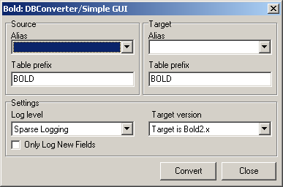
DBCopyConverter will instantiate a TBoldDBCopyConverter. The newly created object will traverse the database and copy everything in all tables that has a corresponding entity in the targetDB. The actual copying of data is the responsibility of a TBoldbatchMover (which in turn delegates the job to a standard TbatchMove component when it assumes the TbatchMove can handle the task), and then update the classIDs in the target database’ data.
All actions are logged, and the log file can be saved to disk for future reference.

DBCopyConvert will try to guess if the database is empty, and if it is found to contain information, the following message will be displayed: 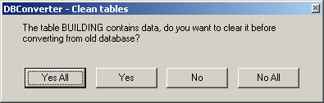

Limitations
As the DBCopyConverter works on a low level, i.e. table/column it may not handle all information transformations very gracefully. Simply put, it handles adding and removing classes and members, but not complete restructures, such as splitting a class in two;
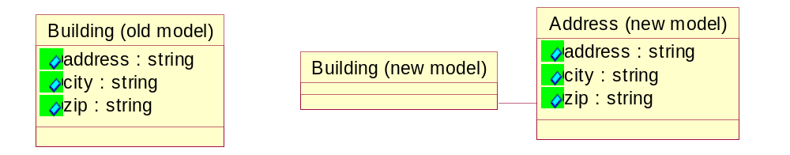

or moving attributes in a hierarchy;
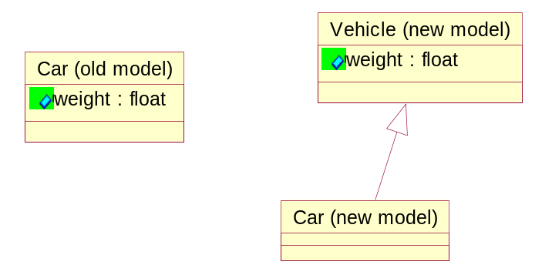

There are other cases of transformation that the DBCopyConverter will not handle in its shipping state. Some can be handled by carefully crafting a subclass of TboldBatchMover. Others yet, may require another application moving data in a more specialized way.

Specialization
You may have other needs that what is implemented. Please feel free to use what you need from the source code or write your own subclasses. The design is as always done with focus on flexibility and reusability. In the code there are clearly marked “hot spots” where you may want to change or override.
As the design goes, the class you are most likely to change/override is the working class TboldBatchMover. To ensure TBoldDBConverter uses your new class when instantiating the internal objects, make sure to set the MoverClass property to hold a class reference to your new class.

Reasons to change
There are several reasons to extend the TboldBatchMover, either by modifying the existing code, or by sub classing it. Below is a brief explanation of the top candidates for rewrite.

BuildSQLForFromQuery
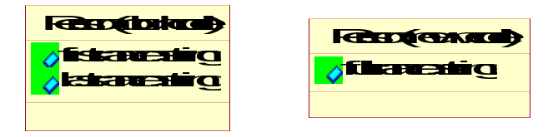
if your model has changed as above, two members are now represented by one single member, you may want to override BuildSQLForFromQuery and add code that checks for a specific table (PERSON) and make the SQL-statement look similar to

SELECT …, lastname + “, “ + firstname as fullname, … FROM PERSON

DefaultForField
If you want newly added fields to be initialized to a specific value, add code in DefaultForField that returns the string representation of this value.

CompatibleFields
The CompatibleFields method is very basic. Apart from allowing float-fields to be converted into currency, it enforces types to be identical, but in the real world this does not necessarily need be the case.
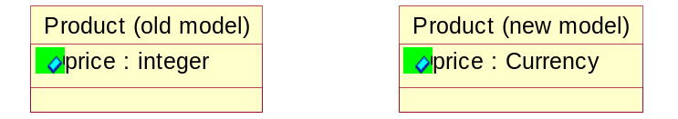
you may want to extend the CompatibleFields method to allow various numerical types conversions.
The simplest way is to add lines of the type
FieldsAllowConversion(ftCurrency, ftFloat);
Containing the allowable conversions (such as Byte to integer).
function TBoldBatchMover.CompatibleFields(ToFieldDef: TFieldDef; FromField: TField): boolean;
function FieldsAllowConversion(FromType, ToType: TFieldType): boolean;
begin
Result := (FromField.DataType = FromType) and
(ToFieldDef.DataType = ToType);
end;
begin
// Allow same type to same type
Result := (ToFieldDef.DataType = FromField.DataType) or
// allow currency => float
FieldsAllowConversion(ftCurrency, ftFloat);
end;
Implementation of CompatibleFields method

BlobFieldTypes
The BlobFieldTypes is not a method, but a typed constant. If your database engine claims there are more BLOB-like fields than what is specified, just add the field types to the constant and you should be home safe.

Example of logs
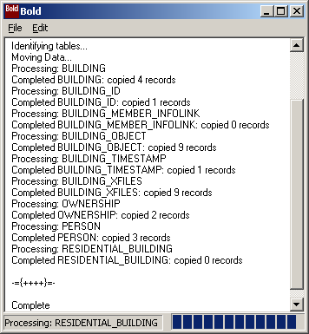
Log after moving the data shipped with the building example from a paradox database to an InterBase DB.

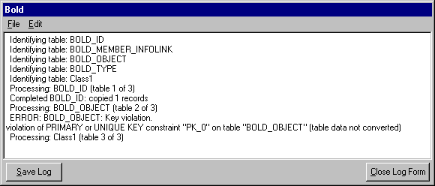In the example above the DBCopyConverter was run twice on the data shipped with the BoldImage example, thus violating primary index’ uniqueness.

