Lab 3

FPGAs as Accelerators

# Introduction

The goal of this Lab is to implement the ***LSAL algorithm*** on the *x86, Arm* and *FPGA* of the *zedboard* and to *optimize* it in every case using ***Valgrind***, ***Intel advisor*** and ***Vitis HLS***.

*LSAL* stands for *local sequence alignment algorithm* that is used in *bioinformatics* and works by giving *an input of two input strings, a database D of length M, and a query Q of length N.*

The *objective* is to find regions of similarity between subsequences of all possible lengths. An *M × N similarity matrix* S is constructed to hold similarity scores for each subsequence comparison.

A *second matrix* (called direction matrix) is formed to hold the direction path through matrix 𝑆 to produce an *alignment*. The cell value of the direction matrix indicates the direction followed to reach that cell. The optimal alignment is produced by starting from the position of the maximum score in matrix 𝑆 and following the directions found at the same index in the direction matrix until a zero in 𝑆 is found.

*In typical cases,* the *size M* of the *database string* can be in the order of millions of *symbols*.

### File Structure

.

├── FPGA

│ ├── lsal.cpp

│ └── lsal.host

├── Software

│ ├── lsal_optimized.cpp

│ └── Makefile

└── Report.pdf

# Software (x86 & Arm)

## Workflow

The general workflow for the development of the code which is meant to run on x86 and Arm environments is as follows:

1. *First* we ***implement*** the *LSAL algorithm* *without* considering the *CPU running time* and only taking into account the *functionality* of the code.
2. *Then* we ***profile*** the code using ***Valgrind***and ***Intel Advisor***while identify the parts of the code that take the *most amount of time to run and which of them can change*.
3. *Depending* on the results of the previous step we change the necessary parts of the code but now *aiming for* ***performance***.
4. *Lastly* we ***compare*** the running times of the *optimized* and *unoptimized version* both by *CPU running times and* ***Roofline analysis*** *results*.

*In both the unoptimized and optimized code* we have added a ***debug*** *DEFINE* that allows us to debug any possible problem by just using the command *make debug* of our *MAKEFILE*.

## Unoptimized

The ***unoptimized code*** represents an *implementation* of the *LSAL algorithm* where the output matrix is being calculated row-wise.

*In the code* we have added a ***second for loop*** *(compared to the lab input)* in order for the algorithm to *calculate* the values of the ***first row*** because it meets a lot of *edge cases* which would be *not efficient* to place it in the *main loop* as all those edge cases would need to be checked for every value of the output arrays while this only needs to happen while the first row is being filled out.

*In the main loop* that was already there from the lab input we have added all the cases and the necessary calculations. *At the end of the for loop* we save the results both in the *similarity matrix* and the *direction matrix* while checking If the max index needs to be *“dethroned”*.

The results for a varying number of array sizes (Query and Database) are shown in the table below.

|  |  |  |  |  |
| --- | --- | --- | --- | --- |
| x86 vs ARM Unoptimized (sec) | | | | |
| Ν | **Μ** | ARM | x86 | Difference |
| 32 | **32** | 0.000098 | 0.00002 | 79.5918% |
| 32 | **65536** | 0.175177 | 0.037108 | 78.8169% |
| 256 | **65536** | 1.402216 | 0.303335 | 78.3675% |
| 256 | **300000** | 6.417753 | 1.388256 | 78.3685% |

*As we can see* the *x86* is ***78.82% faster*** on *average* than the *ARM processor* of the *zedboard*.

## Optimized

*In order to profile the unoptimized code,* we used ***Valgrind*** a *tool* that helps to identify parts of the code that take up most of the *execution time*.

### Branching

*The* ***branches*** are some of the *instances* where to code was ***slow*** and *our solution* to the problem was to *reduce the if commands by* ***unrolling*** *the loops*.

*For example,* the ***northwest*** and the ***west*** during the calculation of cells of the *first column* ***cannot be read*** *because they are out of the bounds of the similarity array*. *Thus* for the *first cell* of the *each row* the calculation of *northwest and west* ***is skipped*** *by unrolling the inner loop*.

### Division & Modulo

*Also* calculations needed to find the *index* of the *similarity* and *direction array* are hard to calculate thus take ***more time*** *to be executed* *(Mostly* ***modulo*** *% and* ***division*** */)*. *So* to *eliminate* the need to calculate the *x and y indexes of the matrices* we ***divide*** the *main loop* to ***two smaller*** *ones* with one of them *representing the rows and the other the columns*.

### Defines

*It was noticed* that ***constant variables*** were used to *define penalty, match, mismatch scores and enumerate the directions of the direction matrix (N, W, NW, C). That* may have *a* ***bad effect*** *on performance* because to access those values it is needed to *access memory*. *So even though the boost performance was minor* we transformed every constant variable to *defined values* *that became static during compilation (****#define****)*.

|  |  |  |  |  |
| --- | --- | --- | --- | --- |
| x86 vs ARM Optimized (sec) | | | | |
| Ν | Μ | ARM | X86 | Optimisation |
| 32 | 32 | 0.000045 | 0.000015 | 66.6667% |
| 32 | 65536 | 0.076079 | 0.024057 | 68.3789% |
| 256 | 65536 | 0.586488 | 0.196926 | 66.4228% |
| 256 | 300000 | 2.685104 | 0.897239 | 66.5846% |

## Comparison

*Lastly* we have run the ***Roofline Analysis***that compares the *optimized* and *unoptimized code (when run on x86)* using the ***Intel Advisor*** as shown below:

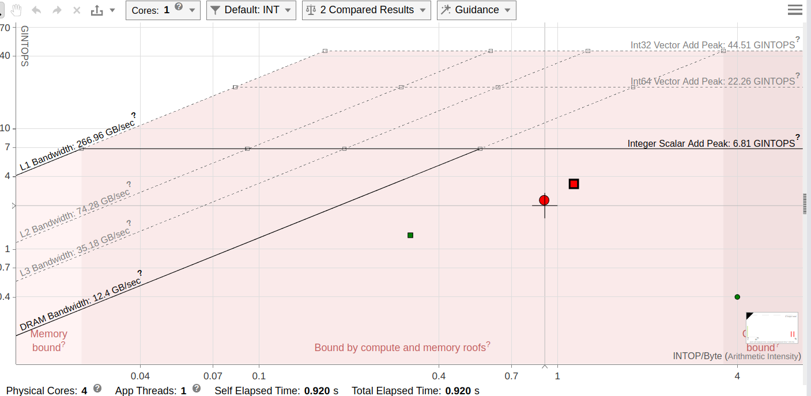

*Image: Diagram of Roofline Model Analysis using Intel Advisor*

The ***red circle*** represents the *unoptimized version* whereas the ***red square*** represents the *optimized version* of the code.

*As we can see* the *optimized version* has achieved *better parallelism* (as it is placed higher) and is even less dependent on the memory bandwidth (as it is placed more to the right).

With these changes the running times have dropped significantly with an average decrease of ***32.65%*** on the x86 and 56% in the ARM processor of the zedboard.

*As a conclusion,* the optimized performs better on all aspects and has reduced running time both on x86 and on Arm by ***44.32%*** on *average*.

|  |  |  |  |  |
| --- | --- | --- | --- | --- |
| x86 (sec) | | | | |
| Ν | Μ | Unoptimized | Optimised | Optimisation |
| 32 | 32 | 32 | 0.00002 | 25.0000% |
| 32 | 65536 | 65536 | 0.037108 | 35.1703% |
| 256 | 65536 | 65536 | 0.303335 | 35.0797% |
| 256 | 300000 | 300000 | 1.388256 | 35.3693% |

|  |  |  |  |  |
| --- | --- | --- | --- | --- |
| ARM (sec) | | | | |
| Ν | Μ | Unoptimised | Optimised | Optimisation |
| 32 | 32 | 0.000098 | 0.000045 | 54.0816% |
| 32 | 65536 | 0.175177 | 0.076079 | 56.5702% |
| 256 | 65536 | 1.402216 | 0.586488 | 58.1742% |
| 256 | 300000 | 6.417753 | 2.685104 | 58.1613% |

# Hardware (FPGA)

*During* the last part of the lab we use ***Vitis HLS*** to implement the *LSAL algorithm* on *FPGA* hardware.

In order to have the optimum outcome we defined a *streamlined* ***workflow***:

* *First* our team tries different ***optimization methods*** on *Visual Studio Code IDE*.
* *Then* *functionality* of the *C code* is tested using *Vitis HLS’s* ***C Simulation***.
* *At this point synthesis* and ***Synthesis Design Report*** of *Vitis HLS* is used to analyze the *resources in-use and the time estimations.*
* *Next* we use the provided *makefile* to ***emulate*** the *kernel design* using ***QEMU***
* *Last*ly we test the design ***natively*** on the FPGA and *extract* the ***timing*** of *our implementation*

*It is important* to note that both *C Simulation*, *which tests functionality of the code before it gets synthesised*, and *software emulation using QEMU* are really important as a simple mistake can be detected and fixed long before the time it takes to have the kernel implemented into a bitstream.

Figure 1: Showing diagonal parallelism, image provided during lecture.

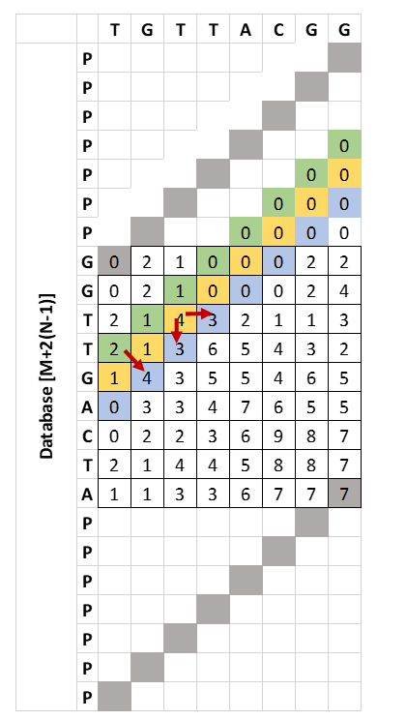

*Also Synthesis Design Report* is a great tool to have in order to make sure the HLS optimizations you use have been implemented in the correct way. *For example* an easy mistake to make is placing a *#pragma* above a loop instead of inside it, which could result in vastly different implementations.

## Algorithmic Optimizations

The main optimization introduced in the category of algorithmic optimizations is using ***diagonals*** to calculate the *similarity matrix*. As mentioned during the lecture in this way we *limit data dependencies* and *“unlock”* ***parallelism***.

This method requires that every diagonal is of the same size. Thus we need to enlarge the database by $2(N-1)$, *where N is the size of query and M the size of database.*

We realized during the calculation of a diagonal that there are data dependencies on the 2 diagonals above the one in calculation. That means once the diagonal is calculated it can be moved to the buffer of the above diagonal.

Also one thing noted to us is that at the beginning of each iteration of the loop we have a ***write-after-read*** on the *current diagonal*, *because* at the *end* of a *iteration* we write the diagonal we just calculated to main memory while at the *start* of the next we try to ***write*** to it. *That may be an* ***obstacle*** to having a ***pipelined*** *design* with***low LL***.

*\*\*\*ADD MORE ABOUT THE LOOPS AND IFs\*\*\**

## HLS Optimizations

This section includes every *optimization* that is ***RTL specific*** using *HLS*.

### Array buffers

A method of making memory access faster is by using memory blocks that are near the processing unit of the acceleration. The designer in this case has 2 main options:

* by using ***Block RAM*** *(BRAM)*, *that is a distinct memory block surrounded by Look-up Tables*, and
* by using the ***Flip-Flops*** inside the *Look-up Tables* of the *FGPA*, *which is faster but at the expense of making the rest of the LuT hard to utilize*.

*Thus* for the best results a combination of the two is needed.

For our implementation the arrays has the following characteristics:

|  |  |  |  |
| --- | --- | --- | --- |
| Array | Description | #pragma |  |
| string1 | Buffer of query | PARTITION | factor=2 cyclic |
| string2 | Buffer of database | PARTITION | factor=2 cyclic |
| current_diag | Buffer of current diagonal | PARTITION | factor=2 block |
| up_diag | Buffer of the above diagonal | PARTITION | factor=2 cyclic |
| upper_diag | Buffer of 2 diagonals above the current one | PARTITION | factor=2 cyclic |
| direction_diag | Buffer of current diagonal | PARTITION | factor=2 block |

***Γιατί cyclic ή block***

### Arbitrary Elements

*Another* easy **optimization** to make is to *reduce the* ***size*** *of the* ***bus*** used on the *design*.

*For example* in the case of the ***query***and ***database***we know *as a fact* that they need to *enumerate* just the *4 nucleotides* in existence plus *one* more undefined state we use in combination with the *diagonals optimization*. Thus we only need to ***3-bits*** to ***enumerate 5 states***,   
($2^{3}= 8 > 5 states$).

*In the exact same fashion* the bits used to represent the ***direction matrix*** are reduced to ***3-bits***.

*To be noted* other data structures such as the *similarity matrix*, it’s *diagonal* *buffers* and *max_index* **must not** be represented by a ***smaller number of bits*** because the *RTL* *designers* cannot *easily* calculate *the maximum value* each structure is going to store.

## Comparison

# Results

## FPGA vs CPU

χαχα