Lab 3

FPGAs as Accelerators

# Introduction

**LSAL Explanation

**File structure

# Software (x86 & Arm)

**workflow

## Unoptimized

## Code Profiling

## Optimized

**valgrind

## Comparison

# Hardware (FPGA)

*During* the last part of the lab we use ***Vitis HLS*** to implement the *LSAL algorithm* on *FPGA* hardware.

In order to have the optimum outcome we defined a *streamlined* ***workflow***:

* *First* our team tries different ***optimization methods*** on *Visual Studio Code IDE*.
* *Then* *functionality* of the *C code* is tested using *Vitis HLS’s* ***C Simulation***.
* *At this point synthesis* and ***Synthesis Design Report*** of *Vitis HLS* is used to analyze the *resources in-use and the time estimations.*
* *Next* we use the provided *makefile* to ***emulate*** the *kernel design* using ***QEMU***
* *Last*ly we test the design ***natively*** on the FPGA and *extract* the ***timing*** of *our implementation*

It is important to note that both *C Simulation*, *which tests functionality of the code before it gets synthesised*, and *software emulation using QEMU* are really important as a simple mistake can be detected and fixed long before the time it takes to have the kernel implemented into a bitstream.

Also *Synthesis Design Report* is a great tool to have in order to make sure the HLS optimizations you use have been implemented in the correct way. *For example* an easy mistake to make is placing a *#pragma* above a loop instead of inside it, which could result in vastly different implementations.

## Algorithmic Optimizations

The main optimization introduced in the category of algorithmic optimizations is using ***diagonals*** to calculate the *similarity matrix*. As mentioned during the lecture in this way we *limit data dependencies* and *“unlock”* ***parallelism***.

*Image: Showing diagonal parallelism, image provided during lecture.*

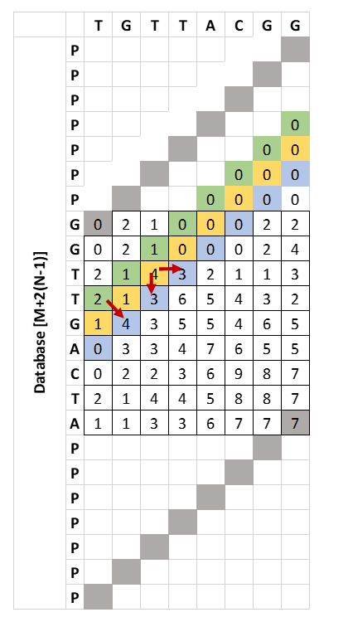

This method requires that every diagonal is of the same size. Thus we need to enlarge the database by $2(N-1)$, *where N is the size of query and M the size of database.*

*\*\*\*ADD MORE ABOUT THE LOOPS AND IFs\*\*\**

## HLS Optimizations

This section includes every *optimization* that is ***FPGA specific*** using *HLS*.

### Array buffers

A method of making memory access faster is by using memory blocks that are near the processing unit of the acceleration. The designer in this case has 2 main options:

* by using ***Block RAM*** *(BRAM)*, *that is a distinct memory block surrounded by Look-up Tables*, and
* by using the ***Flip-Flops*** inside the *Look-up Tables* of the *FGPA*, *which is faster but at the expense of making the rest of the LuT hard to utilize*.

*Thus* for the best results a combination of the two is needed.

For us

## Comparison

# Results

## FPGA vs CPU