# Introduction:

An investment’s systematic risk is far more important than its unsystematic risk.

Systematic sources of risks are common to most investments resulting in a perfect positive correlation and no diversification benefit. Large portfolios will not be affected by unsystematic risk but will be influenced by systematic risk factors.

# What is Factor analysis?

It is a statistical method used to describe variability among observed, correlated variables in terms of a potentially lower number of unobserved variables called factors. Simply put, the factor loading of a variable quantifies the extent to which the variable is related with a given factor.

# My project objectives:

This project presents OLS, Lasso, CV Lasso and CV Elastic Net algorithms built on Historical values of the factor Variables to understand the pattern of their volatility with respect to time and attempts to interpret the source ofthe asset return of asset classes and attribute it to the factor returns.

# Target Audience:

My proposed solution will be useful for retail investor who is a non-professional investor and who lack the education and will lose their money for most of the times.

# Hypothesis, Key questions investigated:

1) How my asset classes are correlated with factors?

2) Am I able to take better decisions by understanding issue as in 1.what is my accuracy of predictions?

# Data Sources, Modeling Techniques, EDA used:

The data is obtained from Federal Reserve Economic Data. FRED is an online database consisting of hundreds of thousands of economic data time series from

Scores of national, international, public, and private sources.

# What has been done Earlier and what be my Benchmarks

Markowitz Portfolio Optimization, CAPM, Arbitrage Pricing Theory, Fama and French 3- Factor Models are some of the research initiatives that have already been done in order to minimize systematic risk factors.

I have put forth my Key questions investigated as above. I would like to know what are my accuracies in able to predict in order to aim at Portfolios optimization.

My major milestone targets would be trying simpler and easy to understand solutions which can get most effortlessly applied by any non-professional investor and which still helps them to optimize their portfolios.

# Major Action Items Implemented:

## US Equities as Target Variable from Asset Class Category:

I have used World Equities, USTreasuries, Bond Risk Premium, Inflation Protection and Currency Protection as Factor Variables.

I have used Asset class namely US Equities as Target Variable to predict the Returns based on the Factor Variables as Independent variables.

I have employed Linear Regression-OLS Model,Lasso Regression,CV Lasso and CV Elastic Net Modeling techniques to predict US Equities Returns.

My Leader Board gives me the following results:

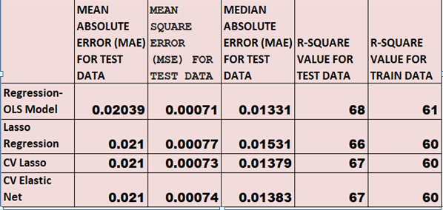

Leader Board-comparison of Metrics for Predictions on US EQUITIES against Factor Variables(World Equities, US Treasuries, Bond Risk Premium, Inflation Protection, Currency Protection)by different prediction Models

Clearly it can be observed that mean Absolute Error, Mean Square error, Median Absolute Error is minimum in case of OLS Model.so we can use OLS Model to predict US Equities Returns against five factor variables used as Independent variables.

Based on OLS Model following is the heat map plot to demonstrate correlation between US Equities Returns and other five factor variables Returns namely World Equities, US Treasuries, Bond Risk Premium, Inflation Protection and Currency Protection.

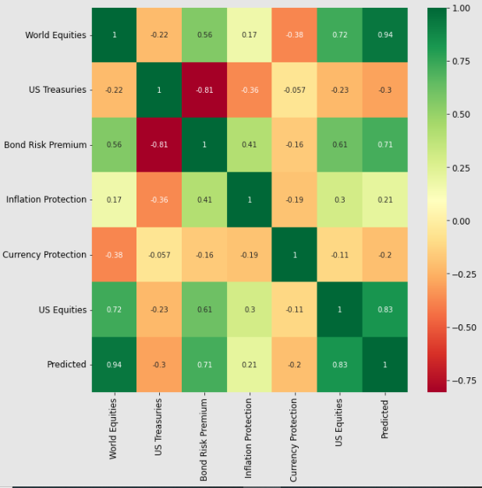

The Insight drawn would be that World Equities and Bond Risk Premium are highly positively correlated whereas other factor variables don’t seem to have significant impact on US Equities Returns.

We also observe that Correlation between Actual US Equities Returns and Predicted returns is 0.83.

## Real Estateas Target Variable from Asset Class Category:

I have used World Equities, US Treasuries, Bond Risk Premium, Inflation Protection and Currency Protection as Factor Variables.

I have used Asset class namely Real Estate as Target Variable to predict the Returns based on the Factor Variables as Independent variables.

I have employed Linear Regression-OLS Model, Lasso Regression, CV Lasso and CV Elastic Net Modeling techniques to predict Real Estate Returns.

My Leader Board gives me the following results:

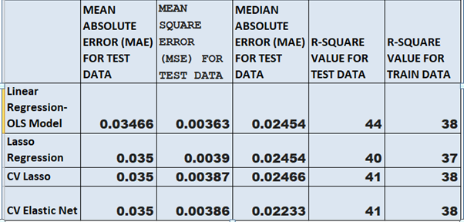

Leader Board-comparison of Metrics for Predictions on Real Estate against Factor Variables(World Equities, US Treasuries, Bond Risk Premium, Inflation Protection, Currency Protection)by different prediction Models

Clearly it can be observed that mean Absolute Error, Mean Square erroris better in case of OLS Model Whereas CV elastic Net gives better Median Absolute error. Mean Absolute Error and Mean Square error also works fine here.so we can use either OLS Model or CV elastic Net to predict Real Estate Returns against five factor variables used as Independent variables.

Based on CV elastic Net following is the heat map plot to demonstrate correlation between Real Estate Returns and other five factor variables Returns namely World Equities, US Treasuries, Bond Risk Premium, Inflation Protection and Currency Protection.

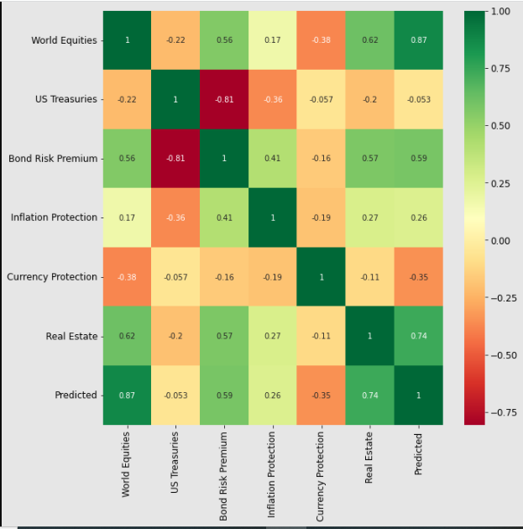

The Insight drawn would be that World Equities and Bond Risk Premium are highly positively correlated whereas other factor variables don’t seem to have significant impact on Real Estate Returns.

We also observe that Correlation between Actual Real Estate Returns and Predicted returns is 0.74.

## Commodities as Target Variable from Asset Class Category:

I have used World Equities, US Treasuries, Bond Risk Premium, Inflation Protection and Currency Protection as Factor Variables.

I have used Asset class namely Commodities as Target Variable to predict the Returns based on the Factor Variables as Independent variables.

I have employed Linear Regression-OLS Model, Lasso Regression, CV Lasso and CV Elastic Net Modeling techniques to predict Commodities Returns.

My Leader Board gives me the following results:

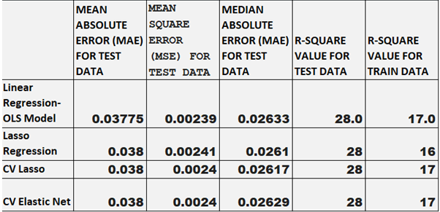

Leader Board-comparison of Metrics for Predictions on Commodities against Factor Variables(World Equities, US Treasuries, Bond Risk Premium, Inflation Protection, Currency Protection)by different prediction Models

Clearly it can be observed that mean Absolute Error, Mean Square error, Median Absolute Error is almost the same for all Modeling algorithms.

Based on CV elastic Net following is the heat map plot to demonstrate correlation between Commodities Returns and other five factor variables Returns namely World Equities, US Treasuries, Bond Risk Premium, Inflation Protection and Currency Protection.

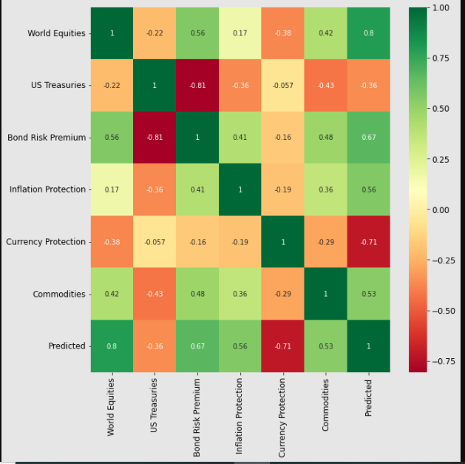

The Insight drawn would be that World Equities and Bond Risk Premium are positively correlated whereas US Treasuries is negatively correlatedwithCommodities Returns.

We also observe that Correlation between Actual Commodities Returns and Predicted returns is 0.53 which is relatively lesser.

## Corp Bondsas Target Variable from Asset Class Category:

I have used World Equities, US Treasuries, Bond Risk Premium, Inflation Protection and Currency Protection as Factor Variables.

I have used Asset class namely Corp Bondsas Target Variable to predict the Returns based on the Factor Variables as Independent variables.

I have employed Linear Regression-OLS Model, Lasso Regression, CV Lasso and CV Elastic Net Modeling techniques to predict Corp Bonds Returns.

My Leader Board gives me the following results:

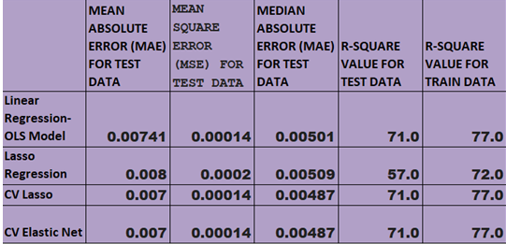

Leader Board-comparison of Metrics for Predictions on Corp Bonds against Factor Variables(World Equities, US Treasuries, Bond Risk Premium, Inflation Protection, Currency Protection)by different prediction Models

Clearly it can be observed that mean Absolute Error, Mean Square error, Median Absolute Error is minimum in case of CV elastic Net.so we can use CV elastic Net Model to predict Corp Bonds Returns against five factor variables used as Independent variables.

Based on CV elastic Net following is the heat map plot to demonstrate correlation between Corp BondsReturns and other five factor variables Returns namely World Equities, US Treasuries, Bond Risk Premium, Inflation Protection and Currency Protection.

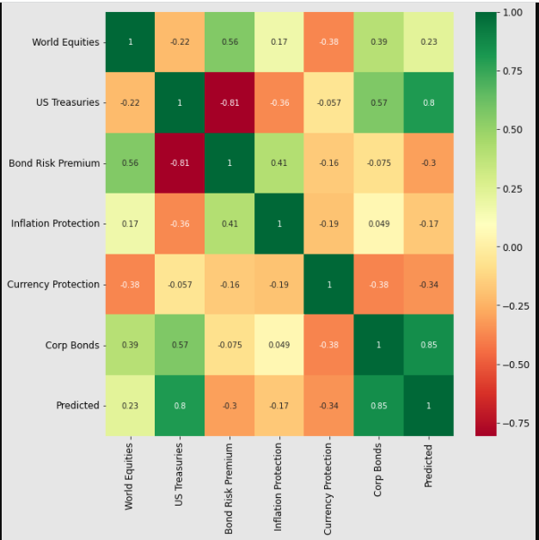

The Insight drawn would be that World Equities and US Treasuries are positively correlated and Currency Protection is negatively correlatedwhereas other factor variables don’t seem to have significant impact onCorp Bonds Returns.

We also observe that Correlation between Actual Commodities Returns and Predicted returns is 0.85.