

A Project Report on
Predicting the Financial Market Regime
With Machine Learning

Submitted in partial fulfilment for the award of the degree of
Master of Business Administration
In Business Analytics

Submitted by

Anand Mohan
R19MBA53

Under the Guidance of
Mithun Dolthody Jayaprakash
Senior Manager - Data Science

REVA Academy for Corporate Excellence
REVA University
Rukmini Knowledge Park, Kattigenahalli,
Yelahanka, Bangalore – 560064

February 2022

Candidate’s Declaration

I, Anand Mohan hereby declare that I have completed the project work towards the first year of Master of Business Administration in Business Analytics at, REVA University on the topic entitled Predicting the Financial Market Regime with Machine Learning under the supervision of Mithun Dolthody Jayaprakash, Senior Manager - Data Science-RACE. This report embodies the original work done by me in partial fulfilment of the requirements for the award of the degree for the academic year 2022.

Place: Bengaluru Name of the Student: Anand Mohan

Date:9 Feb. 22 Signature of Student

Certificate

This is to Certify that the Project work entitled Predicting the Financial Market Regime with Machine Learning carried out by Anand Mohan with SRN R19MBA53, is a bonafide student of REVA University, is submitting the first-year project report in fulfillment for the award of Master of Business Administration in Business Analytics during the academic year 2022. The Project report has been tested for plagiarism and has passed the plagiarism test with a similarity score of less than 15%. The project report has been approved as it satisfies the academic requirements in respect of PROJECT work prescribed for the said Degree.

Signature of the Guide Signature of the Director
Name of the Guide Name of the Director
Guide Director

External Viva
Names of the Examiners
- <Name><Designation><Signature>
- <Name><Designation><Signature>

Place: Bengaluru
Date:

Acknowledgment

I am highly indebted to Dr. Shinu Abhi, Director, Corporate Training for the guidance and
support provided throughout the course and my project.
I would like to thank Mr. Mithun Dolthody Jayaprakash for the valuable guidance provided as my project guide to understand the concept and in executing this project.
It is my gratitude towards our Chief Mentor, Dr. Jay Bharateesh Simha, and all other mentors
including Mr. Ratnakar Pandey and Mr.Hrushikesha Shastry B S for the valuable guidance and suggestions in learning various data science aspects and for the support. I am grateful to them for their valuable guidance on several topics related to the project.
I am thankful to my classmates for their support, suggestions, and friendly advice during the
project work.
I would like to acknowledge the support provided by Hon’ble Chancellor, Dr. P Shayma
Raju, Vice Chancellor, Dr. K. Mallikharjuna Babu, and Registrar, Dr. M. Dhanamjaya.
It is sincere thanks to all members of the program office of RACE who were always supportive in all requirements from the program office.
It is my sincere gratitude towards my parents and my family for their kind co-operation.
Their encouragement also helped me in the completion of this project.

Place: Bengaluru
Date: 9 Feb. 22

Similarity Index Report

This is to certify that this project report titled Predicting the Financial Market Regime with Machine Learning was scanned for similarity detection. Process and outcome are given below.

Software Used: Turnitin
Date of Report Generation:
Similarity Index in %:
Total word count:
Name of the Guide: Mr. Mithun Dolthody Jayaprakash

Place: Bengaluru Name of the Student: Anand Mohan
Date: Signature of Student

Verified by:

Signature
Dr. Shinu Abhi,
Director, Corporate Training

List of Abbreviations

Sl. No | Abbreviation | Long Form
1 | OLS | Ordinary Least Squares regression
2 | LASSO | Least Absolute Shrinkage and Selection Operator
3 | CV Lasso | cross-validation Least Absolute Shrinkage and Selection Operator
4 | CV Elastic Net | cross-validation Elastic Net
5 | FRED | Federal Reserve Economic Data
6 | CRISP-DM | Cross-Industry Standard Process for Data Mining
7 | MAE | Mean Absolute error
8 | MSE | Mean Square Error
9 | MAE | Median Absolute error
10 | R² | R-squared (coefficient of determination)

List of Figures

No. | Name | Page No.
4.1 | Proposed Report for the Factor Loadings Variables | 15
5.1 | CRISP-DM Process Diagram | 16
6.1 | Assumptions in factor analysis | 17
10.1 | Heat map plot to demonstrate the correlation between US Equities Returns and other five-factor variables | 22
10.2 | Heat map plot to demonstrate the correlation between Real Estate Returns and other five-factor variables Returns | 23
10.3 | Heat map plot to demonstrate the correlation between Commodities Returns and other five-factor variables Returns | 24
10.4 | Heat map plot to demonstrate the correlation between Corp Bonds Returns and other five-factor variables Returns | 25

List of Tables

No. | Name | Page No.
11.1 | Leader Board-comparison of Metrics for Predictions on US EQUITIES against Factor Variables by different prediction Models | 26
11.2 | Leader Board-comparison of Metrics for Predictions on Real Estate against Factor Variables by different prediction Models | 27
11.3 | Leader Board-comparison of Metrics for Predictions on Commodities against Factor Variables by different prediction Models | 28
11.4 | Leader Board-comparison of Metrics for Predictions on Corp Bonds against Factor Variables by different prediction Models | 29

Abstract
This project presents Logistic Regression, Decision Tree Classifier, Random Forest Classifier and XGBoost Classifier algorithms built on Historical values of the Asset classes to predict Regimes which acts as Target or Dependent variable with respect to time and attempts to interpret the Bullish and Bearish periods in stock markets. The data is obtained from Federal Reserve Economic Data. FRED is a web database consisting of many thousands of economic data statistics from many national, international, public, and personal sources.
Keywords: Analysis,OLS,Lasso,CV Lasso,CV Elastic Net,Factor Variables,FRED

Contents
Candidate’s Declaration 2
Certificate 3
List of Abbreviations 6
List of Figures 6
List of Tables 7
Abstract 8
Chapter 1: Introduction 10
Chapter 2: Literature Review 12
Chapter 3: Problem Statement 13
Chapter 4: Objectives of Study 14
Chapter 5: Project Methodology 16
Chapter 6: Business Understanding 17
Chapter 7: Data Understanding 18
Chapter 8: Data Preparation 19
Chapter 9: Data Modeling 20
Chapter 10: Data Evaluation 22
Chapter 11: Deployment 26
Chapter 12: Analysis and Results 30
Chapter 13: Conclusions and Recommendations for future work 31
Bibliography 32
Appendix 33
Plagiarism Report 33
Publications in a Journal/Conference Presented/White Paper 33
Any Additional Details 33

Chapter 1: Introduction

Idea of regime change is natural and intuitive. Regimes identified by econometric methods often correspond to different periods in regulation, policy and other secular changes. In other words, different regimes will correspond to periods of high and low volatility, and bull and bear market periods.

Regime switching models will capture stylized behavior of many financial series including fat tails, persistently occurring periods of turbulence followed by periods of low, skewness and time-varying correlations. Through trend filtering algorithm, we will identify recession periods and periods of stock market crashes.

The chapter has discussed the importance of Asset allocation management for our investments in asset classes. The chapter discussed long-term and short-term investments. The chapter also talked about the Certainty Bias phenomena found as characteristics traits of most investors which need to be checked upon and then finally the previous chapter introduced the concept of Factor Investing. In the following chapter, we will scan through some of the literature available which would throw light on various related aspects of factor investing and other related issues.

Chapter 2: Literature Review

Chapter 3: Problem Statement

The key determinant of whether the market is bull or bear is not just the market's knee-jerk reaction to a particular event, but how it's performing over the long term. Small movements only represent a short-term trend or a market correction. Whether or not there is going to be a bull market or a bear market can only be determined over a longer time period.

However, not all long movements in the market can be characterized as bull or bear. Sometimes a market may go through a period of stagnation as it tries to find direction. In this case, a series of upward and downward movements would actually cancel-out gains and losses resulting in a flat market trend.

In a bull market, there is strong demand and weak supply for securities. In other words, many investors wish to buy securities but few are willing to sell them. As a result, share prices will rise as investors compete to obtain available equity. In a bear market, the opposite is true i.e. more people are looking to sell than buy. The demand is significantly lower than supply and, as a result, Assets classes’ prices drop.
It is also a known fact that investor psychology and sentiment affect whether the market will rise or fall.
Because the businesses whose Asset classes are invested on the exchanges are participants in the greater economy, it is already known that the stock market and the economy are strongly linked.
Based on these known factors, Market analysts come up with their own fundamental Analysis with some key Market ratios and Technical indicators. This has been already done earlier which roughly give an estimate of the Bullish and Bearish Regimes.

I have put forth my Key questions investigated as above. I would like to know what are my accuracies in able to predict Bullish and Bearish regimes by using the Asset class returns as Independent variables and Regimes period(Bullish as 0,Bearish as 1)as Target variable.
My major milestone targets would be trying simpler and easy to understand solutions which can get most effortlessly applied by any non-professional investor and which still helps them to optimize their portfolios.

Chapter 4: Objectives of the Study

The main objective of the present work is to design a model with improved forecast precision and apply it to demonstrate that returns can be predicted over time horizons longer than one day.

Factor Modeling aims at reducing the complexity of modeling asset price movements. For instance, trying to build a model that completely explains stock price movements is near impossible. To build a model for our favorite stock one would need to model supply, demand, sentiment, current and expected future earnings of the stock, news, interest rates, risk premia.
It's near impossible to calibrate a hugely complicated model. Instead, factor investors assume that N important factors drive a portion of the asset returns. They then say that at the portfolio level, asset-specific movements can be averaged out, and only those N variables remain. So to understand what drives the portfolio returns this project aims at modeling the effect of that small number of factors.
Alternatively, understanding the factor loadings of the individual assets allows us to estimate the covariance of our returns. Factor loadings represent the hedging ratio which one would use to minimize the volatility of our portfolio.

This paper demonstrates the applicability of Machine Learning algorithms which includes OLS, Lasso, CV Lasso, and CV Elastic Net algorithms built on Historical values of the factor Variables to understand the pattern of their volatility concerning time and attempts to interpret the source of the asset return of asset classes and attribute it to the factor returns. The data is obtained from Federal Reserve Economic Data.FRED is a web database consisting of many thousands of economic data statistics from many national, international, public, and personal sources.
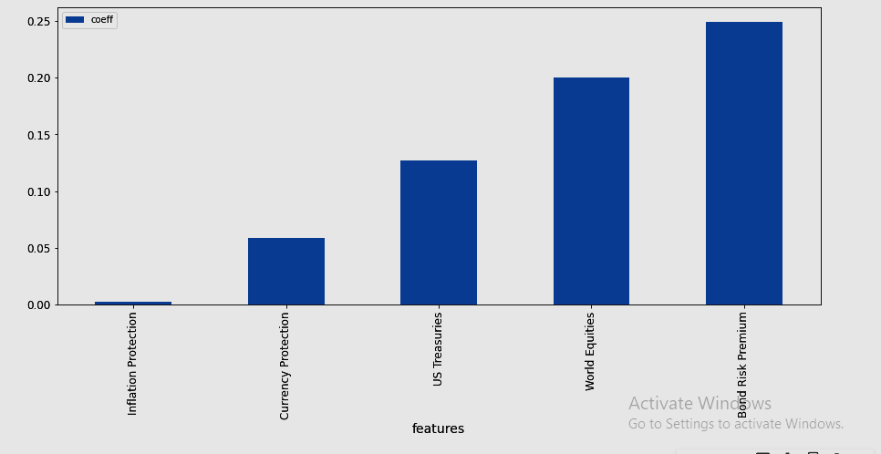

Figure. 4.1 Proposed Report for the Factor Loadings Variables

The Figure shown above is the proposed report of this project, which should benefit the investor to understand how the factor loadings are related with one amongst particular asset classes which we have taken up for investigations namely US Equities, Real Estate, Commodities, and Corp Bonds.

The chapter mentions that the objective of the capstone project is to interpret returns from various asset classes and relate these returns obtained with the returns from the factor variables. The chapter discusses exploring various machine learning algorithms namely OLS, Lasso, CV Lasso, and CV Elastic Net to summarize the findings of our research paper.

Chapter 5: Project Methodology

The CRISP-DM framework has been used here for the project.
"Cross-industry standard process for data processing, referred to as CRISP-DM, is an open standard process model that describes common approaches employed by data processing experts. It is the foremost widely-used analytics model”
(Wikipedia, n.d.-c)

It comprises of the following six phases: Business Understanding, Data Understanding, Data Preparation, Modeling, Evaluation, and Deployment. The project will be explained in these 6 phases in the following pages.

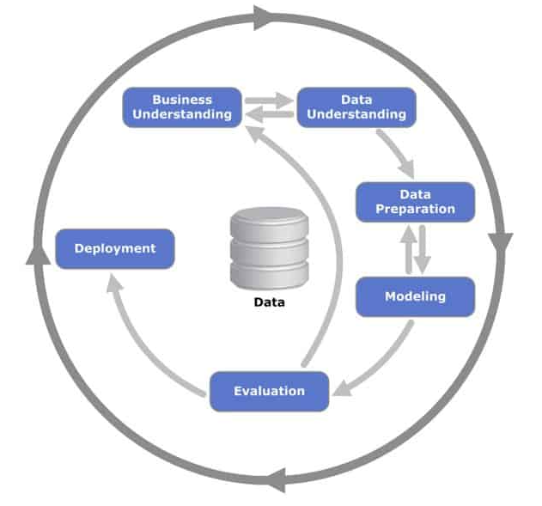 Figure 5.1 CRISP-DM Process Diagram (Wikipedia, 26 April 2012)

The chapter explains The CRISP-DM framework. The framework comprises 6 different phases. The next chapter explained about Business Understanding phase. This helps us to get a clear picture of our Business problem and provides the foundation to remain more focussed and engaged solely on our Business objectives. Threads from Business understanding are gathered to more or less get a complete overview and Blue wire print of the different consecutive phases of our data mining process.

Chapter 6: Business Understanding

Certain factors have earned a long-term risk premium from the historical perspective and represent adequate exposure to systematic sources of risk. Factor investing is the investment process that aims to reap these risk premia through exposure to factors.
There are fewer Assumptions in factor analysis that must be taken care of. There should be no outliers within the data. The sample size of the data under observation should be considerably big. There should not be any multicollinearity between variables in factor analysis otherwise Factor modeling will not give us accurate predictions. There should be no homoscedasticity between the variables on which factor analysis is being done. Factor analysis can use non-linear variables but on transfer, they should change to linear variables so that comparative analysis for regression coefficients is easier and simple.
(blog, n.d.)

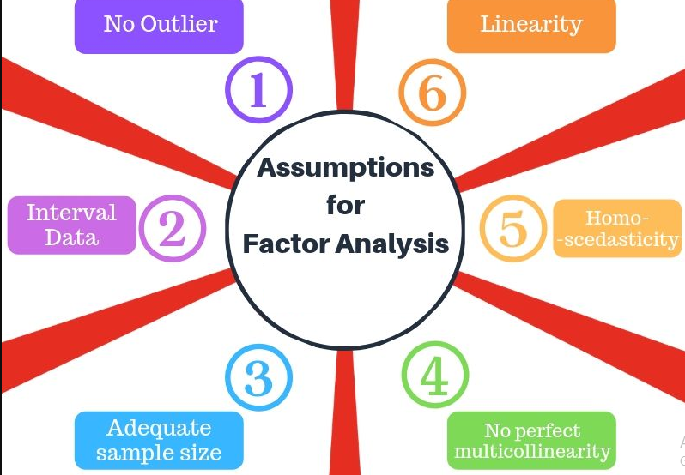

Figure 6.1 – Assumptions in factor analysis

Chapter 7: Data Understanding

Explaining the asset returns with a five-factor model is a matter of interest here:

1) World Equity: This factor represents worldwide equity returns.

2) United States of America Treasury: This factor contains return from treasury bonds within the United States, the bonds with the smallest amount risk.

3) Bond Risk Premia: this is often a credit factor that captures additional yield from risky bonds. Defined as the spread between high-risk bonds and United States of America Treasury bonds.

4) Inflation Protection: this is often a "style" factor that considers the distinction between real and nominal returns, therefore equalization the requirement for each.

5) Currency Protection: this is often additionally a "style" factor that has a risk premium for the United States of America's domestic assets.

Asset categories for which prediction models are going to be built include US Equities, Real Estate, Commodities, and Corp Bonds.

The chapter explained the factor variables returns that may be used as the independent variables. The asset category returns are the Target or dependent variable utilized in the Modelling algorithms. different Modelling algorithms area units utilized one by one for various target variables and the findings are being compared in Leader Boards for various Target variables. the successive chapter explains the Data Preparation section of our CRISP-DM framework. within the data preparation section, we will clean and remodel our data before process and analysis.

Chapter 8: Data Preparation

• Returns values on every date area unit extracted from the Historical return indexes of the 5-factor variables particularly World Equity, United States of America Treasury, Bond Risk Premia, Inflation Protection, and Currency Protection.
• Returns values on every date area unit extracted from the four asset categories also particularly US Equities, Real Estate, Commodities, and Corp Bonds.
• Then all data values area units are scaled between zero and one. In this fashion, unstandardized coefficients are becoming reconverted to standardized coefficients to limit the coefficient values between zero and one.
• The entire thirty-three Years data is Split into Train Data and Test Data.
• Then the Train data and Test data are being remodeled into a supervised Learning Format.
To solve a given problem of supervised learning, one needs to perform the subsequent steps:
1. AN understanding is needed to be developed of the kind of Training data on that the model is being engineered. Data is of assorted classes particularly scalar and categorical data and need to be handled differently as may be required.
2. The input data need to be known which is additionally known as feature variables. Here all Factor variables are the feature variables.
3. we have got four asset categories which might be four completely different target variables and therefore four different Models are being built with every of the four different asset categories.
4. Adequate care is to be taken that an oversized range of feature variables aren't getting used for building models and at the same time adequate data ought to be obtainable to predict the output properly.
5. The optimum modeling algorithmic program is to be chosen which might be best suited to create the model so that model accuracy is higher.
The chapter focussed on making ready the data to be future-ready for the Model Building processes. the successive chapter explains the Data Modelling section of our CRISP-DM framework.
Chapter 9: Data Modeling

The preprocessed data discussed in the previous phase is fed into the OLS Model. Initially, Linear Regression-OLS Model is built via Scikit-learn. Here one of the asset classes namely US Equities is being used as a Target variable whereas all factor variables are being used as Feature variables.

OLS has major drawbacks. OLS has no mechanism to filter out noise variables. We must find out ways of filtering noise variables.

To demonstrate how OLS can be susceptible to noise, we will introduce a noise variable positively correlated with the World Equities factor. Then we will rerun the OLS regression. The OLS regression chooses to average the two signals, changing the loading on the World Equity factor.

LASSO regression, is the simplest version of regularized regression. Regularized regression means that we add a penalty term to the optimization problem to penalize the model's complexity. For the sake of intuition, imagine if we could penalize the number of non-zero coefficients we add to the model. In that instance, the expectation is that the model would only consider the variables that influence Y, and ignore the noise variables. LASSO regression does exactly that.

It is the same as the OLS regression, but with a second penalty term. This directly penalizes the use of non-zero coefficients and can set factor loadings to zero.

Next, Modelling is being further optimized by using LASSO regression with cross-validation. The training set is broken into 𝑘 folds, and a list of 𝜆 values is defined. For each fold, and each 𝜆, the model 𝑘−1 other folds are trained, and the error on the test fold is being calculated.
At the end of this, 𝑘 out of sample errors is obtained for each value of lambda. Then that 𝜆 is picked which satisfies the average error across the out-of-sample tests. Hence, by using cross-validation, the optimal lambda value can get picked for lasso.
Now that we've discussed cross-validation and LASSO regression, we can mix and match penalized regressions to create regressions with specific properties. For instance, we know from the literature that LASSO regression can be used for variable selection. We also know that Ridge regression shrinks coefficients to provide a more robust solution.
Combined, it's called an Elastic Net, and it can provide the benefits of both LASSO regression and Ridge regression. It is being observed that elastic net does better than LASSO when we have many highly correlated variables.

The previous chapter focussed on employing various Modelling algorithms to predict the Target variables values. The chapter initially discussed OLS Model. The chapter then proposed LASSO regression.LASSO is a more improved Modelling Algorithm than OLS. Going further, LASSO regression along with cross-validation brings a more optimized algorithm, and finally, the chapter talks about elastic net along with cross-validation which is more useful for highly correlated independent variables. The next chapter speaks about the Data Evaluation phase of the CRISP-DM framework. The Data Evaluation phase is the results of our Data Modelling phase and produces a report card to clearly explain the extent of successes achieved from the different Modelling Algorithms employed on the Target Variables.

Chapter 10: Data Evaluation

Once the model is built, the scaled output data of the model has to be retransformed.
5-factor variables are input variables namely World Equity, US Treasury, Bond Risk Premia, Inflation Protection, and Currency Protection.
The target variable is taken as US Equities.
Now the model should be evaluated for all the return values of US Equities.
We will predict the values of US equities Returns and Compare the predicted Returns plot with the actual Returns plot. Similar such plots can be computed separately for other Asset classes namely Real Estate, Commodities, and Corp Bonds.
Based on the OLS Model following is the heat map plot to demonstrate the correlation between US Equities Returns and other five-factor variables Returns namely World Equities, US Treasuries, Bond Risk Premium, Inflation Protection, and Currency Protection.

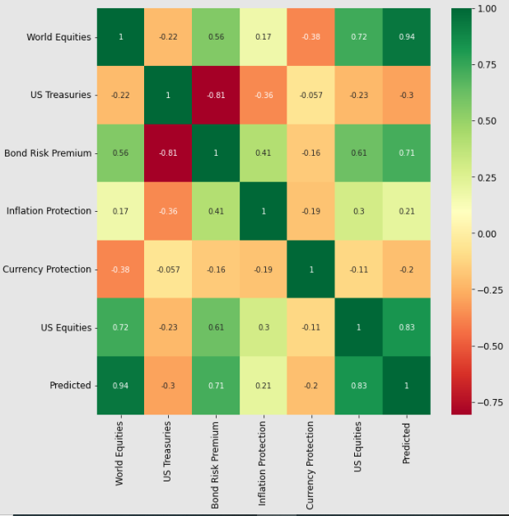

Figure 10.1– Heat map plot to demonstrate the correlation between US Equities Returns and other five-factor variables
The Insight drawn would be that World Equities and Bond Risk Premium are highly positively correlated whereas other factor variables don't seem to have a significant impact on US Equities Returns.

We also observe that Correlation between Actual US Equities Returns and Predicted returns is 0.83.

Based on CV elastic Net following is the heat map plot to demonstrate the correlation between Real Estate Returns and other five-factor variables Returns namely World Equities, US Treasuries, Bond Risk Premium, Inflation Protection, and Currency Protection.

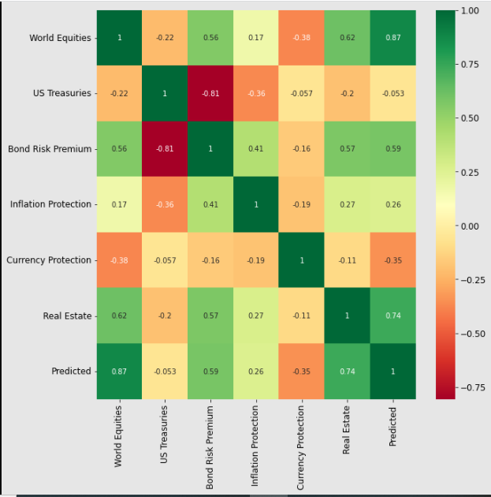

Figure 10.2– Heat map plot to demonstrate the correlation between Real Estate Returns and other five-factor variables Returns
The Insight drawn would be that World Equities and Bond Risk Premium are highly positively correlated whereas other factor variables don't seem to have a significant impact on Real Estate Returns.

We also observe that Correlation between Actual Real Estate Returns and Predicted returns is 0.74.

Based on CV elastic Net following is the heat map plot to demonstrate the correlation between Commodities Returns and other five-factor variables Returns namely World Equities, US Treasuries, Bond Risk Premium, Inflation Protection, and Currency Protection.

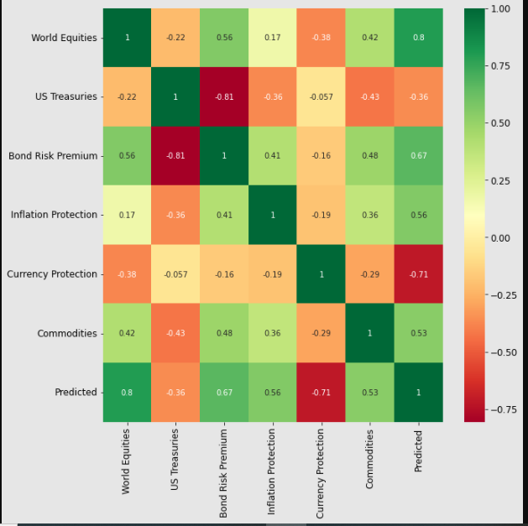

Figure 10.3– Heat map plot to demonstrate the correlation between Commodities Returns and other five-factor variables Returns
The Insight drawn would be that World Equities and Bond Risk Premium are positively correlated whereas US Treasuries are negatively correlated with Commodities Returns.

We also observe that Correlation between Actual Commodities Returns and Predicted returns is 0.53 which is relatively lesser.

Based on CV elastic Net following is the heat map plot to demonstrate the correlation between Corp Bonds Returns and other five-factor variables Returns namely World Equities, US Treasuries, Bond Risk Premium, Inflation Protection, and Currency Protection.

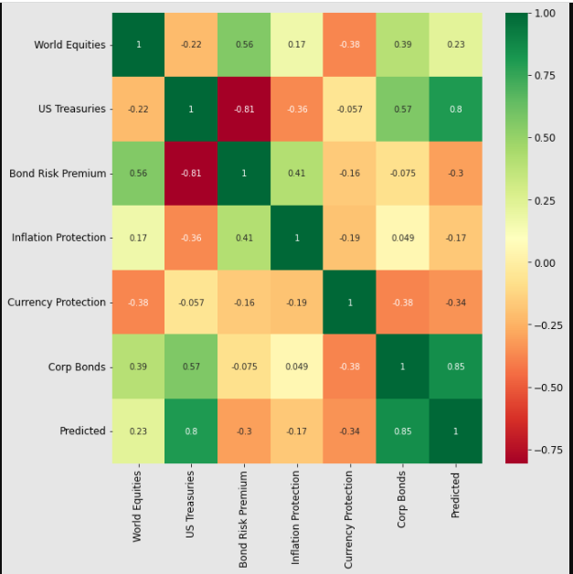

Figure 10.4– Heat map plot to demonstrate the correlation between Corp Bonds Returns and other five-factor variables Returns
The Insight drawn would be that World Equities and US Treasuries are positively correlated and Currency Protection is negatively correlated whereas other factor variables don't seem to have a significant impact on Corp Bonds Returns.

We also observe that Correlation between Actual Commodities Returns and Predicted returns is 0.85.

Chapter 11: Deployment

Major Action Items Implemented:

US Equities as Target Variable from Asset Class Category:

I have used World Equities, US Treasuries, Bond Risk Premium, Inflation Protection, and Currency Protection as Factor Variables.
I have used Asset class namely US Equities as Target Variable to predict the Returns based on the Factor Variables as Independent variables.
I have employed Linear Regression-OLS Model, Lasso Regression, CV Lasso, and CV Elastic Net Modeling techniques to predict US Equities Returns.
My Leader Board gives me the following results:
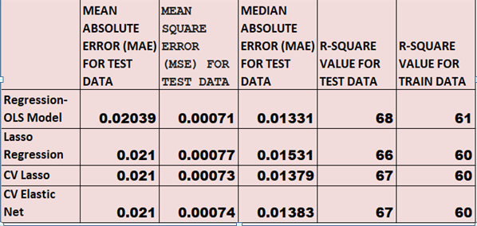
Table 11.1– Leader Board-comparison of Metrics for Predictions on US EQUITIES against Factor Variables(World Equities, US Treasuries, Bond Risk Premium, Inflation Protection, Currency Protection)by different prediction Models

It can be observed that mean Absolute Error, Mean Square error, Median Absolute Error is minimum in the case of the OLS Model. So we can use OLS Model to predict US Equities Returns against five-factor variables used as Independent variables.

Real Estate as Target Variable from Asset Class Category:

I have used World Equities, US Treasuries, Bond Risk Premium, Inflation Protection, and Currency Protection as Factor Variables.
I have used Asset class namely Real Estate as Target Variable to predict the Returns based on the Factor Variables as Independent variables.
I have employed Linear Regression-OLS Model, Lasso Regression, CV Lasso, and CV Elastic Net Modeling techniques to predict Real Estate Returns.
My Leader Board gives me the following results:
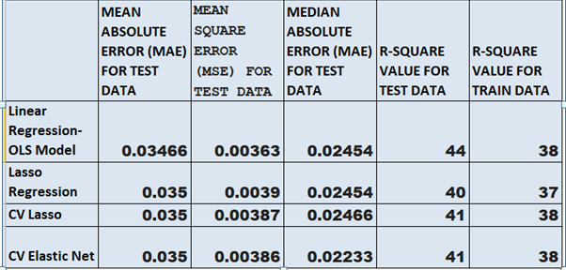
Table 11.2– Leader Board-comparison of Metrics for Predictions on Real Estate against Factor Variables(World Equities, US Treasuries, Bond Risk Premium, Inflation Protection, Currency Protection)by different prediction Models
It can be observed that mean Absolute Error, Mean Square error is better in the case of the OLS Model Whereas CV elastic Net gives better Median Absolute error. Mean Absolute Error and Mean Square error also works fine here. so we can use either OLS Model or CV elastic Net to predict Real Estate Returns against five-factor variables used as Independent variables

Commodities as Target Variable from Asset Class Category:

I have used World Equities, US Treasuries, Bond Risk Premium, Inflation Protection, and Currency Protection as Factor Variables.
I have used Asset class namely Commodities as Target Variable to predict the Returns based on the Factor Variables as Independent variables.
I have employed Linear Regression-OLS Model, Lasso Regression, CV Lasso, and CV Elastic Net Modeling techniques to predict Commodities Returns.

My Leader Board gives me the following results:
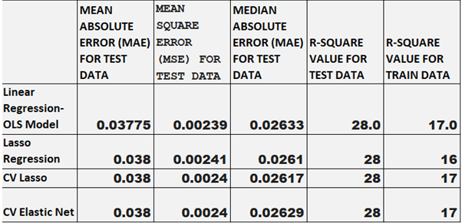
Table 11.3– Leader Board-comparison of Metrics for Predictions on Commodities against Factor Variables(World Equities, US Treasuries, Bond Risk Premium, Inflation Protection, Currency Protection)by different prediction Models
It can be observed that mean Absolute Error, Mean Square error, Median Absolute Error are almost the same for all Modeling algorithms.

Corp Bonds as Target Variable from Asset Class Category:

I have used World Equities, US Treasuries, Bond Risk Premium, Inflation Protection, and Currency Protection as Factor Variables. I have used Asset class namely Corp Bonds as Target Variable to predict the Returns based on the Factor Variables as Independent variables.
I have employed Linear Regression-OLS Model, Lasso Regression, CV Lasso, and CV Elastic Net Modeling techniques to predict Corp Bonds Returns.
My Leader Board gives me the following results:
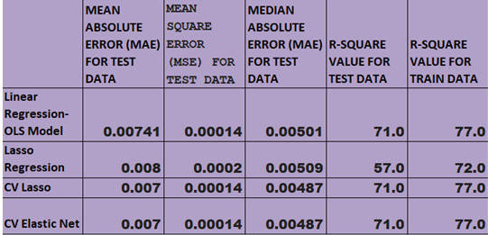

Table 11.4– Leader Board-comparison of Metrics for Predictions on Corp Bonds against Factor Variables(World Equities, US Treasuries, Bond Risk Premium, Inflation Protection, Currency Protection)by different prediction Models

It can be observed that mean Absolute Error, Mean Square error, Median Absolute Error is minimum in the case of CV elastic Net. So we can use the CV elastic Net Model to predict Corp Bonds Returns against five-factor variables used as Independent variables.

Chapter 12: Analysis and Results

5-factor variables are input variables namely World Equity, US Treasury, Bond Risk Premia, Inflation Protection, and Currency Protection. The target variable is taken as US Equities.
Now the model should be evaluated for all the predicted return values of US Equities vs. Actual values. Similar evaluations can be done by building separate models for other Target variables namely Real Estate, Commodities, and Corp Bonds.
In the context of machine learning, absolute error refers to the magnitude of difference between the prediction of observation and the true value of that observation. MAE takes the mean of absolute errors for several predictions and observations as a measurement of the magnitude of errors for the whole group.
The Mean Squared Error (MSE) is probably the only and commonest loss function, often taught in introductory Machine Learning courses. To calculate the MSE, you are taking the difference between your model's predictions and therefore the ground truth, square it and average it out across the entire dataset.
The median absolute error is robust to outliers. The loss is calculated by taking the median of all absolute differences between the target and therefore the prediction.
R-squared is a statistical measure that denotes the worthiness of fit of a regression model. The ideal value for r-square is 1. The closer the worth of r-square to 1, the higher is that the model fitted. The value of R-square can also be negative when the models fitted are worse than the average fitted model. R-square values are computed for both test data and train data separately.
Model performance is being evaluated based on the above-discussed metrics for the different Models built for our project.

Chapter 13: Conclusions and Recommendations for future work

This project solely focuses on the Factor analysis of the Asset classes using OLS, Lasso, CV Lasso, and CV Elastic Net algorithms where the model studies the return values from 5 different factor variables namely World Equity, US Treasury, Bond Risk Premia, Inflation Protection and Currency Protection and predicts the return values of asset class namely US Equities. Similar separate models can be built for other asset classes namely Real Estate, Commodities, and Corp Bonds Based on which the portfolio management concerning asset classes needs to be reviewed and refined accordingly.

Recommendations for Future Work: we assumed that factor loadings are constant over time. However, the assumption that the factor loadings are constant over time is restrictive, and not true. Factor loadings are highly dependent on time.

We haven't discussed how to address one major drawback of factor analysis, namely that over different periods the factor loadings can change.

In future projects, we can show how to define regimes using modern machine learning techniques. We will then use the techniques already discussed in this project to estimate the factor loadings for each of the Normal and Crash regimes.

Bibliography
blog. (n.d.). Factor Analysis. https://statswork.com/blog/factor-analysis/
Cazalet, Zz., & Roncalli, T. (2014). Facts and Fantasies About Factor Investing. SSRN Electronic Journal, 1–112. https://doi.org/10.2139/ssrn.2524547
Emory, C. (2013). Chapter 14: Factor Investing. CFA Digest, 43(4), 6–10. https://doi.org/10.2469/dig.v43.n4.61
Factor-based investing. (2015). April.
Martellini, L., & Milhau, V. (2020). Factor Investing in and Goal-Based Investment Solutions. March.
Wikipedia. (n.d.-a). Factor investing. https://en.wikipedia.org/wiki/Factor_investing#:~:text=Factor investing is an investment,explain differences in stock returns.&text=The approach is quantitative and,than on opinion or speculation.
Wikipedia. (n.d.-b). Portfolio finance. https://en.wikipedia.org/wiki/Portfolio_(finance)
Wikipedia. (n.d.-c). The cross-industry standard process for data mining. https://en.wikipedia.org/wiki/Cross-industry_standard_process_for_data_mining

Appendix

Plagiarism Report

Publications in a Journal/Conference Presented/White Paper

Any Additional Details

Turnitin report to be attached from the University.
URL of the white paper/Paper published in a Journal/Paper presented in a Conference/Certificates to be provided.

