Hello.

This week I researched cellular and wifi module for AED.

1. Cellular

Generally AED’s cellular and wifi module use for find device fast and easily on emergency environment.

Especially Cellular module has several advantages compare with wifi module.

* In-built

A cellular-enabled AED can be connected at the manufacturing level, before it’s packaged and shipped. This means it’s connected to a cellular network out of the box without any additional setup required.

As long as it is kept within range of a cellular signal, it stays connected.

* Automatic

A device that arrives already cellular-connected doesn’t require any manual setup. You can move it anywhere within range of a signal without needing to reconfigure the connection.

Without this capability, an AED would need to be manually reconnected every time it changes location.

A wi-fi- or Bluetooth-only AED also requires an interface to be able to configure the connection. This makes the device bulkier, heavier, and more complicated to use.

* Lower cost

Inbuilt cellular, automated, and carrier-agnostic connection mean you don’t have to worry about setting up and monitoring a manual connection or maintaining a separate wi-fi network. This reduces the time and money involved in owning an AED.

Of course, if it’s not connected at all, the costs get higher. Remembering to manually monitor and maintain the device, keep it charged, and have it ready to go in an emergency is more challenging and potentially more costly than owning an AED with automatic remote monitoring capabilities.

So this part is important and consider seriously.

To implement cellular module on AED, we have to check there is example exist or not.

Smartphone AED is exist. Like this.

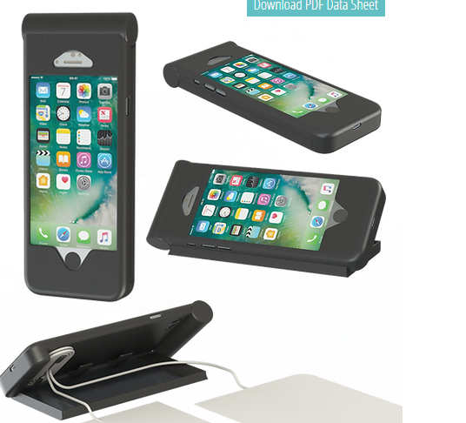

Figure 10. Cellular phone with AED

So prototype design would be good like this

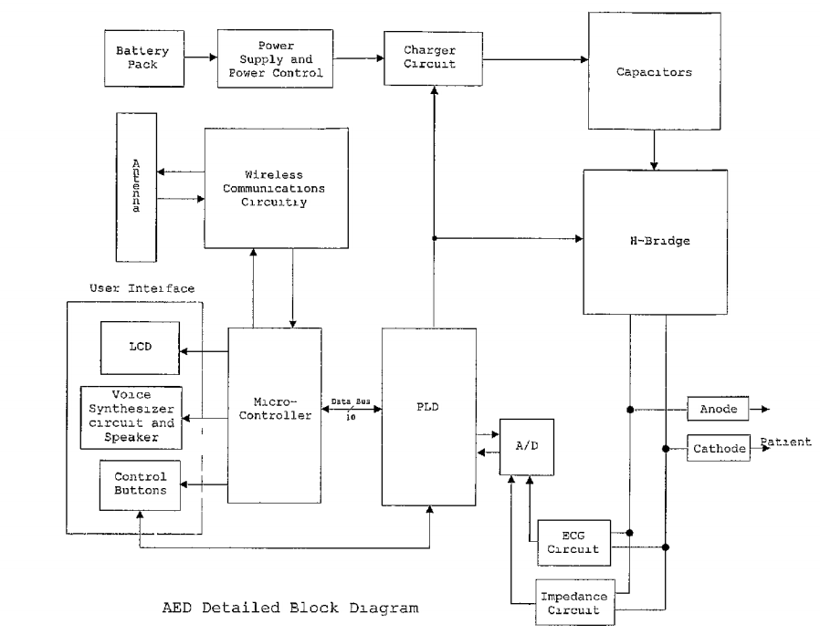

Figure 11. Prototype AED Diagram with Cellular

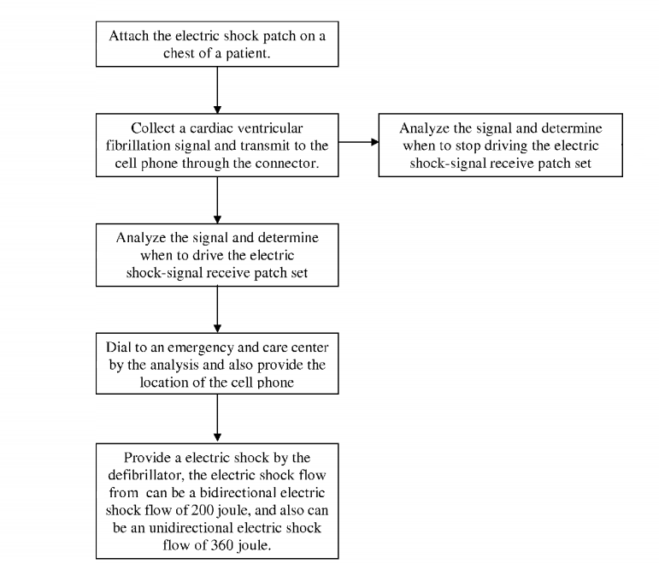

Figure 12. Activity Diagram

* WiFi

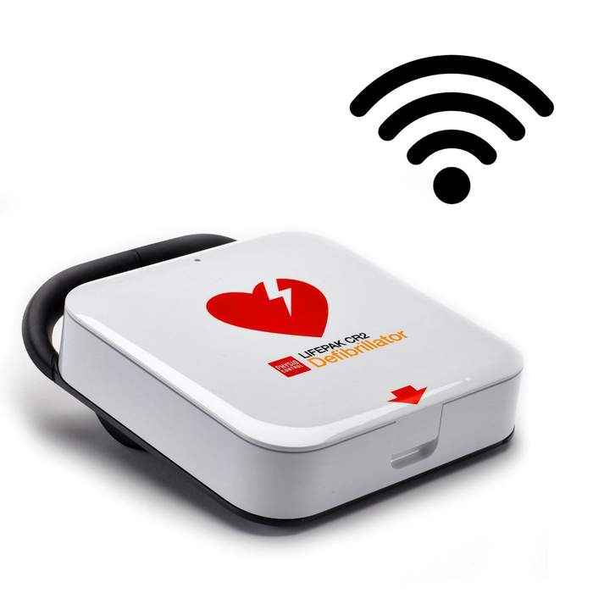

Figure 13. AED with WiFi

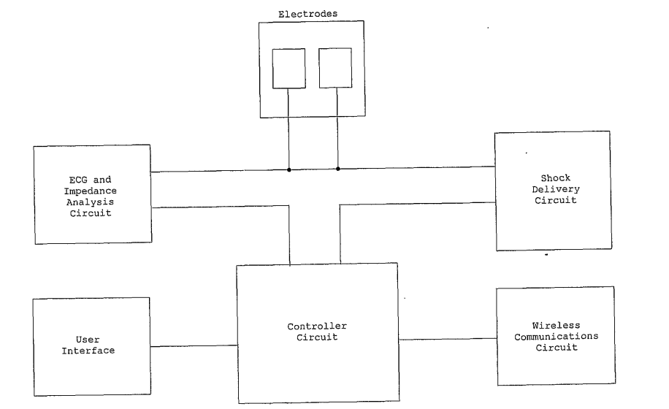

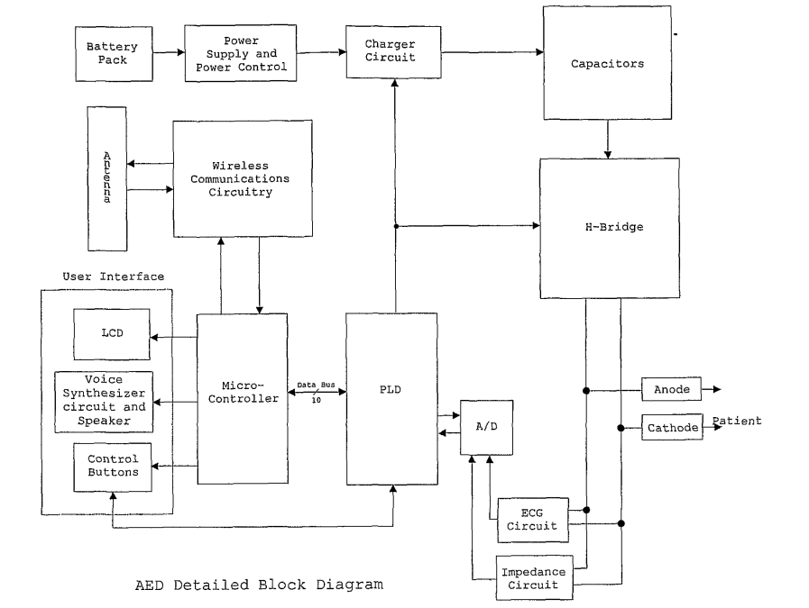

So I decide work flow order like this.

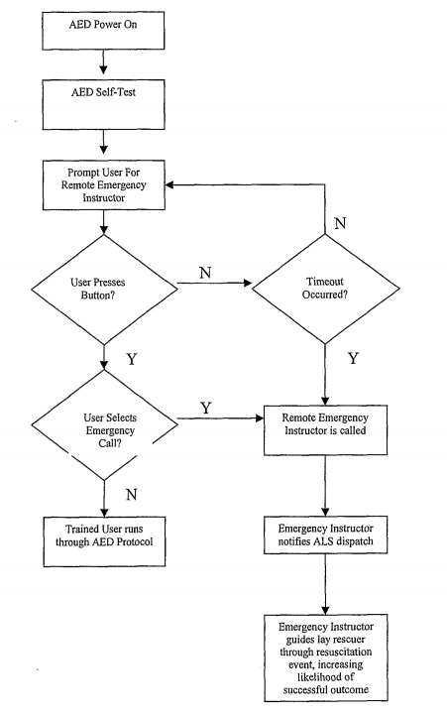

Thank you for your reading this document.