Hello.

I started work from 1/24 for 1st step of development.

To develop embedded device such as AED, have to check all requirement for development, and learn knowledge of platform is very important.

So I checked AED’s general requirement as follows:

1. **What is AED and why this necessary for peoples in our lives?**

Automated external defibrillators (AEDs) are portable, life-saving devices designed to treat people experiencing sudden cardiac arrest, a medical condition in which the heart stops beating suddenly and unexpectedly.

The combination of CPR and early defibrillation is effective in saving lives when used in the first few minutes following collapse from sudden cardiac arrest.

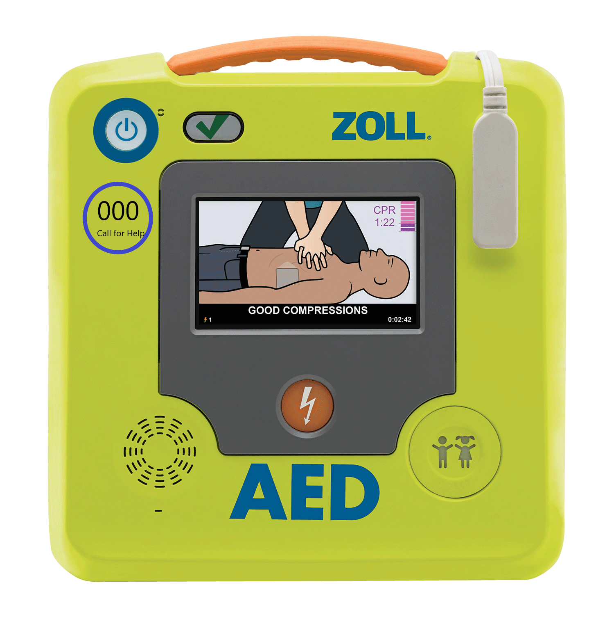

So AEDs are portable, life-saving devices designed to treat people experiencing sudden cardiac arrest, a medical condition in which the heart suddenly and unexpectedly stops beating. The AED system includes accessories, such as a battery and pad electrodes, that are necessary for the AED to detect and interpret an electrocardiogram and deliver an electrical shock. There are two main types of AEDs: public access and professional use.

* **Public access AEDs** can be found in airports, community centers, schools, government buildings, hospitals, and other public locations. They are intended to be used by laypeople who have received minimal training.
* **Professional use AEDs** are used by first responders, such as emergency medical technicians (EMTs) and paramedics, who receive additional AED training.

Then why this platform needs:

Out-of-hospital cardiac arrest (OHCA) is a significant public health issue. In Australia more than 30,000 OHCAs occur every year, with fewer than 10% surviving to leave hospital (Ambulance Victoria, 2016). However, with immediate resuscitation more lives can be saved.

In cardiac arrest the heart is no longer pumping, blood flow stops, the casualty loses consciousness and will not be breathing normally. This person will die, unless within a short period of time blood flow is restored. Immediate cardiopulmonary resuscitation (CPR) will restore some blood flow.

For a short period of time, the non-pumping heart may have an abormal rhythm (ventricular fibrillation (VF) or ventricular tachycardia (VT) which may be “shocked” by defibrillation (a type of electric shock) back to a normal pumping rhythm.

That’s why AED is desperately needed. One of the functions of an AED is to determine whether the casualty has a “shockable” or “non-shockable” rhythm. The time to defibrillation is a key factor that influences survival. For every minute defibrillation is delayed, there is approximately 10% reduction in survival if the patient is in cardiac arrest due to VF or VT, (shockable rhythms).

1. **AED System Theory and Architecture**

Energy-based defibrillators can deliver energy in a variety of waveforms, broadly characterized as monophasic, biphasic or triphasic.

* Monophasic waveform

Defibrillators with this type of waveform deliver current in one polarity and were the first to be introduced. They can be further categorized by the rate at which the current pulse decreases to zero. If the monophasic waveform falls to zero gradually, the term damped sinusoidal is used. If the waveform falls instantaneously, the term truncated exponential is used (figure 1). The damped sinusoidal monophasic waveforms have been the mainstay of external defibrillation for over three decades

* Biphasic waveform. This type of waveform was developed later. The delivered current flows in a positive direction for a specified time and then reverses and flows in a negative direction for the remaining duration of the electrical discharge (figure 2A). With biphasic waveforms there is a lower defibrillation threshold (DFT) that allows reductions of the energy levels administrated and may cause less myocardial damage. The use of biphasic waveforms permits a reduction in the size and weight of AEDs.
* Triphasic waveform. There are no human studies to support the use of multiphasic waveforms over biphasic. Investigation in animals suggests that the benefits of biphasic waveform could be harnessed through the use of a triphasic waveform in which the second phase has the larger strength to lower the DFT and the third phase the lower strength, to minimize damage

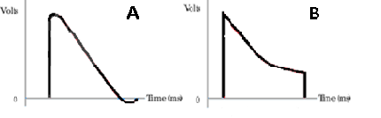

Figure 1.

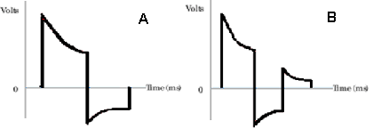

Figure 2.

An automated external defibrillator (AED) is a portable electronic device that automatically diagnoses the potential life threatening cardiac arrhythmias of ventricular fibrillation and ventricular tachycardia in a patient.

Automatic refers to the unit’s ability to autonomously analyze the patient’s condition; to assist this, the vast majority of units have spoken prompts, while some may also have visual displays to instruct the user. With simple audio and visual commands, AEDs are designed to be simple to use for the layman.

Defibrillators can be external, transvenous, or implanted, depending on the type of device used or needed. The external defibrillator could be manual or automatic by operation method, and monophasic or biphasic waveform by energy delivery method.

Defibrillation consists of delivering a therapeutic dose of electrical energy to the affected heart with a device called a defibrillator. This depolarizes a critical mass of the heart muscle, terminates the dysrhythmia, and allows normal sinus rhythm to be reestablished by the body’s natural pacemaker in the sinoatrial node of the heart. The energy selection is decided by the AED device automatically according to the electrocardiogram (ECG) and impedance gotten from both of the defibrillator electrodes, then the safety processor controls the power circuit to charge the high voltage capacitor with selected energy. After the capacitor charging is complete, the device should prompt the user to do a shock operation, which is a high risk operation, and a double confirmation is always needed to make sure both the operator and the patient are safe. Before and after defibrillation, the optional multi-lead ECG monitor (3/5/10 leads) may be used to evaluate the treatment.

The ECG in the defibrillator electrode is a simple single-lead ECG for basic ECG measurement like R wavelet recognition, but the optional multi-lead ECG is a diagnostic monitor level, which can detect complex issues.

1. **Design consideration and Major Challenge**
2. **Components**

The term refers to a portable and lightweight computerized device that incorporates rhythm analysis and defibrillation systems and uses voice and/or visual prompts to guide lay rescuers and healthcare providers to safely defibrillate victims of cardiac arrest due to VF or pulseless VT.

Basically these devices consist of a battery, a capacitor, electrodes and an electrical circuit designed to analyze the rhythm and send an electric shock if is needed.

* Batteries.

Essentially they are containers of chemical reactions and one of the most important parts of the AED system. Initially lead batteries and nickel-cadmium were used but lately non-rechargeable lithium batteries, smaller in size and with longer duration without maintenance (up to 5 years), are rapidly replacing them. Since extreme temperatures negatively affect the batteries, defibrillators must be stored in controlled environments. Also it is important to dispose of the batteries using designated containers as they contain corrosive and highly toxic substances.

* Capacitor

The electrical shock delivered to the patient is generated by high voltage circuits from energy stored in a capacitor which can hold up to 7 kV of electricity. The energy delivered by this system can be anywhere from 30 to 400 joules.

* Electrodes.

These are the components through which the defibrillator collects information for rhythm analysis and delivers energy to the patient's heart. Many types of electrodes are available including hand-held paddles, internal paddles, and self-adhesive disposable electrodes. In general, disposable electrodes are preferred in emergency settings because they increase the speed of shock and improve defibrillation technique.

* Electrical circuit

AEDs are highly sophisticated, microprocessor-based devices that analyze multiple features of the surface ECG signal including frequency, amplitude, slope and wave morphology. It contains various filters for QRS signals, radio transmission and other interferences, as well as for loose electrodes and poor contact. Some devices are programmed to detect patient movement.

* Controls

The typical controls on an AED include a power button, a display screen on which trained rescuers can check de heart rhythm and a discharge button. Defibrillators that can be operated manually have also an energy select control and a charge button. Certain defibrillators have special controls for internal paddles or disposable electrodes.

1. **Consider and implement functions**

Safety is the first priority in AED design. Any operation must ensure the safety of both operator and patient, so some redundant designs are necessary.

* Both the safety and the operation processor need to check each other to ensure the right decision.
* Discharge the charged capacitor if it times out.
* Double confirmation is required for energy delivery.
* An audio prompt is helpful.
* Disable the energy delivery if the target impedance is not in range of the human body.

Isolation is critical for matters internal and external.

* The device must ensure enough insulation between the internal high voltage and the device surface/port.
* The device must provide an insulation mechanism between the internal high voltage and low voltage part. As you know, the defibrillation works in high voltage mode while the signal processor works in low voltage mode. Therefore, a path switch based on the relay can be used.

Fast response is critical. The AED is a device for life saving, so the faster the response of the device, the greater possibility of life saving.

* Fast boot-up for operation.
* Fast response to an external signal like the external patient monitor trigger out.
* Real-time R wavelet recognition for exact time to delivery energy.
* Real-time energy control for the shock procedure; it is IP related to a different energy delivery waveform.
* Fast charge and energy delivery to save time.

Reliability is critical. The AED can be used in many fields: in the hospital and out of the hospital, in high vibration conditions like ambulances and helicopters, and in outdoor applications like in sunshine and rainy weather. So the AED may need antivibration, waterproofing, and so on for complex conditions.

* Wide operation temperature range.
* Lower performance drift over temperature range, like bias current and noise.
* The power circuit should work well for large current surges.

Interaction is helpful to operate the AED easily.

* An audio prompt can be used to indicate how to do the next step.
* An audio recorder can be used to record the rescue procedure for evidence.
* Connectivity is necessary for the modern AED.

Wireless connectivity like ISM and Wi-Fi is helpful for the device in the hospital;

GPRS/3G is helpful for the device out of the hospital. This means cellular module.

* And have to consider use some peripherals like LAN, UART, and a memory card are used for the electrical medical system.

1. **Prototype Diagram**

Below figure3 is show general AED operate order.

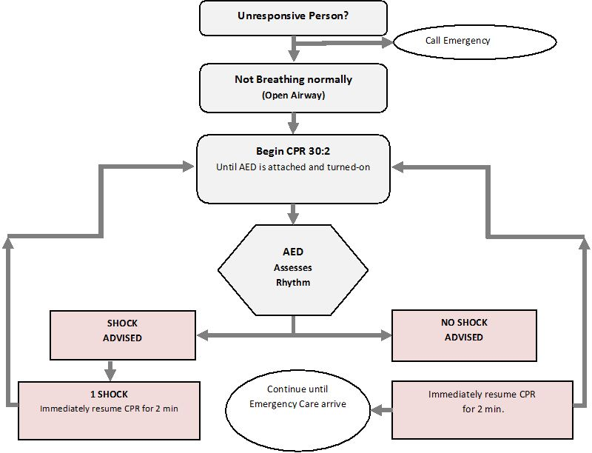

Figure3. Diagram

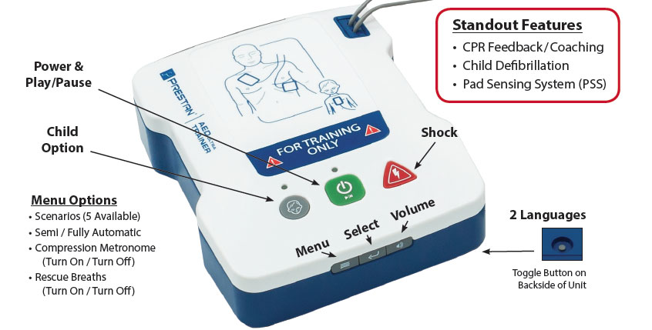

Figure4. General AED

1. **Desired Design**

As shown in Fig. 1, the AED is divided into two main electric boards powered by a battery: a High-voltage board (HV-B) and a control board (C-B).

The HV-B contains the circuitry necessary to perform defibrillation:

* capacitor, used to store the energy to be released to the patient;
* charging circuit, which rapidly charges the capacitor;
* H-Bridge circuit, required to perform biphasic defibrillation;
* internal discharge circuit, used to dump the unused residual energy; and
* two selectors, used to isolate the patient from the capacitor, and to route the ECG signal to the C-B.

The C-B represents the device’s brain. It contains a Programmable System on Chip (Cypress PSoC), which amongst other functions- integrates the analogical front-end used to acquire the ECG and impedance measurements from the patient.

The PSoC also contains an ARM Cortex-M3 CPU, used to analyze the signals and asses the defibrillation needs.

According to MDD 93/42, AEDs are classified as Class IIb devices because they are ‘‘therapeutic devices intended to administer energy in a potentially hazardous way”.

The design has been done ensuring compliance with the standards of the IEC 60601 family.

Comparing the standards above with the commercially available AEDs, we can outline the following technical specifications:

* Nominal voltage: 1700 V;
* Defibrillation energy: 200 J;
* Charging time: 12 s, defined as the maximum time from activation of the rhythm detector to the defibrillator being ready

for discharge at maximum energy;

* Patient leakage currents (not during defibrillation): 50 uA;
* SCA recognition algorithms: Sensitivity >95%, specificity >95%.

The blue blocks on the left side constitute the power supply module. The module comprises the battery and the voltage

regulators included in the control board (C-B), and the high-voltage board (HV-B). The yellow blocks represent the C-B, which is composed of a PSoC and

some input-output components such as switches and LED diodes. Lastly, the green blocks represent the HV-B. The HV-B includes a charging circuit, a

condenser, an H-Bridge circuit, two relays used as selectors, and an internal discharge circuit composed of a power resistor. (For interpretation of the

references to colour in this figure legend, the reader is referred to the web version of this article.)

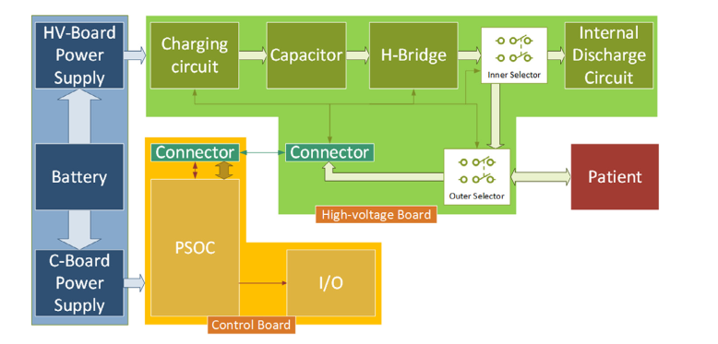

Figure5. Diagram

1. Charging circuit

From an engineering point of view, defibrillation can be approximated as a capacitive discharge on a pure resistive load.

Defibrillation can be schematized with an RC circuit, where the patient is represented as a resistor, while a capacitor represents the defibrillator. For this reason, the most critical aspect of an AED is the charging time of the capacitor, because more than one charge-discharge cycle is usually needed to save a life.

An AED needs a charging circuit with the following characteristics:

* ability of producing a high-voltage output from a low-voltage input;
* high efficiency;
* fast charging speed;
* compact dimensions and low weight;
* low cost;
* compatibility with pure capacitive loads; and
* safety and robustness.

The final charging circuit was designed as a self-oscillating flyback converter, also known as Ringing Choke Converter (RCC). The RCC is derived from the flyback converter. The flyback converter works using a PWM signal to operate its switch. When this signal is high, the switch is closed and a current flows through the primary coil of the transformer.

The flyback diode on the secondary side of the circuit prevents the current from flowing, therefore the transformer accumulates energy. When the PWM signal is low, the switch is open and the transformer releases the energy it had accumulated during the ‘‘on” time in the secondary coil. In a traditional flyback configuration, the PWM signal has a fixed frequency while its duty cycle may vary according to the load. The disadvantage of this configuration is that when the duty cycle is low (meaning a short ‘‘on” time), there will be an excess of dead time, during which the circuit has no current flowing in it.

On the other hand, if the duty cycle is high (meaning a long ‘‘on” time), the transformer might not have enough time to release all its energy onto the capacitor. These two operating modes are commonly known as discontinuous conduction mode and continuous conduction mode respectively.

The purpose of the RCC is to avoid working in both of these two conduction modes. In fact, the RCC is obtained by adding a third coil to the flyback transformer, which will be used to automatically generate a PWM signal. The peculiarity of this approach is that only a few components are sufficient to bring the flyback circuit to work at the exact point of transition between discontinuous and continuous conduction modes. In this condition, as soon as the transformer releases all the energy, the switch is closed again avoiding dead times and energy residuals in the transformer.

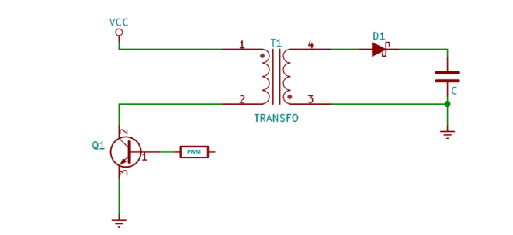

Figure 6. Flyback Converter

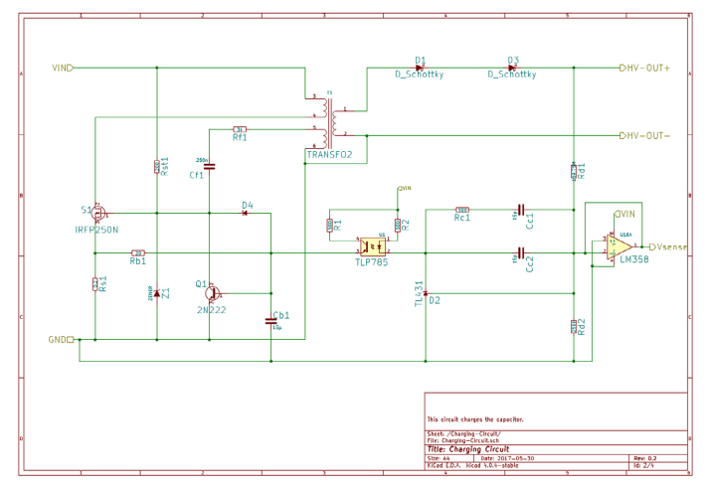

Figure 6.

1. Control Board

The Cypress PSoC 5LP is at heart of the C-B. The PSoC is a one-chip solution integrating analog front-end, digital logic and user interface integrated circuits, with an ARM Cortex-M3 CPU. Its internal circuits can be re-arranged using the Cypress software, in order to obtain various circuit configurations.

In the AED, the PSoC blocks are configured to perform various operations. The general I/O blocks are reported follow image.

These are necessary to communicate with the operator and the High-voltage board and are hereinafter explained:

* The first is a redundant control for the H-Bridge circuit. The block on the left is a software-set register, updated every time the firmware wants to control the H-Bridge. The output is evaluated with logic blocks in order to provide a degree of redundancy. The right block represents the connection to physical pins.
* These are the physical pins used to control the inner, and outer selectors.
* ”Charge_En” is the pin used to enable the charging circuit.
* The first block on the right represents the physical pin to be connected at the push-button that the operator should press to release the defibrillation. Due to its criticality, a de-bouncer is used, which directly calls an interrupt (here represented as lightening).
* This contains the pins connected to the LED diodes. These, as the resistors, are not inside the PSoC, but on the control board.
* This block is required to implement USB UART protocols.
* This block is used to evaluate the capacitor voltage. The label ”Vsense” represents the pin attached to the charging circuit buffer output, presented. This pin is connected to two comparators. When it reaches a value of 2.5 V, the first comparator calls an interrupt to communicate to the processor that the capacitor is ready. On the other hand, when its value falls below 256 mV, the second comparator calls another interrupt, used to communicate to the processor that the capacitor’s voltage is below 10% of its nominal value V0.
* Finally, the last block on the left is the DAC that controls the speaker. The speaker is used to warn bystanders that a defibrillation is about to be released. As for (e), the speaker and the passive elements are outside the PSoC.

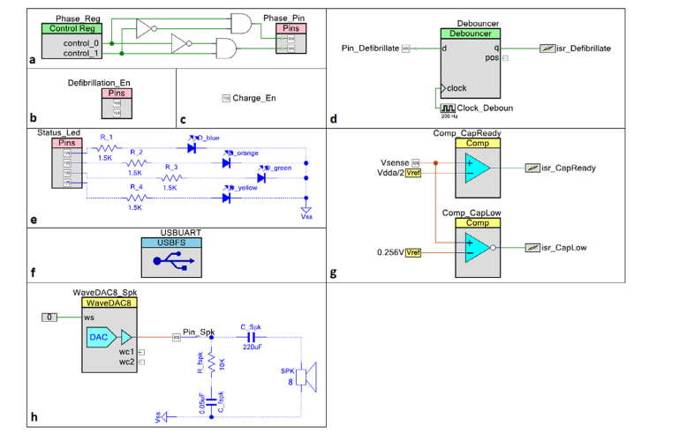

Figure 7.

1. Firmware

AED was programmed with custom firmware in C programming language. The firmware acts as a finite-state machine, in which each state is used to enable or disable specific circuits depending on the state itself. The five different states are presented in Fig. 8, and their operations are:

* Measurement mode is the starting state. In measurement mode, the device has not yet diagnosed SCA in the patient. Therefore, the operations are limited to continuously acquiring ECG and impedance signals from the patient.
* Charging mode state is reached when AED successfully diagnoses SCA for the first time. As a result, the charging circuit is enabled, while the patient is still monitored for SCA.
* Discharge enabled mode is entered when the patient is both suffering from SCA and the capacitor is ready. In this mode the defibrillator is armed and ready to deliver the shock when the operator will press the ‘‘defibrillate” button.

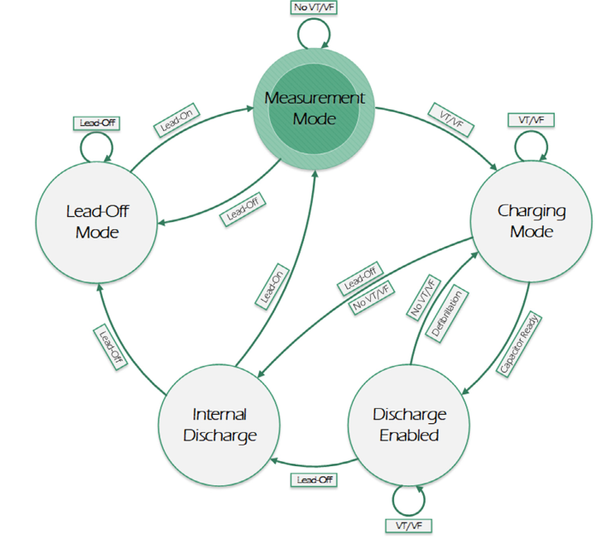

Figure 9. Finite-state machine diagram

* Internal discharge mode represents an emergency stop for AED. Whenever something is not working properly and the capacitor is charged (even partially), AED will dump the defibrillation energy to the internal discharge circuit, which is a power resistor.
* Lead-Off mode is an idle state in which AED just waits for a patient to be connected. Thereafter in this state, AED will only perform impedance acquisitions. When it recognizes a patient, lead-off mode is switched to Measurement mode.

The firmware also includes five different algorithms used in combination to analyze the ECG signals and assert whether the patient is suffering from SCA. These algorithms are: Threshold Crossing Interval (TCI), VF filter, Threshold Crossing Sample Count (TCSC), Phase Shift Reconstruction (PSR), and Hilbert Transform Algorithm (HTA).

Each ECG segment obtained by the acquisition chain is evaluated with all the algorithms and the decision is majority based. If at least two of the last three ECG segments are SCA positive, then AED diagnoses the heartbeat as pathologic.

1. **References**

[1] Newman, Mary. “Sudden Cardiac Arrest: A Healthcare Crisis”.

http://www.sca-aware.org/about-sca.

[2] American Heart Association. “ECC Guidelines – Part 4: The Automated External Defibrillator”. American Heart Association Journals.

ISSN: 1524-4539. http://circ.ahajournals.org/content/102/suppl_1/I-60.full

[3] David Arney, Raoul Jetley, Paul Jones, Insup Lee, and Oleg Sokolsky. 2007. Formal Methods Based Development of a PCA Infusion Pump Reference Model: Generic Infusion Pump (GIP) Project.

In Proceedings of the 2007 Joint Workshop on High Confidence Medical Devices, Software, and Systems and Medical Device Plug-and-Play Interoperability (HCMDSS-MDPNP '07). IEEE Computer Society,

Washington, DC, USA, 23-33.

[4] Amann, A., Tratnig, R., & Unterkofler, K. (2007). Detecting ventricular fibrillation by time-delay methods. Biomedical Engineering, IEEE Transactions on, 54(1), 174-177.

[5] Kewei, H., Jie, L., Ningjun, F., Yuebin, L., Xiaolin, H., & Luo, W. (2009, July). Modeling analysis and simulation of high-voltage flyback DC-DC converter. InIndustrial Electronics, 2009. ISIE 2009. IEEE

International Symposium on(pp. 813-818). IEEE.

[10] Edmar C. Gurjao, A Model for Architecture Centric Development of Automated External Defibrillators

1. **To do on next week for our project**

Next week, I will make design and architecture with Cellular, Wi-Fi, GPS, secondary battery module.

* Cellular

To implement cellular module on AED, we have to check there is example exist or not.

Smartphone AED is exist. Like this.

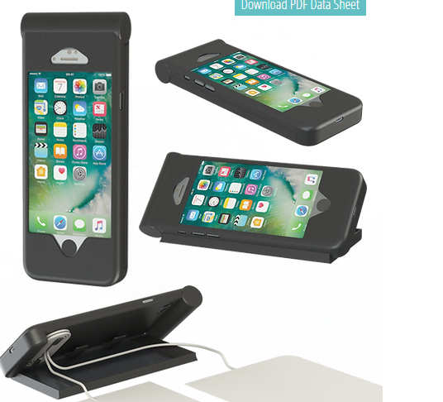

Figure 10. Cellular phone with AED

So prototype design would be good like this

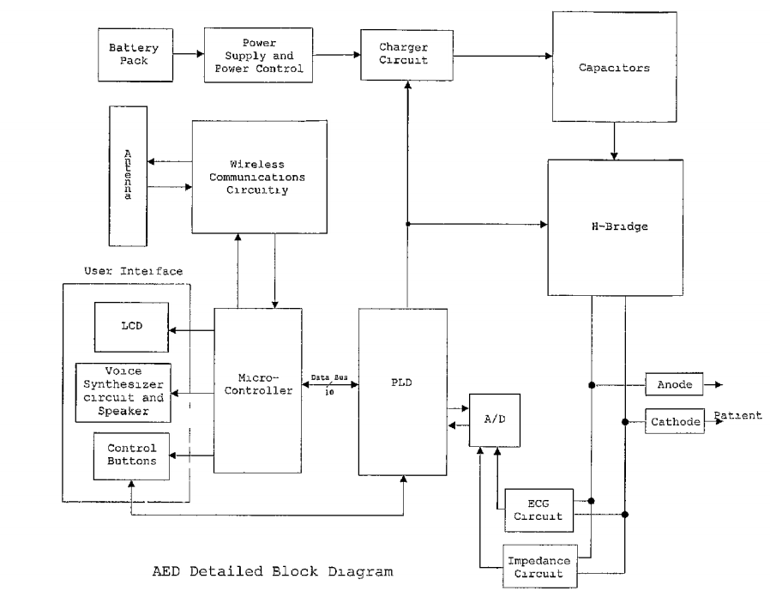

Figure 11. Prototype AED Diagram with Cellular

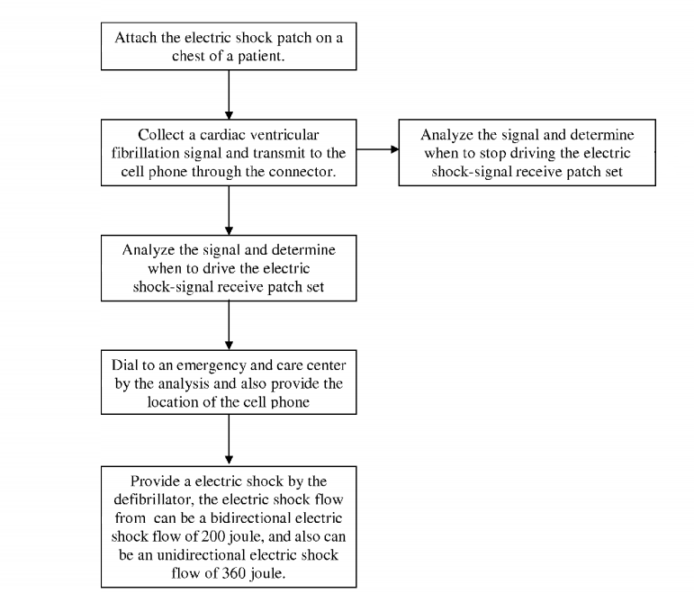

Figure 12. Activity Diagram

* WiFi

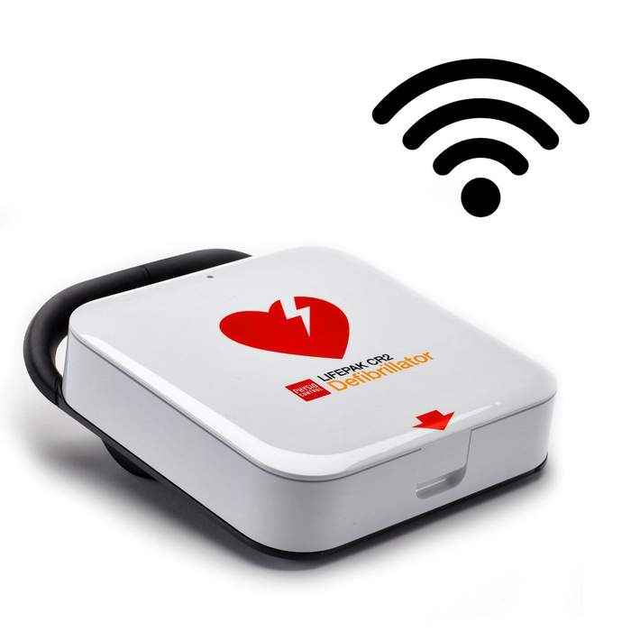

Figure 13. AED with WiFi

So next week I will try hard for complete design and architecture, decide step, components, etc.

Especially Cellular and WiFi module part will researched.

This week’s work time:

|  |  |  |
| --- | --- | --- |
| Day of week | Work time | Work Detail |
| Monday | 1:00PM~10:00PM (9hr) | Analyze requirement of AED,  Understand AED theory and technical, |
| Tuesday | 9:00AM~7:00PM (10hr) | Check components of embedded device and spec, requirement |
| Wednesday | 4:00AM~1:00AM (9hr) | Make diagram and components confirm |
| Thursday | 3:00AM~3:00PM (12hr) | Decide components requirement, specs and work flow |
| Friday | 2:00AM~12:00PM (Today I will work 10hr) | Make desired design and prototype diagram for project |
| Total | 50hr | Total pay amount: 40AUDx50hr = 2000AUD |

Every week I will try work more than 50hr…

Thank you for your reading this document.