Hello.

I think about your project and determine develop 4 step.

1. **Analyze requirement of project and design/architecture**

We have to determine embedded platform for AED.

For example, raspberry pi or STM32 mcu are good for our purpose.

So have to analyze this requirement for start project and choose embedded device and design.

The start of every project, large or small, begins with accurate requirements analysis and design.

I think that the principle of project development is to proceed with the clear structural design of the product requested by the customer and to determine the rational development direction.

I have been and will continue to do all my projects on this principle so far.

Through design, setting and characterization of relevant sensors and devices is carried out.

In particular, I think the setting of the MCU, which is the most important part, is important.

I think STM32H7 series or a simple single board computer is good for MCU, which is a central processing element.

STM32 has low power consumption, good compatibility with peripheral devices, and provides various functions such as USB, RS485, SDCARD, etc. and interface according to your request.

In addition, it supports LCD devices and has the advantage of being advantageous in GUI creation.

However, in terms of user level, it is not superior to other Single Board computers, and in particular, it does not support Android devices.

On the other hand, single board computers such as raspberry, NXP, jetson, nano pi, and rk3358 have very good performance, support powerful interface, and support Android system.

Among them, devices such as the RK3358 or Jetson are good, but the disadvantage is that they are expensive.

It is important to select a reasonable MCU by comprehensively analyzing these shortcomings and the possibility of connection with sensors.

On my personal think, Raspberry Pi or NXP is good for AED.

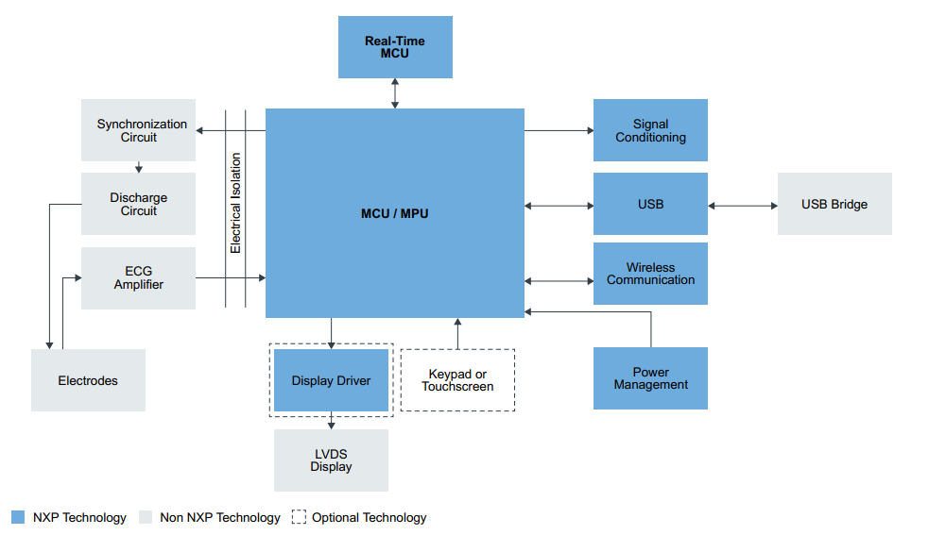

This is Defibrillator’s Block Diagram with NXP MCU, We can make device as similar this and add cellular and wifi module too.

And this is general AED’s activity flow diagram,

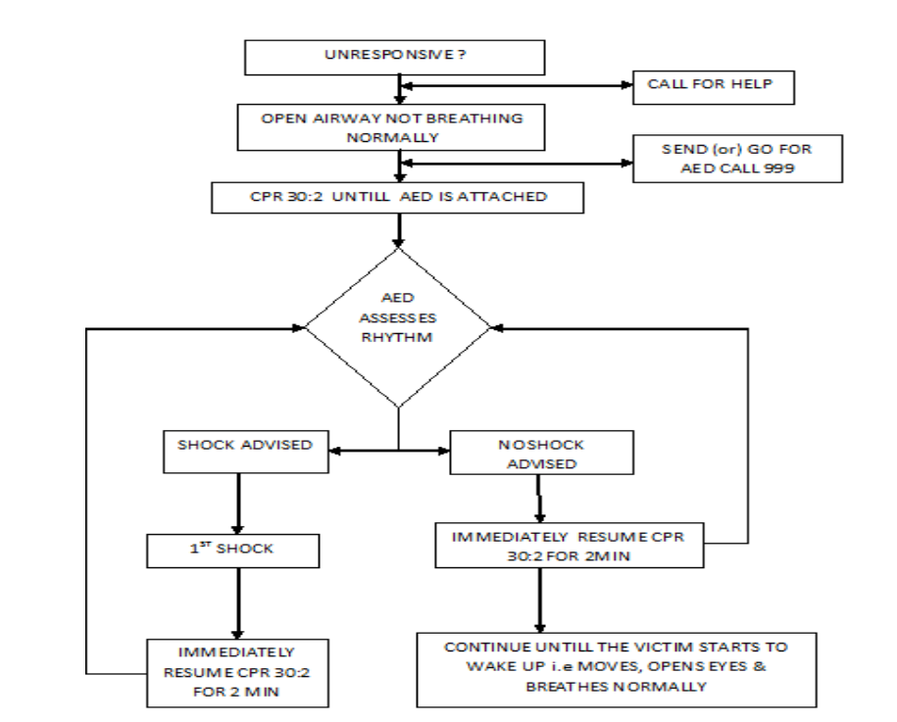

1. **The second step proceeds with the circuit design of the designed device.**

Prepare the schematic of the device, complete the PCB design, and examine the possibility of interworking with the necessary devices.

In this step, I will design PCB using Altium for adding cellular, wifi assistance, then you could check my schematic and gerber files.

After decide device schematic and PCB design, I can send it and you could manufacture hardware or prepare some hardware device for project on your side.

1. **The third step is to make program for cellular and WIFI module , and whole software.**

In this case is most important.

Code of all module such as cellular, wifi, i2c, uart, etc are made here and have to test it.

To do this, I will make code on here and test it on your side via remote such as teamviewer and anydesk.

So at this time, you have to prepare remote workstation.. Of course needed devices are let me know you.

1. **The fourth step is to total test with submodule and program for whole project and to fix the error correction and additional functions, update.**

We are trying to schedule development as above.

Of course, depending on the design and structure determined in the first stage, the development date may be extended or the schedule may be further delayed due to various difficulties that may arise during the development process.

However, I think the most important thing is to make an accurate plan and carry out the project under close agreement with the customer.

In my honest personal opinion, I think can complete at least the 2nd stage and 3rd stage can be done more than 50% in 60days.

Of course, I will do my best to carry out the project in 60 days.

And I am sure that close discussion with you and hard work can speed up your success.

If you agree with me, please let me know your project deadline.

After you tell me deadline for this project, I will divide sub plan for project..

And hope you understand this Is not simple and short finish project, it takes some time.

My hourly rate is 40$/hr, you already checked my profile and bid on your project.

But don’t worry, I will do my best and we can discuss often and try together.

PS: About communication, maybe we can contact easily and anytime more than on freelancer.

So if you have skype, slack, discord, or whatsapp, then please let me know..

And don’t send this info on freelancer, it is out of freelancer’s rule.

So please send this info with file using gmail.

[valeriiahnutova1993@outlook.com](mailto:valeriiahnutova1993@outlook.com) is my mail.

Of course you could ping me directly on skype, or whatsapp.

Skype: live:.cid.3a3a4479b5059ca2

Whatsapp: +380 959248786

Regards.