1. Overall

The aim of this project is design new module of Eurorack and write firmware

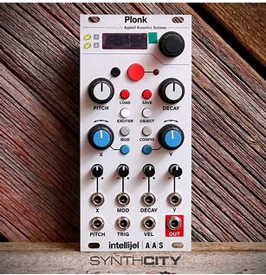

This picture is frontpanel of Eurorack…

It includes LCD, Rotary Encoder, Jack Input, Jack Output, LEDs..

* LCD: 16 x 2 LCD

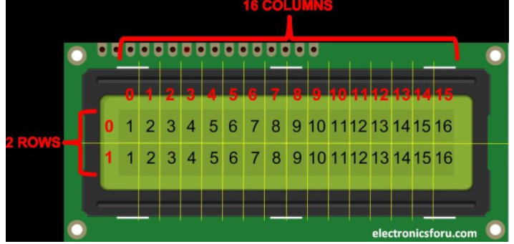

It has 2 rows..

Every pin’s function is like this..

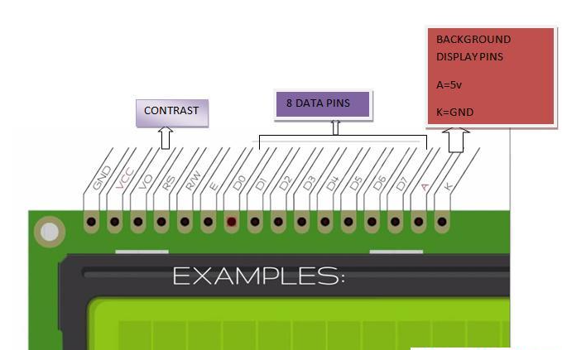

|  |  |  |
| --- | --- | --- |
| **Pin No.** | **Function** | **Name** |
| 1 | Ground (0V) | Ground |
| 2 | Supply voltage; 5V (4.7V – 5.3V) | Vcc |
| 3 | Contrast adjustment; the best way is to use a variable resistor such as a potentiometer. The output of the potentiometer is connected to this pin. Rotate the potentiometer knob forward and backwards to adjust the LCD contrast. | Vo / VEE |
| 4 | Selects command register when low, and data register when high | RS (Register Select ) |
| 5 | Low to write to the register; High to read from the register | Read/write |
| 6 | Sends data to data pins when a high to low pulse is given; Extra voltage push is required to execute the instruction and EN(enable) signal is used for this purpose. Usually, we set en=0, when we want to execute the instruction we make it high en=1 for some milliseconds. After this we again make it ground that is, en=0. | Enable |
| 7 | 8-bit data pins | DB0 |
| 8 | DB1 |
| 9 | DB2 |
| 10 | DB3 |
| 11 | DB4 |
| 12 | DB5 |
| 13 | DB6 |
| 14 | DB7 |
| 15 | Backlight VCC (5V) | Led+ |
| 16 | Backlight Ground (0V) | Led- |

* Rotary

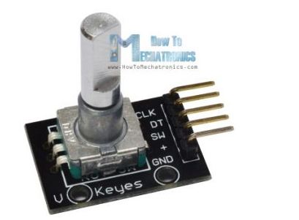

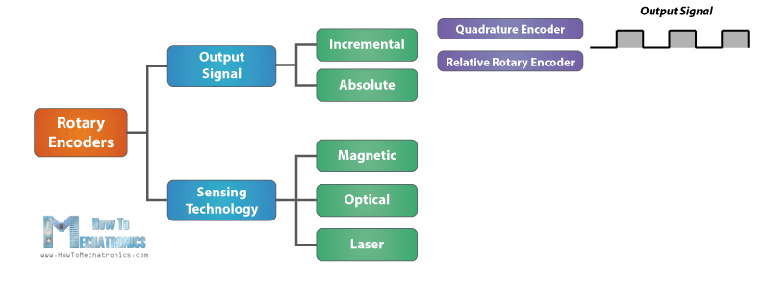

* LED
* JACK Input/Output

Input: 8 port

Output: 8 port

* SDCARD

1. Specification

* MCU: STM32F405
* Audio:
  + Clock : 500BPM
  + Frequency: 44.1KHz
  + Resolution: 24Hz
* Size: 6 cm x 40cm (front panel)
* LCD Interface: parallel
* Flash(or EEPROM)

1. Plan

* First: Make schematic and PCB layout..
  + Make Schematic (this takes 3~4days)..
  + PCB design and layout (this takes 4~5days). Ofcourse in this days, fix schematic’s error..
  + Simulate and test circuit (this takes 3days)

So for make PCB and circuit, take 2weeks…

The result will be like this.

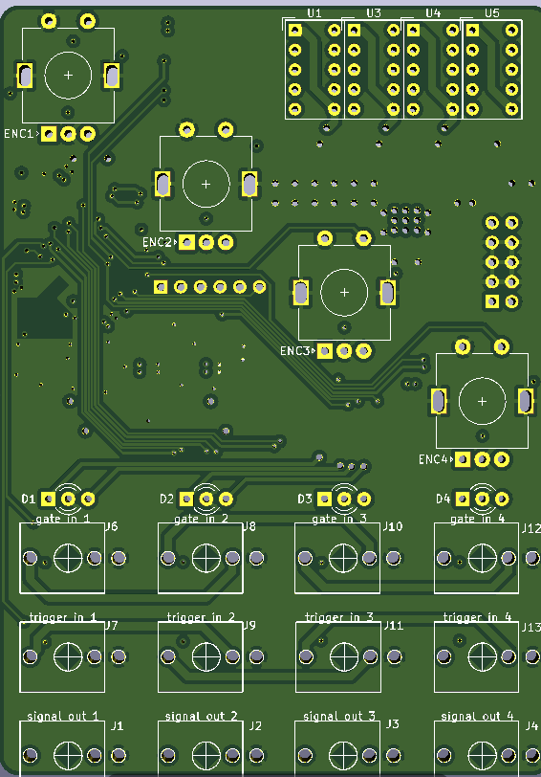

* Second: Write firmware
  + I will make firmware using STM32 CubeMX and Keil IDE… (it takes 10days)

STM32F405RG’s specification:

1MB flash

168MHZ clock

SPI, I2C, UART, 12bit ADC/DAC, etc..

Like this:

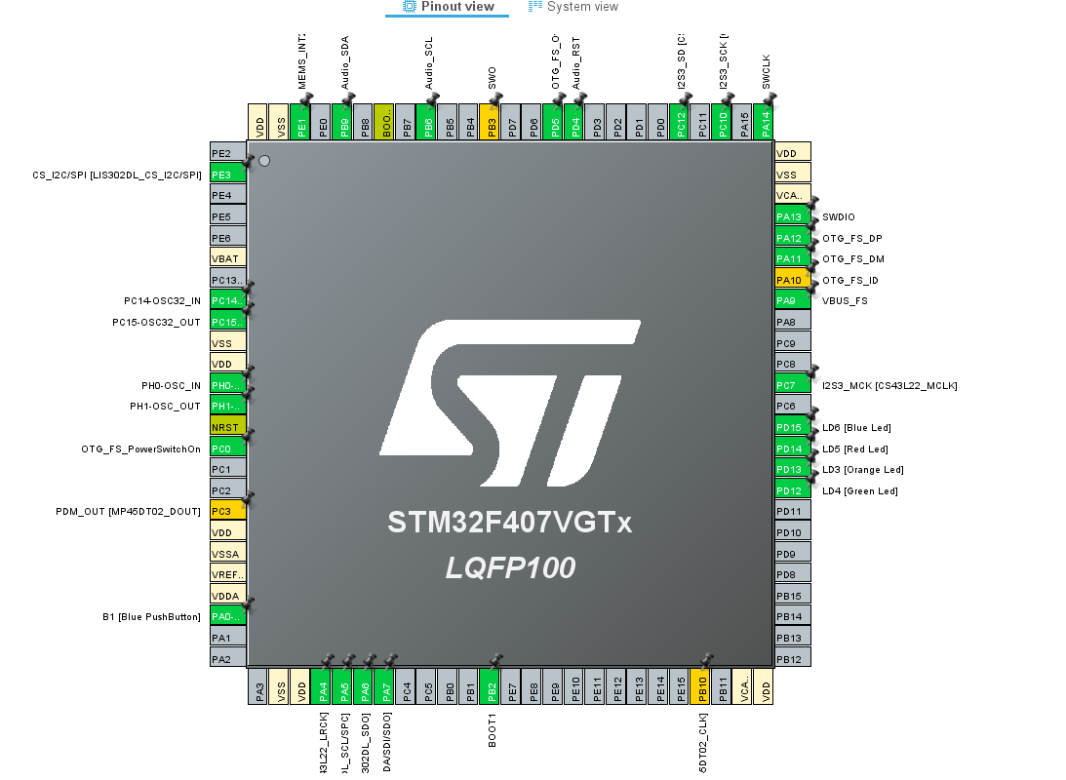

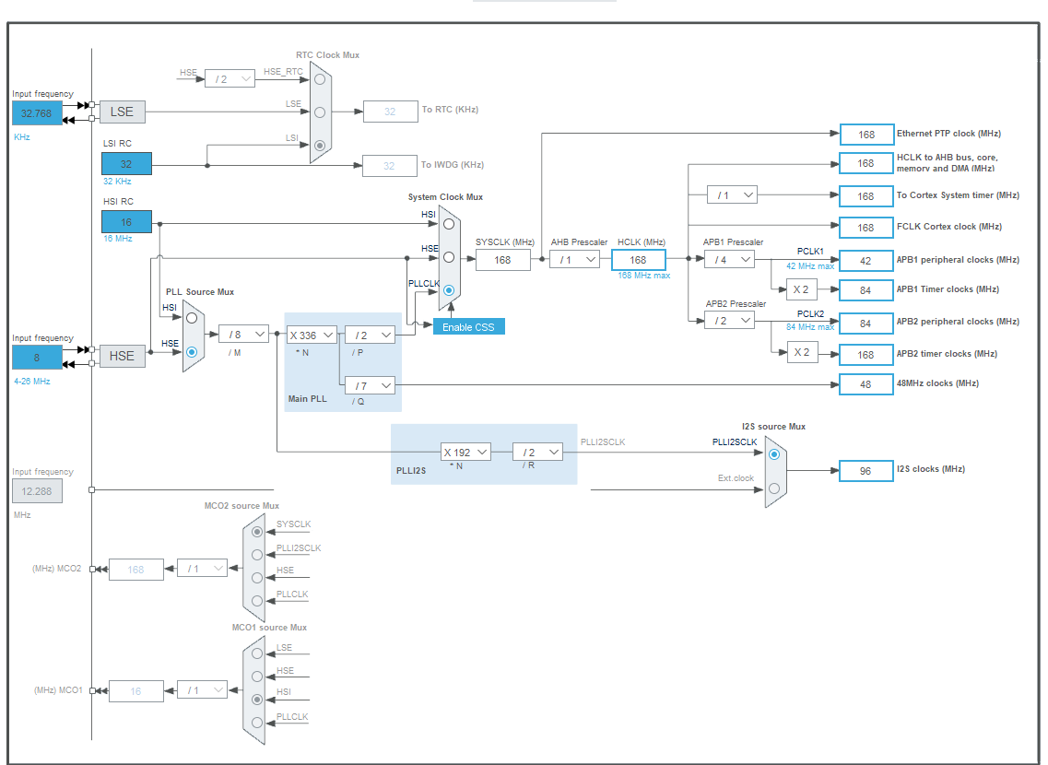

* + Test and fix firmware error.. (this takes 4~5days).

Hope chat with you on skype or other social…

Please add me to your skype.. live:.cid.b8a2dbce25ada6d8

So I suggest 4 weeks(1month) for this project…