***Steps to run jar file in windows:-***

***(need java 1.8.0 or above to run this application)***

> First check that the java is installed on your Desktop or not by running command in cmd.

***>*** To open cmd : Click on the window start button on left bottom side of desktop, search ***cmd*** in search text field and click on it.

***>*** After open cmd type below command

***java -version***

***>*** If you see this message on cmd :

**java version "1.8.0"Java(TM) SE Runtime Environment (build 1.8.0_131-b11)Java HotSpot(TM) 64-Bit Server VM (build 25.131-b11, mixed mode)**

It means java “1.8.0” is installed on your Machine.

> Else to install java on your windows machine follow the link mentioned below:-

<http://www.guru99.com/install-java.html>

>Download PBCLogs.jar from the link:

<https://vvdntech.atlassian.net/secure/attachment/49161/PBCLogs.jar>

> After installing java, Double-click on jar file(i.e PBCLogs.jar) and the application will start.

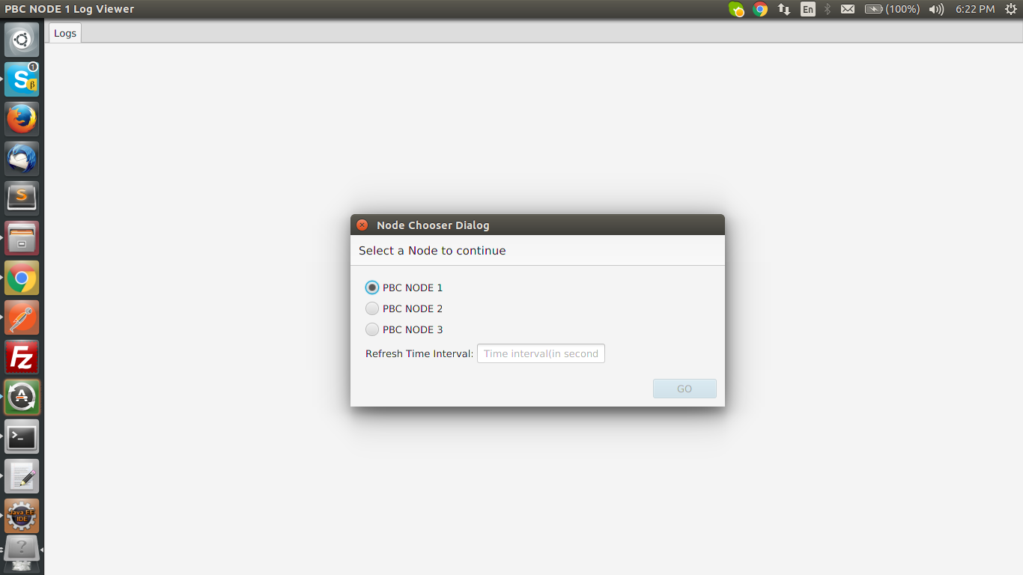

> When app will open, a dialog will appear to ask for which Node you want to view the log.

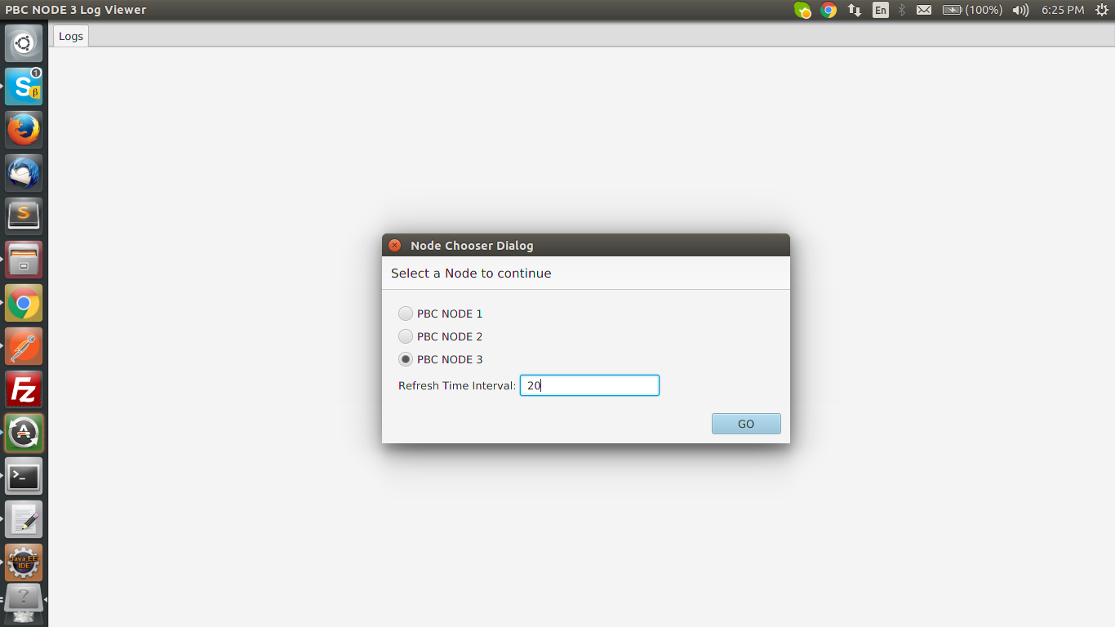> You will be asked for a refresh time interval in seconds(time interval should be between 1-30 secs). It will refresh the log after that fixed time of interval.

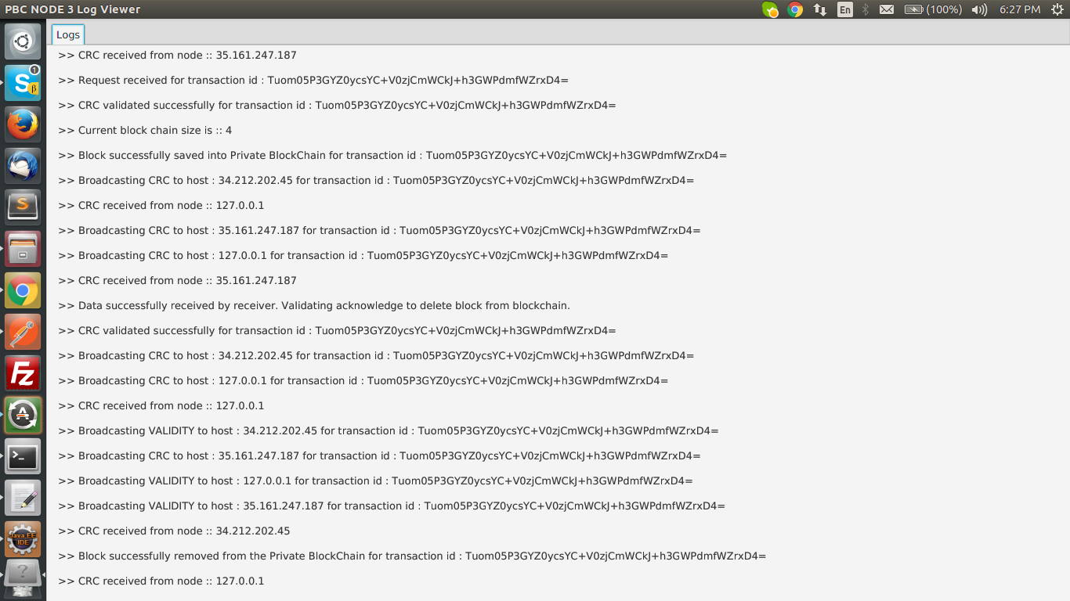

>After submitting all info click on GO and you will be able to see logs on windows.

***Steps to run jar file in Mac:-***

***(need java 1.8.0 or above to run this application)***

> First check that the java is installed on your Desktop or not by running command in terminal.

***>*** To open terminal : Click on search icon on top-right corner ,after clicking on it just type ***terminal*** to open terminal.

***>*** After opening terminal type below command

***java -version***

>If you see this message on terminal :

**java version "1.8.131"Java(TM) SE Runtime Environment (build 1.8.0_131-b11)Java HotSpot(TM) 64-Bit Server VM (build 25.131-b11, mixed mode)**

It means java “1.8.131” is installed on your Machine.

> Else to download java go to this link and download for mac version

<http://www.oracle.com/technetwork/java/javase/downloads/jdk8-downloads-2133151.html>

>1. Download the file. Before the file can be downloaded, you must accept the license agreement.

2. From either the Downloads window of the browser, or from the file browser, double click the .dmg file to launch it.

3. A Finder window appears containing an icon of an open box and the name of the .pkg file Double click the package icon to launch the **Install** app.

4. The Install app displays the **Introduction** window. Click **Continue**.

4a. Note that, in some cases, a **Destination Select** window appears. This is a bug, as there is only one option available. If you see this window, select **Install for all users of this computer** to enable the continue button. Click **Continue**.

5. The **Installation Type** window appears. Click **Install**.

6. A window appears which says "Installer is trying to install new software. Type your password to allow this." Enter the Administrator login and password and click **Install Software**.

7. The software is installed and a confirmation window appears. Click the [ReadMe](http://www.oracle.com/technetwork/java/javase/downloads/jdk-for-mac-readme-1564562.html) for more information about the installation.

After the software is installed, delete the dmg file if you want to save disk space.

>Download PBCLogs.jar from the link:

<https://vvdntech.atlassian.net/secure/attachment/49161/PBCLogs.jar>

>Now double-click on PBClog.jar ,you will get an unidentified developer pop-up to resolve that follow this link.

<https://kb.wisc.edu/helpdesk/page.php?id=25443>

> After installing java, Double-click on jar file(i.e PBCLogs.jar) and the application will start.

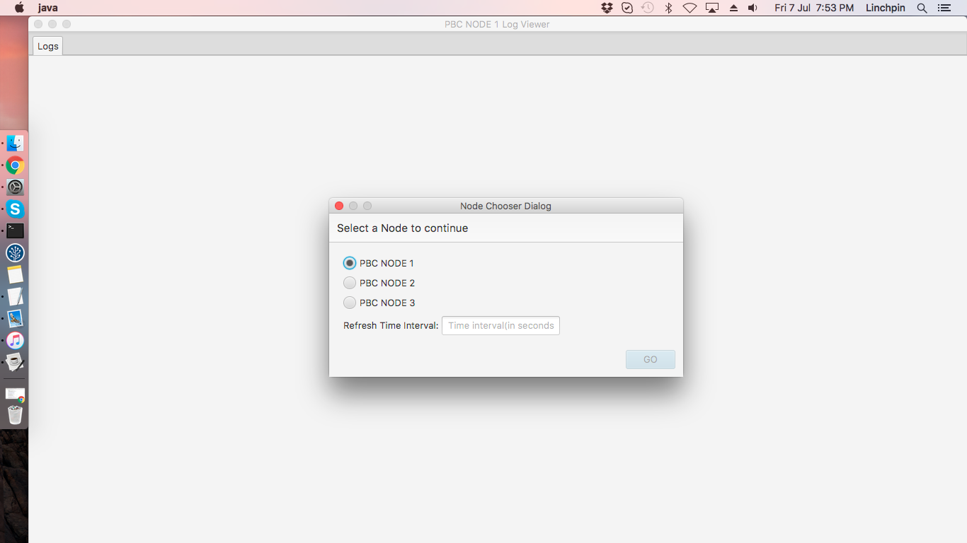

> When app will open, a dialog will appear to ask for which Node you want to view the log.

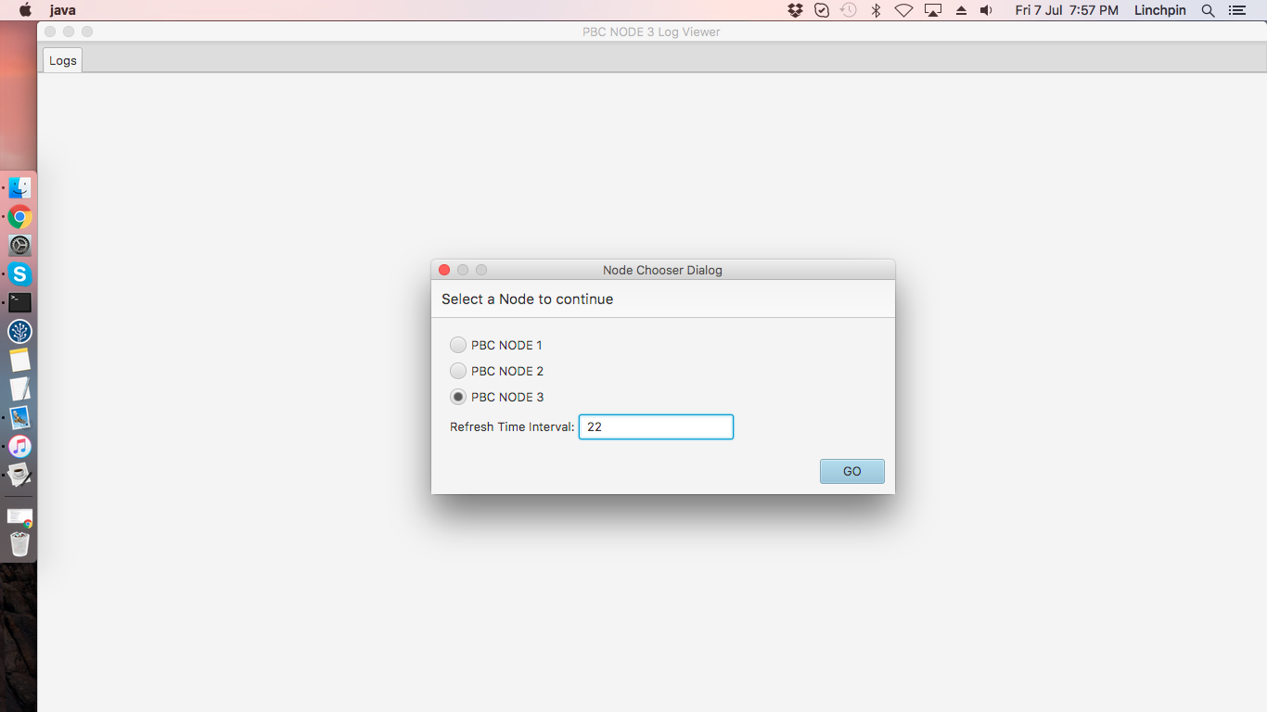

> You will be asked for a refresh time interval in seconds(time interval should be between 1-30 secs). It will refresh the log after that fixed time of interval.



>After submitting all info click on GO and you will be able to see logs on windows.