**BLYNK:**Blynk is a user-friendly IoT platform that simplifies the process of creating connected hardware projects. It provides a comprehensive toolkit for building mobile apps to control hardware remotely over the internet.Blynk stands as a testament to the democratization of IoT development, offering an accessible yet powerful platform for creating connected hardware projects. Since its inception in 2015, Blynk has emerged as a cornerstone of the maker community, empowering DIY enthusiasts, hobbyists, and professional developers alike to bring their IoT visions to fruition with remarkable ease and efficiency. At the heart of Blynk's appeal lies its intuitive drag-and-drop interface, which enables users to design custom mobile applications without any prior coding experience. This user-friendly approach not only accelerates the development process but also fosters creativity, allowing individuals to craft personalized control interfaces tailored to their specific project requirements.

One of Blynk's defining strengths is its extensive hardware compatibility, spanning popular platforms such as Arduino, ESP8266, ESP32, and more. This broad support ensures that developers can leverage their preferred microcontrollers or single-board computers to seamlessly integrate their devices with the Blynk platform. Whether it's controlling a home automation system, monitoring environmental conditions, or managing remote assets, Blynk provides the flexibility and versatility needed to bring diverse IoT applications to life.

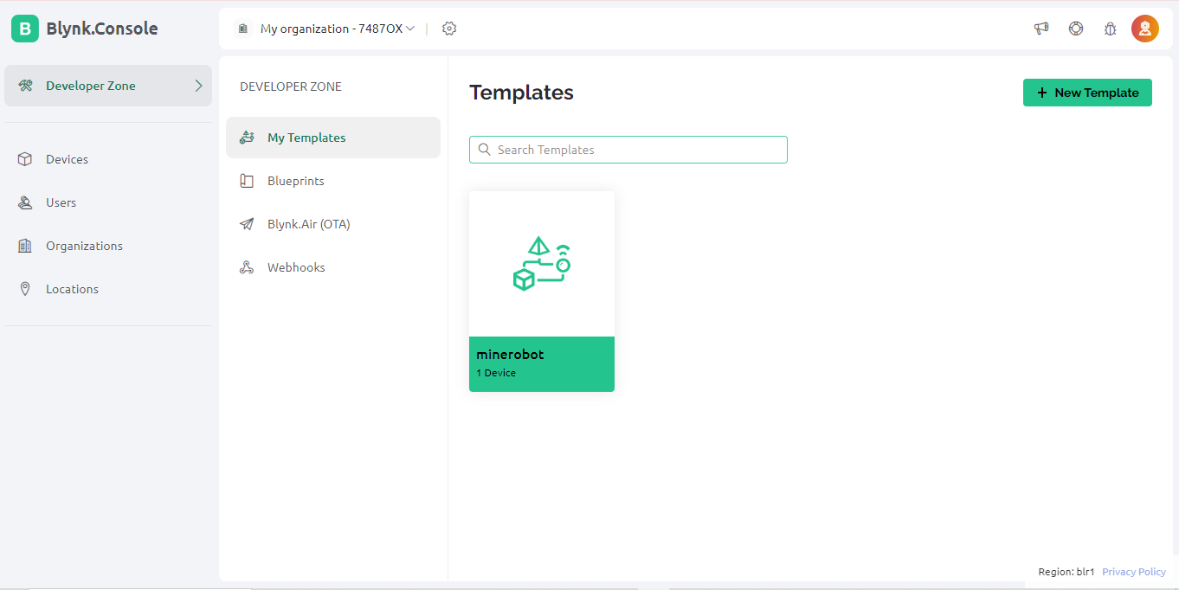

Central to Blynk's functionality is its cloud connectivity, enabling users to remotely monitor and control their IoT devices from anywhere in the world. This capability is invaluable for scenarios requiring real-time access and responsiveness, such as home automation, industrial monitoring, and smart agriculture. By harnessing the power of the cloud, Blynk empowers users to stay connected to their devices, enabling seamless interaction and management regardless of geographic location.

Blynk's repertoire of customizable widgets serves as the building blocks for creating dynamic and interactive user interfaces. From simple buttons and sliders to intricate graphs and gauges, these widgets can be effortlessly tailored to meet the unique demands of each project. Whether visualizing sensor data, toggling LEDs, or adjusting parameters, Blynk offers an extensive array of tools for crafting intuitive control interfaces that enhance user experience and engagement.

In an era where data security is paramount, Blynk prioritizes the protection of sensitive information through robust encryption and authentication mechanisms. All communication between the Blynk app and hardware devices is encrypted, mitigating the risk of unauthorized access and safeguarding the integrity of data transmissions. By upholding stringent security standards, Blynk instills confidence in users, assuring them that their IoT deployments are fortified against potential threats.

Beyond its technical capabilities, Blynk cultivates a vibrant and collaborative open-source community, where developers freely share knowledge, resources, and insights. This ecosystem of shared learning facilitates innovation and accelerates the pace of development, enabling individuals to overcome challenges and unlock new possibilities. Whether seeking guidance, sharing expertise, or collaborating on projects, the Blynk community serves as a supportive and enriching environment for IoT enthusiasts worldwide.

The versatility of Blynk extends across a myriad of use cases, ranging from home automation and environmental monitoring to remote asset management and healthcare applications. Whether it's optimizing energy efficiency, enhancing agricultural productivity, or promoting wellness, Blynk empowers users to harness the transformative potential of IoT technology to address real-world challenges and improve quality of life.

In conclusion, Blynk stands as a beacon of innovation in the realm of IoT development, democratizing access to powerful tools and resources for creating connected hardware projects. With its intuitive interface, extensive hardware compatibility, cloud connectivity, robust security, and vibrant community, Blynk paves the way for individuals to turn their IoT visions into reality, ushering in a future where interconnected devices enrich our lives in profound and meaningful ways.  
  
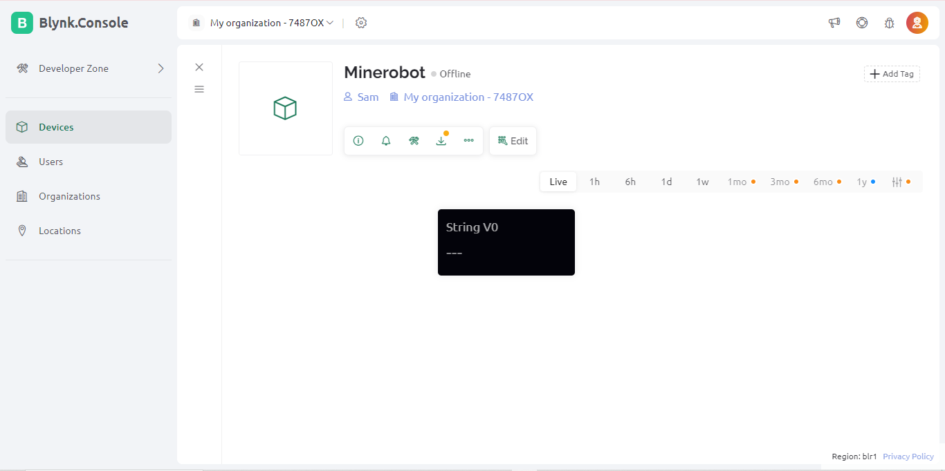

BLYNK DASHBOARD

**REALVNC VIEWER:**

RealVNC Viewer is a leading remote access solution that empowers users to remotely connect to and control computers, servers, and IoT devices with ease. Developed by RealVNC Ltd., the software offers a seamless and secure way to access remote systems, enabling users to troubleshoot issues, collaborate with colleagues, and manage resources efficiently, regardless of their physical location.RealVNC Viewer stands as a base of remote access software, offering users a seamless and secure means to connect and control remote computers and devices from any location. Developed by RealVNC Ltd., this software is a cornerstone of remote collaboration, IT support, server management, and IoT device control. Its cross-platform compatibility ensures that users can access remote systems from a variety of devices and operating systems, including Windows, macOS, Linux, iOS, and Android, facilitating flexibility and accessibility in remote work scenarios. Security is paramount in RealVNC Viewer, as it employs robust encryption protocols and supports two-factor authentication, providing users with peace of mind that their connections are safeguarded against unauthorized access and data breaches.

Where RealVNC Viewer is a comprehensive remote access solution that empowers users to connect and control remote systems with ease and confidence. Its cross-platform compatibility, robust security features, intuitive user interface, and versatile functionality make it an invaluable tool for a wide range of remote access needs, including IT support, remote collaboration, server management, and IoT device control. With RealVNC Viewer, users can work more efficiently and effectively in today's interconnected world, transcending geographical barriers and maximizing productivity in remote work environments.  
  
  
  
  
  
  
**Steps to login with REALVNC VIEWER:**Step 1: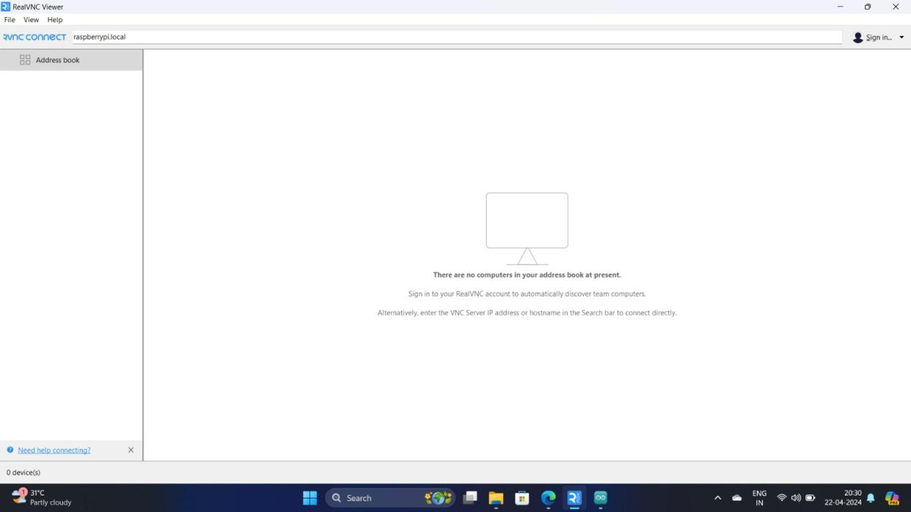

Home Page

Step 2:

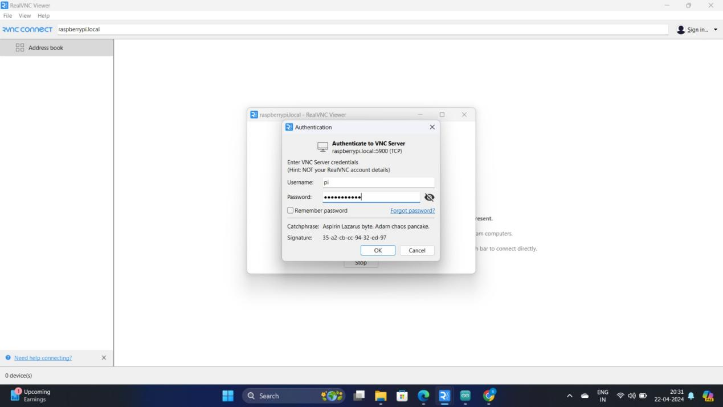

Login Page

Step 3:

