CPUStick™, IOStick™, and StickOS™
User's Guide v1.2
http://www.cpustick.com

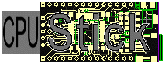
Overview
(actual size)
CPUStick is a 0.9”x1.8” very low cost standalone USB embedded computer based on the Freescale MCF52221 ColdFire MCU, similar in size and form to a USB “memory stick”, and suitable for use in soldered or solderless-breadboard applications.

Internal to the MCF52221 is an entire resident StickOS BASIC programming environment (including an easy-to-use editor, compiler, flasher, and debugger), where external pins are mapped to special “pin variables” for manipulation or examination, and internal peripherals are managed by BASIC control statements and interrupt handlers.

The CPUStick may be directly connected to any USB host computer that supports an FTDI Serial Port (including Windows and Linux) and may then be controlled by any terminal emulator program, with no additional software or hardware required on the host computer. The USB host computer may then be disconnected for standalone operation.

IOStick is a 0.9”x1.8” low cost piggyback I/O board for CPUStick that provides a 2.4GHz zigbee wireless transport and a 3-D accelerometer. Using the 2.4GHz zigbee wireless transport, the CPUStick may be remotely controlled through another CPUStick, via a telnet/rlogin-like interface, eliminating the need for a direct USB connection to the host computer. Additionally, BASIC programs can access variables remotely from other CPUSticks, enabling the use of “remote pin variables” or other forms of inter-MCU communication.

The StickOS BASIC programming environment includes the following features:

- BASIC line editor
  - ansi or vt100'ish terminal support
- BASIC compiler
  - compiles to a fast and safe intermediate bytecode
  - transparent line-by-line compilation is invisible to the user
- interactive BASIC debugger, supporting:
  - breakpoints, assertions, and watchpoints
  - live variable (and pin) manipulation and examination
  - execution tracing and single-stepping
  - edit-and-continue!
- BASIC file system
  - load and store up to three BASIC programs in flash
- 2.4GHz zigbee wireless transport to other CPUSticks
  - remote control via a telnet/rlogin-like interface
  - remote variable access in BASIC
- external control of 29 I/O pins, implicit thru "pin variables"
- digital input or output
- analog input or output (PWM actually)
- frequency output
- uart input or output
- qspi master input and output
- internal peripheral control
  - interrupts delivered to BASIC handlers!
  - interval timers, dma timers, ADC, PWM, uarts, qspi
- internal flash memory control
  - save programs and parameters to flash for standalone operation
  - prolong flash lifetime by storing incremental updates in RAM
  - clone one CPUStick’s flash directly to another
  - upgrade a CPUStick’s StickOS firmware via USB!
  - no external flash programmers needed!

By its very nature, StickOS supports in-circuit emulation when it is running in any StickOS-capable MCU -- all you need is three (USB) wires connecting the MCU to a USB host computer, and you have full control over the target embedded system! Alternatively, you can use the 2.4GHz zigbee wireless transport and have full control over the target embedded system with no wires at all!!!

Once the CPUStick is disconnected from the USB host computer, it may be run standalone from external power or the optional bottom-side CR-2 battery holder.

Table of Contents

1 Overview 1
2 Embedded Systems Made Easy 5
3 Wireless Embedded Systems Made Just as Easy! 8
4 CPUStick 11
4.1 Interface 11
4.2 External Pins 12
4.3 Power 12
4.4 USB 13
5 IOStick 15
5.1 Interface 15
5.2 Piggyback Pins 15
6 StickOS 16
6.1 Command-Line 17
6.1.1 Digital I/O Example 18
6.1.2 Analog I/O Example 20
6.1.3 Frequency I/O Example 21
6.1.4 UART I/O Example 22
6.1.5 QSPI Master I/O Example 24
6.2 StickOS Commands 25
6.2.1 Getting Help 25
6.2.2 Entering Programs 27
6.2.3 Running Programs 30
6.2.4 Loading and Storing Programs 32
6.2.5 Debugging Programs 33
6.2.6 Other Commands 37
6.3 BASIC Program Statements 39
6.3.1 Variable Declarations 39
6.3.2 System Variables 42
6.3.3 Variable Assignments 43
6.3.4 Expressions 44
6.3.5 Print Statements 46
6.3.6 Read/Data Statements 47
6.3.7 Conditional Statements 48
6.3.8 Looping Conditional Statements 49
6.3.9 Subroutines 52
6.3.10 Timers 54
6.3.11 Digital I/O 56
6.3.12 Analog I/O 57
6.3.13 Frequency I/O 58
6.3.14 UART I/O 59
6.3.15 QSPI Master I/O 61
6.3.16 Pin Interrupts 62
6.3.17 Other Statements 63
7 2.4GHz Zigbee Wireless Operation 64
7.1 Zigbee Configuration 64
7.2 Zigbee Remote Control 64
7.3 Zigbee Remote Variables 65
8 Standalone Operation 66
9 Slave Operation 67
10 CPUStick Cloning 68
11 CPUStick Upgrading 69
12 Appendix 70
12.1 CPUStick Features 70
12.2 IOStick Features 70
12.3 StickOS Command Reference 71
12.3.1 Commands 71
12.3.2 Modes 71
12.4 BASIC Program Statement Reference 72
12.4.1 Statements 72
12.4.2 Block Statements 72
12.4.3 Device Statements 73
12.4.4 Variables 73
12.4.5 Expressions 73
12.4.6 Pins 74
12.4.7 Zigbee 74
12.5 CPUStick Schematic 75
12.6 IOStick Schematic 76

Embedded Systems Made Easy
A simple embedded system, like a toaster oven temperature profile controller, can be brought online in record time!

CPUStick

an0
an1
USB
toaster oven
op- amp
thermocouple
solid state relay
ac power
relay control
to host computer
Hyper Terminal
(during program development only)
It’s as easy as...

- wire the CPUStick I/O pins to the embedded circuit
  - wire CPUStick pin an0 to thermocouple op-amp output
(I use an LM358)
  - wire CPUStick pin an1 to solid state relay control input
(I use a Teledyne STH24D25)
- connect a host computer to the USB interface on the CPUStick
- let the host computer automatically install the FTDI Serial Port transport drivers
- open a Hyper Terminal console window and connect to the CPUStick; press <Enter> for a command prompt
- configure the CPUStick I/O pins as appropriate
  - configure pin an0 as an analog input
  - configure pin an1 as a digital output
- write and debug your BASIC control program, live on the CPUStick (see below)
- type “save”
- type “autorun on”
- type “autoreset on”
- turn the toaster oven full on (so that the relay can control it)
- type “reset”
- disconnect the host computer from the USB interface on the CPUStick

The entire toaster oven temperature profile controller BASIC control program is shown below:

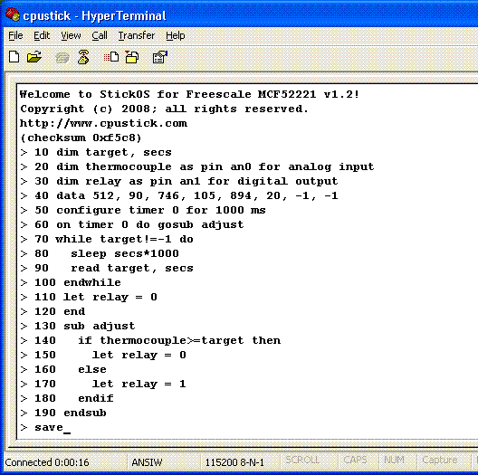

- Line 10 declares two simple RAM variables named “target” and “secs” for use in the program, and initializes them to 0.
- Line 20 declares an analog input "pin variable" named “thermocouple” that is bound to pin an0, to read the thermocouple voltage, in millivolts
- Line 30 declares a digital output "pin variable" named “relay” that is bound to pin an1, to control the solid state relay.
- Line 40 declares the temperature target and delay time pairs for our temperature profile ramp.
- Lines 50 and 60 configure a timer interrupt to call the "adjust" subroutine asynchronously, every second, while the program runs.
- Lines 70 thru 100 set the target temperature profile while the program runs.
- Lines 110 and 120 end the program with the solid state relay control turned off.
- Lines 130 thru 190 use the declared pin variables to simply turn the solid state relay control off if the target temperature has been achieved, or on otherwise.

Then:

- “save” saves the program to non-volatile flash memory.
- “autorun on” sets the program to run automatically when the CPUStick is powered up.
- “autoreset on” sets the CPUStick to automatically reset itself when it is awakened from a sleep (as opposed to continuing running the saved BASIC program from where it left off).
- Finally, “reset” resets the CPUStick as if it was just powered up.

Note that if terse code were our goal, lines 60 and 130 thru 190 could have all been replaced with the single statement:

> 60 on timer 0 do let relay = thermocouple<target

Wireless Embedded Systems Made Just as Easy!
With the aid of an IOStick, a simple wireless embedded system, like a remote LED dimmer, can be brought online just as easily as a local embedded system!

CPUStick
& IOStick
#1
an0

USB
to host computer
Hyper Terminal
(during program development only)

CPUStick
& IOStick
#2
dtin0

2.4GHz
zigbee
wireless
potentiometer
LED
It’s as easy as...

- set the 2.4GHz zigbee wireless nodeid on each CPUStick
- wire CPUStick #1 to its embedded circuit
  - wire CPUStick #1 pin an0 to the potentiometer
- wire CPUStick #2 to its embedded circuit
  - wire CPUStick #2 pin dtin0 to the LED
- connect a host computer to the USB interface on CPUStick #1
- write and debug your BASIC control program, live on CPUStick #1 (see below)
- use the 2.4GHz zigbee wireless transport to connect to CPUStick #2
- write and debug your BASIC control program, live on CPUStick #2 (see below)
- run the program on CPUStick #2
- disconnect from CPUStick #2
- run the program on CPUStick #1

The entire debugging session, including the writing and running of both CPUStick’s BASIC control programs, is shown below:

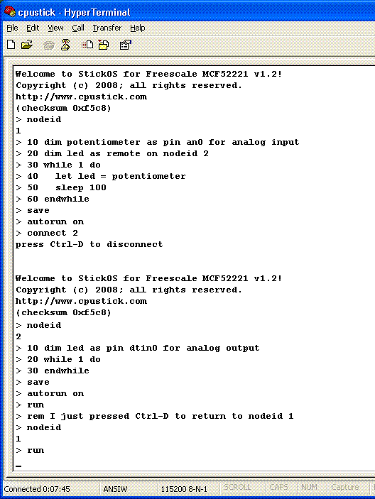

Note that all of this debugging session is occurring on the Hyper Terminal connected to the USB interface on CPUStick #1!

First we write the program on CPUStick #1.

- Notice in line 10 that we declare a local pin variable named “potentiometer” to read the value of the potentiometer, through analog input pin an0, in millivolts.
- Then, in line 20, we declare a remote pin variable to control the LED on CPUStick #2 (through CPUStick #2’s local pin variable!); the “as remote on nodeid 2” indicates that the real variable declaration is found on CPUStick #2.
- Then we simply enter an infinite loop reading the value of the potentiometer (again, in millivolts) every 100ms, and writing it to the LED on CPUStick #2.

We then save the program to flash memory on CPUStick #1 and configure it to run automatically when the CPUStick powers up.

Then we remotely connect to CPUStick #2 and write its program.

- Notice in line 10 that we declare a local pin variable named “led” to control the LED, through analog output pin dtin0, in millivolts.
- Then we simply enter an infinite loop, waiting for our local pin variable to be written remotely from CPUStick #1 every 100ms!

We then save the program to flash memory on CPUStick #2 and configure it to run automatically when the CPUStick powers up.

Finally, we run the program on CPUStick #2, disconnect from CPUStick #2 by pressing <Ctrl-D>, and run the program on CPUStick #1.

At this point, adjusting the potentiometer on CPUStick #1 causes the LED brightness on CPUStick #2 to be correspondingly adjusted, after a 100ms delay!!!

CPUStick

Interface
The CPUStick contains a sleep switch, two LEDs, a USB mini-B connector, 38 external 0.1” header pins, and 2 power jumpers, as depicted below.

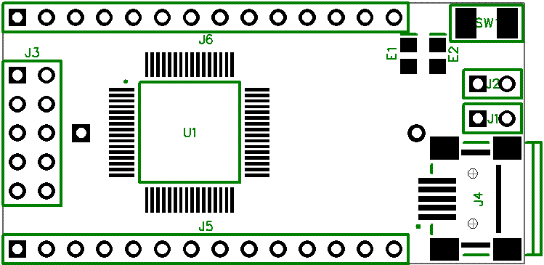

When the StickOS in the CPUStick is running LED “e1” (on digital output pin “irq7*”) will blink slowly; when the BASIC program in the CPUStick is running, LED “e1” will blink quickly. LED “e2” is under BASIC program control on digital output pin “irq4*”, unless an IOStick is also in use.

When the sleep switch “sw1” (on pin “irq1*”) is depressed, the CPUStick enters a low-power mode (drawing ~70 uA) and tri-states all external pins until the sleep switch is depressed again. Holding switch “sw1” depressed during power-on prevents autorun of the BASIC program. If autoreset mode is set, the CPUStick automatically resets itself when it is awakened from a sleep (as opposed to continuing running the saved BASIC program from where it left off).

External Pins
CPUStick external pins must be configured prior to use.

All CPUStick external pins support general purpose digital input or output. In addition, eight an? pins can support analog input, four dtin? pins can support analog output (PWM actually) or frequency output, two urxd? pins can support UART input, and two utxd? pins can support UART output. The qspi? pins can support QSPI master input/output.

The CPUStick 0.1” header pinout is listed below. Pins indicated with strikethrough text are intended for debug and initial code load only.

  J3 | 1 | GND
   | 2 | +3.3V
   | 3 | rsti*
   | 4 | scl
   | 5 | sda
   | 6 | qspi_din
   | 7 | qspi_dout
   | 8 | qspi_clk
   | 9 | qspi_cs0*
   | 10 | rcon*/irq4*
  J5 | 1 | GND
   | 2 | +3.3V
   | 3 | dtin3
   | 4 | dtin2
   | 5 | dtin1
   | 6 | dtin0
   | 7 | an0
   | 8 | an1
   | 9 | an2
   | 10 | an3
   | 11 | an4
   | 12 | an5
   | 13 | an6
   | 14 | an7
  J6 | 1 | GND
   | 2 | +3.3V
   | 3 | ucts0*
   | 4 | urts0*
   | 5 | urxd0
   | 6 | utxd0
   | 7 | ucts1*
   | 8 | urts1*
   | 9 | urxd1
   | 10 | utxd1
   | 11 | irq7*
   | 12 | irq4*
   | 13 | irq1*
   | 14 | +5V

Power
The power jumpers J1 and J2 and the optional CR-2 battery holder determine where the CPUStick will draw power from, as follows:

J1 | J2 | CR-2 | Power
Installed | Installed | - | USB
- | Installed | - | +5V header
- | - | Installed | CR-2
- | - | - | +3V header

All digital and analog circuitry within the CPUStick runs at +3.3V. See the schematic in the appendix for details.

USB
When the CPUStick is connected to a USB host computer, it will present an FTDI Serial Port function to the host computer. An appropriate driver will be loaded automatically from microsoft.com, if needed, or you can manually install the VCP driver from http://www.ftdichip.com/FTDrivers.htm.

Once the driver is loaded, a new virtual COM port (VCP) will be present on your system. This virtual COM port will be visible in Device Manager:

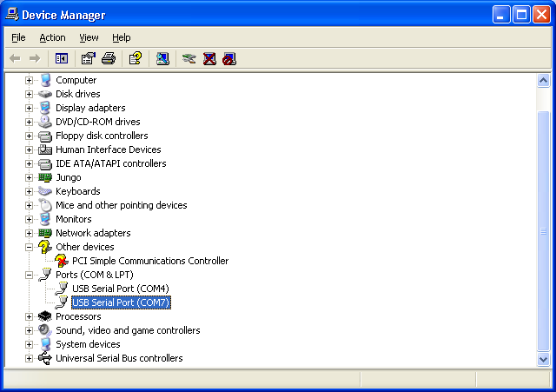

At this point you can use Hyper Terminal (typically found under Start -> All Programs -> Accessories -> Communications -> Hyper Terminal) to connect to the new virtual COM port. Specify a new connection name, such as “cpustick”, and then select the new virtual COM port under Connect To; the baud rate and data characteristics in Port Settings are ignored.

Press <Enter> when you are connected and you should see the command prompt:

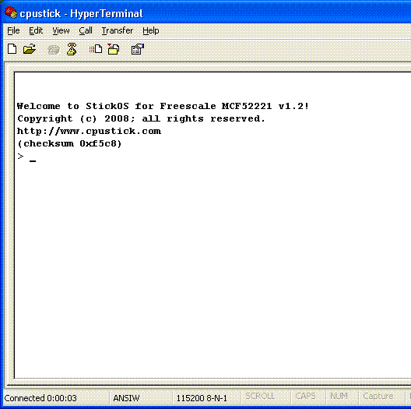

If the USB connection is lost (such as when you unplug and re-plug in the CPUStick), press the “Disconnect” button followed by the “Call” button, to reconnect Hyper Terminal.

Note that if you do not have Hyper Terminal (such as in Windows Vista or Linux), my favorite terminal emulator program is “putty”, available free from http://www.putty.org/; the latest version supports serial port connections.

You are now ready to enter StickOS commands and/or BASIC program statements!

See also: Zigbee Remote Control

IOStick

Interface
IOStick contains a 2.4GHz zigbee wireless transceiver, a compact PCB trace antenna, and a 3-axis accelerometer, and two 0.1” sockets that allow it to piggyback on the CPUStick headers, as depicted below:

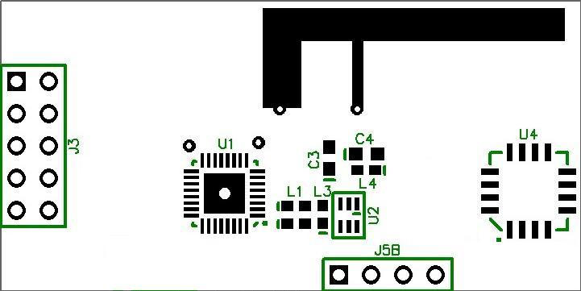

Piggyback Pins
The zigbee and accelerometer components of the IOStick connect to the following MCU pins thru the piggyback connectors:

  J3 | MCU pin | IOStick pin (zigbee)
   | qspi_clk | spiclk
   | qspi_din | miso
   | qspi_dout | mosi
   | qspi_cs0 | ce*
   | irq4* | irq*
   | scl | rst*
   | sda | rxtxen
   | vss | vss
   | vdd | vdd
  J5B | MCU pin | IOStick pin (accelerometer)
   | an4 | zout
   | an5 | yout
   | an6 | xout
   | an7 | gset1/gsel2

In general, native StickOS services manage the zigbee pins, though you can manage them manually in BASIC as well. The accelerometer pins are available to BASIC programs on MCU pins an4 thru an7.

StickOS
StickOS supports a BASIC programming environment, where external pins are mapped to special “pin variables” for manipulation or examination.

External pins can be dynamically configured as one of:

- digital input or output,
- analog input or output (PWM actually),
- frequency output, or
- uart input or output
- qspi master input/output

BASIC programs as well as “persistent parameters” can be stored in non-volatile flash memory; volatile variables as well as recent code edits (up to the next “save” command) are stored in RAM.

Command-Line
In the command and statement specifications that follow, the following nomenclatures are used:

bold | literal text; enter exactly as shown
italics | parameterized text; enter actual parameter value
(alternate1|  alternate2|  ...) | alternated text; enter exactly one alternate value
regular | displayed by StickOS
<key> | press this key

To avoid confusion with array indices (specified by [...]), optional text will always be called out explicitly, either by example or by text, rather than nomenclated with the traditional [...].

When StickOS is controlled with an ansi or vt100'ish terminal emulator, command-line editing is enabled via the terminal keys, as follows:

key | function
← | move cursor left
→ | move cursor right
↑ | recall previous history line
↓ | recall next history line
<Home> | move cursor to start of line
<End> | move cursor to end of line
<Backspace> | delete character before cursor
<Delete> | delete character at cursor
<Ctrl-C> | clear line
<Ctrl-D> | disconnect from remote node (zigbee)
<Enter> | enter line to StickOS

If you enter a command or statement in error, StickOS will indicate the position of the error, such as:

> print i forgot to use quotes
error - ^
> _

Digital I/O Example
As a simple example, the following BASIC program generates a 1 Hz square wave on the “dtin0” pin:

> 10 dim square as pin dtin0 for digital output
> 20 while 1 do
> 30 let square = !square
> 40 sleep 500
> 50 endwhile
> run
<Ctrl-C>
STOP at line 40!
> _

Press <Ctrl-C> to stop the program.

Line 10 configures the “dtin0” pin for digital output, and creates a variable named “square” whose updates are reflected at that pin. Line 20 starts an infinite loop (typically CPUStick programs run forever). Line 30 inverts the state of the dtin0 pin from its previous state -- note that you can examine as well as manipulate the (digital or analog) output pins. Line 40 just delays the program execution for one half second. And finally line 50 ends the infinite loop.

If we want to run the program in a slightly more demonstrative way, we can use the “trace on” command to show every variable update as it occurs:

> trace on
> run
30 let square = 1
30 let square = 0
30 let square = 1
30 let square = 0
<Ctrl-C>
STOP at line 40!
> _

Again, press <Ctrl-C> to stop the program.

Note that almost all commands that can be run in a program can also be run in “immediate” mode, at the command prompt. For example, after having run the above program, the “square” variable (and dtin0 pin) remain configured, so you can type:

> print "square is now", square
square is now 0
> let square = !square
> print "square is now", square
square is now 1
> _

This also demonstrates how you can examine or manipulate variables (or pins!) at the command prompt during program debug.

Analog I/O Example
The CPUStick can perform analog I/O as simply as digital I/O.

The following BASIC program takes a single measurement of an analog input at pin “an0” and displays it:

> new
> 10 dim potentiometer as pin an0 for analog input
> 20 print "potentiometer is", potentiometer
> run
potentiometer is 2026
> _

Note that analog inputs and outputs are represented by integers in units of millivolts (mV).

Note that almost all commands that can be run in a program can also be run in “immediate” mode, at the command prompt. For example, after having run the above program, the “potentiometer” variable (and an0 pin) remain configured, so you can type:

> print "potentiometer is now", potentiometer
potentiometer is now 2027
> _

This also demonstrates how you can examine variables (or pins!) at the command prompt during program debug.

Frequency I/O Example
The CPUStick can perform frequency I/O as simply as digital or analog I/O.

The following BASIC program generates a 1kHz square wave on a frequency output pin “dtin0” for 1 second:

> new
> 10 dim audio as pin dtin0 for frequency output
> 20 let audio = 1000
> 30 sleep 1000
> 40 let audio = 0
> run
> _

Note that frequency outputs are represented by integers in units of hertz (Hz).

Note that almost all commands that can be run in a program can also be run in “immediate” mode, at the command prompt. For example, after having run the above program, the “audio” variable (and dtin0 pin) remain configured, so you can type:

> print "audio is now", audio
audio is now 0
> let audio = 2000
> print "audio is now", audio
audio is now 2000
> _

This also demonstrates how you can examine or manipulate variables (or pins!) at the command prompt during program debug.

UART I/O Example
The CPUStick can perform serial uart I/O as simply as digital or analog I/O.

The following BASIC program configures a uart for loopback mode, transmits two characters and then asserts it receives them correctly:

> new
> 10 configure uart 0 for 9600 baud 7 data even parity loopback
> 20 dim tx as pin utxd0 for uart output
> 30 dim rx as pin urxd0 for uart input
> 40 let tx = 48
> 50 let tx = 49
> 60 while tx do
> 70 endwhile
> 80 assert rx==48
> 90 assert rx==49
> 100 assert rx==0
> 110 print "ok!"
> run
40 let tx = 48
50 let tx = 49
ok!
> _

(Note that tracing is still enabled from the previous example.) Line 10 configures uart 0 for 9600 baud loopback operation. Lines 20 and 30 configure the “utxd0” and “urxd0” pins for uart output and input, and creates two variable named “tx” and “rx” bound to those pins. Line 40 sends a character (‘0’, ascii 48) out the uart and line 50 sends another (‘1’, ascii 49). Line 60 waits until all characters are sent (when “tx” reads back 0). Line 80 and 90 then receive two characters from the uart and assert they are what we sent. Line 100 then asserts there are no more characters received (“rx” reads back 0).

The uart can also be controlled using interrupts rather than polling. The following program shows this:

> trace off
> 10 configure uart 0 for 9600 baud 7 data even parity loopback
> 20 dim tx as pin utxd0 for uart output
> 30 dim rx as pin urxd0 for uart input
> 40 on uart 0 input do gosub receive
> 50 let tx = 48
> 60 let tx = 49
> 70 sleep 1000
> 80 end
> 90 sub receive
> 100 print "received", rx
> 110 endsub
> run
received 48
received 49
> _

QSPI Master I/O Example
The CPUStick can perform serial QSPI master I/O as simply as digital or analog I/O.

The following BASIC program configures QSPI to talk to the EzPort of another CPUStick via QSPI, assuming a clone cable is attached. It enables flash memory writes and then queries the status register:

> list
10 dim nrsti as pin scl for digital output
20 configure qspi for 0 csiv
30 dim cmd as byte
40 dim status as byte
50 rem pulse rsti* low
60 let nrsti = 0
70 let nrsti = 1
80 sleep 100
90 rem send write enable command
100 let cmd = 0x6
110 qspi cmd
120 rem send read status register command
130 let cmd = 0x5
140 qspi cmd, status
150 print hex status
end
> run
0x2
> _

Line 10 configures a digital output pin to reset the target CPUStick. Line 20 configures the QSPI chip select inactive value to be 0, for use with EzPort. Lines 20 and 30 just dimension two byte sized variables for use below; note that QSPI transfers are sized by the variables specified in the qspi statement. Lines 60 and 70 reset the target CPUStick. Line 80 delays 100 ms before talking to the EzPort. Lines 100 and 110 send a one byte “write enable” command. Lines 130 and 140 send a one byte “read status register” command and receive a one byte status. Line 150 prints the status, which shows writes are enabled but the configuration register is not yet loaded.

A more complicated program can be used to control the IOStick’s 2.4GHz zigbee transceiver, when it is not otherwise being used by native StickOS services.

StickOS Commands
StickOS commands are used to control the StickOS BASIC program. Unlike BASIC program statements, StickOS commands cannot be entered into the StickOS BASIC program with a line number.

Getting Help
The help command displays the top level list of help topics:

help

To get help on a subtopic, use the command:

help subtopic

Examples
> help
for more information:
help about
help commands
help modes
help statements
help blocks
help devices
help expressions
help variables
help pins
help board
help clone
help zigbee

see also:
http://www.cpustick.com
> help commands
clear [flash] -- clear ram [and flash] variables
clone [run] -- clone flash to slave CPUStick [and run]
cls -- clear terminal screen
cont [<line>] -- continue program from stop
delete [<line>][-][<line>] -- delete program lines or <subname>
dir -- list saved programs
edit <line> -- edit program line
help [<topic>] -- online help
list [<line>][-][<line>] -- list program lines or <subname>
load <name> -- load saved program
memory -- print memory usage
new -- erase code ram and flash memories
purge <name> -- purge saved program
renumber [<line>] -- renumber program lines (and save)
reset -- reset the CPUStick!
run [<line>] -- run program
save [<name>] -- save code ram to flash memory
undo -- undo code changes since last save
upgrade -- upgrade StickOS firmware!
uptime -- print time since last reset

for more information:
help modes
> _

Entering Programs
To enter a statement into the BASIC program, precede it with a line number identifying its position in the program:

line statement

If the specified line already exists in the BASIC program, it is overwritten.

To delete a statement from the BASIC program, enter just its line number:

line

To list the BASIC program, or a range of lines from the BASIC program, use the command:

list
list line
list -line
list line-
list line-line

Alternately, you can list an entire subroutine by name with the command:

list subname

To set the listing indent mode, use the command:

indent (on|off)

To display the listing indent mode, use the command:

indent

If the listing indent mode is on, nested statements within a block will be indented by two characters, to improve program readability.
To delete a range of lines from the BASIC program, use the command:

delete line
delete -line
delete line-
delete line-line

Alternately, you can delete an entire subroutine by name with the command:

delete subname

To edit an existing line of the BASIC program via command-line editing, use the command:

edit line

A copy of the unchanged line is also stored in the history buffer.

To undo changes to the BASIC program since it was last saved (or renumbered, or new'd, or loaded), use the command:

undo

To save the BASIC program permanently to flash memory, use the command:

save

Note that any unsaved changes to the BASIC program will be lost if the CPUStick is reset or loses power.

To renumber the BASIC program by 10's and save the BASIC program permanently to flash memory, use the command:

renumber

To delete all lines from the BASIC program, use the command:

new

Examples
> 10 dim a
> 20 for a = 1 to 10
> 30 print a
> 40 next
> save
> list 20-40
20 for a = 1 to 10
30 print a
40 next
end
> delete 20-40
> list
10 dim a
end
> undo
> list
10 dim a
20 for a = 1 to 10
30 print a
40 next
end
> 1 rem this is a comment
> list
1 rem this is a comment
10 dim a
20 for a = 1 to 10
30 print a
40 next
end
> renumber
> list
10 rem this is a comment
20 dim a
30 for a = 1 to 10
40 print a
50 next
end
> new
> list
end
> _

Running Programs
To run the BASIC program, use the command:

run

Alternately, to run the program starting at a specific line number, use the command:

run line

To stop a running BASIC program, press:

<Ctrl-C>

To continue a stopped BASIC program, use the command:

cont

Alternately, to continue a stopped BASIC program from a specific line number, use the command:

cont line

To set the autorun mode for the saved BASIC program, use the command:

autorun (on|off)

To display the autorun mode for the saved BASIC program, use the command:

autorun

If the autorun mode is on, when the CPUStick is reset, it will start running the saved BASIC program automatically.

To set the autoreset mode for the saved BASIC program, use the command:

autoreset (on|off)

To display the autoreset mode for the saved BASIC program, use the command:

autoreset

If the autoreset mode is on, the CPUStick will reset itself when it is awakened from a sleep, as if powering on; otherwise, it will continue running the saved BASIC program from where it left off.

Note that any unsaved changes to the BASIC program will be lost if the CPUStick is reset or loses power.

Examples
> 10 dim a
> 20 while 1 do
> 30 let a = a+1
> 40 endwhile
> save
> run
<Ctrl-C>
STOP at line 40!
> print a
5272
> cont
<Ctrl-C>
STOP at line 30!
> print a
11546
> autorun
off
> autorun on
> _

Loading and Storing Programs
StickOS can load and store up to three BASIC programs by name.

To display the list of currently stored programs, use the command:

dir

To store the current program under the specified name, use the command:

save name

To load a stored program to become the current program, use the command:

load name

To purge (erase) a stored program, use the command:

purge name

Examples
> 10 dim a
> 20 while 1 do
> 30 let a = a+1
> 40 endwhile
> dir
> save spinme
> dir
spinme
> new
> list
end
> load spinme
> list
10 dim a
20 while 1 do
30 let a = a+1
40 endwhile
end
> purge spinme
> dir
> _

Debugging Programs
There are a number of techniques you can use for debugging StickOS BASIC programs.

The simplest debugging technique is simply to insert print statements in the program at strategic locations, and display the values of variables.

A more powerful debugging technique is to insert one or more breakpoints in the program, with the following statement:

line stop

When program execution reaches line, the program will stop and then you can use immediate mode to display or modify the values of any and all variables.

To continue a stopped BASIC program, use the command:

cont
cont line

An even more powerful debugging technique is to insert one or more conditional breakpoints in the program, with the following statement:

line assert expression

When the program execution reaches line, expression is evaluated, and if it is false (i.e., 0), the program will stop and you can use immediate mode to display or modify the values of any and all variables.

Again, to continue a stopped BASIC program, use the command:

cont
cont line

The most powerful debugging technique, though also the most expensive in terms of program performance, is to insert a watchpoint expression in the program, with the following statement

line on expression do statement

The watchpoint expression is re-evaluated before every line of the program is executed; if the expression transitions from false to true, the watchpoint statement handler runs.

When debugging, the statement handler is typically a “stop” statement, such as:

line on expression do stop

This will cause the program to stop as soon as the specified expression becomes true, such as when a variable or pin takes on an incorrect value.

Note that StickOS supports only a single watchpoint expression, shared between debugging functionality and pin interrupt functionality.

At any time when a program is stopped, you can enter BASIC program statements at the command-line with no line number and they will be executed immediately; this is called "immediate mode". This allows you to display the values of variables, with an immediate mode statement like:

print expression

It also allow you to modify the value of variables, with an immediate mode statement like:

let variable = expression

Note that if an immediate mode statement references a pin variable, the live CPUStick pin is examined or manipulated, providing a very powerful debugging technique for the embedded system itself!

Thanks to StickOS’s transparent line-by-line compilation, you can also edit a stopped BASIC program and then continue it, either from where you left off or from another program location!

When the techniques discussed above are insufficient for debugging, two additional techniques exist -- single-stepping and tracing.

To set the single-step mode for the BASIC program, use the command:

step (on|off)

To display the single-step mode for the BASIC program, use the command:

step

While single-step mode is on, the program will stop execution after every statement, as if a stop statement was inserted after every line.

Additionally, while single-step mode is on, pressing <Enter> (essentially entering what would otherwise be a blank command) is the same as the cont command.

To set the trace mode for the BASIC program, use the command:

trace (on|off)

To display the trace mode for the BASIC program, use the command:

trace

While trace mode is on, the program will display all variable modifications while running.

Examples
> 10 dim a, sum
> 20 for a = 1 to 10000
> 30 let sum = sum+a
> 40 next
> 50 print sum
> run
50005000
> 25 stop
> run
STOP at line 25!
> print a, sum
1 0
> cont
STOP at line 25!
> print a, sum
2 1
> 25 assert a != 5000
> cont
assertion failed
STOP at line 25!
> print a, sum
5000 12497500
> cont
50005000
> delete 25
> trace
off
> step
off
> trace on
> step on
> list
10 dim a, sum
20 for a = 1 to 10000
30 let sum = sum+a
40 next
50 print sum
end
> run
STOP at line 10!
> cont
20 let a = 1
STOP at line 20!
> <Enter>
30 let sum = 1
STOP at line 30!
> <Enter>
40 let a = 2
STOP at line 40!
> <Enter>
30 let sum = 3
STOP at line 30!
> _

Other Commands
To clear BASIC program variables, use the command:

clear

To clear BASIC program variables, including flash parameters, use the command:

clear flash

To display the StickOS memory usage, use the command:

memory

To reset the CPUStick as if it was just powered up, use the command:

Note that the reset command inherently breaks the USB connection between the CPUStick and host computer; press the “Disconnect” button followed by the “Call” button, to reconnect Hyper Terminal.

To clear the terminal screen, use the command:

cls

To display the time since the CPUStick was last reset, use the command:

uptime

Examples
> memory
0% ram code bytes used
0% flash code bytes used
0% ram variable bytes used
0% flash parameter bytes used
0% variables used
> 10 dim a[100]
> 20 rem this is a loooooooooooooooooooooooooooooooooooooong line
> run
> memory
4% ram code bytes used (unsaved changes!)
0% flash code bytes used
19% ram variable bytes used
0% flash parameter bytes used
1% variables used
> save
> memory
0% ram code bytes used
1% flash code bytes used
19% ram variable bytes used
0% flash parameter bytes used
1% variables used
> clear
> memory
0% ram code bytes used
1% flash code bytes used
0% ram variable bytes used
0% flash parameter bytes used
0% variables used
> list
10 dim a[100]
20 rem this is a loooooooooooooooooooooooooooooooooooooong line
end
> uptime
1d 15h 38m
> reset
_

BASIC Program Statements
BASIC Program statements are typically entered into the StickOS BASIC program with an associated line number, and then are executed when the program runs.

Most BASIC program statements can also be executed in immediate mode at the command prompt, without a line number, just as if the program had encountered the statement at the current point of execution.

Variable Declarations
All variables must be dimensioned prior to use. Accessing undimensioned variables results in an error and a value of 0.

Simple RAM variables can be dimensioned as either integer (32 bits, signed), short (16 bits, unsigned), or byte (8 bits, unsigned) with the following statements:

dim var
dim var as (integer|short|byte)

Array RAM variables can be dimensioned with the following statements:

dim var[n]
dim var[n] as (integer|short|byte)

Where n is the length of the array. Array indices start at 0 and end at the length of the array minus one.

Note that simple variables are really just array variables with only a single array element in them, so the array element var[0] is the same as var, and the dimension dim var[1] is the same as dim var.

Note that if no variable size (integer, short, or byte) is specified in a dimension statement, integer is assumed; if no as ... is specified, a RAM variable is assumed.

Multiple variables can be dimensioned in the same statement, by separating them with commas:

dim var, var, ...

Variables can also be dimensioned as persistent integer (32 bits) flash variables with the following statements:

dim varflash as flash

dim varflash[n] as flash

Persistent flash variables retain their values from one run of a program to another (even if power is lost between runs), unlike RAM variables which are cleared to 0 at the start of every run.

Note that since flash memory has a finite life (100,000 writes, typically), rewriting a flash variable should be a rare operation reserved for program configuration changes, etc. To attempt to enforce this, StickOS delays all flash variable modifications by 0.5 seconds (the same as all other flash memory updates).

Finally, variables can be dimensioned as pin variables, used to manipulate or examine the state of CPUStick I/O pins with the following statements:

dim varpin as pin pinname for (digital|analog|frequency|uart) \
(input|output)

These are discussed in detail below, in the sections on Digital I/O, Analog I/O, Frequency I/O, and UART I/O.

See also: Zigbee Remote Variables

Examples
> new
> 10 dim array[4], b, volatile
> 20 dim led as pin dtin0 for digital output
> 30 dim potentiometer as pin an0 for analog input
> 40 dim persistent as flash
> 50 for b = 0 to 3
> 60 let array[b] = b*b
> 70 next
> 80 for b = 0 to 3
> 90 print array[b]
> 100 let led = !led
> 110 next
> 120 print "potentiometer is", potentiometer
> 130 print "volatile is", volatile
> 140 print "persistent is", persistent
> 150 let persistent = persistent+1
> run
0
1
4
9
potentiometer is 1745
volatile is 0
persistent is 0
> run
0
1
4
9
potentiometer is 1745
volatile is 0
persistent is 1
> _

System Variables
The following system variables may be used in expressions or simply with “print” statements to examine internal system state. These variables are all read-only.

drops | number of dropped zigbee rx packets
failures | number of failed zigbee tx packets
nodeid | zigbee nodeid
receives | number of zigbee packets received
retries | number of zigbee transmit retries
seconds | number of seconds since boot
ticks | number of milliseconds since boot
transmits | number of zigbee packets transmitted

Examples
> print seconds, ticks, ticks/1000
813 813408 813
>

Variable Assignments
Simple variables are assigned with the following statement:

let variable = expression

If the variable represents an output "pin variable", the corresponding CPUStick output pin is immediately updated.

Similarly, array variable elements are assigned with the following statement:

let variable[expression] = expression

Where the first expression evaluates to an array index between 0 and the length of the array minus one, and the second expression is assigned to the specified array element.

Multiple variables may be assigned in a single statement by separating them with commas:

let var1 = expr1, var2 = expr2, ...

Examples
> 10 dim simple, array[4]
> 20 while simple<4 do
> 30 let array[simple] = simple*simple
> 40 let simple = simple+1
> 50 endwhile
> 60 for simple = 0 to 3
> 70 print array[simple]
> 80 next
> run
0
1
4
9
> _

Expressions
StickOS BASIC expressions are very similar to C expressions, and follow similar precedence and evaluation order rules.

The following operators are supported, in order of decreasing precedence:

n | decimal constant
0xn | hexadecimal constant
variable | simple variable
variable[expression] | array variable element
( ) | grouping
! ~ | logical not, bitwise not
* / % | times, divide, mod
+ - | plus, minus
>> << | shift right, left
<= < >= > | inequalities
== != | equal, not equal
| ^ & | bitwise or, xor, and
|| ^^ && | logical or, xor, and

The plus and minus operators can be either binary (taking two arguments, one on the left and one on the right) or unary (taking one argument on the right); the logical and bitwise not operators are unary. All binary operators evaluate from left to right; all unary operators evaluate from right to left.

Logical and equality/inequality operators, above, evaluate to 1 if true, and 0 if false. For conditional expressions, any non-0 value is considered to be true, and 0 is considered to be false.

If the expression references an input "pin variable", the corresponding CPUStick input pin is sampled to evaluate the expression.

Note that when StickOS parses an expression and later displays it (such as when you enter a program line and then list it), what you are seeing is a de-compiled representation of the compiled code, since only the compiled code is stored, to conserve RAM and flash memory. So superfluous parenthesis (not to mention spaces) will be removed from the expression, based on the precedence rules above.

Examples
> 10 print 2*(3+4)
> 20 print 2+(3*4)
> list
10 print 2*(3+4)
20 print 2+3*4
end
> run
14
14
> print 3+4
7
> print -3+2
-1
> print !0
1
> print 5&6
4
> print 5&&6
1
> print 3<5
1
> print 5<3
0
> print 3<<1
6
> _

Print Statements
While the CPUStick is connected to the host computer's USB port, print statements can be observed on the Hyper Terminal console window.

Print statements can be used to print integer expressions, using either a decimal or hexadecimal output radix:

print [dec|hex] expression

Or strings:

print "string"

Or various combinations of both:

print "string", [dec|hex] expression, ...

If the expression references an input "pin variable", the corresponding CPUStick input pin is sampled to evaluate the expression.

Note that when the CPUStick is disconnected from the host computer's USB port, print statement output is simply discarded.

Examples
> print "hello world"
hello world
> print 57*84
4788
> print hex 57*84
0x12b4
> print 9, "squared is", hex 9*9
9 squared is 0x51
> _

Read/Data Statements
A program can declare read-only data in its code statements, and then consume the data at run-time.

To declare the read-only data, use the data statement as many times as needed:

data n
data n, n, ...

To consume data values and assign them to variables at runtime, use the read statement:

read variable
read variable, variable, ...

If a read is attempted when no more data exists, the program stops with an "out of data" error.

A line may be labeled and the current data consumer pointer may be moved to a specific (labeled) line with the statements:

label label
restore label

Examples
> 10 dim a, b
> 20 data 1, 2, 3
> 30 data 4
> 40 data 5, 6
> 50 data 7
> 60 while 1 do
> 70 read a, b
> 80 print a, b
> 90 endwhile
> 100 data 8
> run
1 2
3 4
5 6
7 8
out of data
STOP at line 70!
> _

Conditional Statements
Non-looping conditional statements are of the form:

if expression then
statements
elseif expression then
statements
else
statements
endif

Where statements is one or more program statements and the elseif and else clauses (and their corresponding statements) are optional.

Examples
> 10 dim a
> 20 for a = -5 to 5
> 30 if !a then
> 40 print a, "is zero"
> 50 elseif a%2 then
> 60 print a, "is odd"
> 70 else
> 80 print a, "is even"
> 90 endif
> 100 next
> run
-5 is odd
-4 is even
-3 is odd
-2 is even
-1 is odd
0 is zero
1 is odd
2 is even
3 is odd
4 is even
5 is odd
> _

Looping Conditional Statements
Looping conditional statements include the traditional BASIC for-next loop and the more structured while-endwhile and do-until loops.

The for-next loop statements are of the form:

for variable = expression to expression step expression
statements
next

Where statements is one or more program statements and the step expression clause is optional and defaults to 1.

The for-next loop expressions are evaluated only once, on initial entry to the loop. The loop variable is initially set to the value of the first expression. Each time the loop variable is within the range (inclusive) of the first and second expression, the statements within the loop execute. At the end of the loop, if the incremented loop variable would still be within the range (inclusive) of the first and second expression, the loop variable is incremented by the step value, and the loop repeats again. On exit from the loop, the loop variable is equal to the value it had during the last iteration of the loop.

The while-endwhile loop statements are of the form:

while expression do
statements
endwhile

Where statements is one or more program statements .

The while-endwhile loop conditional expression is evaluated on each entry to the loop. If it is true (non-0), the statements within the loop execute, and the loop repeats again. On exit from the loop, the conditional expression is false.

The do-until loop statements are of the form:

do
statements
until expression

Where statements is one or more program statements .

The do-until loop conditional expression is evaluated on each exit from the loop. If it is false (0), the loop repeats again. On exit from the loop, the conditional expression is true.

In all three kinds of loops, the loop can be exited prematurely using the statement:

break

This causes program execution to immediately jump to the statements following the terminal statement (i.e., the next, endwhile, or until) of the innermost loop.

Additionally, multiple nested loops can be exited prematurely together using the statement:

break n

Which causes program execution to immediately jump to the statements following the terminal statement (i.e., the next, endwhile, or until) of the innermost n loops.

Similarly, a loop can be continued, causing execution to resume immediately with the conditional expression evaluation, using the statement:

continue

This causes program execution to immediately jump to the conditional expression evaluation, at which point the loop may conditionally execute again.

Multiple nested loops can be continued together using the statement:

continue n

Which causes program execution to immediately jump to the conditional expression evaluation of the innermost n loops.

Examples
> 10 dim a, b, sum
> 20 while 1 do
> 30 if a==10 then
> 40 break
> 50 endif
> 60 let sum = 0
> 70 for b = 0 to a
> 80 let sum = sum+b
> 90 next
> 100 print "sum of integers 0 thru", a, "is", sum
> 110 let a = a+1
> 120 endwhile
> run
sum of integers 0 thru 0 is 0
sum of integers 0 thru 1 is 1
sum of integers 0 thru 2 is 3
sum of integers 0 thru 3 is 6
sum of integers 0 thru 4 is 10
sum of integers 0 thru 5 is 15
sum of integers 0 thru 6 is 21
sum of integers 0 thru 7 is 28
sum of integers 0 thru 8 is 36
sum of integers 0 thru 9 is 45
> _

Subroutines
A subroutine is called with the following statement:

gosub subname

A subroutine is declared with the following statements:

sub subname
statements
endsub

The sub can be exited prematurely using the statement:

return

This causes program execution to immediately return to the statements following the gosub statement that called the subroutine.

In general, subroutines should be declared out of the normal execution path of the code, and typically are defined at the end of the program.

Any variables dimensioned in a subroutine are local to that subroutine. Local variables hide variables of the same name dimensioned in outer-more scopes. Local variables are automatically un-dimensioned when the subroutine returns.

In StickOS v1.2, there is no way to pass parameters to or return values from subroutines. This is the highest-priority roadmap item.

Examples
> 10 dim a
> 20 while 1 do
> 30 if a==10 then
> 40 break
> 50 endif
> 60 gosub sumit
> 70 endwhile
> 80 end
> 90 sub sumit
> 100 dim b, sum
> 110 for b = 0 to a
> 120 let sum = sum+b
> 130 next
> 140 print "sum of integers 0 thru", a, "is", sum
> 150 let a = a+1
> 160 endsub
> run
sum of integers 0 thru 0 is 0
sum of integers 0 thru 1 is 1
sum of integers 0 thru 2 is 3
sum of integers 0 thru 3 is 6
sum of integers 0 thru 4 is 10
sum of integers 0 thru 5 is 15
sum of integers 0 thru 6 is 21
sum of integers 0 thru 7 is 28
sum of integers 0 thru 8 is 36
sum of integers 0 thru 9 is 45
> _

Timers
StickOS supports up to four internal interval timers (0 thru 3) for use by the program. Timer interrupts are delivered when the specified time interval has elapsed since the previous interrupt was delivered.

Timer interrupt intervals are configured with the statement:

configure timer n for m ms

This configures timer n to interrupt every m milliseconds.

The timer interrupt can then be enabled, and the statement(s) to execute when it is delivered specified, with the statement:

on timer n statement

If statement is a "gosub subname", then all of the statements in the corresponding sub are executed when the timer interrupt is delivered; otherwise, just the single statement is executed.

The timer interrupt can later be completely ignored (i.e., discarded) with the statement:

off timer n

The timer interrupt can be temporarily masked (i.e., held off but not discarded) with the statement:

mask timer n

And can later be unmasked (i.e., any pending interrupts delivered) with the statement:

unmask timer n

Examples
> 10 dim ticks
> 20 configure timer 0 for 1000 ms
> 30 on timer 0 do print "slow"
> 40 configure timer 1 for 200 ms
> 50 on timer 1 do gosub fast
> 60 sleep 3000
> 70 print "ticks is", ticks
> 80 end
> 90 sub fast
> 100 let ticks = ticks+1
> 110 endsub
> run
slow
slow
slow
ticks is 14
> _

Digital I/O
StickOS supports digital I/O on all pins.

A pin is configured for digital I/O, and a variable bound to that pin, with the following statement:

dim varpin as pin pinname for digital (input|output)

If a pin is configured for digital input, then subsequently reading the variable varpin will return the value 0 if the digital input pin is currently at a low level, or 1 if the digital input pin is currently at a high level. It is illegal to attempt write the variable varpin (i.e., it is read-only).

If a pin is configured for digital output, then writing varpin with a 0 value will set the digital output pin to a low level, and writing it with a non-0 value will set the digital output pin to a high level. Reading the variable varpin will return the value 0 if the digital output pin is currently at a low level, or 1 if the digital output pin is currently at a high level.

Examples
See Digital I/O Example

Analog I/O
StickOS supports analog input on the pins an0 thru an7, and analog output (PWM actually) on the pins dtin0 thru dtin3.

A pin is configured for analog I/O, and a variable bound to that pin, with the following statement:

dim varpin as pin pinname for analog (input|output)

If a pin is configured for analog input, then subsequently reading the variable varpin will return the analog voltage level, in millivolts (mV). It is illegal to attempt write the variable varpin (i.e., it is read-only).

If a pin is configured for analog output, then writing varpin with a millivolt value will set the analog output (PWM actually) pin to a corresponding analog voltage level. Reading the variable varpin will return the analog voltage level, in millivolts (mV).

Examples
See Analog I/O Example

Frequency I/O
StickOS supports frequency output on the pins dtin0 thru dtin3.

A pin is configured for frequency I/O, and a variable bound to that pin, with the following statement:

dim varpin as pin pinname for frequency (input|output)

If a pin is configured for frequency output, then writing varpin with a hertz (Hz) value will set the frequency output pin to the specified frequency. Reading the variable varpin will return the output frequency, in hertz (Hz).

Examples
See Frequency I/O Example

UART I/O
StickOS supports up to 2 uarts (0 and 1). UARTs can be configured for a specific serial communication protocol and then used to transmit or receive serial data. UARTs can also be configured to generate interrupts when they receive or transmit a character (or more specifically, when the uart receive buffers are not empty, or when the uart transmit buffers are empty).

UART serial communication protocols are configured with the statement:

configure uart n for b baud d data (even|odd|no) parity
configure uart n for b baud d data (even|odd|no) parity loopback

This configures uart n for b baud operation, with d data bits and the specified parity; 2 stop bits are always transmitted and 1 stop bit is received. If the optional "loopback" parameter is specified, the UART is configured to loop all transmit data back into its own receiver, for testing purposes.

Once the UART is configured, pin variables should be bound to the specified UART's transmit and receive pins with one or more of the following statements:

dim varrx as pin urxdn for uart input
dim vartx as pin utxdn for uart output

This binds the varrx variable to the specified UART's receive data pin, and the vartx variable to the specified UART's transmit data pin. From then on, receive data can be examined by reading the varrx variable, and transmit data can be generated by writing the vartx variable.

At this point, if desired, interrupt handlers can be set up to handle UART receive and/or transmit interrupts. UART receive interrupts are delivered when the uart receive buffers are not empty; UART transmit interrupts are delivered when the uart transmit buffers are empty.

The UART receive or transmit interrupt can be enabled, and the statement(s) to execute when it is delivered specified, with the statement:

on uart n (input|output) statement

If statement is a "gosub subname", then all of the statements in the corresponding sub are executed when the timer interrupt is delivered; otherwise, just the single statement is executed.

Note that an initial UART transmit interrupt is generated when the transmit interrupt is enabled, since the uart transmit buffers are empty!

The UART receive or transmit interrupt can later be completely ignored (i.e., discarded) with the statement:

off uart n (input|output)

The UART receive or transmit interrupt can be temporarily masked (i.e., held off but not discarded) with the statement:

mask uart n (input|output)

And can later be unmasked (i.e., any pending interrupts delivered) with the statement:

unmask uart n (input|output)

Examples
See UART I/O Example

QSPI Master I/O
StickOS supports QSPI master I/O on the qspi_din, qspi_dout, qspi_clk, and qspi_cs0 pins. Unlike UART I/O, pin variables are not used for QSPI I/O. Instead, there is a new qspi statement which specifies the data variables (and implicitly, the data sizes) to be transferred via QSPI. QSPI transfers are always bidirectional -- the current values of the variables are shifted out and new values are shifted in.

The only configuration possible is the “chip select inactive value”, or csiv, set with the statement:

configure qspi for (0|1) csiv

This specifies whether qspi_cs0 should be at a logic 0 or 1 level when deasserted.

Data is transferred (again, bidirectionally) with a single statement:

qspi variable, ...

The chip select will be asserted, the current value of all variables, for their corresponding sized (8 bits, 16 bits, or 32 bits) will be shifted out, and the new values for the same variables will be shifted in.

Examples
See QSPI Master I/O Example

Pin Interrupts
StickOS can also support pin interrupts on any input (or output, for that matter) pin thru the use of pin variables in the watchpoint expression:

line on expression do statement

The watchpoint expression is re-evaluated before every line of the program is executed; if the expression transitions from false to true, the watchpoint statement handler runs.

Note that StickOS supports only a single watchpoint expression, shared between debugging functionality and pin interrupt functionality.

Since watchpoints have to transition from false to true, you can think of them as an edge-sensitive interrupt on a digital input pin. On an analog input pin, you can think of then as detecting an edge at a specific voltage level.

For the example below, the CPUStick sw1 should be pressed one or more times after running the program.

Examples
> 10 dim switch as pin irq1* for digital input
> 20 on ! switch do print "switch pressed!"
> 30 sleep 100000
> run
switch pressed!
switch pressed!
switch pressed!
> _

Other Statements
You can delay program execution for a number of milliseconds using the statement:

sleep expression

Note that in general it would be a bad idea to use a sleep statement in the on handler for a timer or uart interrupt.

You can add remarks to the program, which have no impact on program execution, with the statement:

rem remark

Examples
> 10 rem this program takes 5 seconds to run
> 20 sleep 5000
> run
> _

2.4GHz Zigbee Wireless Operation

Zigbee Configuration
Prior to any wireless operation, each CPUStick/IOStick pair needs to have a unique zigbee nodeid set. Zigbee nodeid’s are integers from 0 to 65534. The zigbee nodeid is set with the following command:

nodeid nodeid

Zigbee Remote Control
To connect to another CPUStick from the current one, use the command:

> connect new-nodeid
press Ctrl-D to disconnect

At that point you should press <Enter> to get a prompt from the remote CPUStick (or press <Ctrl-C> to stop it if it is running a program), and verify its nodeid:

<Enter>
> nodeid
new-nodeid
> _

When you are done using the other CPUStick, press <Ctrl-D> and the original CPUStick will print a prompt again. It is always a good idea to re-verify its nodeid:

> nodeid
old-nodeid
> _

Zigbee Remote Variables
A CPUStick can modify variables on a remote CPUStick using zigbee remote variables. A remote variable is declared with the statement:

dim varremote as remote on nodeid nodeid

This tells StickOS that the variable varremote is actually dimensioned on another node, nodeid, and any updates of that variable on this node should be forwarded to that other node for processing.

When varremote is modified, the request will be forwarded to the other nodeid; if the other nodeid does not accept the request, varremote will be reset to -1 instead.

The following example shows a remote LED dimmer, where the potentiometer on nodeid 1 is used to control the LED on nodeid 2.

Examples
> nodeid
1
> 10 dim potentiometer as pin an0 for analog input
> 20 dim led as remote on nodeid 2
> 30 while 1 do
> 40 let led = potentiometer
> 50 sleep 100
> 60 endwhile
> save
> autorun on
> connect 2
press Ctrl-D to disconnect

> nodeid
2
> 10 dim led as pin dtin0 for analog output
> 20 while 1 do
> 30 endwhile
> save
> autorun on
> run
<Ctrl-D>
> nodeid
1
> run
now adjust the potentiometer on nodeid 1
and watch the LED change on nodeid 2!!!

Standalone Operation
Once the CPUStick is disconnected from the USB host computer, it may be run standalone from external power or the optional bottom-side CR-2 battery holder.

Based on the “autorun” mode, when the CPUStick is powered up, it will typically start running the (saved) BASIC program automatically.

Again, when the StickOS in the CPUStick is running LED “e1” (on digital output pin “irq7*”) will blink slowly; when the BASIC program in the CPUStick is running, LED “e1” will blink quickly. LED “e2” is under BASIC program control on digital output pin “irq4*”.

Note that any unsaved changes to the BASIC program will be lost if the CPUStick is reset or loses power.

Slave Operation
Though this probably goes without saying, the CPUStick can also be permanently connected to the USB host computer and used as a slave data acquisition/control device, all under USB host computer software control!

To do this, the USB host computer software program would simply open the CPUStick virtual COM port and then write StickOS commands and/or statements to the COM port, and then read the results from the COM port.

Often it is useful to disable terminal echo and prompts when running in slave mode.

To set the terminal echo and prompt modes, use the commands:

echo (on|off)
prompt (on|off)

To display the terminal echo and prompt modes, use the commands:

echo
prompt

CPUStick Cloning
A master CPUStick can clone its flash to a slave CPUStick, including any BASIC programs and flash parameter values, by simply connecting the master CPUStick to the slave CPUStick with the following cable:

master | slave
qspi_clk | qspi_clk (ezpck)
qspi_din | qspi_dout (ezpq)
qspi_dout | qspi_din (ezpd)
qspi_cs0 | rcon* (ezpcs*)
scl | rsti*
vss | vss
vdd | vdd

And then using the following command on the master CPUStick:

> clone
Welcome to StickOS for Freescale MCF52221 v1.2!
Copyright (c) 2008; all rights reserved.
cloning...
done!
> _

Or if you want the slave CPUStick to start running immediately following the clone procedure, use the following command instead:

> clone run
Welcome to StickOS for Freescale MCF52221 v1.2!
Copyright (c) 2008; all rights reserved.
cloning...
done!
> _

CPUStick Upgrading
A CPUStick’s StickOS firmware (i.e., the BASIC development environment itself) can be upgraded with the following command:

> upgrade
paste S19 upgrade file now...

At that point you should paste the entire S19 upgrade file into your terminal emulator.

When upgrade is nearly complete (about two minutes), you will see:

paste done!
programming flash...
wait for CPUStick LED e1 to blink!

Then wait for the CPUStick LED e1 to blink, indicating flash programming is complete. Then reconnect your Hyper Terminal. Note that once flash programming begins, a failed (or interrupted) upgrade procedure can only be recovered via a re-clone from a working CPUStick.

Note that the upgrade procedure wipes out all BASIC programs and parameters from flash memory.

Appendix

CPUStick Features
The CPUStick includes the following features:

- Freescale MCF52221 ColdFire MCU with 128k bytes flash and 16k bytes RAM
  - QSPI serial flash programming interface for initial code load
  - 19 high-current GPIO pins and 10 low current GPIO pins
  - 8 analog input pins, 4 analog output pins (PWM actually)
  - 4 frequency output pins
  - 2 uarts
  - timers, SPI master serial port, i2c serial port, etc.
  - USB on-the-go host/device interface
  - low-current standby mode
  - internal 8MHz on-chip oscillator, PLL'd up to 48MHz
- 0.1” headers for all external connections
- soft power switch
- up to two surface mount LEDs
- optional 48MHz crystal
- optional CR-2 battery holder

IOStick Features
The IOStick includes the following features:

- Freescale MC13201 Zigbee Wireless Transceiver
  - compact PCB trace antenna
- Freescale MMA7260 3-Axis Accelerometer
  - 1.5G or 6G sensitivity
- piggyback connection to CPUStick

StickOS Command Reference

Commands
clear [flash] -- clear ram [and flash] variables
clone [run] -- clone flash to slave CPUStick [and run]
cls -- clear terminal screen
cont [<line>] -- continue program from stop
delete [<line>][-][<line>] -- delete program lines or <subname>
dir -- list saved programs
edit <line> -- edit program line
help [<topic>] -- online help
list [<line>][-][<line>] -- list program lines or <subname>
load <name> -- load saved program
memory -- print memory usage
new -- erase code ram and flash memories
purge <name> -- purge saved program
renumber [<line>] -- renumber program lines (and save)
reset -- reset the CPUStick!
run [<line>] -- run program
save [<name>] -- save code ram to flash memory
undo -- undo code changes since last save
upgrade -- upgrade StickOS firmware!
uptime -- print time since last reset

Modes
autoreset [on|off] -- autoreset (on wake) mode
autorun [on|off] -- autorun (on reset) mode
echo [on|off] -- terminal echo mode
indent [on|off] -- listing indent mode
prompt [on|off] -- terminal prompt mode
step [on|off] -- debugger single-step mode
trace [on|off] -- debugger trace mode

BASIC Program Statement Reference

Statements
<line> <statement> -- enter program line into code ram

assert <expression> -- break if expression is false
data <n> [, ...] -- read-only data
dim <variable>[[n]] [as ...] [, ...] -- dimension variables
end -- end program
label <label> -- read/data label
let <variable> = <expression> [, ...] -- assign variable
print ("string"|<expression>) [, ...] -- print strings/expressions
qspi <variable> [, ...] -- perform qspi I/O by reference
read <variable> [, ...] -- read read-only data into variables
rem <remark> -- remark
restore [<label>] -- restore read-only data pointer
sleep <expression> -- delay program execution (ms)
stop -- insert breakpoint in code

Block Statements
if <expression> then
[elseif <expression> then]
[else]
endif

for <variable> = <expression> to <expression> [step <expression>]
[(break|continue) [n]]
next

while <expression> do
[(break|continue) [n]]
endwhile

do
[(break|continue) [n]]
until <expression>

gosub <subname>

sub <subname>
[return]
endsub

Device Statements
qspi:
configure qspi for <n> csiv

timers:
configure timer <n> for <n> ms
on timer <n> do <statement> -- on timer execute statement
off timer <n> -- disable timer interrupt
mask timer <n> -- mask/hold timer interrupt
unmask timer <n> -- unmask timer interrupt

uarts:
configure uart <n> for <n> baud <n> data (even|odd|no) parity [loopback]
on uart <n> (input|output) do <statement> -- on uart execute statement
off uart <n> (input|output) -- disable uart interrupt
mask uart <n> (input|output) -- mask/hold uart interrupt
unmask uart <n> (input|output) -- unmask uart interrupt

watchpoints:
on <expression> do <statement> -- on expr execute statement
off <expression> -- disable expr watchpoint
mask <expression> -- mask/hold expr watchpoint
unmask <expression> -- unmask expr watchpoint

Variables
all variables must be dimensioned!
variables dimensioned in a sub are local to that sub
array variable indices start at 0; v[0] is the same as v

ram variables:
dim <var>[[n]]
dim <var>[[n]] as (byte|short)

flash parameter variables:
dim <varflash>[[n]] as flash

pin alias variables
dim <varpin> as pin <pinname> for (digital|analog|frequency|uart) \
(input|output)

system variables (read-only)
drops failures nodeid receives
retries seconds ticks transmits

Expressions
the following operators are supported as in C,
in order of decreasing precedence:
<n> -- decimal constant
0x<n> -- hexadecimal constant
<variable> -- simple variable
<variable>[<expression>] -- array variable element
( ) -- grouping
! ~ -- logical not, bitwise not
* / % -- times, divide, mod
+ - -- plus, minus
>> << -- shift right, left
<= < >= > -- inequalities
== != -- equal, not equal
| ^ & -- bitwise or, xor, and
|| ^^ && -- logical or, xor, and

Pins
pin names:
dtin3 dtin2 dtin1 dtin0
an0 an1 an2 an3
an4 an5 an6 an7
ucts0* urts0* urxd0 utxd0
ucts1* urts1* urxd1 utxd1
irq7* irq4* irq1*
qspi_cs0 qspi_clk qspi_din qspi_dout
scl sda

all pins support general purpose digital input/output
an? = potential analog input pins (mV)
dtin? = potential analog output (PWM actually) pins (mV)
dtin? = potential frequency output pins (Hz)
urxd? = potential uart input pins (received byte)
utxd? = potential uart output pins (transmit byte)

Zigbee
nodeid (<nodeid>|none) -- set/display zigbee nodeid

connect <nodeid> -- connect to CPUStick <nodeid> via zigbee

remote node variables
dim <varremote>[[n]] as remote on nodeid <nodeid>

zigbee cable:
MCU MC1320X
--------- -------
qspi_clk spiclk
qspi_din miso
qspi_dout mosi
qspi_cs0 ce*
irq4* irq*
scl rst*
sda rxtxen
vss vss
vdd vdd

CPUStick Schematic

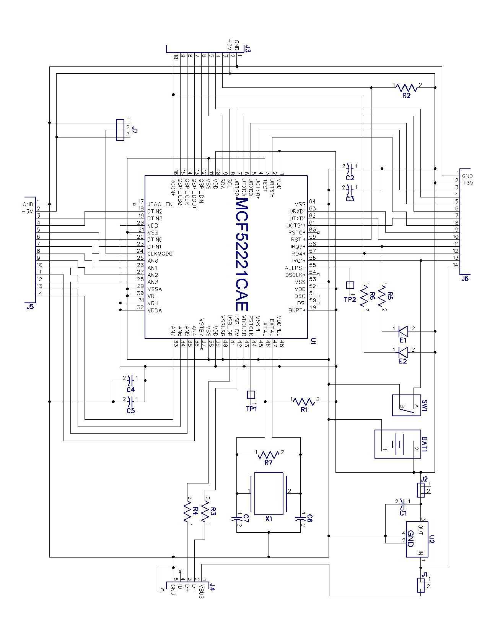

IOStick Schematic
