Microcontrollers For Everyone!  
Lowering the barrier to entry to useful microcontroller development for casual users.  
Rich Testardi (rich@testardi.com, 1-303-443-4254), 20 Feb, 2012

Contents

Goal, Requirements, and Anti-Requirements 1

The StickOS Approach 3

How Easy is StickOS, Really? 4

1 of 5: Blink an LED 5

2 of 5: Blink an LED with a Timer ISR 6

3 of 5: Blink an LED with an Output Compare Module 6

4 of 5: Read a Potentiometer with an A/D Converter 7

5 of 5: Tying It All Together -- An Analog to Frequency Converter! 7

MFE Deployment Phases and Cost Points 8

1. minimum introduction kit, $10 8

1a. minimum introduction with easy assembly kit, $15 9

2. user interface extensions , $20 10

3. sensors and actuators extension, $30 10

4. CUI32Stem grove system, $40 and up 11

Curriculums, Etc. 11

# 

# Goal, Requirements, and Anti-Requirements

The goal of the Microcontrollers For Everyone (MFE) project is to encourage new sets of casual users, including students, hobbyists, and other non-career users, to learn about, have fun with, and build useful projects with ***state-of-the-art microcontroller technologies***. The goal of MFE is explicitly ***not*** to hide or abstract the microcontroller technologies, but rather, to make them ***more approachable, transparent, and forgiving*** so that casual users can learn the same fundamental concepts that are used by career users, but without the career investment.

To achieve these goals, the following requirements must be met:

* ***the microcontroller must be approachable and transparent*** -- the casual user must be able to approach the microcontroller in the same hands-on way that they would approach a lawn sprinkler system in their yard; the user must be able to touch and manipulate the inner workings of the MCU, to see and feel what is going on with every pin and every peripheral, step-by-step, and in real time.
* ***the microcontroller must be forgiving*** -- the casual user must be able to incrementally adjust a program and watch the resulting change, in the same way that they would adjust a lawn sprinkler system in their yard, adjusting one sprinkler head at a time until it had the desired coverage, and then moving on to the next head as the system continues to run.
* ***the user must be able to build the microcontroller system "from scratch"*** -- if the casual user is to truly learn the fundamental concepts of microcontrollers, they can't start with a "black box" that does everything for them; "wizards" may be conducive to getting a small set of canned tasks accomplished, but they rarely provide the learning and fun of truly understanding what you are doing.
* **the user must get nearly immediate results, encouragement, and feedback** -- effort and results/fun must go hand-in-hand; after the first five minutes of effort, the user should see five minutes of results/fun, to thereby encourage the user to put in more effort; after the first hour of effort, the user should see an hour of results/fun, and so on.

***The first two of these requirements can only be met in a truly*** ***interactive system*** -- ***interactivity, by its very nature, is conducive to learning!*** With interactivity, you can experiment with the microcontroller and immediately correlate your actions with the results of those actions -- if something doesn't work, you can immediately try something else. Furthermore, in a truly interactive system, you can build your solution in pieces, programming the pieces that you understand and "running" the remaining pieces "by hand", experimenting, until you figure out the entire solution. And on your way to programming the entire solution, you can change your program on the fly, back it up, or skip it forward, never losing state!

Ironically, if there are any ***anti-requirements*** for a system like this, it would be the traditional "reset-and-run" methodology of debugging, as well as the traditional "edit-compile-debug" loop of software development -- both of which are exemplified by nearly all "introductory" microcontroller systems today, such as ***Arduino and BASIC Stamp***. The "reset-and-run" methodology of debugging basically is the opposite of "approachable and transparent" -- instead, the bottom line of reset-and-run is "the program didn't work, somewhere, would you like to try again?". The "edit-compile-debug" isn't much better and is the opposite of "forgiving" -- basically every time the program doesn't work, you get to lose all your state (both in the microcontroller and in your brain!) and try again, from the very beginning.

# The StickOS Approach

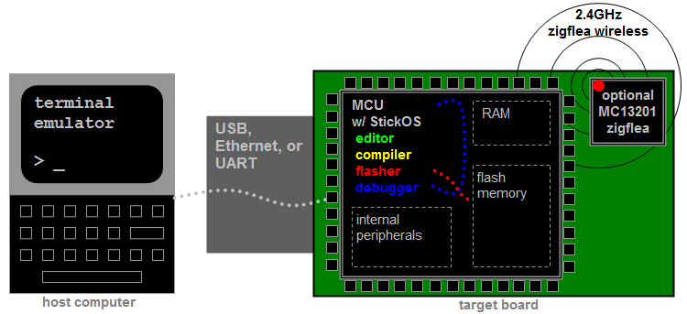

StickOS® BASIC is an entirely MCU-resident interactive programming environment, which includes an easy-to-use editor, transparent line-by-line compiler, interactive debugger, performance profiler, and flash filesystem, ***all running entirely within the MCU and controlled thru an interactive command-line user interface.*** In StickOS, external MCU pins may be bound to "pin variables" for manipulation or examination, and internal MCU peripherals may be managed by BASIC control statements and interrupt handlers. A StickOS-capable MCU may be connected to a host computer via a variety of transports and may then be controlled by any terminal emulator program, with no additional software or hardware required on the host computer. Once program development is complete, the MCU may be configured to autorun its BASIC program autonomously.

***Most importantly, though, StickOS is entirely interactive***... From the terminal emulator, the user communicates directly with the MCU and can ask the MCU to manipulate or examine any of its internal state, the state of any of its output or input pins, or the state of any of its internal peripherals! You can execute BASIC statements in "immediate mode" directly from the command prompt (for immediate feedback!), write and run a program, or even interactively debug a program.

The interactive debugger of StickOS supports ***all the same fundamental concepts used by career users***, including:

* trace or single-step program execution,
* use sampling profiling to see where the program is spending its time,
* use breakpoints, assertions, and watchpoints,
* use live variable (and pin) manipulation and examination while the program is stopped, and
* even edit-and-continue the program!!! (OK, career users actually can't do this! :-)

The StickOS BASIC language similarly supports ***most all of the same fundamental concepts used by career users***, including:

* main program loop
* interrupt handlers, maskable and disablable
  + 4 periodic timer interrupts
  + pin interrupts on any pin
  + peripheral interrupts
* block structured programming constructs
* parameterized subroutines
* bit manipulation operators
* variable sized data types, arrays, and strings
* external pin manipulation
  + digital input/output
  + analog input/output (PWM)
  + servo output
  + frequency output
* serial input/output
  + uart
  + spi
  + i2c
* raw MCU register examination/manipulation

StickOS BASIC also has other features traditionally missing from other development environments:

* BASIC assisted interface to:
  + 4-bit HD44780-compatible LCD output
  + 4x4 scanned keypad input
* 2.4GHz zigflea wireless transport (using an MCU-external zigbee chip)
  + remote control via a telnet/rlogin-like interface
  + remote variable access in BASIC
  + wireless BASIC program update
* USB Host Mode (on selected MCUs)
  + log StickOS "print" statements to external USB flash drive

For more information on StickOS, see: <http://www.cpustick.com>

# How Easy is StickOS, Really?

Using a USB-capable microcontroller, logging into StickOS is as easy as:

1. If you're running Windows, download cpustick.inf, right-click on the file and select "Install"; this simply binds the StickOS VID/PID to the "CPUStick" name for display in Device Manager; Mac and Linux automatically know how to talk to StickOS.
2. If you're running Windows or Linux, download a terminal emulator program (I use "Tera Term" on Windows and "minicom" on Linux); Mac has the built-in "screen" command.
3. Connect your MCU to the host computer.
4. Determine your COM port or device file name; in Windows you just look for CPUStick in Device Manager; in Mac, look for a /dev/tty.usbmodemXXX file, where XXX matches the Location ID of the CPUStick device in "About This Mac -> More Info... -> Hardware -> USB"; on Linux the device file name depends on the distribution.
5. Open the terminal emulator program and connect to your COM port or device file.
6. Press <Enter> for a prompt:

Welcome to StickOS for Microchip PIC32MX2-F128B v1.92c!  
Copyright (c) 2008-2012; all rights reserved.  
http://www.cpustick.com  
support@cpustick.com  
(checksum 0x8725)  
> _

Once you are logged into StickOS, you're ready for action! The following examples, which give immediate results, encouragement, and feedback, use the PIC32MX250F128B as an example of the kinds of trivial things you can do with StickOS. See the "Curriculum" section below for an example curriculum.

## 1 of 5: Blink an LED

As the "hello world!" of embedded programming, let's get an LED to blink on pin 6 of the MCU:

> **10 dim led as pin 6 for digital output**> **20 while 1 do**> **30 let led = !led**> **40 endwhile**> **run**_

Line 10 of the program dimensions (declares) a variable named "led" that is bound to pin 6 of the MCU, which is configured for digital output; from then on, any manipulation of the variable is immediately reflected at the pin. Lines 20-40 of the program form the main loop of the program. Line 30 simply inverts the state of the led on pin 6 of the MCU, inside the loop.

Oops! Something is wrong -- the LED isn't blinking but it seems to be half on... Oh! We forgot to add a delay! So let's stop the program with a <Ctrl-C>, fix the program by adding a 500ms delay, and then continue from where we left off:

**<Ctrl-C>**  
STOP at line 30  
> **35 sleep 500 ms**> **cont**_

Much better!

OK, now let's get a bit more interactive with the MCU and stop the program again with a <Ctrl-C>... Then we'll examine the state of the LED (i.e., print the value of the "led" variable) and then blink the LED by hand...

**<Ctrl-C>**  
STOP at line 35  
> **print led**0  
> **let led = 1**> **print led**1  
> **let led = 0**> **print led**0> _

Notice that when we change the variable, the LED changes state!

## 2 of 5: Blink an LED with a Timer ISR

Now that our LED is blinking, let's graduate to using a timer ISR rather than a programmed loop -- this way we can do other things with the "main loop" in the future. We'll keep line 10 of the program, but wipe out all the lines that followed, list the program, and start from there:

> **delete 20-**> **list** 10 dim led as pin 6 for digital output  
end> **20 configure timer 1 for 500 ms**> **30 on timer 1 do let led = !led**> **40 halt**> **run**_

Line 10 still dimensions (declares) a variable named "led" that is bound to pin 6 of the MCU, which is configured for digital output; line 20 configures timer #1 to pop every 500ms; line 30 enables the timer interrupt and says that every time the timer pops, we should run the statement "let led = !led" (if we had more work to do we could have called a subroutine); finally line 40 just puts the main loop to sleep -- we just service interrupts from then on!

Wow, that worked on the first try! :-)

## 3 of 5: Blink an LED with an Output Compare Module

Now that we understand timers a bit, let's try using an MCU "output compare module" peripheral so we can blink the LED without using the CPU at all! Again, these are all the ***same fundamental concepts used by career users***!!!

We have to stop the program again with a <Ctrl-C>, and then we'll just do this at the command line (not even writing a program) because we're a bit unsure of ourselves...

**<Ctrl-C>**  
STOP at line 40  
> **dim hz as pin 6 for frequency output**> **hz = 1**> _

The first line there dimensioned (declared) a variable named "hz" that is bound to pin 6 of the MCU, which is configured to receive the output of an output compare module; from then on, any manipulation of the variable is immediately programmed as the output frequency, in Hz, of the output compare module. The second line sets the "hz" variable to 1, resulting in a 1 Hz signal on pin 6 of the MCU.

Wow, that is cool!!! Let's make it go faster:

> **hz = 10**> _

And faster:

> **hz = 100**> _

I want to hook up a buzzer to this thing, but before we go any farther, let's try another experiment...

## 4 of 5: Read a Potentiometer with an A/D Converter

For this experiment, we'll hook up the middle lead of a potentiometer to pin 7 of the MCU, and the outer leads of the potentiometer to ground and 3.3V. Let's again do this at the command line (no program) so we can see how it works:

> **dim pot as pin 7 for analog input**> **print pot**1876  
> _

The first line there dimensioned (declared) a variable named "pot" that is bound to pin 7 of the MCU, which is configured for analog input thru the A/D converter; from then on, any reference of the variable reflects the current number of millivolts read on the pin. The second line prints the value of the "pot" variable, displaying the number of millivolts on pin 7 of the MCU.

Now let's turn the pot a bit and try it again:

> **print pot**1201  
> _

Cool!!!

## 5 of 5: Tying It All Together -- An Analog to Frequency Converter!

OK, let's replace the LED on pin 6 of the MCU with a small buzzer... And now let's write a program using all of the skills we just learned to create an "analog to frequency converter"! We'll start out by wiping out everything we've done so far with a "new" command, and then move from there:

> **new**> **10 dim buzzer as pin 6 for frequency output**> **20 dim pot as pin 7 for analog input**> **30 configure timer 1 for 100 ms**> **40 on timer 1 do let buzzer = pot**> **50 halt**> **run**_

Now turn the pot and listen to the buzzer -- it goes from 0 to 3300 Hz, updated from the pot every 100ms!

We rock! :-)

# MFE Deployment Phases and Cost Points

The MFE project has the following phases and possible cost points:

1. minimum introduction (solderless), $10
   1. minimum introduction with easy assembly (solderless), $15
2. user interface extensions (solderless), $20
3. sensors and actuators extension (solderless), $30
4. CUI32Stem grove system ($40 and up)

Each of these "from scratch" kits is described in the sections below. The first three depend on a pre-programmed PIC32MX250F128B in DIP package, for $3. The last one depends on a PIC32MX795F512H on a CUI32Stem board, for $40.

## 1. minimum introduction kit, $10

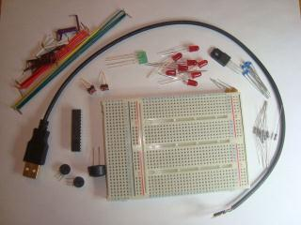

PIC32MX250F128B

The minimum introduction kit contains:

* PIC32MX250F128B
* solderless breadboard
* resistors, capacitors
* 8 red LEDs, 2 green LEDs
* 2 mini potentiometers
* 2 mini push button switches
* mini buzzer
* usb cable
* 3.3V regulator
* jumper wires

## 1a. minimum introduction with easy assembly kit, $15

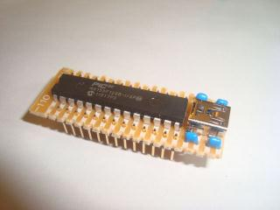

The minimum introduction with "easy assembly" kit includes everything above, and the PIC32MX250F128B on a small pre-assembled PCB with the USB connector and regulator already soldered on, as well as the following components:

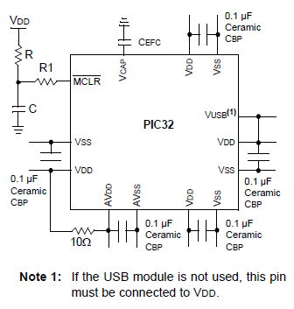

The "easy assembly" means the user can get right to the active pins of the MCU, by just hooking up the USB connector, without having to wire up filter capacitors, regulator, etc. The "small pre-assembled PCB" will have 28 downward facing pins (on 0.5" centers) that can still plug into the solderless breadboard, just like the PIC32, with "VBUS" being an output of the PCB as well as an input to the PIC32.

## 2. user interface extensions , $20

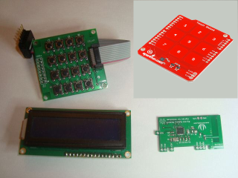

The user interface extensions kit contains:

* HD44780-compatible LCD
* 4x4 scanned keypad
* i2c touch sensor/proximity on a board with 8 keypads and 4 external inputs
* zigflea module :-)

All modules have header pins for connection in the solderless breadboard.

## 3. sensors and actuators extension, $30

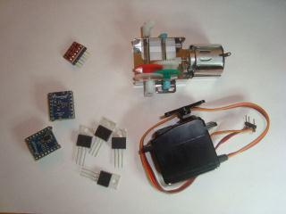

The sensors and actuators extension kit contains:

* i2c accelerometer on a board
* i2c magnetometer on a board
* i2c thermometer on a board
* 4 power FETs
* 2 servo motors
* 2 hobby motors

All modules have header pins for connection in the solderless breadboard.

## 4. CUI32Stem grove system, $40 and up

The CUI32Stem grove system is the next step up -- you get a more powerful MCU (more pins, twice the clock frequency) and a zigflea daughter card. You get a bank of 14 connectors that connect to grove system components, and another connector that connects to i2c peripherals, as well as a bunch of pins on the board for other purposes.

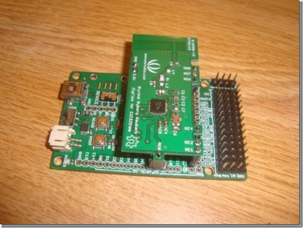 [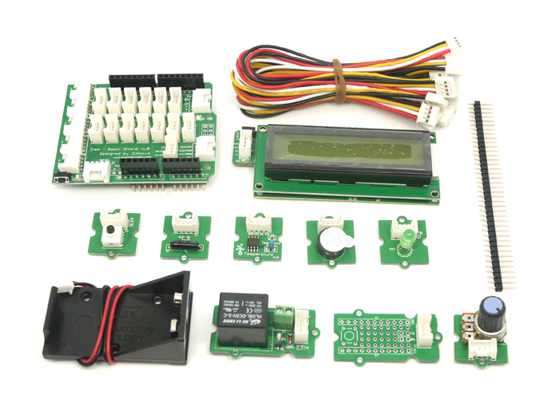](http://www.seeedstudio.com/wiki/File:Newbundle1.jpg)

The grove system components include close to a hundred sensors and actuators, which all connect thru 4-position cables from the component to the CUI32Stem -- no soldering.

See a list of grove system components here: <http://www.seeedstudio.com/wiki/GROVE_System>

# Curriculums, Etc.

If we get this going, I can come up with curriculums that take the user thru lots of projects, step by step like we did the voltage to frequency converter, above, including:

* TBD