notes on EpServerEngineSampleClient/Server

OVERVIEW

The EpServerEngineSampleClient runs on the laptop as a tcp client to the linux tcp
server running on the TS-7200. The EpServerEngineSampleServer is an optional server that runs on the garage desktop that has an additional tcp connection to the client via a WiFi connection. The laptop connection to the TS-7200 uses a crossover cable and has a static IP address and the other connection to the EpServerEngineSampleServer
(home server) is DHCP.

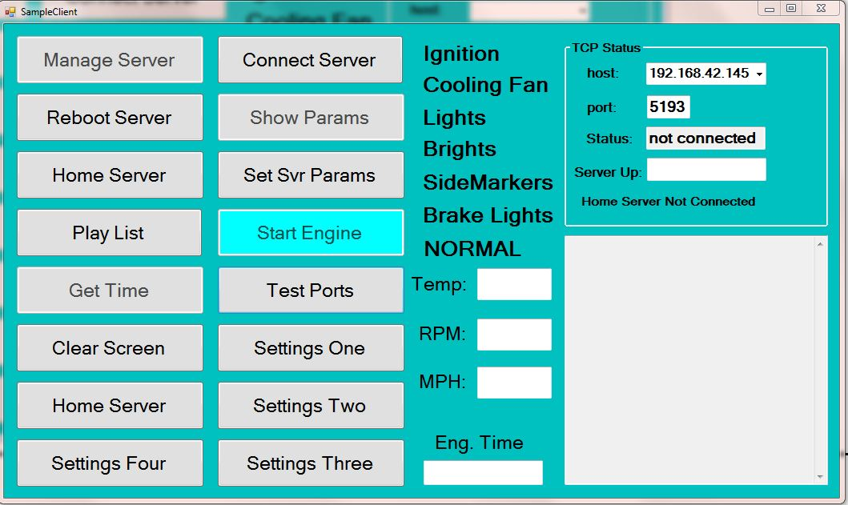
Figure 1 show the client dialog

The VGA connector on the laptop goes to an 8” monitor in the dash. The keypad can navigate the 5 buttons starting from 'Play List' and 'Start Engine' to the bottom. The keys 'A'->'D' and '*' are used for navigating the buttons:
A: move up
B: move down
C: execute
D: exit
* (star) : move to other column

The buttons: 'Test Port', 'Settings On/Two/Three/Four' pull up other dialogs to do other things. 'Start Engine' does the same thing as the '1' and '2' on the keypad: start/stop the engine. (The Start Engine function only starts the fuel pump, enables the ignition and enables the starter solinoid for 10 seconds – the driver has to push the green button which completes the circuit to the starter relay). The 'Play List' button opens a dialog of wav files specified by an xml file that can play threw the speaker on the laptop. The 'Clear Screen' button clears the system messages that scroll on the edit box on the lower right. The 'Get Time' button gets the time on the linux server and shows the sched version number.

The 'Home Server' button makes a connection to the server program running on the desktop in the garage as long as the home server is listening.

Message Processing

The OnReceived callback in FrmSampleClient.cs routes the messages to any of the child dialogs's Process_Msg methods if they are visible, if not, it routes the messages to the main Process_Msg in FrmSampleClient.cs
Messages like: SERVER_UPTIME, ENGINE_RUNTIME, ENGINE_TEMP, SEND_RPM & SEND_MPH set the appropriate edit boxes on the main display. The SEND_MSG has an additional parameter which changes the labels for the lights and sets the text of the start button.

LIST OF CONFIGURATION PARAMETERS
(in client/home server)
(public class ConfigParams)
public int fan_on { get; set; }
public int fan_off { get; set; }
public int rpm_update_rate { get; set; }
public int mph_update_rate { get; set; }
public int high_rev_limit { get; set; }
public int low_rev_limit { get; set; }
public int FPGAXmitRate { get; set; }
public int blower_enabled { get; set; }
public int blower1_on { get; set; }
public int blower2_on { get; set; }
public int blower3_on { get; set; }
public int lights_on_delay { get; set; }
public int engine_temp_limit { get; set; }
public int battery_box_temp { get; set; }
public int test_bank { get; set; }

(in linux server)
typedef struct params
{
int rpm_update_rate; // update rates for LED displays
int mph_update_rate;
int fpga_xmit_rate; // how fast fpga transmit to STM32
int high_rev_limit; // rev limiter (rpm to shut off at)
int low_rev_limit; // rpm to turn back on at
int cooling_fan_on; // temp to turn on cooling fan
int cooling_fan_off; // temp to turn off cooling fan
int blower_enabled; // temp at which heater is enabled
int blower1_on; // lowest indoor temp for blower
int blower2_on; // medium indoor temp for blower
int blower3_on; // highest indoor temp for blower
int lights_on_delay; // how many seconds to leave lights on after ign off
int engine_temp_limit; // engine temp to sound alarm
int batt_box_temp; // temp to turn off battery box heater
int test_bank; // for testing ports
}PARAM_STRUCT;
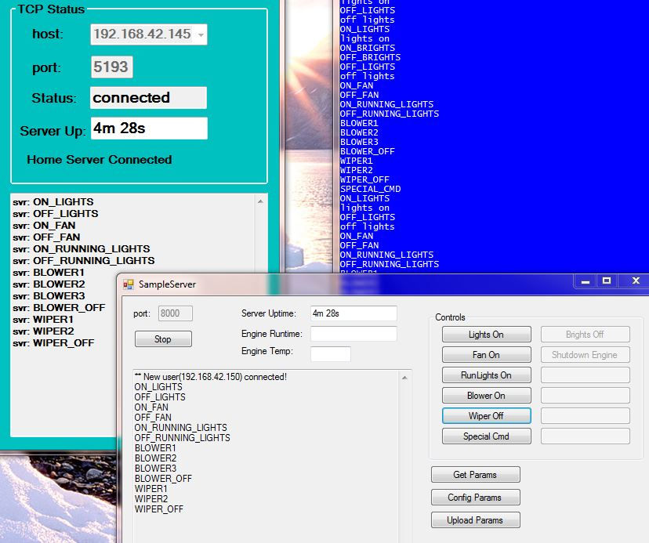
Figure 2 shows the client dialog along with the home server and the output of the Comm2 monitor in the background over a tty screen.

The SEND_CONFIG gets a string of parameters that are sent from the linux server and are comprised of the configuration data in the param.conf file.
The NAV messages: NAV_UP, NAV_DOWN, NAV_SIDE, NAV_CLICK and NAV_CLOSE corrispond to the A,B,*,C and D buttons. They are sent to the 'navigate_buttons' method which keeps track of the current button and sets the color to blue and changes the previous color back to grey.

Each of the child dialogs has it's own OnRecieved and Process_Msg callbacks which work the same with the navigation keys.

OnReceived() (FrmSampleClient.cs)
if (m_client2.IsConnectionAlive)
m_client2.Send(receivedPacket); -> OnReceived() (FrmSampleServer.cs) -> Process_Msg()
if (child dialog visible) -> packet sent to child dialogs OnReceived/Process_Msg
else packet sent to FrmSampleClient's Process_Msg
Server's Process_Msg SEND_CONFIG sets the cfg_params in the server
Client's Process_Msg SEND_CONFIG sets the cfg_params in the client
Send_Cmd method in server sends a SVR_CMD message to client with extra param as another message which just routes it to the linux server.
'Get Params' button on server sends a SET_PARAMS msg to the linux server via the SVR_CMD msg which causes the linux server to get the current params from the param.conf file and send them to the client as a SEND_CONFIG msg.
'Config Params' button on the server brings up a dialog to change any of the config parameters.
'Upload Params' button on the server packs all the param config data into a byte array and sends it as a parameter of the SEND_CONFIG2 msg to the client which parses the byte array and stuffs them into the config param on the client which the client, in turn, sends them on to the linux server with an UPDATE_CONFIG which stuffs them into the local PARAMS_CONFIG struct and then the linux server sends some of the param data to the STM32 via the serial port.

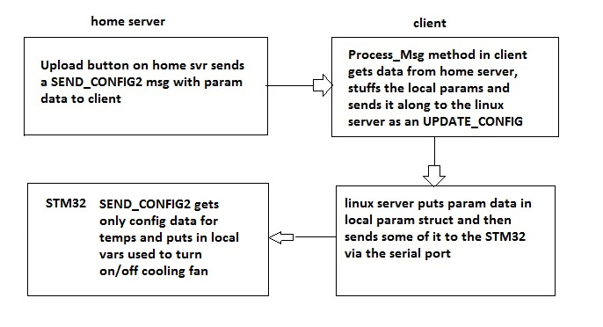
The only params sent to the STM32 are: fan on, fan off, blower enabled, blower1, blower2
blower3, engine temp limit & battery box temp.

