**Introduction**

SDIO (secure digital input output) provides an interface between the APB2

peripheral bus and MultiMediaCards (MMCs), SD memory cards, SDIO cards devices.

SD memory card is a superset of the MMC protocol, SD memory card appeared after MMC card, thus it is better than MMC card in many aspects (speed, storage capability,...)

SDIO card is a superset of the SD card specifications.

Without the need of studying deeply about the working principle of SDIO bus, most people choose to use the help of available libraries.

**Fat File System by ChaN**

Porting the FatFS to a target microcontroller requires some knowledge and expertise, as well as doing research and time effort.

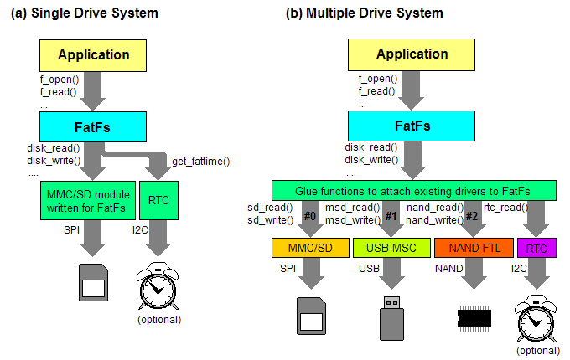

*Replace SPI by SDIO in this image*

In this case, FatFS (FAT file system) library acts as middleware for connecting between the STM32’s SDIO low level and FatFS’s usable functions, we need to provide the FatFS library with some necessary functions (mainly SDIO hardware functions). For example:

*disk_initialize(...)* function in file `*diskio.c*` (in FatFS library) use *SD_Init()* function, which is defined in `*stm32f4_discovery_sdio_sd.c*`

After successfully porting the FatFS library on target microcontroller, we can use functions provided by FatFS library to work with SDcard, such as: f_mount, f_read, f_write,... (defined in ff.c file).

**Wiring between STM32 and Sdcard module is as follow:**

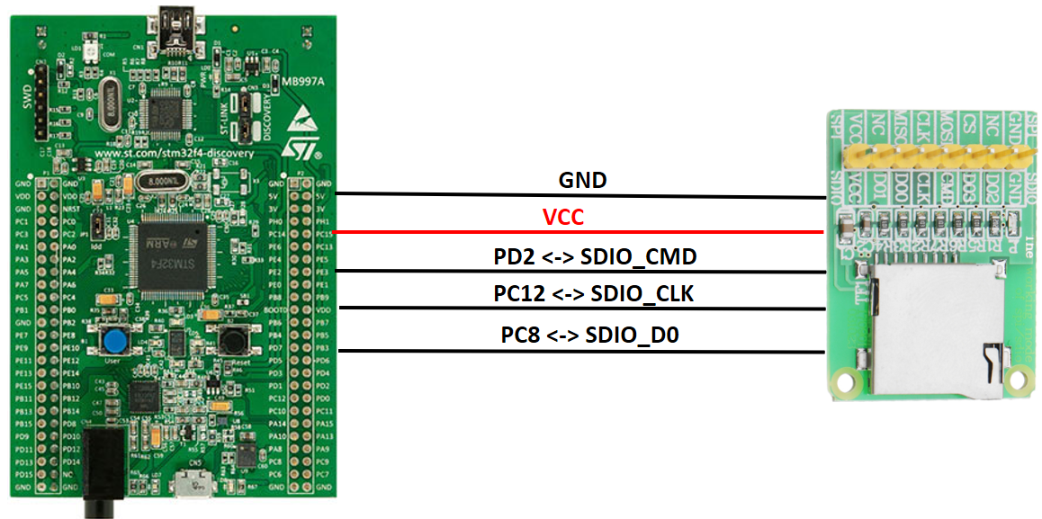

**SDIO initialization**

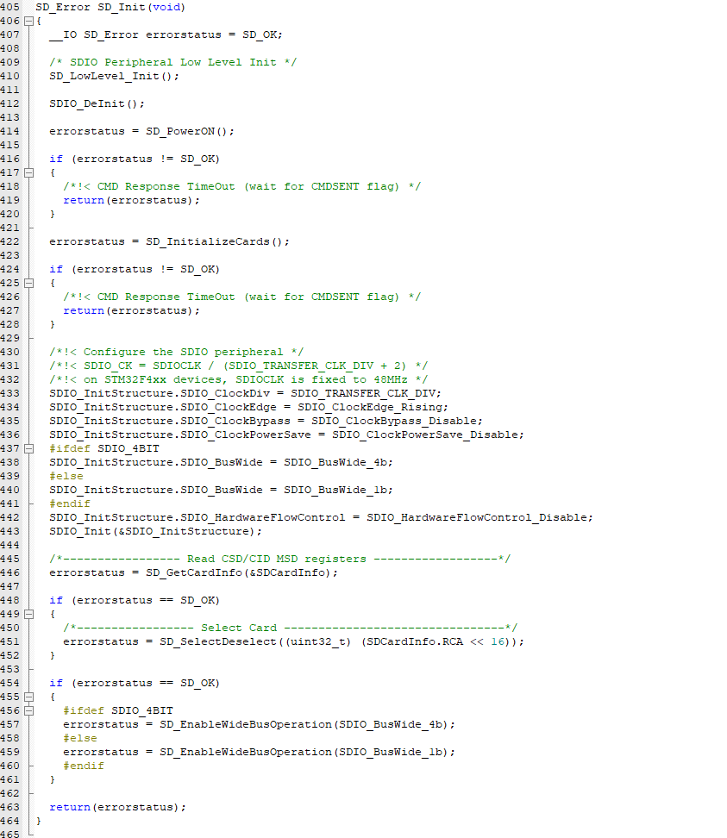

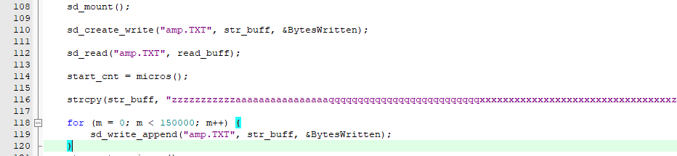

1.

sd_mount();

gọi hàm này đầu tiên để mount sd card vào hệ thống.

2.

sd_create_write();

tạo file có tên là “amp.TXT”, đồng thời ghi vào file đó string trong biến *str_buff*,

BytesWritten: số lượng byte đã được ghi vào file.

3.

sd_write_append();

Viết tiếp vào file đã có sẵn trong thẻ SD “amp.TXT” chuỗi *str_buff*

4.

sd_read()

Đọc từ file “amp.TXT”, chuỗi string đọc được đưa vào biến *read_buff*

**References:**

STM32F4xx’s reference manual, Section 31. SDIO

<https://www.proe.vn/micro-sd-card-module-tf-card-reader-card-sdio-spi-interface>

<https://community.st.com/s/question/0D50X00009XkZzBSAV/sdio-and-sd-fat-access-example>

<http://stm32f4-discovery.net/2014/07/library-21-read-sd-card-fatfs-stm32f4xx-devices/>