**产品规格书**

**SPECIFICATION**

**DEC.**

产品名称 石英晶体谐振器

Description Crystal Unit

型号 · 标称频率

Type · Nominal Frequency 3225 25.000MHZ

规格书号

Specification . X3225 25.000M 2001

物料号

. 90013014

批准

APPROBED BY

审核

CHECKED BY

制作

DESIGNED BY

1. **外观 · 印字**

**Outline and Marking**

|  |  |
| --- | --- |
| 型号  Type | SMD Crystal3225/4PAD |
| 外形尺寸图  Outline and Dimensions | 附图 1  Drawing 1 |
| 印字示意图  Marking | 附图 2  Drawing 2 |
| 回流焊温度曲线图  Reflow Temp. Profile | 附图 3  Drawing 3 |

1. **电气性能**

**Electrical Performance**

|  |  |
| --- | --- |
| 标称频率  Nominal Frequency | 25.000MHz |
| 振荡模式  Mode of Oscillation | Fund |
| 负载电容  Load Capacitance | 20pF |
| 存储温度范围  Storage Temperature | -40℃ ～ +85℃ |
| 工作温度范围  Operating Temperature | -20℃ ～ +70℃ |
| 频率公差  Frequency Tolerance | ±10ppm (at +25℃±2℃) |
| 温度特性  Frequency-Temperature Characteristics | ±20ppm (-20℃ ～ +70℃)  Based on the measured value at +25℃ |
| 等效串联电阻  Equivalent Series Resistance | 附表1 |
| 并联电容  Shunt Capacitance | 5pf MAX |
| 激励功率  Level of Drive | 100uW |
| 年老化率  Aging | ±1ppm/year |

**附表1**

|  |  |  |
| --- | --- | --- |
| Resonance resistance | | |
| Frequency (MHz) | Mode | Ohm Max |
| 8≤Fr≤10 | Fundamental | 70 |
| 10＜Fr≤12 | Fundamental | 60 |
| 12＜Fr≤16 | Fundamental | 50 |
| 16＜Fr≤40 | Fundamental | 40 |

**3.机械性能**

**Mechanical Performance**

|  |  |  |
| --- | --- | --- |
| 冲击(自由落体)  Shock (Random Drop) | 下落高度 Height: 75mm  下落次数 Dropped Time: 3  自由落体到硬质木板(30mm)  Rigid Hardwood Surface | 频率变化量  Frequency change permitted ：  ±3 ppm  等效串联阻抗所允许的变化量  Equivalent series resistance change permitted:  ±5Ω or ±10%  两者选最大  whichever is the large |
| 回流焊耐热性  Thermal Stability of Solder | 参考图 3 |
| 气密性  Leakage | 细漏Fine leak: Helium leak test  *JIS C 6701 10.6 | 漏率  Leak rate  5*10-8Pa.m³/sMAX |

1. **测试设备**

**Test Set**

Π网络分析仪 Network Analyzer: S&A 250B

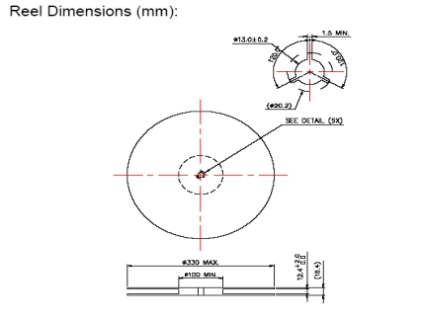附图 1

Drawing 1

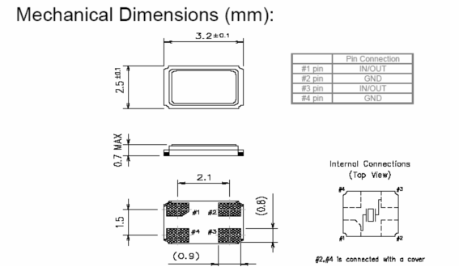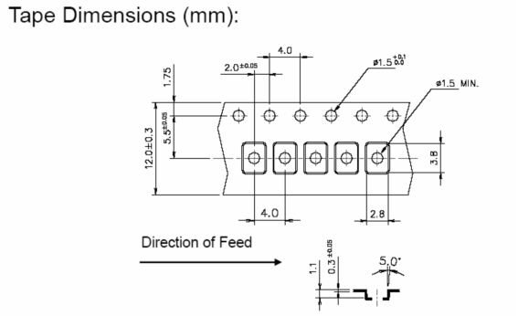

1)晶体编带方向有一致性。Pin1必须要在taping圆洞的那一边。

The orientation of typing should be coherent. Pin1 must be at the side of hole.

2)印字的左下角是在pin1的上方。

Under left corner is the pin 1.

见下图

As follows:

C:\Users\ADMINI~1\AppData\Local\Temp\ksohtml\wpsAA07.tmp.pngC:\Users\ADMINI~1\AppData\Local\Temp\ksohtml\wpsAA08.tmp.pngC:\Users\ADMINI~1\AppData\Local\Temp\ksohtml\wpsAA09.tmp.pngC:\Users\ADMINI~1\AppData\Local\Temp\ksohtml\wpsAA0A.tmp.png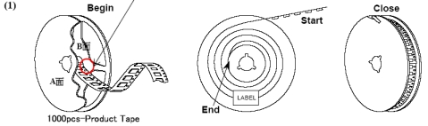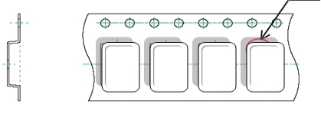

C:\Users\ADMINI~1\AppData\Local\Temp\ksohtml\wpsAA0D.tmp.png

在装入晶体前必须至少留300mm（40个空格）的空的载带，并用胶膜封上。

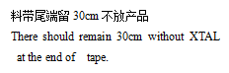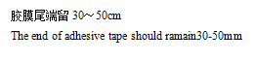There should remain at least 300mm (Forty blanks) before typing and be sealed.

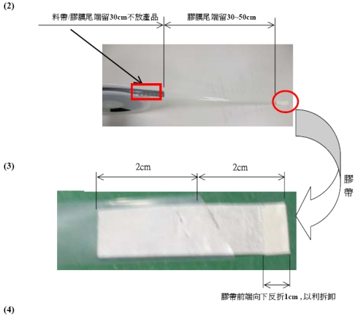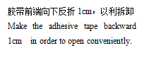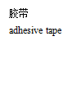C:\Users\ADMINI~1\AppData\Local\Temp\ksohtml\wpsAA42.tmp.pngC:\Users\ADMINI~1\AppData\Local\Temp\ksohtml\wpsAA43.tmp.png

料带拉力值：30-60g。

Material belt pulling strength: 30-60g

a．料带拉力测试角度：165°～180°。

Material belt pulling force test angle: 165°～180°

b．料带拉力测试速度：300mm/min。

Material belt pulling force test speed: 300mm/min。

c．料带拉力测试长度：300mm。

Material belt pulling force test length

5.在胶盘正面粘贴标签，将胶盘放入气泡袋中，将气泡袋塑封密闭。

Affix the label on the obverse side of reel, then put the reel into air bubble bag and seal it.

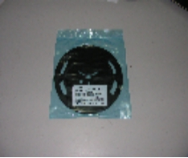

1. 将装好胶盘的防静电袋装入小纸箱中，在纸箱表面标贴标签与无铅标识。

Put the anti-electrostatic bag into case and affix label and lead free mark.

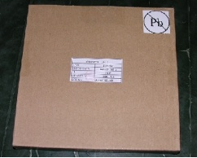

**7.**10只小纸箱放入大纸箱中，四周使用气泡袋填充。内附出货检验报告。

Put 10 small boxes into a big one and fill them with bubble bags. Enclose the goods inspection report.

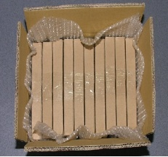

附图 2

Drawing 2

Marking

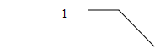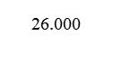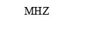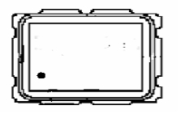

1.标识:

Nominal Frequency: XX.XXX

(e.g.) 12.000000Mhz ------ 12.00

16.934400Mhz ------ 16.93

附：产品电气参数验收依据：GB2828-87 一般检验水平Ⅱ AQL=0.4

Enclose: The product electricity parameter approval rests on GB2828-87 commonly test level Ⅱ AQL=0.4