Cost Estimate

[update: 12/11/2024]

This document aims to estimate all the costs involved in producing the Tiny Scarab board, its enclosure and graphical overlay membrane.

# 1. PCB Circuit

## 1.1 Component Cost

I purchase all components directly at the circuit manufacturer JLCPCB. I typically buy the components before ordering the PCB itself. They are stored in my personal inventory in the JLCPCB factory (each client has an account and a personal inventory tied to that account, where you can pre-order components).

These are the components I order for one board:

|  |  |  |  |  |  |
| --- | --- | --- | --- | --- | --- |
| **Designator** | **Value** | **LCSC Part #** | **Quantity @1 board** | **Quantity @100 boards** | **Price @100 boards** |
| C1, C2, C4 | 100n | C307331 | 3 | 300 | $1.4100 |
| C10, C15, C16, C17, C23, C24, C25, C26, C27, C30, C31, C37, C38, C39, C40, C41, C5, C6, C7, C8, C9 | 100n | C1525 | 21 | 2100 | $1.8900 |
| C11, C13, C14, C18 | 1u | C52923 | 4 | 400 | $1.1600 |
| C12, C19 | 10u | C15525 | 2 | 200 | $0.6800 |
| C20, C21, C22, C3, C32, C33, C34, C35, C36 | 10u | C15850 | 9 | 900 | $6.8400 |
| C28, C29, C42, C43 | 22p | C1555 | 4 | 400 | $0.3600 |
| D1 | 5V6 | C2943833 | 1 | 100 | $2.6200 |
| D2 | 40V 350mA | C397613 | 1 | 100 | $1.6700 |
| F1 | 2A | C1972777 | 1 | 100 | $8.6400 |
| J1 | USB_C | C2927038 | 1 | 100 | $3.8500 |
| J3, J4 | PIN_HEADER | C84004 | 2 | 200 | $8.7000 |
| LED1, LED5 | GREEN | C9900122772 | 2 | 200 | $1.0800 |
| LED2 | RED | C9900122773 | 1 | 100 | $0.5400 |
| LED3, LED4 | BLUE | C9900122774 | 2 | 200 | $1.0800 |
| Q1, Q2, Q6 | DMG1012UW-7 | C156390 | 3 | 300 | $7.6800 |
| Q3, Q4, Q5 | DMP1045U-7 | C177033 | 3 | 300 | $17.2500 |
| R1 | 330 | C25104 | 1 | 100 | $0.0600 |
| R12, R18, R28 | 1k | C11702 | 3 | 300 | $0.1500 |
| R13, R24, R25, R30 | 100k | C25741 | 4 | 400 | $0.2000 |
| R14, R16 | 33 | C25105 | 2 | 200 | $0.1000 |
| R19, R20, R27 | 10k | C25744 | 3 | 300 | $0.1500 |
| R21, R22, R23 | 0 | C17168 | 3 | 300 | $0.1500 |
| R26 | 470 | C25117 | 1 | 100 | $0.0500 |
| R29, R3 | 210 | C25090 | 2 | 200 | $0.0600 |
| R4, R5 | 5k1 | C25905 | 2 | 200 | $0.0800 |
| R6 | 100 | C25076 | 1 | 100 | $0.0500 |
| R7, R9 | 220 | C25091 | 2 | 200 | $0.1000 |
| SW4 | 12V 50mA | C2884764 | 1 | 100 | $8.8100 |
| SW5 | 12V 50mA | C146695 | 1 | 100 | $4.6600 |
| TVS1, TVS2 | 5V | C20884 | 2 | 200 | $12.7800 |
| TVS10, TVS11, TVS12, TVS13, TVS14, TVS15, TVS16, TVS17, TVS18, TVS19, TVS20, TVS21, TVS22, TVS23, TVS24, TVS25, TVS26, TVS27, TVS28, TVS29, TVS30, TVS31, TVS32, TVS33, TVS34, TVS35, TVS7, TVS8, TVS9 | 5V | C3001954 | 29 | 2900 | $20.0200 |
| TVS3 | 5V | C83329 | 1 | 100 | $7.5000 |
| U1 | AP2141WG-7 | C500761 | 1 | 100 | $14.9900 |
| U2 | 3V3 | C145411 | 1 | 100 | $71.2200 |
| U3 | CH32V305FBP6 | C5123443 | 1 | 100 | $139.2400 |
| U4 | CH32V003F4P6 | C5187096 | 1 | 100 | $20.0400 |
| XTAL1 | 12MHz | C2901629 | 1 | 100 | $17.9900 |
| XTAL2 | 24MHz | C5261157 | 1 | 100 | $8.7200 |
| LED Spacer | 3mm | C92325 | 5 | 500 | $2.1500 |

NOTE: I purchased the LEDs at Shenzhen Xinsheng Microelectronics Technology, on Alibaba, at a price of 54$ per 10 000 parts. Then I had them sent directly to the JLCPCB factory to be added to my personal component inventory. The price per LED is therefore $0.0054.

The total component cost for 100 boards is $394.72. So the component cost per board is:

**$3.9472** component cost per board.

(**$4.2630** incl Chinese VAT 8%)



## 1.2 PCB Production and Assembly Cost

I’ve listed the PCB production and assembly (parts placement and soldering) costs in the table below. Please note that these costs are under the assumption that >100 PCBs are ordered:

|  |  |  |
| --- | --- | --- |
|  | $/100 boards | Notes |
| PCB Production | 68.31 |  |
| PCB Assembly | 162.89 |  |
| Photo Confirmation | 7.97 | Only needed for first batch after a change. |
| Board Cleaning | 15.94 |  |
| Secondary processing | 19.43 | The LEDs must be spaced 3mm from the board. |
| Shipping | 3.23 | Shipping to Embeetle office in Shenzhen |

The total cost PCB production and assembly cost, including the shipping inside China, is $277.77 for 100 boards. It’s fair to deduct the $7.97 photo confirmation cost, as that is only required for a first batch. So we end up at $269.80:

**$2.6980** board production cost

(**$2.9138** incl Chinese VAT 8%)



# 2. Enclosure

The following table lists the costs for the 3D printed enclosures:

|  |  |  |
| --- | --- | --- |
|  | $ / 100 units | Notes |
| Box + Lid | 321.57 |  |
| Shipping | 3.96 |  |

**$3.2553** enclosure production cost

(**$3.5157** incl Chinese VAT 8%)



# 3. Graphical Membrane

The cost per membrane is very dependent on the order quantity – much more so than the PCB production. For that reason, I decided to put here the cost per membrane provided that 500 would be purchased instead of only 100:



**$0.7060** graphical membrane cost

(**$0.7625** incl Chinese VAT 8%)

# 4. Miscellaneous Costs

Four screws need to be inserted to fasten the enclosure. Last but not least – I place a small iron block in each enclosure to give the product extra weight.

|  |  |  |
| --- | --- | --- |
|  | $/unit | Notes |
| Screws | $0.002211 x 4 | $22.11 for 10.000 screws, including VAT |
| Iron block | $0.11055 | $22.11 for 200 blocks, including VAT |

So the total cost per board for these items would be:

**$0.11055** miscellaneous costs

(**$0.119394** incl Chinese VAT 8%)



**SCREWS**

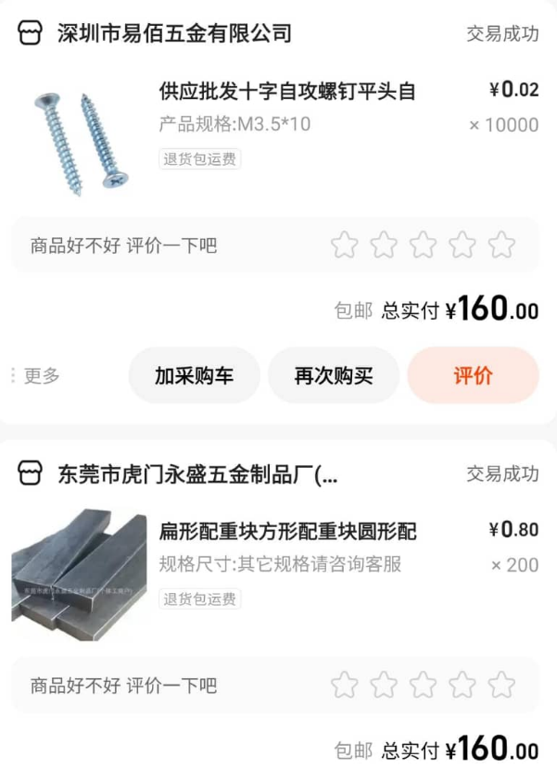

IRON BLOCKS

**Seller:**

-0.15mm negative tolerance and +0.1mm positive tolerance.

About 54g.

We can provide you with samples.

How many do you need?

**Buyer:**

Can you quote for 100 and 200 pieces? We need this many for samples and will place an order directly.

Are you also based in Dongguan?

**Seller:**

The surface is electroplated white zinc.

**Buyer:**

No surface treatment is required.

0.8 each.

**Seller:**

The surface is untreated and has oil on it.

**Buyer:**

If it has oil, it might not work well. Then could you process it? How much would it cost?

**Seller:**

(Attaches a picture of the product)

**Buyer:**

We need to put this inside electronic components, so it must be completely clean, neat, and tidy.

Actually, the plating is not that important to us. We just need the product to be clean and dry. Can you do that?

**Seller:**

(Attaches another picture of the product)

# 5. Box

I purchased 100 customized boxes for 240 yuan ($ 33.16). This includes shipping and Chinese VAT.

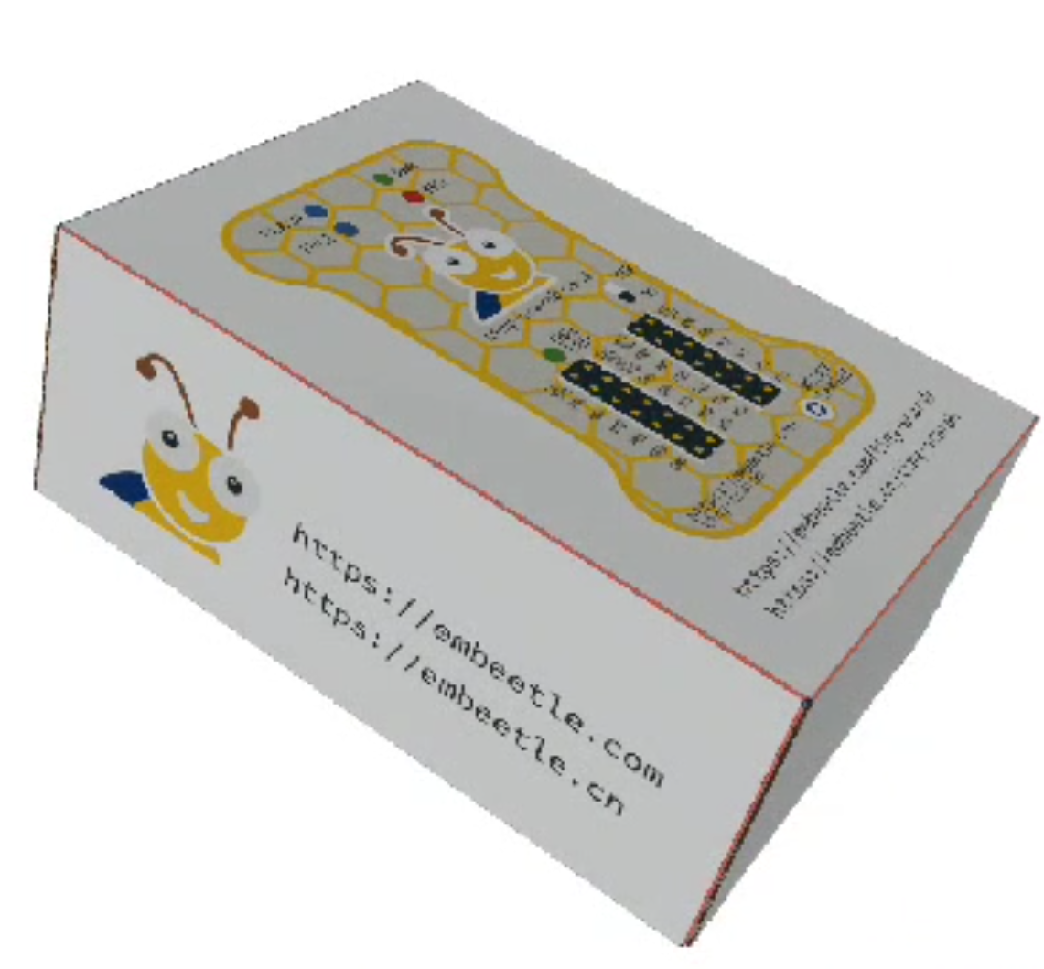

**$0.3070** box cost

(**$0.3316** incl Chinese VAT 8%)



# TOTAL

Let’s compute the total cost per unit (incl shipping and taxes):

|  |  |  |
| --- | --- | --- |
|  | $ / unit | $ / unit (incl Chinese VAT) |
| PCB components | $ 3.9472 | $ 4.2630 |
| Board Production | $ 2.6980 | $ 2.9138 |
| Enclosure | $ 3.2553 | $ 3.5157 |
| Graphical Membrane | $ 0.7060 | $ 0.7625 |
| Miscellaneous | $ 0.1106 | $ 0.1194 |
| Boxes | $ 0.3070 | $ 0.3316 |
| TOTAL | **$11.0241** | **$11.9060** |