USB Impedance

The impedance of the USB data traces should be 90 Ohm. The USB traces on the Tiny Scarab should be around that value. From the DigiKey impedance calculator (see <https://www.digikey.be/en/resources/conversion-calculators/conversion-calculator-pcb-trace-impedance>) I get:

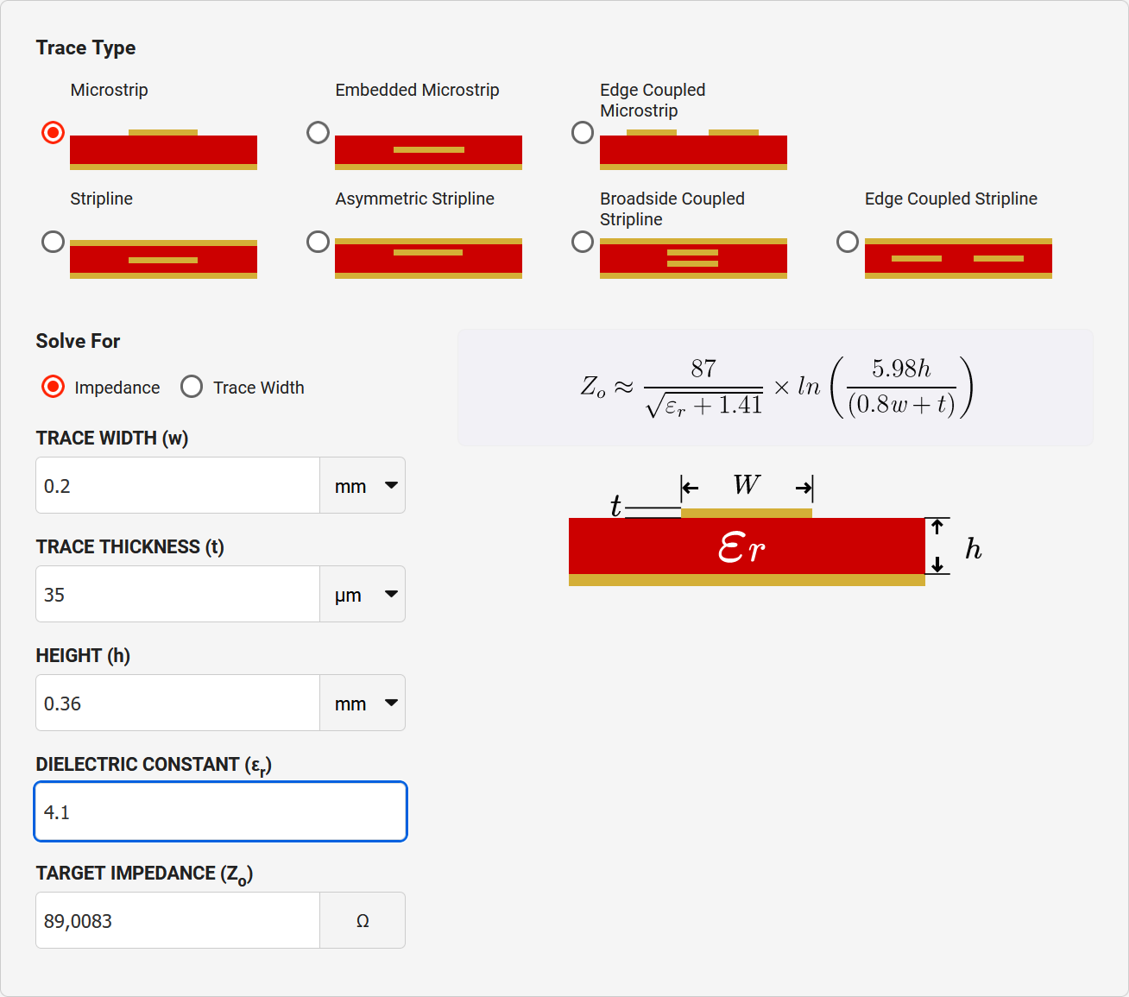

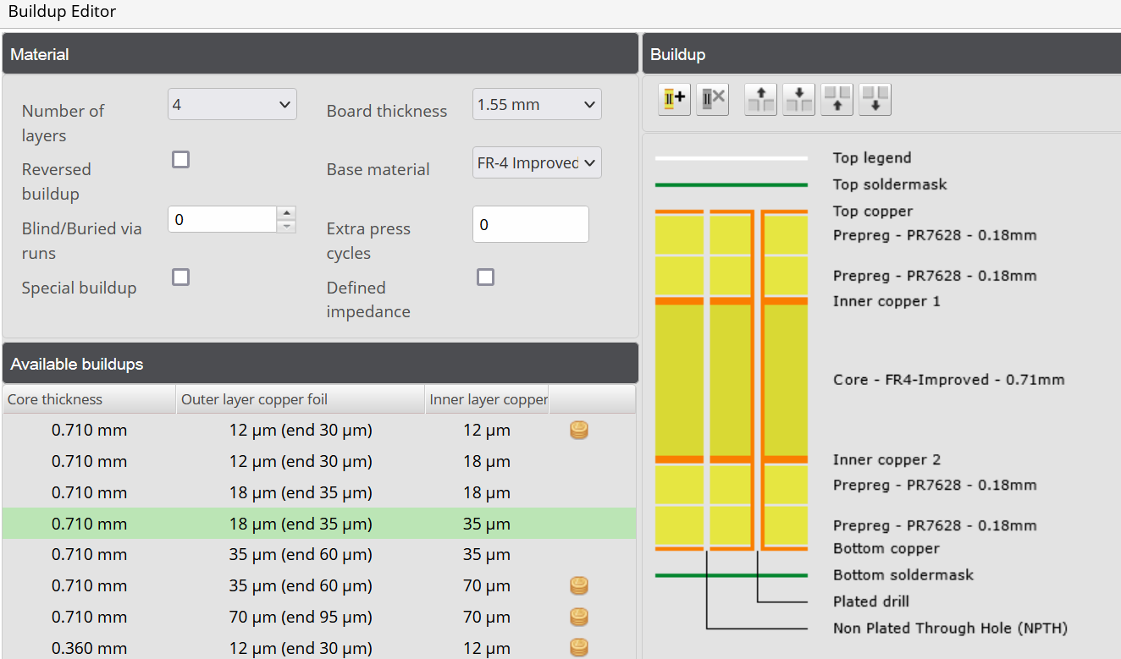For the board buildup, I use the standard 4-layer circuit data from Eurocircuits:

From this I get:

* Trace thickness (outer layer): 35 um
* Prepreg thickness: 0.36 mm

I looked up the dielectric constant for Prepreg PR7628 (see <https://resources.altium.com/p/pcb-core-vs-prepreg-material-what-designers-need-to-know>):

Using the DigiKey calculator, I find that:

|  |  |
| --- | --- |
| $$ε_{r}$$ | $$Z_{0}$$ |
| 4.1 | 89.0083 Ω |
| 4.6 | 85.2254 Ω |