# Graphic Overlay Specifications

I’m Kristof Mulier, a Belgian electronics engineer and cofounder of Embeetle IDE. We’re developing a product, but still need a graphic overlay membrane in PET (Polyester), PC (Polycarbonate) or another elastomer material. For this graphic overlay membrane, we would like to cooperate with your company. This document clarifies what we need.

## Our Product

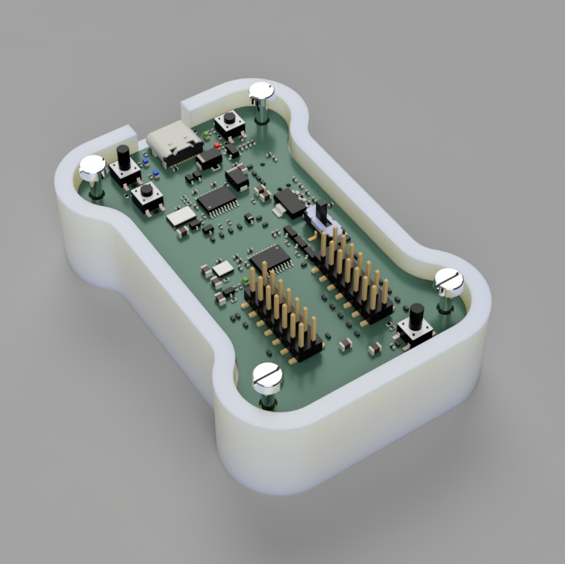The product consists of a circuit board mounted with bolts in a plastic box:

The cover has a few holes for the buttons, slide switches and LEDs. The circuit board is mounted just 4mm below the surface, so some of these components stick out through the holes in the cover:

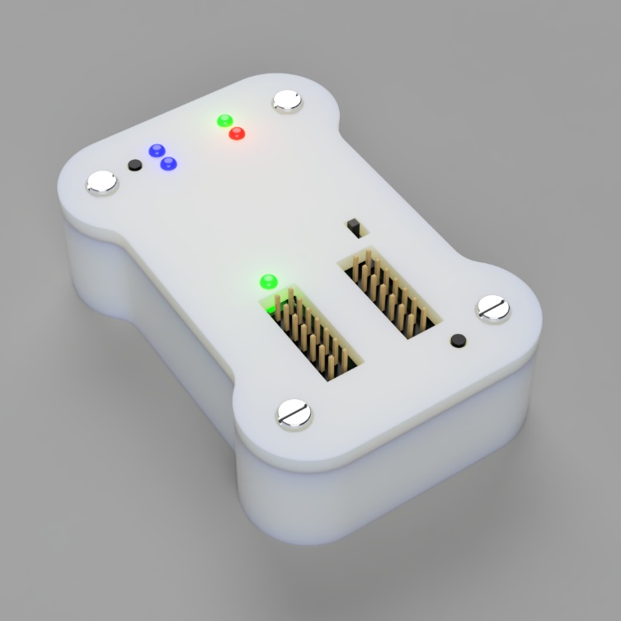

## Overview

We need a graphic overlay membrane to glue on top of our product’s cover:

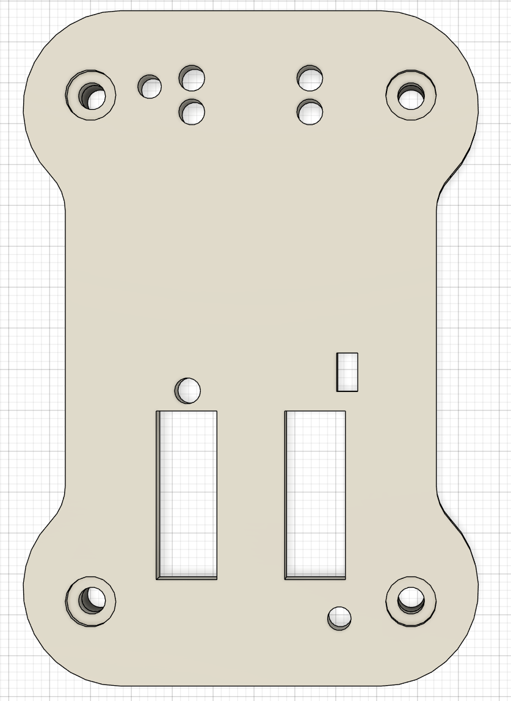

LED hole

⌀ 3.07mm

screw hole

⌀ 3.20mm

countersink (for screw head)

⌀ 6.00mm

pushbuttons

⌀ 3.00mm

slider switch slot

2.50 x 4.50mm

pin header slot

7.20 x 20.0mm

This is what we envision the graphic overlay membrane to look like. The hatched areas are holes and cutouts in the membrane to give space for the LEDs, screws, slider switch and pin header connectors that poke through the cover. For the two pushbuttons, no holes should be drilled in the membrane! Instead, the membrane should cover them (see page 9).

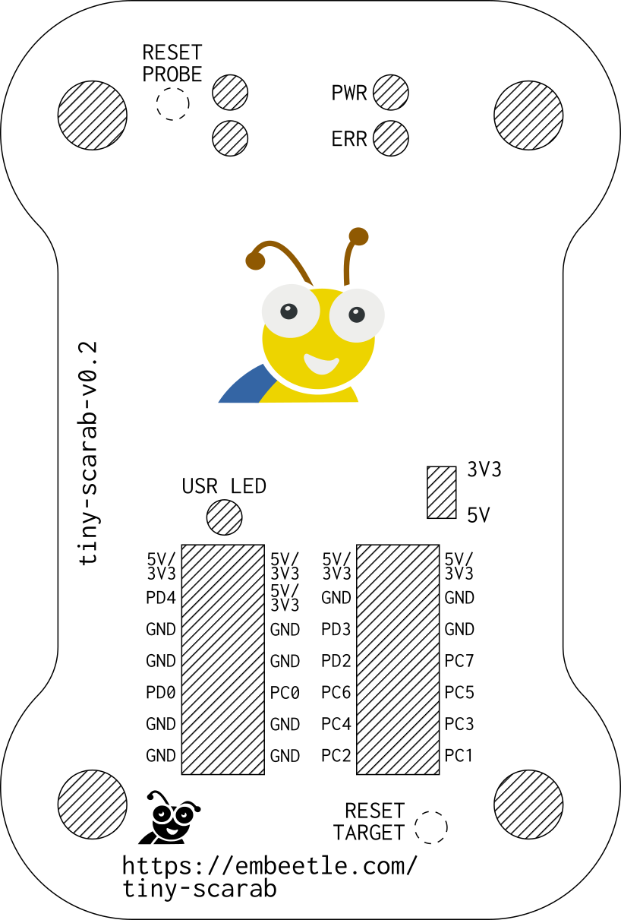

This drawing is also available as a **.svg** file for your convenience. If you need it in another format, please contact me.

The next pages show all the dimensions for the membrane – the outer dimensions as well as all the dimensions for the cutouts and where the embossments for the two pushbuttons should be located.

## Outer Dimensions

The overall dimensions of the graphic overlay membrane is 54 x 80 mm. Below you can see the dimensions in more detail (all in mm):

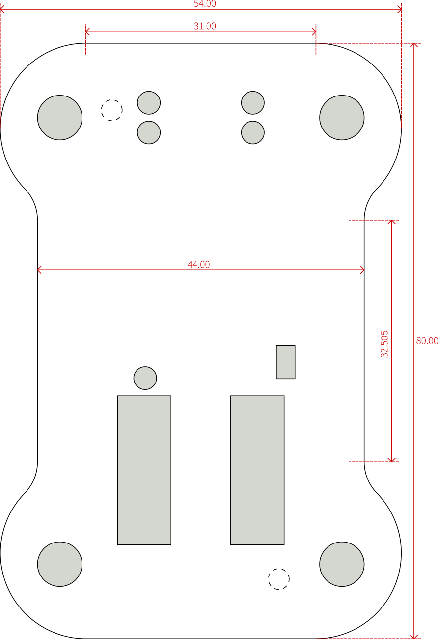

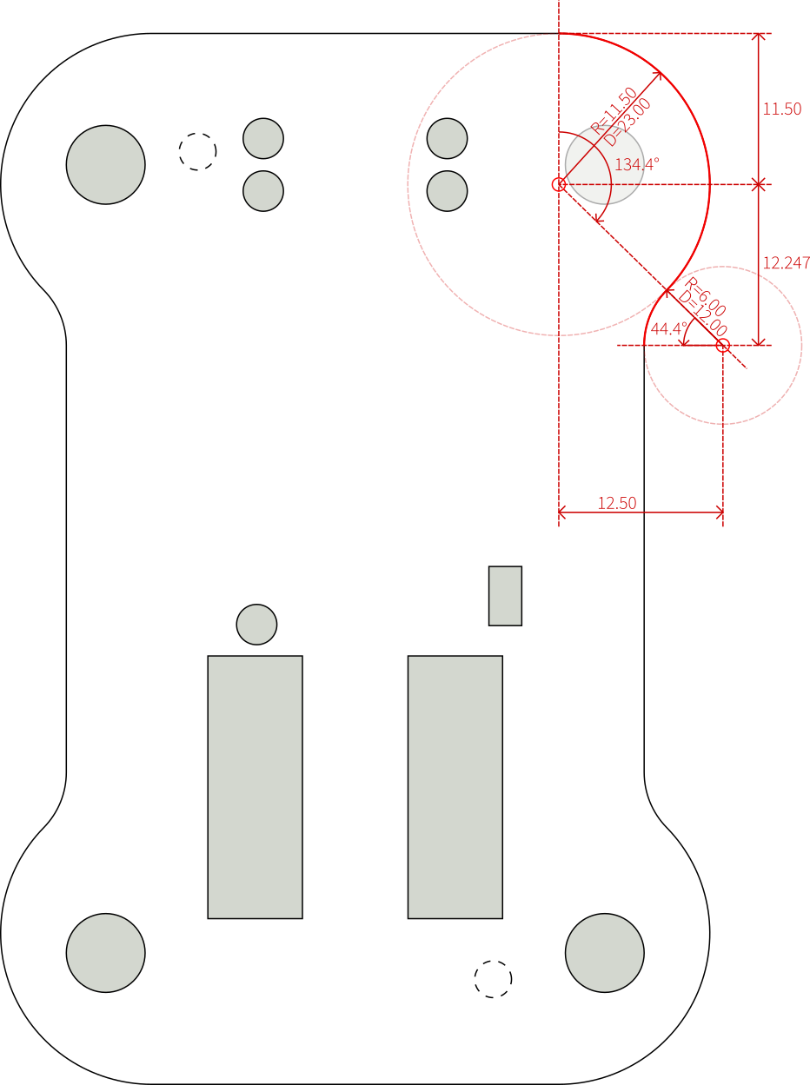As for the corners, they consist of two intersecting arcs. The first arc has a diameter of 23.00 mm, the second one 12.00 mm:

Be careful! The centerpoint of the first arc (the one of 23mm diameter) is NOT the same as the centerpoint of the nearby screw hole:

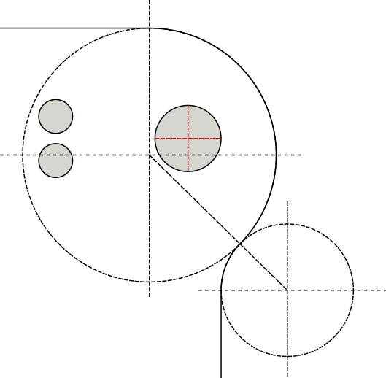

**!**

## Screw Holes

The horizontal space between the screw holes is 38.00mm, the vertical space is 60mm – measured between the hole centerpoints. For the screw holes themselves, we need a 6mm diameter cutout in the membrane:

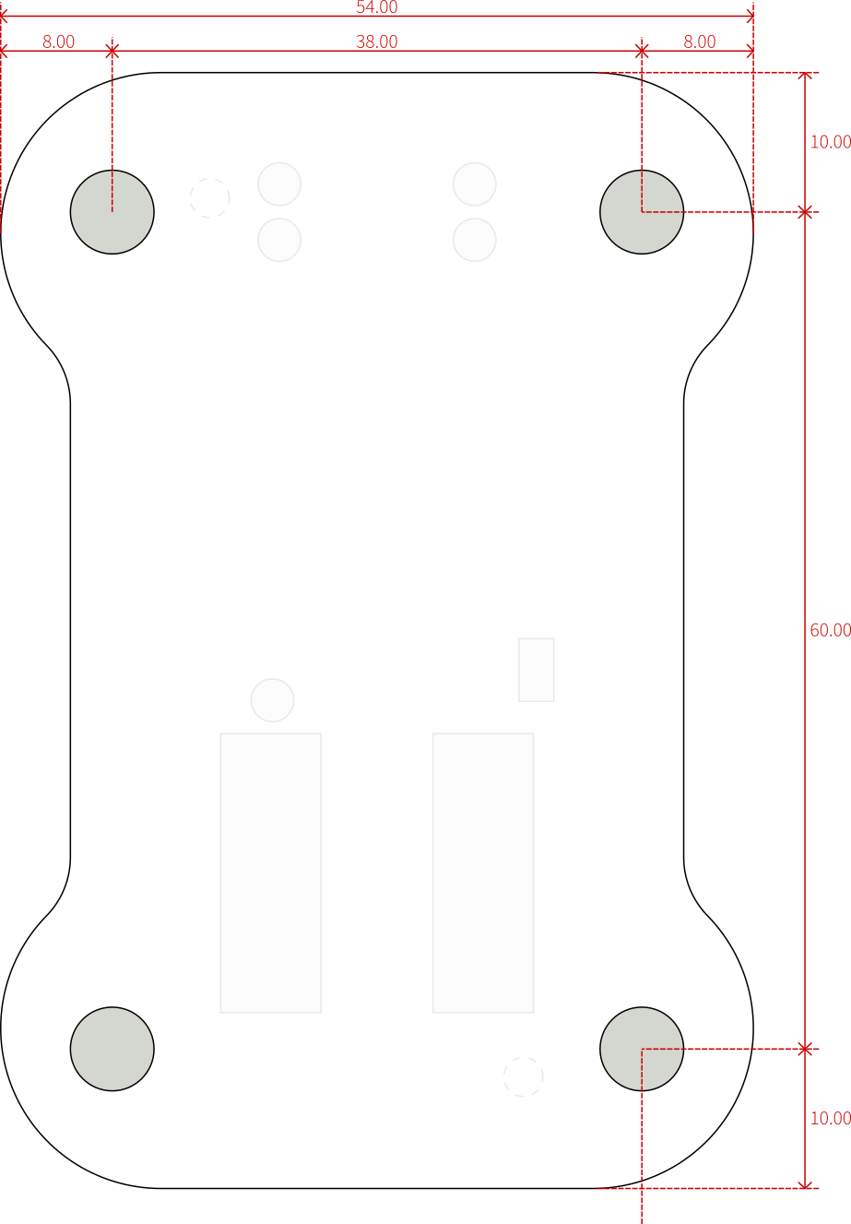

hole for screw and screw head: ⌀ 6.00mm

## LED holes

The graphic overlay membrane should have 5 holes to give space to the LEDs poking out. Each hole should be 3.07mm in diameter. The following figure shows their locations (all dimensions in mm):

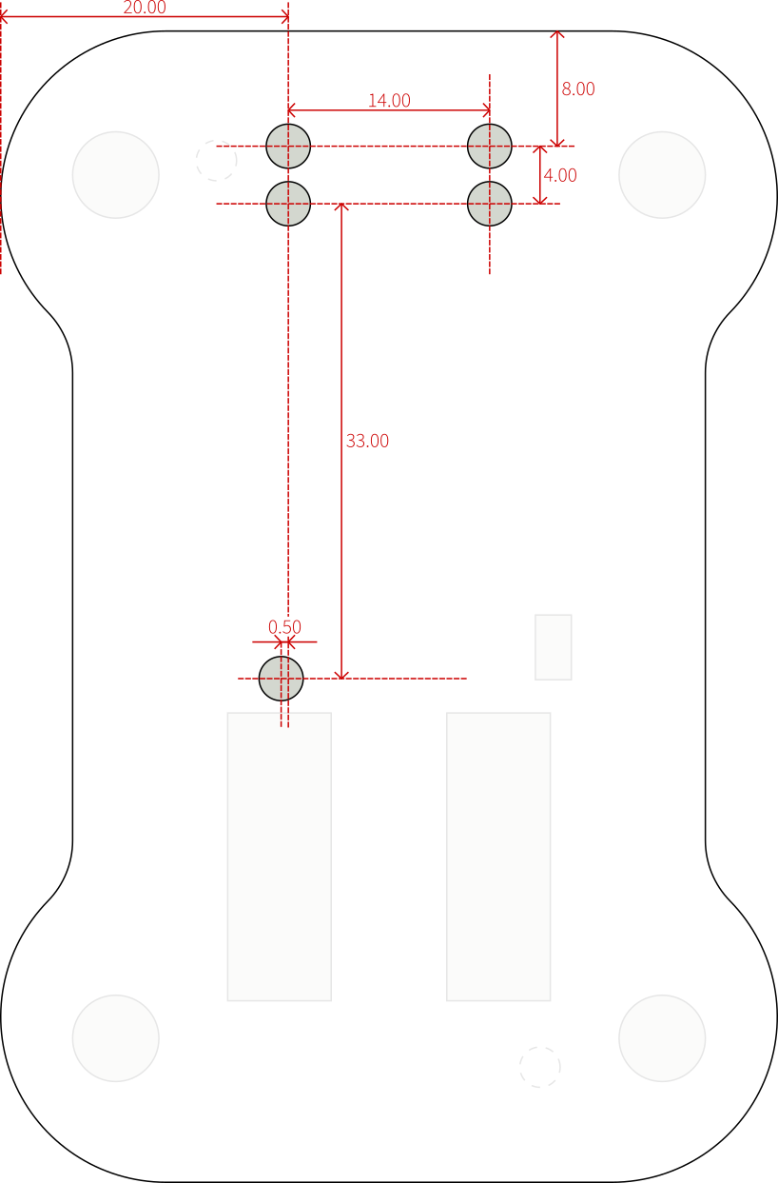

LED hole

⌀ 3.07mm

## Slider Switch and Pin Header Slots

Three slots should be milled at the bottom of the graphic overlay membrane: one for a slider switch handle, and two for the pin headers. The following figure shows their locations and dimensions:

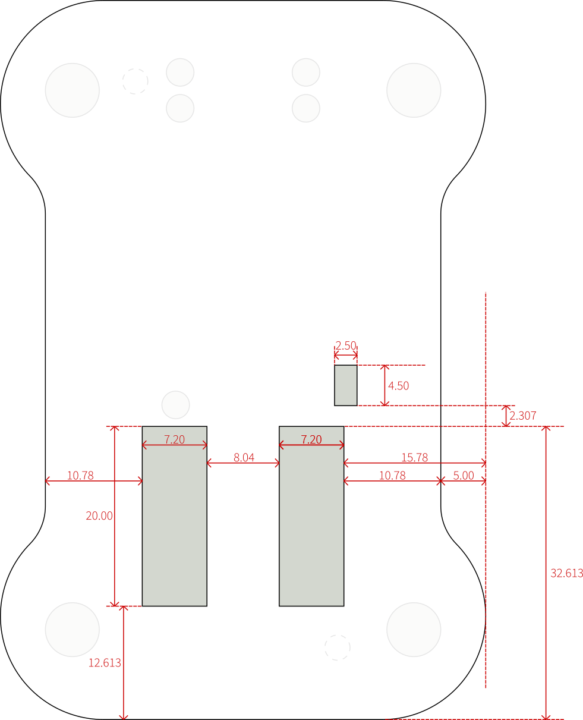

## Pushbutton Embossments

There are two pushbuttons in the design. Each of them pokes through a hole of 3.00mm diameter in the top of the box. However, there should be ***no holes for these pushbuttons*** in the graphic membrane! Instead, the graphic membrane should cover them with an embossment:

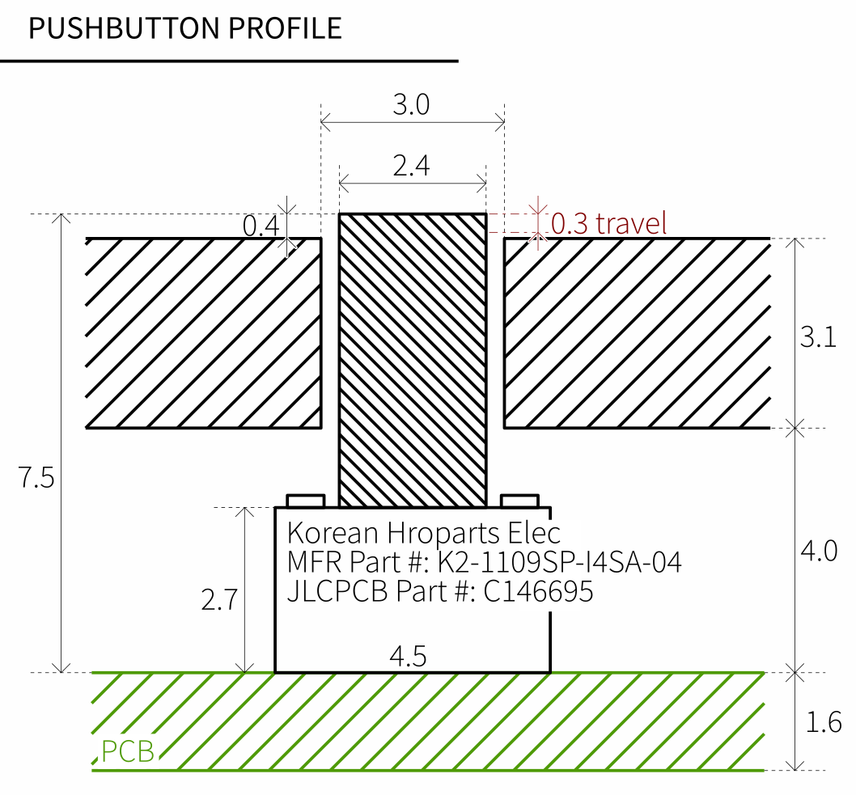

BOX

COVER

PCB

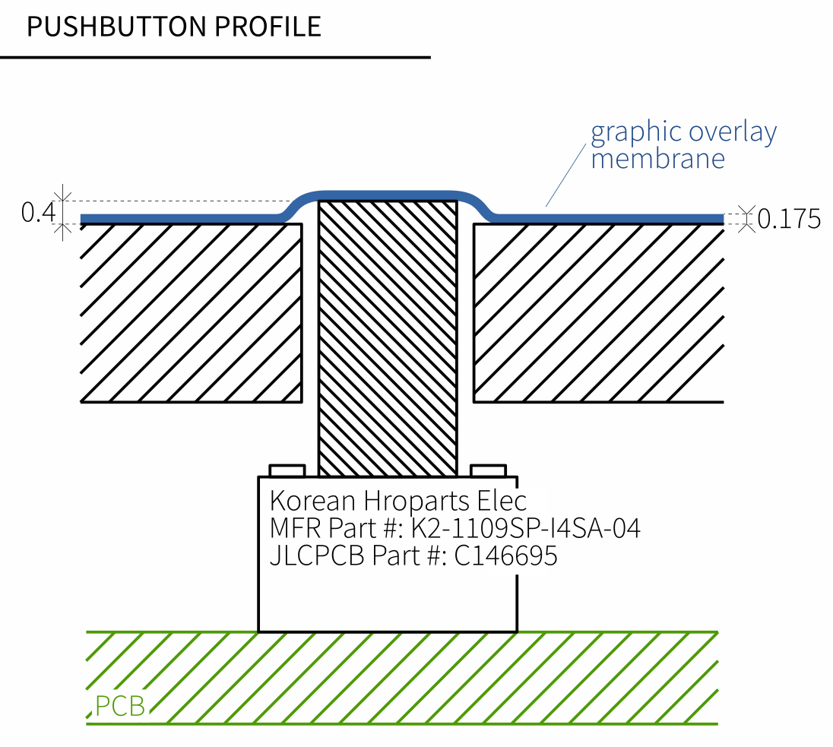As shown in the figure below, the graphic membrane should cover the button handle. The button handle is only 0.4mm above the surface. The push stroke travels 0.3mm down.

The following figure shows where the pushbuttons are located:

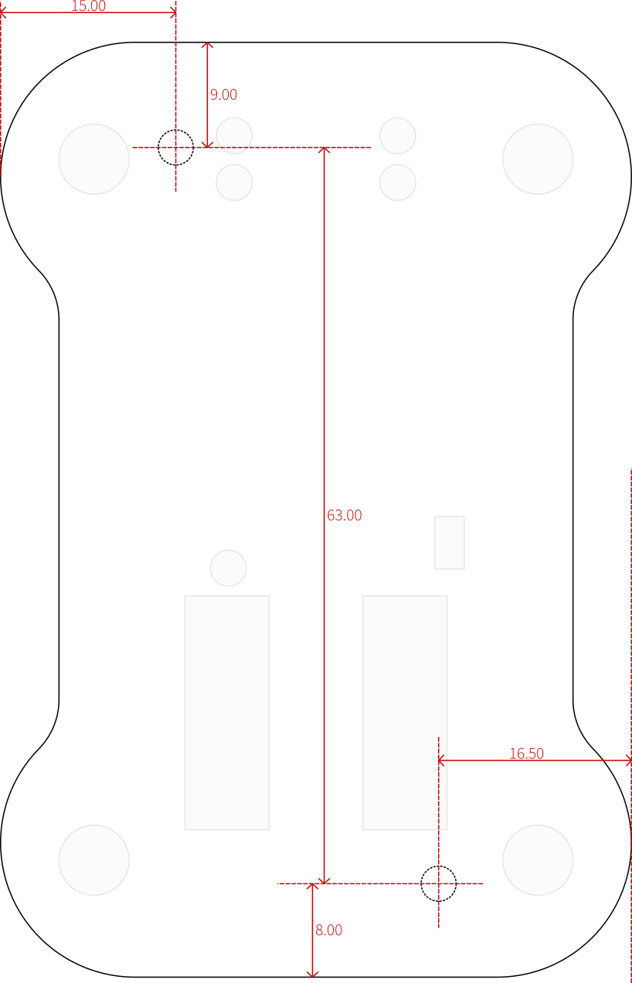

## Text Sizes

Some of the text on the graphic membrane is really small – only 1mm tall. Please let me know if your machines are able to print such small text on the graphic membrane.



Text is about

1mm tall

## Logo Colors

I’d like to put our logo in the middle of the product. If possible in color. How much extra cost would a colored logo incur? Please let me know the cost difference, so I can decide to provide you with a colorless logo design instead if the difference is too high.

## Contact

Considering our needs – is your company able to meet these requirements? Please contact me on my WeChat:

+86 136 9181 5371