# Graphic Overlay for Tiny Scarab

I’m Kristof Mulier, a Belgian electronics engineer and cofounder of Embeetle IDE. We’re developing a product, but still need a graphic overlay membrane in PET (Polyester), PC (Polycarbonate) or another elastomer material. For this graphic overlay membrane, we would like to cooperate with your company. This document clarifies what we need.

## Our Product

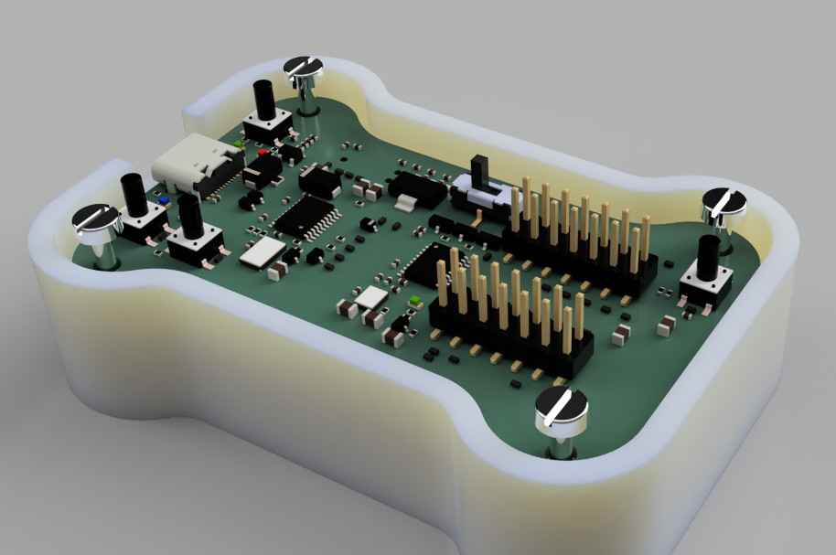The product consists of a circuit board mounted with bolts in a plastic box:

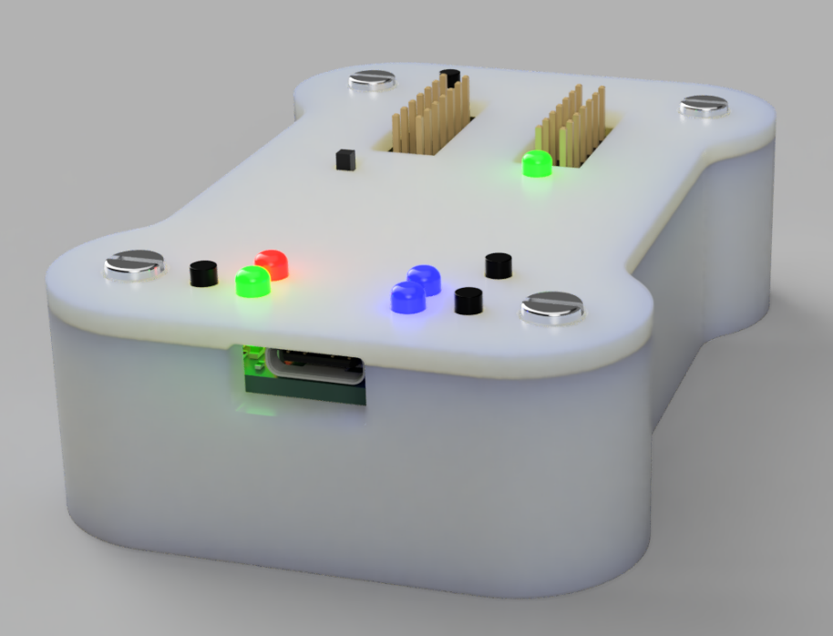The cover has a few holes for the buttons, slide switches and LEDs. The circuit board is mounted just 4mm below the surface, so all these components stick out through these holes.

## Graphic Overlay Membrane

We need a graphic overlay membrane to glue on top of our product’s cover:

Our product contains the following user-interface elements:

* Pushbuttons
* Slide switches
* LEDs

The graphic overlay membrane should take these elements into account.

## Pushbuttons

I envision the graphic overlay membrane to cover the pushbuttons:

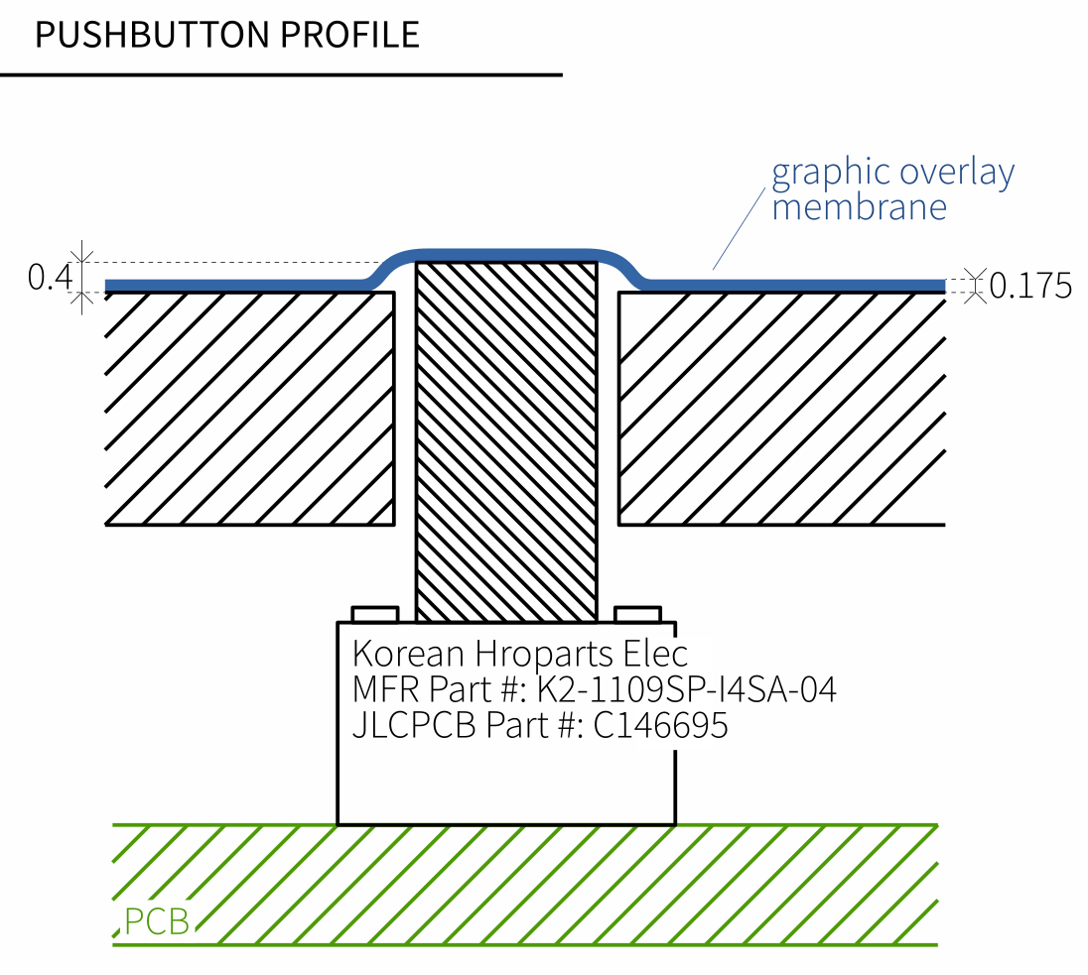

## Slide Switches

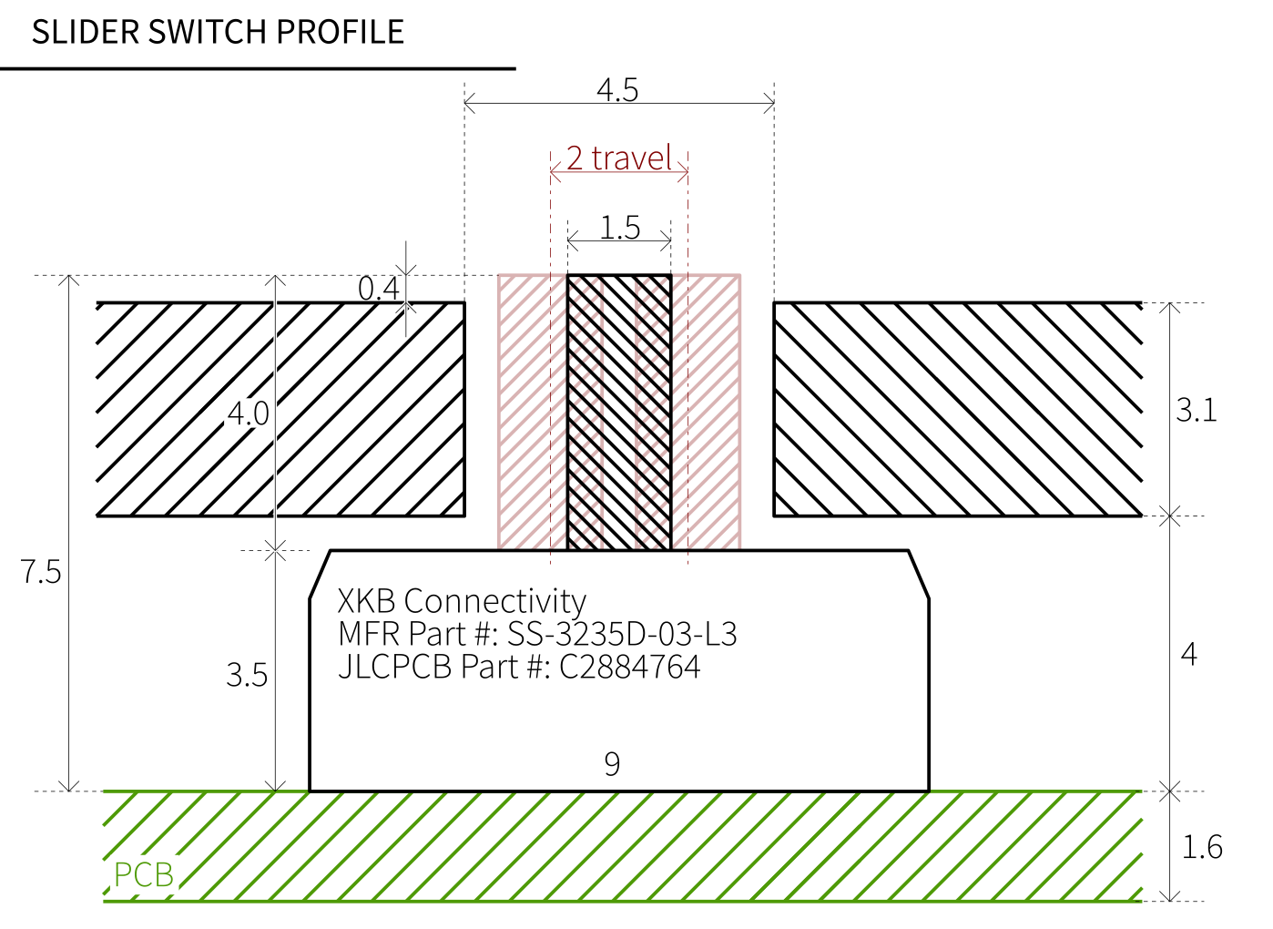The Slide Switches have following dimensions:

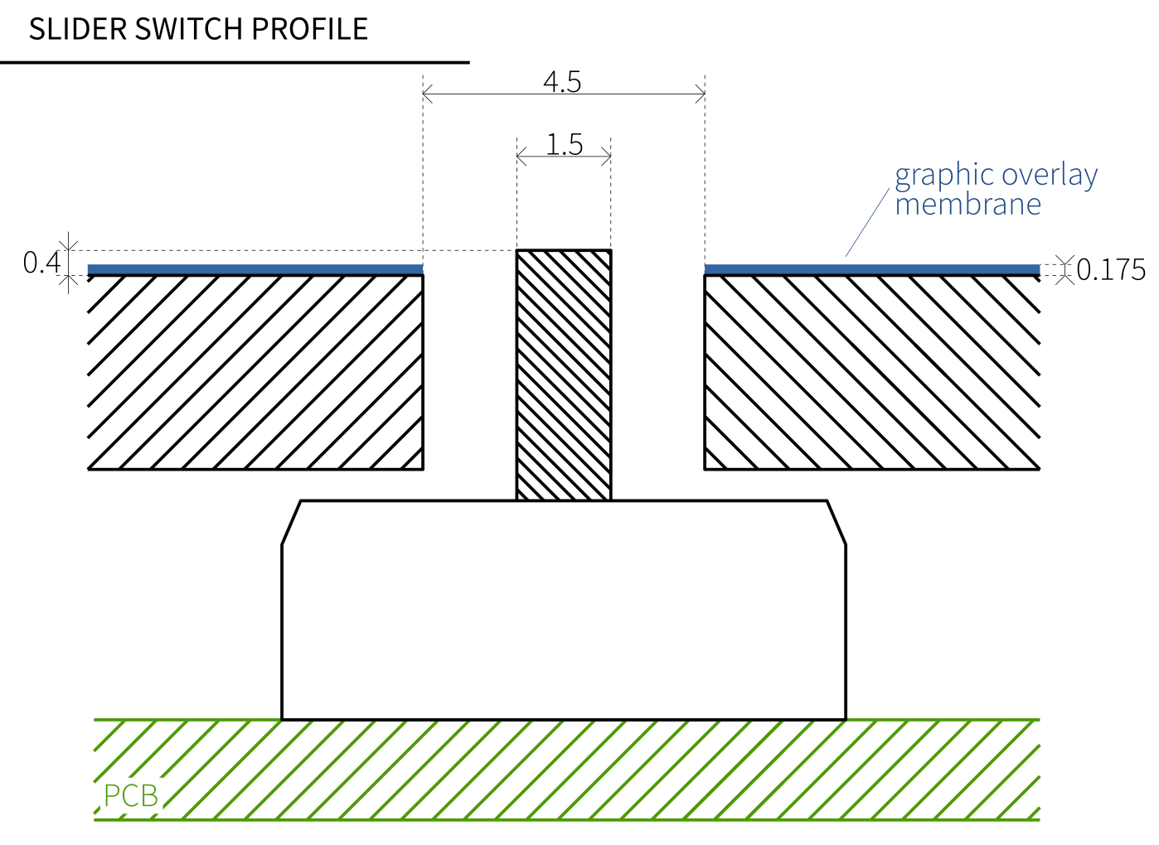Unless there’s a more elegant solution, the graphic overlay should probably just stop at the edges of the cutout from the slider button:

## LEDs

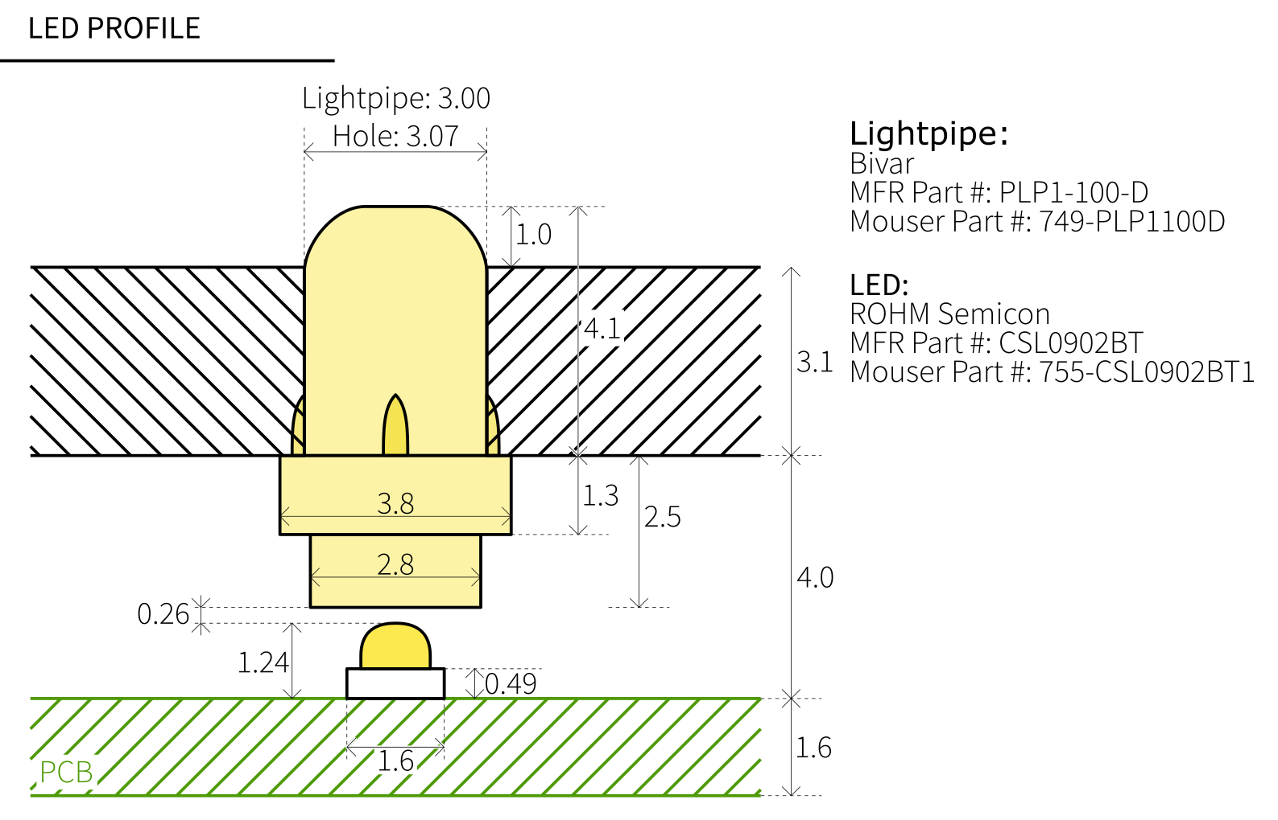The LEDs shine into ⌀ 3.0 mm lightpipes. These stick out 1.0 mm above the surface:

Can the graphic overlay cover these LEDs? Perhaps with a transparent part in the graphic overlay to let the light pass through?

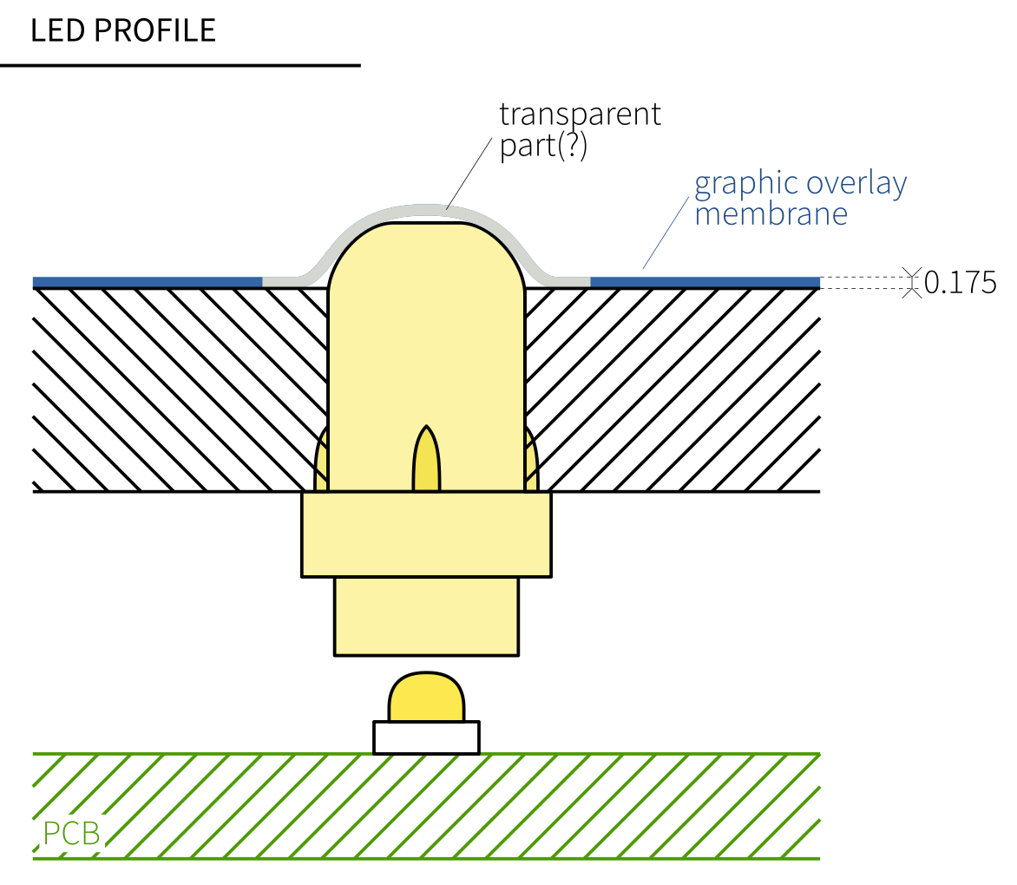

## Contact

Considering our needs – is your company able to meet these requirements? Please contact me on my WeChat:

+86 136 9181 5371