# Graphic Overlay Specifications

I’m Kristof Mulier, a Belgian electronics engineer and cofounder of Embeetle IDE. We’re developing a product, but still need a graphic overlay membrane in PET (Polyester), PC (Polycarbonate) or another elastomer material. For this graphic overlay membrane, we would like to cooperate with your company. This document clarifies what we need.

## Our Product

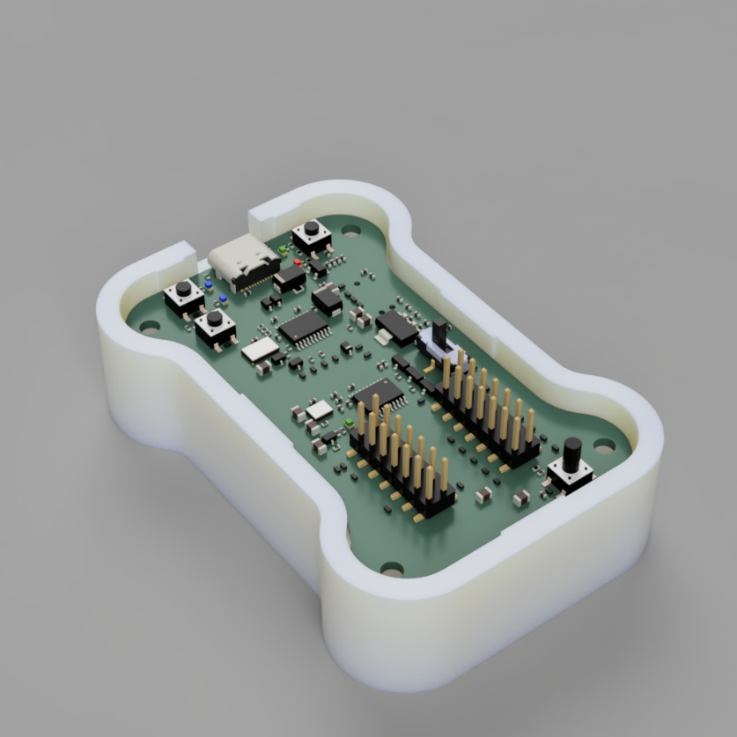The product consists of a circuit board mounted with bolts in a plastic box:

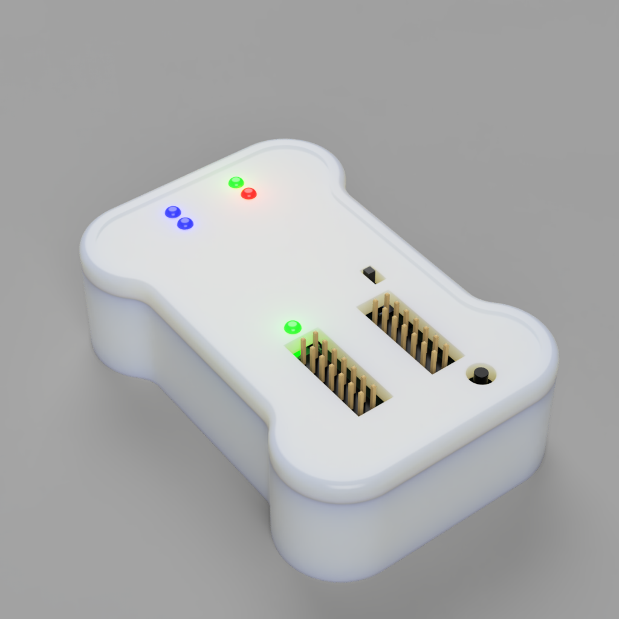The cover has a few holes for the buttons, slide switches and LEDs. The circuit board is mounted just 4mm below the surface, so some of these components stick out through the holes in the cover:

## Overview

We need a graphic overlay membrane to glue on top of our product’s cover:

LED hole

⌀ 3mm*

pushbutton

⌀ 5.00mm

slider switch slot

2.50 x 4.50mm

pin header slot

7.20 x 20.0mm

This is what we envision the graphic overlay membrane to look like. The hatched areas are holes and cutouts in the membrane to give space for the LEDs, slider switch and pin header connectors that poke through the cover. For the pushbutton, no hole should be drilled in the membrane! Instead, the membrane should cover the pushbutton (see page 8).

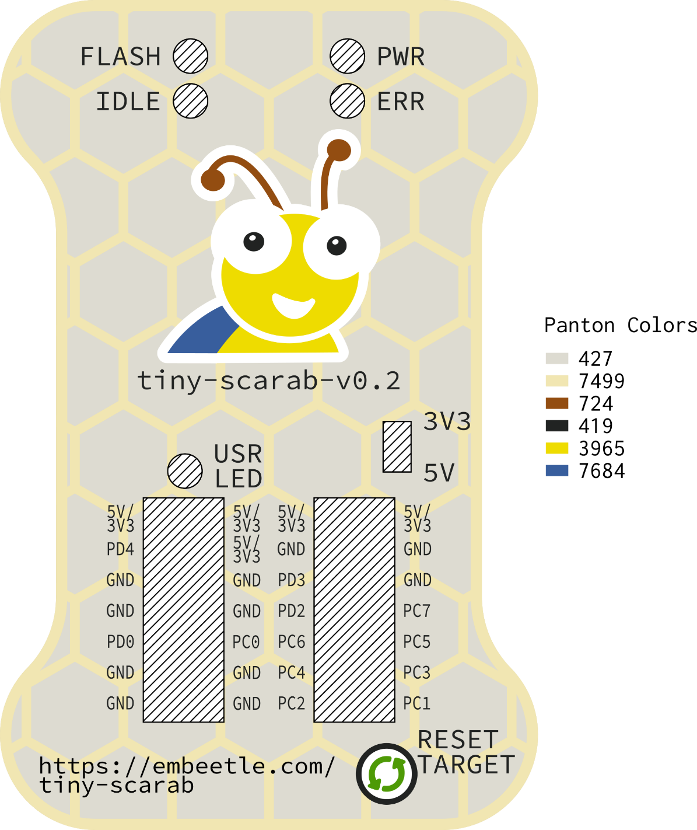

This drawing is also available as a **.svg** file and a **.pdf** file for your convenience. For more info on the files I provided, please check the last page of this document. If you need it in another format, please contact me.

The next pages show all the dimensions for the membrane – the outer dimensions as well as all the dimensions for the cutouts and where the embossment for the pushbutton should be located.

## Outer Dimensions

The overall dimensions of the graphic overlay membrane is 48 x 74 mm. Below you can see the dimensions in more detail (all in mm):

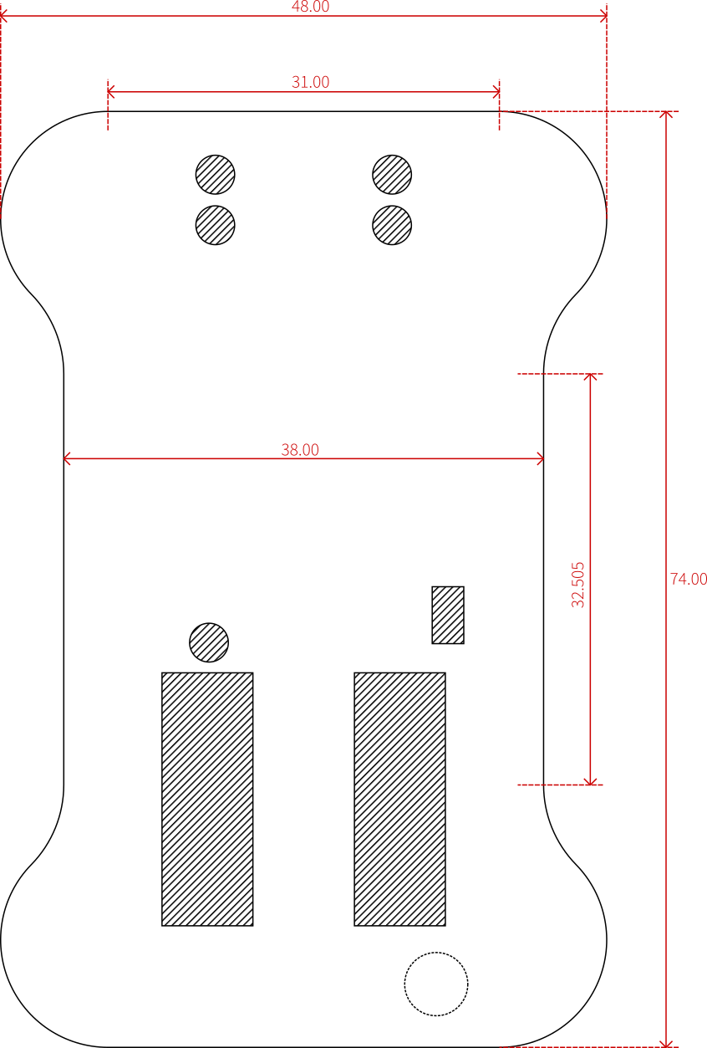

As for the corners, they consist of two intersecting arcs. The first arc has a diameter of 17.00 mm, the second one 18.00 mm:

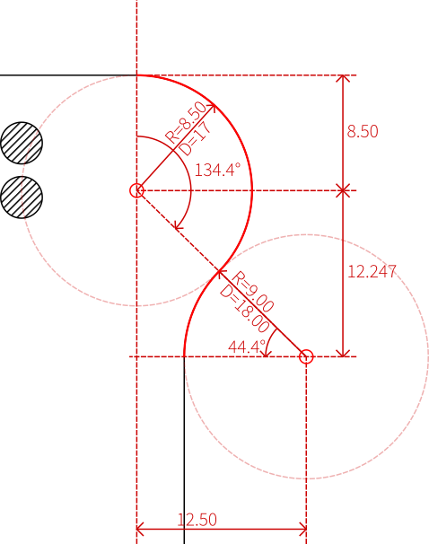

## LED holes

The graphic overlay membrane should have 5 holes to give space to the LEDs poking out. Each hole should be 3.0mm in diameter. The following figure shows their locations (all dimensions in mm):

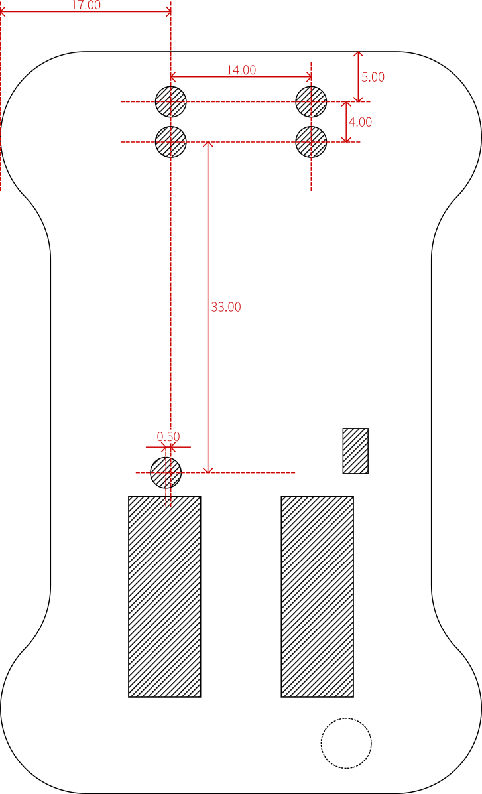

LED hole

⌀ 3.0mm

## Slider Switch and Pin Header Slots

Three slots should be milled at the bottom of the graphic overlay membrane: one for a slider switch handle, and two for the pin headers. The following figure shows their locations and dimensions:

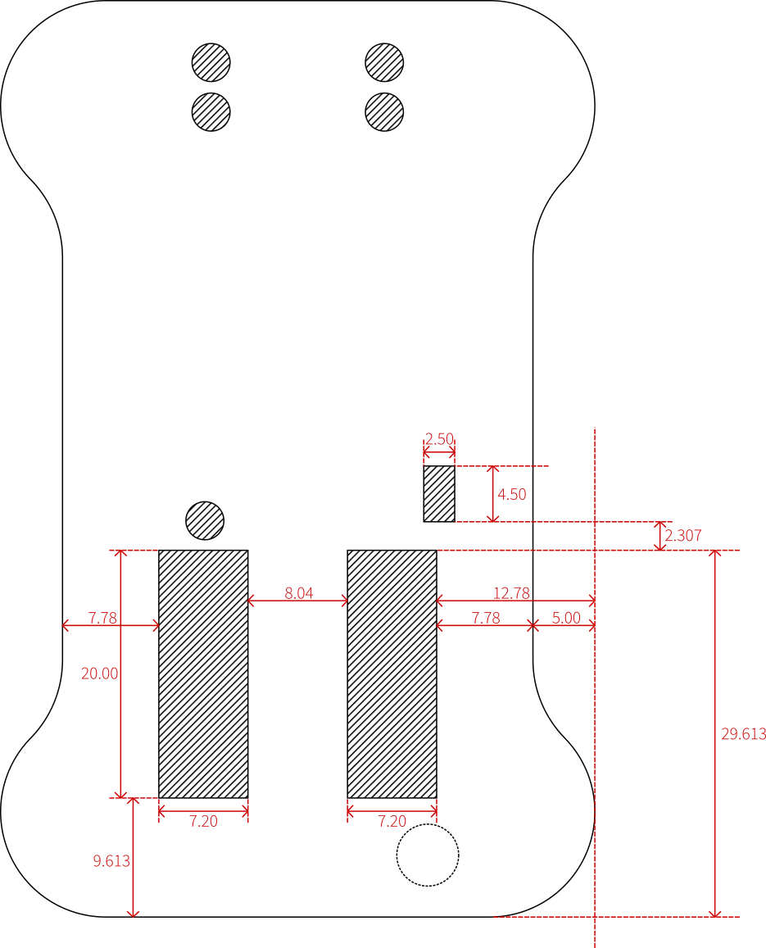

## Pushbutton Embossments

There is one pushbutton in the design. It pokes through a hole of 5.0mm diameter in the top of the box. However, there should be ***no hole for the pushbutton*** in the graphic membrane! Instead, the graphic membrane should cover the button with an embossment:

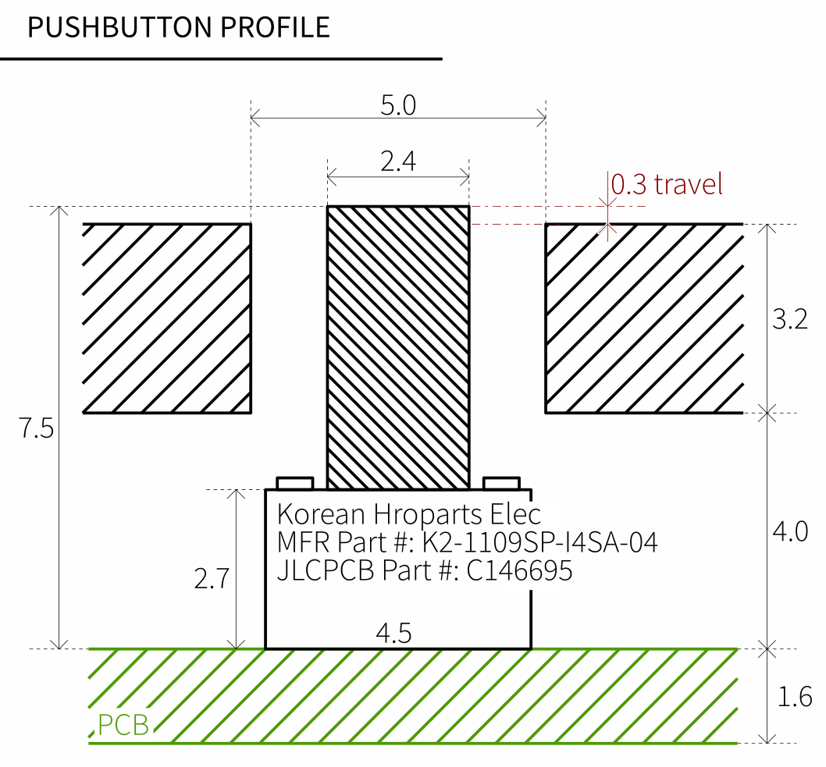

As shown in the figure below, the graphic membrane should cover the button handle. The button handle is only 0.3mm above the surface. The push stroke travels 0.3mm down, so the handle will be co-planar with the rest of the box surface when the button is pushed down.

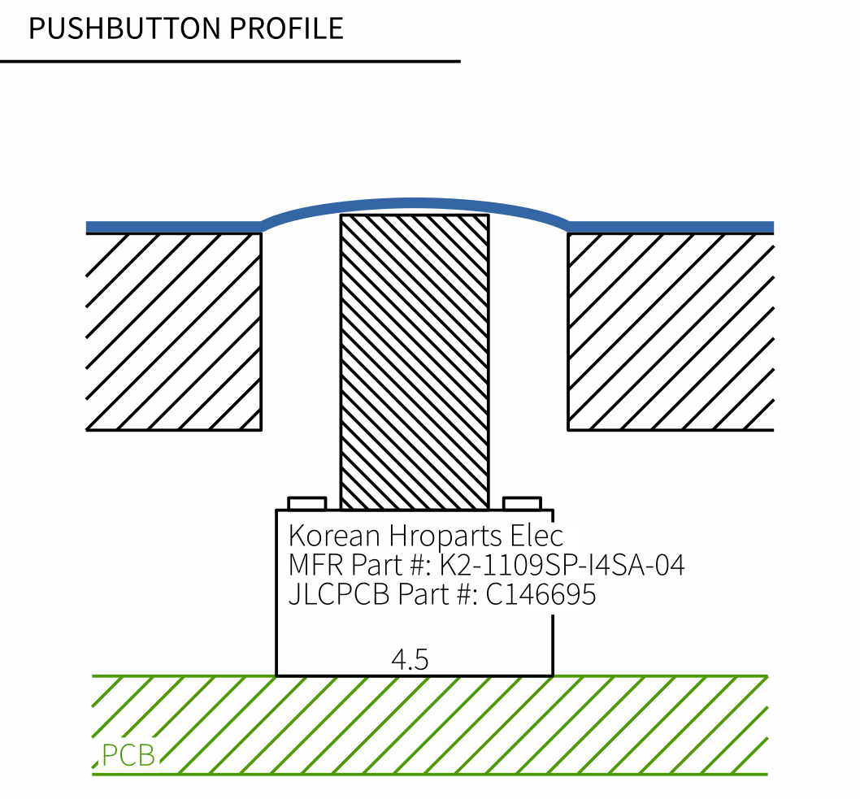

The following figure shows where the pushbutton is located:

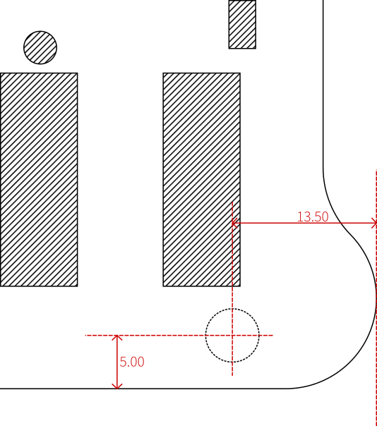

## Result

When the membrane is glued on the product, it will look like this:

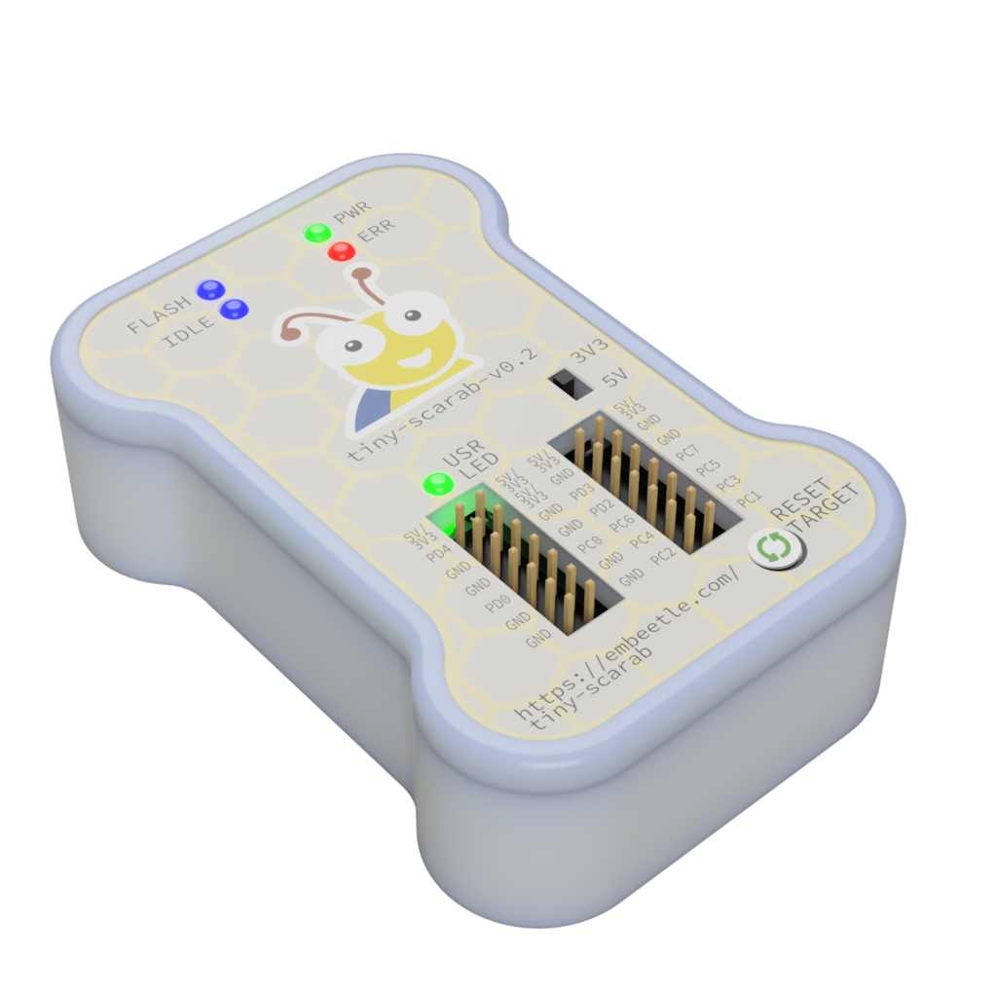

## Files

Along with this document, I provide the following files:

The files **design_01.pdf** and **design_01.svg** show the cutouts with a “hatched” pattern:

The files **design_02.pdf** and **design_02.svg** just leave the cutouts as a “void” (no material):

Both files are identical in all other aspects. Please choose the file that is most convenient for your engineers.

## Contact

Considering our needs – is your company able to meet these requirements? Please contact me on my WeChat:

+86 136 9181 5371