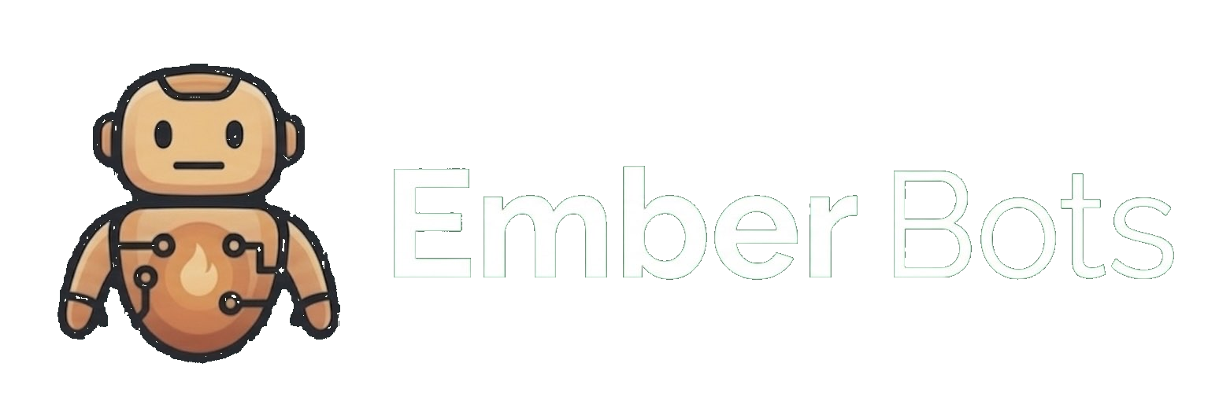  ONE-PAGE SALES SHEET  Your business deserves intelligent automation.  Ember Bots helps small businesses automate lead response, follow-up, scheduling, customer communication, onboarding, and back-office work with systems built around the way the business actually runs. | Best fit  - service-based SMBs  - home-services operators  - local businesses with steady inbound leads  - teams losing time to manual follow-up and admin

Where small businesses lose momentum  - leads sit too long before someone responds  - missed calls turn into missed revenue  - scheduling and follow-up happen manually  - customer messages get scattered across channels  - teams re-enter the same information in multiple places  - admin work steals time from sales, service, and growth | What Ember Bots deploys  - Lead Response Automation  - Customer Message Routing  - Scheduling & Reminder Automation  - Client Onboarding Automation  - Follow-Up Automation  - Back Office Admin Automation  - Executive Daily Briefing

What the business gets
Faster  Lead response without adding office overhead | Cleaner  More consistent follow-up and scheduling workflows | Organized  Customer communication and task routing in one system | Practical  Less repetitive admin and more time for conversations, service, and decisions

How Ember Bots works  Audit the bottlenecks. Deploy the right automation system. Tailor it to the business. Then manage and improve it over time so the system keeps creating value. | Start here  EmberBots.ai  For businesses serious about removing operational drag and responding faster without adding more overhead.

