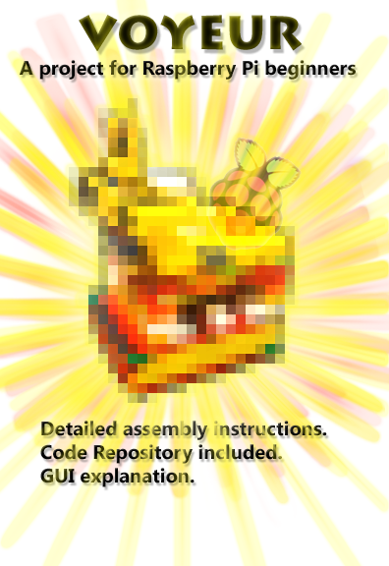

**Introduction:**

The purpose of this document is to guide beginner programmers and hardware-enthusiasts through the process of creating a fully autonomous monitoring system.

This instruction manual will go through the process of assembling the hardware, preparing the software, and using the Graphical User Interface (GUI) of the open source Voyeur system.

This manual will expect basic to intermediate understanding of computers and computer science terminology.

**Table of content**

Primary Components…3

Operating System…4

Hardware Assembly…6

Preparing Software…9

GUI Elements…11

Citation…13

**Primary components**

This project will require the following:

1- Jumper cable x3  
2- USB-to-USB cable x3  
3- Raspberry pi 3.0 or later x1  
4- Battery bank for mobile devices x1  
5- Raspberry pi camera module x1  
6- Servos motor x1   
7- Servos control board x1  
8- HDMI-to-HDMI cable x1  
9- SD card reader x1  
10- 8GB or more SD card x1  
11- Keyboard and mouse x1  
12- Some kind of display that reads HDMI x1

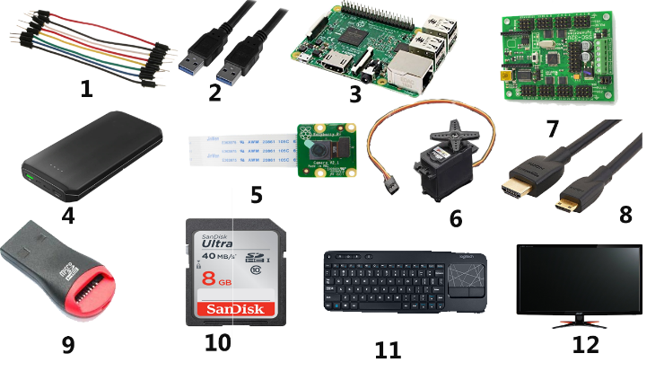The most expensive component on this list being the battery bank, any type that provides 1.2A will suffice. Needs to have at least 2 USB output ports.

**Operating System**

Start out by attaching the SD card into the SD card reader and plugging that into a PC.

Go to: [www.raspberrypi.org/downloads/](http://www.raspberrypi.org/downloads/)

And download NOOBS operating system, while that is taking place go to:   
[www.sdcard.org/downloads/formatter_4](http://www.sdcard.org/downloads/formatter_4)

And download the SD card formatter.

Once the SD card formatter .zip is finished downloading, go ahead and install the software.  
Open the SD card formatter software and be sure to select the drive letter associated with the SD card (commonly G)

Once the formatting is complete that software is no longer needed, so feel free to uninstall it now.

**Operating System**

After the NOOBS.zip finishes downloading right click it and select “Extract All” which will prompt a navigation screen.

Navigate to the SD card’s location and click “Extract” this operation may take some time depending on your PC and its specifications.

Once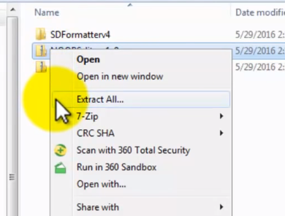 the extraction is complete, navigate to “Computer” file and right click the SD card, then click “Eject” to allow for safe removal.

Figure 1 Click “Extract All” and navigate to the SD card drive (commonly G :\)

With that last step the SD card may now be removed from the SD card reader and plugged it into the raspberry pi SD card slot.   
The NOOBS files are no longer needed, now is a good time to remove those.

**Hardware Assembly**

Now the system is ready for assembly.  
Start out by attaching one of the USB cables from the raspberry pi to the battery bank.  
Next attach the servos control board to the power bank, also using a USB cable.

The final USB cable is used to connect the raspberry pi to the servos control board.

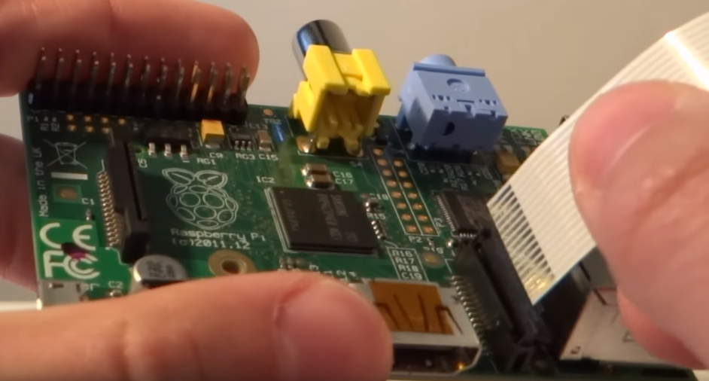Next connect the camera to the raspberry pi, notice it has a unique “ribbon” type of cable. This connects to a special port between the pi’s HDMI port and USB port. Make sure the shiny part faces the HDMI port as shown in figure 2 below.

Figure 2 the ribbon cable should fit into the pi tightly.

**Hardware Assembly**

Use the jumper cables to attach the servos to its control board, use any of the available ports.  
Next attach the camera on top of the servos. The solution to this part is up to the engineer.

Consider using rubber bands to keep the camera in place on top of the servos, the   
solution does not need to be permanent.

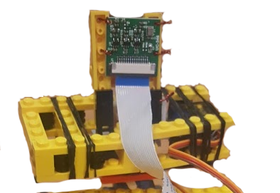Notice that the camera has 4 empty slots that can be used to secure it to a surface using screws or cords. Figure 3 shows a solution with LEGO pieces and copper wire.

Figure 3 solution using LEGOs and copper wire

**Hardware Assembly**

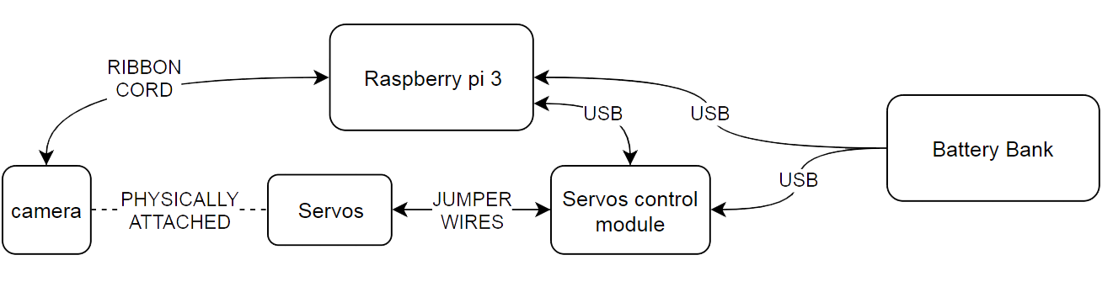At this point the system should look something like figure 4.

Figure 4 basic diagram of the project

Notice the servos and camera are not connected through any ports, just physically bound together, so changes in the servos angle can be expressed as camera span.

Now for the final stage of retrieving the code for the Voyeur system and testing it.

Attach the raspberry pi to and HDMI cable then to an HDMI-accepting monitor, most modern TVs have an HDMI port as well.

**Preparing Software**

With the raspberry pi booted into NOOBS operating system click the red icon in the top left side of the screen -> preferences -> Raspberry Pi Configuration.

Ensure “Camera” is enabled, it it’s not, enable it and reboot the Pi.

Click the Pi icon at the top left again and open up the internet browser, head over to:

<https://github.com/Embersz/Voyeur>

And click the green “Clone or download” tag then click “Download ZIP” as shown in figure 5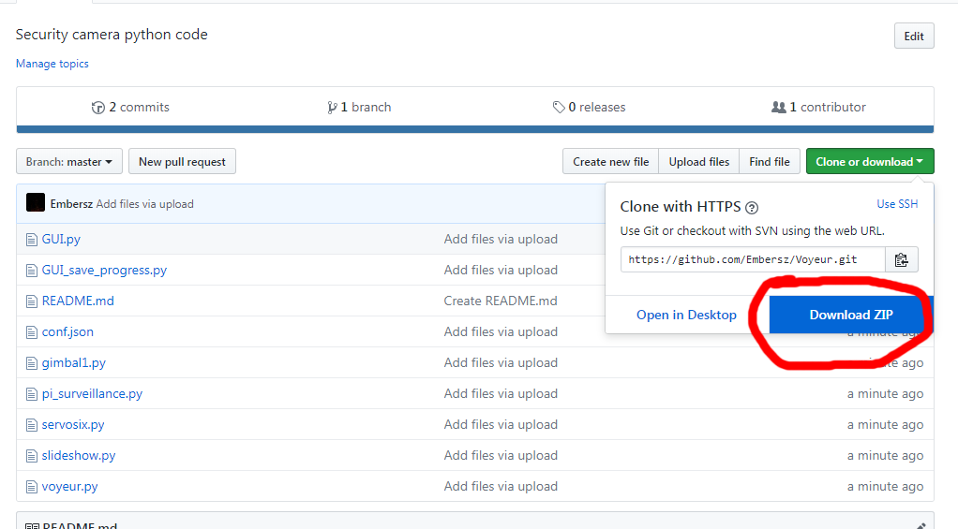

Figure 5 view of the GitHub repository for the Voyeur code.

**Preparing Software**

After downloading the files, extract them anywhere and open up the conf.json with a text editor.

If the engineer wishes for the Voyeur videos and images to be stored locally then edit “use_dropbox” to read “false”.

Otherwise go to:

[www.dropbox.com/developers/apps](http://www.dropbox.com/developers/apps)

And create a dummy “app”

From the dummy app’s “settings” page there is a “Generate access token” button that will create a link which provides access to the engineer’s DropBox account.

Copy that link and use it to replace the “[TOKEN MISSING]” line in the “conf.json”

With this done Voyeur is ready for business!

**User Interface Elements**

Double click the GUI.py this will open up in the Raspberry Pi Python editor, from this point simply click F5 and the software will start, prompting for a username and password, type “admin” in both fields.

A greeting message will appear before the software displays the main menu.

It is from this interface that the Voyeur can be prepared for long-term deployment: simply click “camera on” and now the HDMI cable may be disconnected and the Voyeur will upload change in motion as pictures to the DropBox.

The next page will list the elements of the page as well as a brief description of each.

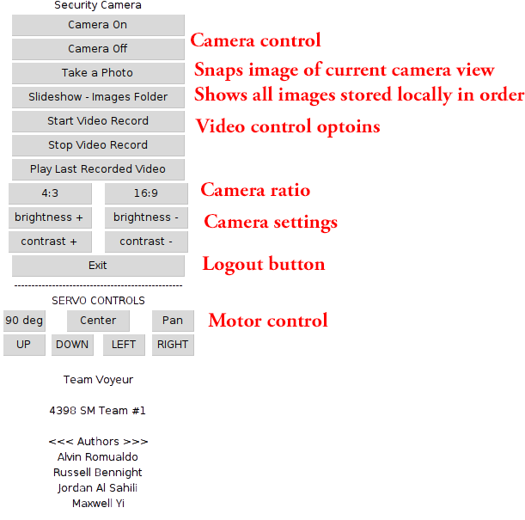

Figure Voyeur User Interface, starting a video recording will limit Motor Controls

**Citations**

Figure 2: TheRaspberryPiGuy. “Raspberry Pi - Camera Tutorial...” *YouTube*, YouTube, 26 May 2013, <https://youtu.be/T8T6S5eFpqE>

All other figures are generated by Jordan Al-Salihi

PROJECT BY: JORDAN AL-SALIHI