Steps taken in the development of the Field EP devices

# Hardware:

|  |  |
| --- | --- |
| **Part** | **Role** |
| Raspberry Pi Zero W | Main controller |
| LiPo Shim | Boost converter 3.7V to 5V |
| Witty Pi Mini3 | Power management |
| Adafruit Feather Fona 32u4 | GPRS network connection |
| Raspberry Pi HQ camera | Camera sensor |
| Blue Robotics TSYS01 | Temperature sensor |

Pinout diagrams are provided in Appendix 1.

## Hardware connections

The hardware of the FieldEP comprises a suite of modules which provide all required functionality. Connections are summarised in Appendix 2. The base unit is a Raspberry Pi Zero (RPi) single-board computer, which is powered from a 3.7V lithium battery, via a boost converter to increase the voltage to 5V. This power is supplied via the power management board, which controls the duty cycle of the FieldEP. The boost converter monitors battery power and signals for a safe shutdown of the Pi if it detects a voltage below 3V.

At present, the power management board does not shut down the boost converter board. This will be incorporated once duty cycles and power budgets are being optimised during field testing.

Environmental sensors use the I2C bus for data transfer, with TSYS01 occupying I2C address 77. Care should be taken to ensure other environmental sensors occupy different addresses. Environmental sensors can be connected in parallel to the same pins as the TSYS01 sensor. Be aware that some environmental sensors are sensitive to electronic interference (e.g. pH and some O2 sensors) and require voltage isolation.

Data are transmitted using a SIM800L board or an Adafruit Feather Fona 32u4 microcontroller with integrated SIM800H board. These make use of the serial UART communication to send and receive data using AT-commands.

# Raspberry Pi configuration

The hardware components need to be integrated on the RPi platform. This ensures the relevant drivers are available and that the necessary GPIO pins are accessible or reassigned where necessary.

GPIO clashes

With the current hardware setup, there is a clash where the 1-wire interface is enabled on GPIO4 by default. The Witty Pi Mini3 and LiPo shim both require this pin for low-voltage safe shutdown signals.

It is therefore necessary to make the following changes:

Change 1-wire interface from GPIO4 to GPIO21.

Once LiPo Shim daemon has been installed, change the trigger GPIO from GPIO4 to GPIO18.

Install the relevant drivers and modules on the Pi.

|  |  |  |
| --- | --- | --- |
| Item | Install | Install method |
| Witty Pi3 Mini |  |  |
|  |  |  |
|  |  |  |

Connect the hardware

Check the hardware

Run a test script

Set up the bootup file to run a script on startup

Reboot to test operation

Set up duty cycle in Witty Pi GUI

|  |  |  |  |
| --- | --- | --- | --- |
|  |  |  |  |
| LiPo Shim | One-line install to operate safe shutdown function | https://github.com/pimoroni/clean-shutdown | Change pin from GPIO4 to GPIO18. This is the last pin available on the LiPo shim, since the others are in use for other comms. |
| Adafruit Feather 32u4 Fona |  |  |  |
| Witty Pi3 Mini | Install GUI |  | Change 1-wire interface to a pin other than GPIO4… set to GPIO21 |
|  |  |  |  |
|  |  |  |  |
|  | Configure Pi for using UART | <https://www.raspberrypi.org/documentation/configuration/uart.md> |  |
|  | Install TSYS01 driver from BlueRobotics Github |  |  |
|  |  |  |  |

# Appendix 1: Pinout diagrams

## Appendix 1.1: Raspberry Pi Zero W

|  |  |
| --- | --- |
|  | [https://pinout.xyz/#](https://pinout.xyz/) |

## Appendix 1.2: LiPo shim

|  |  |
| --- | --- |
|  |  |

## Appendix 1.3: Witty Pi 3 Mini

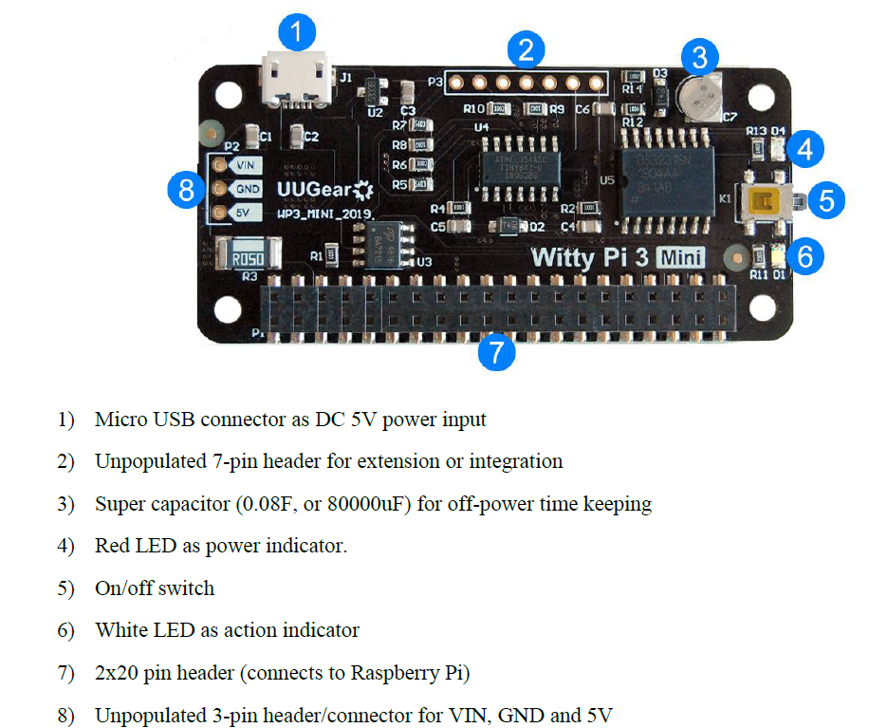

## Appendix 1.4: Adafruit Feather 32u4 Fona

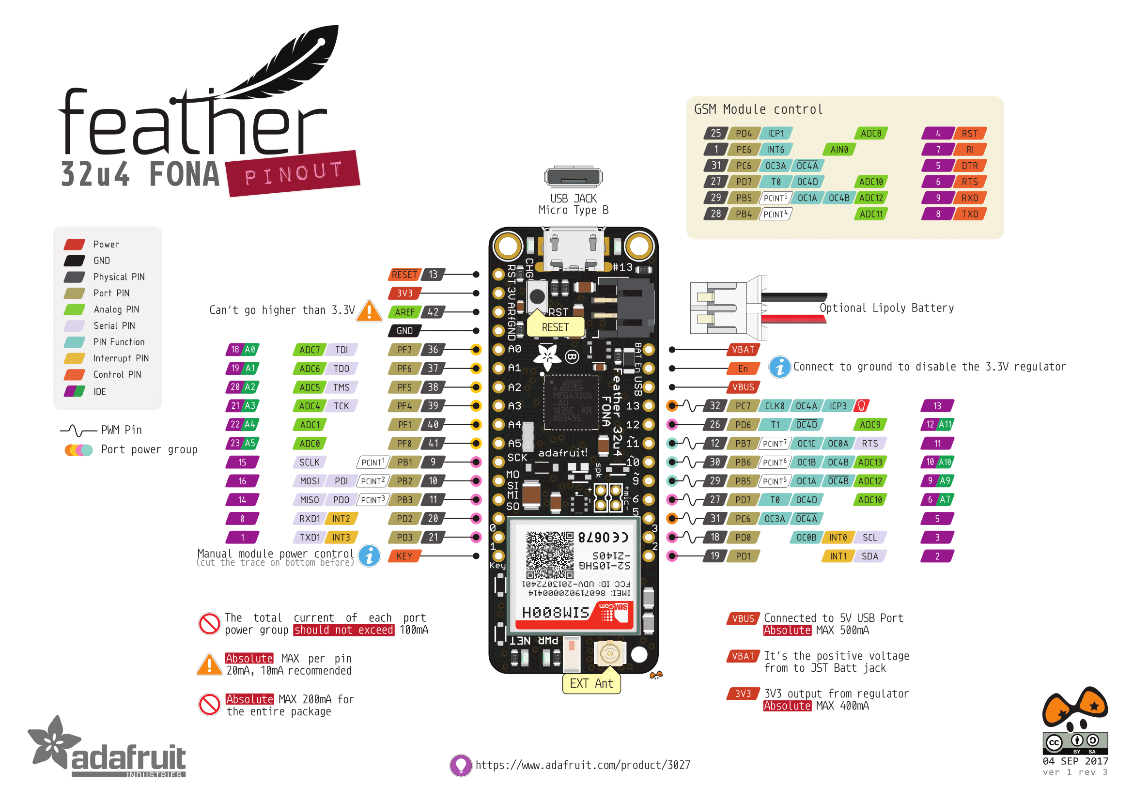

# Appendix 2: Summary of hardware connections to RPi.

|  |  |  |  |  |  |  |  |
| --- | --- | --- | --- | --- | --- | --- | --- |
| **Function** | **Module/Pin** | **GPIO** | **Rpi** | **pin** | **GPIO** | **Module/Pin** | **Function** |
| Sensor power | I2C board/VCC | 3.3V | 1 | 2 | 5V |  |  |
| I2C serial data | I2C board/SDA | GPIO2 SDA (I2C) | 3 | 4 | 5V |  |  |
| I2C serial clock | I2C board/SCK | GPIO3 SCK (I2C) | 5 | 6 | GND | I2C board/GND | Ground |
|  |  | GPIO4 | 7 | 8 | GPIO14 (UART TX) | SIM800/4 | Rx |
|  |  | GND | 9 | 10 | GPIO15 (UART RX) | SIM800/5 | Tx |
|  |  | GPIO17 Chip Enable-CE1 (SPI1) | 11 | 12 | GPIO18 Chip Enable-CE0 (SPI1) [PWM] | LiPo Shim/12 | Low-voltage shutdown signal |
|  |  | GPIO27 | 13 | 14 | GND |  |  |
|  |  | GPIO22 | 15 | 16 | GPIO23 |  |  |
| 3.3V reference | LiPo Shim/1 | 3.3V | 17 | 18 | GPIO24 |  |  |
|  |  | GPIO10 MOSI (SPI0) | 19 | 20 | GND |  |  |
|  |  | GPIO9 MISO (SPI0) | 21 | 22 | GPIO25 |  |  |
|  |  | GPIO SCLK (SPI0) | 23 | 24 | GPIO8 Chip Enable-CE0 (SPI0) |  |  |
|  |  | GND | 25 | 26 | GPIO7 Chip Enable-CE1 (SPI0) |  |  |
|  |  | GPIO 0 EEPROM SDA (I2C) | 27 | 28 | GPIO 1 EEPROM SCK (I2C) |  |  |
|  |  | GPIO5 | 29 | 30 | GND |  |  |
|  |  | GPIO6 | 31 | 32 | GPIO12 (PWM) |  |  |
|  |  | GPIO13 (PWM) | 33 | 34 | GND |  |  |
|  |  | [PWM] GPIO19 MISO (SPI1) | 35 | 36 | GPIO16 Chip Enable-CE2 (SPI1) |  |  |
|  |  | GPIO26 | 37 | 38 | GPIO 20 MISO (SPI1) |  |  |
| GND | SIM800/6 | GND | 39 | 40 | GPIO 21 SCLK (SPI1) |  |  |

# Appendix 3: Connection diagram.

|  |  |
| --- | --- |
|  |  |