Mark Lam
Computer Networking
Homework 1

1.List 3 different protocols that appear in the protocol column in the unfiltered packet-listing window in step 7 above.

Three protocols I captured were: HTTP, TCP, and DNS.
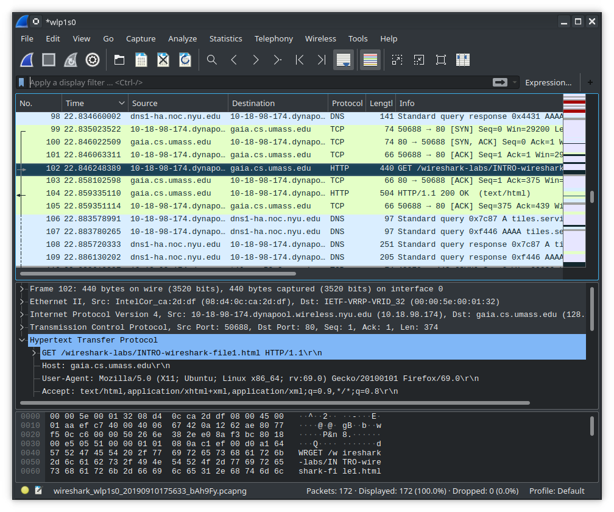

2.How long did it take from when the HTTP GET message was sent until the HTTP OK reply was received? (By default, the value of the Time column in the packet-listing window is the amount of time, in seconds, since Wireshark tracing began. To display the Time field in time-of-day format, select the Wireshark Viewpull down menu, then select Time Display Format, then select Time-of-day.)

It took 0.013086721 seconds to get a reply from the HTTP GET request.
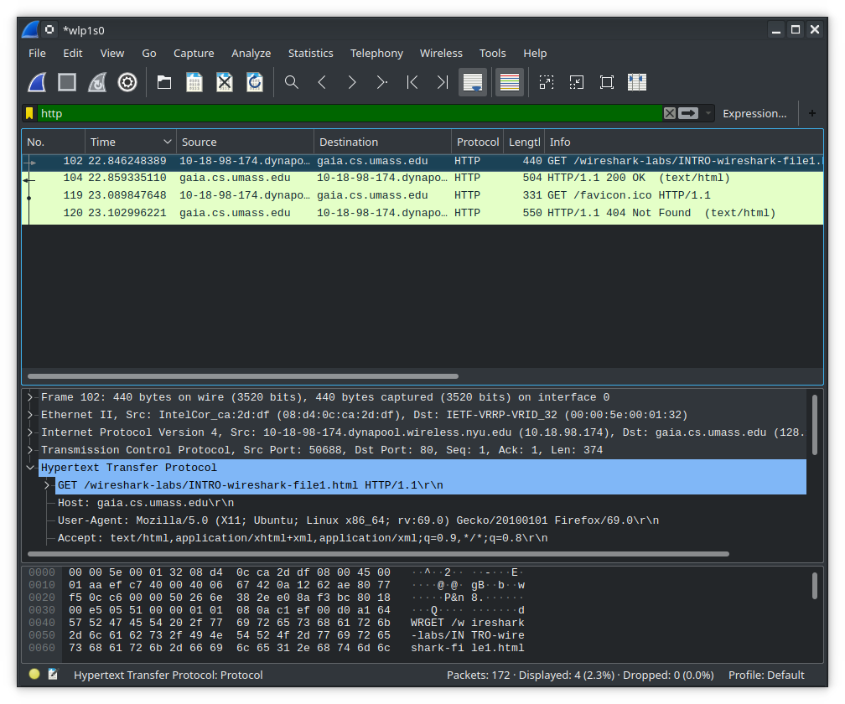

3.What is the Internet address of the gaia.cs.umass.edu (also known as www-net.cs.umass.edu)? What is the Internet address of your computer?

The IP address of gia.cs.umass.edu is: 128.119.245.12
My IP address at NYU: 10.18.98.174.

4.Print the two HTTPmessages (GET and OK) referred to in question 2 above. To do so, select Printfrom the Wireshark Filecommand menu, and select the“Selected Packet Only”and “Print as displayed”radial buttons, and then click OK.

