Mark Lam
2 October 2019
Computer Networking

Wireshark Lab 2

1. There are four fields in the UDP header: source port, destination port, length, and checksum.
2. Each header field is 2 bytes.
3. The Length field is the length of headers, 8 bytes, and the data bytes. This packet is has 43 bytes of data.
4. The maximum number of bytes that can be used with UDP is 2^16 – the headers, 65527 bytes.
5. The largest possible source pot is 65535
6. The protocol number is 17 or 0x11.
7. The two packets use the same two ports but in different fields. The first packet has src port of 4372 and dst port 53 and the second packet had src port 53 and dst port 4372

1.
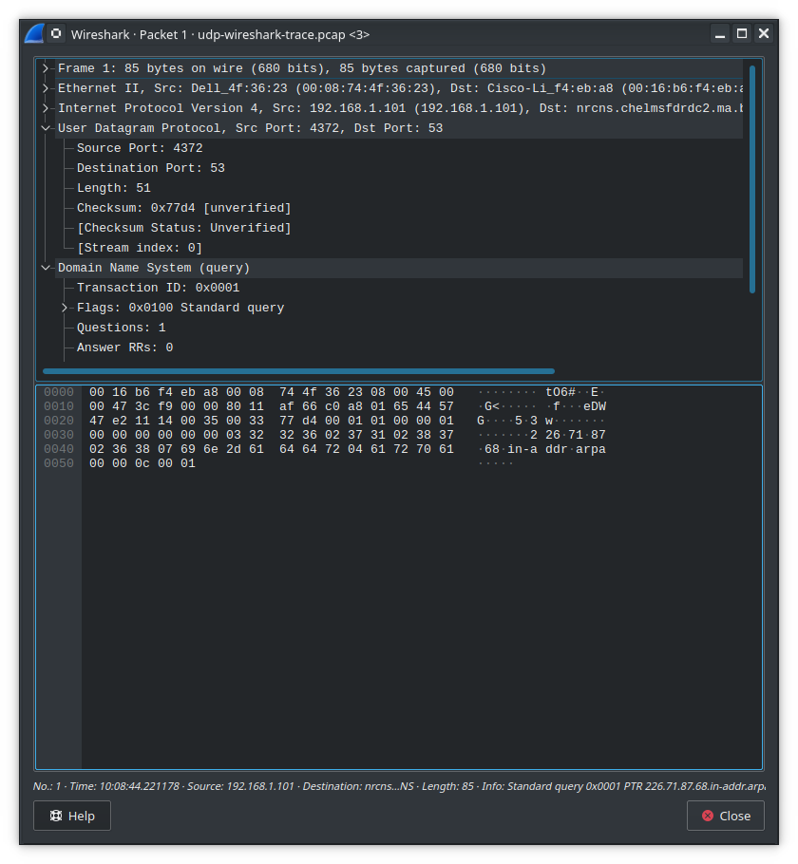

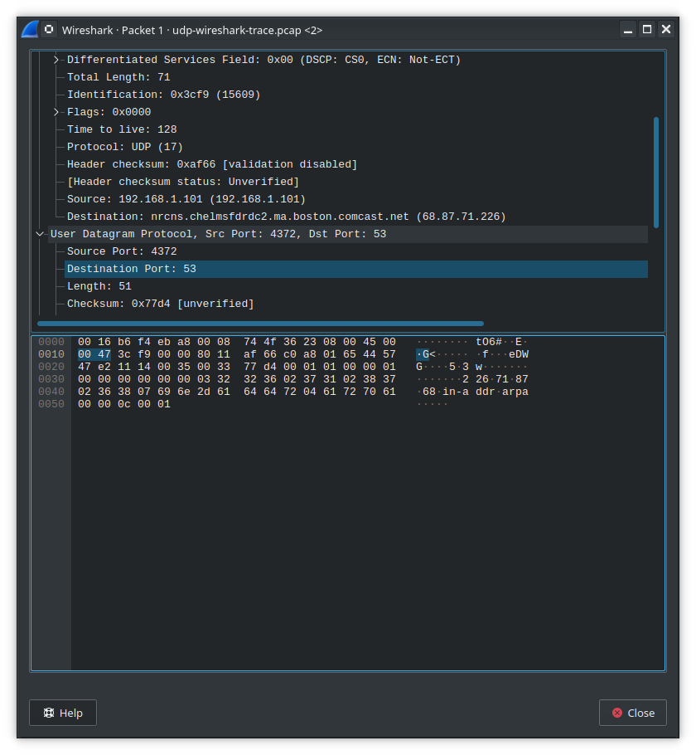
6.

7.
