Vertical: Start

Horizontal: Start

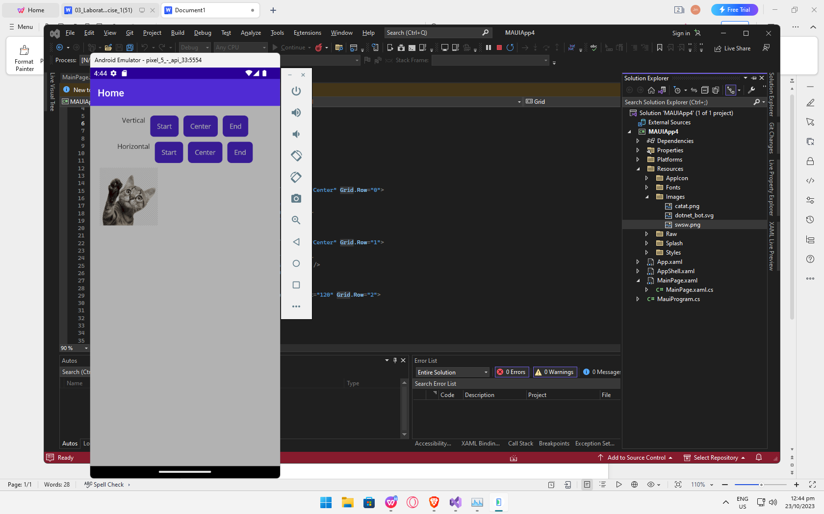

Vertical: Start

Horizontal: Center

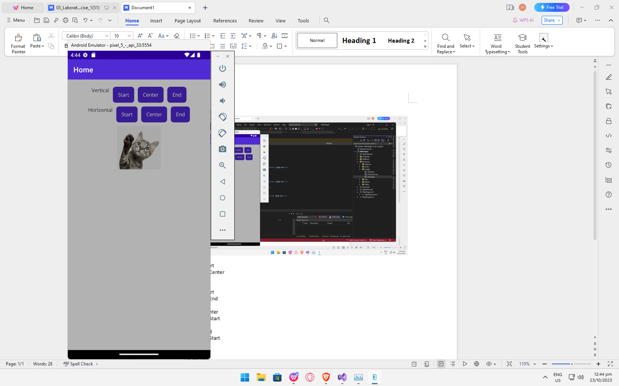

Vertical: Start

Horizontal: End

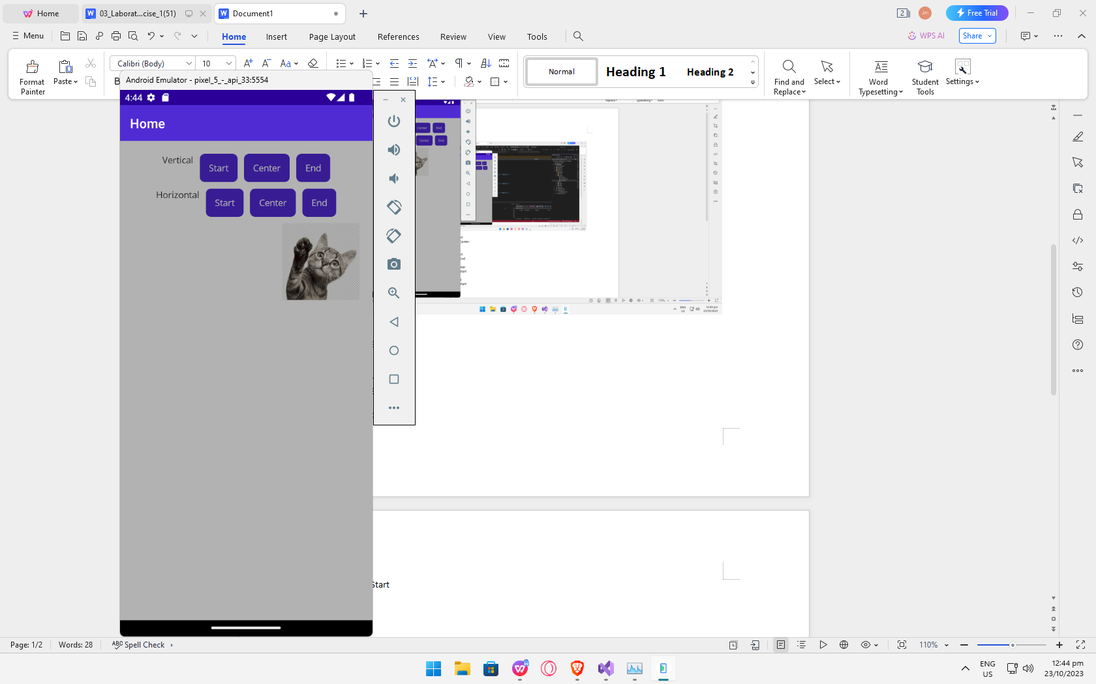

Vertical: Center

Horizontal: Start

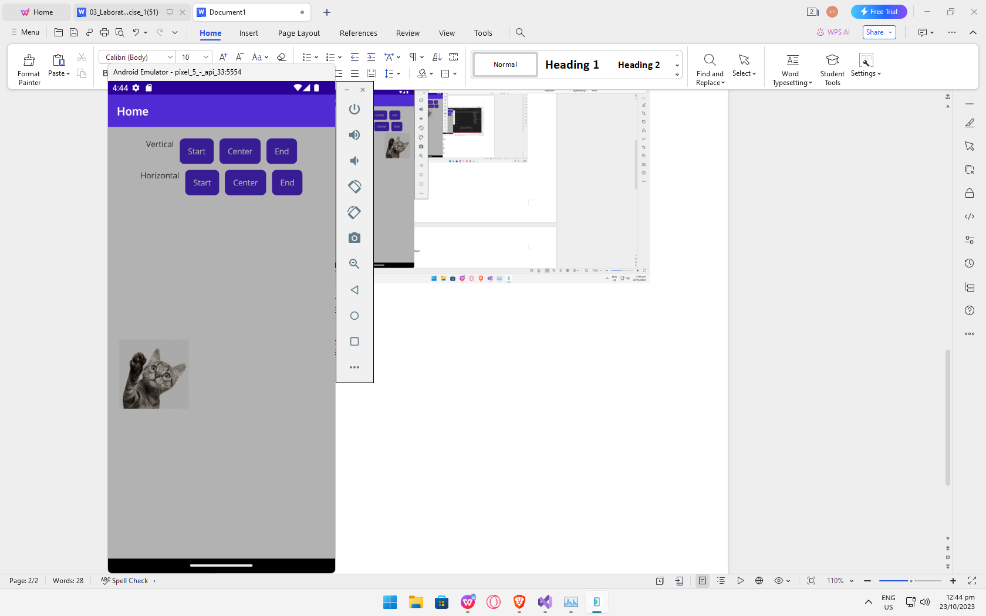

Vertical: End

Horizontal: Start

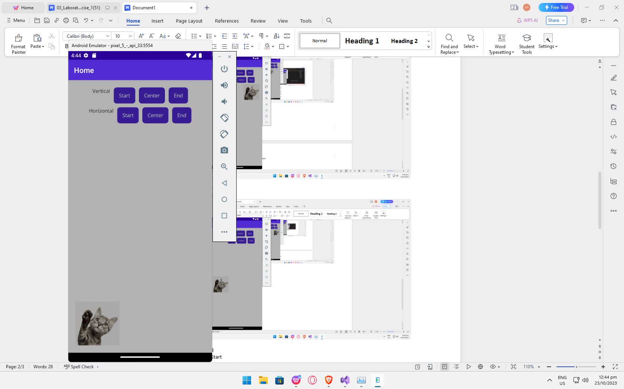

Vertical: Center

Horizontal: Start

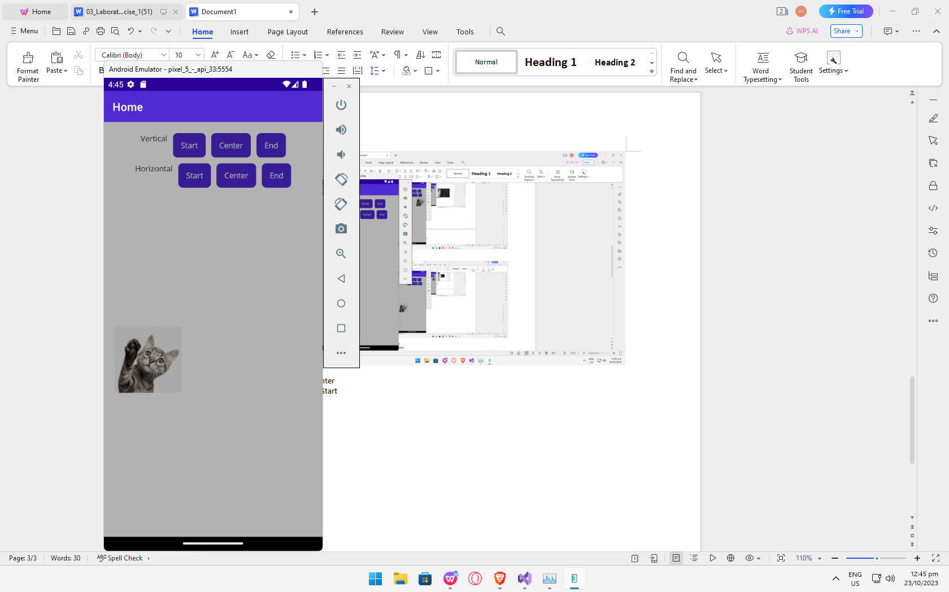

Vertical: Center

Horizontal: Center

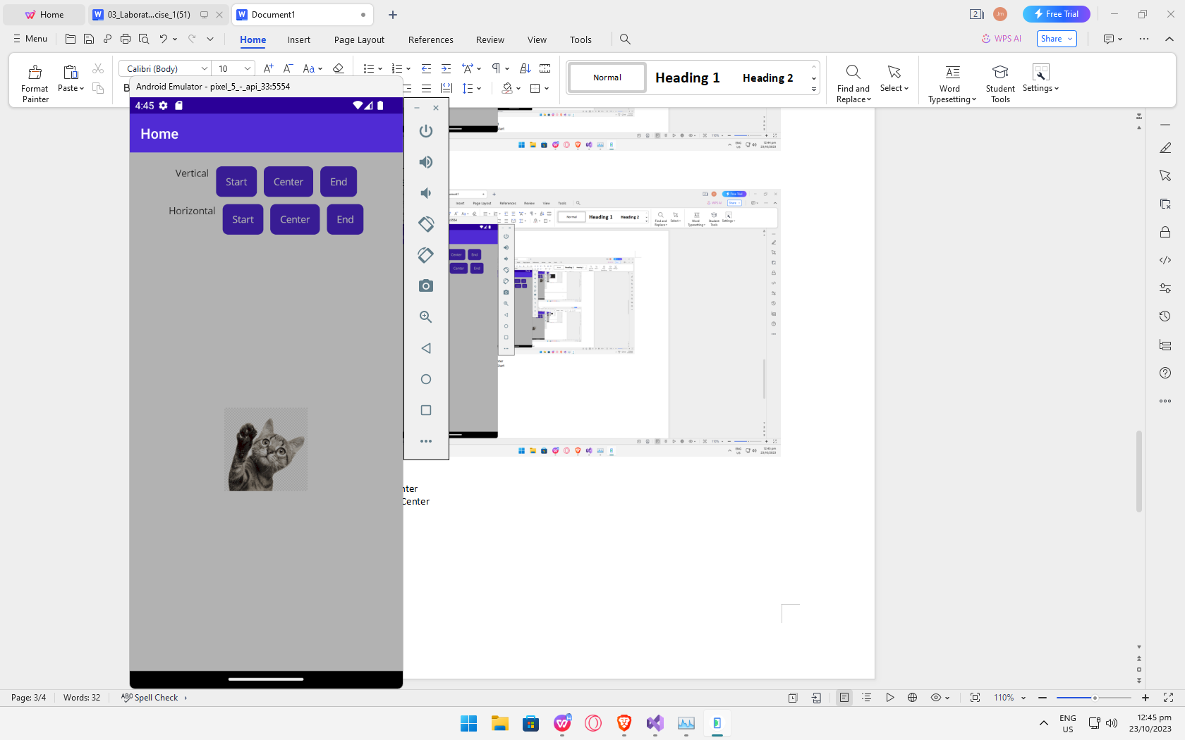

Vertical: Center

Horizontal: End

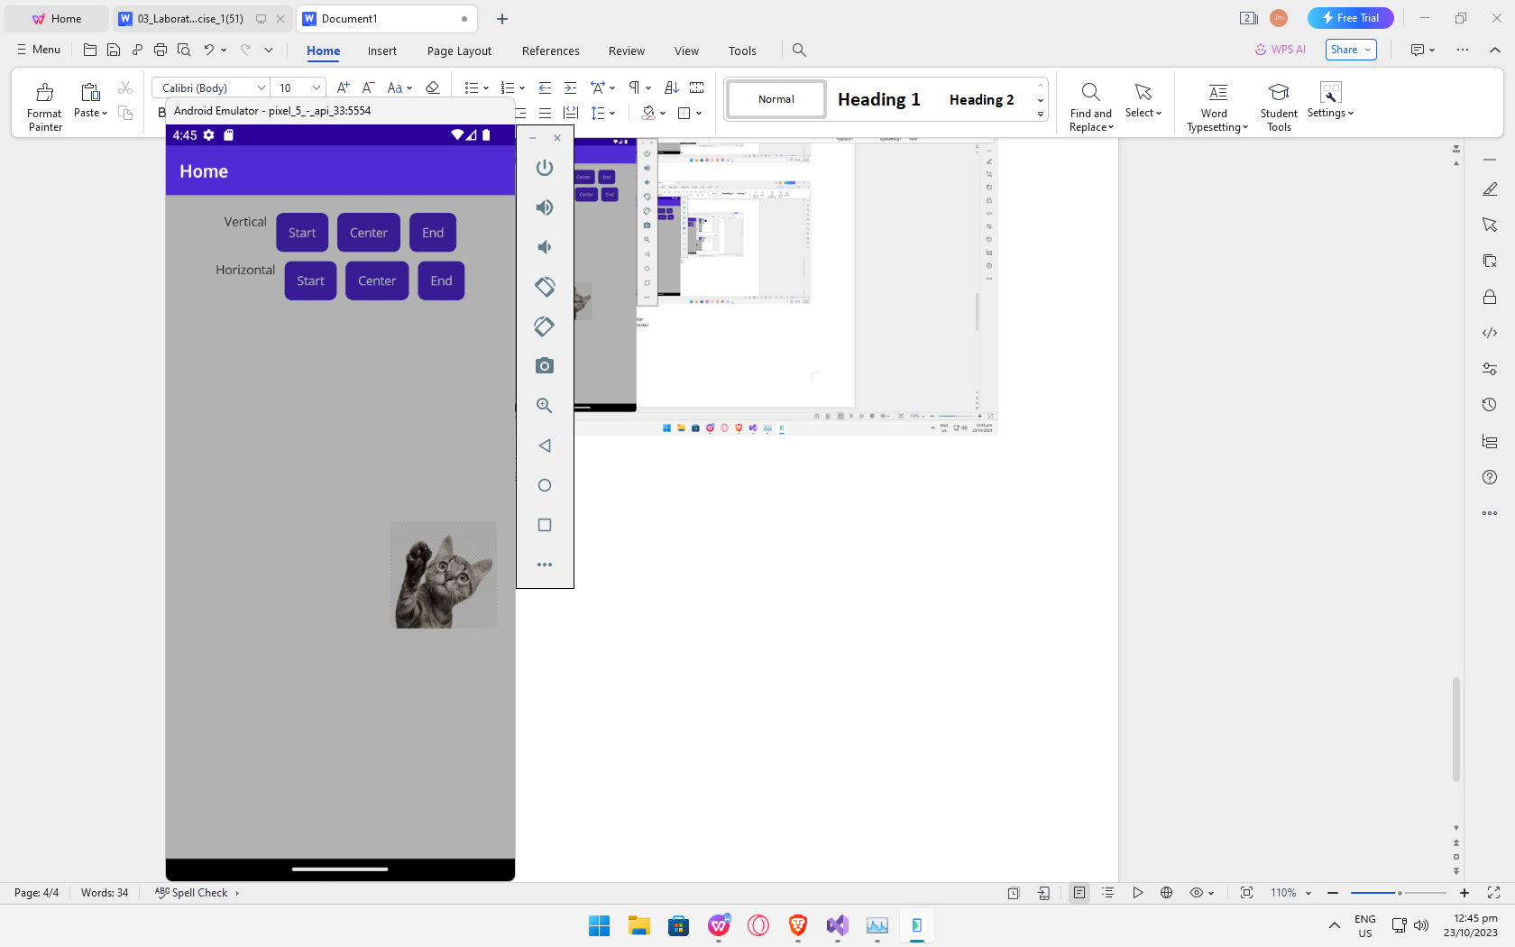

Vertical: Start

Horizontal: Center

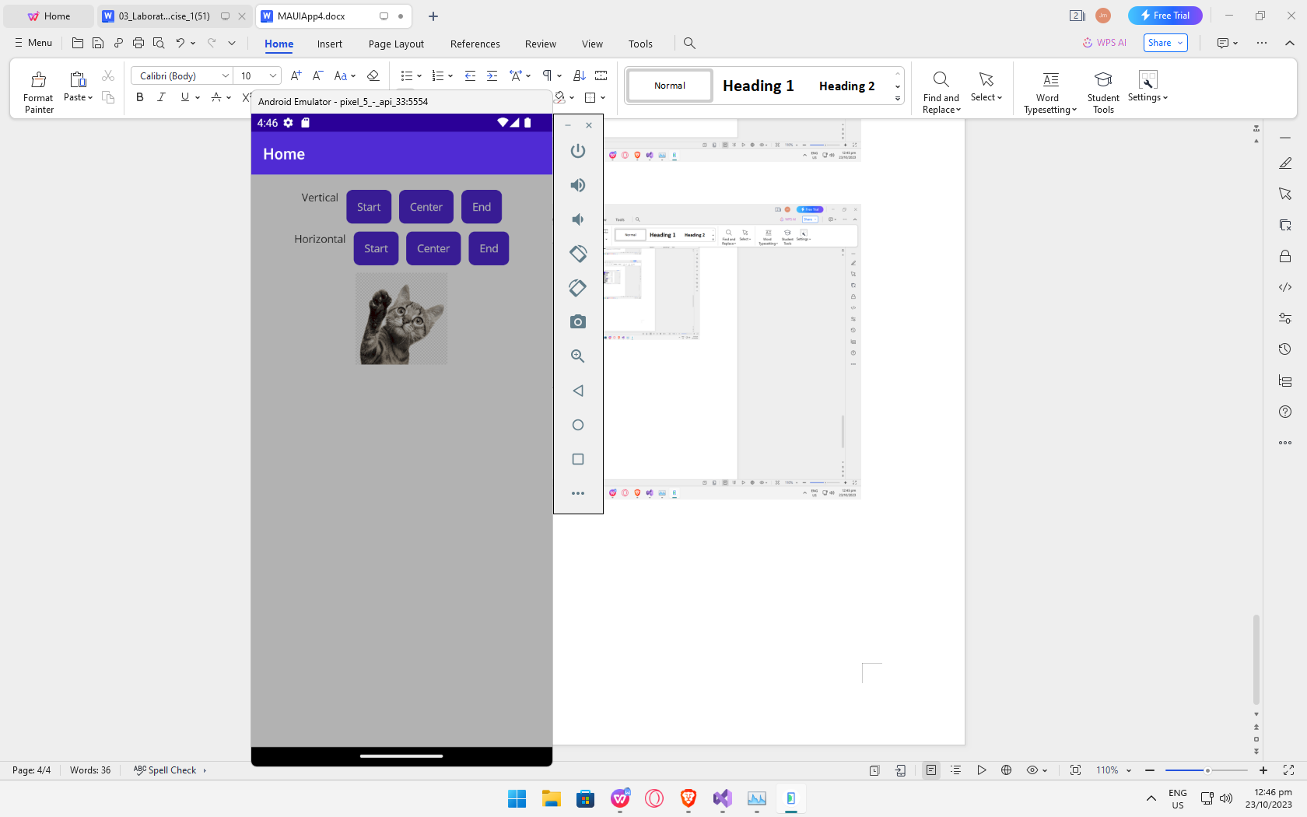

Vertical: End

Horizontal: Center

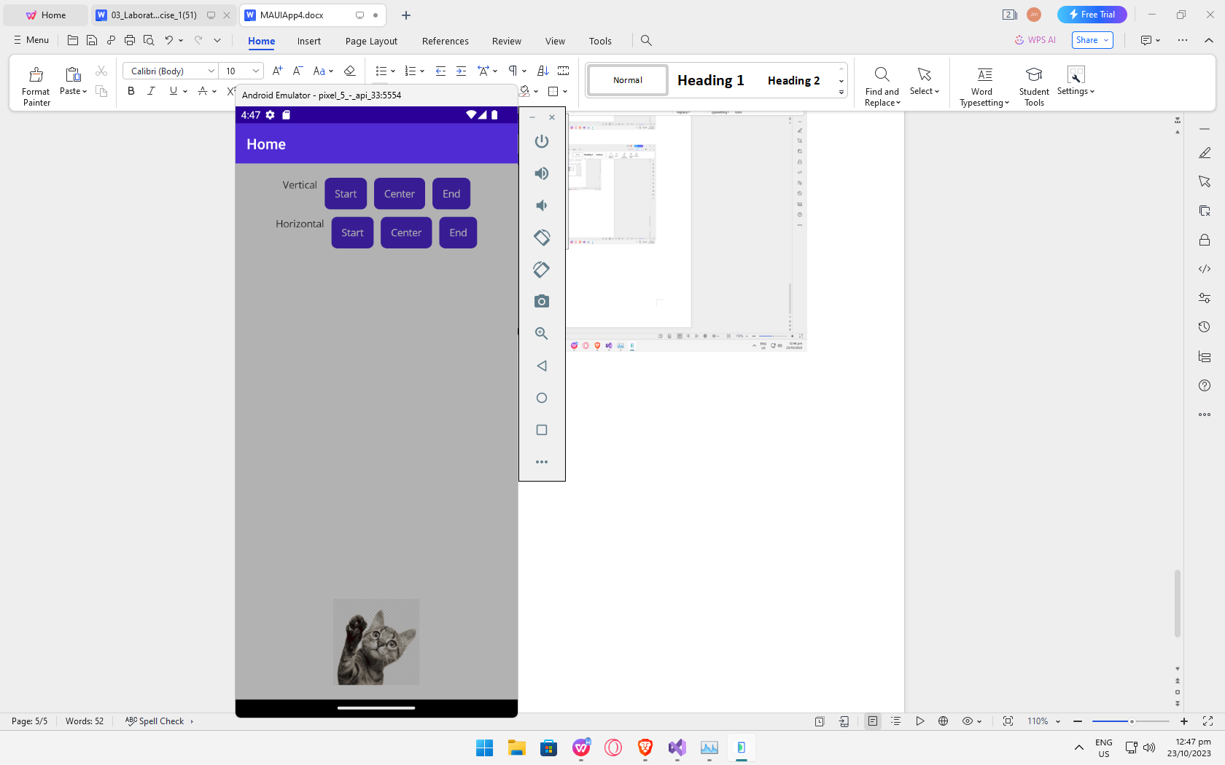

Vertical: End

Horizontal: End

