Marc Dave U. Ofilanda
C334 – IT
WSTL31C
Ms. Gen-Gen H. Roma

Actiivity Today Online Class (November 27, 2025)
Below is the link for the video demonstration I did for the activity today:
https://drive.google.com/file/d/1D0c6EJE34DINke91RdOx5RJ16S-Db0ub/view?usp=drive_link

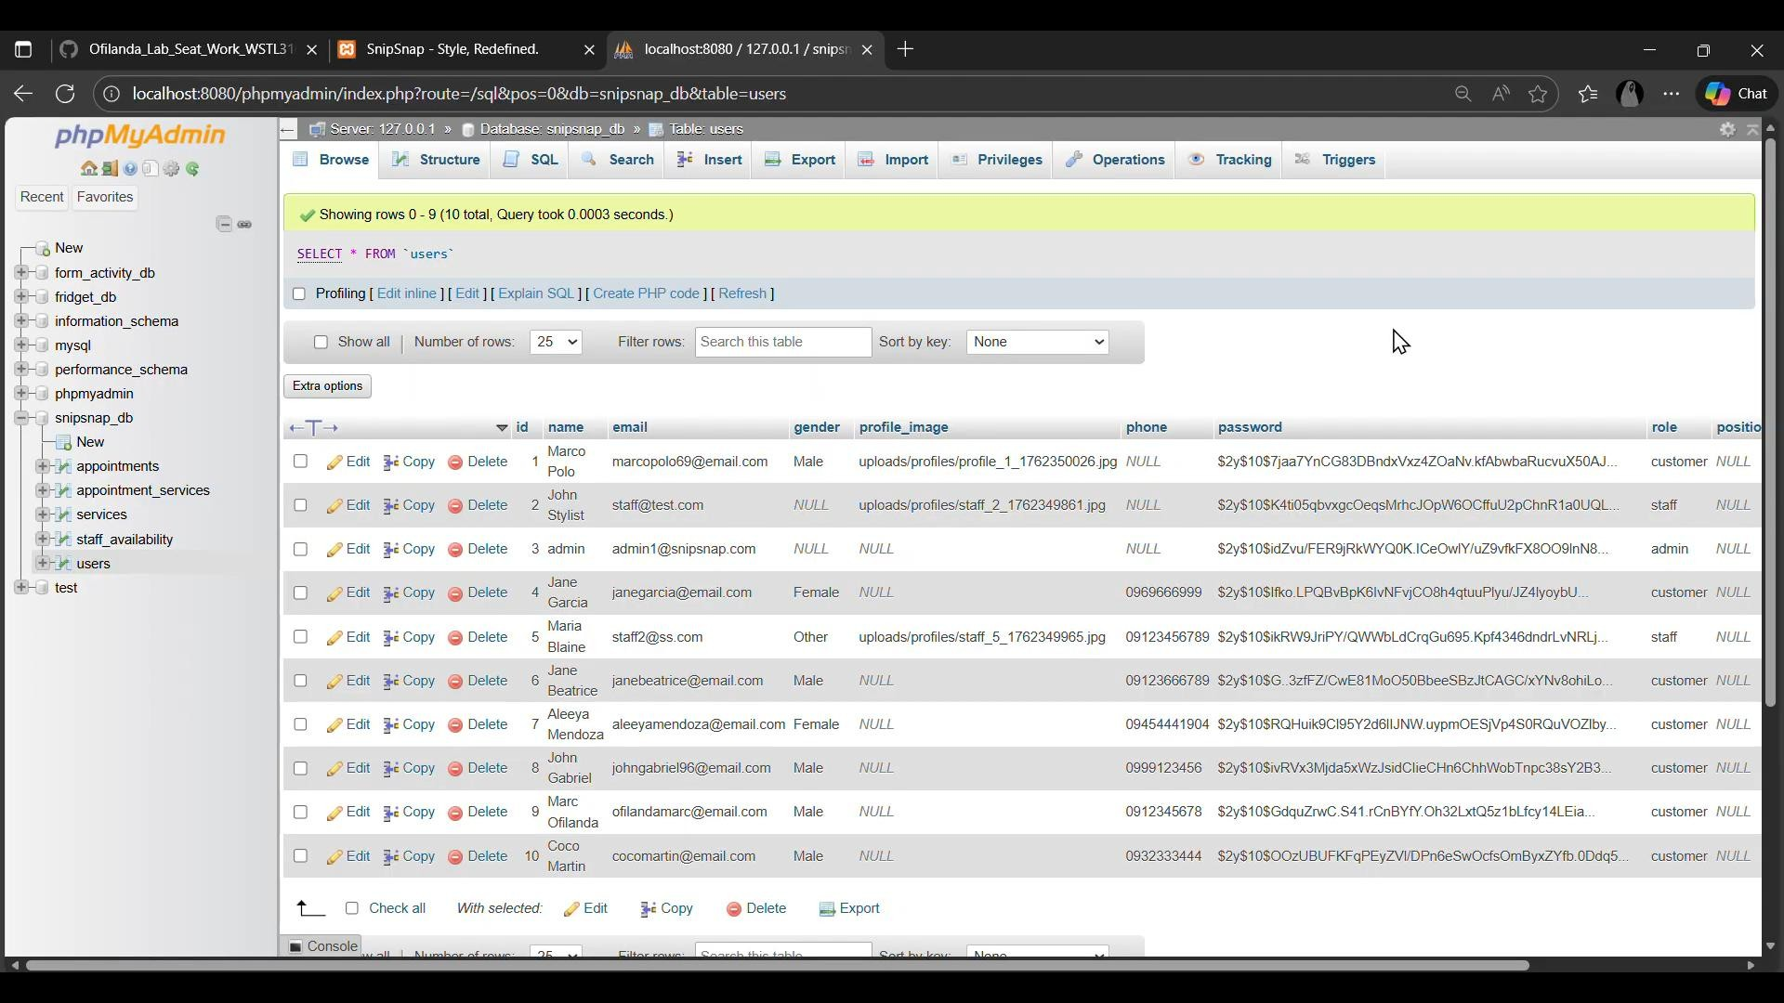
Before
(
T
here
are

only 10 user
s in the
users tables)

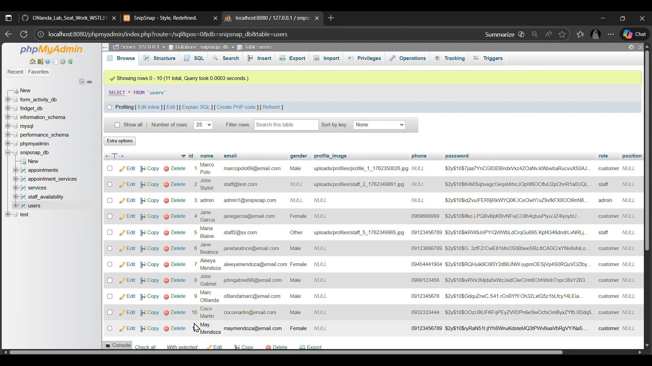
Creating or signing up a new account in the snipsnap website
11
th

U
ser

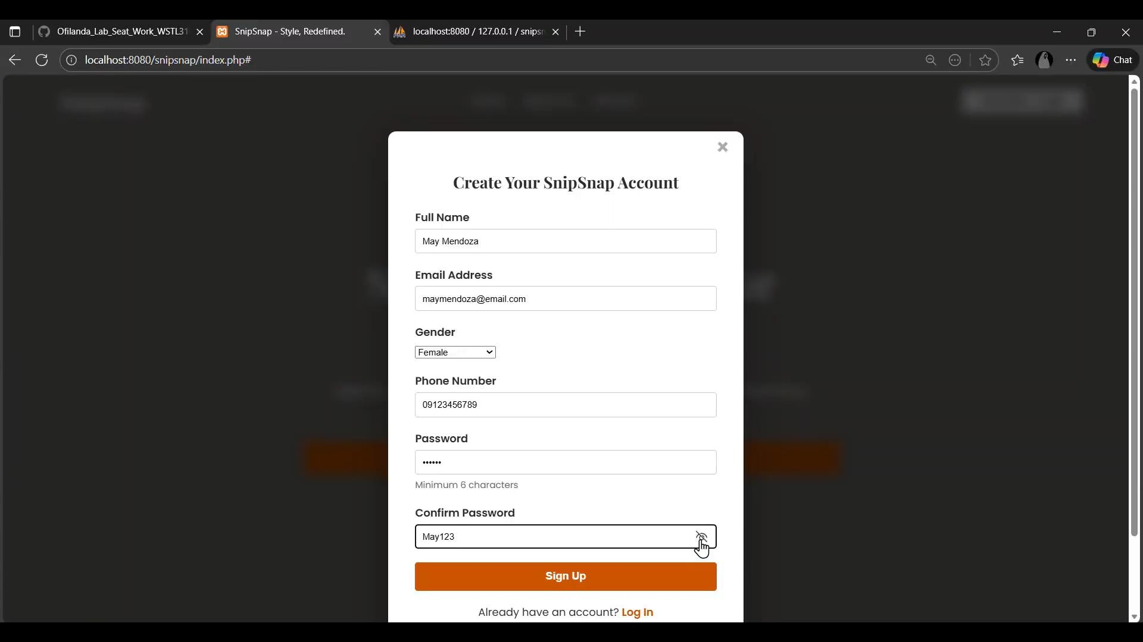

After (Now there are 11 users in the users table after signing up a new one)

