**FORMAN CHRISTIAN COLLEGE (A CHARTERED UNIVERSITY)**



COMP 401 B

SP24

Ethics for Computing Professionals

Assignment 2

Hafsah Shahbaz

251684784

**COMP 401: Ethics for Computing Professionals**

**Assignment 2**

The protection of intellectual property rights, or IPR, is essential for the inventions of the mind, including software. Software is covered by a number of different IPR kinds, each with a different protection period and scope. When compared to traditional property like land or goods, intellectual property is more difficult to protect because it is intangible.

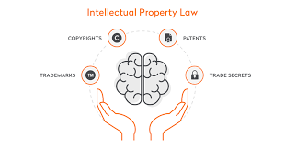

**Patents:**

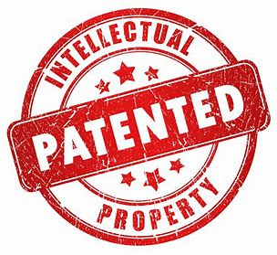

It grants the inventor an exclusive right to use, produce, and sell an invention giving the owner the right to exclude others from making, using, selling, offering to sell, and importing an invention for a limited period of time typically 20 years. Software patents can be challenging to obtain due to the requirement of novelty, usefulness, non-obviousness, and patentable subject matter. In the context of software, a patent might protect a unique algorithm or functionality.

A patent will protect things like:

* Systems
* Functions
* Solutions to computer problems

**Copyrights**:

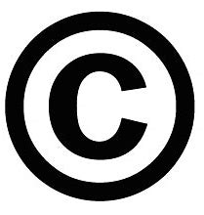

Conversely, copyrights shield ideas' expression rather than the ideas themselves. This indicates that the particular code or user interface is protected in software. When a work is created, copyright is immediately awarded and is valid for the author's lifetime plus 50 years, or 75 years from the date of publication if the work was made by an employee of the company.

When you hold the copyright to software code, you can:

* Make copies of your software code
* Sell or give away the code.
* Make a "derivative work," which is a second software that uses a lot of the original code
* Post the code somewhere, or otherwise display it.

**Trademarks:**

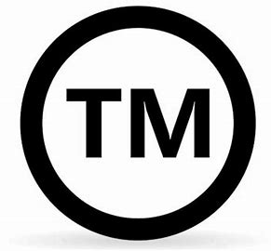It guards names, symbols, and catchphrases that are used to brand products or services. They safeguard the brand identification by prohibiting third parties from using a confusingly similar name or emblem, even though they do not protect the program code. Names of brands or products are often marked as trademarks using a trademark symbol: ™ for unregistered trademarks, and ® for registered ones.

**Trade secrets:** Any methods, plans, formulas, procedures, or any knowledge that gives a company an edge over rivals that are unaware of or unwilling to employ it. In the context of software, this could refer to trade secrets or proprietary development processes used to preserve a competitive advantage.

You must take reasonable measures to keep the software a secret:

* Prevent the public from accessing the software.
* Request non-disclosure agreements from staff members.
* Request that workers sign non-compete clauses.
* Conduct exit interviews with departing personnel to ensure that no intellectual property is being taken with them.
* Remove all file and data access from an employee as soon as they are dismissed or resign.
* Look into any shady staff behavior.
* Store intellectual property in separate areas and restrict access to those personnel who require it.

**Practical examples of the importance of registering these rights include:**

1. If a software company creates a ground-breaking data analysis tool but doesn't file a patent, rivals may be able to legally copy the tool's features, costing it market share and possibly even money.

2. The code for a unique game app is created by a developer without copyright protection. A different developer might steal the code, publish a game that is identical, and hurt the sales and reputation of the first app.

The absence of legal protection in both situations may lead to large financial losses and a loss of control over the software product.

Examples of successful software patents:

* Amazon "One-Click-Buy" software, U.S. Patent No. 5960411
* The mp3 audio software, U.S. Patent No. 5579430

**References**

(1) Software Intellectual Property 101: IP Protection & More | Thales. <https://cpl.thalesgroup.com/software-monetization/protecting-software-intellectual-property.>

(2) Intellectual Property Protection for Software: What to Know - UpCounsel. <https://www.upcounsel.com/intellectual-property-software.>

(3) Intellectual property rights and software | BCS. [https://www.bcs.org/articles-opinion-and-research/intellectual-property-rights-and-software/.](https://www.bcs.org/articles-opinion-and-research/intellectual-property-rights-and-software/)

(4) en.wikipedia.org. [https://en.wikipedia.org/wiki/Intellectual_property.](https://en.wikipedia.org/wiki/Intellectual_property.%20)