1. an abstract (200-250 words); (B) a short intro (2-3 paragraphs) about the question, (C) a description of the methods (data collection & analysis), (C) a results section and a summary paragraph (~3-4 pages total). Reports should be referenced and including figures is advised.

Mosses

Here, we aimed to answer two questions: 1. Are moss species (Bryophyta) growing in dry substrates better at water retention? And 2. Are mosses species with lower dehydration rates more derived in the evolutionary history of the group? To answer these questions, we collected information about the dehydration rates of ten species of bryophytes as well as the growing substrate and the environment where they were found. We analyzed the relationships between the rates of dehydration and the environmental measurements using a Bayesian approximation for phylogenetic mixed effects models. We predict that species that live in dryer environments as rocks, will have a small dehydration rate. As well, we expect that species with lower water loss are more derived in the phylogeny.

Table . Pairwise comparison per model by substrate.

|  |  |  |  |
| --- | --- | --- | --- |
| **Rates complete** | | | |
| **Comparison** | **Posterior Mode** | **Lower Boundary** | **Upper Boundary** |
| rock vs sand | -0,507 | -1,824 | 0,644 |
| sand vs soil | 0,169 | -1,341 | 1,089 |
| soil vs wood | 0,724 | -0,063 | 1,806 |
| rock vs soil | -0,504 | -1,234 | 0,247 |
| rock vs wood | 0,349 | -0,561 | 1,337 |
| sand vs wood | 1,261 | -0,486 | 2,323 |
| **Rates separate** | | | |
| rock vs sand | -0,597 | -1,897 | 0,598 |
| sand vs soil | -0,315 | -1,395 | 1,025 |
| soil vs wood | 0,599 | -0,341 | 1,532 |
| **rock vs soil** | **-0,822** | **-1,457** | **-0,042** |
| rock  vs wood | -0,324 | -1,006 | 0,863 |
| sand vs wood | 0,269 | -0,926 | 1,926 |
| **Immediate loss complete** | | | |
| rock vs sand | -1,159 | -2,367 | 0,178 |
| sand vs soil | 0,768 | -0,367 | 2,120 |
| soil vs wood | 0,576 | -0,529 | 1,398 |
| rock vs soil | -0,274 | -1,051 | 0,619 |
| rock vs wood | 0,293 | -0,554 | 1,511 |
| sand vs wood | 1,604 | -0,094 | 2,775 |
| **Immediate loss separate** | | | |
| rock vs sand | -0,119 | -2,150 | 2,191 |
| sand vs soil | -1,027 | -2,739 | 1,659 |
| soil vs wood | 0,287 | -0,983 | 2,282 |
| rock vs soil | -0,473 | -1,870 | 0,657 |
| rock vs wood | -0,164 | -1,610 | 1,759 |
| sand vs wood | 0,056 | -2,458 | 2,529 |

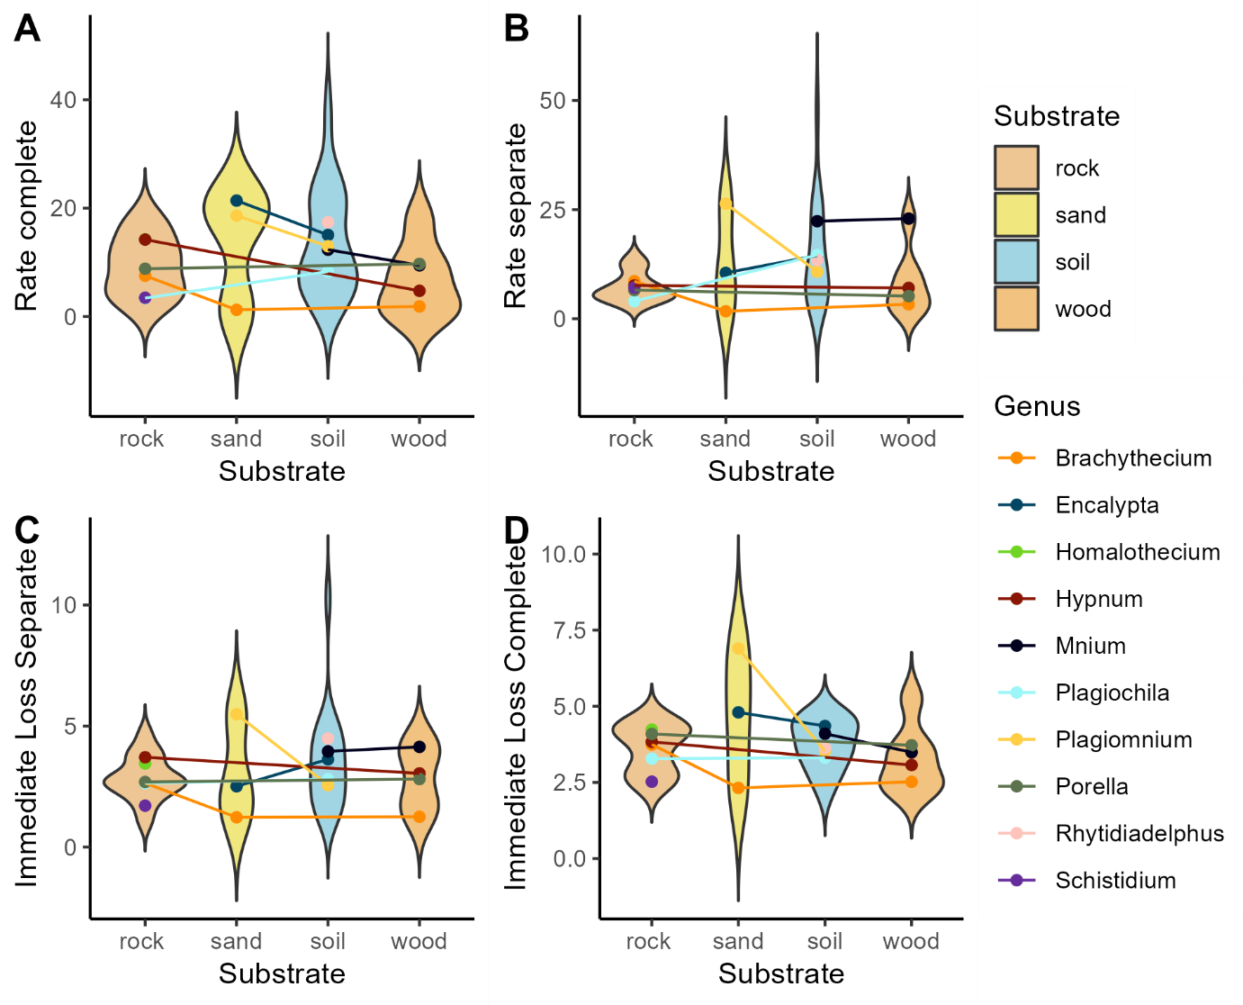

Figure . Substrate divided data for A. rate of water loss in complete pieces, B rate of water loss in separated pieces, C Immediate water loss in separated pieces, and D immediate water loss in complete pieces.

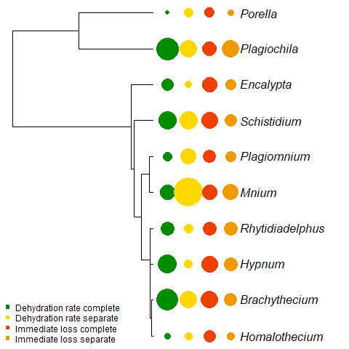

Figure . Bryophytes tree with Dehydration rates and Immediate water loss values.