# **Improving Cognitive Functions in Seniors**

Victor Boström Emelie Thunborg Emma Österberg  
 KTH – TIMEL3 KTH – TIMEL3 KTH – TIMEL3  
 [vbostrom@kth.se](mailto:vbostrom@kth.se) [emelieth@kth.se](mailto:emelieth@kth.se) [emmaoste@kth.se](mailto:emmaoste@kth.se)

**Abstract**

Unfortunately, cognitive ability will deteriorate in seniors. There is no medical treatment methods towards cognitive impairment. The product presented will help slow down the cognitive impairment and help our seniors to successfully maintain their cognitive ability. The product in question is a medical treatment towards cognitive impairment  
 ***Keywords: Brain activity, EEG, cognitive ability***

**I. Introduction**

Humans continue to live longer, but deterioration in the cognitive ability will begin around the same age, regardless of life expectancy. The seniors may experience a decline in several cognitive functions, such as memory, attention, executive functions and processing.   
 Deterioration in these functions are common symptoms in senile dementia and today there is no specific treatment for this, but there are recommendations to slow it down [1]. Studies show that continuous brain exercises for a few weeks, that require cognitive skills, will lead to improvement in cognitive ability [2].

The contribution from this paper is a prototype in response to medical treatment of cognitive impairment and giving an in-depth analysis using EEG.

**II. Design**

*A. System design*

The system consists of four different parts.

* A computer that assigns and receives data and acts as an interaction between the user and the system.
* An Arduino UNO with a programmed microcontroller that assigns instructions to the circuit board.
* The interaction between the user and the circuit board
* A Ganglion PCB that collects data using EEG.

The system is shown in figure 1.

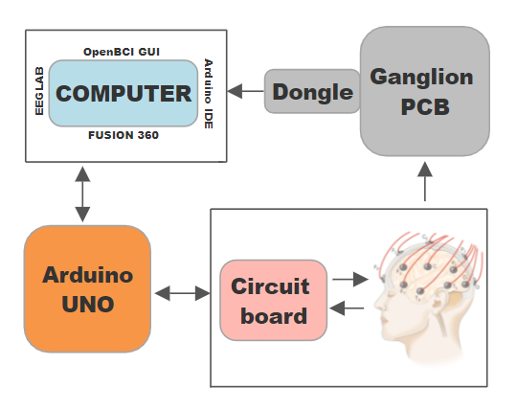

Figure 1: Block diagram of the system.

The system this paper presents allows the user to choose whether to perform a memory or reaction test.

The memory test involves the user memorizing a sequence of LEDs. The test starts at level one where only one diode lights up, the user then presses the corresponding pushbutton. If the user passes this level, they go on to level two where two diodes are now lit up. This progression continues up to level nine, where the progress will be shown on the computer and a higher level will indicate an improvement in memory. If the user fails at any level, the test ends and user returns to the menu.

The reaction test means that the user must press the corresponding pushbutton of the LED that lights up as quickly as possible. When the test starts, there is a randomized delay between 0-5 seconds before the first diode lights up. Then a timer is started which takes the time between the LED being lit up and the user pressing the button, this time will be visible on the computer showing the users reaction time. A shortened time implies an improvement in reaction. After this, a new delay of 0-5 seconds occurs before the second diode is lit. This is repeated 15 times in a randomly generated order. When the test is finished the user returns to the menu.

*B. Hardware*

*1)* An Arduino board called Arduino Uno SMD is used and powered via USB connection to a computer. The ATmega328 microcontroller on the board comes pre-burned with a [bootloader](https://www.arduino.cc/en/Tutorial/Bootloader) that allows new code to be uploaded to it without the use of an external hardware programmer.

*2)* PCB from OpenBCI called Ganglion is used for measuring EEG, which is compatible with their free open-source software, OpenBCI GUI. Four channels are used to measure activity from the brain via electrodes with specific placements according to the 10-20 system. 

*C. Software*

*1)* We use the open-source Arduino Software (IDE) which makes it easy to upload instructions directly to the Arduino UNO. A program written for an Arduino board is written in C++ with some additional functions and special methods [3].

The whole program is based on a loop where the user either presses the yellow or red button. From here a function is called, depending on the button pressed, initializing one of the two tests. The menu is shown in Arduino’s own *serial monitor* together with the results from the two different tests.

The software can also be used with any Arduino board available. 

*2)* For measuring and collecting EEG data from the Ganglion PCB, we use OpenBCI's free open-source software, GUI. The raw EEG data is saved as a text file. 

*3)* There are several third-party programs that can be used in conjunction with the OpenBCI software, MATLAB is one of them. Some of the MATLAB toolboxes have been created especially for working with EEG and BCI, of which we chose to use EEGLAB for processing and analysing the text files.  
  
*D. Prototype design and fabrication*Two different software’s were used in the design procedure for different purposes. Tinker CAD was used to develop a 3D design, and FUSION360 was used to develop a CAD design.

**III. Results and Evaluation**

To be able to determine if the test results have improved and analyse what happens in the brain during cognitive treatments, we have put a lot of focus on EEG measurements. The user receives the result in the form of a level or reaction time, while the result that is significant for later studies is obtained from the EEG. The EEG will show improvements in the form of a higher amplitude.

The cognitive ability includes several functions for different purposes. Therefore, we chose to examine two functions instead of only one. Additional functions are discussed in part IV*.*

*A. Electrodes and brainwaves*

Different data can be collected from the brain activity depending on the placements of the electrodes. As our product relates to the improvement of cognitive ability, the frontal lobe, the temporal lobe, and the occipital lobe are examined. The frontal lobe is responsible for cognitive abilities, such as problem solving, planning and organization. The temporal lobe is responsible for short-term memory and the occipital lobe is responsible for visual processing such as colours and patterns [4].

To be able to measure the desired brain waves, we used the 10-20 system with six placements and two reference points. As can be seen in figure 2, Fp1, Fp2, T3, T4, O1 and O2 were used to measure their counterpart. A1 and A2 are used as reference points. Fp1 and Fp2 measure the activity in the frontal lobe, T3 and T4 measure the activity in the temporal lobe and O1 and O2 measure the activity in the occipital lobe. An EEG paste was used to get a better signal from the electrodes.  
 Brain waves with various frequencies are emitted during different activities. The majority of brain waves will change depending on the activity. There are five different types of waves where each wave type is defined by its frequency. As a result of the activity performed by our users, beta waves will be emitted with frequencies between 12 and 38 Hz [5].

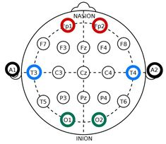

Figure 2: Electrode placements

*B. During sessions*

When a session is performed, the user is connected according to previous descriptions. In OpenBCI, an impedance check is made to check the connection of each electrode to the user's head. Depending on the impedance, the program gave a simple indication through a green dot with a good connection and a red dot with a bad connection. The user chooses whether to perform a memory or reaction test. Depending on the test and user, the session varied between 40 and 105 seconds.

Compared to the amplitude of the signals derived from the brain activity, noise was noticed at 50 Hz which generated an amplitude which was about ten times higher. Noise can be generated both from an external source, called external noise, or from the device itself as internal sound. To reduce the noise, we use a notch filter that interrupts signals between 49Hz and 51Hz. Other filters are not applicable during an ongoing session.  
 Notes were taken during the session to facilitate analysis of the EEG data.  
  
*C. Analysing the data*Several measurements were performed for both memory and reaction tests. More data makes it easier to analyse brain waves and see both patterns and differences. After trying to analyse the first sessions without much success, we decided to take notes during the tests and add a timestamp for each time a button is pressed to make it easier to compare the EEG readings with the corresponding event during the measurement.  
 Since filters can not be used during an ongoing session it is later applied in EEGLAB during the analysis. We used a band pass filter to look at the specific frequency range for the beta waves we are aiming to measure. This filter cut-off frequencies lower than 12Hz and higher than 38Hz.  
 After the filter was applied, clear curves could be read and analysed. The result is shown in figure 3 for memory and figure 4 for reaction.

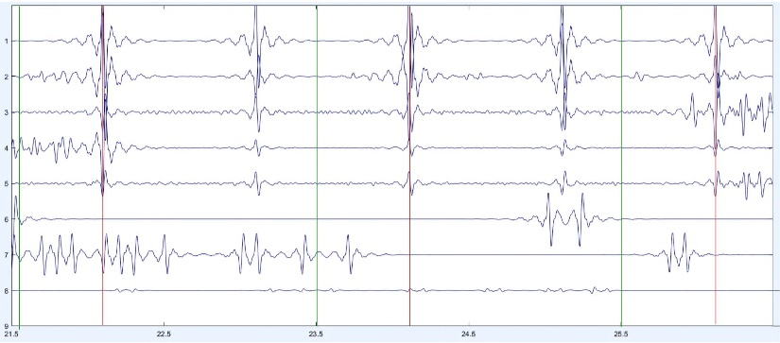

Figure 3: EEG plot for memory   
  
         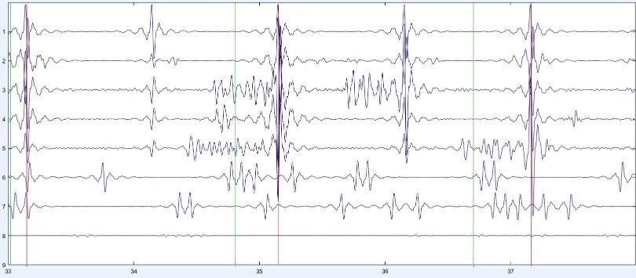Figure 4: EEG plot for reaction

In the two figures above, there are three green lines and three red ones. The green lines correspond when the button has been pressed according to our timestamp and the red lines correspond to the same event with a certain time delay in the EEG measurement. Due to human and technical factors, it is difficult to get the timestamp and the EEG measurement at the same spot, so through careful analysis of our measurements we can conclude that these lines are related to the same event.

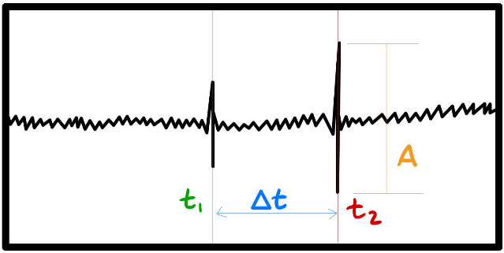

Figure 5: Simplified image of an EEG plot

Using figure 5 we can now explain the use of time stamps and how an improvement is anticipated to be noticed. The x axis is the time, and the y axis is the amplitude, *t1* refers to the event of a LED being lit, *t2* refers to the user pressing a push button and *∆t* is the reaction time. The amplitude *A* is noted as shown in the figure above. Improvements will be noticed when either *A* is showing an increase or *∆t* is showing a reduction [6].  
 When analysing EEG data from the reaction test, it is clear when a button has been pressed. By using the timestamp as well as the reaction time from the Arduino, we can also distinguish directly in the graph when the user has reacted to an LED and presses the corresponding button.   
 Unlike reaction, the memory test is longer with several levels, which makes the analysis more complex. However, we were able to distinguish a pattern in the sequence that became clearer at higher levels, as the user needed to memorize more LEDs. Between each press of a button more activity could be seen indicating that the user needed to concentrate more on the task on higher levels.

We anticipate that improvement will be higher amplitudes and more activity while performing a task, all indicating that the user has become better at memorizing several things and reacts faster. 

D. Prototype design  
A major priority for the project was to design a user-friendly device. First, we developed a CAD design that can be seen in Figure 6. The rectangular hole on the tilted part is intended for a future LCD screen, which is discussed more in part IV. The four holes on the same part are intended to hold four LEDs in the colours yellow, white, green and red. The remaining four holes below are intended to hold the corresponding push buttons in the same colours. We have also provided the product with an input suitable for USB-B port. Second, a 3D prototype was developed that represents what the final product should look like.

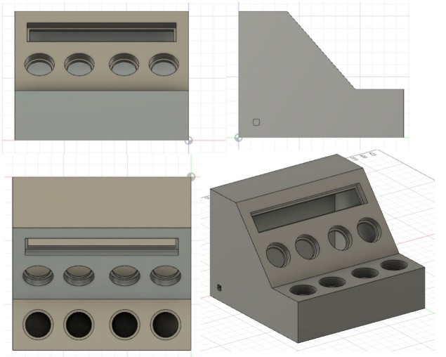

Figure 6: CAD design

**IV. Future work and conclusion** *A. Future work*The priority for future work will consist of 3D print our design and manufacture a PCB circuit board to present a final product.

Furthermore, performing continued tests for a longer period to ensure improvement in users. These measurements will be performed on seniors with varying degrees of impaired cognitive ability.

Finally, focusing on diagnosing and predicting cognitive impairment and thereby slowing it down before deterioration has occurred. By calling for a voluntary test, we want to be able to see deviating patterns that indicate cognitive impairment with the help of mathematical algorithms. As everyone is unique, this deterioration will occur at different ages. With this development, we also want to add more features of problem solving, such as mathematics.

*B. Conclusion*We have presented a prototype that can improve cognitive performance as a solution for deterioration in several cognitive functions due to aging. However, there is still some work to be done to ensure improvements and to have an integrated product that works fully.

**V. References**

[1] Rydén, M., & Berggren, J. (2018). Kognitiv sjukdom. Hämtat från Vårdgivarguiden: [https://vardgivarguiden.se/globalassets/kunskapsstod/vardprogram/kognitiv-sjukdom.pdf?IsPdf=true](https://vardgivarguiden.se/globalassets/kunskapsstod/vardprogram/kognitiv-sjukdom.pdf?IsPdf=true&fbclid=IwAR09St4oxLh5NUyGz3_6423eXwBtDRZqLu0JcAUa_LS5mwAs3lHnLgqmoQc)

[2] Nouchi R, Taki Y, Takeuchi H, Hashizume H, Akitsuki Y, Shigemune Y, et al. (2012) Brain Training Game Improves Executive Functions and Processing Speed in the Elderly: A Randomized Controlled Trial.

[3] <https://www.circuito.io/blog/arduino-code/>

[4] (2012). Mapping the Brain. Hämtat från BrainFacts: <https://www.brainfacts.org/brain-anatomy-and-function/anatomy/2012/mapping-the-brain>

[5] What is the purpose of Theta brain waves. Hämtat från healthline: <https://www.healthline.com/health/theta-waves#theta-waves-vs-other-waves>

[6] Olfers, K & Band, G. (2017). Game-based training of flexibility and attention improves task-switch performance: near and far transfer of cognitive training in an EEG study. Hämtat från KTH library: [https://link-springer-com.focus.lib.kth.se/article/10.1007/s00426-017-0933-z](https://l.facebook.com/l.php?u=https%3A%2F%2Flink-springer-com.focus.lib.kth.se%2Farticle%2F10.1007%2Fs00426-017-0933-z%3Ffbclid%3DIwAR1uX6lGQKgdwK9cMBu6vazgC_2JcHnvmdZUYoi23LFBQfMGKY86xaO37mY&h=AT2RIbsmxG6BN2u-s_iqkXFvybplbn0GVvQm1wSd00IZEz3ItA461GT3nedkiJqjqlXK8Wf2tuoE4kUIVvOIWz2iBXQ0_E3Belobbi_s09dpuuYKvh7X_5RxY5Ep9i8Ahd8WRK4)

**APPENDIX   
  
TABLE I**

**COMPONENTS USED**

|  |  |  |
| --- | --- | --- |
| **NAME** | **COMPONENT** | **FUNCTION** |
| **Arduino Uno** | **Arduino UNO Rev3 SMD** | **Microcontroller ATmega328p** |
| **USB cable** | **USB-B** | **Connecting to computer** |
| **PCB Board** | **OpenBCI Ganglion PCB (4-channels)** | **Bio-sensing microcontroller** |
| **Ganglion  Dongle** | **Bluetooth v4.0  Low Energy (BLE) Dongle** | **Connect Ganglion board with computer** |
| **Breadboard** | **300 tie point breadboard** | **-** |
| **Jumper wires** | **PCB-connecting cables (10-25 cm)** | **-** |
| **Pushbutton (4x)** | **Micro pressure switch, 6x6mm** | **-** |
| **Resistor (8x)** | **220 ohm (4x) 10k ohm (4x)** | **-** |
| **Diode (4x)** | **LED 5mm, 2 pins** | **-** |