NISR 2026 BIG DATA HACKATHON
TRACK 1 — AGRICULTURAL PRODUCTIVITY
HARVESTGUARD RWANDA
Machine Learning and AI-Assisted Decision Support for Post-Harvest Loss Prioritization

SUBMISSION DOCUMENTATION
Competition | NISR 2026 Big Data Hackathon
Track | Track 1 — Agricultural Productivity
Live prototype | https://emely2005-harvestguard-harvestguard-app-ezocjy.streamlit.app/
Public repository | https://github.com/Emely2005/HarvestGuard

  Live Streamlit App |   Public GitHub Repository
October 2026

Table of Contents
Executive Summary | 3
1. Problem Understanding and National Relevance | 4
2. Data Sources and Integration | 5
3. Data Preparation and Target Definition | 6
4. Machine-Learning Methodology | 7
5. Model Selection and Validation | 8
6. From Predicted Rate to Intervention Priority | 9
7. AI Decision-Support Layer | 10
8. Streamlit Prototype and User Experience | 11
9. Technical Innovation and System Architecture | 12
10. Tangible Impact and Real-World Use | 13
11. Responsible Use, Limitations and Declarations | 14
12. References | 15

Submission components
This report accompanies the deployed Streamlit application and the public GitHub repository required by the NISR 2026 Big Data Hackathon.

Executive Summary
Rwanda’s post-harvest challenge is also an allocation problem: when drying, storage, processing and packaging resources are limited, decision-makers need evidence on where intervention can protect the largest amount of production. Parliament reported post-harvest losses of 13.8% for maize and 12.4% for rice in March 2026, while drying and storage capacity remained constrained. HarvestGuard translates agricultural and climate data into a district-level prioritization tool.
HarvestGuard combines NISR Seasonal Agricultural Survey data with CHIRPS rainfall, NASA POWER climate variables and Rwanda district boundaries. The target is the percentage of a farmer/crop profile’s production lost through storage, processing and packaging. We selected a two-part Hurdle XGBoost model for this continuous, non-negative and highly zero-heavy target. Production quantity stays outside the model and is reattached after prediction to estimate expected physical loss burden in kilograms or tonnes.
The deployed Streamlit application lets users select a season and crop, view Rwanda’s district map, inspect ranked districts and request natural-language insights from a Llama model served through the Groq API. The ML model produces the quantitative prediction; the AI layer explains the verified result and provides advisory recommendations.

Project journey
Stage | What we did
1. Define the decision problem | Focused on where post-harvest intervention should be prioritized, not only on predicting a percentage.
2. Build an actionable target | Restricted the target to storage, processing and packaging losses.
3. Integrate and clean data | Combined NISR survey records with climate and district geography; removed invalid and conflicting observations.
4. Develop and validate ML | Compared baselines and boosting models using grouped development validation and a 2025 temporal holdout.
5. Build the decision layer | Converted predicted rates into expected physical loss burden using retained production quantity.
6. Deploy the prototype | Built the Streamlit map/ranking workflow and added Groq/Llama explanations and recommendations.

1. Problem Understanding and National Relevance

1.1 The decision problem
Post-harvest loss occurs after land, labour, inputs, water and time have already been invested in production, so the country loses food, farmer income and marketable supply. In March 2026, Rwanda’s Chamber of Deputies reported estimated post-harvest losses of 13.8% for maize and 12.4% for rice. The same review reported mechanized drying capacity of 18% for maize and 9% for rice, and storage capacity equivalent to about 33% of total harvests (Parliament of Rwanda, 2026).
A national percentage shows the scale of the challenge but does not tell MINAGRI, RAB, districts or development partners where limited support should go first. HarvestGuard addresses this gap by combining predicted loss intensity with production exposure so districts can be screened by expected physical loss, not percentage alone.
Core decision question
For a selected crop and season, which districts are expected to lose the largest amount of actionable production, what factors are associated with the prediction, and what intervention should be considered first?

1.2 Alignment with national priorities
National priority | Alignment with HarvestGuard
NISR Track 1 — Agricultural Productivity | Directly addresses post-harvest collection/storage and agricultural processing/value addition using NISR data plus public climate data.
NST2 2024–2029 | NST2 targets post-harvest losses below 5% and emphasizes improved post-harvest handling, drying infrastructure, market linkages and agro-processing.
Vision 2050 | Supports the transition toward market-oriented, climate-resilient and high-tech agriculture through digital and spatial decision support.
Government / RAB operations | Provides a transparent way to screen district–crop–season combinations before allocating limited post-harvest support.

2. Data Sources and Integration
The project uses official agricultural survey data as the statistical backbone and external climate/geographic data as contextual information. The final analytical workflow was built from the following sources.
Dataset | Source | Use in HarvestGuard
Seasonal Agricultural Survey 2024 | NISR | Crop, district, farmer type, plot area, production and reported post-harvest outcomes across Seasons A, B and C.
Seasonal Agricultural Survey 2025 | NISR | Independent later-year agricultural observations used for temporal validation and prototype scoring.
CHIRPS daily rainfall, 2023–2025 | Climate Hazards Center, UC Santa Barbara | Rainfall totals and rainy-day conditions around estimated harvest periods.
NASA POWER, 2023–2025 | NASA POWER | Relative humidity and 2 m air temperature features around harvest.
Rwanda ADM2 boundaries | District geographic boundary asset | Map geometry for all 30 districts in the Streamlit interface.

2.1 Data integration
Survey records were harmonized across years and seasons, then linked to district-level climate windows using district and estimated harvest timing. Climate coverage includes 2023 because Season A 2024 windows can extend into the preceding calendar year. District geometry is used only for visualization and does not create the model target.

2.2 Final analytical coverage
Property | Value
Analytical records | 125,422 total: 66,108 in 2024 and 59,314 in 2025
Geographic / crop coverage | 30 districts; 87 crop labels; Seasons A, B and C
Final analytical columns | 17 after restoring production as a non-feature support field
Target distribution | approximately 93.15% zero observations

3. Data Preparation and Target Definition

3.1 Actionable target
The supervised target is actionable_loss_rate_pct, defined as the percentage of a farmer/crop profile’s total crop production lost specifically during storage, processing and packaging. These stages were selected because they are directly relevant to post-harvest interventions.
Target formula
Actionable loss rate (%) = 100 × (storage loss + processing loss + packaging loss) / total crop production

Transport loss, theft, birds and other unrelated mechanisms were not included in the target. The resulting target is non-negative, strongly right-skewed and dominated by zero observations, which directly influenced the choice of model architecture.

3.2 Cleaning safeguards
- Negative storage, processing or packaging loss values were treated as anomalies and excluded rather than silently corrected.
- Missing loss values were not converted to zero.
- Repeated records with conflicting production or loss values were excluded to avoid ambiguous targets.
- Rows in which actionable loss exceeded total crop production were removed as physically inconsistent.
- Year is used only for temporal separation and is not included as a predictive feature.
- Total crop production is retained as a support field but excluded from the model feature matrix. It is used only after prediction to calculate physical loss burden.

3.3 Production quantity and leakage control
The machine-learning model continues to predict a rate rather than raw kilograms. This prevents production scale from becoming a shortcut in the learning problem. After the model produces a percentage, the corresponding production quantity is reattached to the same record and used to convert the predicted rate into expected kilograms lost. The restored production field was matched programmatically to the existing cleaned model-ready rows, preserving the original analytical records.

4. Machine-Learning Methodology

4.1 Models evaluated
The modeling stage compared historical baselines and several regression/boosting approaches rather than selecting a model by convenience. The tested families included historical exact and shrinkage baselines, Tweedie regression, XGBoost, CatBoost and a two-part Hurdle XGBoost model. Hyperparameter search used Optuna for the boosting candidates.

4.2 Why Hurdle XGBoost was selected
Because more than 90% of the target observations are zero, a single regression must simultaneously learn two different behaviors: whether any actionable loss occurs and, if it occurs, how severe it is. The final Hurdle XGBoost model separates these tasks. The occurrence component estimates the probability of positive loss, while the severity component estimates the expected loss rate among positive-loss observations. Their combination produces a continuous expected actionable loss rate.
Component | Function
Occurrence model | Estimates P(actionable loss > 0).
Severity model | Estimates E(loss rate | actionable loss > 0) using an XGBoost Gamma objective.
Final prediction | Occurrence probability × conditional severity = expected actionable loss rate (%).

4.3 Final predictive features
The final model uses variables available at or before harvest: season, district, crop name, farmer type, harvest month, number of plots for the crop, total crop plot area, number of crops in the plot, rainfall in the 30 days before harvest, and mean relative humidity in the 7 days before harvest. Future realized post-harvest weather is not used in the final at-harvest model.

4.4 Validation design
The model was developed on 2024 observations using three-fold StratifiedGroupKFold, with groups defined by district × crop × season. This reduces overly optimistic row-level leakage across closely related profiles. Model choice was locked using 2024 out-of-fold results before evaluating the final candidate on 2025 data as a temporal holdout.

5. Model Selection and Validation
HarvestGuard predicts a continuous percentage and is also used to rank districts. We therefore report Mean Absolute Error (MAE) for numeric error and NDCG@5 plus Top-5 overlap for ranking quality rather than a classification-style accuracy percentage. NDCG@5 is a standard ranking metric that gives more credit when the most relevant items appear near the top of a five-item ranking; 1 represents a perfect ranking. The 2025 holdout is used transparently: the final model improves MAE slightly, while the historical exact baseline remains stronger on the ranking metrics, so HarvestGuard is used as decision support rather than an autonomous allocation mechanism.

5.1 Development performance (2024 grouped out-of-fold)
Metric | Final Hurdle XGBoost
Row-level MAE | 0.439 percentage points
District-level MAE | 0.216 percentage points
NDCG@5 | 0.557
Top-5 overlap | 51.5%
Macro Spearman | 0.415

5.2 Temporal validation (2025 Seasons A+B)
Metric | Final Hurdle XGBoost | Historical exact baseline
Row-level MAE (pp) | 0.497 | 0.500
District MAE (pp) | 0.297 | 0.312
NDCG@5 | 0.275 | 0.308
Top-5 overlap | 30.3% | 35.3%

6. From Predicted Rate to Intervention Priority
The machine-learning target remains a percentage because a rate allows the model to learn relative post-harvest loss patterns without allowing very large producers to dominate the target. However, a percentage alone is not the correct final metric for intervention prioritization. A district can have a high loss rate but very little production, while another district can have a lower rate but lose a much larger physical quantity.

6.1 Burden calculation
Profile-level conversion
Expected loss (kg) = total crop production (kg) × predicted actionable loss rate (%) / 100

After this conversion, expected loss quantities are aggregated within year + season + crop + district. Districts are then ranked by total expected physical loss burden. The production-weighted district loss rate remains useful as supporting context, but the primary intervention question is which district–crop–season combination represents the largest expected amount of production lost.
Output | Meaning | Decision role
Predicted actionable loss rate (%) | Expected loss intensity relative to production. | Model output / context
Production exposed (kg or tonnes) | Amount of crop production represented by the profiles. | Scale of exposure
Expected actionable loss (kg or tonnes) | Predicted physical quantity lost through storage, processing and packaging. | Primary burden metric
Priority rank | Ordering of districts for the selected crop and season. | Intervention screening output

6.2 Why the distinction matters
For example, a district losing 2% of a very large maize production volume can represent more national loss than a district losing 30% of a very small volume. HarvestGuard therefore keeps both measures visible: the predicted rate explains the intensity of loss, while the expected tonnes lost support resource-prioritization decisions.

7. AI Decision-Support Layer
HarvestGuard contains two separate intelligence components. The Hurdle XGBoost model produces the numerical post-harvest loss prediction. A Llama language model served through the Groq API is used after that prediction to turn structured outputs into understandable insights and advisory recommendations. The generative-AI layer does not replace the machine-learning model and does not create the predicted loss percentage.

7.1 AI workflow in the application
- The user selects a season, crop and district in the Streamlit interface.
- The application retrieves the district’s model result, ranking and supporting context.
- The Groq/Llama layer receives only the relevant structured context needed for the selected case.
- The AI explains the result in plain language and summarizes the factors made available to it by the application.
- The AI provides an advisory post-harvest recommendation for the selected context; the recommendation remains subject to human review.

7.2 Responsible interpretation
Predictive importance is not the same as causality. A district indicator, crop category or weather feature can help the model predict loss without proving that the variable itself caused the loss. AI-generated explanations are therefore framed as interpretations of model evidence, not causal diagnoses. Recommendations are decision-support suggestions and should be checked against agricultural guidance, feasibility, cost and local conditions before implementation.
Separation of roles
Machine learning answers “what is the expected loss rate?” The AI layer helps answer “what does this result mean for this user, and what action can be considered?”

8. Streamlit Prototype and User Experience
The prototype was developed in Streamlit to make the analytical workflow usable without requiring a decision-maker to run notebooks or inspect model files. The interface is intentionally organized around a simple policy workflow: choose a season and crop, identify priority districts on the national map, inspect the ranking and district details, and then request an AI explanation or recommendation.
Step | User interaction
1 | Select agricultural season.
2 | Select crop available for that season.
3 | View all 30 district boundaries on the Rwanda map.
4 | Identify highlighted priority districts and inspect ranking information.
5 | Review the selected district’s prediction, evidence/support information and production-burden context.
6 | Use the Groq/Llama insight panel for a plain-language explanation and advisory recommendation.

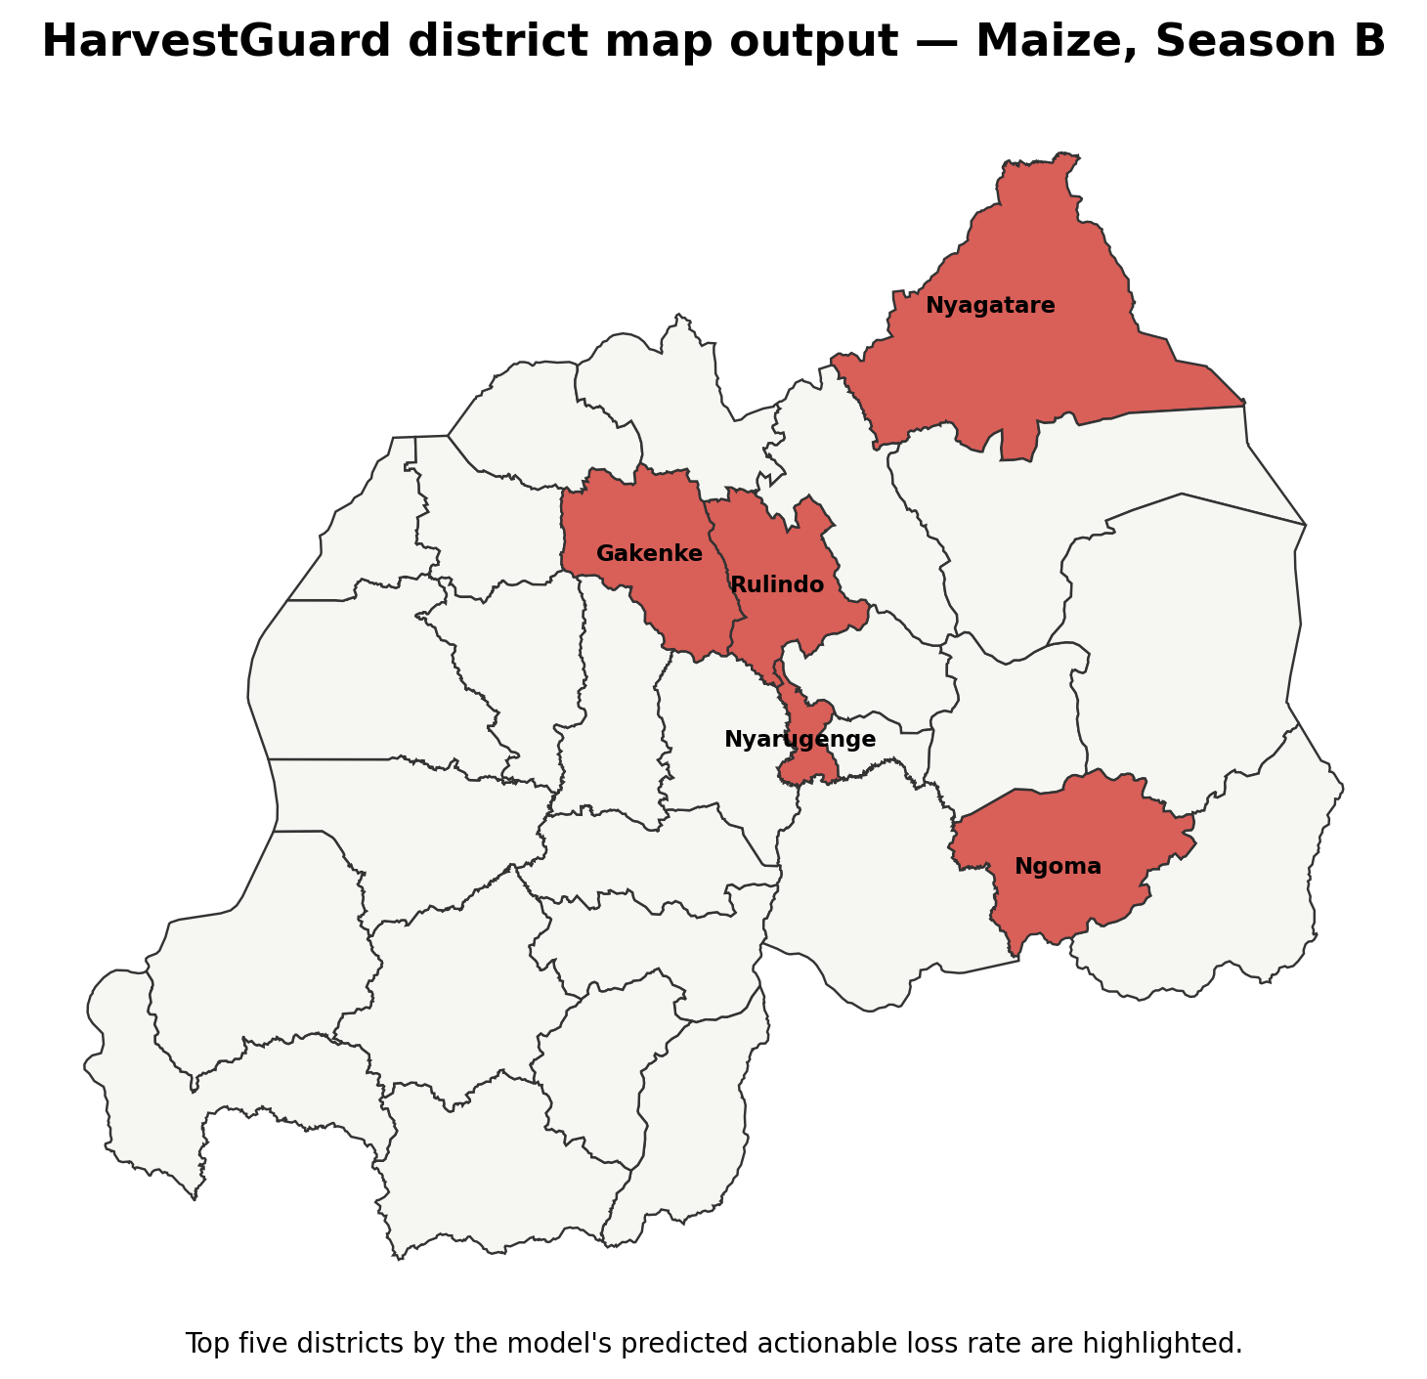
Figure 1. HarvestGuard district map output for Maize, Season B. The map keeps the full national context visible while highlighting the leading districts for the selected view.

9. Technical Innovation and System Architecture
HarvestGuard combines official survey statistics, satellite/station-informed climate data, spatial visualization, zero-aware machine learning, a physical-loss decision layer and a generative-AI explanation layer in one workflow. The innovation is not any single algorithm; it is the integration of prediction, prioritization and explanation around a real government allocation question.
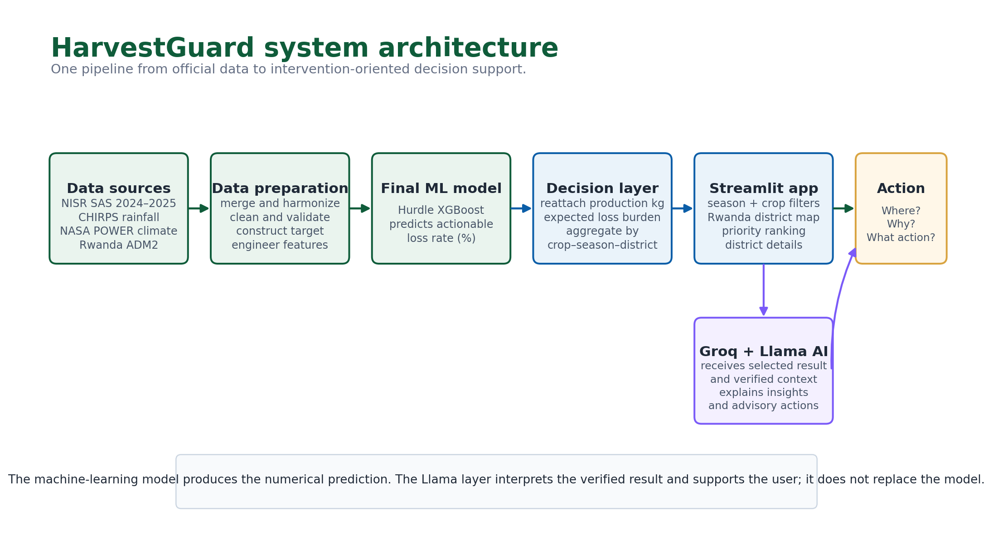
Figure 2. HarvestGuard end-to-end architecture. The ML model generates the quantitative estimate; Groq/Llama interprets the verified context for the user.

9.1 Technology stack
Layer | Technology
Data engineering | Python, pandas, NumPy; Google Colab and local Conda workflows
Machine learning | scikit-learn, XGBoost; Optuna for hyperparameter search
Climate data | CHIRPS rainfall and NASA POWER meteorological data
Geospatial visualization | Rwanda ADM2 boundaries, Plotly
Application | Streamlit
Generative AI | Groq API with a Llama model
Version control / delivery | Git and public GitHub repository

10. Tangible Impact and Real-World Use
HarvestGuard is designed for operational users who must decide where limited post-harvest resources can protect the greatest amount of production. Its main value is to move from a national average or descriptive dashboard toward a district–crop–season screening tool that combines risk intensity, production exposure and a clear explanation layer.
Potential user | How HarvestGuard supports the decision
MINAGRI | National screening and prioritization of post-harvest interventions by crop, season and district.
RAB | Evidence-informed targeting of drying, storage, processing and quality-management support.
District authorities | Local identification of crop/season combinations requiring attention and communication of model-supported evidence.
NGOs / development partners | Targeting of limited equipment, training or infrastructure support using a transparent prioritization workflow.
Researchers / analysts | Comparison of post-harvest patterns, model performance and temporal changes across districts and crops.

10.1 What changes compared with a descriptive dashboard?
A conventional dashboard mainly answers “what happened?” HarvestGuard is built to support a sequence of operational questions: where is the expected post-harvest burden highest for the selected crop and season; how much production is exposed; how much physical loss is expected; why did the model produce this result; and what response can be considered? This sequence is directly aligned with the competition’s emphasis on tangible practical impact for agricultural planners and policymakers.

10.2 National relevance
NST2 calls for post-harvest losses to fall below 5% and emphasizes improved handling, drying infrastructure, market linkages and agro-processing. Vision 2050 describes a market-oriented, climate-resilient and high-tech agricultural sector. HarvestGuard contributes to both priorities by turning existing agricultural and climate data into a digital decision-support workflow that can improve the targeting of post-harvest action.

11. Responsible Use, Limitations and Declarations

11.1 Current limitations
Limitation | Current interpretation
Temporal ranking performance | The final model improves 2025 MAE slightly but does not exceed the historical exact baseline on NDCG@5 or Top-5 overlap. Rankings are therefore decision-support evidence, not autonomous allocation instructions.
Survey weighting | Production quantity is available for burden conversion, but population-level national estimates should incorporate the appropriate NISR survey design weights when those are available in the scoring workflow.
Uncertainty | Current outputs are point estimates; formal model and survey-design uncertainty intervals are not yet displayed.
AI interpretation | Groq/Llama explanations are advisory. They do not prove causality and do not replace agricultural expertise or program feasibility assessment.
Forecast integration | The final model uses information available at or before harvest. Future post-harvest weather should be integrated only through forecast-compatible training and validation.

11.2 AI-use disclosure
Generative-AI tools were used as development assistants during the project, including ChatGPT for tasks such as code review, debugging, methodological discussion and documentation support. The deployed HarvestGuard application also uses a Llama model through the Groq API to generate user-facing explanations and advisory recommendations from structured project context. AI tools were not used to fabricate NISR observations, validation results or model metrics. The submitted analysis, code and claims remain the responsibility of the project team.

11.3 Originality declaration
By submitting HarvestGuard, we declare that this project is our original work, that all external datasets, software libraries and references have been acknowledged, and that the work has not knowingly been submitted to another competition or entity in a manner that violates the NISR competition rules. We accept responsibility for the accuracy of the submitted analysis and for the disclosed use of AI-assisted tools.

12. References
1. National Institute of Statistics of Rwanda (NISR). 2026. 2026 Big Data Hackathon Competition.
2. Parliament of Rwanda. 2026. MPs call for stronger monitoring of post-harvest losses in rice and maize. 3 March 2026.
3. Ministry of Finance and Economic Planning (MINECOFIN). 2024. National Strategy for Transformation (NST2) 2024–2029, Abridged.
4. Ministry of Finance and Economic Planning (MINECOFIN). Rwanda Vision 2050.
5. National Institute of Statistics of Rwanda (NISR). Seasonal Agricultural Survey 2024 Annual Report.
6. National Institute of Statistics of Rwanda (NISR). Seasonal Agricultural Survey 2025.
7. Climate Hazards Center, UC Santa Barbara. CHIRPS rainfall data.
8. NASA POWER. Daily API and meteorological data documentation.
9. National Institute of Statistics of Rwanda (NISR). Microdata Release Policy.
10. Rwanda Agriculture and Animal Resources Development Board (RAB). Crop Post-Harvest and Processing Management.
11. Järvelin, K., & Kekäläinen, J. 2002. Cumulated gain-based evaluation of IR techniques. ACM Transactions on Information Systems, 20(4), 422–446.

Project links
Live application: HarvestGuard Streamlit App
Source code: HarvestGuard GitHub Repository

