**CHAPTER ONE**

**INTRODUCTION**

* 1. **Background of Study**

The internet of things, or IoT, is a network of physical objects: “things” that are embedded with sensors, software, and other technologies for the purpose of connecting and exchanging data with other devices and systems over the internet. These devices range from ordinary household objects like temperature sensors to sophisticated industrial tools like military radar (“Gillis”, 2022). By means of low-cost computing, the cloud, data analytics, and mobile technologies, physical things can share and collect data with minimal human intervention. In this hyper connected world, digital systems can record, monitor, and adjust each interaction between connected things. The physical world meets the digital world and they cooperate.

In a world of growing complexity, new methods and strategies have to be developed to make the life of everyone easier, faster and more efficient. Technological advancements play a large part in making this possible. In the past all paper work had to be written by hand, signed and transported by train before it could get to its destination; today that is no longer the case. Phones and the internet have totally changed the way we transmit information.

Radio-frequency identification (RFID) IoT devices and sensors use electromagnetic fields to automatically identify and track tags attached to objects. (“RFID”, 2022) Meaning they don’t need physical touch to be detected. They only need to be close enough.

A microcontroller is a compact integrated circuit designed to govern a specific operation in an embedded system. A typical microcontroller includes a processor, memory and input/output (I/O) peripherals on a single chip.

Sometimes referred to as an embedded controller or microcontroller unit (MCU), microcontrollers are found in vehicles, robots, office machines, medical devices, mobile radio transceivers, vending machines and home appliances, among other devices. They are essentially simple miniature personal computers (PCs) designed to control small features of a larger component, without a complex front-end operating system (OS).

* 1. **Problem Statement**

Current administrative tasks and activities in Nigerian schools and corporate offices can be made faster and much more efficient.

According to Princewill Ene (2022) There are many factors that affect development of science and technological advancement, including but not limited to:

* Lack of funds
* Lack of expertise
* Low level of education
* Lack of appropriate market
* Inadequate infrastructure
* Poverty
* Economic fluctuation
* Political instability
* Ethnicity
* Social vices

With these problems in mind, for technology to be feasible in Nigeria, it has to be: cheap, easy to operate, secure, durable, solve an important problem, small, consume low power and be cheap to maintain. As impossible as all this sounds, with the right tools, technology and mindset it can be done. A simple device that scans student’s ID cards, confirms their info from an online database, and returns a simple yes or no response. This will help boost administrative efficiency and reduce paperwork.

* 1. **Aim and Objectives**
* Design and build a small hardware device that connects to the internet through Wi-Fi.
* Design and build a small hardware device that can read RFID tags.
* Design and build a small hardware device that runs on minimal electricity and uses batteries.
* Design and build a small hardware device that is easy to use and understand.
* Design and build a website hosted online that communicates efficiently with the small hardware device.
* Design and build a website hosted online that stores the data gotten from the small hardware device.
* Design and build a website hosted online that lets its users download summarized data in any of these formats: Excel and CSV.
* Build a fully functional Iot device that can scan student’s RFID enabled ID cards and confirm/store any data needed.
  1. **Significance of the Study**
* Make administrative tasks like checking for fee payment, leasing library books, taking attendance faster and more efficient
* Make the life of students and staff easier
* Reduce the use of hardcopy
* Boost data analysis through direct electronic data availability
* Higher security through advanced monitoring of students from their entries and direct confirmation from an online database
* Reduce our carbon footprints through burning of paper containing information that is readily available online
  1. **Scope of the Study**

The scope of this study covers the hardware device and online website that holds all the needed data and functionality. It also covers the students and staff of ESUT.

* 1. **Limitation of the Study**
* Purchase of the RFID enabled cards and assigning them to each student
* Cannot work without an internet active Wi-Fi hotspot device
* Each Wi-Fi hotspot device has to be set to a particular Wi-Fi name and password for the device to find.
  1. **Organization of the Report**

This project report is organized into five chapters:

**Chapter One:** The whole idea behind the work. Includes objective of the study, statement of the research, area of coverage limitation and definition of terms.

**Chapter Two:** This section deals with the review of study, review of concept theories upon which this work is built on and the potential issues

**Chapter Three:** This section talks about the software and hardware tools used in the project. The methodology at which this research work will be implemented.

**Chapter Four:** The system is implemented and presented with its analysis. Functions are in depth explained for reader understating and comprehension. The system requirements are also detailed.

**Chapter Five:** Summarizes the whole work done and makes possible recommendation and suggest other points to be included into the work for future propose

* 1. **Definition of Terms**

1. IoT: The internet of things, or IoT, is a system of interrelated computing devices, mechanical and digital machines, objects, animals or people that are provided with unique identifiers (UIDs) and the ability to transfer data over a network without requiring human-to-human or human-to-computer interaction(“Gillis”, 2022).
2. Sensors: A sensor is a device that produces an output signal for the purpose of sensing a physical phenomenon.
3. RFID: Radio-frequency identification (RFID) uses electromagnetic fields to automatically identify and track tags attached to objects (“RFID”, 2022).
4. RFID Tags: A radio-frequency identification system uses tags, or labels attached to the objects to be identified. Two-way radio transmitter-receivers called interrogators or readers send a signal to the tag and read its response (“RFID”, 2022).
5. Microcontroller: A microcontroller contains one or more CPUs (processor cores) along with memory and programmable input/output peripherals. Microcontrollers are designed for embedded applications, in contrast to the microprocessors used in personal computers or other general-purpose applications consisting of various discrete chips.
6. Input/Output(I/O): In computing, input/output (I/O, i/o, or informally io or IO) is the communication between an information processing system, such as a computer, and the outside world, possibly a human or another information processing system. Inputs are the signals or data received by the system and outputs are the signals or data sent from it (“General Purpose Input/Output”, 2022).
7. Wi-Fi: A family of wireless network protocols, based on the IEEE 802.11 family of standards, which are commonly used for local area networking of devices and Internet access, allowing nearby digital devices to exchange data by radio waves. These are the most widely used computer networks in the world, used globally in home and small office networks to link desktop and laptop computers, tablet computers, smartphones, smart TVs, printers, and smart speakers together and to a wireless router to connect them to the Internet, and in wireless access points in public places like coffee shops, hotels, libraries and airports to provide visitors with Internet connectivity for their mobile devices.
8. Wi-Fi Hotspot: A hotspot is a physical location where people can obtain Internet access, typically using Wi-Fi technology, via a wireless local-area network (WLAN) using a router connected to an Internet service provider.
9. Website: is a collection of web pages and related content that is identified by a common domain name and published on at least one web server.
10. Online Hosting/Cloud Hosting: is the on-demand availability of computer system resources, especially data storage (cloud storage) and computing power, without direct active management by the user.
11. NodeMCU: is an open source firmware for which open source prototyping board designs are available (“NodeMCU”, 2022).
12. MRC522 RFID Sensor: The RC522 RFID Reader/Writer Module (Transceiver) is based on a highly integrated reader/writer IC MFRC522 from NXP Company. It is used for contactless Multi-communication at 13.56 MHz (“RFID”, 2022).
13. Arduino IDE: The Arduino Integrated Development Environment - or Arduino Software (IDE) - contains a text editor for writing code, a message area, a text console, a toolbar with buttons for common functions and a series of menus. It connects to the Arduino hardware to upload programs and communicate with them (“Arduino”, 2022).
14. VS Code: Visual Studio Code, also commonly referred to as VS Code, is a source-code editor made by Microsoft with the Electron Framework, for Windows, Linux and macOS. Features include support for debugging, syntax highlighting, intelligent code completion, snippets, code refactoring, and embedded Git (“Visual Studio Code”, 2022).
15. PHP: is a general-purpose scripting language geared toward web development (“PHP”, 2022).
16. JavaScript: JS, is a programming language that is one of the core technologies of the World Wide Web, alongside HTML and CSS (“JavaScript”, 2022).
17. MySQL: is an open-source relational database management system (RDBMS). Its name is a combination of "My", the name of co-founder Michael Widenius's daughter My, and "SQL", the acronym for Structured Query Language.
18. Git: is a distributed version control system: tracking changes in any set of files, usually used for coordinating work among programmers collaboratively developing source code during software development.
19. GitHub: GitHub, Inc is an Internet hosting service for software development and version control using Git. It provides the distributed version control of Git plus access control, bug tracking, software feature requests, task management, continuous integration, and wikis for every project.
20. Debug: In computer programming and software development, debugging is the process of finding and resolving bugs (defects or problems that prevent correct operation) within computer programs, software, or systems.
21. LEDs: A light-emitting diode (LED) is a semiconductor device that emits light when current flows through it. Electrons in the semiconductor recombines with electron holes, releasing energy in the form of photons.
22. Buzzers: A buzzer or beeper is an audio signaling device, which may be mechanical, electromechanical, or piezoelectric (piezo for short). Typical uses of buzzers and beepers include alarm devices, timers, train and confirmation of user input such as a mouse click or keystroke.

**CHAPTER TWO**

**LITERATURE REVIEW**

1. **Overview of Relevant Technology**

Radio-frequency identification (RFID) uses electromagnetic fields to automatically identify and track tags attached to objects. An RFID system consists of a tiny radio transponder, a radio receiver and transmitter. When triggered by an electromagnetic interrogation pulse from a nearby RFID reader device, the tag transmits digital data, usually an identifying inventory number, back to the reader. This number can be used to track inventory goods (“Radio Frequency Identification”, 2022).

Passive tags are powered by energy from the RFID reader's interrogating radio waves. Active tags are powered by a battery and thus can be read at a greater range from the RFID reader, up to hundreds of meters.

Unlike a barcode, the tag does not need to be within the line of sight of the reader, so it may be embedded in the tracked object. RFID is one method of automatic identification and data capture.

RFID tags are used in many industries. For example, an RFID tag attached to an automobile during production can be used to track its progress through the assembly line, RFID-tagged pharmaceuticals can be tracked through warehouses, and implanting RFID microchips in livestock and pets enables positive identification of animals. Tags can also be used in shops to expedite checkout, and to prevent theft by customers and employees.

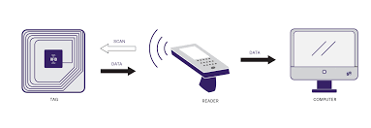

**Fig 2.1: RFID Technology**

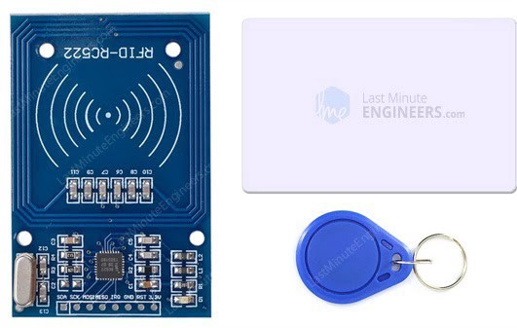

**Fig 2.2: RC522 RFID Module with Its two Tags**

Since RFID tags can be attached to physical money, clothing, and possessions, or implanted in animals and people, the possibility of reading personally-linked information without consent has raised serious privacy concerns. These concerns resulted in standard specifications development addressing privacy and security issues.

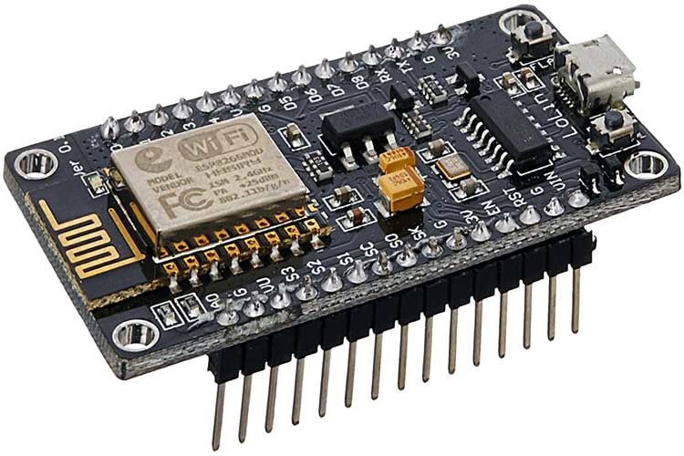

**Fig 2.3: NodeMCU ESP8266 Microcontroller with USB Connector**

The NodeMCU is a low-cost open source IoT platform. Its initial versions included firmware which runs on the ESP8266 Wi-Fi SoC from Espressif Systems. The firmware uses the Lua scripting language and is based on the eLua project, and built on the Espressif Non-OS SDK for ESP8266. It uses many open source projects, such as lua-cjson and SPIFFS (“NodeMCU”, 2022).

ESP8266 is a highly integrated chip designed for the needs of a new connected world. It offers a complete and self-contained Wi-Fi networking solution, allowing it to either host the application or to offload all Wi-Fi networking functions from another application processor. This module comes with a built in USB connector and a rich assortment of pin-outs. With a micro USB cable, you can connect the NodeMCU devkit to your laptop and flash it without any trouble, just like Arduino. It is also immediately breadboard friendly.

NodeMCU was created shortly after the ESP8266 came out. On December 30, 2013, Espressif Systems began production of the ESP8266. NodeMCU started on 13 Oct 2014, when Hong committed the first file of nodemcu-firmware to GitHub. Two months later, the project expanded to include an open-hardware platform when developer Huang R committed the gerber file of an ESP8266 board, named devkit v0.9.

In the summer of 2015, the original creators abandoned the firmware project and a group of independent contributors took over. By the summer of 2016 the NodeMCU included more than 40 different modules.

1. **Review of Related Work**

For the study of an existing system or technology, Take RFID Door Lock Access Control System as a case of study

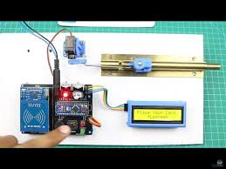

**Fig 2.4: RFID Door Lock System with Arduino**

This is a popular project for Arduino hobbyists. RFID door lock systems are very common for access control, as they provide a reliable, consistent experience with trackable data. Unlike other forms of traditional access control such as swipe cards, RFID locking systems are contactless, meaning that the credential doesn’t have to touch the reader for it to work.

Similar to a barcode reader, RFID readers work by sending and receiving data, but instead of having to scan a code, the data is transmitted over radio frequencies. An RFID door locking system requires RFID tags, antennas, an RFID reader, and a transceiver in order to function as a complete system.

In an RFID door lock access control system, the user’s credential (usually a keycard or fob with an RFID chip) contains unique identifying information called a tag. When the user comes within proximity of a reader, the reader’s signal locates the information stored on the user’s RFID tag, and sends it through antennas and transceivers to authorize the tag in the access control system. Once read, the system will either accept or deny the request to unlock the door. Data from an RFID-enabled system is automatically stored, making it possible to track entry activity in an access control system (“Nikhil”, 2019).

1. **Summary of the Problem of Existing Systems**
2. The machine is very rigid. The keys are stored directly on the hardware.
3. There are no means to monitor how the system is being used, microcontrollers aren’t known for having much storage memory
4. The data is not persistent, in case of a power outage all data is lost.
5. It is very difficult to update/maintain. Any required changes mean the lock has to be dismantled down to the microcontroller
6. **Summary**

Microcontroller/IoT technology can be used to build powerful applications. The power of the internet when combined with this brings about interesting results. This study will make use of an online web app and an RFID scanning machine. When a card/tag is presented to it, operations/communication occur between the server and the machine, both of them covering each other’s weaknesses.

**CHAPTER THREE**

**METHODOLOGY**

1. **Design Consideration**

The proposed RFID Smart Card Reader is a software – hardware hybrid, that detects student ID cards as input, sends this input to the server and return a true or false (red or green lights), depending on what operation was done. The hardware consists of:

* Node MCU ESP8266 Microcontroller
* MRC522 RFID Sensor and its Tags
* A Buzzer
* 9V Batteries
* I/O Switch
* LED’s (Red, Green, Yellow, Blue)

The software is a web application hosted on an Apache hosting service built with:

* HTML
* CSS
* PHP
* JavaScript
* MySQL

At the end of development, the hardware should be able to read a student’s ID card, send this info to the server, and get a true or false response.

1. **Summary of Project Methodology**

After coupling all the hardware parts and making sure the Wi-Fi connects successfully, the software/web app should be built and the correct API endpoints setup. The hardware should be able to read a student’s ID card, send this info to the server, the server confirms if he or she has performed a task like paying school fees, paying departmental/faculty fees and returns a true or false reply. The hardware device displays this as either Red(false) or Green(true).

1. **Data Source/Collection**
2. Manual Registration/Entries: The web app is built to allow Staff and Students to register. This includes assignment of individuals to unique ID cards
3. Mockaroo Test Data: Mockaroo is an online service that allows users create mock data, up to 1000 rows, in many formats including: JSON, CSV, SQL and so on.
4. Usage: With every card scan, data is stored. The users name, context of use, date, time and so on.
5. **Hardware Requirements**
6. Power supply of 9 to 12 Volts is recommended for the Node MCU Microcontroller
7. The Wi-Fi hotspot name (SSID) and its password, must be set to what is specified for the device to connect successfully
8. A stable internet connection on the Wi-Fi hotspot enabled device.
9. A working RFID tags
10. Arduino IDE: This is a free and open source Integrated Development Environment(I|DE) used for programming Arduino based microcontrollers and building IoT devices.
11. **Software Requirements**
12. VS Code IDE: This is a free and open source Integrated Development Environment(I|DE) used for programming vast amounts of programming languages through its publicly available extensions.
13. Apache Web Server: This is a free and open source web server that powers a very high percentage of the web. It contains support for multiple programming languages (PHP, Rust) and multiple Database Management Systems (SQL, Postgress)
14. Postman: This is a free and open source tool used for simulating, testing and troubleshooting web API’s
15. Google Chrome: This is a popular web browser created by Google. Used for surfing the web and using our web app.
16. **Block Diagram of Proposed System**

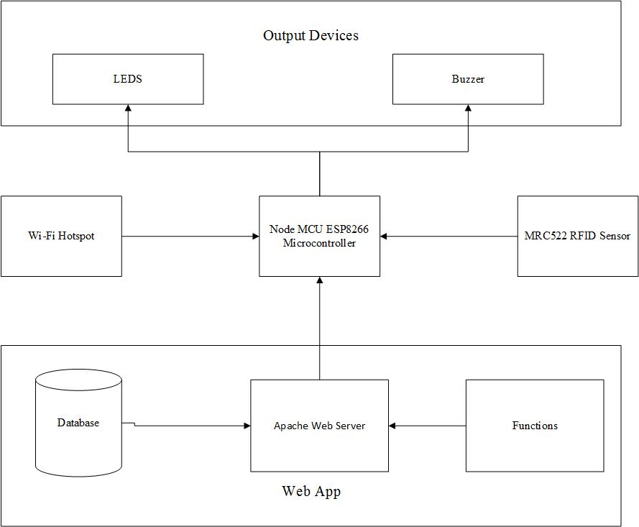

**Fig 3.1: Block Diagram of Both Hardware and Software Systems**

1. **Software Universal Modelling Language Diagrams**

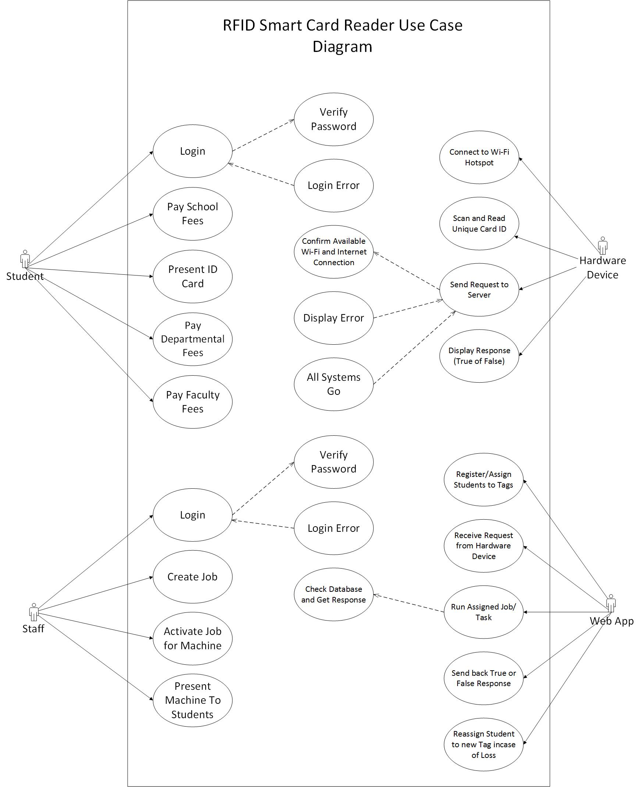

**Fig 3.2: UML Use Case Diagram of Smart RFID Card Reader**

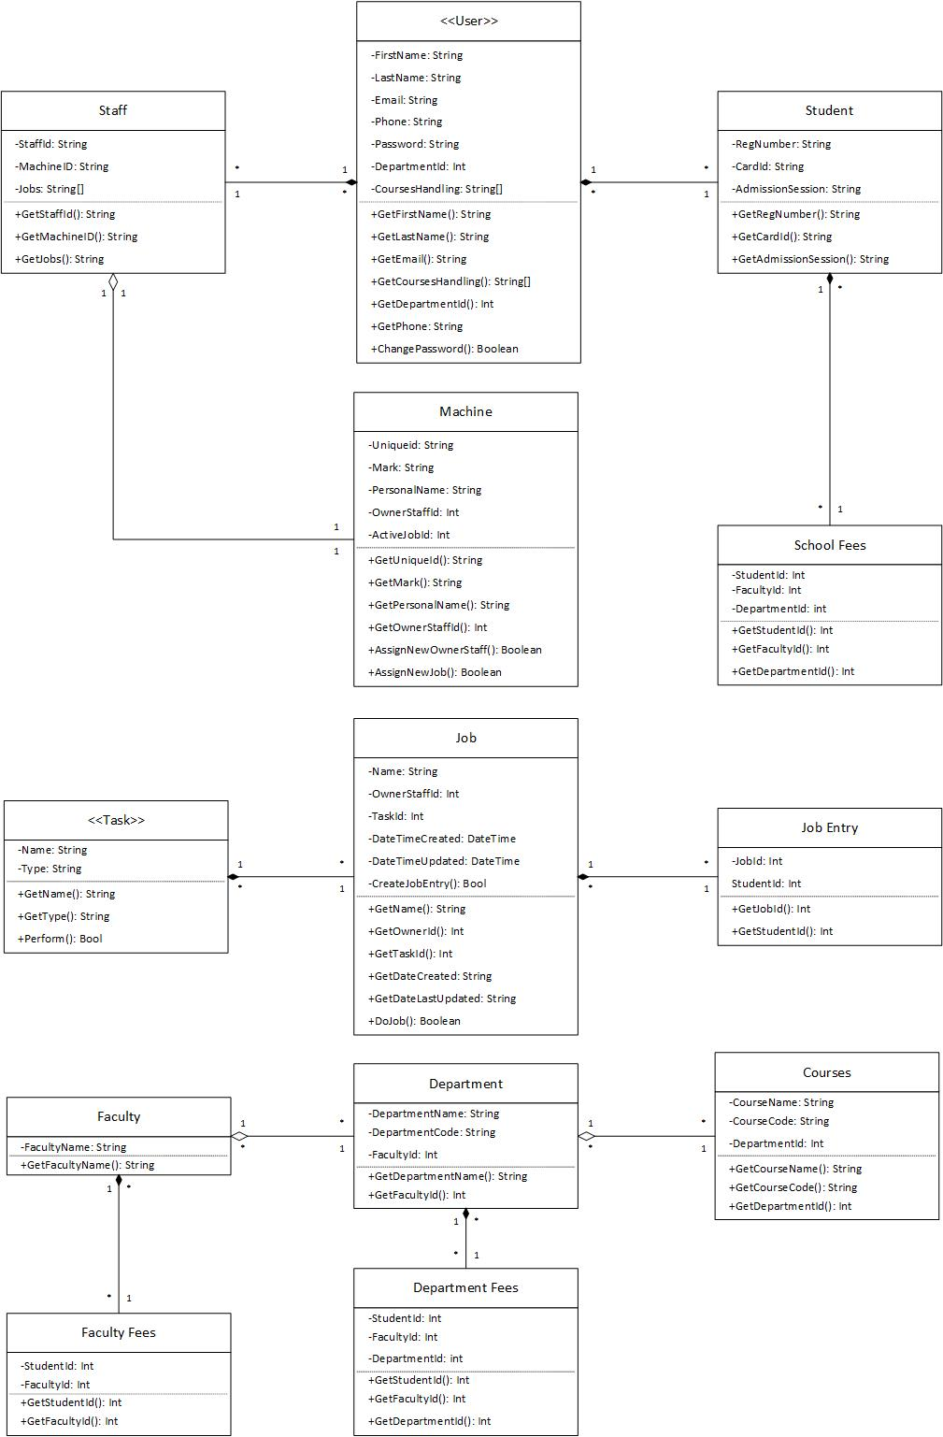

**Fig 3.3: UML Class Diagram of Smart RFID Card**

**CHAPTER FOUR**

**RESULTS AND DISCUSSION**

1. **Implementation Procedures**

At the end of development, we have a very light weight device connected to a hosted web app through the internet with Wi-Fi. After the hardware was wired, soldered, coupled and programmed using Arduino IDE, it went through a rigorous testing phase for speed and durability. Next, was the software/web app. The UML Use case and Class diagrams helped to guide the next phases of development. The SQL database was built first with several tables including:

* Students
* Staff
* Machines
* Tasks
* School Fees
* Departmental Fees
* Faculty Fees
* Jobs
* Job Entries
* Faculties
* Departments
* Courses

The coding went next, with the appropriate user interface built with HTML, CSS, JavaScript, then the server-side code written with PHP. The web app has a page that accepts GET requests comprising of the Machine ID and the Unique card ID of a student. Once received, the web app confirms the task assigned to it by the lecturer then proceeds to check the database for what is required. This results a true or false value depending on how successful the task went. The code for both the hardware and software are hosted online at: <https://www.github.com/Emerald2240/rfid-smard-card-reader>

1. **Wiring / Assembly**

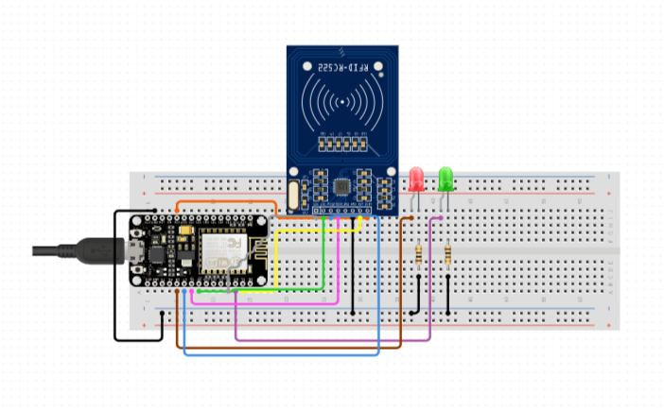

**Fig 4.1: Breadboard Wiring of The System**

In Fig X, the base/prototype wiring of the project is shown on a bread board. The Node MCU is powered by a type-a USB cord. The wiring configurations:

**Table 4.1: RFID Sensor and its Pin Connections to the Node MCU**

|  |  |
| --- | --- |
| **MRC522 RFID Sensor Pins** | **Node MCU Pin** |
| SDA | D4 (GPIO2) |
| SCK | D5 (GPIO14) |
| MOSI | D7 (GPIO13) |
| MISO | D6 (GPIO12) |
| IRQ | Not Connected |
| GND | GND |
| RST | D3 (GPIO0) |
| 3.3V | 3V3/3.3V |

**Table 4.2: Other Components and their Pin Connections to the Node MCU**

|  |  |
| --- | --- |
| **Other Components** | **Node MCU Pins** |
| Red LED | D0 (GPIO16) |
| Green LED | D1 (GPIO5) |

The tables above show the connections between the microcontroller, LEDs and RFID sensor. Some more LEDs and a Buzzer was added as the work progressed. When a registered RFID tag is shown to the device, it scans its unique ID and sends a request to the database. It takes less than a second for the server to respond with a true or false value. If the server returns a false, the red LED comes on for two seconds. If the reply was true, the green LED comes on for two seconds.

1. **Coding**

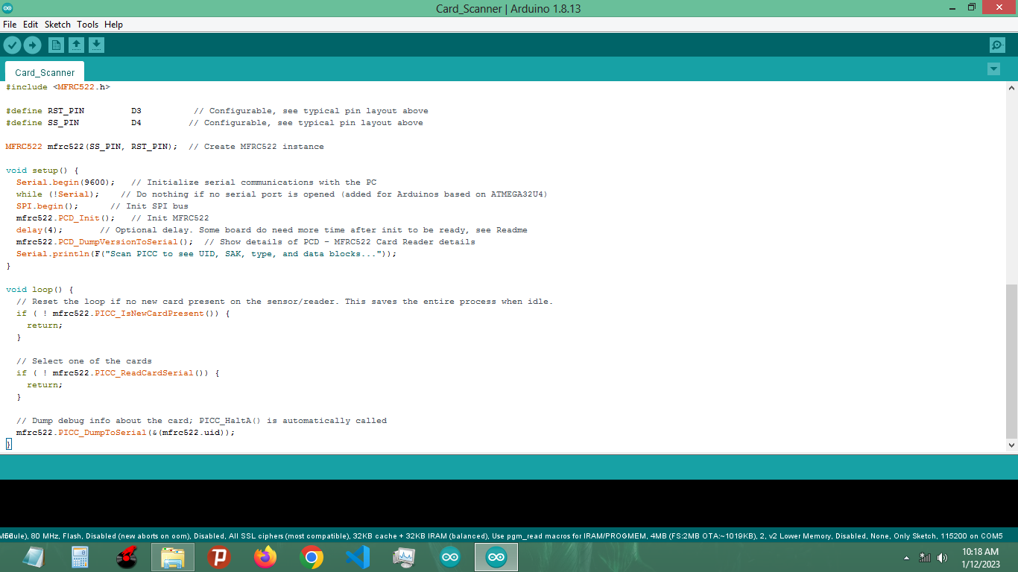

**Fig 4.2: Arduino IDE**

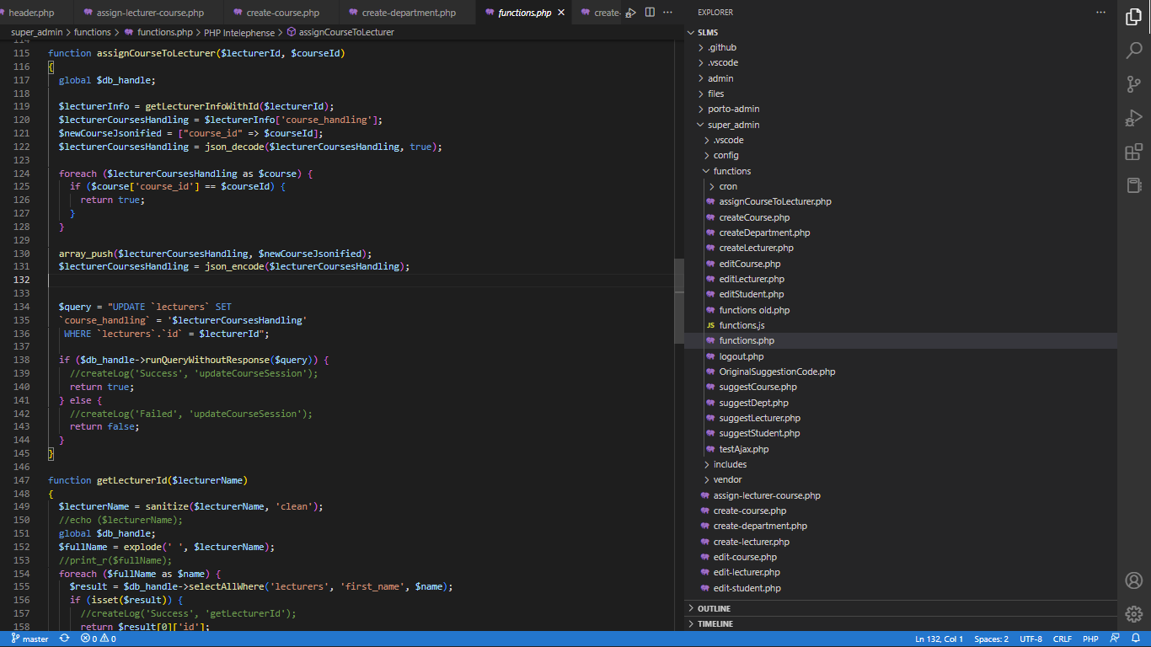

**Fig 4.3: Microsoft VS Code IDE**

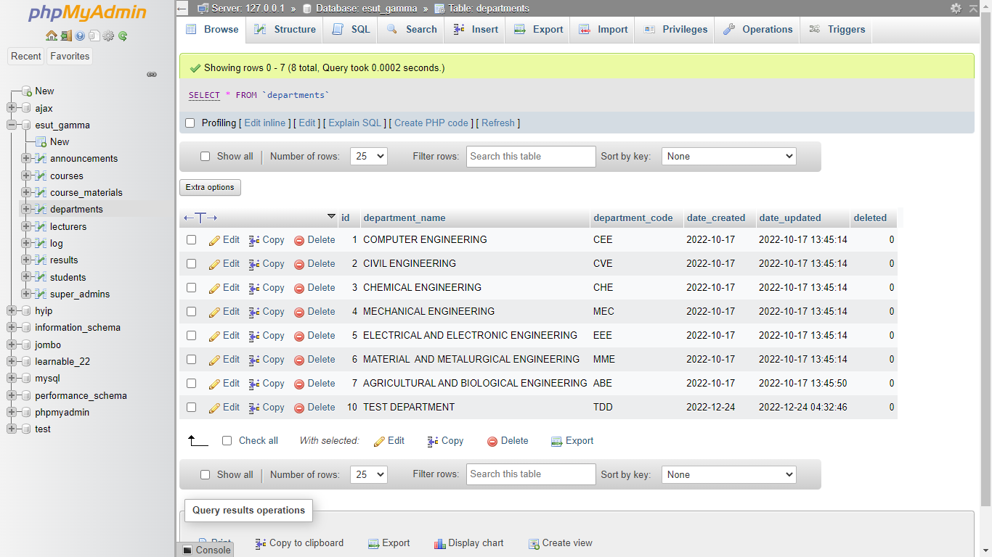

**Fig 4.4: XAMPP PHPMyAdmin Screenshot**

The above figures show the two IDE’s used to build the hybrid. The first is the official Arduino IDE used to write and upload C code to the Node MCU. The second is Microsoft’s Visual Studio Code, an open source IDE that supports multiple languages including HTML, CSS, JavaScript, MySQL and PHP. The third image is a screenshot of the localhost XAMPP PHPMyAdmin Database management system specifically installed so code can be run on my computer.

The code for both is hosted on GitHub at: <https://www.github.com/Emerald2240/rfid-smard-card-reader>

1. **Implementation Results**

After the assembling, wiring, soldering, coding, debugging and testing; here are the results.

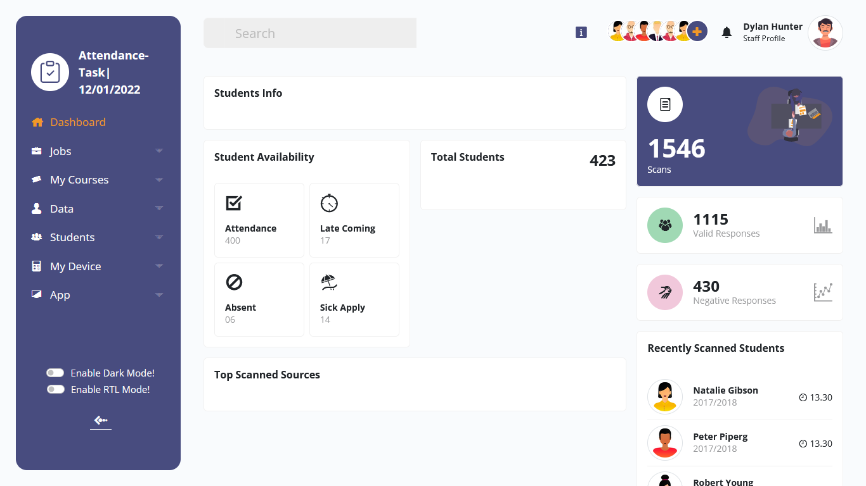

**Fig 4.5: Screenshot of Web App Staff Side Dashboard**

The figure above shows a simple screenshot of the web app UI. This particular screenshot contains very basic stats for the “Attendance Task” Job created by the currently logged in staff. Stats like Students Info, Attendance, Late coming, Absentee, Total Scans, Responses and so on. The staff is also able to download this data in two formats: CSV and Excel.

1. **Summary of Results**

The aim of this project was to build a smart card reading device that connects to the internet and stores its data online. As at the final day of development, I can say this application has reached its main purpose as stated in Chapter One.

After building and running the device for the first time, here are the results that were observed:

1. The machine is extremely Lean and can work for hours without any signs of slowing down or heat.
2. Because of its low data output, the machine is extremely fast. Returning card results within 200 milliseconds.
3. The machine is really portable and can easily fit into a pocket.
4. My beta testers found the Web app UI really clean and easy to use.
5. Data online can be easily sorted and retrieved through the web app.
6. Users loved the idea of downloading the data as excel or csv but preferred excel because of its popularity.
7. The device has shown to be secure. External readers cannot make use of the tag unique ID’s except in the extreme case of forceful collection/Stealing
8. The web app/web server showed no stress whatsoever after repeated use

**CHAPTER FIVE**

**CONCLUSION AND RECOMMENDATIONS**

1. **Conclusion**

This paper presents a comprehensive survey of a fully functional IoT device that works to gather what used to be manually retrieved information, and digitize it. This device will make the lives of students and staff alike easier, by: reducing manual tasks and carrying around of hardcopy evidence for students; It will save the space used by librarians and admin officers for storing documents; It will reduce the carbon footprint created through the burning of unneeded documents; It will also boost data analysis by offering huge insights into the behavior and activities of students in and around the school.

**5.2 Problems Encountered/Limitations**

Below are the list of issues or problems I encountered while building the device.

1. Updating server code was data expensive, I had to make two uploads, one to GitHub and one to my cloud hosting. I discovered GitHub actions and it made my life easier. I only need to upload code to GitHub once and it does the rest for me.
2. Understanding the Node MCU pin counterparts for Arduino, because all code samples were made for Arduino boards.
3. Unable to mount an LCD screen because all the Node MCU pins were in use. Opted for LED’s instead.
4. Sometimes bad internet connection

**5.3 Recommendations/Suggestions for Future Work**

I strongly recommend that more research should be carried out in this very project, as further development will strongly improve the lives of people and also benefit companies, industries and small-scale business too.

**References**

Apache HTTP Server. (2022, April 22). *In Wikipedia*. <https://en.wikipedia.org/wiki/Apache_HTTP_Server>

Arduino. (2022, April 22). *In Wikipedia*. <https://en.wikipedia.org/wiki/Arduino>

Gillis Alexander. (2022). What is the Internet of Things (IoT). Tech Target. <https://www.techtarget.com/iotagenda/definition/Internet-of-Things-IoT>

General Purpose Input/Output. (2022, April 22). *In Wikipedia*. <https://en.wikipedia.org/wiki/General-purpose_input/output>

JavaScript. (2022, April 22). *In Wikipedia*. <https://en.wikipedia.org/wiki/JavaScript>

Moreno Ricardo. (2019). Lesson 21 – RC522 RFID Module. Elegoo Arduino Lessons. [Video]. YouTube. <https://www.youtube.com/watch?v=gTQmLkwnUxk&ab_channel=RicardoMorenohttps://www.youtube.com/watch?v=gTQmLkwnUxk&ab_channel=RicardoMoreno>

Nikhil Agnihotri. (2019). Arduino Based RFID Door Lock. Engineers Garage. <https://www.engineersgarage.com/arduino-rfid-rc522-door-lock/>

NodeMCU. (2022, April 22). *In Wikipedia*. <https://en.wikipedia.org/wiki/NodeMCU>

PHP. (2022, April 22). *In Wikipedia*. <https://en.wikipedia.org/wiki/PHP>

Radio Frequency Identification. (2022, April 22). *In Wikipedia*. <https://en.wikipedia.org/wiki/Radio-frequency_identification>

Visual Studio Code. (2022, April 22). *In Wikipedia*. <https://en.wikipedia.org/wiki/Visual_Studio_Code>

Ene Princewill. (2022, June 22). Problems of Science and Technology Development in Nigeria.[https://www.walyben.com/problems-of-science-and-technology-development-in-nigeria/#:~:text=Lack%20of%20Funds%3A%20Science%20and,technological%20growth%20in%20the%20country.](https://www.walyben.com/problems-of-science-and-technology-development-in-nigeria/%23:~:text=Lack%20of%20Funds%3A%20Science%20and,technological%20growth%20in%20the%20country.)