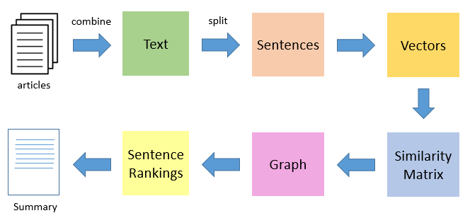

* The first step would be to concatenate all the text contained in the articles
* Then split the text into individual sentences
* In the next step, we will find vector representation (word embeddings) for each and every sentence
* Similarities between sentence vectors are then calculated and stored in a matrix
* The similarity matrix is then converted into a graph, with sentences as vertices and similarity scores as edges, for sentence rank calculation
* Finally, a certain number of top-ranked sentences form the final summary