The engine simulates a particle effect with a gravity component. The particles that are instantiated has different components like: particle’s radius, mass, starting velocity, acceleration, particle effect’s position and particle limit size. These properties configuration can be seen in the “instantiateParticles” function in the main.cpp.   
  
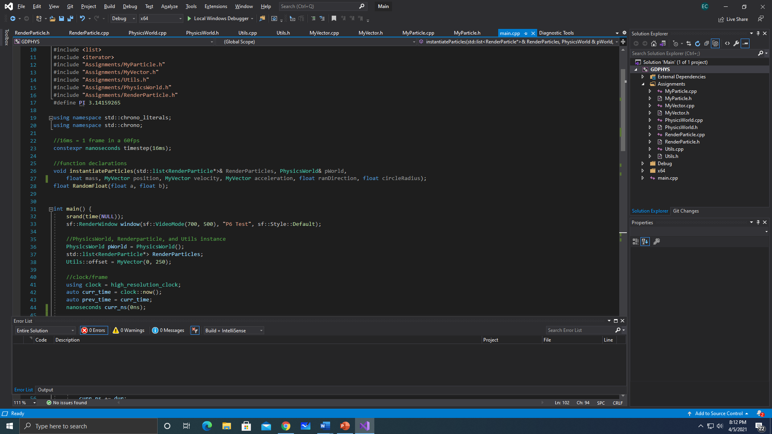

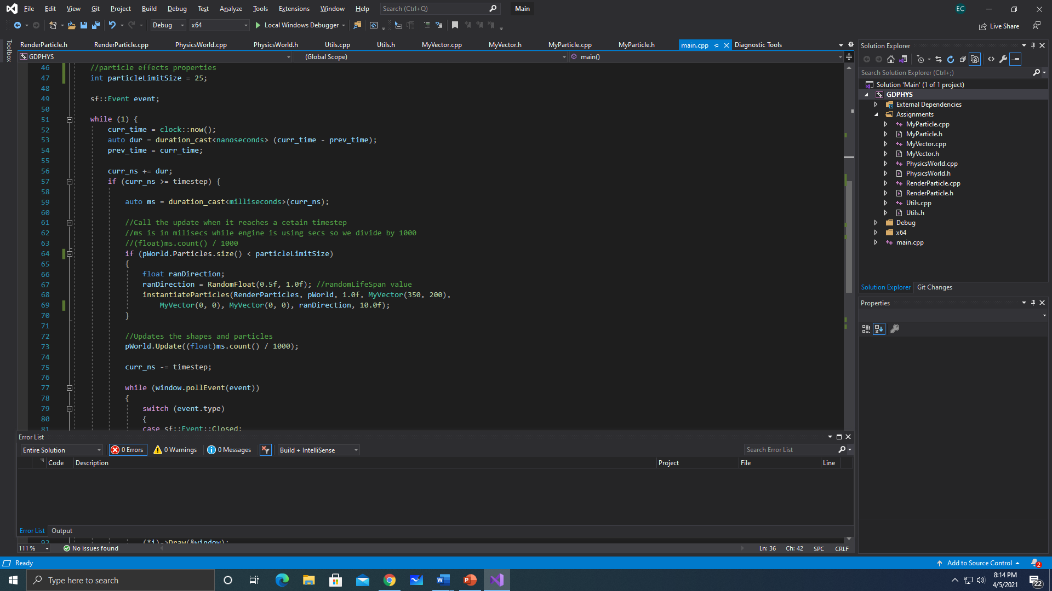

The called function is only written in one line and it’s located in line 68 of “main.cpp”. The lifespan of the particle can also be configured and it’s just above the called function statement. There are also some attributes in the engine that can be change, and this are the Physics component. In the Physics component, the gravitational value can be change and this is found in the “PhysicsWorld.h”

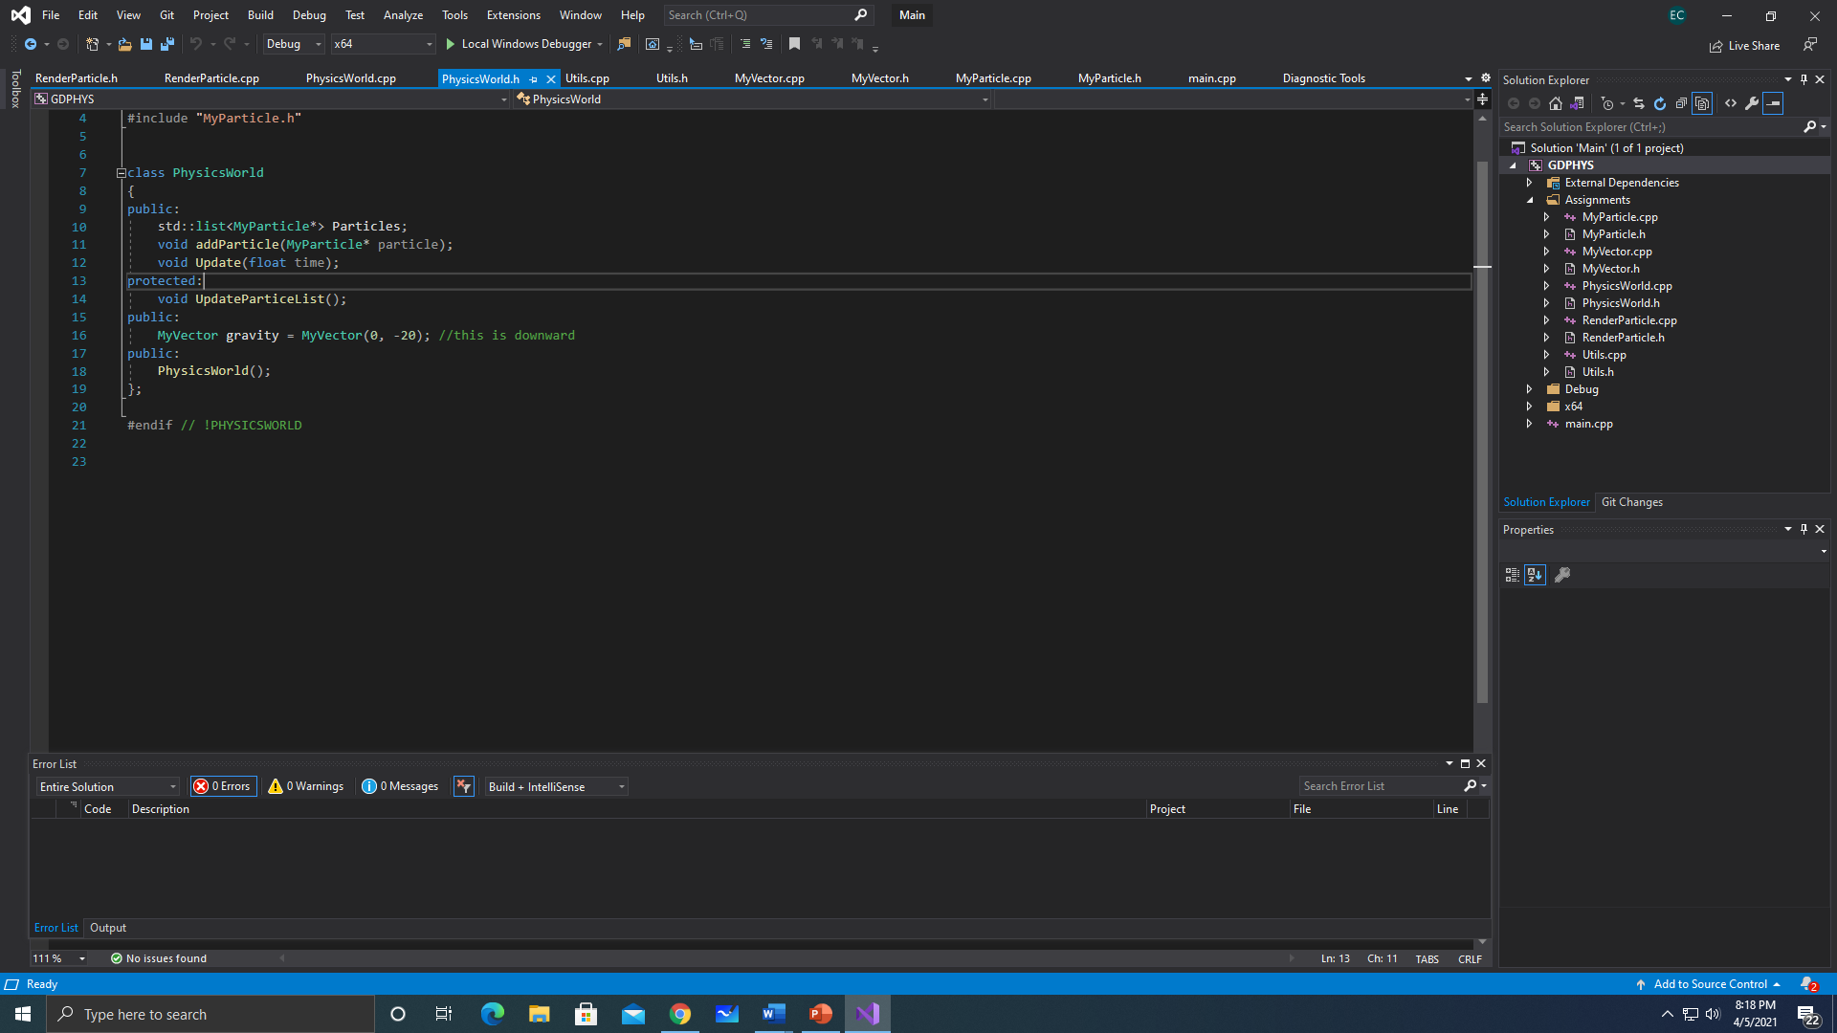

The particle component also has a “dampening” attribute that can also be change and this is found in the “MyParticle.h”. The dampening acts as the velocity decay for the particles.

Back to the particle’s effects, the direction of the particle being shoot can be configure as well as the force of it. This configuration can be seen inside the “instantiateParticles” function in the main.cpp. 