The current engine simulates the newton cradle, which follows the law of conservation of momentum and energy.

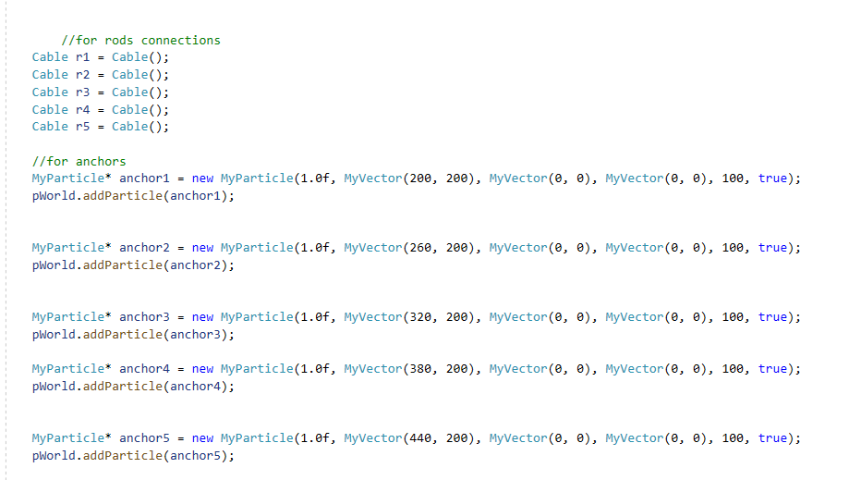

The first thing we do is create a cable and anchor to where it will be attached, the anchor has the following : mass, position, velocity, acceleration, lifeSpan, stationary.

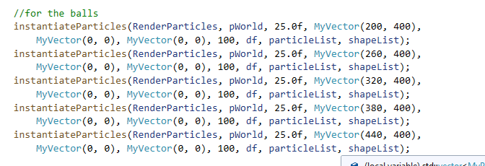

After creating a cable with anchor, we then create our object and instantiate it.

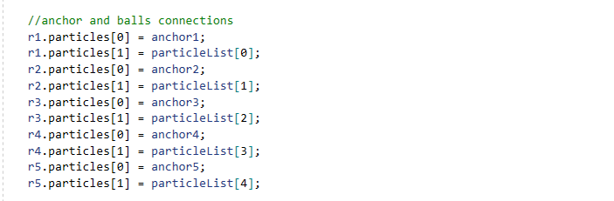

We then connect all the objects we created. The anchor point will be the one holding the cable and the particle is the object that will be simulated.

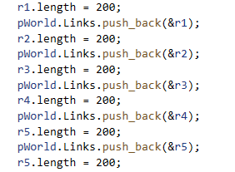

This is where we set the length of the cable. Then, we will make the representation of the cable using lines.

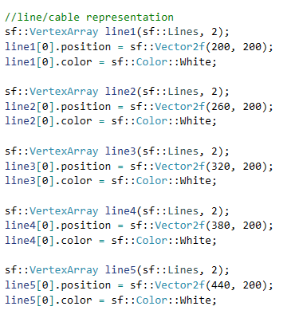

We set the necessary attributes for our lines to represent it properly.

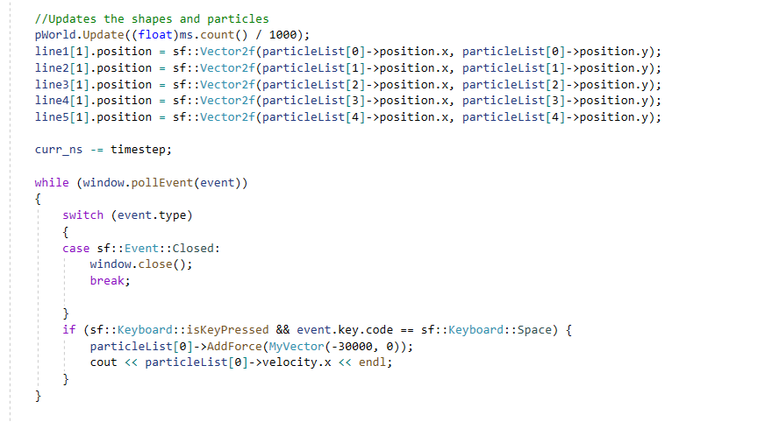

In our update, the position of the line follows the position of the particle, which is being simulated.

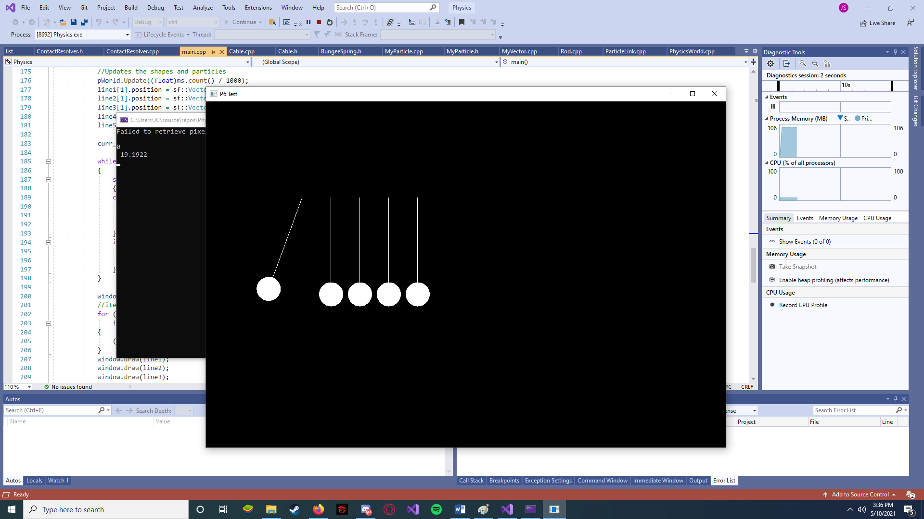

The simulation will begin if the space key is pressed. It will add force to our object and the simulation will begin.

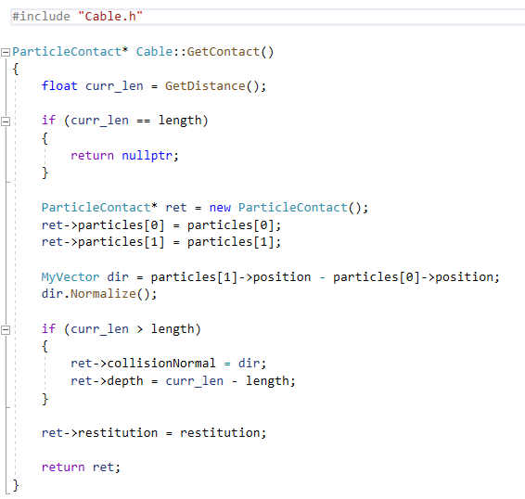

The cable class can go less than its set length but cannot exceed it. The cable is also anchors to a point which we instantiate earlier.