POKEMON MP

FUNCTION

SPECIFICATIONS

Term 2, AY 2019-2020

Emerson Celestial

s-18

|  |  |  |  |
| --- | --- | --- | --- |
| **Function Name** | **Description** | **Input Parameter** | **Return Data** |
| startMenu | This function shows the starting menu of the game and also consists the entry point of the game and the exit point. | none | none(void) |
| playerNames | This function lets the users put their Pokemon trainer names. | none | none(void) |
| pokemonList | This function only displays the list of the 7 Pokemons that the players will choose. | *c1stName* – string variable that holds player one’s name.  *c2ndName* – string variable that holds player two’s name. | none(void) |
| pokemonSelection | This function gets the input for the players selection of their pokemon and also makes a string variable for the pokemons’ names. | *c1stName* – string variable that holds player one’s name.  *c2ndName* – string variable that holds player two’s name. | none(void) |
| instructions | This function consists of the instructions of the game for the users to understand the mechanics of it and also serves as a transition that passes the pokemons’ names parameter to the battle system. | *cPokemon1* – char variable that identifies player one’s pokemon’s name.  *cPokemon2* – char variable that identifies player two’s  pokemon’s name.  *cPokemonName1* – string variable that holds player one’s pokemon’s name.  *cPokemonName2* – string variable that holds player two’s  pokemon’s name.  *c1stName* – string variable that holds player one’s name.  *c2ndName* – string variable that holds player two’s name. | none(void) |
| mainGame | After getting the chosen pokemon of the users, this function will initialize the Pokemons’ stats and moves that are utilized in a switch statement. It encompasses the phase for both players, the damage computation, STAB implementation, and moves effects (attack effectiveness, protect and charge up). It also includes the trainers’ phrases in the game. | *cPokemon1* – char variable that identifies player one’s pokemon’s name.  *cPokemon2* – char variable that identifies player two’s  pokemon’s name.  *cPokemonName1* – string variable that holds player one’s pokemon’s name.  *cPokemonName2* – string variable that holds player two’s  pokemon’s name.  *c1stName* – string variable that holds player one’s name.  *c2ndName* – string variable that holds player two’s name. | none(void) |
| pickMove1 | This function will serve as the UI for the picking phase of player one where he/she will have to choose one of the four moves given to his/her chosen pokemon. This function takes the parameter of player one pokemon’s stats where it will be displayed in the UI for the player to be guided in his/her pick. | *cPokemonName1* – string variable that holds player one’s pokemon’s name.  *cPokemonName2* – string variable that holds player two’s  pokemon’s name.  *c1stName* – string variable that holds player one’s name.  *c2ndName* – string variable that holds player two’s name.  *sAttack1*- name of the first move of player one’s pokemon.  *sAttack2* - name of the second move of player one’s pokemon.  *sAttack3*- name of the third move of player one’s pokemon.  *sAttack4* - name of the fourth move of player one’s pokemon.  *fAbp1*- base power for the first move of player one’s pokemon.  *nApp1* - power points for the first move of player one’s pokemon.  *fAbp2*- base power for the second move of player one’s pokemon.  *nApp2*- power points for the second move of player one’s pokemon.  *nApp3*- power points for the third move of player one’s pokemon.  *nApp4*- power points for the fourth move of player one’s pokemon.  *fP1Uhp*- updated health points of player one’s pokemon.  *fP2Uhp*- updated health points of player two’s pokemon.  *fP1hp -* original health points of player one’s pokemon.  *fP2hp-* original health points of player two’s pokemon. | returns player one’s chosen move for the specific turn(char) |
| pickMove2 | This function will serve as the UI for the picking phase of player two where he/she will have to choose one of the four moves given to his/her chosen pokemon. This function takes the parameter of player two pokemon’s stats where it will be displayed in the UI for the player to be guided in his/her pick. | *cPokemonName1* – string variable that holds player one’s pokemon’s name.  *cPokemonName2* – string variable that holds player two’s  pokemon’s name.  *c1stName* – string variable that holds player one’s name.  *c2ndName* – string variable that holds player two’s name.  *s2Attack1*- name of the first move of player two’s pokemon.  *s2Attack2* - name of the second move of player two’s pokemon.  *s2Attack3*- name of the third move of player two’s pokemon.  *s2Attack4* - name of the fourth move of player two’s pokemon.  *f2Abp1*- base power for the first move of player two’s pokemon.  *n2App1* - power points for the first move of player two’s pokemon.  *f2Abp2*- base power for the second move of player two’s pokemon.  *n2App2*- power points for the second move of player two’s pokemon.  *n2App3*- power points for the third move of player two’s pokemon.  *n2App4*- power points for the fourth move of player two’s pokemon.  *fP1Uhp*- updated health points of player one’s pokemon.  *fP2Uhp*- updated health points of player two’s pokemon.  *fP1hp -* original health points of player one’s pokemon.  *fP2hp-* original health points of player two’s pokemon. | returns player two’s chosen move for the specific turn(char) |
| healthBarP1 | This function displays the current health of player1 by showing a health bar feature. | *fP1Uhp*- updated health points of player one’s pokemon.  *fP1hp -* original health points of player one’s pokemon. | none(void) |
| healthBarP2 | This function displays the current health of player2 by showing a health bar feature. | *fP2Uhp*- updated health points of player two’s pokemon.  *fP2hp-* original health points of player two’s pokemon. | none(void) |
| gameWinner | This function determines the winner of the game where it takes the parameter name ”winner” that dictates whose the winner of the game by making first its opponent battle points to 0. | *nWinner*- the player who first makes his opponent’s battle points to 0(if value is 1 then player1 wins, and if its 2 player 2 wins )  *cPokemonName1* – string variable that holds player one’s pokemon’s name.  *cPokemonName2* – string variable that holds player two’s  pokemon’s name.  *c1stName* – string variable that holds player one’s name.  *c2ndName* – string variable that holds player two’s name.  *fP1Uhp*- updated health points of player one’s pokemon.  *fP2Uhp*- updated health points of player two’s pokemon.  *fP1hp -* original health points of player one’s pokemon.  *fP2hp-* original health points of player two’s pokemon. | none(void) |

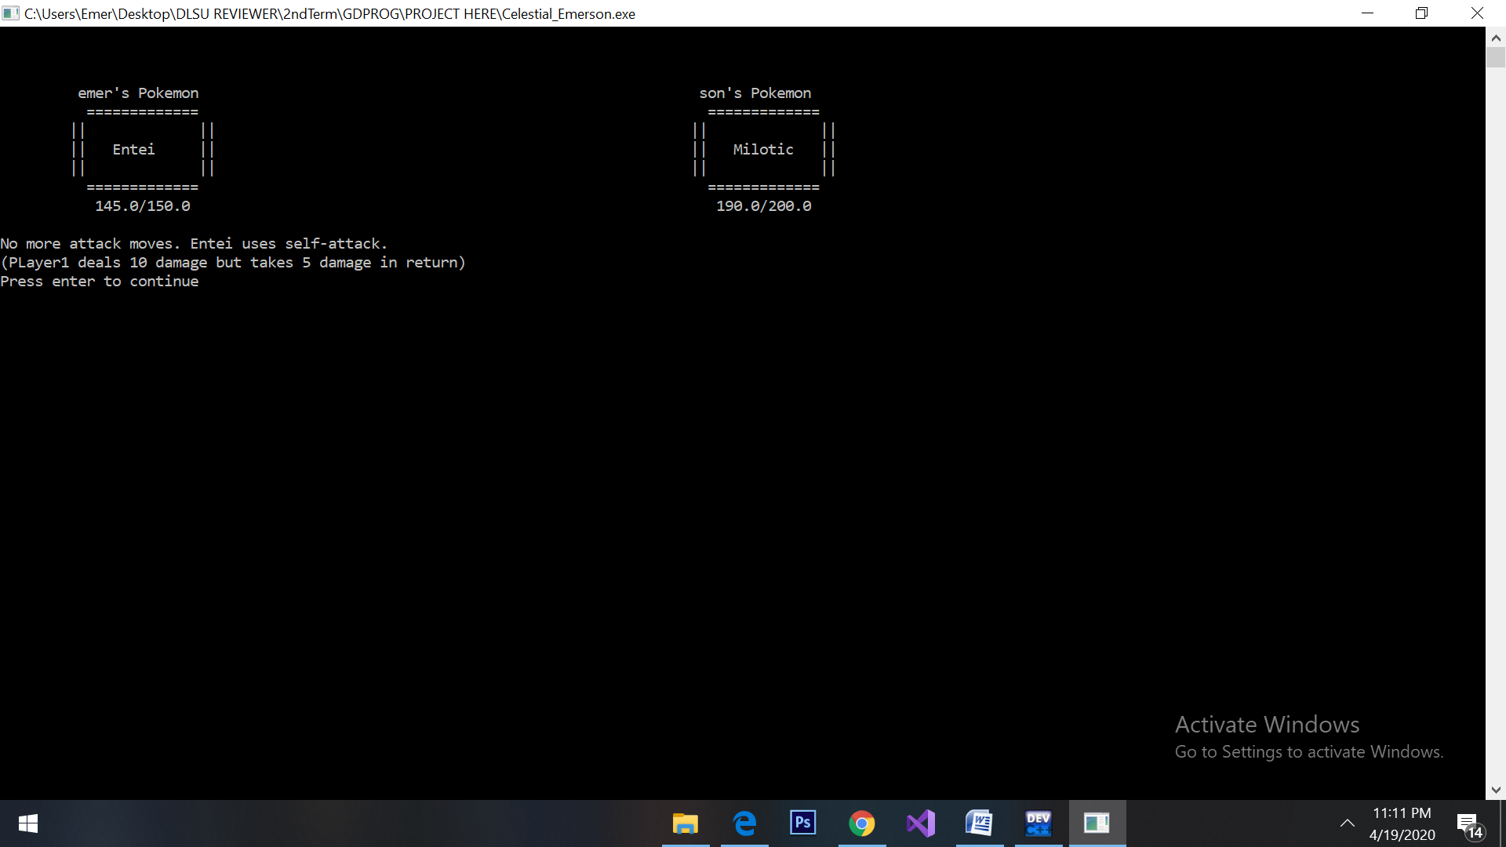**TEST CASE GENERATION**

1.1. If the Pokémon of Player 1 does not have any moves whose Power Points are greater than 0, then the Pokémon of Player 1 takes 5 damage and deals 10 damage to the Pokémon of Player 2. The turn ends.(I forcely adjusted the pp to 0 already to show the outcome, but even in its normal form, it will still show that output if the situation will happen ☺)

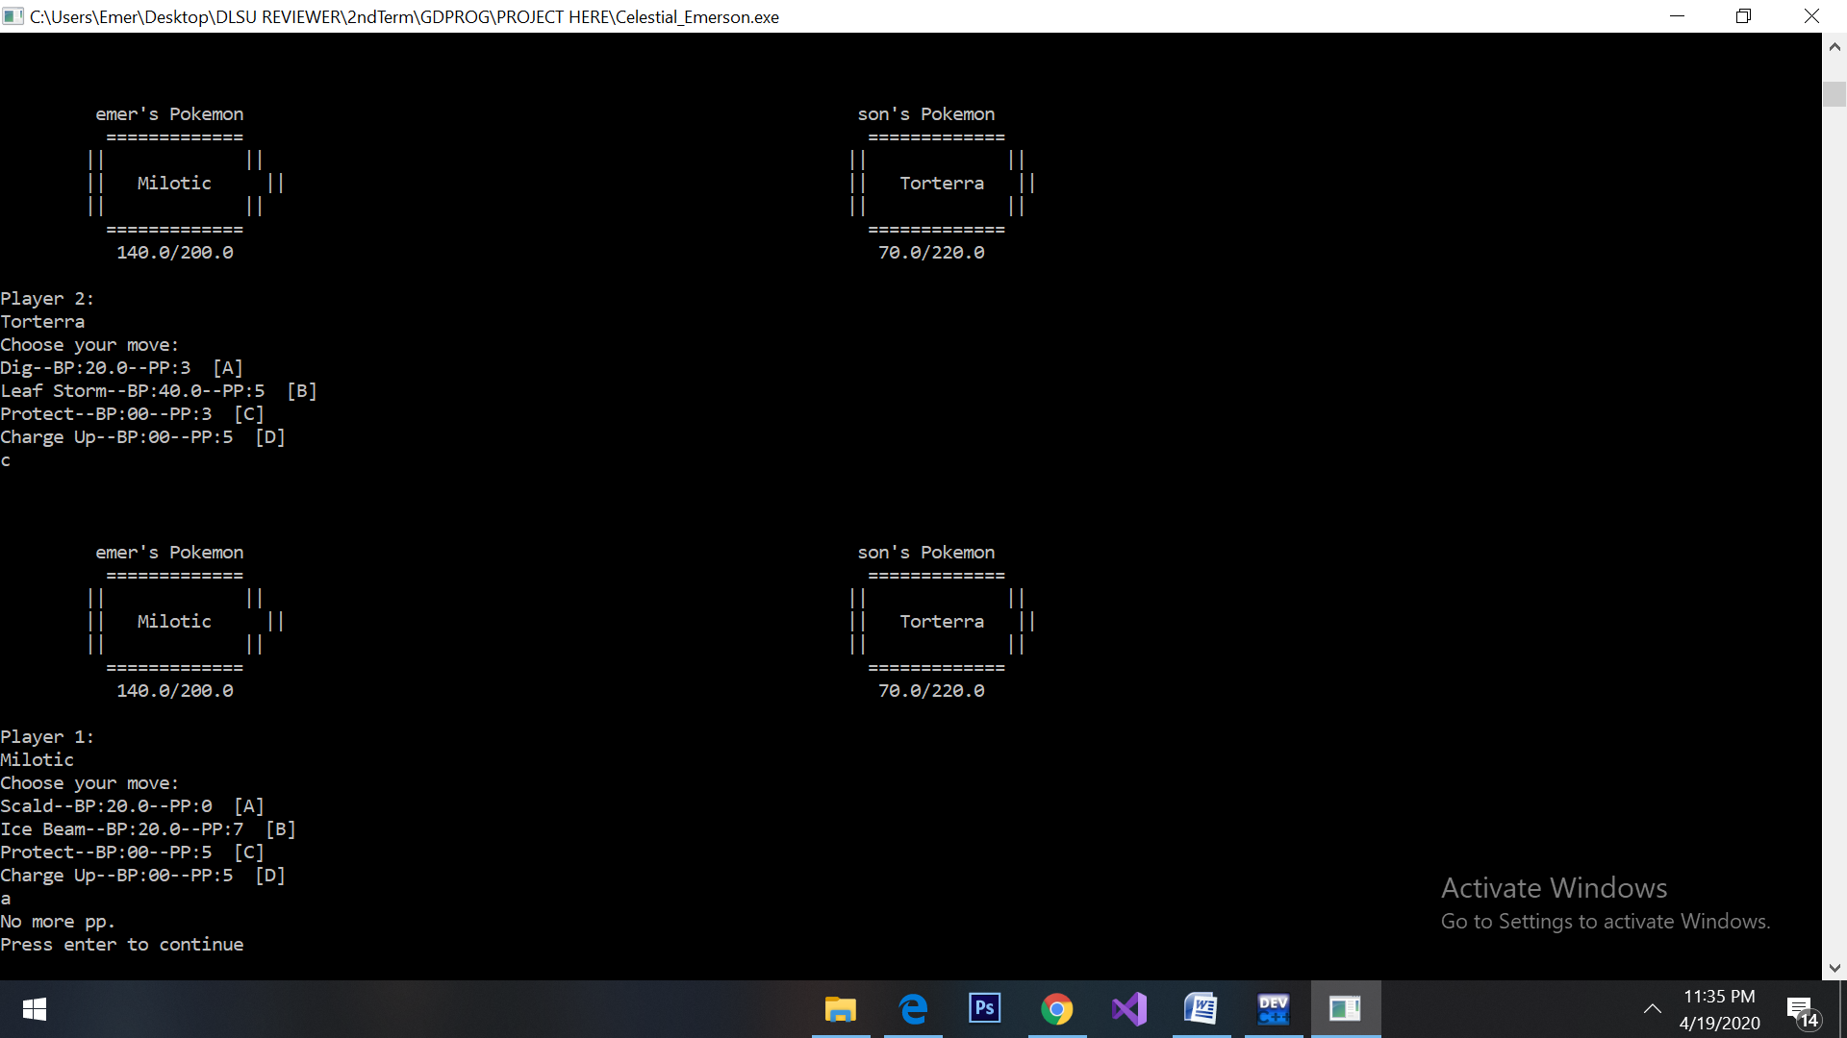1.2. If the Power Points of the move is 0, it will tell the trainer that he or she cannot select that move.

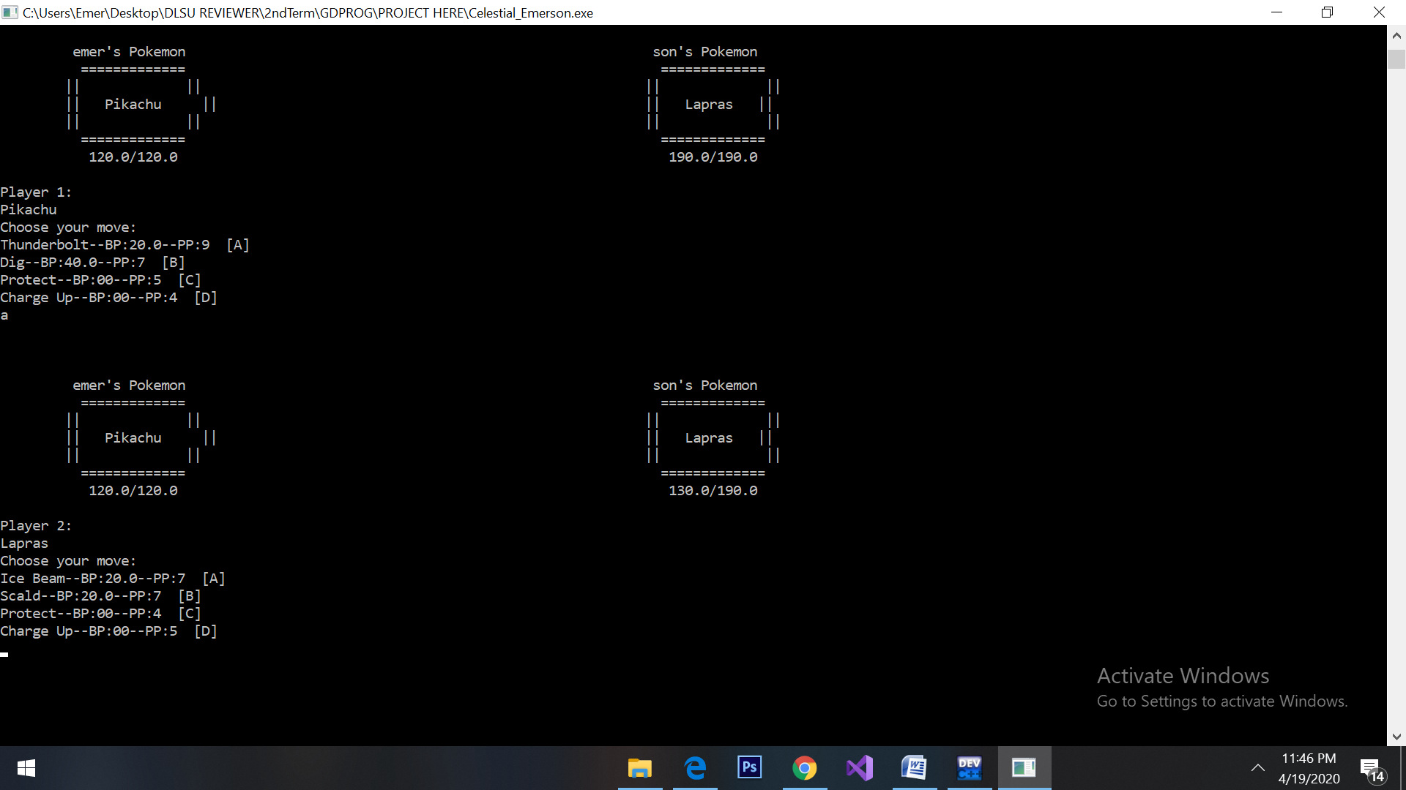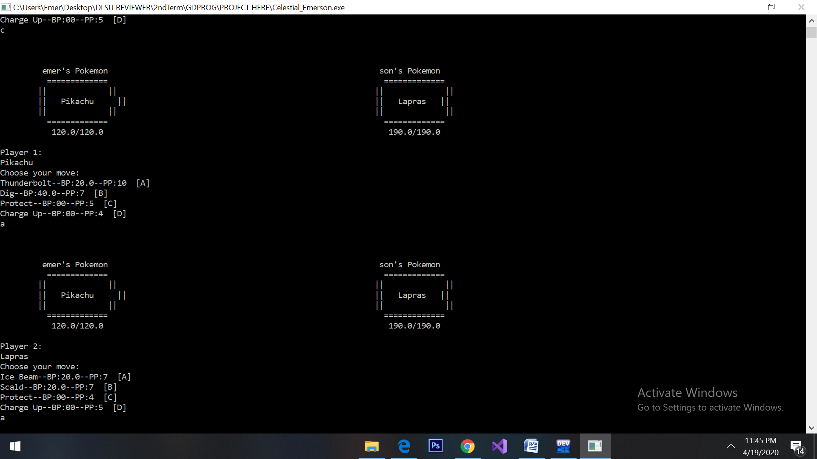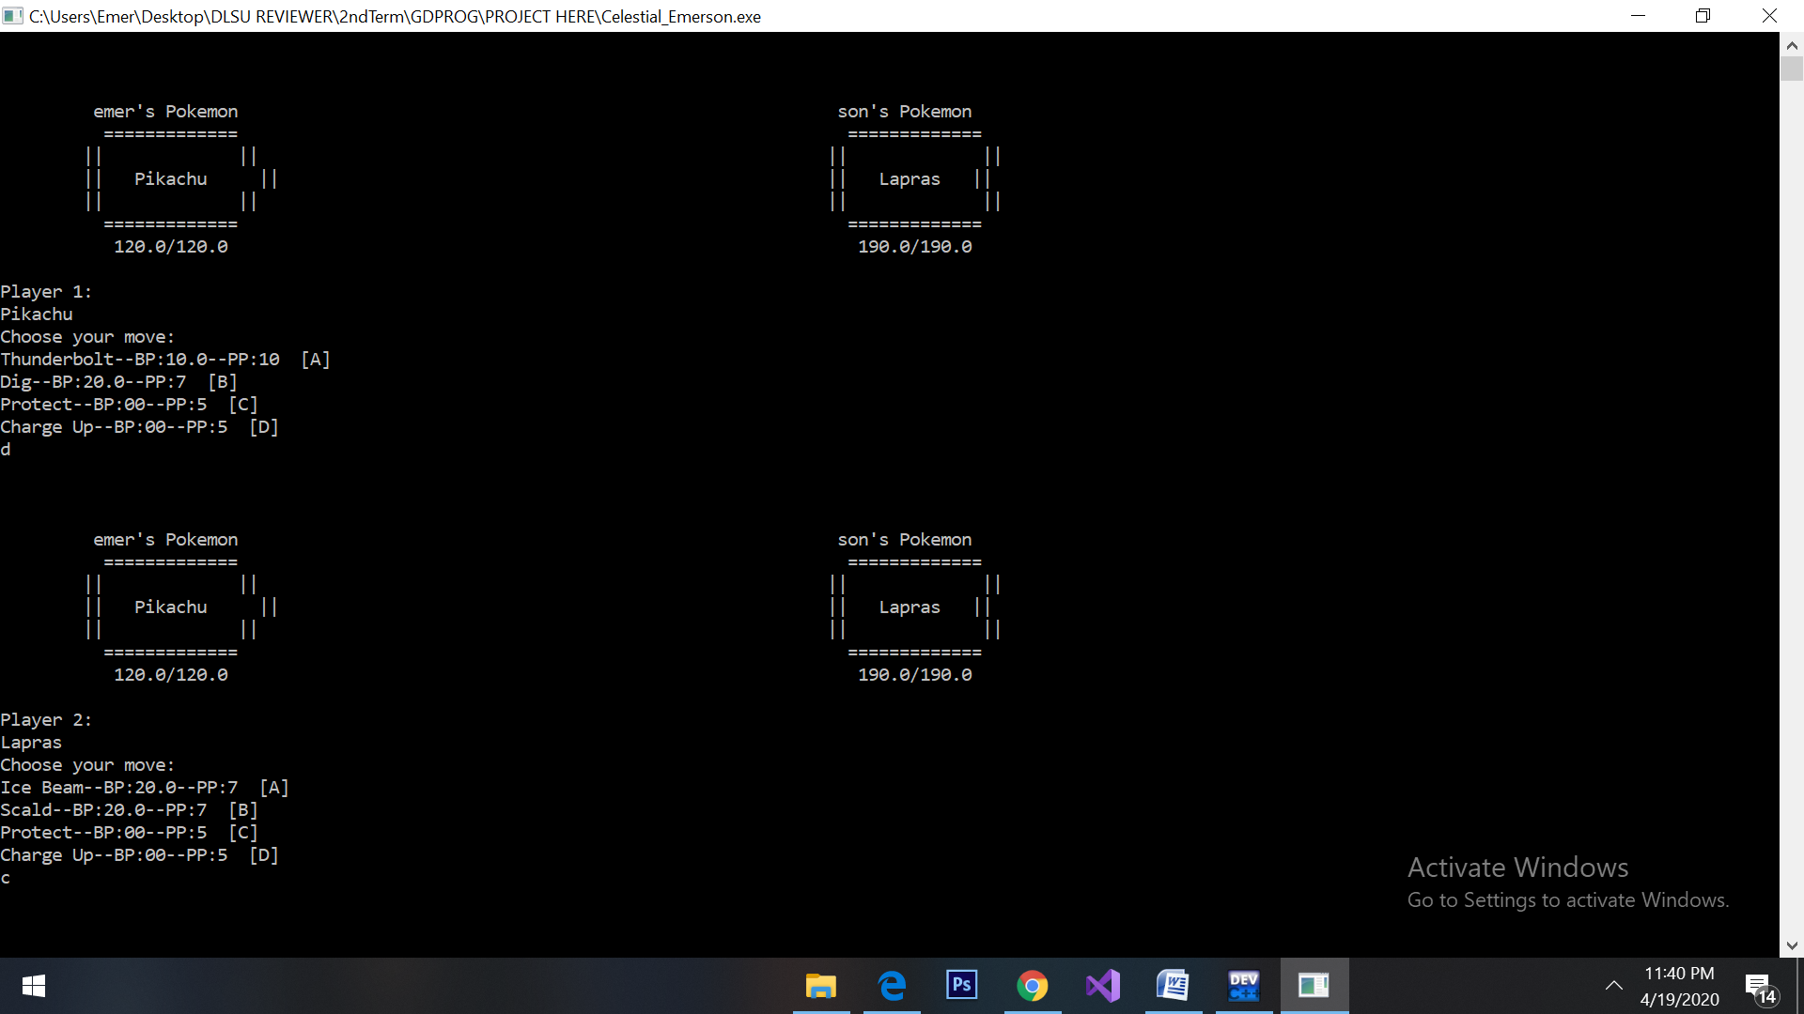

1.3. The move that will deal damage does not need to be the next move used after Charge Up, a Pokémon may use Charge Up followed by Protect then by a damaging move then the damaging move will receive the bonus. The bonus will only affect one move; the Pokémon must use Charge Up again to gain the bonus.

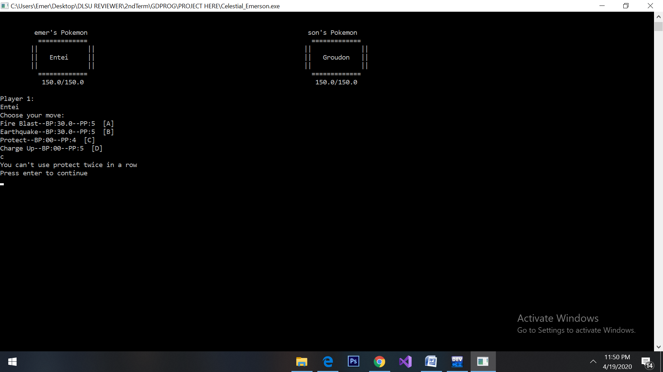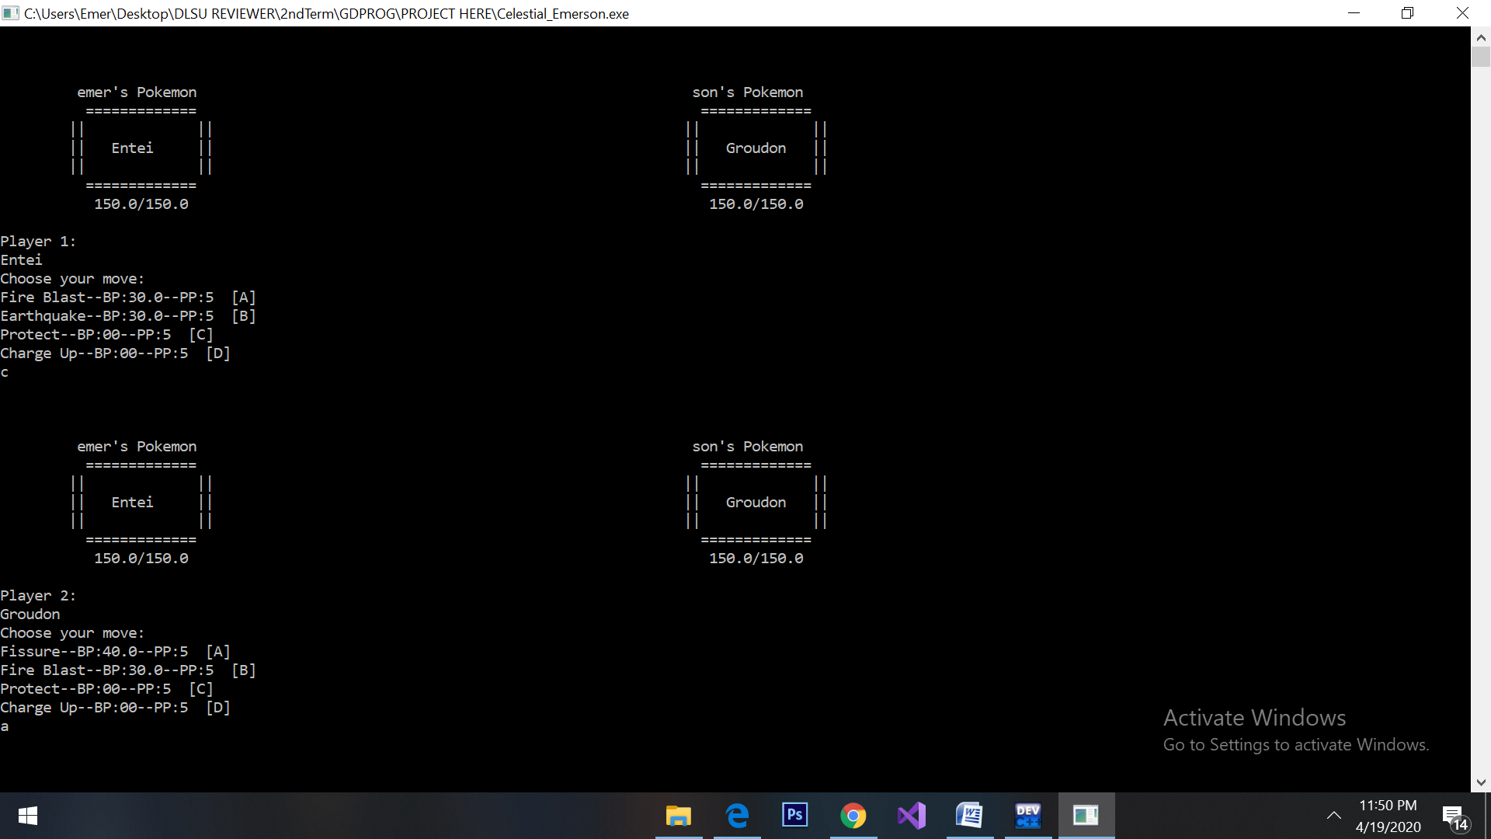1.4. Protect cannot be used twice in a row.

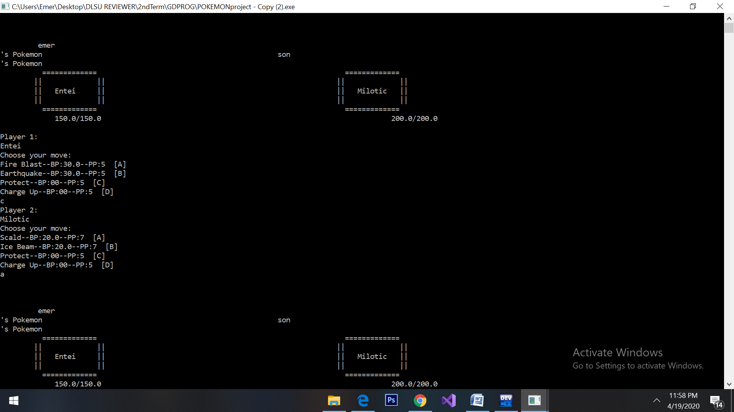**Ability to Test and Debug Program**

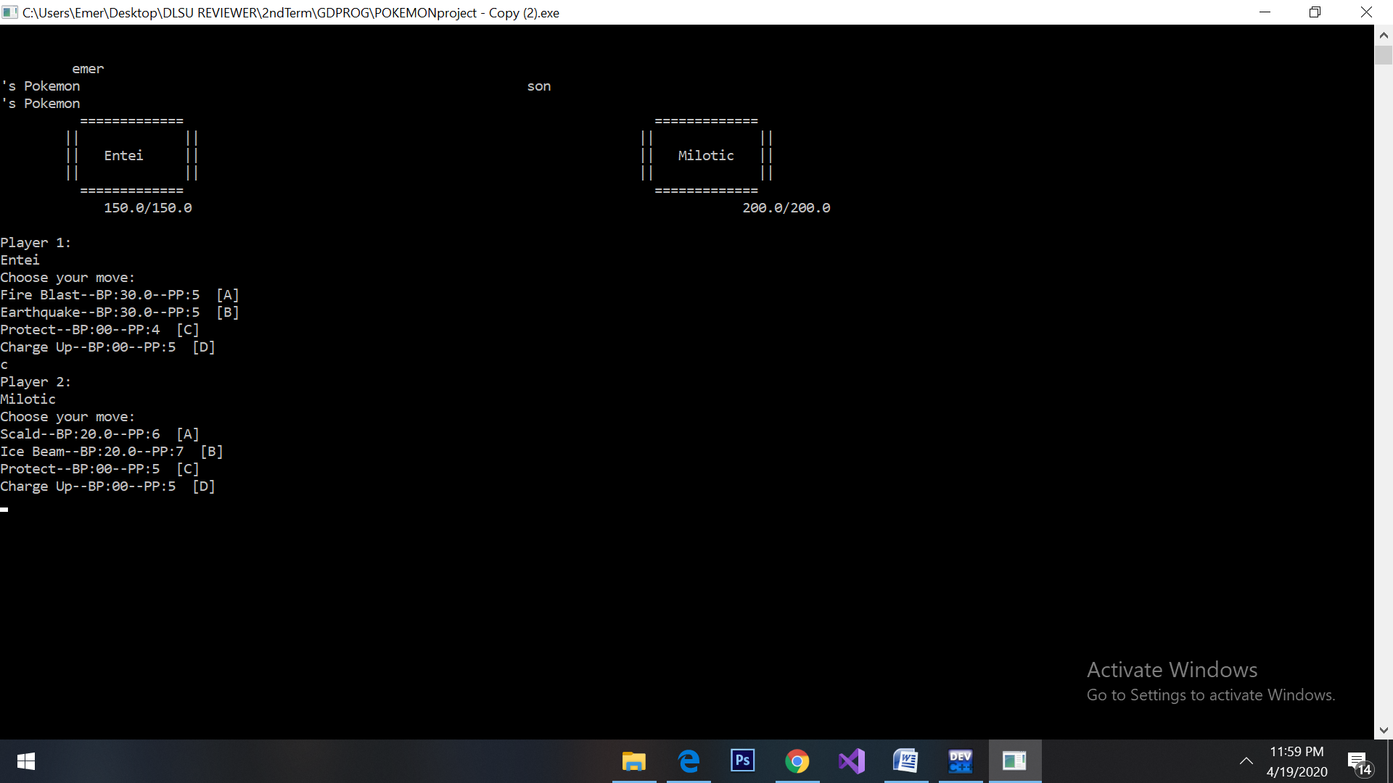-in my version 3.0, I was still able to use "protect" in a row because I’m getting a hard time constructing its code. After two more versions, I’ve finally come up with the code system for it to be limitedly used base on the specification. I created a variable name “nProtectTurn1” and “nProtectTurn2” where it has 2 phase countdown so for every end of turn for the player, the variable will be decrement to 1 until the variable was set to 0 or lower then he can use the “protect” again.

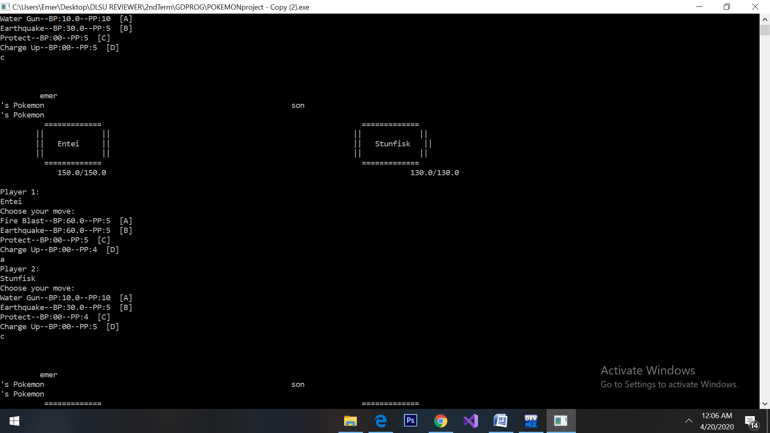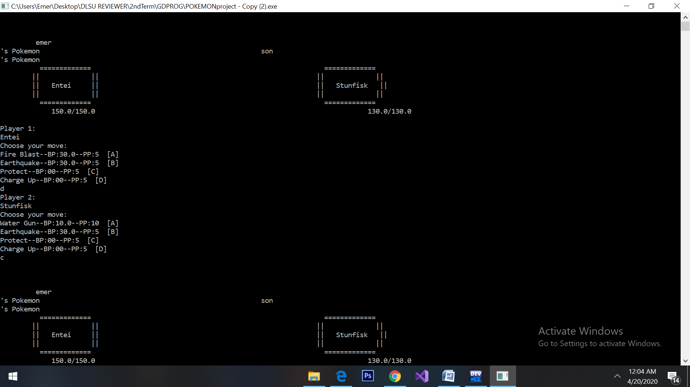

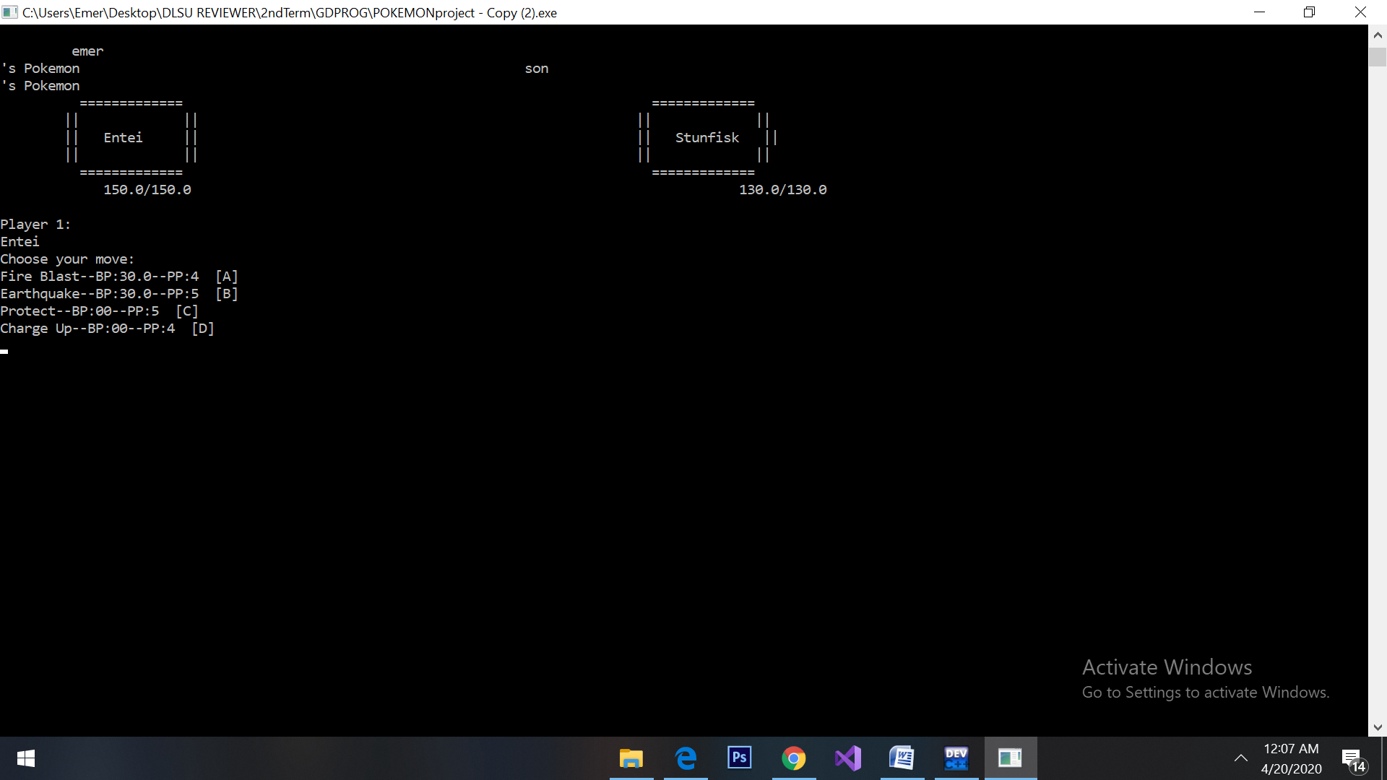-in my version 3.0 again, it doesn’t follow the principles of charged that when the next player uses "protect" and I immediately attack it with my charge up boost then it will absorb and then the boost will be gone for the next turn. And also, I didn’t focus yet on these minor specifications because I focus first on the general system of the game yet, in the later versions I’ve successfully created a code for this situation. For this specification, I created a system where the charged up boost will be like an on/off system that will be triggered only if the boost used in damaging moves that will avoid the other moves like “protect”.

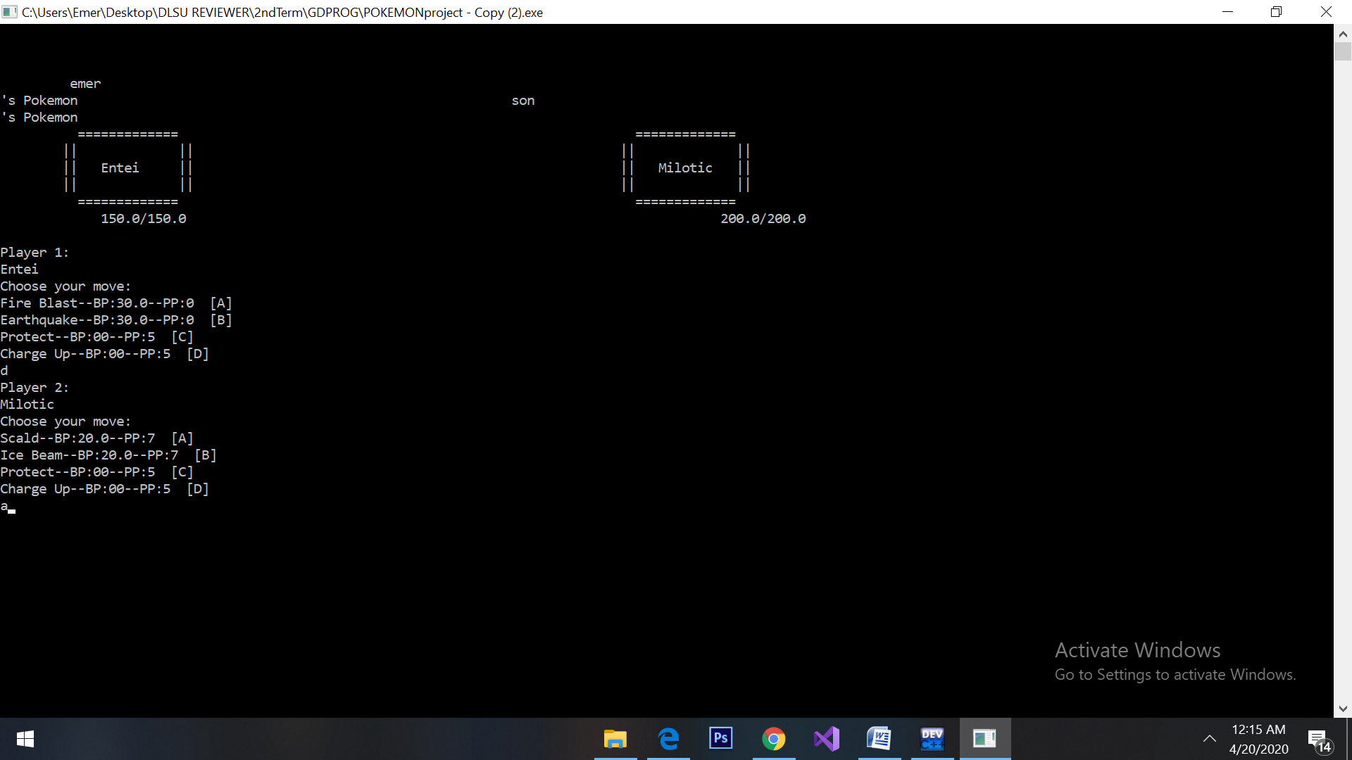- earlier in my version 2.0, I begin to focus on the types of moves system of the game but the “no more pp attack mechanic” where the pokemon will auto-attack if its two damaging moves have no pp available then it will deal 10 damage to the opponent and takes 5 damage in return. I didn’t know how to implement it inside my code, but later in my program works and the recent 5.0 version, I’ve finally implemented the “no more pp attack mechanic”. In this specification, I created an “if statement” for this situation where the statement will trigger if the attack move 1 && 2 will be both equal to 0. I’ve also distinctly placed an “if statement” for the normal phase of the pokemon because it kinda interfere with my code if I didn’t distinguish this statement.

**Additional features added to the game:**

* Users can give their chosen pokemon a nickname.
* A displayed text from the pokemon trainer for every attack move of the pokemon. (Pikachu, use thunderbolt!)
* A healthbar for the pokemon (healthBarP1 & healthBarP2 function)