Maker Module: Manual Prototyping

Individual sketches

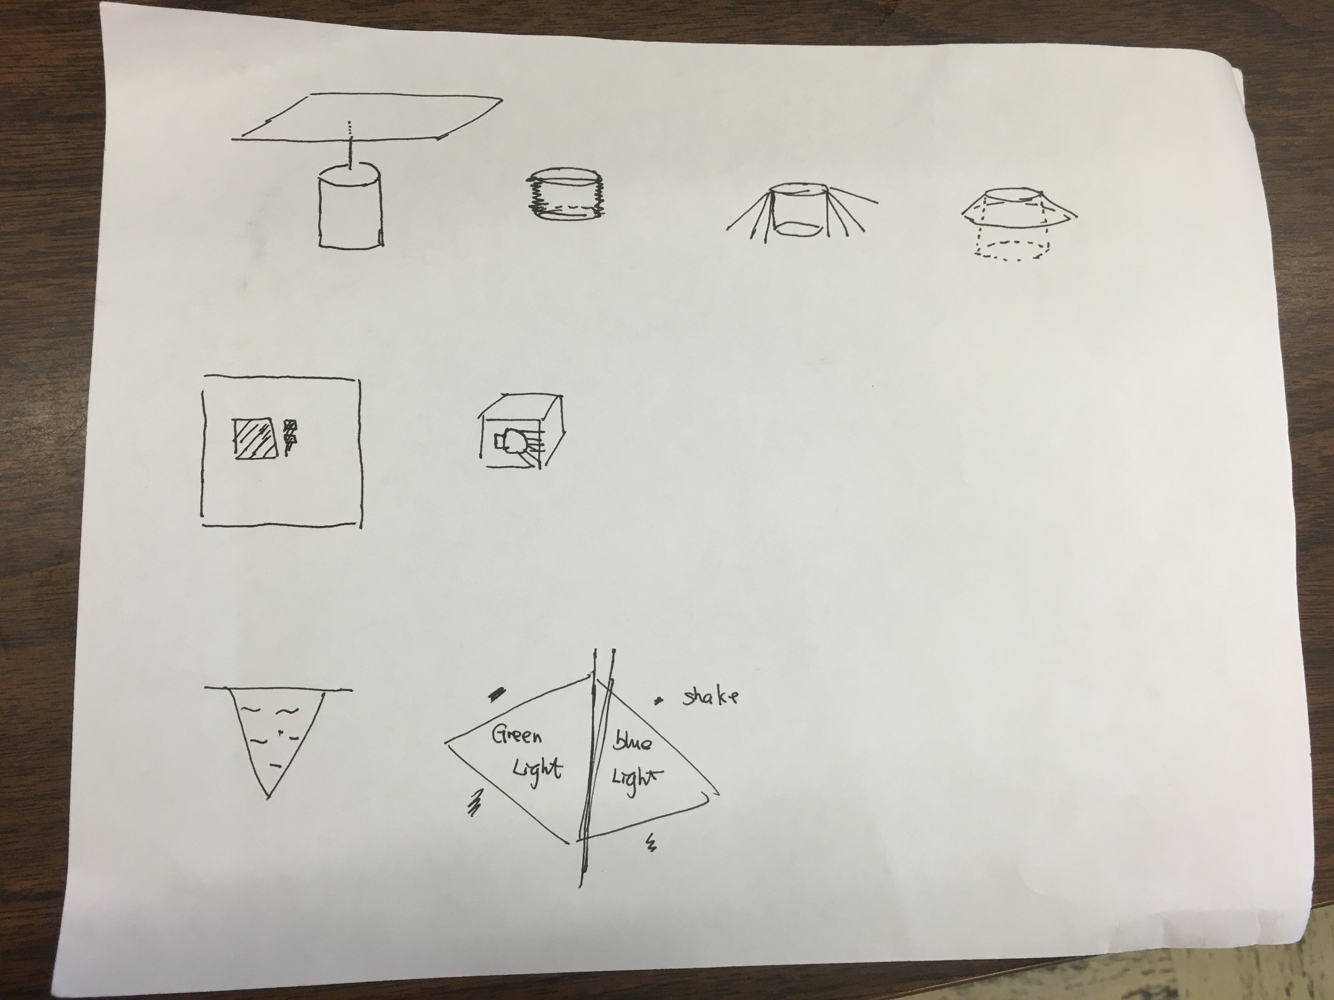

Individual sketch of interactive lamps. Each row stands for one interactive lamp.

Concept1: First lamp is located on the roof, which could be controlled by voice. It would spread itself to provide more light than usual. Also it could shrink to a plane so that it could save a lot of space. I designed some simple command for this lamp to interactive with people. For example, “Open Lamp” means the lamp would open to provide more light in room while “Close Lamp” means another way. “Down Lamp” means let the lamp down while “Up Lamp” means that lamp would shrink to a plane.

So through the voice controlling, this lamp would have a unique and convenient way to be interacted with.

Concept2: Second lamp is located in the wall! The surface of this lamp would be some special dark glass, in that way, it could hide in the wall. In my concept, it should be a cube with a LED bulb in it. And the simple way to open the lamp is to tap on the surface of the lamp. When you tap on it, it would open and show the normal yellow light. While you swipe on that surface, the lamp should change the color! So this lamp could provide up to seven different kinds of color with its unique interactive way.

And another reason I made the LED bulb in the cube is that this bulb could spin and change the direction so that it could lighten wherever you want.

Concept3: Third lamp is just for fun. It is combined with two pyramids and each of pyramids stands for one color. So you can choose either side of the lamp to be lightened. And you can shake this lamp, so these two pyramids would combine their color and give you a whole new experience. So the way to interact with the third lamp is to shake!

Group prototype

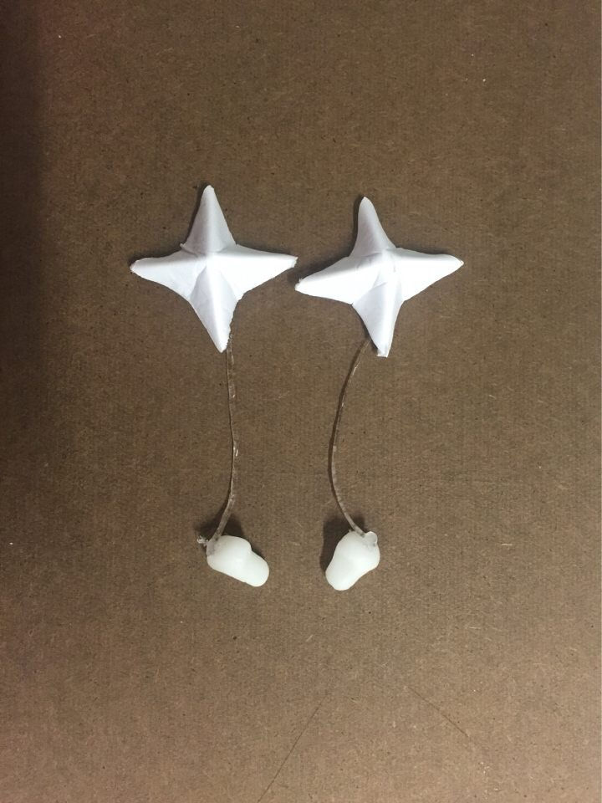

These two pictures show our final prototype that is an interactive lamp combined with all lamp, earrings, and earphones. So we created the earring part with the core foam and the earphone part with the glue.

In our mind, the earring would be responsible for the lightening, as a lamp while the way how it shines and the color of the earrings is based on the music people are listening to. So we could connect our earrings with the phones through Bluetooth. So that we could know what kind of music it is playing. So in this way, we created our own interactive lamp.