**Assignment-1**

**Team:** - 3ENB04

- GGC (Gold Glasses Company)

- Auyeskhan Elmira, Kurmanzhankyzy Akmaral,Abiyr Maira

- Portal logins (13623,13330,13342)

-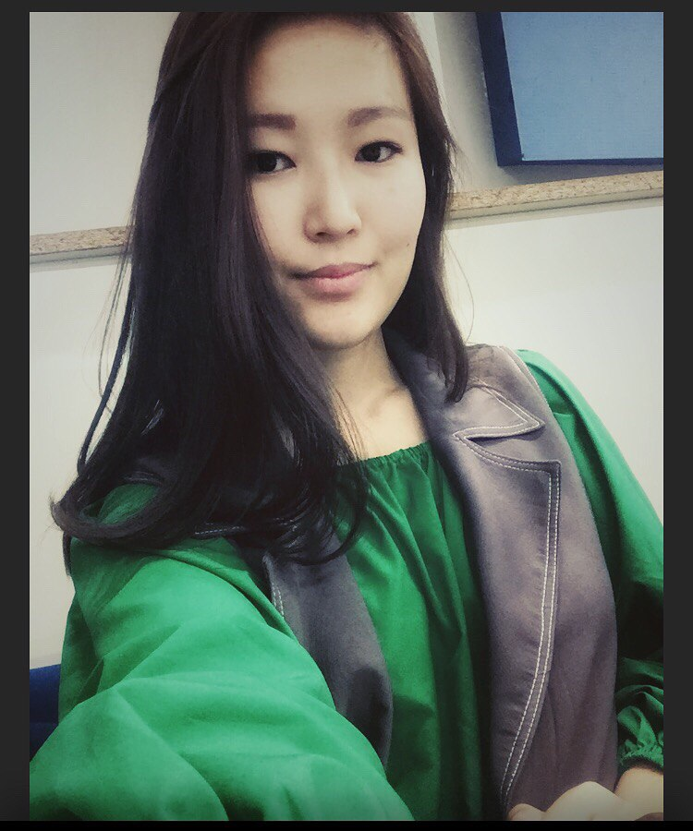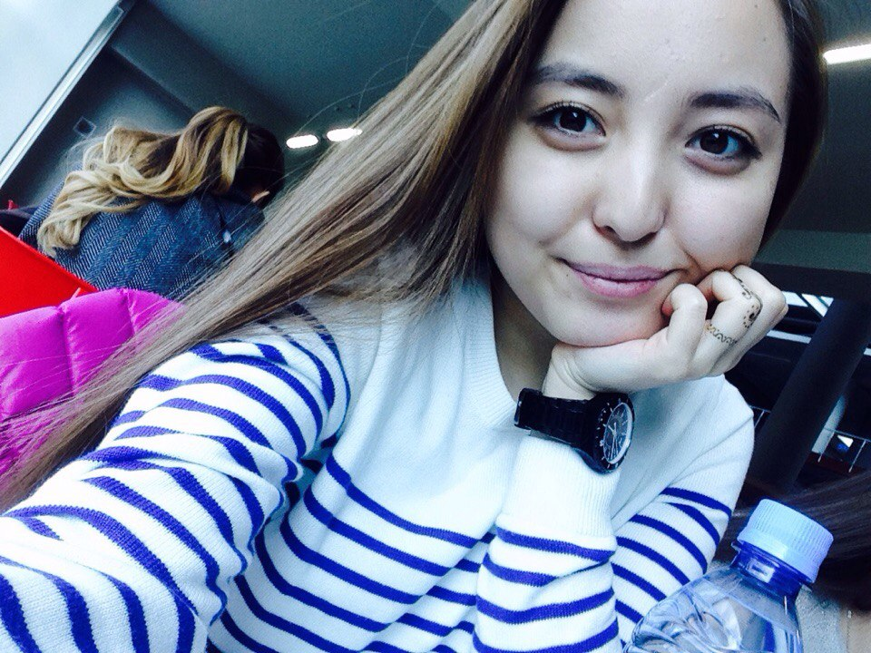 Photos

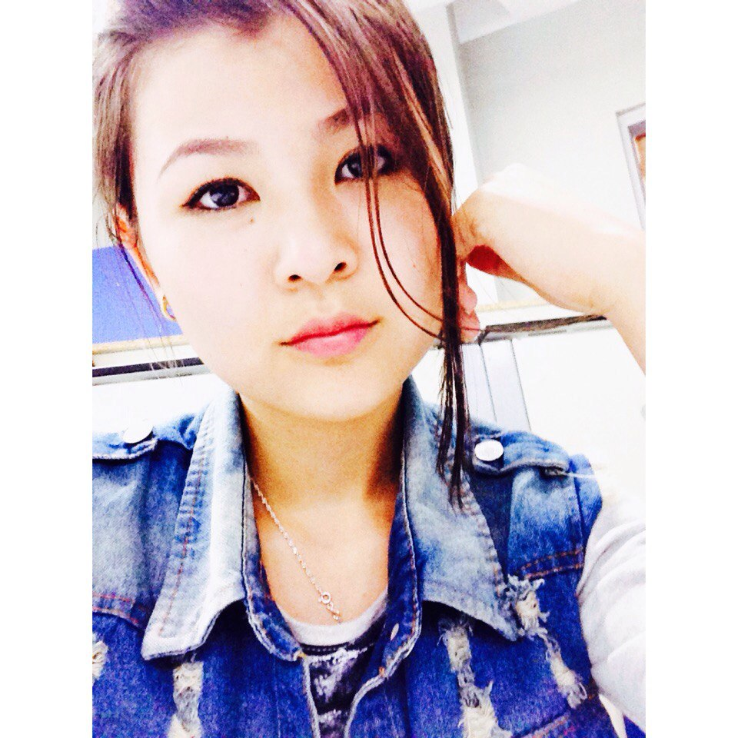

**Name**: Kids learning

**Description**: our project contains of two main parts. At the first page there are three menus(alphabet,colours,numbers).This is learning part.At the second page there are two menus(alphabet,numbers) This is testing(game)part.

**Languages/Platforms**:

Android Development, Web app, Java, HTML,CSS,Java script

**Complexity**: We do two projects: mobile application for android users and web application. It will be very useful and very interesting project. Inside android application will be the link to pass to web application.

**Customer**: name of the customer, occupation, and contact information written in contract.

**Source control:** ihttps://github.com/Emi95/GGC