**Read Me**

* Jie Ren

1. **How to install or run the program**

Step 1:

Our program is made based on the Visual Studio 2015, so the user need to install Visual Studio 2015 firstly and then double click the “CMS4.sln” file to run. The CMS4.sln file is as the following picture.

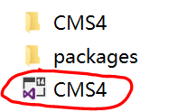

Step 2:

In the Solution Explorer box, left click the “CMS4”.

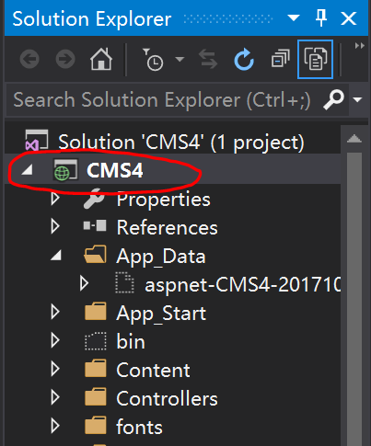

Step 3:

Left click the green run icon on the top.

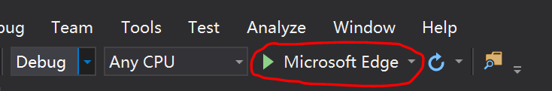

A browser has been opened. Now you are running our program successfully:

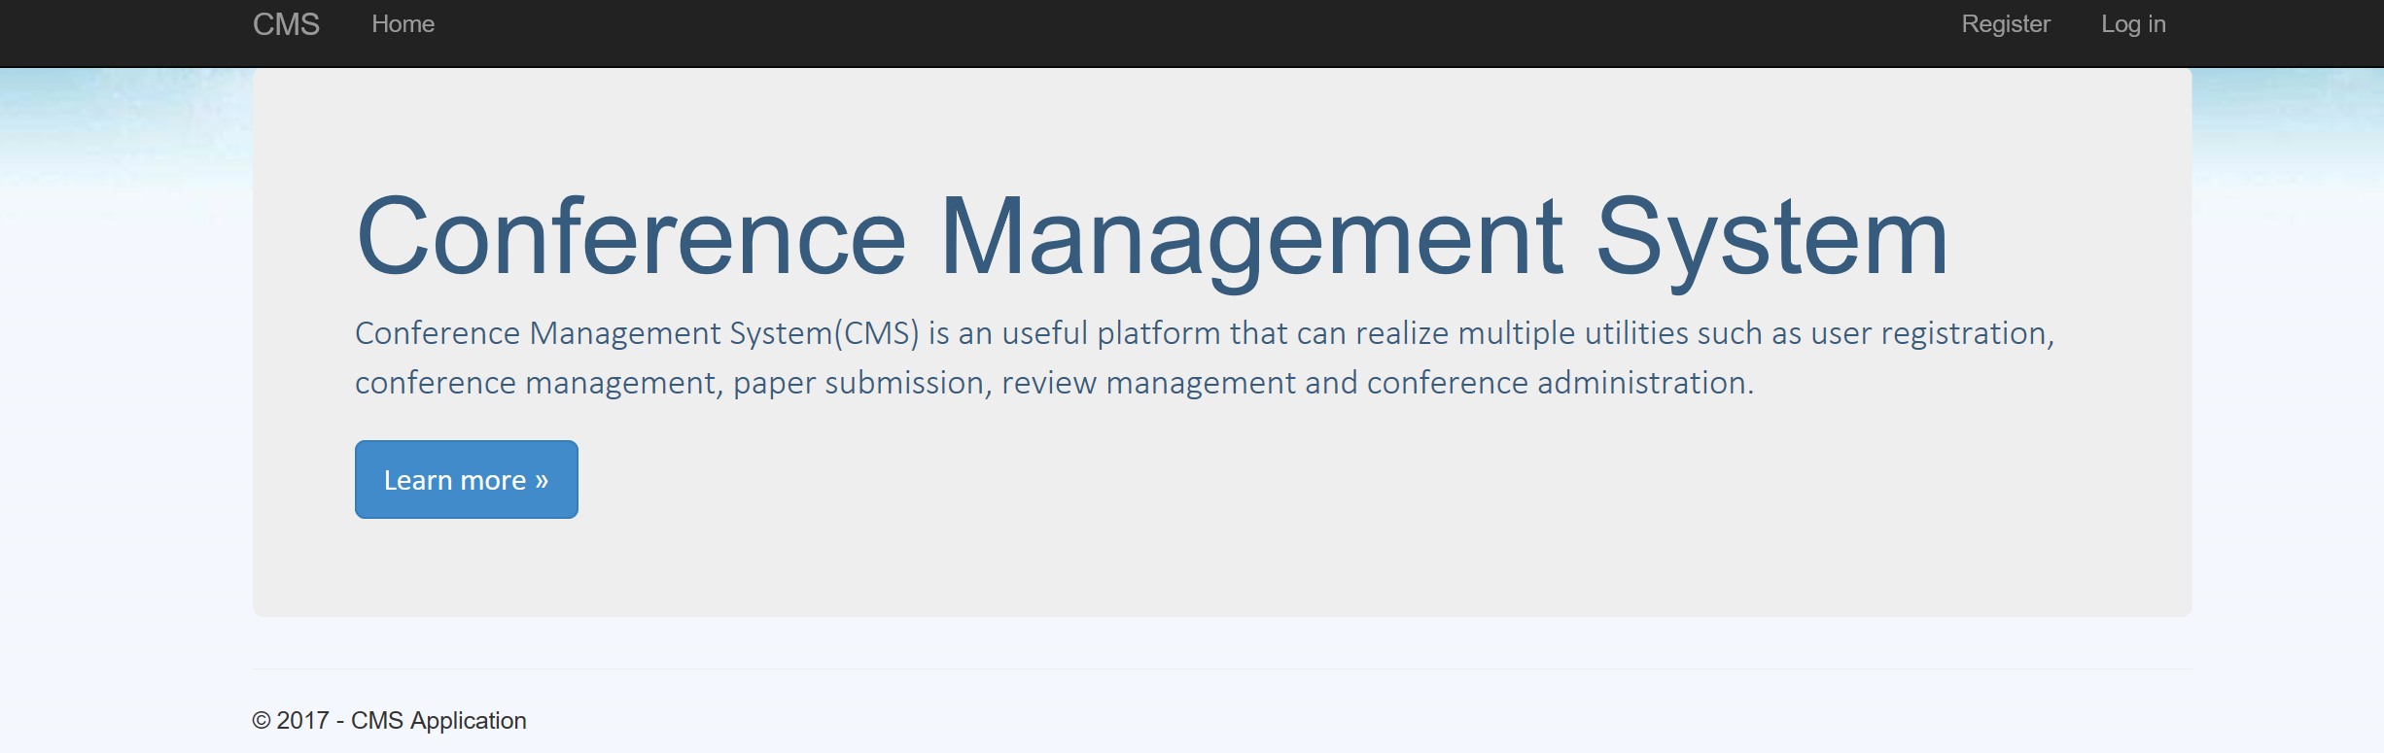

In addition to this, we provided several accounts for you to test the program or you can also create new users by yourself (Note: **Admin cannot be created on the webpage!** **Please use the provided admin account** or create a new one in the database at backstage):

|  |  |  |
| --- | --- | --- |
| Username | Password | Role |
| Admin1 | Admin1@gmail.com | Admin |
| Author1 | Author1@gmail.com | Author |
| Author2 | Author2@gmail.com | Author |
| Author3 | Author3@gmail.com | Author |
| Author4 | Author4@gmail.com | Author |
| Author5 | Author5@gmail.com | Author |
| Chair1 | Chair1@gmail.com | Chair |
| Chair2 | Chair2@gmail.com | Chair |
| Chair3 | Chair3@gmail.com | Chair |
| Reviewer1 | Reviewer1@gmail.com | Reviewer |

1. Functionalities

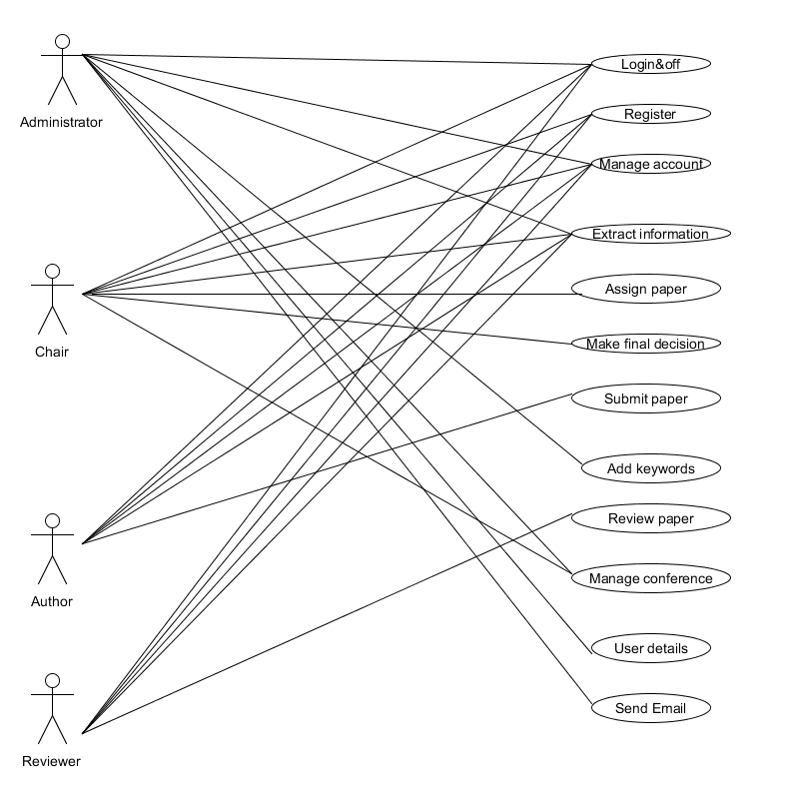

1. How each functionality is implemented

The functionality is based on the user role (ordered by the display of website):

1. Admin
2. Login&off

Based on MVC framework, it is implemented by the Model-AccountViewModels-LoginViewModel/ Controllers-AccountController, View-Account-Login/Logoff.

It is worth to mention that the visitor cannot create an admin account by the register function.

1. Retrieve user details.

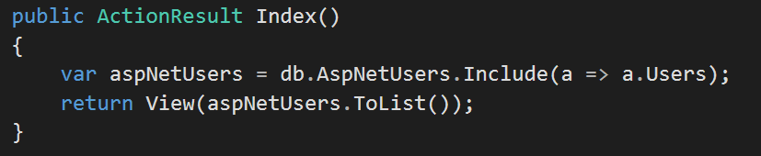

In the AspNetUsertsController, there is a function as the above picture, it retrieves the registered users’ information from database through the CMS4 model and return it to the index view of AspNetUsers.

1. Manage Account

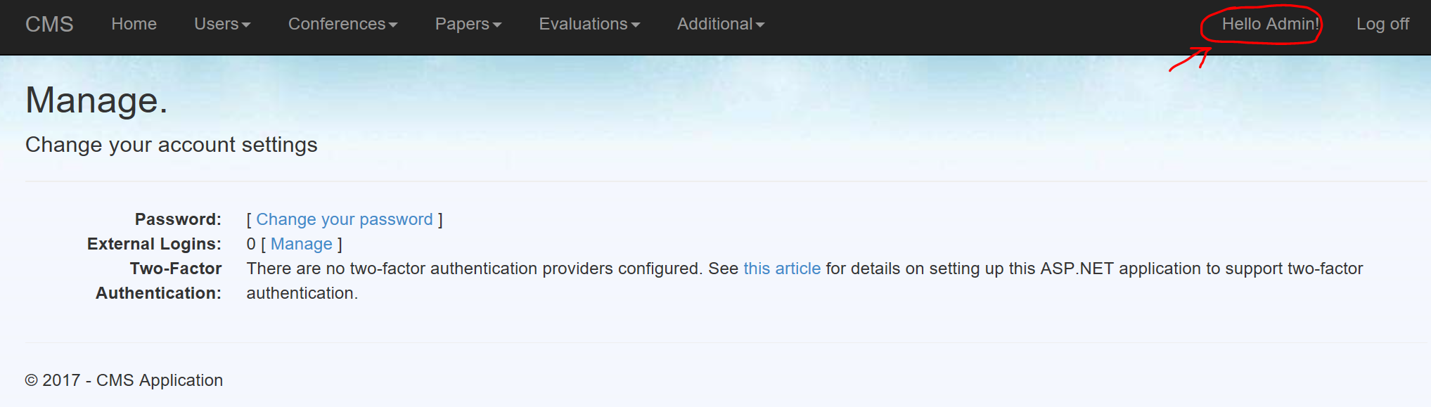

All registered users can click the top right click to manage their account with the several functions. They are implemented by Mode-ManageViewModel, Controller-ManageController, View-Manage.

1. Create conferences

The admin can create the conferences by clicking the Create New button, as follows. (**Only the admin can create conferences**, chairs can just edit the information of their **individual conference.** Implement by role authorize and different role layout page)

 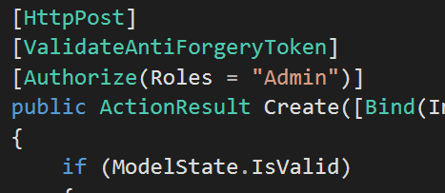

Conference creating function is implement by the Model-CMS4-Conference, Controller-ConferencesController, View-Conference-Create.

1. Add keywords

Before creating a conference, the compulsory step is adding a keyword. This function is under the Additional button on the admin page only.

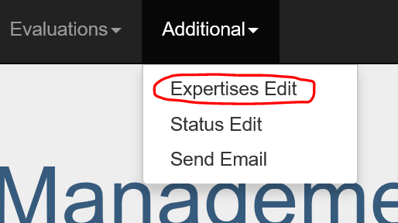

1. Retrieve Information

Admin can retrieve almost all the information, including all users, conferences, papers, evaluations, expertise and status. And it can also searching by keywords, this function is implement by JQuery-dataTable.



1. Sending Email

We can see in the add keywords parts the picture shows that there are sending email function under the status edit. After clicking that, the admin could send email by entering the email address of a recipient with an attachment.

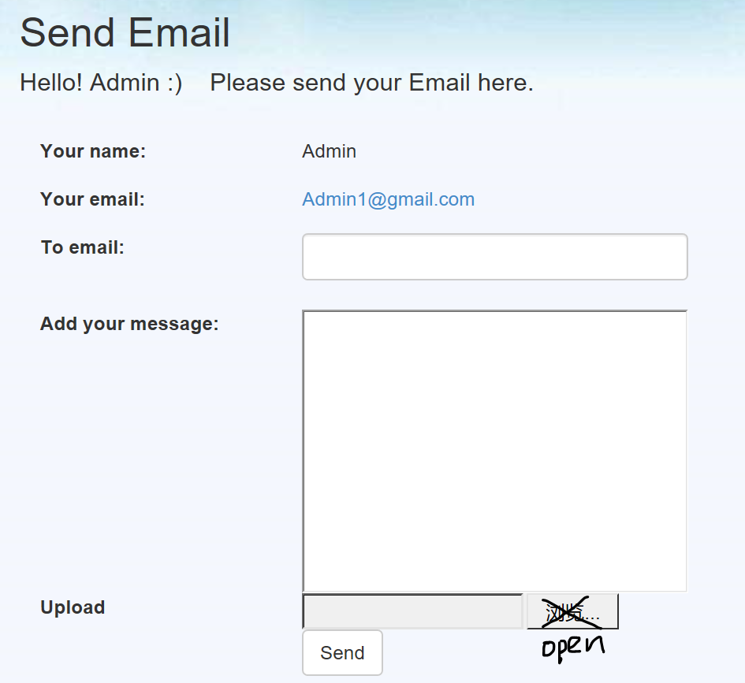

It need to be noted that the admin’s email is [admin1@gmail.com](mailto:admin1@gmail.com) which is not a real email address and might cause sending unsuccessfully.

1. Chair
2. Register

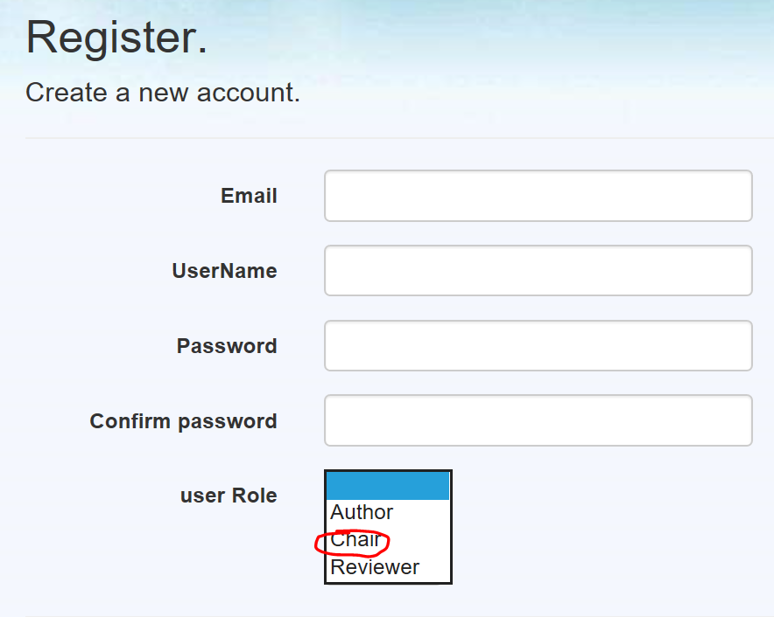

When the user clicks the register button, he/she need to complete the above information and choose a role to register. This function is implement by Model-AccountViewModel, Controllers-AccountControllers, View-Account.

1. Login&off

This part is as same as the Admin Login&off.

1. Manage Account

This part is as same as the Admin Manage Account.

1. Extract information

The chair could extract information of conference, my conference, paper and evaluation.

1. Make final decision

When the chair sees the status of paper is review completed, he/she can make the final decision by clicking the edit button in the evaluation part. And set it to accepted or rejected status.

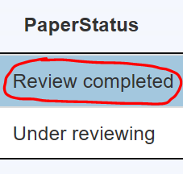 

1. Manage conference

Chairs can publish conference information and change them but cannot create it. This is implement by editing function of conference. Model and controller used conference one and the view used View-conferences-edit.

1. Assign paper

Chairs assign paper to reviewers by clicking the button as following. The char Id is needed. It is implement by the Model and Controller of evaluation and view-evaluation-create.

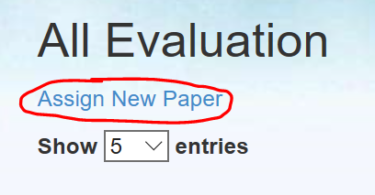

Only the chair could assign new paper, it is implemented by adding an authorize in evaluation controller.

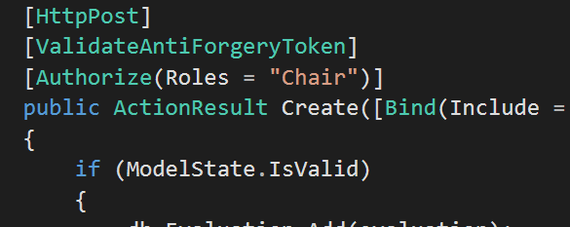

1. Author
2. Register

This part is as same as the Chair Register.

1. Login&off

This part is as same as the Admin Login&off.

1. Manage Account

This part is as same as the Admin Manage Account.

1. Extract information

The authors could extract information of conference, all paper, my papers and evaluations.

1. Submit paper

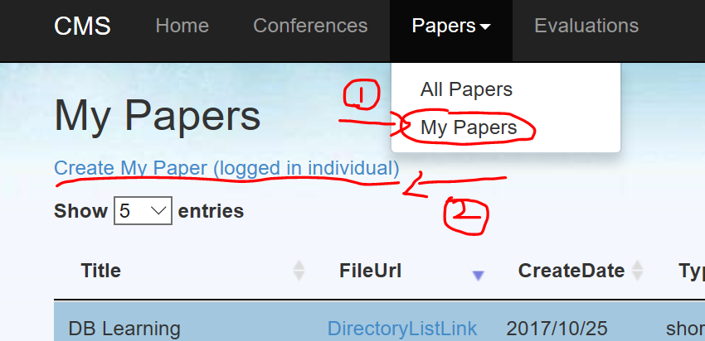

Author just has one way to submit paper, it is the above two steps. The author can just create their own paper by using the logged in ID, this function is implemented by the following added CreateIndividual method in paper controller.

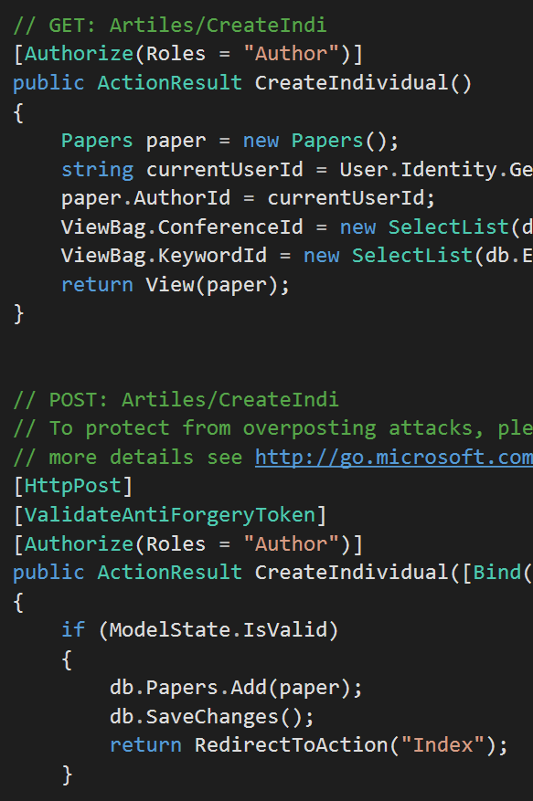

At the same time, please notice that the message show below the create your paper. Author should click the link first and upload his/her paper. And the paper will be saved at the path of ~/Upload/. This is realized by controller and view of File -Upload and UploadPaper.

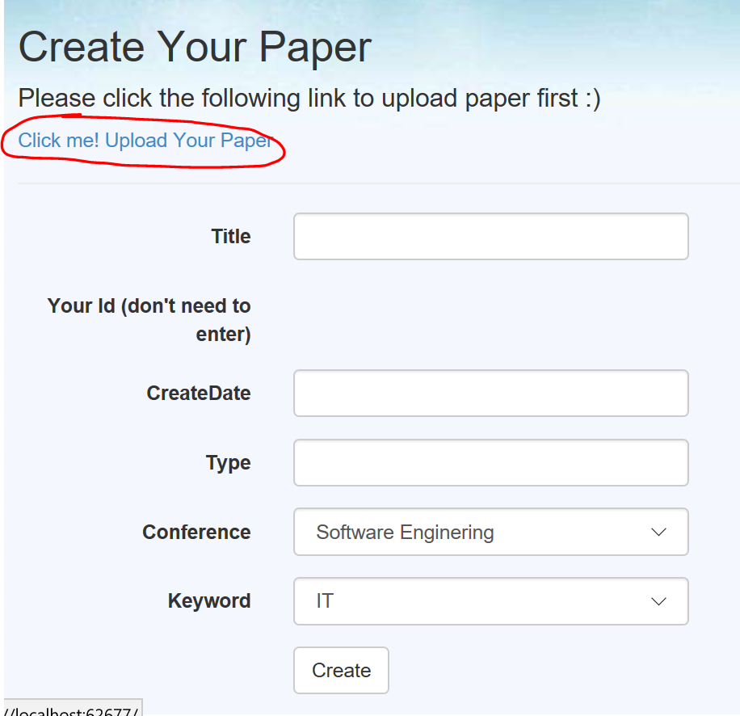

1. Reviewer
2. Register

This part is as same as the Chair Register.

1. Login&off

This part is as same as the Admin Login&off.

1. Manage Account

This part is as same as the Admin Manage Account.

1. Extract information

The reviewers could extract information of conference, paper and my assigned evaluations.

1. Review Paper

Reviewers can only review their own assigned papers; the function is implemented by an added method called IndexUserNames in Evaluation controllers and the view of Evaluation. The detail steps are as follows.

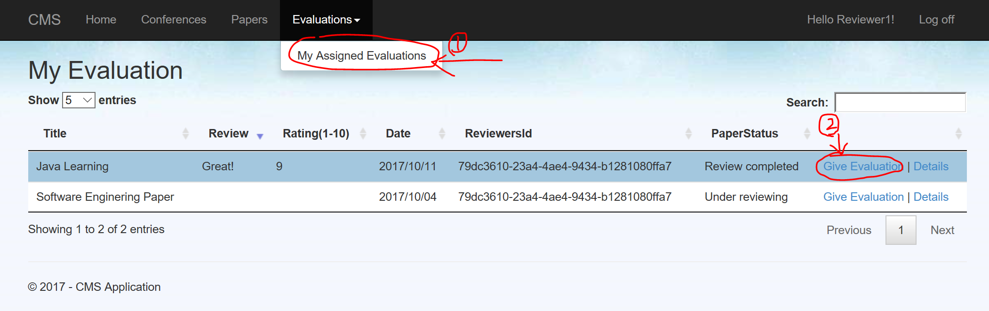

1. Important features of the implementation
2. Role should be selected in registration.
3. Conference can only create by admin.

Chair can publish conference information.

1. Keywords (In our website called expertise) should be added by the admin before conference created.
2. Reviewer can only give evaluation to their own assigned paper (assigned by chairs).
3. Author can only create their own papers. In the all papers page, there is no creating function there.
4. Different user role has different navigation bar at the top of website
5. When the user doing create or edit function, please complete all the text box before submit.
6. If you have designed candidates for earning extra credit, you need to clearly explain them.

This website is designed based on the Asp.net MVC framework. We chose this because it is a more convenient tool to realize and visualize a web application structure. The model and controller parts used C# and the View part use html language. The database we used the SQL Server database. We also added the jQuery-UI elements (dataTable) and bootstrap tools to help us to implement a more user-friendly web application.

It is worth to mention that the database is normally hidden, if you want to access it please follow the picture.

