Bewijsstukken

Screenshot van browser naar http://10.0.0.150

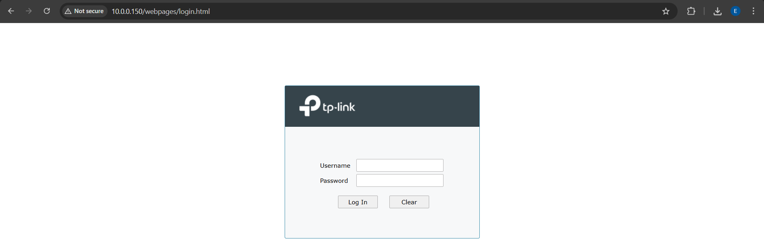

Screenshot van browser naar https://10.0.0.150
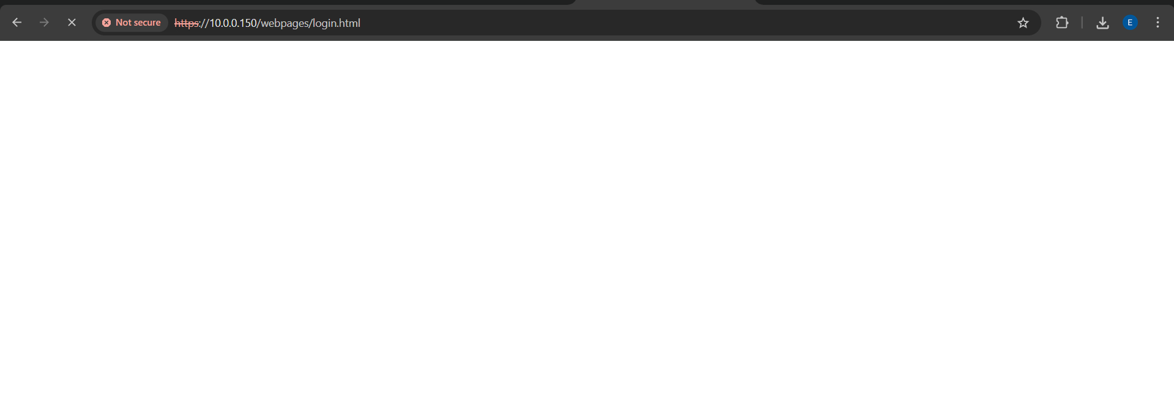
DE HTTPS PAGINA WIL NIET LADEN

Screenshot van browser naar http://192.168.0.212
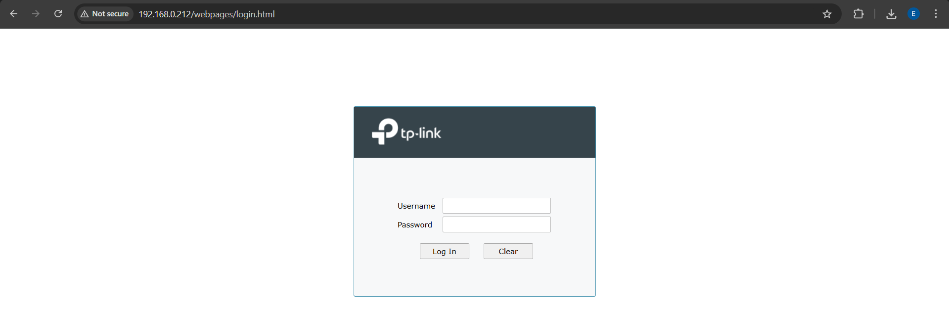

Screenshot van browser naar https://192.168.0.212
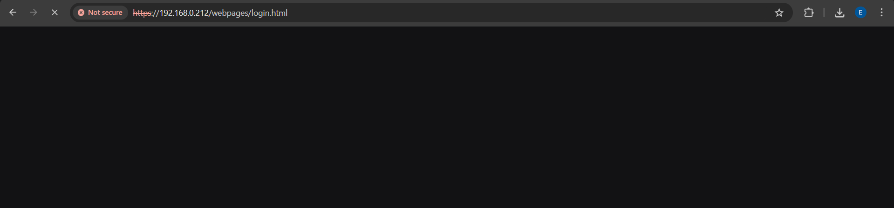
DE HTTPS PAGINA WIL NIET LADEN

Screenshot van browser naar http://10.0.0.60:8888 indien toegestaan
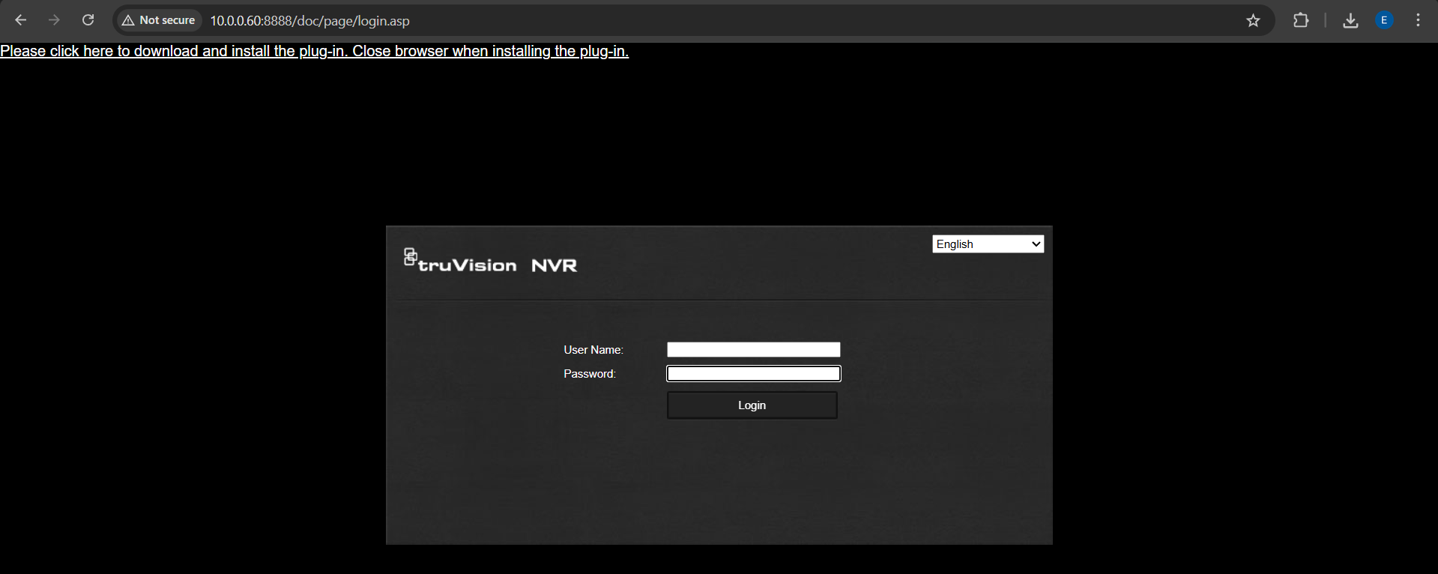

PowerShell Test-NetConnection per relevante poort
PS C:\Users\emiel> Test-NetConnection 10.0.0.150 -Port 80

ComputerName : 10.0.0.150
RemoteAddress : 10.0.0.150
RemotePort : 80
InterfaceAlias : Wi-Fi
SourceAddress : 10.0.0.156
TcpTestSucceeded : True

PS C:\Users\emiel> Test-NetConnection 10.0.0.150 -Port 443

ComputerName : 10.0.0.150
RemoteAddress : 10.0.0.150
RemotePort : 443
InterfaceAlias : Wi-Fi
SourceAddress : 10.0.0.156
TcpTestSucceeded : True

PS C:\Users\emiel> Test-NetConnection 192.168.0.212 -Port 80

ComputerName : 192.168.0.212
RemoteAddress : 192.168.0.212
RemotePort : 80
InterfaceAlias : Wi-Fi
SourceAddress : 10.0.0.156
TcpTestSucceeded : True

PS C:\Users\emiel> Test-NetConnection 192.168.0.212 -Port 443

ComputerName : 192.168.0.212
RemoteAddress : 192.168.0.212
RemotePort : 443
InterfaceAlias : Wi-Fi
SourceAddress : 10.0.0.156
TcpTestSucceeded : True

PS C:\Users\emiel> Test-NetConnection 10.0.0.60 -Port 8000

ComputerName : 10.0.0.60
RemoteAddress : 10.0.0.60
RemotePort : 8000
InterfaceAlias : Wi-Fi
SourceAddress : 10.0.0.156
TcpTestSucceeded : True

PS C:\Users\emiel> Test-NetConnection 10.0.0.60 -Port 8888

ComputerName : 10.0.0.60
RemoteAddress : 10.0.0.60
RemotePort : 8888
InterfaceAlias : Wi-Fi
SourceAddress : 10.0.0.156
TcpTestSucceeded : True

PS C:\Users\emiel> Test-NetConnection 10.0.0.60 -Port 554
WARNING: TCP connect to (10.0.0.60 : 554) failed

ComputerName : 10.0.0.60
RemoteAddress : 10.0.0.60
RemotePort : 554
InterfaceAlias : Wi-Fi
SourceAddress : 10.0.0.156
PingSucceeded : True
PingReplyDetails (RTT) : 2 ms
TcpTestSucceeded : False

Wireshark-capture van loginpagina laden, zonder wachtwoord in te vullen
DEZE CAPTURES ZIJN OPGESLAGEN

Screenshot van NVR/service-instellingen: HTTP, HTTPS, RTSP, ONVIF, SDK/serverpoort
