Bewijsstukken

Installatie-/configuratiefiche Tavati met vermelding van DynDNS en NVR-poort 8888.
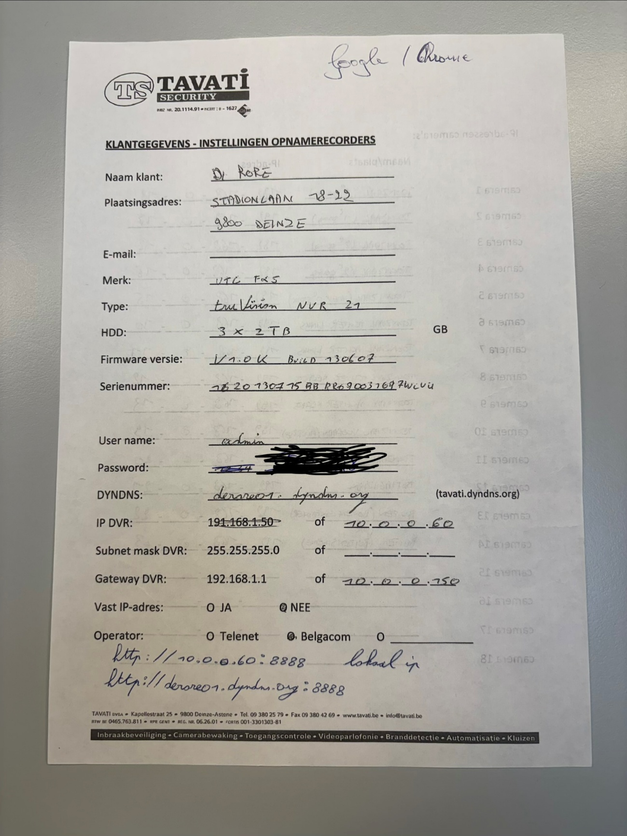

Interne validatie van NVR-poort 8888.
PS C:\Users\emiel> Test-NetConnection derore01.dyndns.org -Port 8000
WARNING: TCP connect to (141.135.202.68 : 8000) failed
WARNING: Ping to 141.135.202.68 failed with status: TimedOut

ComputerName : derore01.dyndns.org
RemoteAddress : 141.135.202.68
RemotePort : 8000
InterfaceAlias : Wi-Fi
SourceAddress : 10.0.0.156
PingSucceeded : False
PingReplyDetails (RTT) : 0 ms
TcpTestSucceeded : False
TCP-connectiviteitstest naar DynDNS-hostname op poort 8888
PS C:\Users\emiel> Test-NetConnection derore01.dyndns.org -Port 8888
WARNING: TCP connect to (141.135.202.68 : 8888) failed
WARNING: Ping to 141.135.202.68 failed with status: TimedOut

ComputerName : derore01.dyndns.org
RemoteAddress : 141.135.202.68
RemotePort : 8888
InterfaceAlias : Wi-Fi
SourceAddress : 10.0.0.156
PingSucceeded : False
PingReplyDetails (RTT) : 0 ms
TcpTestSucceeded : False

DNS-validatie van historische DynDNS-hostname
PS C:\Users\emiel> nslookup derore01.dyndns.org
Server: UnKnown
Address: 10.0.0.150

Non-authoritative answer:
Name: derore01.dyndns.org
Address: 141.135.202.68

