Brand

short brand story
- Colours/feel: loveable decided
- Photos well be added
Products
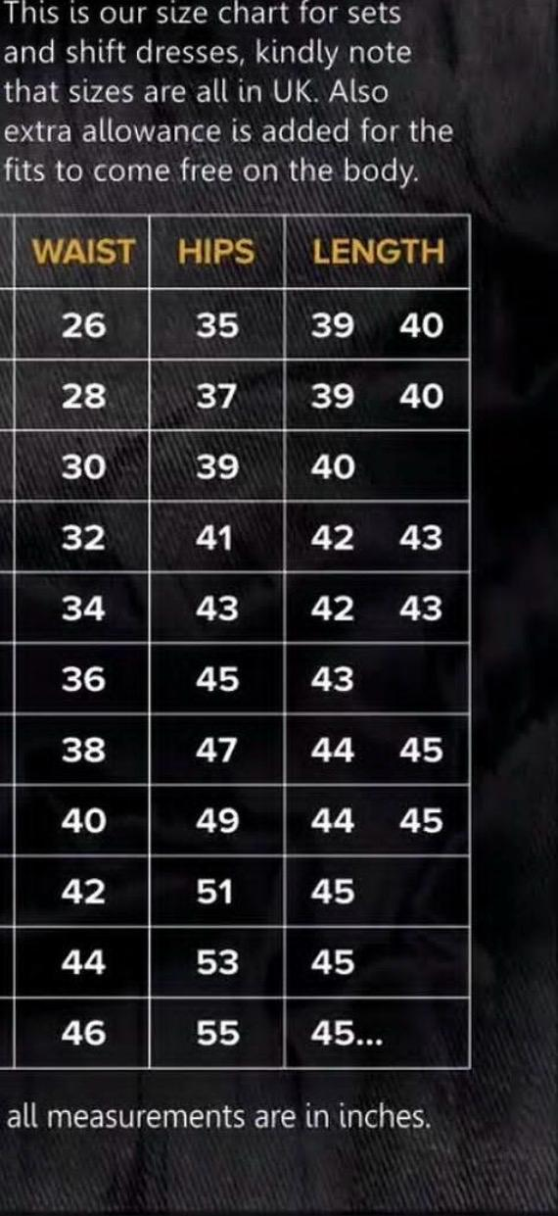
- Sizes: pictures here are uploaded, all sizes are in UK, extra allowance is added for the fits to come free on the body – all measurements are inches. 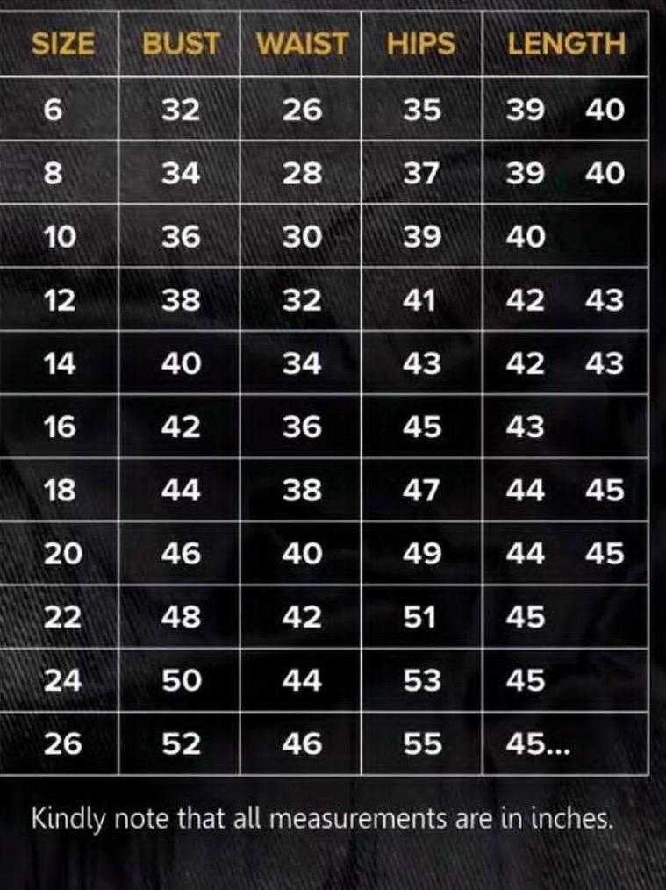
- Categories: LOVEABLE CREATE THIS PLEASE
Selling
- Shipping all around SA, Paxi for now (for delivery), currency stays ZAR
- Return policy:
# Returns & Exchange
At Serenity, we want you to feel confident and happy with your purchase. If your order isn't quite right, we're happy to assist with an eligible return or exchange.
### Return Period
Items may be returned within **7 days of delivery**.
To be eligible for a return, items must:
* Be unworn and unused
* Be in their original condition
* Have all original tags attached
* Be returned in the original packaging where applicable
* Have no makeup, perfume, stains, damage, or other signs of wear
### Items We Cannot Accept
For hygiene and safety reasons, certain items may not be eligible for return, including:
* Underwear and intimate items
* Swimwear if the hygiene seal has been removed
* Earrings
* Items marked as **Final Sale**
### Exchanges
If you would like to exchange an item for another size or eligible item, please contact us within **7 days of delivery**.
Exchanges are subject to availability. If the requested item is unavailable, you may be offered an alternative or store credit.
### Sale Items
Items purchased on sale may be **exchange-only or final sale**, depending on the promotion. Please check the product description before purchasing
### Return Shipping
Customers are responsible for the cost of returning an item unless the item received was incorrect, damaged, or faulty.
We recommend using a tracked delivery service, as Serenity cannot be held responsible for parcels lost while being returned to us.
### Refunds
Once your return has been received and inspected, we will notify you whether your return has been approved.
Approved refunds will be processed to the original payment method. Please allow additional processing time depending on your bank or payment provider.
### Faulty or Incorrect Item
If you receive an incorrect, damaged, or faulty item, please contact us as soon as possible with your order number and photographs of the item. We will assess the issue and assist you with a replacement, exchange, or refund where applicable.
### How to Start a Return
To request a return or exchange, please contact us through serenityhair8@gmail.com with:
* Your order number
* The item(s) you wish to return
* The reason for the return
* Photographs, where applicable

We'll provide you with the next steps.
Contact & socials
- Instagram: @serenitywearrsa
- TikTok: @serenity.wears.rsa
One decision: create the Shopify please

Product info:
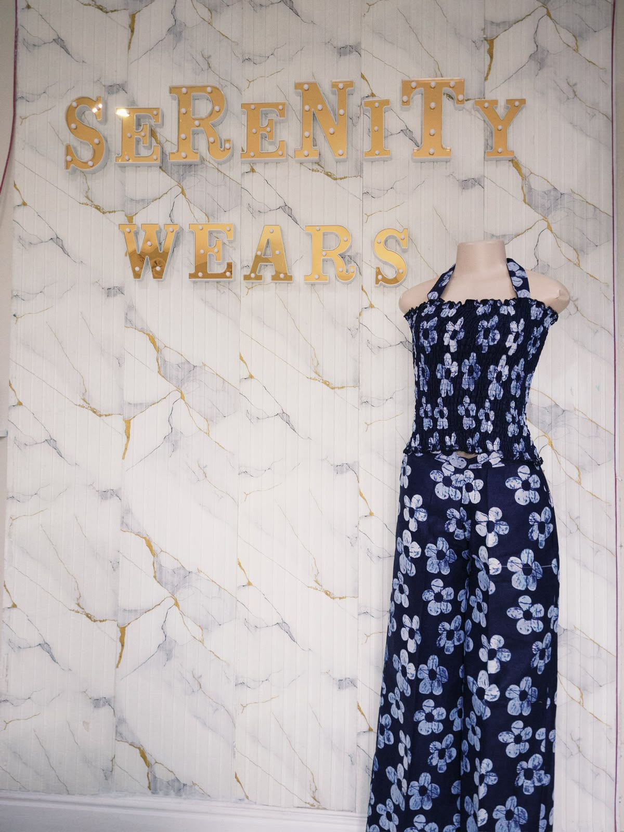Imani set : R650 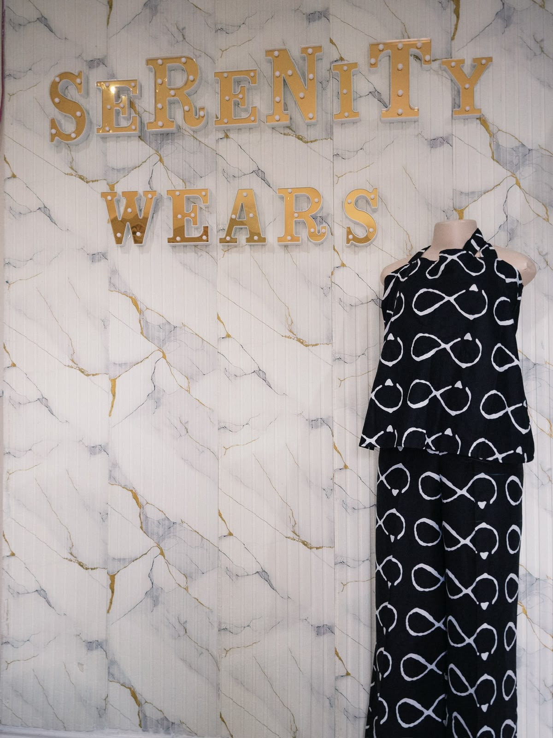
Amara set: R650
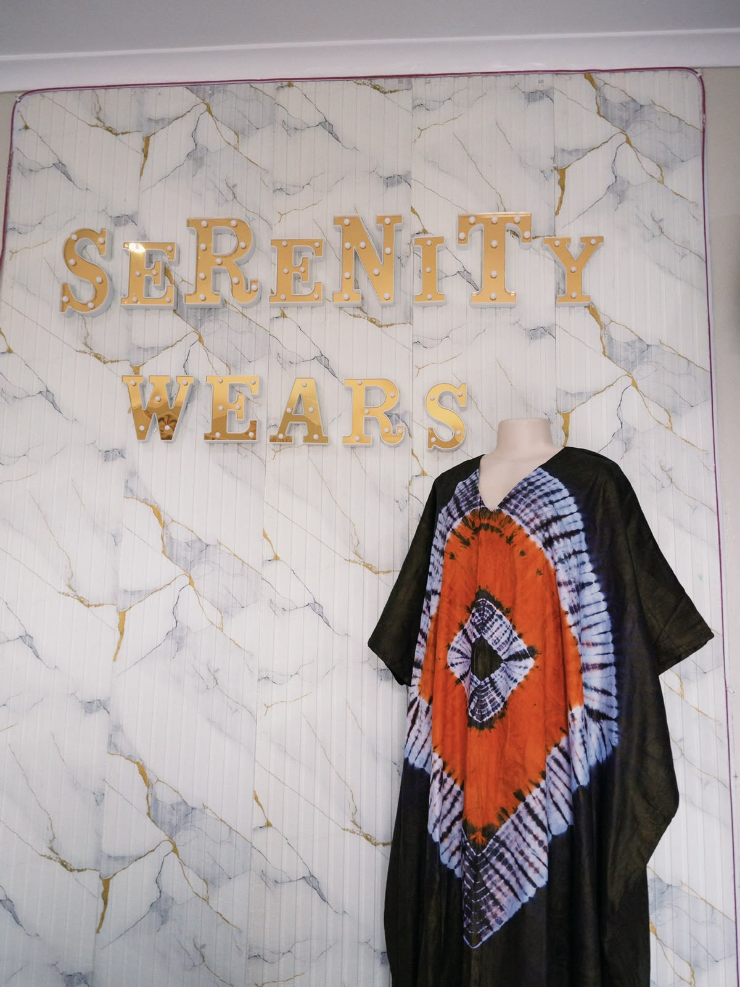
Zuri: R800
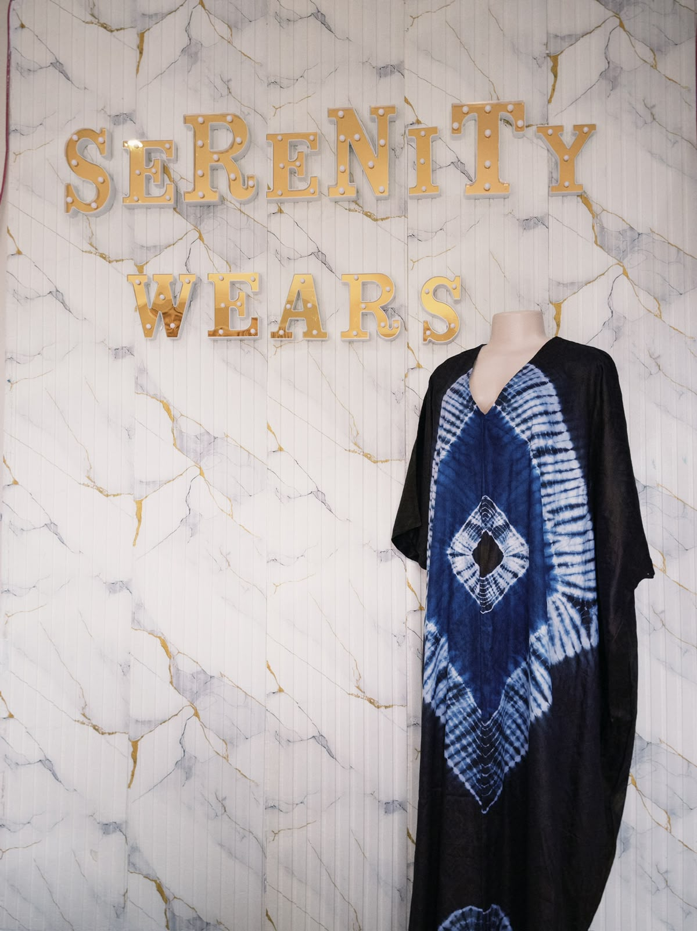
Simi R800
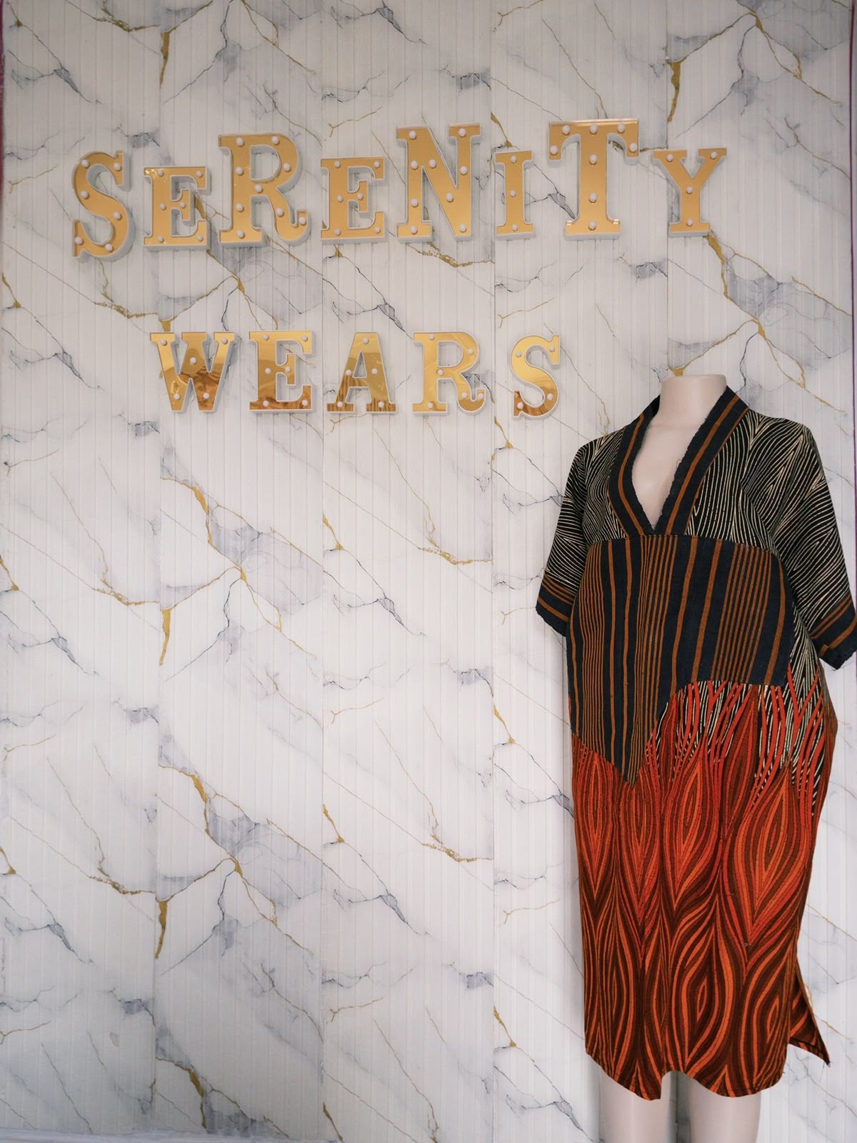
Amahle R750
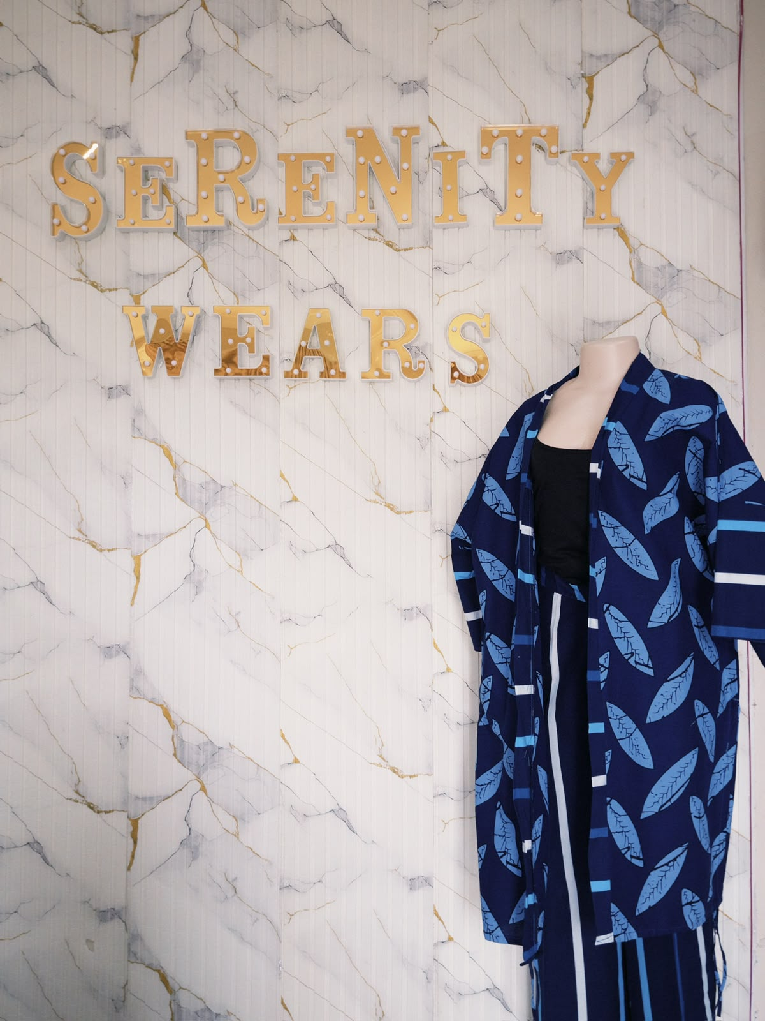
Naledi R900
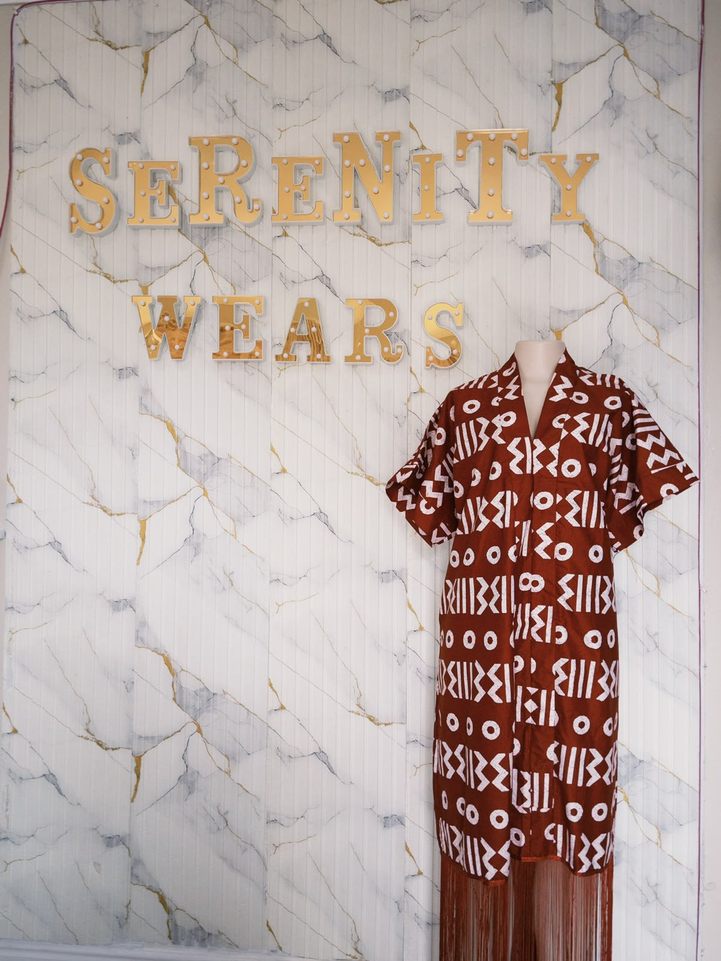
Ayanda R600
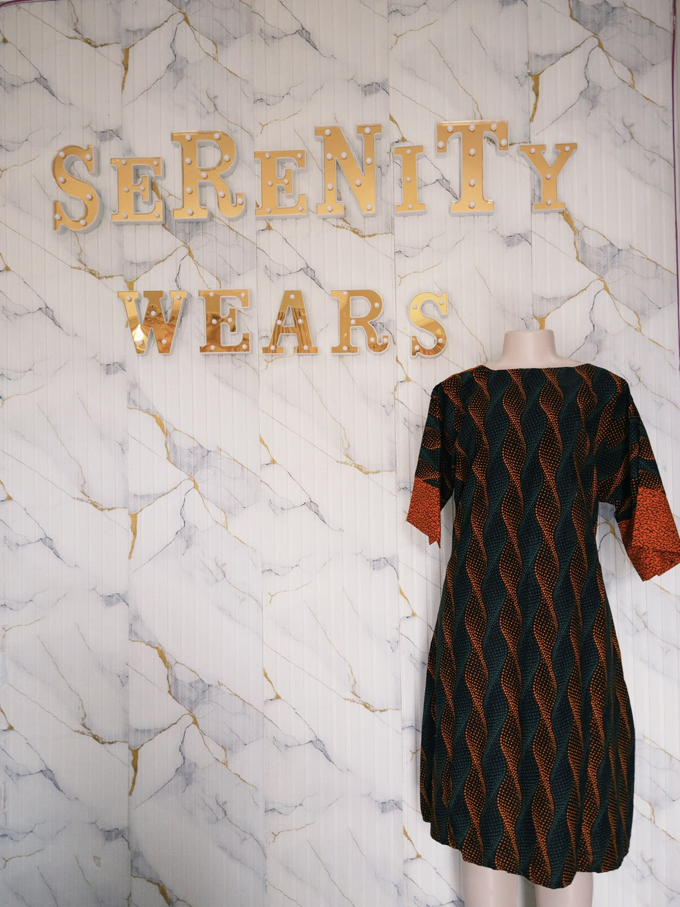
Zinhle Dress R500
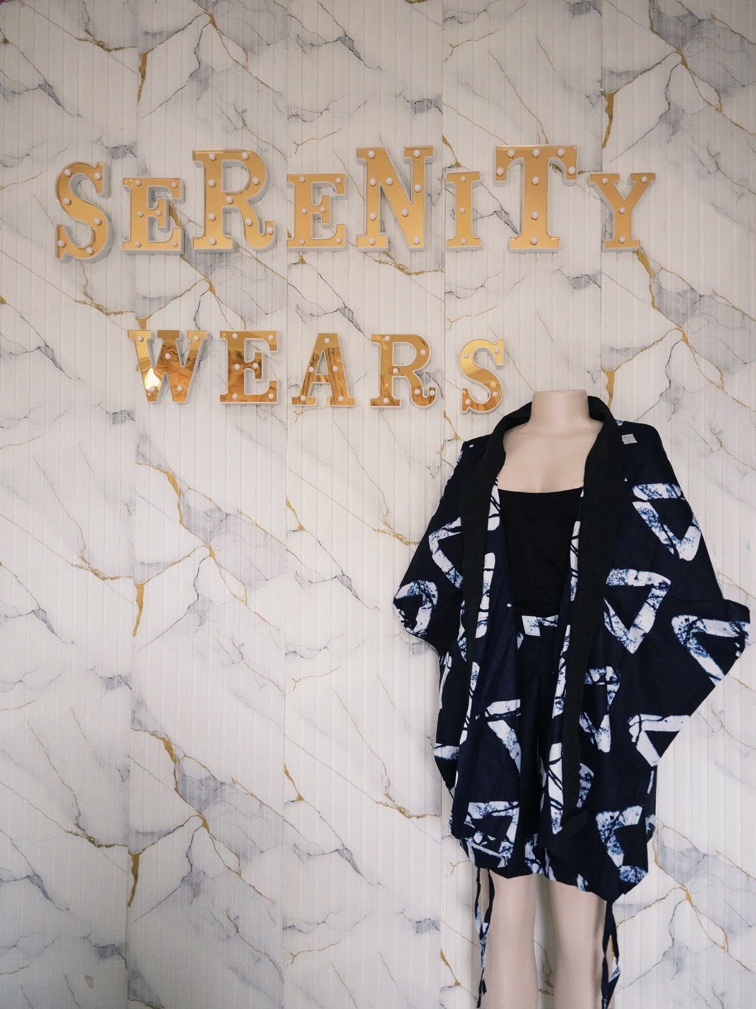
Chioma set R600
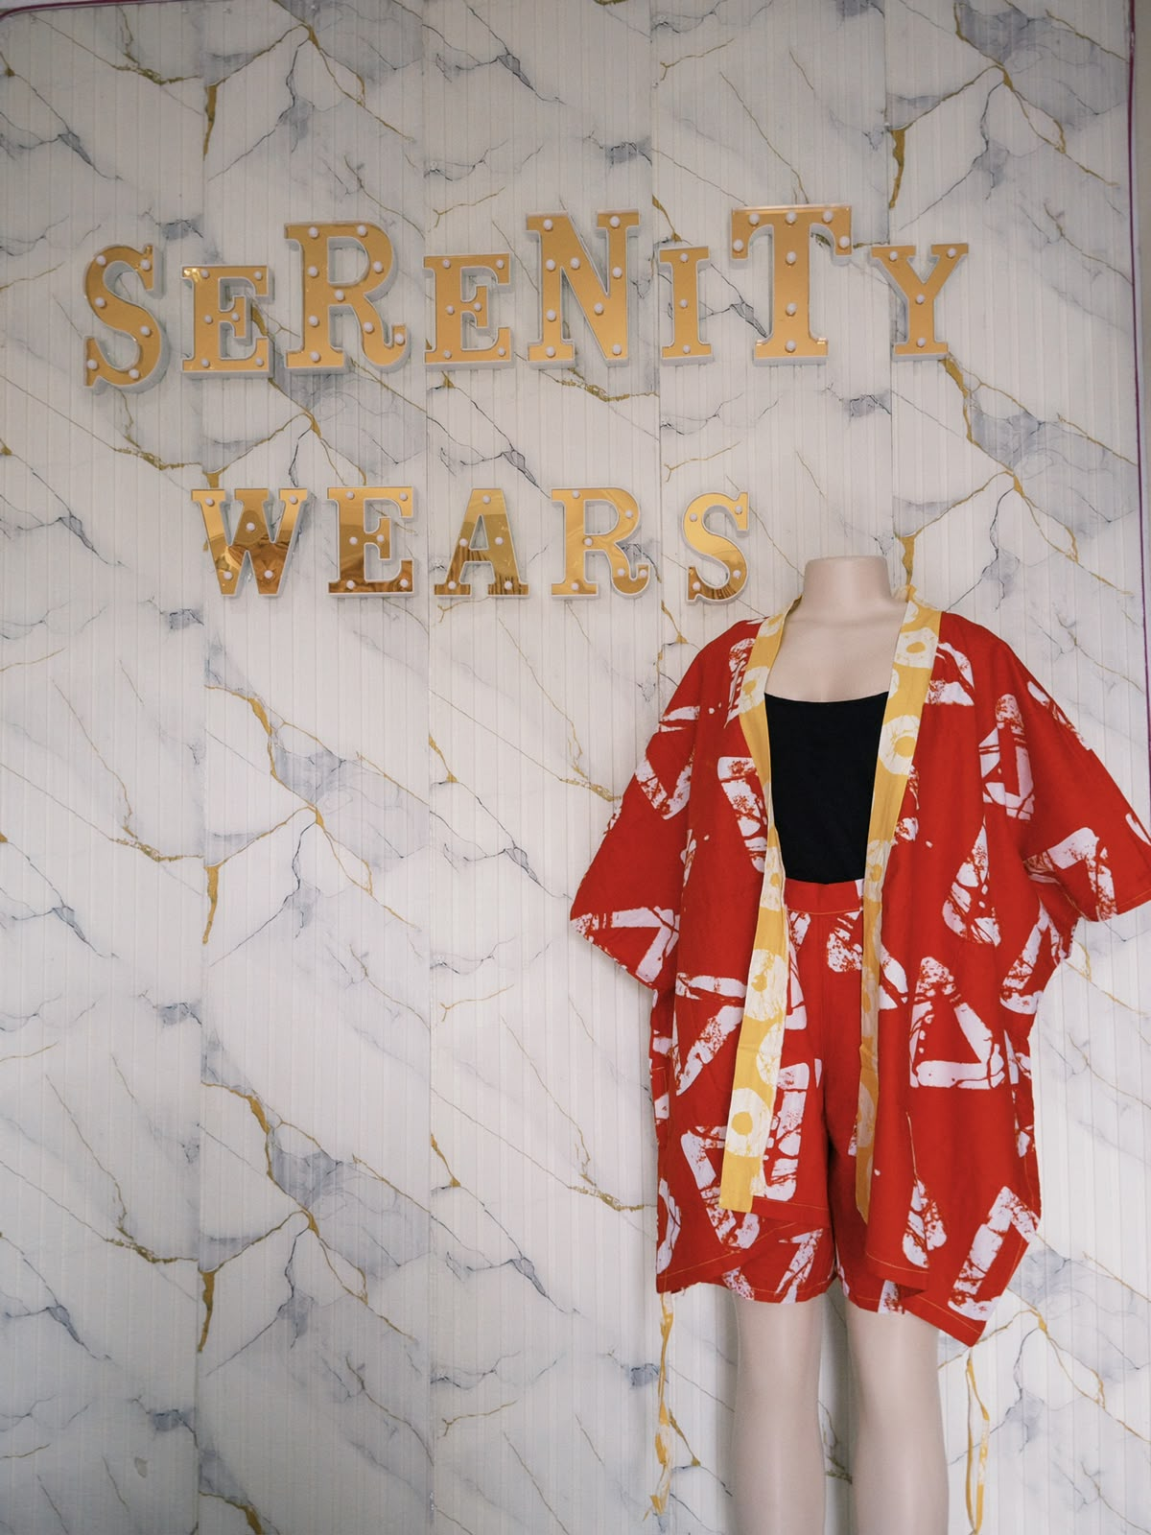
Nandi set R600
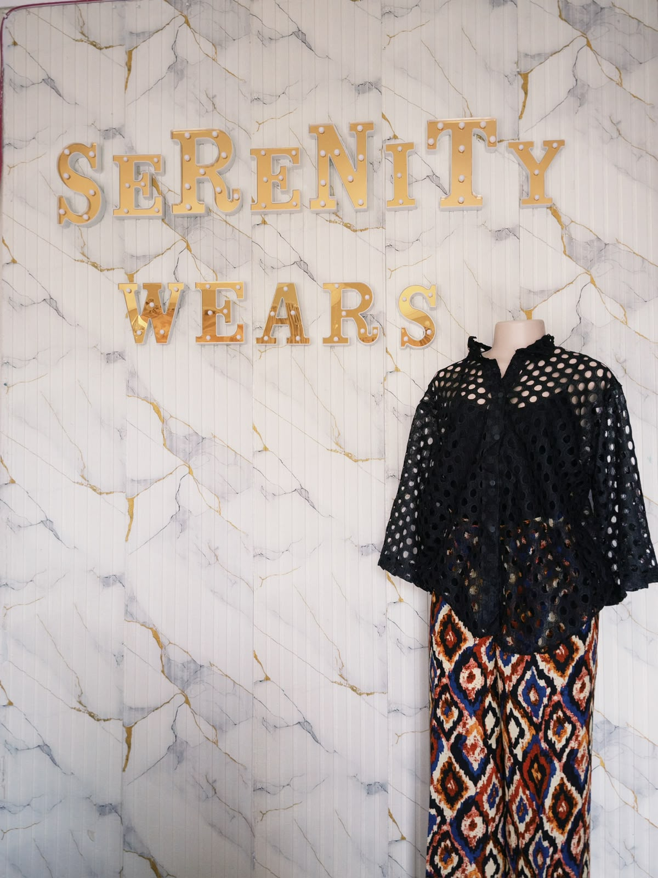
Temi set R700
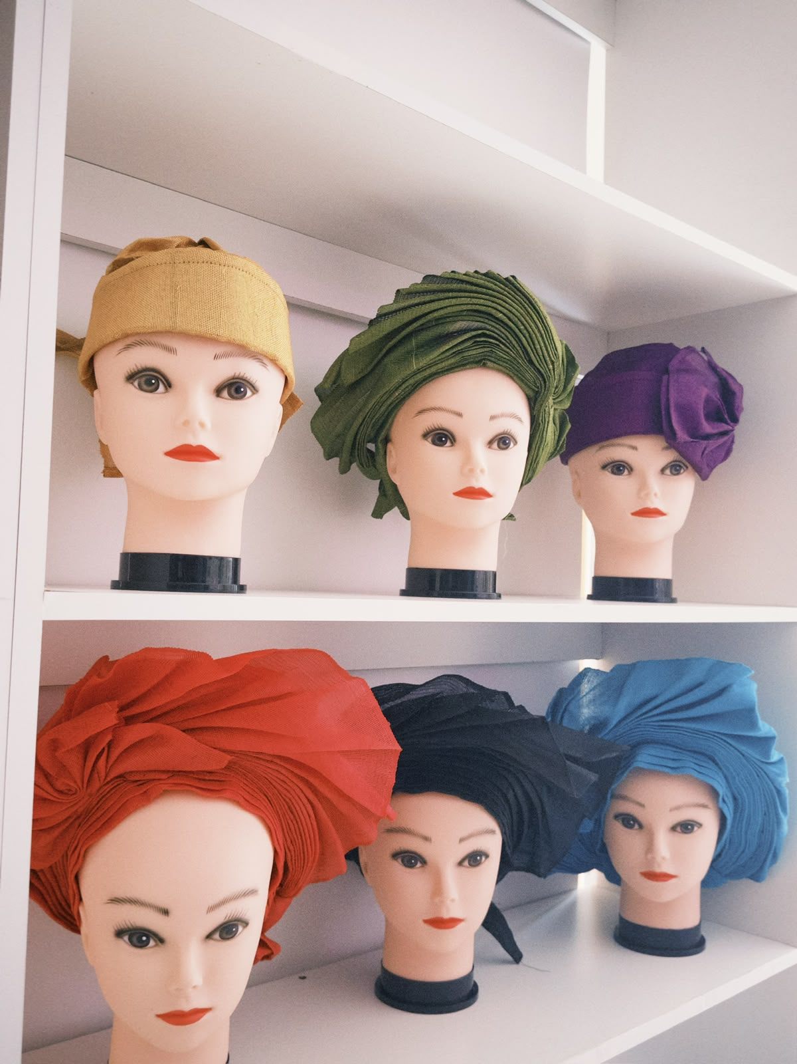
Auto-Gele R500 each
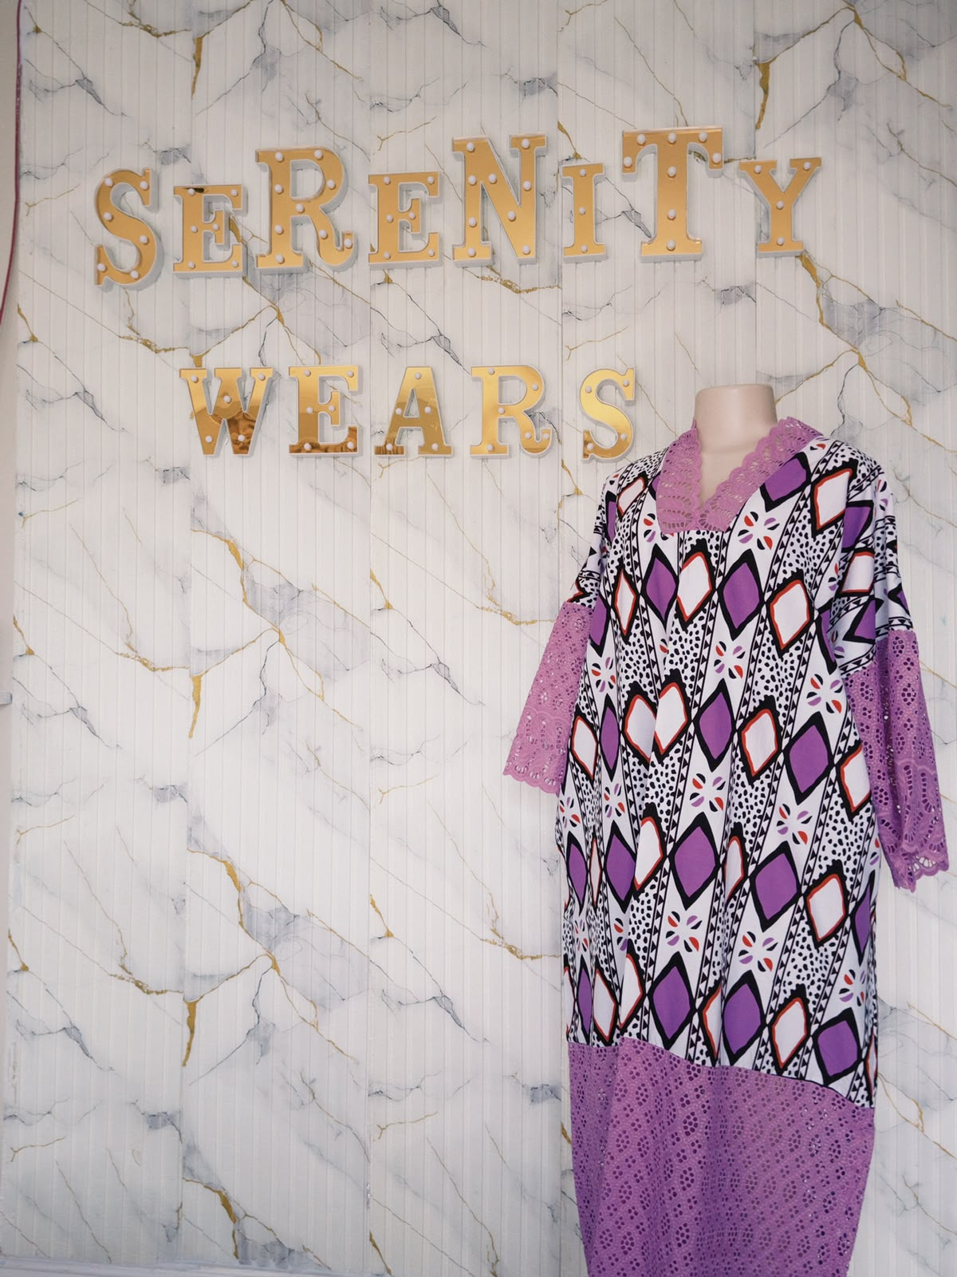
Adanna Dress R1000
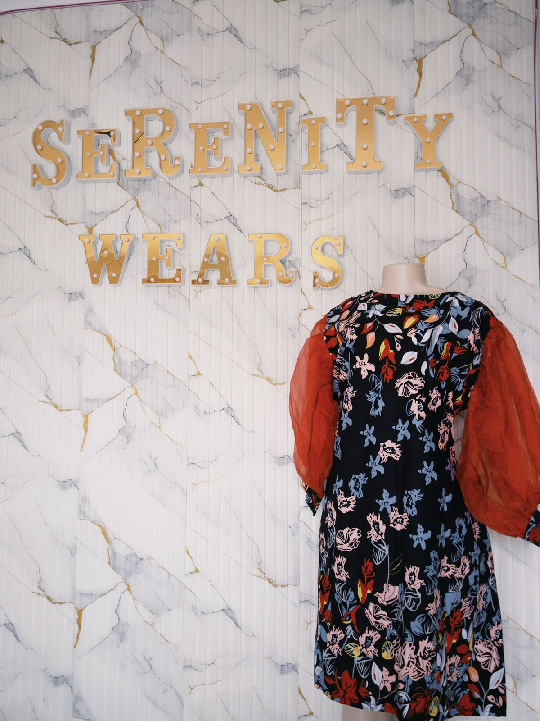
Tolani Dress R500
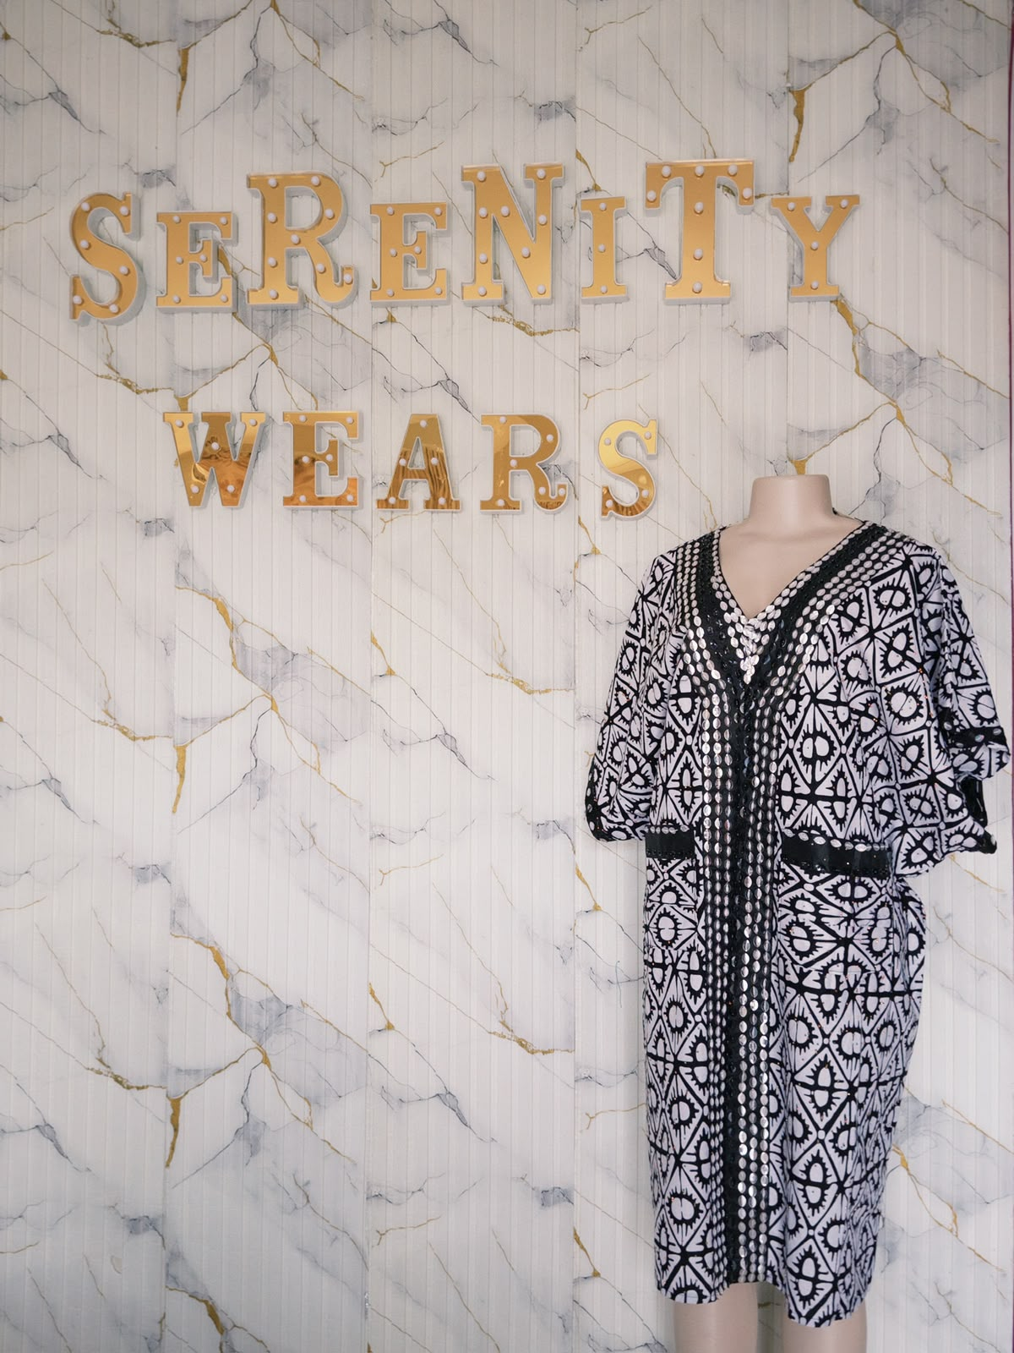
Folake dress R800
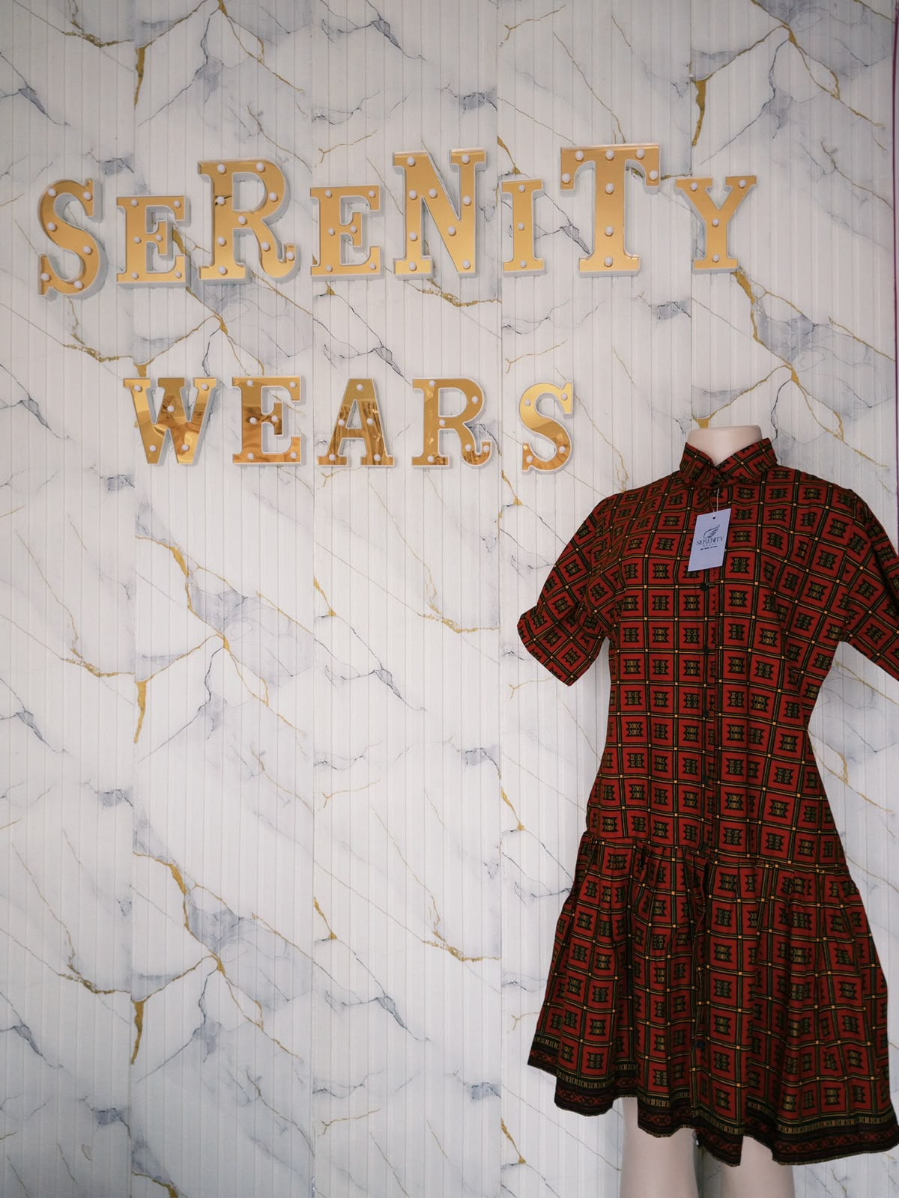
Sade dress R600
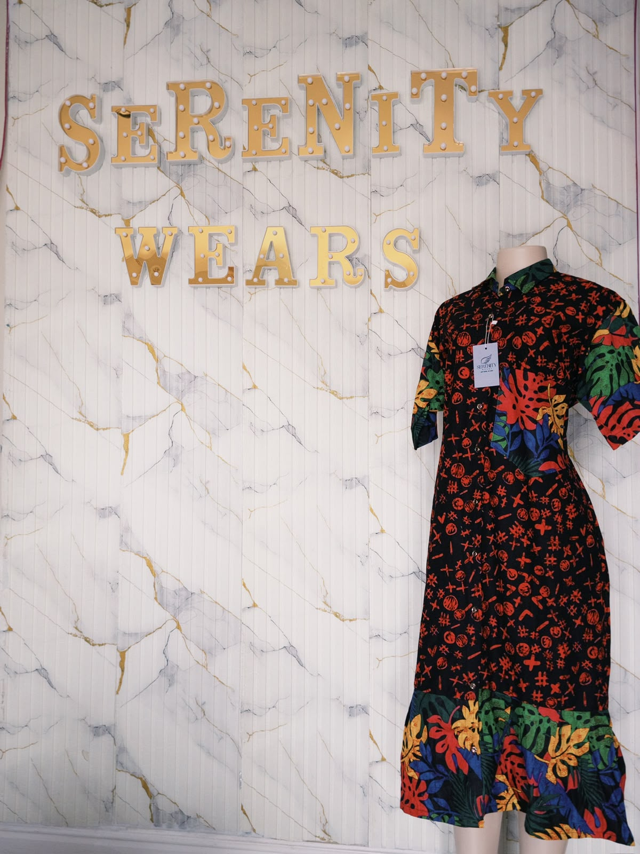
Zainab dress R650
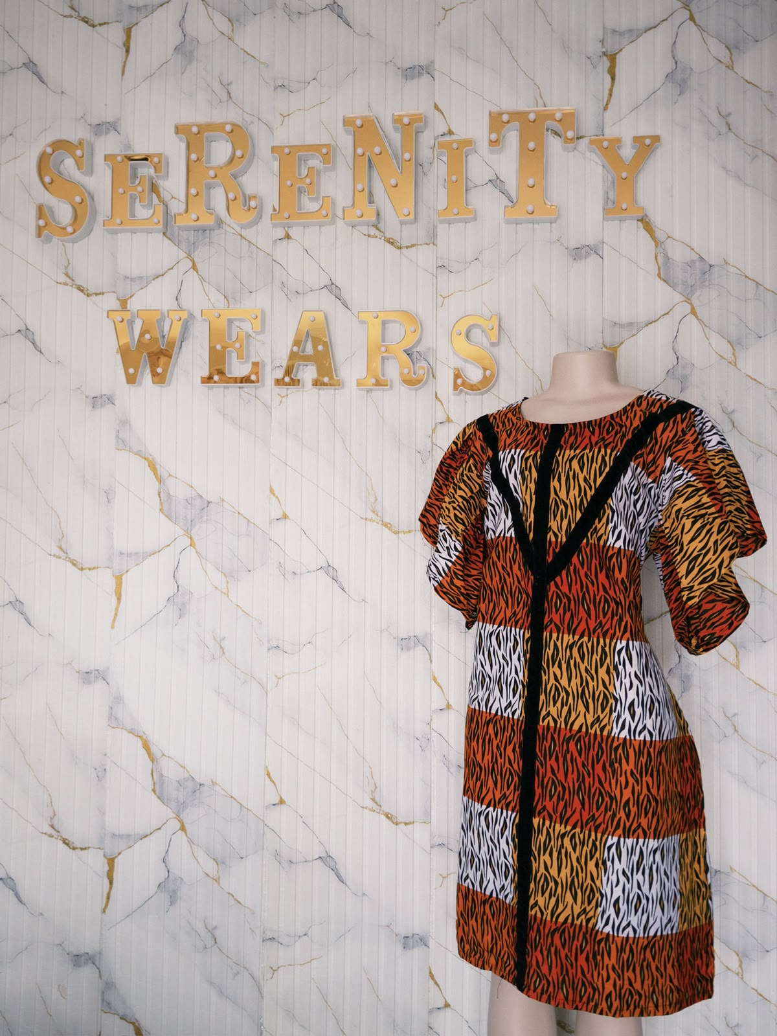
Kamsi dress R600
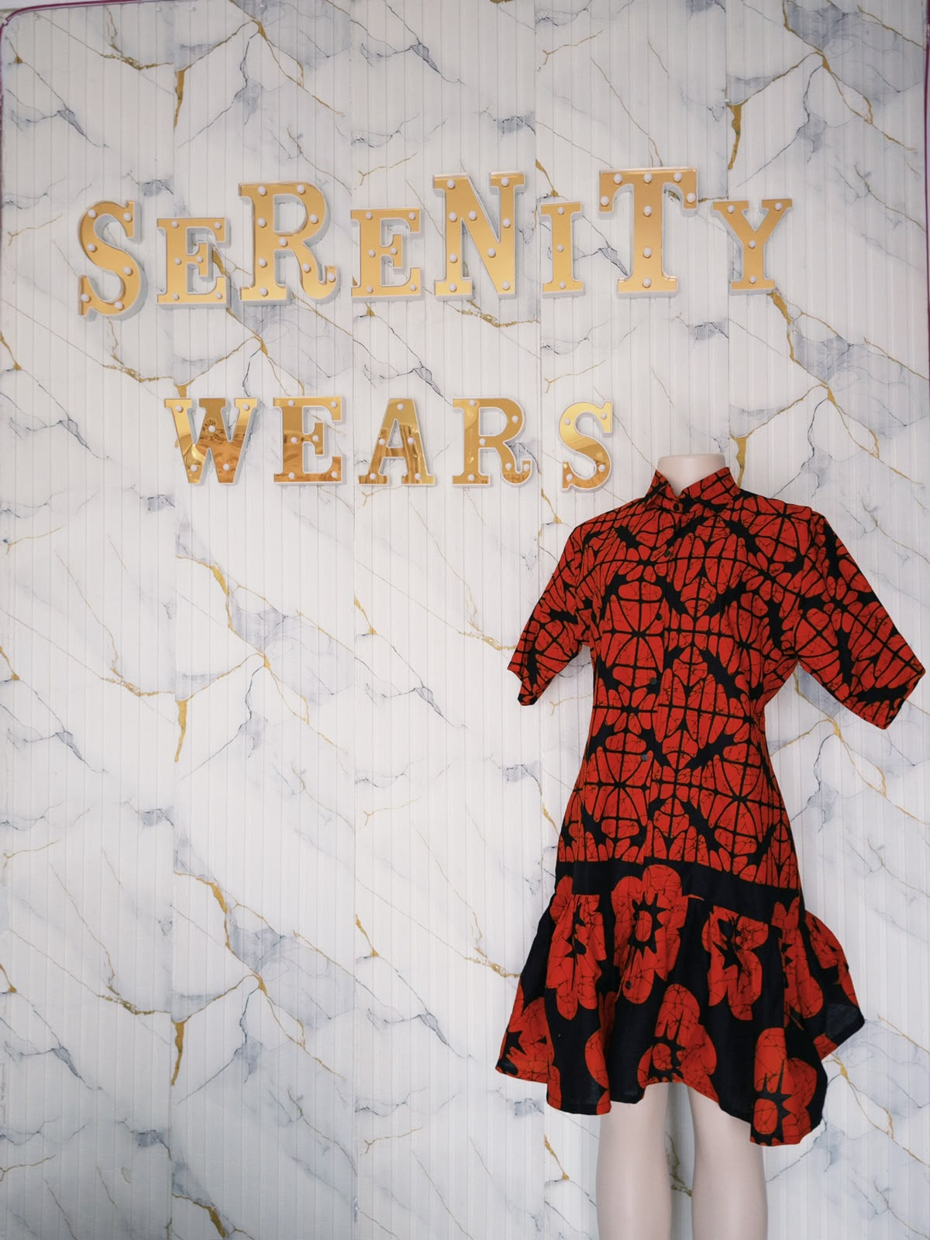
Chisom dress R600
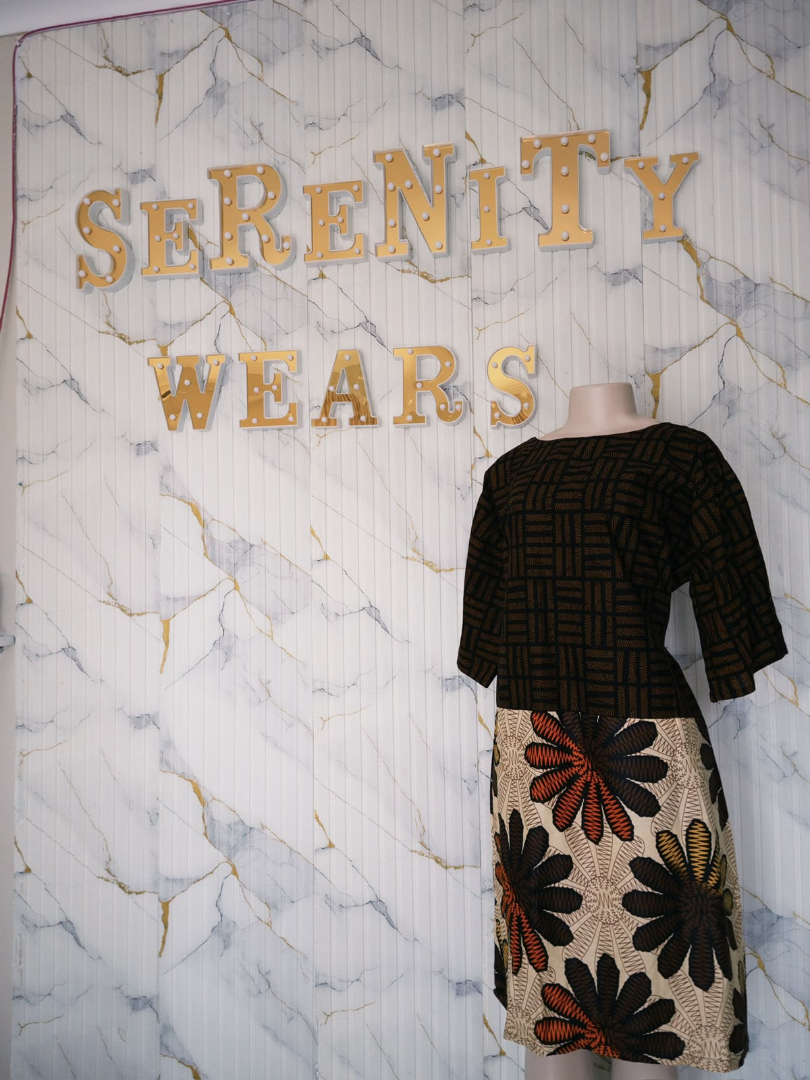
Munachi dress R600
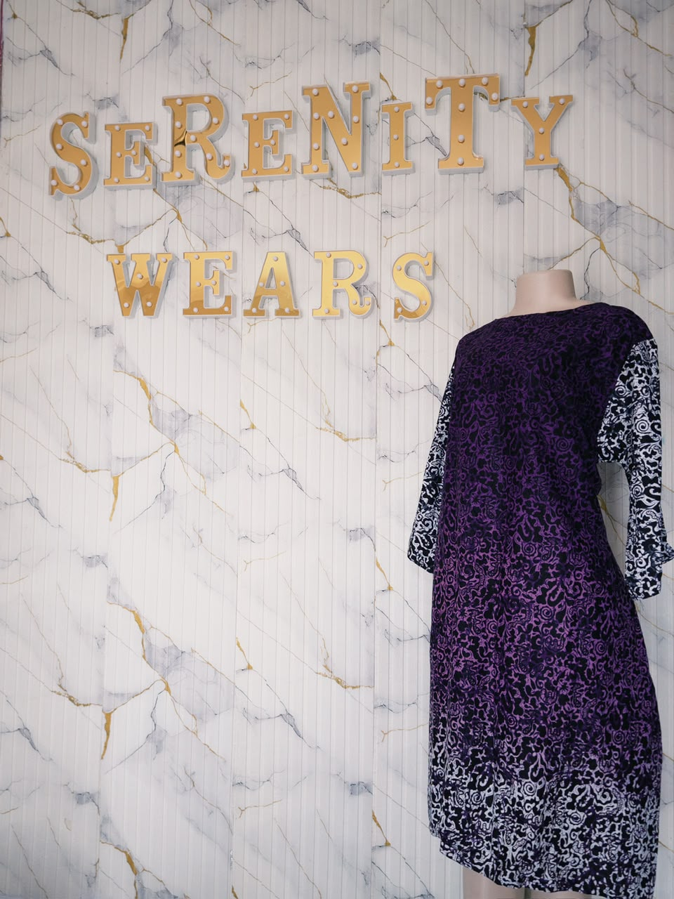
Temilola dress R600
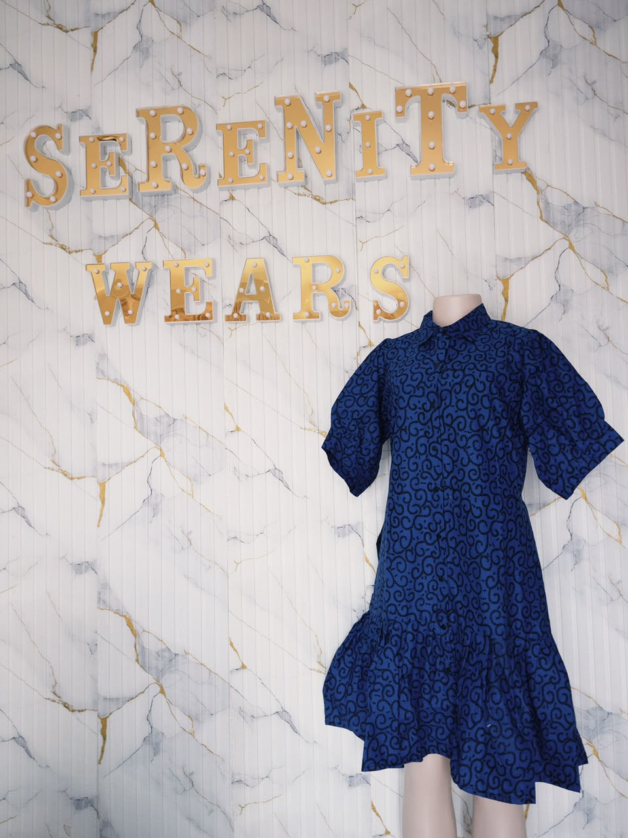
Thandi dress R600
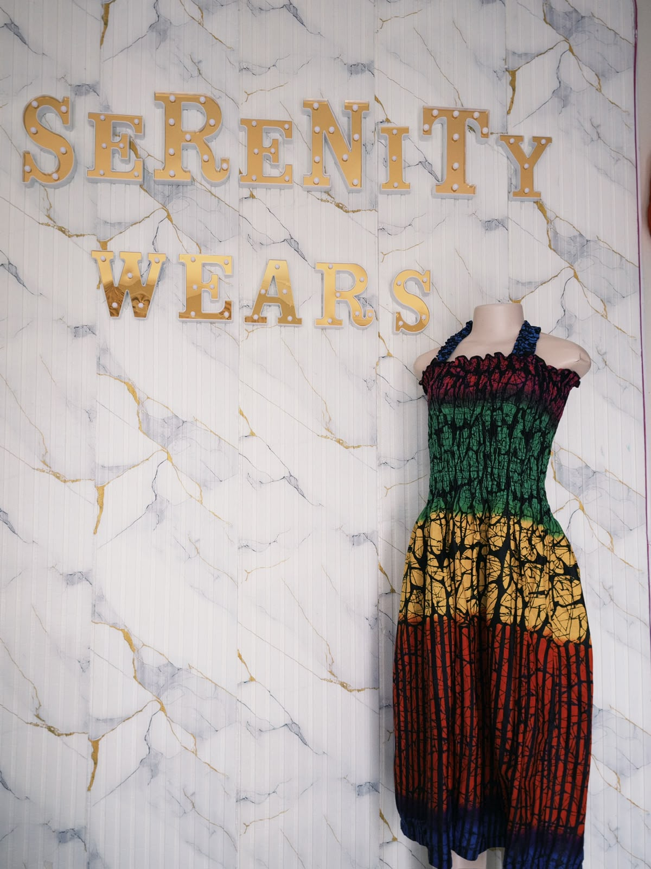
Thandeka dress R650
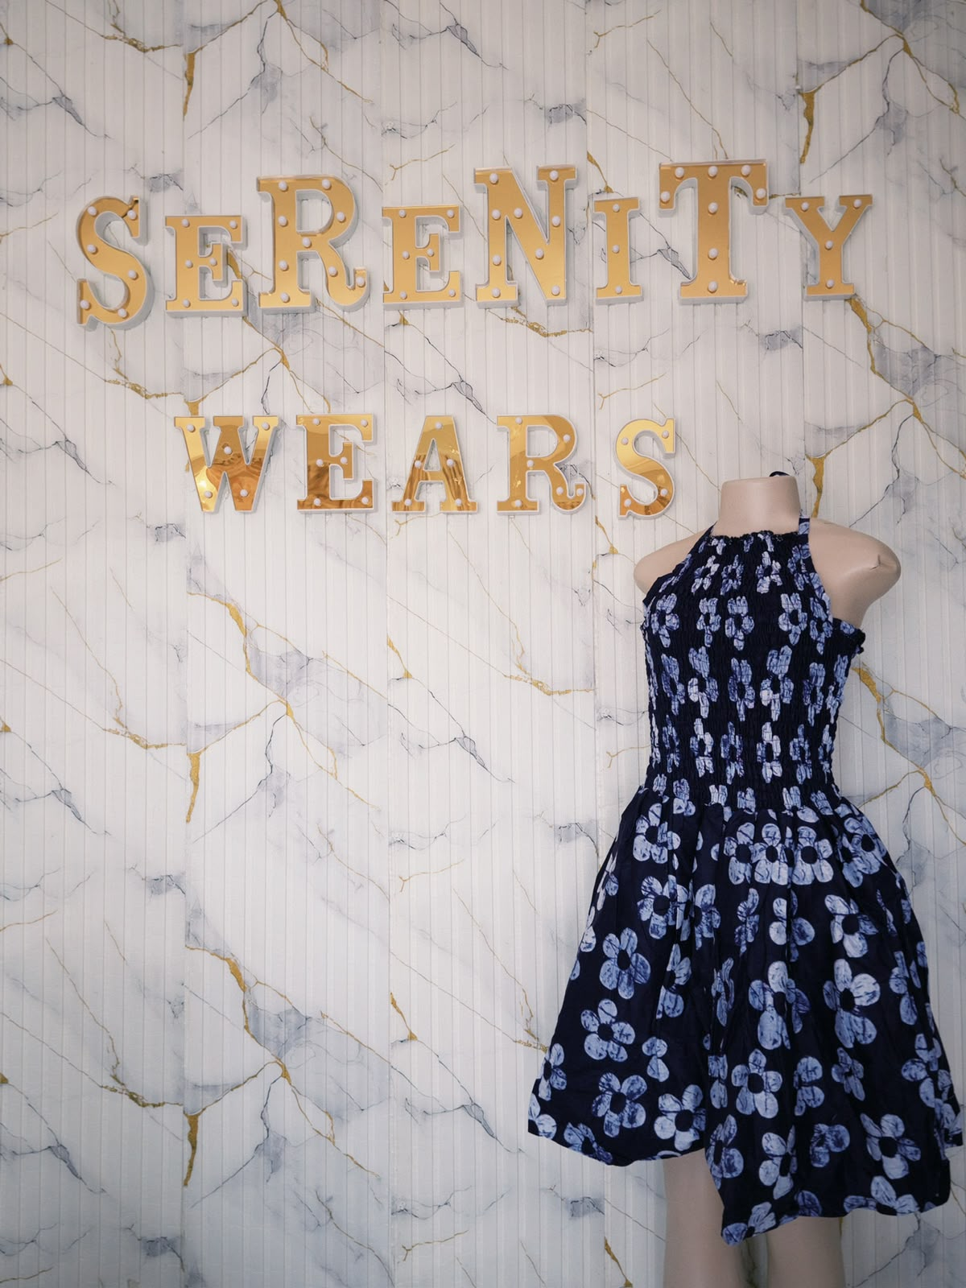
Ayana Halter Dress R650
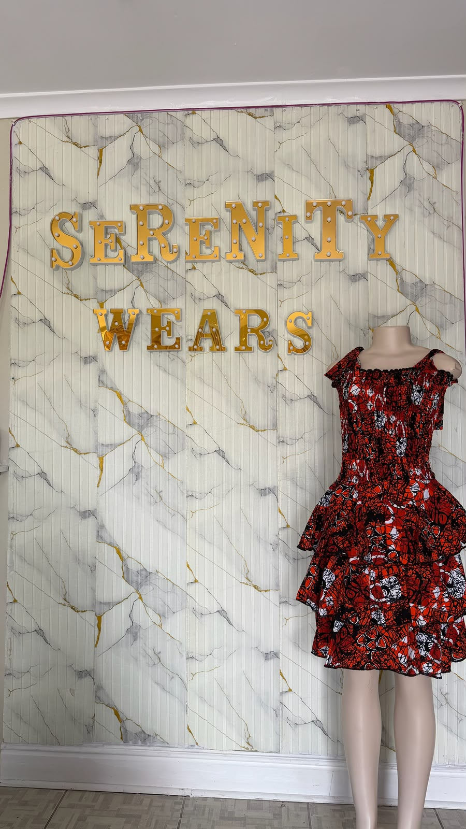
Mila dress R600

