|  |
| --- |
| ROUGH RECORD |
| Project Name : Rocket Auto |
|  |

Submitted By,

Emi Yohannan

KTE16MCA17,

S6 MCA,

RIT, Kottayam

**FUNCTIONAL REQUIREMENTS**

**Module: ACCOUNTS**.

**Sub module 1 : ACCOUNT TRANSACTIONS**

1. TITLE : Ledger Group

Description: A ledger group is a combination of standard ledgers for the purpose of applying the functions and processes of General Ledger Accounting to the group as a whole.

* Group is head category or it is base of ledger creation.
* If we have changed group from one category to another, all ledgers will automatically change by this.
* Each ledger within the ledger group shares a common physical structure based on the ledger template, and also has unique characteristics.
* Tally provides us 23 automated groups for ledger creation.

|  |  |
| --- | --- |
| **15 Primary Groups** | **13 Sub Groups** |
| Branch / Divisions | Bank Accounts |
| Capital Account | Bank OD A/c |
| Current Assets | Cash-in-hand |
| Current Liabilities | Deposits (Asset) |
| Direct Expenses | Duties & Taxes |
| Direct Incomes | Loans & Advances (Asset) |
| Fixed Assets | Provisions |
| Indirect Expenses | Reserves & Surplus |
| Indirect Incomes | Secured Loans |
| Investments | Stock-in-hand |
| Loans (Liability) | Sundry Creditors |
| Misc. Expenses (ASSET) | Sundry Debtors |
| Purchase Accounts | Unsecured Loans |
| Sales Accounts |  |
| Suspense A/c |  |

As a user,

* The software provides provision for adding ledger groups under the four main ledger groups namely Assets, Liabilities, Expenses and Income.
* Provision for view the list of ledger groups
* Provision for update records/ledger groups.
* Provision for Search using keywords.

1. TITLE: Ledger

Description: A default ledger is created for each customer and supplier whenever a job card and purchase invoice is created respectively.

Groups are major heads of ledger, under which ledgers are classified. Nature of the ledger depends on the group it is classified. Basically, ledgers of similar nature are classified under one head.

Format:

|  |  |  |  |  |  |  |
| --- | --- | --- | --- | --- | --- | --- |
| **LEDGER BOOK** | | | | | | |
| **From :DD/MM/YYY To: DD/MM/YYYY** | | | | | | |
| **SI No.** | **Date** | **Transaction No.** | **Ledger** | **Debit** | **Credit** | **Narration** |
|  |  |  |  |  |  |  |
|  |  |  |  |  |  |  |

As a user,

* The software also provides provision for adding ledgers.
* The list of ledgers provides complete detail about the ledger heads, ledger groups and corresponding opening balances.
* Provision for update ledgers.
* Provision for Search using keywords or ledger groups.

1. TITLE: Bank

Description: This section is used to add bank information.

As a user,

* The software should have provision for update bank details and search using keywords.
* The list of banks information added.

**Sub module 2: ACCOUNT TRANSACTIONS.**

1. TITLE : Receipt

Description: Receipts are the amount of cash a business takes in during any one accounting period. Receipts are cash sales, as well as money received on a customer's account. It also includes any cash received in the business from any source, including loan or credit line proceeds or funding from investors.

As a user,

* The software should generate receipt for every sale (cash/credit).
* Amount can be received via Cash/Cheque.
* The list of receipts generated
* Provision for update receipts.
* Provision for printing the receipts.

**SPRINT BACKLOG**

|  |  |
| --- | --- |
| Sprint Duration: 25/02/2019 To 06/03/2019 | |
| **REQUIREMENT** | **PRIORITY** |
| Database creation | 1 |
| Login page creation | 2 |
| Create Ledger groups | 3 |
| Create Ledger | 4 |
| Create Bank Master | 5 |
| Generate receipt for every sales(cash/credit) | 6 |

.

**DAILY SPRINT**

|  |  |  |  |
| --- | --- | --- | --- |
| **ID** | **Requirements** | **To Do** | **Status** |
| **Date:25/02/2019** | | | |
| 1 | Database Creation | Database creation | In Progress |
| 2 | User should see a login page when he opens the application. | Login Page Design | Completed |
| 3 | User should able to login with individual credentials. | Login Page Coding | In Progress |
| **Date:26/02/2019** | | | |
| 3 | User should able to login with individual credentials (Continues…) | Login Page Coding | Completed |
| Database Connectivity | Completed |
| 4 | Software should provide provision for adding ledger groups. | Add Ledger Group - Form creation | Completed |
| View Ledger Group – Form Creation | In Progress |
| **Date:27/02/2019** | | | |
| 4 | Software should provide provision for adding ledger groups.(Continues…) | View Ledger Group- Form Creation | Completed |
| Option for Update ledger groups | Completed |
| Search Ledger Group entries using keywords | Completed |
| **Date:28/02/2019** | | | |
| **5** | A default ledger is created for each customer and supplier whenever a job card and purchase invoice is created respectively. | Add Ledger - Form creation | Completed |
| View Ledger Details - Form Creation | Completed |
| Option for Update ledger Details | Completed |
| Search Ledger entries using keywords or Ledger Group names | In Progress |
| **ID** | **Requirements** | **To Do** | **Status** |
| **Date:01/03/2019** | | | |
| 5 | A default ledger is created for each customer and supplier whenever a job card and purchase invoice is created respectively (Continues…) | Search Ledger entries using keywords or Ledger Group names | Completed |
| **6** | Provision for adding bank information | Add Bank – Form Creation | Completed |
| Option for Update Bank Details | Completed |
| Search Banks list using keywords or Bank names | In Progress |
| **Date:05/03/2019** | | | |
| **7** | Generate receipt for every sale (cash/credit). | Receipt via Cash– Form Creation | Completed |
| Receipt via Cheque – Form Creation | Completed |
| View Receipts –Form Creation | In Progress |
| **Date:06/03/2019** | | | |
| **7** | Generate receipt for every sale (cash/credit) (Continues…) | View Receipts –Form Creation | Completed |
| Option for Update Receipts | In Progress |
| Print option for receipts | In Progress |

**DATABASE DESIGN**

Table Name: LoginTable

|  |  |  |
| --- | --- | --- |
| **Fields** | **Data Type** | **Description** |
| UserID | Integer | Primary Key |
| UserName | Varchar | User name of the user |
| Password | Varchar | Password |
| UserType | Integer | Employee Type |
| Status | Integer | Active/Not Active(1/0) |

Table Name: LedgerGroupTable

|  |  |  |
| --- | --- | --- |
| **Fields** | **Data Type** | **Description** |
| LedgerGroupID | Integer | Primary Key |
| LedgerGroupName | Varchar | Ledger Group Name |
| LedgerGroupCode | Varchar | Ledger Group Code |
| LedgerGroupHead | Integer | Asset/Income/Liability/Expenses |
| ParentGroup | Integer | Parent Ledger Name |
| LedgerType | Varchar | Debit/Credit |
| AddedDate | Date | Date ,the record is added |
| Status | Integer | Active/Not Active(1/0) |

Table Name: Ledger Table

|  |  |  |
| --- | --- | --- |
| **Fields** | **Data Type** | **Description** |
| LedgerID | Integer | Primary Key |
| LedgerName | Varchar | Ledger Name |
| LedgerCode | Varchar | LedgerCode |
| LedgerGroup | Integer | Foreign Key |
| OpeningBalance | Integer | Opening Amount |
| BalanceType | Varchar | Debit/Credit |
| AddedDate | Date | Date ,the record is added |
| Status | Integer | Active/Not Active(1/0) |

Table Name: BankTable

|  |  |  |
| --- | --- | --- |
| **Fields** | **Data Type** | **Description** |
| BankID | Integer | Primary Key |
| BankName | Varchar | Bank Name |
| AccountNo | Varchar | Account Number |
| Branch | Integer | Branch |
| IFSC | Integer | IFSC Code |
| AddedDate | Date | Date ,the record is added |
| Status | Integer | Active/Not Active(1/0) |

Table Name: ReceiptTable

|  |  |  |
| --- | --- | --- |
| **Fields** | **Data Type** | **Description** |
| ReceiptID | Integer | Primary Key |
| LedgerCode | Varchar | Foreign Key |
| Amount | Varchar | Amount Paid/Received |
| Narration | Integer | Narration on receipt |
| PaymentType | Varchar | Cheque /Cash |
| RefNo | Integer | Reference Number of Cheque |
| ChequeNo | Integer | Cheque Number |
| BankID | Integer | Foreign Key |
| AddedDate | Date | Date, the record is added |
| Status | Integer | Active/Not Active(1/0) |

**UI DESIGN**

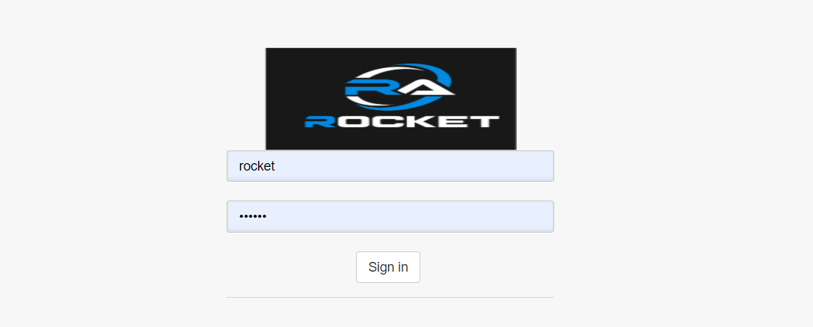

Fig 1: Login Form

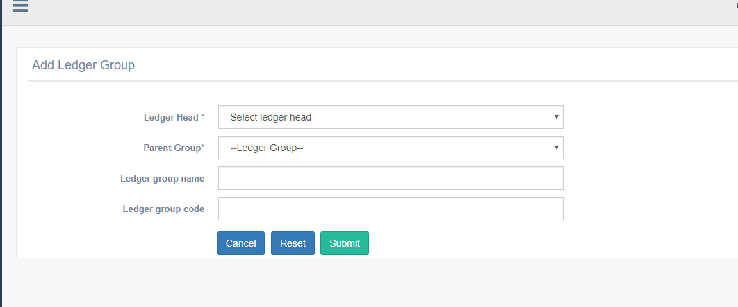

Fig 2: Add Ledger Group

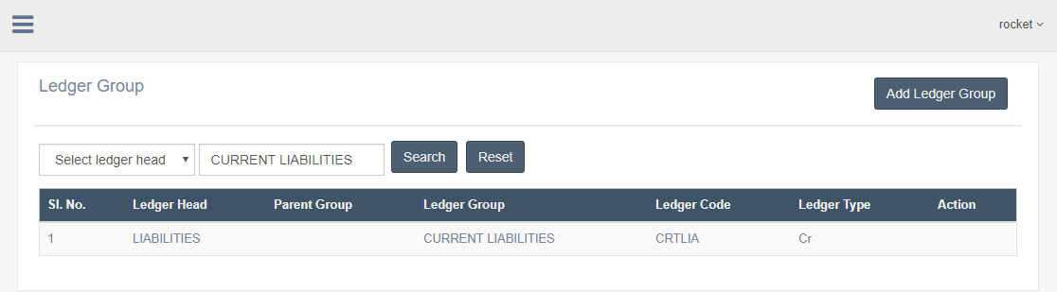

Fig 3: Search Ledger Group

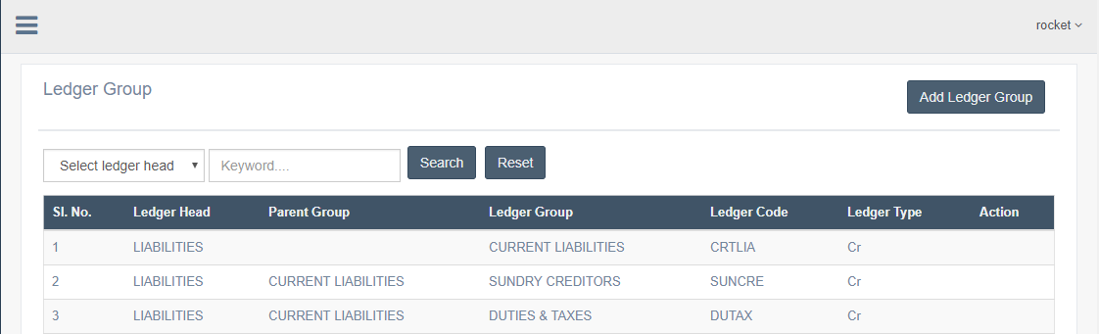

Fig 4: View Ledger Group

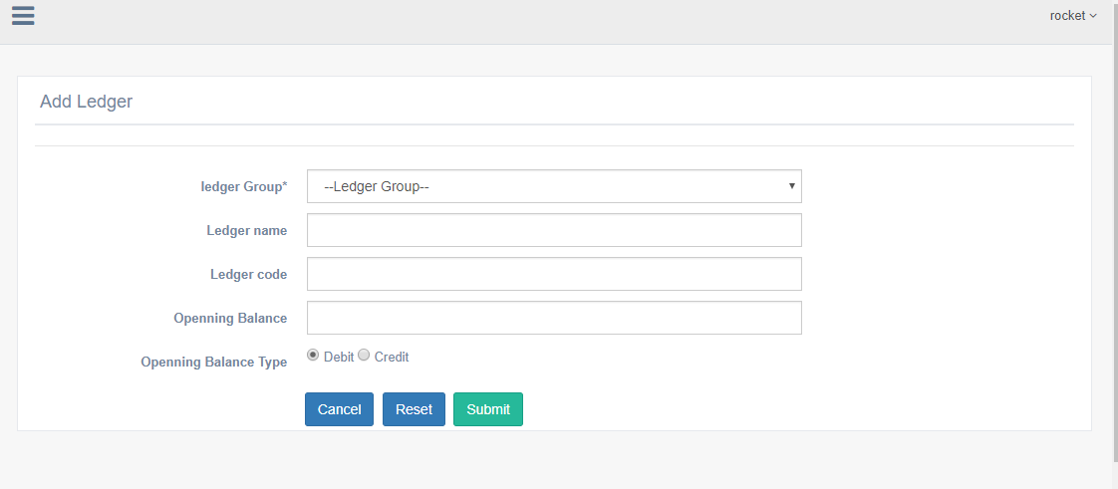

Fig 5: Add Ledger

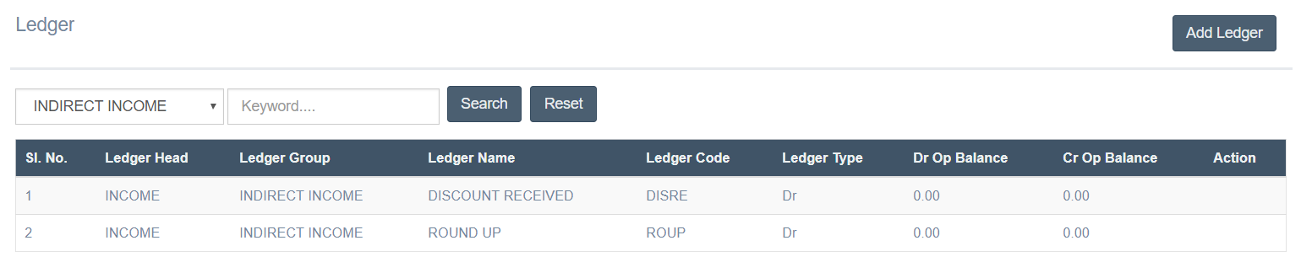

Fig 6: Search Ledger

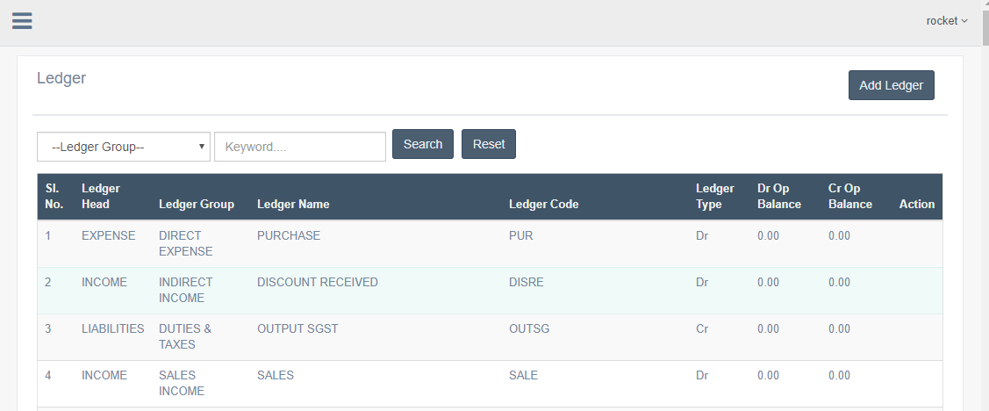

Fig 7: View All Ledgers