Offline Mobile App Utilizing RGB and Infrared Imaging for Classifying Downy Mildew in Corn using Deep Learning.

A Thesis Presented to the Faculty of Computer Engineering Program
College of Engineering, Architecture and Technology
De La Salle University –Dasmariñas
Dasmarinas City, Cavite

In Partial Fulfillment of the Requirements for the Degree of
Bachelor of Science in Computer Engineering

Abou Shaban, Mohammad I.
De Asis, Shunsuke
Hernandez, Emil Joaquin G.
Valenciano, Hans Bedenic A.

April 2025

Approval Sheet here

Abstract
Philippine Downy Mildew (PDM) is a major fungal disease that threatens corn production in the Philippines, capable of causing total crop failure when left undetected and unmanaged. Early and accurate diagnosis is crucial for minimizing its impact, particularly in remote farming communities with limited access to agricultural experts or internet connectivity. This study presents the development of an offline mobile application designed to classify the severity levels of PDM in corn leaves using both RGB and infrared imaging, empowered by deep learning algorithms. Images were gathered under controlled field-like conditions using a standardized blackboard backdrop to reduce background noise and enhance feature extraction. Convolutional Neural Networks (CNN), specifically MobileNetV2, were trained on expert-labeled datasets and converted to TensorFlow Lite models for mobile integration. The application allows users to classify leaf images in real time through an intuitive interface with buttons for RGB and thermal input, gallery access, and classification results. Evaluation metrics such as accuracy, precision, recall, and F1-score were used to assess model performance, revealing that thermal imaging performed better in detecting early-stage infections, while RGB imaging proved more effective in identifying visible symptoms in advanced stages. Overall, this mobile solution offers a practical, cost-efficient, and scalable tool to empower Filipino farmers in diagnosing PDM on-site, reducing reliance on connectivity and external diagnostic support, and contributing to improved crop management and food security.

Acknowledgement
This research would not have been possible without the support, guidance, and encouragement of many individuals. We, the researchers, would like to express our heartfelt appreciation to the following:
We are deeply grateful to our family members: our mothers, fathers, and siblings who have consistently supported us throughout this thesis journey. Their unwavering belief in us, along with their help during financial struggles and stressful times, has been invaluable. Special mention to “Baba” for his tireless effort in driving us to and from fieldwork locations, even when they were 2 to 3 hours away. His valuable suggestions, continuous support and entertaining stories were greatly appreciated.
We would also like to extend our heartfelt thanks to our friends for believing in us and offering constant encouragement. Their willingness to listen to our concerns, provide comfort, and support us through challenging moments was an immense help.
We would also like to express our sincere gratitude to our professors for equipping us with the knowledge and skills needed to complete this research. Their teachings have played a vital role in the successful execution of this study. Special thanks to Engr. Mark O. Montances, our thesis adviser, for his attentiveness, professionalism, and unwavering patience. His understanding and guidance were essential to the progress of our work.

We are thankful to our spiritual friends and relatives for always keeping us in their thoughts and prayers. Their encouragement and emotional support have been a constant source of strength.
Lastly, we would like to express our gratitude to the researchers whose previous studies, particularly in the area of thermal imaging, provided the foundation and inspiration for this study. Their work has been pivotal in shaping the direction of our research.

We are sincerely grateful to each of you. This study is not only a product of our efforts but also a reflection of your steadfast support and encouragement. From the bottom of our hearts Thank you.

Table of Contents
Title Page…………………………………………………………………………………… 1
Approval Sheet……………………………………………………………………………… 2
Abstract…………………….……………………………………………………………….. 3
Acknowledgement……….....………………………………………………………………. 4
Table of Contents…………………………...………………………………………………. 6
List of Tables……………………………………………………………………………….. 9
List of Figures……………………………………………………………………………... 10
Chapter 1 Introduction 12
1.1 Background of the Study 13
1.2 Objectives of the Study 16
1.4 Scope and Limitation 18
1.5 Conceptual Framework 20
1.6 Definition of Terms 21
Chapter 2 Review of Related Literature 23
2.1 Introduction to Deep Learning in Agriculture 24
Overview of deep learning and its applications in agriculture. 24
2.2 Downy Mildew in Corn 26
Brief overview of Downy Mildew disease in corn. 26
2.3 RGB and Infrared Imaging in Agriculture 28
2.4 Deep Learning for Plant Disease Classification 35
2.5 Offline Mobile Applications in Agriculture 39
2.6 Infrared with Deep Learning 40
2.7 Gaps in Existing Literature 42
2.8 Summary and Conclusion 42
Chapter 3 Methodology 45
3.1 Methodological Framework 46
3.2 Data Gathering Procedure 47
3.3 Research Design 51
3.4 Research Instruments 51
3.5 Testing Methodology 52
3.6 System Process and Design: 61
3.7 System Components 63
3.8 User Interface 66
CHAPTER 4 Results and Discussion 68
4.1 Dataset Description/Overview 68
4.2 Performance Evaluation of Models 74
4.2.1 Evaluation Metrics 74
4.2.2 Preprocessing 74
4.2.3 Model Performance Comparison 99
4.3 Analysis of Model Results 101
4.4 Comparative Analysis with Existing Approaches 106
4.5 Challenges and Limitations 107
4.5.1:Dataset Issues 107
4.5.2: Generalization and Model Performance 108
4.6 Android Studio for Mobile Application Development 108
4.6.1 Mobile Application GUI 111
4.7 Validation of Findings 113
4.8 Summary of Findings 117
Chapter 5 Results and Conclusion 119
Bibliography 124
Appendix 128

List of Tables
Table 1.1: IPO (Input Process Output) of the Study 21
Table 3.1: Testing and validation of Model 61
Table 3.2: Evaluation Metrics for the Performance of the Model 62
Table 4.1: Number of thermograms per classification 73
Table 4.2: Number of RGB Images per classification 73
Table 4.3 Number of RGB images per classification after data cleaning 77
Table 4.3: Comparison of the top 3 preprocessing techniques with Raw. 106
Table 4.4: Performance Metric Table for Thermal Images with Augmented Dataset 110
Table 4.5: Performance Metric Table for RGB Images with Augmented Dataset 110
Table 4.6: Field testing results of preprocessed RGB and thermal with rainbow filter 125
Table 5.1: Comparison of the top 3 preprocessing techniques with Raw. 132
Table 5.2: Field testing results of preprocessed RGB and thermal with rainbow filter 132

List of Figures

Figure 3.1: Methodological Framework 47
Figure 3.2: Data gathering process flow diagram 48
Figure 3.3: Thermal corn image model 53
Figure 3.4: RGB corn image model 53
Figure 3.5: Confusion matrix 58
Figure 3.6: Mobile Application Deployment process flowchart diagram. 64
Figure 3.7: Thermal Image Camera 66
Figure 3.8: Android Phone 67
Figure 3.9: Jupyter Notebook 67
Figure 3.10: Android Studio 68
Figure 3.11: User Interface 69
Figure 4.1: Field testing and data gathering set-up 74
Figure 4.2: RGB Images collected 75
Figure 4.3: Raw Image Sample 78
Figure 4.4: Raw Image Scores 79
Figure 4.5: Raw Image Confusion Matrix 80
Figure 4.6: Isolated Image Sample 81
Figure 4.7: Isolated Image Scores 81
Figure 4.8: Isolated Image Confusion Matrix 82
Figure 4.9: Isolation with CLAHE (CL=1.5) Image Samples 83
Figure 4.10: Isolation with CLAHE (CL=1.5) Image Scores 84
Figure 4.11: Isolation with CLAHE (CL=1.5) Image Confusion Matrix 85
Figure 4.12: Isolation with CLAHE (CL=1.0) Image Samples 86
Figure 4.13: Isolation with CLAHE (CL=1.0) Image Scores 87
Figure 4.14: Isolation with CLAHE (CL=1.0) Image Confusion Matrix 88
Figure 4.15: Isolation with Red/Green Channel Filter Image Samples 89
Figure 4.16: Isolation with Red/Green Channel Filter Image Scores 90
Figure 4.17: Isolation with Red/Green Channel Filter Image Confusion Matrix 91
Figure 4.18: Isolation with Blue Channel Removal Image Samples 92
Figure 4.19: Isolation with Blue Channel Removal Image Scores 93
Figure 4.20: Isolation with Blue Channel Removal Image Confusion Matrix 93
Figure 4.21: Isolation with Red/Green Channel Amplification Image Samples 94
Figure 4.22: Isolation with Red/Green Channel Amplification Image Scores 96
Figure 4.23: Isolation with Red/Green Channel Amplification Image Confusion Matrix 96
Figure 4.24: Background Isolation with Fine Tuning Scores 98
Figure 4.25: Background Isolation with Fine Tuning Confusion Matrix 99
Figure 4.26: Isolation with CLAHE (CL=1.0) with Fine Tuning Scores 101
Figure 4.27: Isolation with CLAHE (CL=1.0) with Fine Tuning Confusion Matrix 102
Figure 4.28: Isolation with Red/Green Channel Amplification with Fine Tuning Scores 103
Figure 4.30: Isolation with Red/Green Channel Amplification with Fine Tuning Confusion Matrix 104
Figure 4.31: Thermal Image Samples 107
Figure 4.32: Thermal Image Scores 107
Figure 4.33: Thermal Image Confusion Matrix 108
Figure 4.34: Confusion Matrix of EfficientNetB3(Thermal) 110
Figure 4.35: Confusion Matrix of MobileNetV2(Thermal) 111
Figure 4.36: Confusion Matrix of EfficientNetB3 (RGB) 112
Figure 4.37: Confusion Matrix of MobileNetV2 (RGB) 113
Figure 4.38: System Calculation Performance Metrics for EfficientNetB3(Thermal) 114
Figure 4.39: System Calculation Performance Metrics for MobileNetV2(Thermal) 115
Figure 4.40: System Calculation Performance Metrics for EfficientNetB3(RGB) 115
Figure 4.41: System Calculation Performance Metrics for MobileNetV2(RGB) 115
Figure 4.42: Android Studio Application Development 120
Figure 4.45: Classification Information Page 122
Figure 4.46: Information Page 122
Figure 4.44: Classification Page 122
Figure 4.43: Home Page 122
Figure 4.47: EfficientNet RGB Results 123
Figure 4.48: EfficientNet Thermal Results 124

Chapter 1
Introduction
This chapter presents the foundational elements of the study. It begins by introducing the background and context of the research, emphasizing the importance of corn as a staple crop in the Philippines and the challenges posed by Philippine Downy Mildew (PDM). It outlines the objectives and significance of developing an offline mobile application capable of detecting and classifying PDM severity using RGB and infrared imaging. The chapter also presents the conceptual framework guiding the study, detailing how the inputs, processes, and outputs contribute to addressing the research problem. Furthermore, it defines the scope and limitations of the study, including technical constraints and environmental conditions that affect data collection and model deployment. Lastly, key terms relevant to the study are clarified to ensure a comprehensive understanding of the technical concepts involved. These components collectively establish the purpose and direction of the research conducted by the proponents.

1.1 Background of the Study

Agriculture is a vital part of the Philippine economy, with nearly half (47%) of the country’s land dedicated to farming. Among staple crops, corn ranks as the second most important, serving as the primary source of income for one-third of Filipino farmers (Binas Jr., 2021). As a vital food and feed source, corn plays a crucial role in ensuring food security and sustaining the livelihoods of millions. However, corn production faces significant challenges, particularly from pests and diseases that compromise yield and quality.

One of the most devastating diseases affecting corn in the Philippines is Philippine Downy Mildew (PDM), caused by the oomycete Peronosclerospora philippinensis. This pathogen spreads through airborne spores and thrives in humid conditions, leading to severe outbreaks in tropical and subtropical regions such as Asia (Simon-Ada et al., 2024). Under normal field conditions, PDM can reduce corn yield by 15% to 40%, but under favorable conditions such as prolonged wet weather, losses can escalate to as high as 80% to 100% (Simon-Ada et al., 2024). Additionally, infected seeds further exacerbate disease transmission, leading to long-term impacts on production. Given these risks, timely detection and classification of PDM severity are essential for effective disease management and intervention.

Recent advancements in artificial intelligence (AI) and machine learning (ML) have shown great promise in agricultural automation, particularly in disease detection and classification. Deep learning, particularly Convolutional Neural Networks (CNNs), has revolutionized image-based analysis by achieving human-level accuracy in identifying plant diseases (Saleem et al., 2021). For instance, studies such as that of Wang, Sun, and Wang demonstrated the potential of CNNs in classifying apple leaf black rot severity using RGB images, achieving a high accuracy of 90.4% through deep transfer learning. These findings underscore the potential of deep learning in automating disease severity assessment, reducing dependence on manual labor, and improving overall agricultural efficiency.
Despite these advancements, significant research gaps remain in the detection and classification of PDM severity, particularly regarding the most effective imaging modality. While previous studies have demonstrated the utility of both RGB and infrared thermography in plant disease detection, the comparative effectiveness of these modalities for PDM severity classification remains largely unexplored. Infrared thermography, which captures heat variations associated with infected crops, has shown high accuracy in detecting plant diseases. A study by Barrios et al. (2024) successfully utilized thermal imaging to classify PDM severity. However, the high cost of thermal cameras limits their accessibility to farmers. In contrast, RGB imaging is more affordable and widely available through smartphones, making it a practical solution for large-scale agricultural applications. Nonetheless, its effectiveness in PDM classification compared to thermal imaging remains uncertain, necessitating further research.
Another critical challenge in disease detection tools is accessibility. Many existing AI-driven classification models rely on an internet connection, making them impractical for farmers in remote areas with limited connectivity. The lack of an offline, user-friendly application for real-time disease classification restricts the timely implementation of disease control measures, potentially exacerbating crop losses.

Given these challenges, this study aims to bridge the research gap by evaluating the comparative effectiveness of RGB and infrared thermography in detecting and classifying PDM severity. Additionally, it seeks to develop an offline mobile application to assist farmers in identifying disease severity in real time without requiring an internet connection. By addressing these gaps, this research aspires to enhance disease management practices, reduce yield losses, and contribute to the sustainability of corn production in the Philippines.

This study's findings will provide valuable insights into the practical application of deep learning models for plant disease classification, particularly in resource-limited agricultural settings. Ultimately, by determining the viability of RGB imaging as a cost-effective alternative to thermal imaging and integrating it into an offline mobile application, this research aims to equip researchers with an accessible and efficient tool for early PDM detection. This will enable timely interventions, improve decision-making, and promote sustainable agricultural practices, leading to increased productivity and food security in the Philippines.

1.2 Objectives of the Study
The objective is to develop, optimize, and validate an image-based robust machine learning model capable of accurately classifying the severity level of downy mildew across six categories: highly resistant, resistant, moderately resistant, moderately susceptible, susceptible, and highly susceptible. The severity ranges are defined by the percentage of infection: 0%, 1% - 10%, 11% - 25%, 26% - 50%, 51% - 75%, and 76% - 100%, respectively.
The study aims to ensure the model's practical utility by integrating it into an offline mobile application. This application will enable users, particularly farmers and agricultural workers, to assess downy mildew severity directly in the field, even without internet connectivity.
1.2.1 To prepare a balanced dataset of minimum 900 raw images of corn (450 RGB and 450 infrared, with 75 images per class) showing different severity levels of Downy Mildew, sourced from the University of Philippines Los Banos, Institute of Plant Breeding (UPLB-IPB), and to optimize pre-trained convolutional neural networks for classifying Downy Mildew severity using techniques like batch normalization and hyperparameter tuning, developing separate models for RGB and infrared images.

1.2.2 To deploy the optimized model within an offline mobile application and evaluate its effectiveness under diverse operational conditions. Additionally, a thermal image camera and RGB camera will be utilized for the classification of severity of the Philippine Downy Mildew present in the corn crop.

1.2.3 To evaluate and compare if there is a significant difference between the performance and generalizability of the two optimized models, in RGB “raw” and “preprocessed” will be used, and performance metrics including accuracy, precision, recall, and F1-score will be used.

1.3 Significance of the Study
The proposed agriculture design entails an accessible and user-friendly app-based device, providing a unique dataset of properly categorized RGB and infrared images of corn. This is an accurate and cost-effective solution to Philippine Downy Mildew severity classification. The intended users and beneficiaries of this research include:
- IPB Researchers: Collaboration in this study enables IPB researchers to evaluate Downy Mildew disease more efficiently and effectively by integrating RGB and infrared thermography into a mobile application, facilitating accurate, faster, non-invasive detection and more objective classification of disease which is helpful for plant breeding.
- Farmers: Local farmers benefit from the deep learning system for early stress detection of Philippine Downy Mildew, leading to increased crop yield, reduced cost, precision management, promotes sustainable farming practices and enhanced knowledge.
- Future Researchers: The study's findings, thorough literature review, research insights, design, and development guidelines offer valuable support for future researchers aiming to advance image processing systems and expand the utilization of RGB and infrared thermography for detecting a wide range of crop diseases.

1.4 Scope and Limitation
This study aims to detect Philippine Downy Mildew in corn using image processing and deep learning techniques. It will employ an established framework, utilizing Convolutional Neural Networks (CNN) for classification. RGB images will be captured with a camera, using a blackboard or illustration board as a backdrop to enhance image clarity and reduce noise. Additionally, thermal images from an existing dataset provided by Barrios et al. will be utilized.

The study's scope is limited to the detection of Philippine Downy Mildew on corn and does not extend the review of other corn diseases or the broader impact of this specific disease on other plants. The smartphone to be used should be android and be able to handle the deep learning capabilities embedded within the application. Furthermore, testing and data collection are subject to the availability of corn, which may be affected by weather patterns like intense rain, cloud cover, heatwaves, or dry periods. Data will be gathered under specific conditions: early morning and in the absence of recent rainfall as these factors may influence the collected data. Moreover, the performance of the models deployed within the mobile app will be tested in a controlled and ideal environment to evaluate its efficacy and in the fields on the unseen raw sample images of corn plants affected with different severities of Downy mildew in different times to test its durability and performance in actual field conditions.

1.5 Conceptual Framework

INPUT | PROCESS | OUTPUT
The thermal image camera would be connected to the mobile phone, to capture both RGB and infrared photos of the corn crop. These images will be stored locally on the mobile phone.  Upon launching the application, the user will upload the RGB or infrared photos. The colors and characteristics from these images will be utilized for processing within the application, facilitating the detection and classification of Philippine Downy Mildew. | The model will undergo retraining with new image data to continually improve its accuracy and effectiveness. For the image processing process, Convolutional Neural Networks (CNN) will be utilized.  Using the RGB or infrared photo, the CNN will analyze and determine which severity category the corn crop falls into based on the presence and extent of Philippine Downy Mildew. | The mobile application will display the severity of Philippine Downy Mildew in the crop, categorizing it as highly susceptible, susceptible, moderately susceptible, moderately resistant, resistant, or highly resistant. This classification will be based on image recognition of Philippine Downy Mildew present in the crop, analyzed through the RGB or infrared image captured by the thermal imaging camera.
Table 1.1: IPO (Input Process Output) of the Study

1.6 Definition of Terms

Convolutional Neural Network (CNN) represents a form of deep learning model mainly applied in processing visual data, like images. It excels in tasks such as image classification, object recognition, and segmentation.

Deep learning is a specialized branch of machine learning, takes inspiration from the human brain's functioning. It utilizes complex networks called neural networks, comprising multiple layers, to decipher intricate patterns from data.

Thermal image camera is a device that captures pictures based on the heat emitted by objects rather than visible light. It identifies infrared radiation emitted by objects with a temperature above absolute zero.

Image Processing is the manipulation and analysis of digital images through computer algorithms. It involves various operations such as enhancing image quality, removing noise, extracting useful information, and recognizing patterns or objects within images.

Infrared Image is a thermal image of objects.

Machine Learning refers to the computers learning from data to make predictions and decisions.

Early Stress Detection refers to the ability to detect plant diseases like Downy Mildew before they spread.

OpenCV is an Open-source computer vision and image processing library.

Philippine Downy Mildew is a destructive plant disease caused by the fungus, Peronosclerospora philippinensis.

UPLB-IPB: University of the Philippines – Los Baños, Institute of Plant Breeding, specializing in plant breeding and variety development.

Chapter 2

Review of Related Literature

Introduction

This chapter provides a comprehensive review of the existing literature related to plant disease classification, with a specific focus on Downy Mildew in corn. The review explores the application of Convolutional Neural Networks (CNNs) for image-based disease detection, the integration of infrared and RGB imaging, and the role of offline mobile applications in facilitating timely disease diagnosis, especially in remote agricultural areas. The successful detection and management of plant diseases are pivotal in ensuring crop health and agricultural productivity. Over the past decade, advances in image processing, deep learning techniques, and mobile technology have shown promising potential in revolutionizing plant disease detection. Through examining previous research on deep learning models, infrared thermography, and offline mobile technology, this chapter highlights the potential of these innovations in improving the accuracy, accessibility, and efficiency of plant disease monitoring systems. Furthermore, it identifies the gaps in current methodologies and underscores the need for continued research in optimizing these approaches for practical field applications.

2.1 Introduction to Deep Learning in Agriculture

Overview of deep learning and its applications in agriculture.

Deep learning makes significant strides across diverse fields like agriculture and food science, offering powerful tools for analyzing data and processing images. In agriculture, it has been effectively used for tasks such as predicting yield, identifying weeds, and detecting diseases. This has revolutionized farm management, turning it into a real-time AI-driven process that offers valuable insights and decision-making support for farmers (Bharman, 2022). Notably, the utilization of deep ensemble neural networks (DENN) through transfer learning yielded promising outcomes in identifying diseases in plant leaves, surpassing established models like ResNet, InceptionV3, and MobileNetV3 (Vallabhajosyula, 2021).

Importance of automated disease detection in crop management.

The study conducted by Francisco et al. (2023) underscored the paramount importance of automated disease detection in the effective management of agricultural crops. With plant diseases and pests posing significant threats to food production, the adoption of technological solutions for timely and accurate detection is imperative. Through a systematic review of algorithms and models for automatic detection and classification of diseases and pests in agricultural crops, Francisco et al. shed light on the potential of automated systems to revolutionize crop management practices. By leveraging advanced technologies, such as machine learning and computer vision, these systems enable swift and precise identification of diseases and pests, allowing farmers to implement timely interventions. This proactive approach not only minimizes yield losses but also reduces reliance on chemical inputs, promoting sustainable agricultural practices. Moreover, by facilitating early detection and targeted treatment, automated disease detection systems contribute to the overall resilience and health of agricultural ecosystems, ultimately enhancing global food security.

Previous studies on using deep learning for plant disease detection.
The study by T.N. Pham et al. (2020) addressed the critical issue of plant disease detection, emphasizing its significance in ensuring global food security. Although the research focused on detecting diseases in mango leaves, it underscored the importance of accurate and timely detection methods to mitigate agricultural productivity losses. The study's utilization of artificial neural networks (ANNs) for early disease detection highlighted the potential for similar approaches to be applied in diverse agricultural contexts. Specifically, the use of ANNs for detecting early-stage diseases suggested a promising avenue for the development of innovative solutions, such as an offline mobile app utilizing RGB and infrared imaging for classifying Downy Mildew in corn using deep learning. By leveraging advanced technologies, including ANNs and image processing techniques, such an app could enable farmers to promptly identify and classify Downy Mildew infections, thereby enhancing crop management practices and ultimately contributing to improved agricultural productivity and food security.

2.2 Downy Mildew in Corn

Brief overview of Downy Mildew disease in corn.
Downy mildew is a disease that poses a significant threat to sweet corn crops. Characterized by symptoms such as leaf chlorosis, stunted growth, and the presence of a white powdery layer under the leaf surface, downy mildew can lead to a decline in sweet corn production (Purwanti et al., 2023). Many methods have been developed and utilized to inhibit and control the growth of this disease; however, some methods damage beneficial microorganisms found in the soil, which in turn leads to diminished crop yields (Djaenuddin et al., 2020).
The study by Rashid et al. (2012) rigorously categorized disease severity levels to assess CIMMYT maize lines' resistance to Peronosclerospora species. Ranging from highly resistant to highly susceptible, these categories offered a nuanced understanding of maize line responses to the disease pathogen. By employing such meticulous categorization and corresponding percentages, the research facilitated a comprehensive evaluation of CIMMYT maize lines' resistance across diverse screening techniques and environmental conditions. This detailed analysis provided valuable insights into downy mildew resistance in maize within lowland tropical Asia, contributing significantly to our understanding of plant disease management strategies and the development of resistant crop varieties.

Economic impact and significance of early detection.

Salcedo et al. (2021) highlighted the substantial economic impact of downy mildew pathogens on crop production globally, emphasizing the critical need for early detection and accurate identification for effective disease management. Their insights underscored the importance of implementing advanced molecular diagnostic methods, such as high-throughput sequencing and genomics, to detect downy mildew pathogens at early infection stages, enabling timely intervention strategies. Early detection offers multifaceted benefits, including preventing yield losses by facilitating prompt disease control measures, optimizing fungicide use to reduce chemical treatments and associated costs, preserving crop quality, minimizing environmental impact, and ensuring food security by safeguarding crop production. These findings align closely with the objectives of our study on developing an offline mobile app utilizing RGB and infrared imaging for classifying Downy Mildew in corn using deep learning. By integrating advanced technological solutions for early disease detection, our app aims to contribute significantly to improved agricultural sustainability, increased profitability for farmers, and enhanced food security for communities.

Traditional methods vs. modern approaches for disease detection in agriculture.

Khakimov et al. (2022) extensively discussed traditional and modern methods for agricultural plant disease detection, shedding light on various techniques utilized in disease diagnosis. Traditional methods, such as visual observation, microscopy, mycological analysis, and biological diagnostics, involved meticulous examination and isolation of pathogens through techniques like the "moist chamber" method. Conversely, modern approaches, including immunodiagnostics and molecular-genetic identification using polymerase chain reaction (PCR), offer advanced tools for precise and rapid pathogen detection. The emphasis on early identification and diagnosis of plant diseases underscores the importance of timely implementation of control measures to prevent disease spread and minimize crop losses. These insights resonate with the objectives of our study on developing an offline mobile app utilizing RGB and infrared imaging for classifying Downy Mildew in corn using deep learning. By integrating modern technological advancements in quick disease detection and classification, effective disease control and management are enabled in agricultural settings.

2.3 RGB and Infrared Imaging in Agriculture

Explanation of RGB imaging and its applications in agriculture.

The detection and classification of plant diseases play a crucial role in maintaining agricultural productivity and sustainability. Advanced imaging techniques, such as thermal, hyperspectral, fluorescence, multispectral, and 3D imaging, combined with computer vision approaches, enable early identification of plant stress and disease. These techniques provide detailed data on plant health and help distinguish different types of plant conditions. Studies have explored image classification methods like Support Vector Machines (SVM), K-means clustering, deep learning, and K-Nearest Neighbors (K-NN), which facilitate efficient analysis and classification of plant diseases. Although these technologies offer significant potential, challenges remain in terms of cost-effectiveness and deploying reliable sensors. Future research should focus on developing more robust and efficient systems for early automatic tracing of plant diseases to protect crops and enhance farming practices.

The study highlights the significance of early detection of plant diseases in safeguarding crop production and ensuring food security. RGB imaging plays a key role in this process by providing detailed visual information on plants, allowing researchers and farmers to identify disease symptoms such as discoloration and lesions. Studies have emphasized the need for efficient and reliable imaging methods, and RGB imaging, with its cost-effectiveness and versatility, aligns with this goal. RGB imaging's compatibility with various classification methods, such as SVM and deep learning models, further demonstrates its value in plant disease detection.

Recent advancements in plant disease detection have focused on utilizing computational intelligence and image processing techniques to accurately identify and classify plant diseases. Researchers have explored the potential of computer vision and soft computing methods to detect plant diseases, particularly in leaves, which are common indicators of infection. These methods include image acquisition, preprocessing, segmentation, and classification, all aiming to enhance the efficiency and reliability of plant disease detection systems. Various approaches, such as Support Vector Machines (SVM), K-means clustering, deep learning, and K-Nearest Neighbors (K-NN), have been employed for classification. While the use of advanced imaging techniques, such as thermal, hyperspectral, and fluorescence imaging, holds promise, challenges persist, including the cost of deploying reliable sensors and the quality of image data. As research continues, the development of robust, cost-effective systems for early detection and prevention of plant diseases is essential for sustaining agricultural productivity and minimizing economic losses.
In the study by Vishnoi et al. (2021), RGB imaging was highlighted as a fundamental approach in analyzing plant health and detecting diseases through visual inspection of plant leaves. The study emphasized the benefits of RGB imaging in capturing high-quality images that reveal disease symptoms such as discoloration and lesions. By leveraging computer vision and soft computing methods, researchers were able to effectively classify different plant diseases based on these visual cues. RGB imaging was particularly advantageous due to its accessibility, cost-effectiveness, and compatibility with various classification techniques such as Support Vector Machines (SVMs) and deep learning models. Through RGB imaging, large datasets of plant images were analyzed, enabling the development of automated and efficient plant disease detection systems. The study underlined the importance of high-quality RGB images in ensuring accurate classification and diagnosis, ultimately contributing to improved agricultural practices and enhanced crop production.
In the study Disease Detection of Asian Rice (Oryza Sativa) in the Philippines Using Image Processing, Pascual et al. (2019) investigated the automation of disease detection in rice plants through advanced image processing techniques. The research targeted common fungal diseases, including Sheath Rot, Sheath Blight, Bacterial Leaf Blight, Rice Tungro, and Rice Blast, which severely affected rice production. The methodology encompassed several stages: image acquisition, pre-processing, segmentation, feature extraction, classification via Support Vector Machine (SVM) and Random Forest, and validation. A notable finding was the superior performance of SVM using blue pixel segmentation, achieving an accuracy of 82.41%. This highlighted the efficacy of image processing in enhancing the precision and efficiency of disease identification, demonstrating significant potential for agricultural applications. These insights are particularly relevant for the development of an offline mobile app utilizing RGB and infrared imaging for classifying downy mildew in corn using deep learning, as they underscore the importance of effective image processing techniques and classifier selection in disease detection.
In the study by Valdoria et al. (2019), they explored the development of a mobile application for detecting terrestrial plant diseases in the Philippines using deep learning and image processing. The study targeted diseases such as Bacterial Blight, Leaf Spot, and Powdery Mildew, among others. By collecting a dataset of 1,650 images of both healthy and diseased plants, the researchers trained their model using TensorFlow and integrated it into the iDahon application. This app captured plant images, processed them through the trained model, and provided disease identification results. Achieving an 80% accuracy rate, the iDahon application demonstrated strong performance in functionality, reliability, usability, efficiency, accuracy, and portability. These findings are pertinent to the development of an offline mobile app for classifying downy mildew in corn using RGB and infrared imaging with deep learning, as they emphasized the effectiveness of integrating image processing and neural networks in mobile disease detection systems.
Thermal imaging has been applied in various studies for the early detection of plant diseases, showcasing its potential in agriculture. For instance, Stoll et al. (2008) investigated the capability of thermal techniques for pathogen detection in grapevines, finding that the method could detect local pathogen infections before visual symptoms appeared. Oerke et al. (2006) utilized infrared thermography to measure scab disease on apple leaves and found that maximum temperature differences increased with scab growth, providing insight into the progression of infection. Research by Wang et al. (2014) examined the effects of virus diseases in sweet potatoes using chlorophyll fluorescence (ChlF) and thermal infrared leaf thermography (TIR) imaging, establishing the effectiveness of these methods for monitoring physiological and morphological changes. Studies on tea disease detection by Wu et al. (2019) and on peanut leaf spot identification by Ahmad et al. (2016) also revealed the successful application of thermal imaging for differentiating diseased and healthy plants. These findings underscored the importance of thermal imaging as a tool for precision agriculture, allowing for early detection and management of plant diseases. This research emphasized the importance of early disease detection for maintaining the sustainability of the farming sector. By utilizing non-destructive and non-contact methods, thermal imaging offered a feasible way to monitor plant health in real-time. The study discussed the principles of thermal imaging, which involved detecting the infrared radiation emitted by plants and converting it into images that revealed temperature variations across the plant's surface.

Introduction to infrared imaging and its advantages for crop analysis.

Infrared imaging is a non-destructive technique used for rapid quality assessment of crops. It is also used in precision agriculture, where temporal, spatial, and individual data are collected and used in conjunction with other information to provide improved resource efficiency, profitability, and sustainability (Messina & Modica, 2020). Studies have used variations of infrared, such as Near-Infrared Hyperspectral Imaging (NIR-HSI), to assess the physical and chemical components of various food crops. Adesokan et al. (2023) used NIR-HSI to collect and characterize biochemical and biophysical data. Lu et al. (2020) discussed different methods of Hyperspectral Imaging to capture agricultural features such as soil quality and crop classification.

Previous research utilizing RGB and infrared imaging for plant disease detection.

The application of thermal imaging for plant disease detection has gained attention in agricultural research due to its potential to enhance crop monitoring and maintenance. In the study "Disease Detection in Banana Trees Using an Image Processing-Based Thermal Camera," researchers N. Anasta et al. from the Department of Electrical Engineering at Universitas Lampung, Indonesia, focused on utilizing thermal imaging technology to detect diseases in banana plants. Their study aimed to identify common diseases like Sigatoka spot and Fusarium wilt using a combination of thermal cameras and image processing techniques.
Anasta et al. (2021) proposed a novel approach using multilevel thresholding methods to analyze thermal images of banana leaves. These images were processed to identify disease-induced leaf spots and compared with ground truth images obtained from a digital camera to assess the method's effectiveness. The study reported promising results, with all evaluation parameters—recall, precision, F-measure, and accuracy—exceeding 80%. The overall accuracy of the method was reported to be 92.8%, indicating a high level of effectiveness in detecting disease-induced leaf spots.
The use of thermal imaging for crop analysis offers significant advantages, including the ability to quickly assess large areas in real-time and provide early detection of diseases. These capabilities help farmers take timely action to mitigate damage and improve crop yield and quality. Overall, the study by Anasta et al. has highlighted the potential of thermal imaging combined with image processing techniques for precise and efficient monitoring of banana plant health and disease detection.

In a study by Yang et al. (2019), Tea Diseases Detection Based on Fast Infrared Thermal Image Processing Technology, Yang et al. developed an efficient and simple computer vision algorithm to detect tea diseases using infrared thermal image processing techniques. The study found that tea diseases could be identified based on the regularity of gray distribution in infrared images. By classifying canopy infrared thermal images and converting RGB images to HSV (hue, saturation, value) format, the researchers were able to accurately identify and estimate tea disease areas.
RGB imaging, which involves capturing images in red, green, and blue light spectrums, has various applications in agriculture. These include monitoring plant health, assessing crop quality, and detecting diseases. By analyzing the colors and variations in plants, RGB imaging provides valuable insights into crop conditions and helps farmers make informed decisions. In this study, Yang et al. utilized a classifier to improve detection accuracy and speed up the identification process of diseased areas in tea plants.
The researchers' approach offers a promising method for early detection and monitoring of tea diseases, which can lead to more efficient disease management and reduced economic losses. The algorithm's high correlation coefficient (R² of 0.97) between the proposed method and human observation indicates its effectiveness.

2.4 Deep Learning for Plant Disease Classification
Fundamentals of deep learning algorithms for image classification.

Sharifani & Amini (2023) and Obaid et al. (2020) have discussed the use of Machine Learning and deep learning in many fields such as medicine, finance, and agriculture. Deep learning utilizes neural networks to solve complex problems, learning from unstructured and unlabeled data such as images and speech. Computer vision is one of the many applications of deep learning using Convolutional Neural Networks (CNN), which allows researchers to develop accurate object recognition and image classification models using user-inputted images.

Overview of convolutional neural networks (CNNs) and their suitability for plant disease detection.

In their study, Mahomodally et al. (2023) evaluated machine learning techniques for plant disease detection, focusing on convolutional neural networks (CNNs) and their suitability for the task. CNNs have emerged as a prominent tool in the field due to their capacity to analyze visual data effectively, making them particularly well-suited for processing plant images. The authors highlighted the architecture of CNNs, emphasizing their ability to extract features from images through convolutional layers and hierarchical learning. They also discussed the advantages of transfer learning, a technique that enables the adaptation of pre-trained CNN models to plant disease detection tasks, especially when working with limited annotated data. Furthermore, Mahomodally et al. underscored the scalability and efficiency of CNNs in handling large volumes of image data, essential for analyzing extensive plant image datasets containing diverse plant species and disease types. Their insights provide valuable considerations for the development of an offline mobile app utilizing RGB and infrared imaging for classifying Downy Mildew in corn using deep learning, emphasizing the potential of CNNs to enhance disease detection capabilities in agricultural settings.

Examples of successful applications of deep learning in plant disease classification.

The utilization of deep learning for plant disease detection has emerged as a promising approach, emphasizing the critical importance of timely identification to prevent plant destruction. Chohan et al. (2020) developed a deep learning model named the 'plant disease detector,' achieving an impressive testing accuracy of 98.3% using images of plant leaves. Their study, based on the PlantVillage dataset comprising 14,059 images from 38 different classes, utilized 20% of the dataset for testing. Remarkably, even real-time images captured from local environments were included in testing, resulting in over 95% accuracy, demonstrating the model's robustness beyond the dataset classes. Despite challenges such as night captures and image impurities, the model effectively distinguished between healthy and unhealthy leaves, with 96 out of 100 images classified correctly.
In a similar study, another study by Chohan et al. (2020) focused on employing various deep learning models, including MaizeNet, VGG-16, VGG-19, ResNet-50, Inception-v3, and Inception ResNet-v2, for classifying maize crop diseases. MaizeNet, with nine convolution layers, emerged as the top-performing model, outperforming others in terms of accuracy and efficiency. The dataset used comprised 2996 images split into training and testing datasets in different ratios. Notably, MaizeNet reported the highest accuracy of 98.50% on the testing dataset, with the lowest number of parameters and training time, making it highly efficient for disease prediction and crop loss estimation. Furthermore, the integration of MaizeNet with a web application enhanced its real-life usability in predicting disease severity and estimating crop loss accurately.
Despite the remarkable achievements showcased in these studies, challenges persist in deep learning-based disease detection. These challenges include data scarcity, variability in environmental conditions affecting image quality, and the need for robust models capable of generalizing across different disease types and plant species. Addressing these challenges requires interdisciplinary collaboration, methodological advancements, and the development of standardized datasets and evaluation metrics.
In another study, Hassan et al. (2021) proposed two models, Shallow Visual Geometry Group (Shallow VGG) with Random Forest (RF) and Extreme Gradient Boosting (Xgboost), to detect three diseases in three crops, namely corn, potato, and tomato. Their results showed that VGG using Xgboost provided a disease detection accuracy rate of 94.47% in corn, 98.74% in potato, and 93.91% in tomato databases. When used in field testing, the average accuracy obtained was 94.22% in corn, 97.36% in potato, and 93.14% in tomato field images.

2.5 Offline Mobile Applications in Agriculture
Omara et al. (2023) emphasized the significance of offline mobile applications in addressing agricultural challenges, particularly in remote regions. Their study focused on crop disease detection, highlighting the effectiveness of the RetBERT model despite data scarcity. By integrating online and offline functionalities, the application addressed the limited internet access prevalent in rural areas. The potential success of this tool holds promise for broader trials, with implications for mitigating food security challenges in sub-Saharan Africa and other resource-constrained settings.
Galeon et al. (2019) identified the hurdles associated with accessing and disseminating crucial agricultural information. They discussed the role of Knowledge Sharing Systems (KSS) in overcoming these challenges, including social media, websites, mobile apps, and digital libraries. However, they also underscored barriers to the effectiveness of ICT solutions in agriculture, such as limited farmer exposure to technology and infrastructure constraints.
Both studies have underscored the importance of leveraging technology to address agricultural information dissemination challenges. While Omara et al. (2023) focus on the specific application of offline mobile applications for crop disease detection, Galeon et al. (2019) provide broader insights into the obstacles and opportunities in agricultural information sharing. The integration of online and offline functionalities in mobile applications, as demonstrated by Omara et al. (2023), offers potential for enhancing information accessibility in remote agricultural regions. Nonetheless, addressing the barriers identified by Galeon et al. (2019) remains essential for maximizing the effectiveness of such ICT solutions.
The findings from Omara et al. (2023) and Galeon et al. (2019) have highlighted the need for ongoing research and development efforts to enhance the accessibility and efficacy of ICT solutions in agricultural contexts. Building upon these insights, the current study aims to contribute to this evolving body of knowledge by focusing on the utilization of offline mobile applications. Through the exploration of offline mobile technology, this research seeks to address the challenges of limited internet connectivity in remote agricultural areas, thereby enhancing the dissemination of crucial agricultural information and fostering sustainable agricultural practices.

2.6 Infrared with Deep Learning

The review by Zhou et al. (2021) provides a comprehensive examination of the role of infrared thermal imagery in assessing crop water stress, addressing the increasing global water scarcity and the necessity for precision irrigation scheduling. The study discusses technological advancements, including the introduction of uncooled thermal cameras on ground-based and UAV platforms for thermal imaging acquisition, and strategies for canopy segmentation in thermal imaging to determine the Crop Water Stress Index (CWSI). Challenges in utilizing UAVs for monitoring crop water stress, such as weather conditions and flight time, are noted, alongside the importance of image processing techniques for canopy segmentation. The review also explores the correlation between CWSI and physiological indicators, highlighting the potential of deep learning approaches to enhance water stress assessment accuracy. This provides valuable insights into the current practices, challenges, and future prospects of infrared thermal imagery in precision agriculture, which is crucial for addressing water scarcity challenges and improving irrigation scheduling efficiency.

Barrios et al. (2024) examined the application of infrared thermography in detecting Philippine Downy Mildew in corn and classifying its severity. The study discussed the use of ground-based thermal cameras for data acquisition and classifications in thermal imaging to determine the severity rate. It noted challenges in using thermal imagery, such as weather conditions and the irrigation time of the crops. The study provides valuable insights into the current practices and challenges of infrared thermal imagery in disease detection, which plays a crucial role in improving plant health and crop yields. Seven different filters were also tested: the rainbow, lava, arctic, iron, warm, cool, and gray filters. They found that the rainbow filter was the most effective, as it distinctively highlighted the contrast between hot and cold areas and thus will be used in this study.

2.7 Gaps in Existing Literature

Building upon Barrios et al.'s (2024) investigation into detecting Downy Mildew in corn using infrared thermography, this study seeks to compare the classification accuracy of RGB and infrared images. By comparing these image types, the research aims to determine whether there is a significant difference in using RGB or thermal images for classifying Downy Mildew disease. The researchers intend to explore methods for effectively comparing both image types by creating two optimized deep learning models. Additionally, they plan to develop a mobile application, similar to Barrios et al. (2024), for quick disease assessment in the field. Furthermore, the study focuses on gathering, labeling, and evaluating collected data to ensure the effectiveness and practicality of the proposed approach for widespread use in agricultural settings. Through these efforts, the researchers aim to enhance the performance of plant disease classification systems, thereby contributing to more precise and dependable tools for monitoring and managing crop health.

2.8 Summary and Conclusion

The studies provide insight into the use of advanced imaging techniques, deep learning algorithms, and offline mobile applications in agriculture, setting the foundation for the current study on developing an offline mobile app utilizing RGB and infrared imaging for classifying Downy Mildew in corn using deep learning. Key findings from the literature review have underscored the critical importance of early disease detection in crop management, with a particular emphasis on the economic impact of diseases like Downy Mildew on sweet corn production. Comparisons between traditional methods and modern approaches for disease detection have highlighted the need for advanced technological solutions to enable timely intervention and minimize crop losses. Furthermore, the review has emphasized the potential of deep learning algorithms, such as convolutional neural networks (CNNs), in accurately classifying plant diseases, offering promising avenues for enhancing disease detection capabilities in agricultural settings.

By integrating RGB and infrared imaging with deep learning techniques, the proposed offline mobile app aims to address the challenges of timely disease detection and classification, particularly for Downy Mildew in corn. The use of advanced imaging technologies allows for comprehensive plant health assessment, while deep learning algorithms enable efficient disease classification based on visual cues captured by RGB and infrared images. The proposed methodology aligns with the findings of previous studies, which have emphasized the importance of leveraging technology to enhance agricultural sustainability and food security.

The justification for the proposed methodology and research approach lies in the demonstrated effectiveness of deep learning algorithms and advanced imaging techniques in plant disease detection. Studies have shown that combining these technologies into an offline mobile app can help overcome the limitations of traditional disease detection methods, offering farmers a convenient and accessible tool for monitoring crop health in real time. The integration of RGB and infrared imaging enhances the app's capabilities and provides valuable insights into the potential benefits of multi-spectral imaging for disease classification. Overall, the proposed approach aligns with the objectives of enhancing agricultural productivity, minimizing crop losses, and promoting sustainable farming practices, as highlighted in the reviewed literature.

Chapter 3
Methodology

Introduction
This chapter outlines the methodology used to ensure transparency, accuracy, and reliability in the study's results. It details the various components essential to the research, including the methodological framework, data collection procedures, research design, system processes, and testing methodology. The chapter focuses on the integration of deep learning models with RGB and infrared imaging to detect and classify the severity of Downy Mildew in corn. Data was gathered from controlled field environments, such as the Institute of Plant Breeding (UPLB-IPB), under expert supervision, ensuring high-quality, accurate images. These images were then processed through data augmentation techniques to improve model performance. Additionally, the study employed an 80/20 training-validation split to evaluate the model's ability to generalize to unseen data. Expert validation was used to ensure the reliability of the results, while the developed mobile application was designed to facilitate field use by providing quick and accessible disease classification. This chapter provides a comprehensive overview of the methods used in both the development and evaluation of the deep learning model and mobile application, ensuring robust and effective plant disease monitoring in the field.

3.1 Methodological Framework

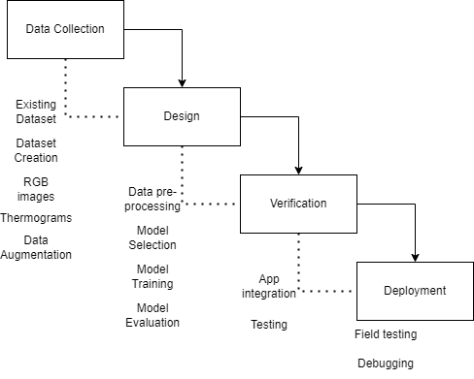
Figure 3.1: Methodological Framework

3.2 Data Gathering Procedure
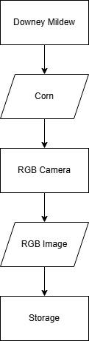
Figure 3.2: Data gathering process flow diagram

Data Gathering Procedure
To construct a reliable dataset for the classification of Philippine Downy Mildew in corn crops, the researchers conducted field visits to the Institute of Plant Breeding at the University of the Philippines Los Baños (UPLB-IPB). These visits were coordinated under the guidance and with the approval of UPLB-IPB experts, who provided the necessary support and resources for controlled data collection. The field data collection sessions were strategically scheduled early in the morning, beginning at 6:00 AM, to take advantage of crop conditions optimal for image capture.

Prior to data collection, the UPLB-IPB experts had deliberately prepared and infected specific corn crops with Philippine Downy Mildew under a controlled environment. The process involved harvesting sporangia spores from infected plants, preparing a spore suspension, and inoculating young corn crops at a susceptible growth stage. An open-field environment was maintained after inoculation to promote successful infection and symptom development. This method allowed the researchers to ensure the availability of corn plants displaying various stages of Downy Mildew infection necessary for comprehensive data gathering. The specific steps for the inoculation process were as follows:
- Day 0: Sporangia were collected from naturally infected corn. A spore suspension was prepared by mixing the harvested sporangia with sterile distilled water. The concentration of the solution is 100 thousand spores per ml.
- Day 14: Healthy corn plants, around 14 days old and at the 2- to 3-leaf stage, were inoculated by spraying the spore suspension onto the foliage, particularly targeting the whorl of the corn plant.
- Day 21-onwards: Symptoms such as pale-yellow stripes began to manifest, with further development of sporulation depending on environmental conditions.
This systematic inoculation and environmental management ensured a reliable, consistent appearance of Downy Mildew symptoms across the experimental corn population.
During the field collection, the researchers utilized two Android smartphones equipped with RGB cameras to capture images of the infected corn crops. All images were taken from a top-down perspective to effectively capture the inner leaves, where symptoms of Downy Mildew typically appear first. To improve the quality and usability of the collected images, a black background was placed behind the subject leaves. This approach minimized background distractions and enabled the focus to remain on the disease symptoms. Additionally, an umbrella was used to shield the samples from direct sunlight, ensuring that the discoloration—particularly the characteristic yellowing of the leaves—was consistently and accurately recorded across samples.
Once the images were collected, they were uploaded to a secure online storage system and shared with the plant pathology experts at UPLB-IPB for further assessment and classification. Each image was evaluated based on visible indicators of disease severity, including:
- The presence and intensity of yellow to white leaf stripes
- Widespread yellowing or pale discoloration on the upper leaf surface
Based on these criteria, the expert classified each image according to the severity of the infection. After classification, the images were sorted into designated online folders corresponding to their severity level, forming a structured and labeled dataset suitable for model training and evaluation in the subsequent stages of the study.

Data Preprocessing

The initial preprocessing stage included cleaning the captured images by eliminating artifacts, noise, and unwanted elements that might have interfered with the precise classification of Downy Mildew characteristics. This step allowed the model to focus on distinguishing the severity of Downy Mildew. Following this, the images of the corn disease were resized to an appropriate resolution. This resizing ensured compatibility with the specified architectures and enabled streamlined processing during both model training and evaluation.

Data Augmentation
In this stage, researchers utilized data augmentation methods to enhance the diversity and variability of the Downy Mildew images. This step was crucial for developing a feature detection model that was both robust and adaptable. To achieve this, the researchers used popular deep learning frameworks like TensorFlow.
The researchers employed a variety of augmentation techniques on Downy Mildew images. These methods include image rotations, image flipping, and modifying brightness and contrast. By applying these transformations randomly to the images, the dataset was expanded, leading to a greater variety of variations for each image of the corn disease. Image rotations helped the model learn to identify features from various angles, emulating the potential variations seen in real-world situations. Flips aided in capturing the symmetrical attributes of the corn disease, which were relevant for detection. Modifying brightness and contrast helped train the model to adapt to changes in lighting conditions.

3.3 Research Design
The study is a heavily quantitative hybrid design, with Dataset Selection, Deep Learning Model Development, Experimental Setup, and Evaluation Metrics serving as the quantitative elements, while Expert Validation functioned as the qualitative element.
​

3.4 Research Instruments
For this study, Python will serve as the primary programming language. The deep learning model to be employed is EfficientNetB3. To support the development and implementation of these models, the researchers utilized a range of frameworks and libraries, including Scikit-learn, OpenCV, and TensorFlow. Additionally, to enhance the efficiency of the training process, the study made use of GPUs to accelerate computation and reduce training time.

3.5 Testing Methodology
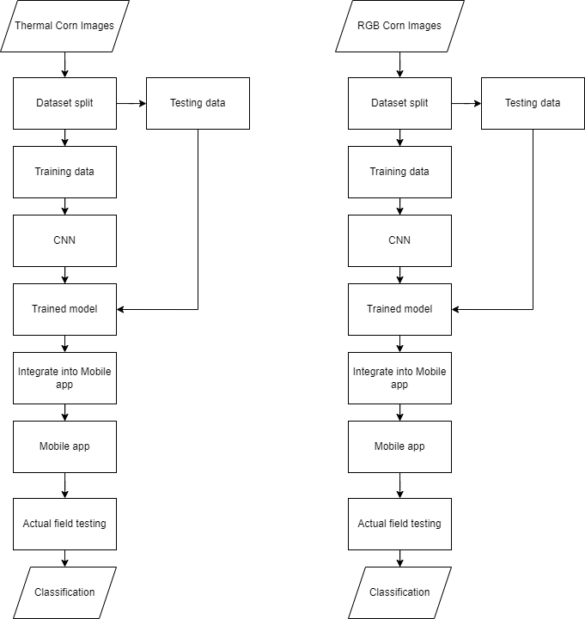


Figure 3.3: Thermal corn image model
Figure 3.4: RGB corn image model

Testing and Validation
In this stage, the purpose was to assess the performance of the model and validate its generalization capabilities. This split was commonly performed to allocate a portion of the dataset specifically for evaluation purposes.
For the study, an 80/20 split was used, with 80% of the data allocated for training and 20% for validation. The training set played a crucial role in training the model's parameters and optimizing its performance, while the validation set served as an independent dataset to evaluate the model's performance on unseen examples. During model training, the model learned to extract relevant features from the training set and make predictions based on those features. The researchers fed the validation set through the trained model and assessed its performance metrics. The experts of UPLB intentionally infected the corn crops with the disease before testing the model and application.

Before conducting field testing of the application, the researchers first consulted with experts at the Institute of Plant Breeding (IPB) to assess the severity level of Philippine downy mildew on corn. This consultation aimed to ensure that the evaluation was unbiased and that the data reflected an accurate representation of the disease's impact on the crops.

Functional Testing
Functional testing ensures that the system's core functionalities work as intended. For this study, the following functional tests were conducted to evaluate the system’s key features:
- Image Capture and Input The system was tested to verify whether it can successfully capture both RGB and thermogram images of corn crops through the mobile app’s camera functionality. This was checked by using both buttons for taking images from the camera and uploading existing images from the gallery.
- Disease Detection and Classification The primary function of the mobile app is to classify the severity of Downy Mildew in corn. The model was tested for accuracy in detecting the presence of the disease and classifying it into predefined categories (mild, moderate, or severe). This includes evaluating the model's ability to handle variations in the images, such as lighting or angles, through its data augmentation techniques.
- System Integration It was also important to test the integration of the best trained model with the mobile application, ensuring that the app is capable of using the trained model to classify Downy Mildew in real time and display the results to users.

Non-Functional Testing
Non-functional testing focuses on the system’s performance, usability, and other quality attributes to ensure it meets the desired operational standards. The following non-functional tests were conducted:
- Performance Testing: This test measures how well the system performs under various conditions. Specifically, it evaluates the response time of the app when capturing and processing images. Performance is critical in field settings where quick disease classification can help farmers take immediate action.
- Usability Testing Usability tests were conducted to ensure that the mobile app is user-friendly, especially for field workers who may not have technical expertise. The interface was assessed for intuitiveness, with particular focus on the simplicity of the buttons for image capture and upload. Ease of use ensures that the system can be effectively adopted in real-world scenarios.
- Reliability and Stability Testing This test ensures that the system is stable under different operating conditions. The app was tested to see how it handles repeated use and large volumes of data (e.g., multiple images being processed in sequence). Stability is key to ensuring that the system works reliably over time in the field.
- Security Testing: Given that data may be uploaded and stored remotely, security tests were carried out to ensure that the images and results are handled safely, preventing unauthorized access.

By performing both functional and non-functional testing, the study ensures that the mobile app is not only capable of accurately diagnosing Downy Mildew but also performs efficiently and is reliable for field use. This comprehensive testing approach ensures that the developed system meets both its intended functional goals and its operational requirements in real-world settings.

Evaluation Metrics

In this phase, the trained model is assessed for its performance on the validation set. This evaluation aims to measure the model's effectiveness and accuracy in detecting features relevant to Downy Mildew severity classification. In this case, a confusion matrix is utilized as a reference in evaluating the model’s effectiveness and accuracy in feature detection.

The confusion matrix is a commonly used tool for evaluating the performance of a classification model. It provides a tabular representation of the model's predictions compared to the actual ground truth labels. The matrix is organized into rows and columns, where each row represents the instances in a predicted class and each column represents the instances in an actual class. The cells of the matrix contain the count or percentage of instances that fall into each combination of predicted and actual classes.
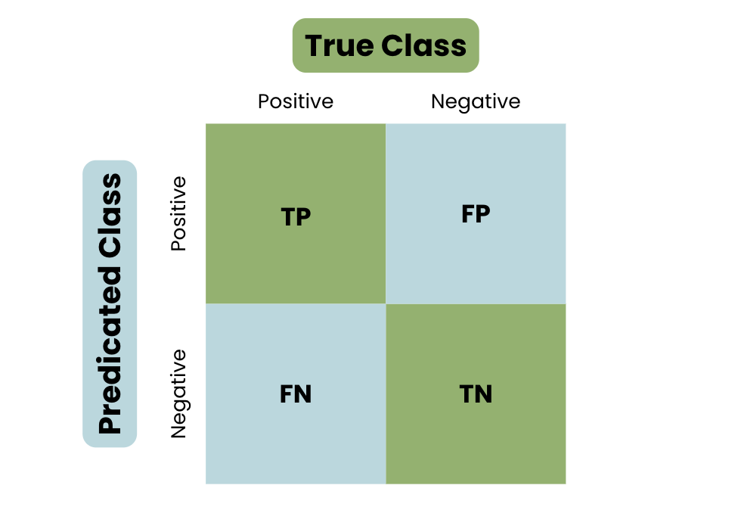
Figure 3.5: Confusion matrix

Several evaluation metrics are utilized to assess the model's performance. One commonly used metric is accuracy, which measures the overall correctness of the model's predictions. It represents the proportion of correctly classified Downy Mildew features compared to the total number of samples in the validation set. A higher accuracy indicates a more reliable and accurate feature detection capability of the model.
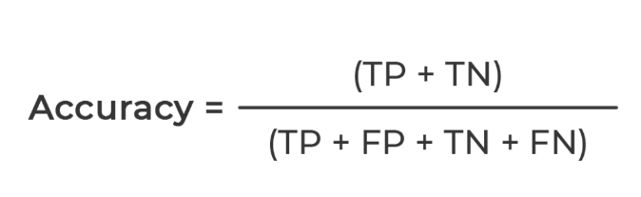

Precision and recall are additional evaluation metrics that provide insights into the model's performance in specific classes. Precision measures the proportion of correctly detected features within a specific class, while recall represents the proportion of correctly detected features out of all the actual features belonging to that class. These metrics help evaluate the model's ability to correctly classify the severity of Downy Mildew in corn crops.

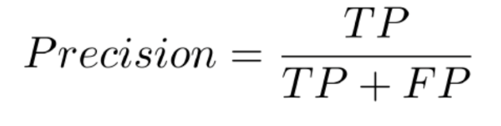
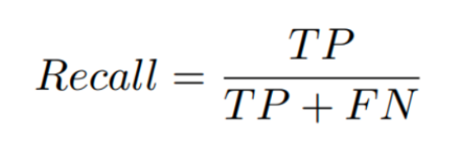
F1 score is another commonly used metric that combines both precision and recall into a single measure. It provides a balanced evaluation of the model's performance by considering both the ability to detect relevant features (precision) and the comprehensiveness of the detection (recall).
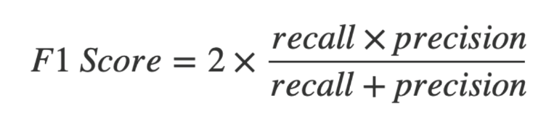

Through the evaluation process on the validation set, researchers gain insights into the model's strengths and weaknesses. If the model exhibits high accuracy, precision, recall, and F1 score, it indicates that the model has effectively learned and extracted the relevant features for Classifying Downy Mildew.

Model Testing | Initial Testing |  | Final Testing
 | YES | NO | YES | NO
Is the model able to detect the objects in the training data?
Does the image augmentation enhance the performance of the model to identify and classify the data?
Does the model integrate seamlessly with the mobile application?
Table 3.1: Testing and validation of Model
Table 3.1 shows the guide questions that will ensure the functionality of the machine learning model

Performance  Testing | Initial Testing |  |  |  | Final Testing
 | Accuracy | Precision | Recall | F1 | Accuracy | Precision | Recall | F1
The performance of the model to identify the object in the image?
The performance of the model to classify the object in the image
Table 3.2: Evaluation Metrics for the Performance of the Model
Table 3.2 shows the models ability to Identify (detect the presence of the disease) and Classify (group the identified disease into the correct categories) the target object

3.6 System Process and Design:

Flowchart

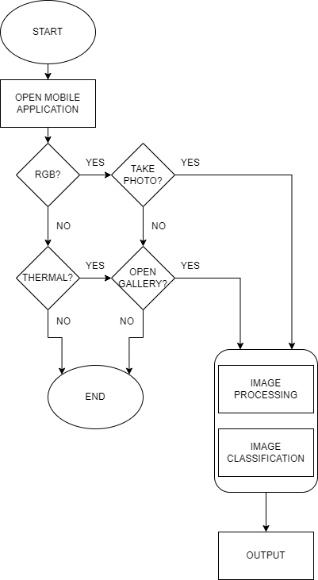
Figure 3.6: Mobile Application Deployment process flowchart diagram.

Architecture
In the system process and design, images for both training and testing will be sourced by the researchers, while users will capture images using the developed mobile application. The initial preprocessing phase involves cleaning the captured images to remove artifacts, noise, and unwanted elements that could impede the accurate classification of Downy Mildew characteristics. This step ensures that the model focuses on distinguishing various types of Downy Mildew. Following cleaning, the images of corn diseases will be resized to a suitable resolution, aligning them with specified architectures and facilitating efficient processing during both model training and evaluation. For feature extraction, the system will utilize different models and the model will be able to determine and predict the severity of the Downy Mildew image.

3.7 System Components
Hardware components

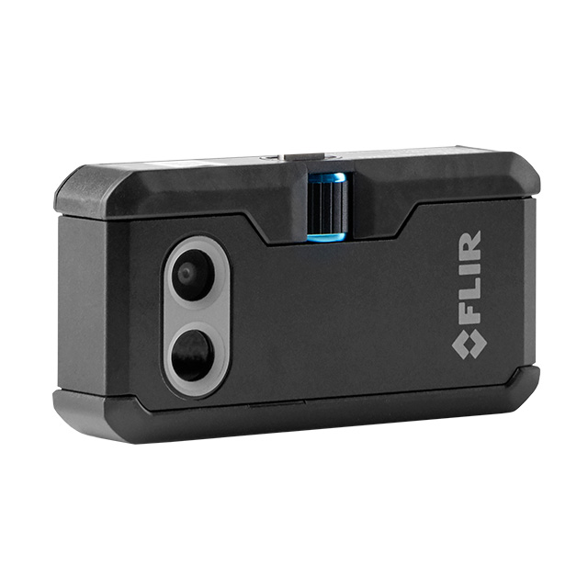
Figure 3.7: Thermal Image Camera

Thermal image camera – A portable thermal imaging camera that can be attached to a smartphone through a Type C port.

​


Figure 3.8: Android Phone

An Android phone that is capable of handling the deep learning model will serve as the primary device for managing the user interface of the Downy Mildew classifier application. This device has been chosen for its versatility and widespread availability, allowing for efficient deployment and user accessibility. This device is selected because it's expected to be accessible to most individuals.

Software Components

Figure 3.9: Jupyter Notebook

Jupyter Notebook is a free, open-source application in the Project Jupyter collection that allows for the creation of documents that is able to facilitate the execution of programs. It has a wide range of extensions and integrations that makes it a valuable tool for data scientists, researchers, programmers, and educators.


Figure 3.10: Android Studio

Android Studio is the official integrated development environment for Google’s Android Operating System, providing developers with the necessary tools to develop, debug, and deploy android applications. The IDE allows developers to customize android applications to suit their specific demands.

3.8 User Interface

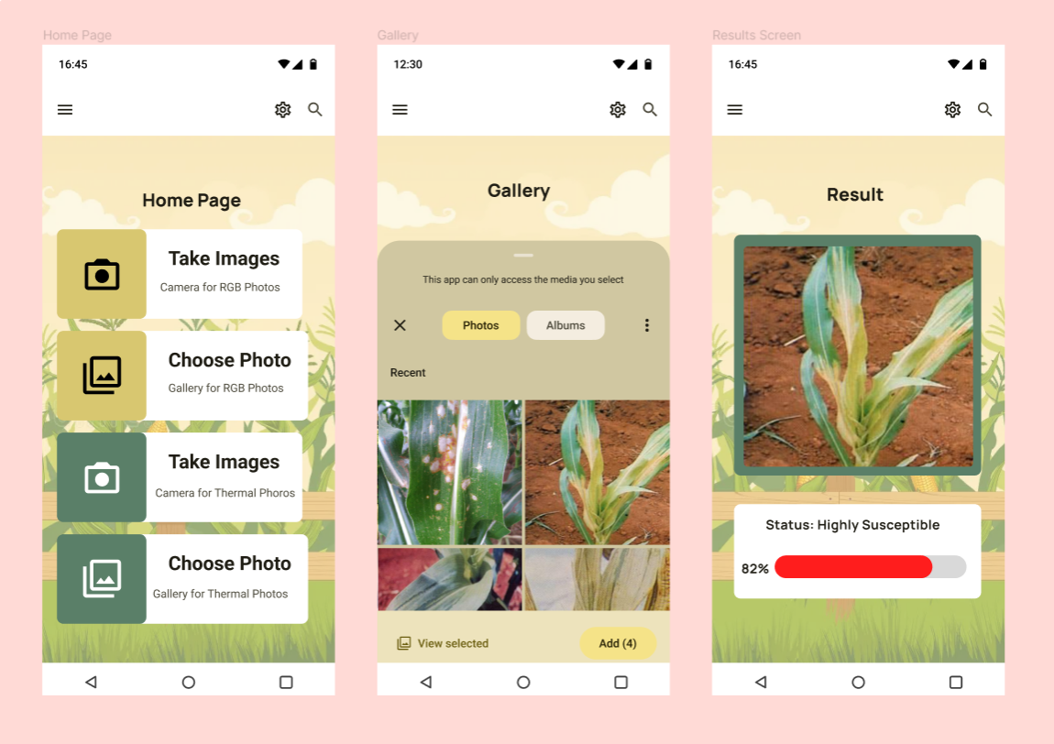
Figure 3.11: User Interface

The user interface will be comprised of 4 buttons:
The “Take Images” button for RGB images, gives the user the option to take a picture directly for easy and quick input of images, useful for capturing new RGB images to input into the mobile application. There is also a “Take Images” button but for Thermogram images, it also gives the user the option to take a picture directly for easy and quick input of images, useful for capturing new thermogram images to input into the mobile application.

The “Choose photo” button for both RGB and thermogram pictures, opens the phone storage or gallery and allows the user to select an image to upload.

The thermogram image buttons expect and assume thermogram images to be uploaded, likewise, the RGB image buttons also expect and assume RGB images to be uploaded. In the case that an RGB feature receives thermograms or vice versa, the model will give inaccurate results.

3.9 Selection of Samples
The selection of samples will be conducted and conditioned by the IPB (Institute of Plant Breeding) researchers from the University of the Philippines - Los Baños since they have more knowledge on what sampling method is the most fitting.

CHAPTER 4

RESULTS AND DISCUSSION

This chapter focuses on discussion of the results in relation to the stated objectives of the study. The development and evaluation of Offline Mobile App Utilizing RGB and Infrared Imaging for Classifying Downy Mildew in Corn using Deep Learning, aimed to meet the needs identified within these objectives.

4. 1 Dataset Description/Overview

This study utilizes RGB and thermal images of corn, collected and preprocessed by researchers from the University of the Philippines Los Baños (UPLB), as the primary dataset. Both RGB and thermal images were captured under real field conditions at UPLB. The RGB images were collected by the current research team, while the thermal images were obtained from previous researchers at the same institution.
Table 4.1.1 presents the distribution of RGB images across six resistance categories: Highly Resistant, Resistant, Moderately Resistant, Moderately Susceptible, Susceptible, and Highly Susceptible. Similarly, Table 4.1.2 shows the distribution of thermal images (thermograms) across the same resistance categories. The dataset size is kept consistent throughout the training of all Convolutional Neural Network (CNN) models to ensure a fair comparison.
Classification | Number of Thermogram
Highly Resistant | 223
Resistant | 156
Moderately Resistant | 259
Moderately Susceptible | 206
Susceptible | 166
Highly Susceptible | 182
Total | 1132
Table 4.1: Number of thermograms per classification

Classification | Number of RGB Images
Highly Resistant | 233
Resistant | 297
Moderately Resistant | 202
Moderately Susceptible | 168
Susceptible | 142
Highly Susceptible | 254
Total | 1296
Table 4.2: Number of RGB Images per classification

For building a reliable model having the right dataset size is essential to avoid overfitting and for the model to generalize well to unseen or new data. In this study, both thermal and RGB images are needed. The researchers got the thermal images from previous researchers while the RGB images were gathered directly from the UPLB IPB corn fields. Experts guided the collection process to ensure the severity labels were accurate and consistent.
Data collection occurred between 8:00 AM and 12:00 PM, when conditions are optimal for data collection for consistency. Beyond noon, the leaves begin to curl, obscuring the delicate yellow streaks of downy mildew. Furthermore, we avoided collecting data during or shortly after rainfall, as wet leaves could introduce unwanted noise that would ultimately compromise model accuracy.
For the collection of RGB images, we used a standard smartphone camera positioned top-down to clearly capture the yellow streaks key indicators of downy mildew for expert evaluation. Initially, farmers assisted with the image collection, but many of their photos failed to clearly show the disease markers which are the yellow streaks in the leaves. Sir Jay-vee, the plant pathology expert that is helping us with the data collection then advised us to take the images ourselves to ensure quality and the symptoms of the disease to be visible.

After the data collection, we asked if the symptoms of the Philippine Downy Mildew were visible and then he rated the pictures. Any ambiguous images were not rated and not used by the researchers for the training of the model. He rated every image using a 1-6 severity scale from Highly Resistant to Highly Susceptible.
When RGB images were taken environmental conditions such as temperature or humidity were not factored unlike with the thermal images. However, we made sure that the images were taken properly by using a black illustration board.
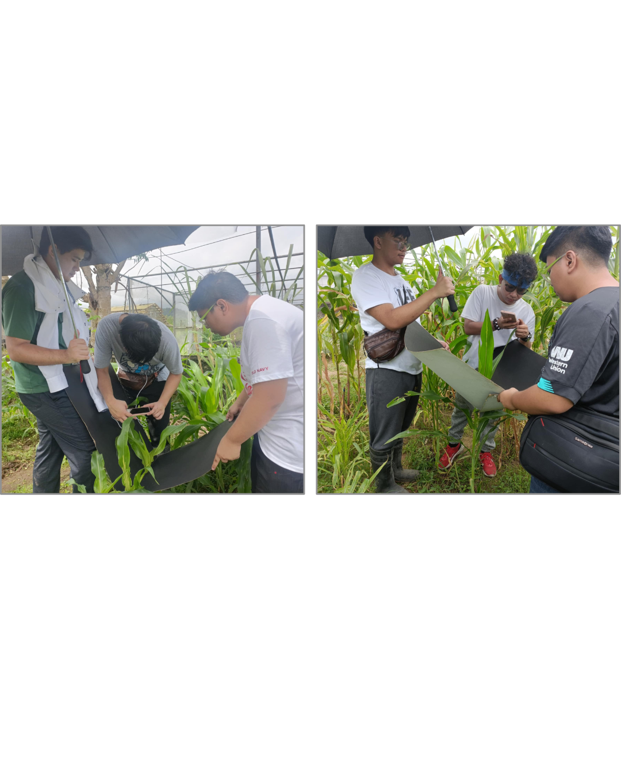
Figure 4.1: Field testing and data gathering set-up

The images below compare the collected data: correct angles (left) versus incorrect angles (right). These follow the guidelines recommended by Sir Jayvee on how to properly capture images for accurate rating.
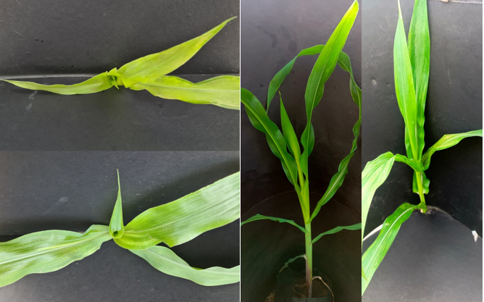
Figure 4.2: RGB Images collected
The figures above illustrate a comparison between correct and incorrect methods of capturing RGB images. In the improperly angled images (on the right), the side view prevents clear visibility of downy mildew streaking, making classification impossible. To determine the best angle, we consulted an expert from IPB, who advised that a top-down view with a slight tilt is acceptable as long as the center of the plant remains visible.

To reduce noise, the researchers used a black background to isolate the leaves for a consistent background. This also made masking which is a preprocessing that we applied to be easier. Masking was used to isolate the leaves from the background, making sure that only the leaves were visible for the model to classify.
After getting rid of bad data, the remaining images, shown on the left, represented the dataset selected to be used for the model. These images were chosen based on the advice of the plant pathology expert. The table below represents the current count of the images we have collected for the study, including a breakdown of the images based on their classification.
Classification | Number of RGB images
Highly Resistant | 206
Resistant | 215
Moderately Resistant | 175
Moderately Susceptible | 154
Susceptible | 128
Highly Susceptible | 198
Total | 1076
Table 4.3 Number of RGB images per classification after data cleaning

4.2 Performance Evaluation of Models

4.2.1 Evaluation Metrics
The researchers have used the confusion matrix for evaluating the model's performance which allowed us to visualize the true positive, true negative, false positive, and false negative values. This matrix is important for calculating the metrics such as accuracy, precision, recall, and F1-score, which provide a comprehensive view of the model's effectiveness. The decision to choose confusion matrix was decided because it helps check the model's performance in detail. This also made sure that the researchers will be given the complete picture or view of the model's performance as imbalance can affect the accuracy of the model.

4.2.2 Preprocessing

RGB Preprocessing Results

Raw Image

The raw image, which is the original image before any preprocessing techniques are applied, acts as the baseline for the preprocessing.

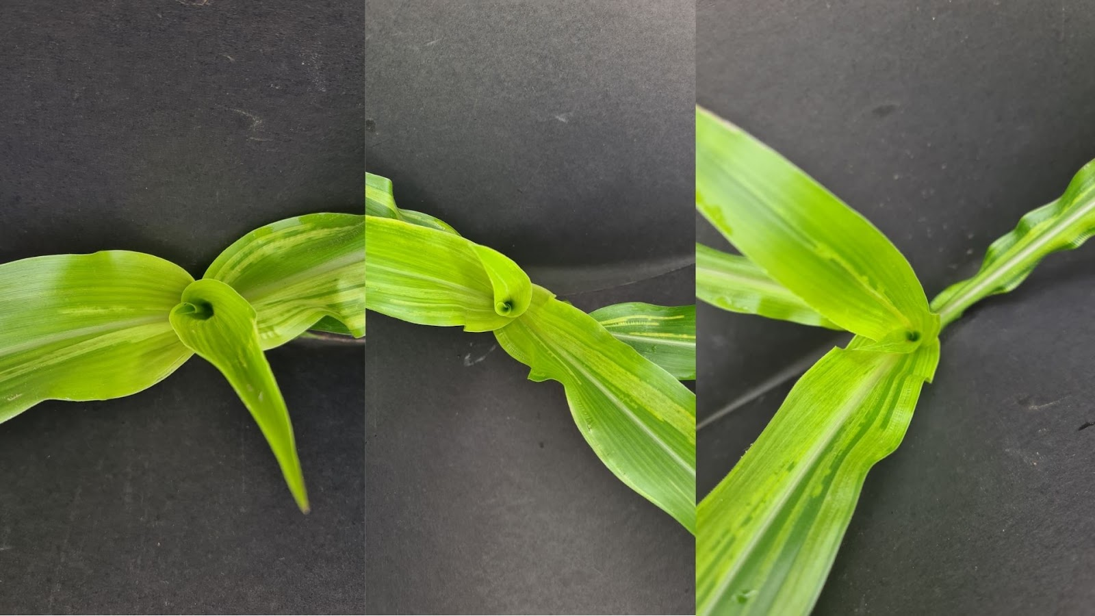
Figure 4.3: Raw Image Sample
Precision, Recall, and F1-score:

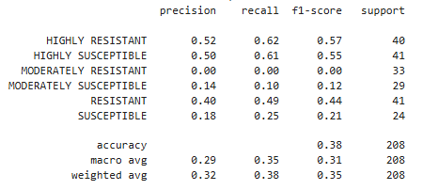
Figure 4.4: Raw Image Scores
Confusion Matrix:
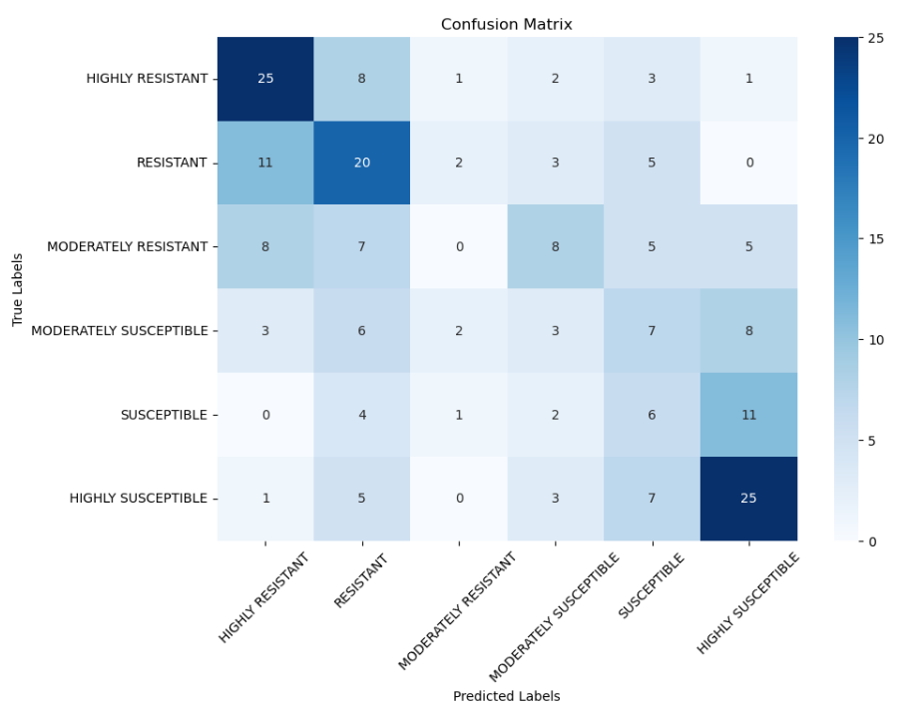
Figure 4.5: Raw Image Confusion Matrix

With F1-scores of 0.57 and 0.55 for the raw, unprocessed images, respectively, the model performed best at the extremes, correctly identifying the Highly Resistant and Highly Susceptible classes. It had a lot of trouble with middle-ground cases, though. The Moderately Susceptible class did not fare much better at 0.12, and the Moderately Resistant class received a pitiful 0.00 F1-score. The macro-averaged F1-score was only 0.31, and overall accuracy was about 38%.

Isolation Preprocessing

Isolation was applied to help the model focus on the key feature most relevant to downy mildew detection which is leaf discoloration. This process enables the model to better identify color changes, such as yellowing or spotting, which are crucial for classifying disease resistance levels.
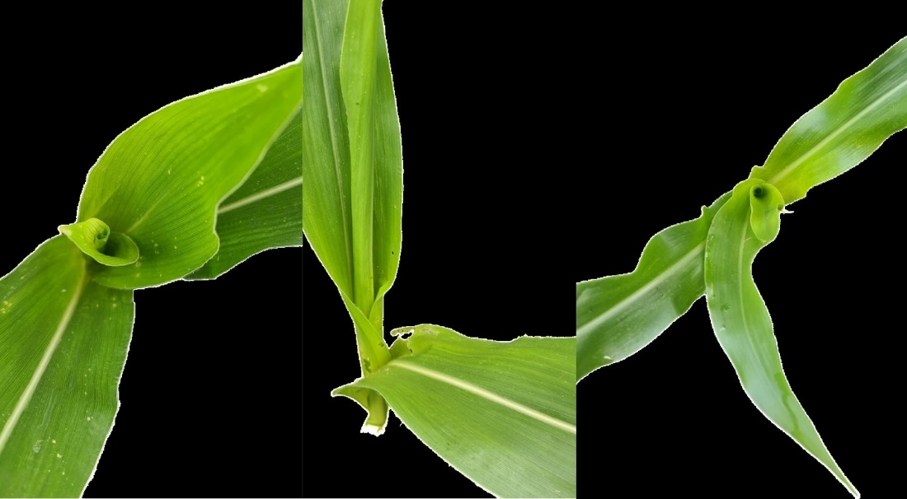
Figure 4.6: Isolated Image Sample

Precision, Recall, and F1-score:

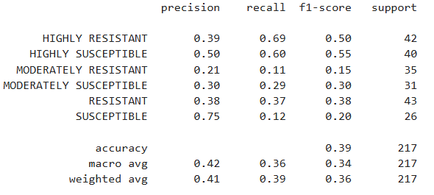
Figure 4.7: Isolated Image Scores
Confusion Matrix:
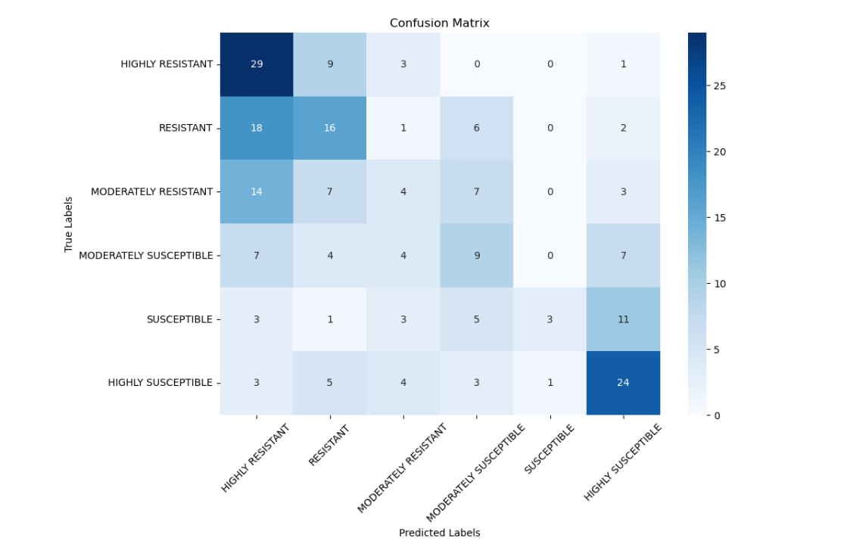
Figure 4.8: Isolated Image Confusion Matrix

Using isolated images improved the model's performance in most classes. The Highly Resistant and Highly Susceptible classes maintained their strong performance (F1-scores of 0.50 and 0.55), while the Moderately Resistant and Moderately Susceptible classes improved (F1-scores of 0.15 and 0.30). However, the performance of the Susceptible class drastically decreased, with an F1-score of 0.20. Overall accuracy was 39%, and the macro-averaged F1-score increased to 0.34. These results suggest that isolating the leaf improved the model's ability to discriminate between resistance categories by allowing it to focus on important traits like color.

Isolation with CLAHE(Contrast Limited Adaptive Histogram Equalization)(CLIP_LIMIT=1.5)
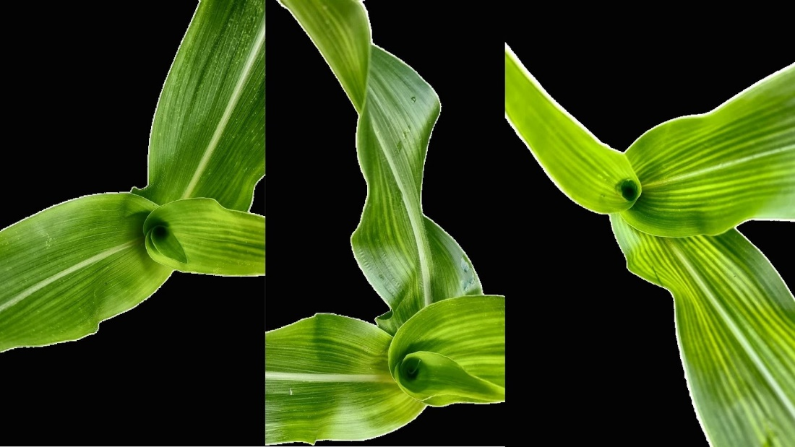
Figure 4.9: Isolation with CLAHE (CL=1.5) Image Samples
CLAHE (Contrast Limited Adaptive Histogram Equalization) with a clip_limit of 1.5 was used to increase the model's ability to focus on crucial traits relevant to downy mildew detection, particularly leaf discoloration. By enhancing local contrast within the leaf regions, CLAHE draws attention to minute changes in color and texture. This improves the model's ability to identify crucial symptoms, such as spotting or yellowing, which are essential for classifying the level of disease resistance.

Precision, Recall, and F1-score:
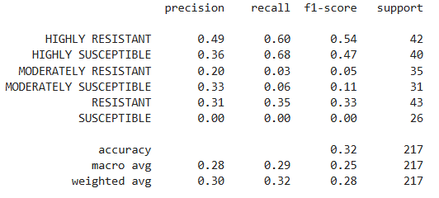
Figure 4.10: Isolation with CLAHE (CL=1.5) Image Scores
Confusion Matrix:
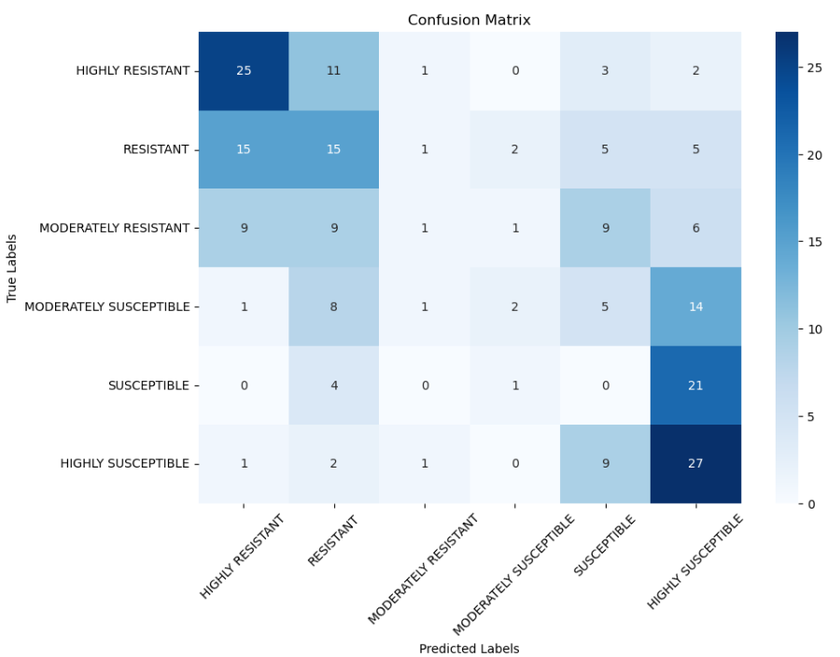
Figure 4.11: Isolation with CLAHE (CL=1.5) Image Confusion Matrix

Using the CLAHE(clip_limit=1.5) preprocessing, the model's performance showed a mix of improvements and decline. The highly Resistant and highly susceptible classes performed well that it got a F1-score of 0.54 and 0.47, respectively, indicating that the model was able to reasonably detect these classifications. However, the model struggled with Moderately Resistant and Moderately Susceptible classes getting a F1-scores of 0.05 and 0.11, suggesting that the CLAHE's contrast didn't help with these categories. The resistant class got an F1-score of 0.33. The susceptible class has the lowest f1-score which is 0.0, meaning that it was not able to detect any instances of this class. The overall accuracy of this model was 32%. These results suggest that the contrast enhancement was too much or it was not effective as a preprocessing. The next preprocessing will use a lower clip_limit to check if this was too much contrast enhancement.

Isolation + CLAHE(Contrast Limited Adaptive Histogram Equalization) (CLIP_LIMIT=1.0)
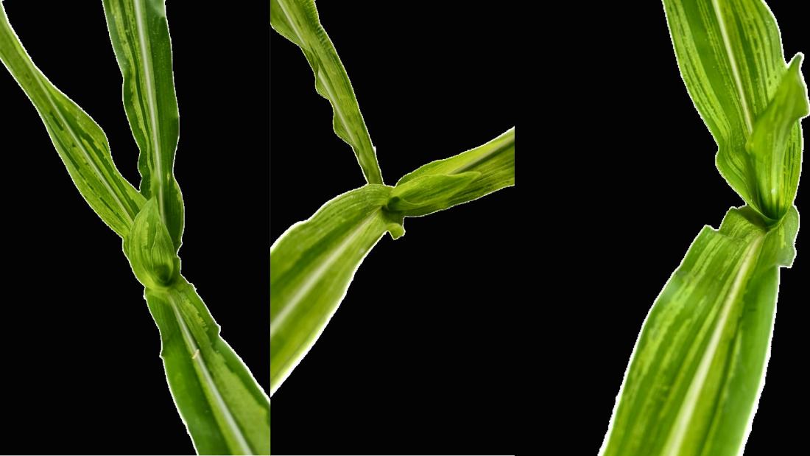
Figure 4.12: Isolation with CLAHE (CL=1.0) Image Samples
CLAHE (Contrast Limited Adaptive Histogram Equalization) with a clip_limit of 1.0 was used to increase the model's ability to focus on crucial traits relevant to downy mildew detection, particularly leaf discoloration. By enhancing local contrast within the leaf regions, CLAHE draws attention to minute changes in color and texture. This improves the model's ability to identify crucial symptoms, such as spotting or yellowing, which are essential for classifying the level of disease resistance.

Precision, Recall, and F1-score:
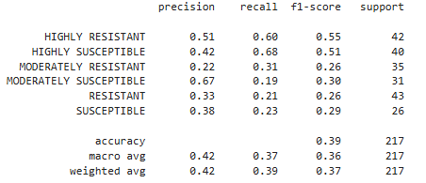
Figure 4.13: Isolation with CLAHE (CL=1.0) Image Scores

Confusion Matrix:
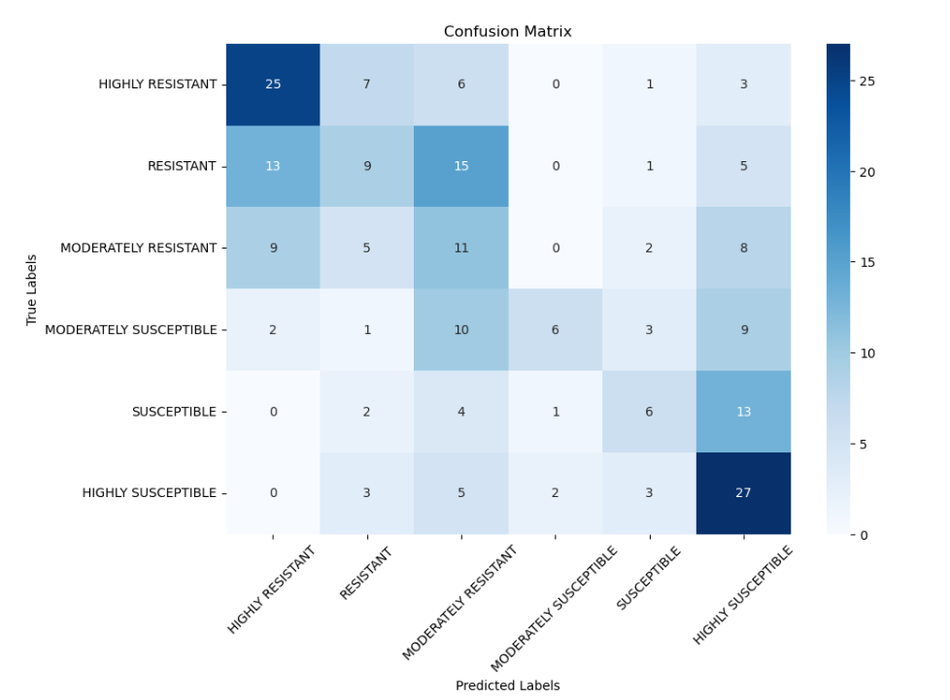
Figure 4.14: Isolation with CLAHE (CL=1.0) Image Confusion Matrix

Using CLAHE with a clip_limit of 1 showed an improved performance compared to clip_limit of 1.5 which means that the contrast enhancement with a clip limit of 1.5 was too much. The Highly Resistant and Highly Susceptible classes performed well again, with F1-scores of 0.55 and 0.51, respectively. The Moderately Resistant class saw improvement with an F1-score of 0.26, while the Moderately Susceptible class had a high precision which is 0.67 it has a low recall which is 0.19. The resistant and susceptible classes still struggled, with f1-scores of 0.26 and 0.29, respectively. The overall accuracy increased when compared to other preprocessing.
Isolation + Red and Green Channel Filter
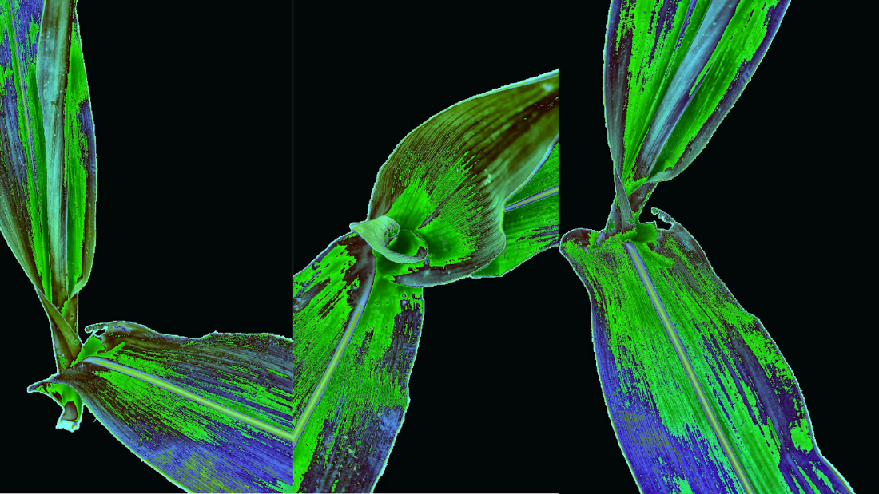
Figure 4.15: Isolation with Red/Green Channel Filter Image Samples

The filter used in this preprocessing is to reduce the blue channel to 0.5 and for the red and green channel to be 1.5. The thought behind this preprocessing is for the yellow hues of the leaves to pop out. By focusing on these key color features, the filter may help the model better detect the subtle color changes between classes, improving the classification accuracy of the downy mildew.

Precision, Recall, and F1-score:
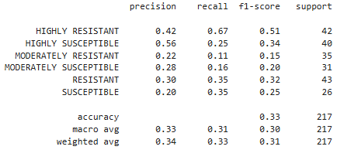
Figure 4.16: Isolation with Red/Green Channel Filter Image Scores

Confusion Matrix:
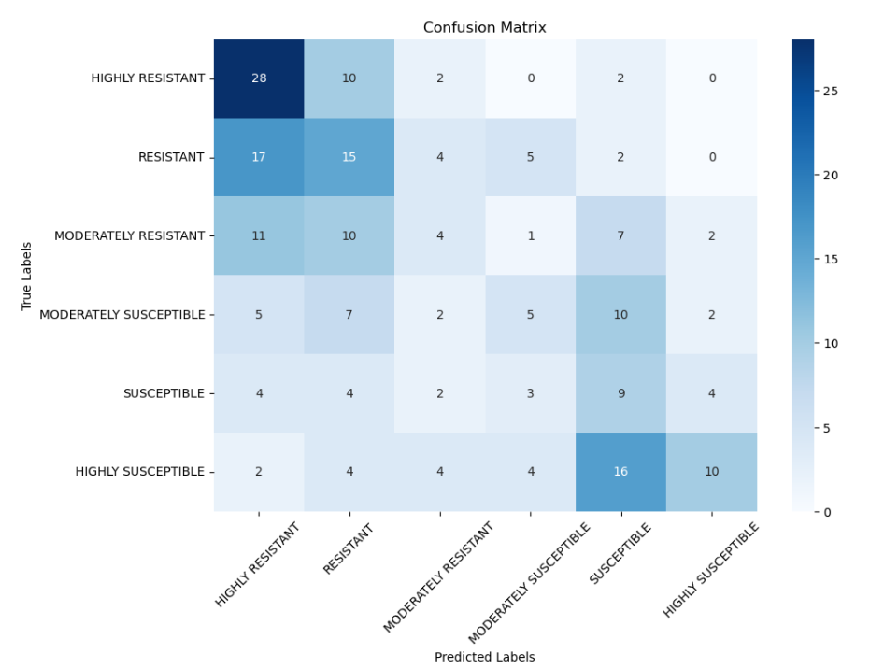
Figure 4.17: Isolation with Red/Green Channel Filter Image Confusion Matrix
With the filter applied, the model's performance was worse when compared to previous preprocessing. The highly resistant class performed well with an F1-score of 0.51, but other classes have shown poor results. Overall accuracy dropped to 33% which means that the filter may not have improved generalization possibly due to overemphasis on certain color features.

Isolation + removal of blue channel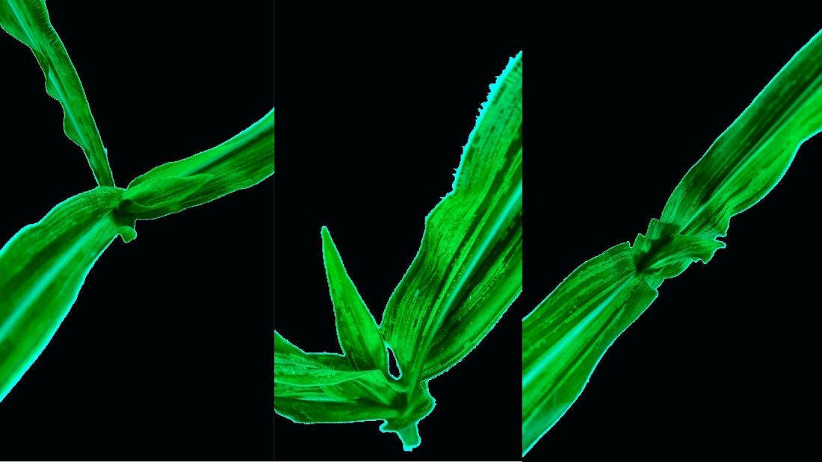
Figure 4.18: Isolation with Blue Channel Removal Image Samples

The filter used in this preprocessing is the enhancement of red and green channels to highlight yellow and reddish discoloration from downy mildew, improving disease detection. This made the yellow parts of the leaves appear red making it more visible for the model to detect downy mildew.

Precision, Recall, and F1-score:
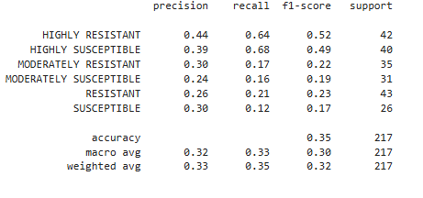
Figure 4.19: Isolation with Blue Channel Removal Image Scores

Confusion Matrix:
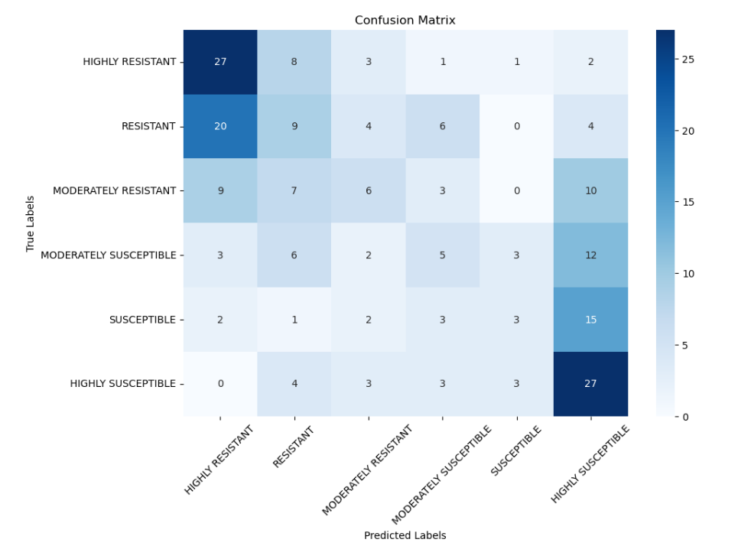
Figure 4.20: Isolation with Blue Channel Removal Image Confusion Matrix
With the filter applied, the model's performance was still not good. The highly resistant and highly susceptible performed well with an F-1 score of 0.52 and 0.49 respectively. The f1-score of other classes have performed poorly hovering around 0.17-0.23. The overall accuracy is 35% which means that the filter has not improved the model's performance to detect downy mildew.
Isolation + Green and Red Channel Amplification
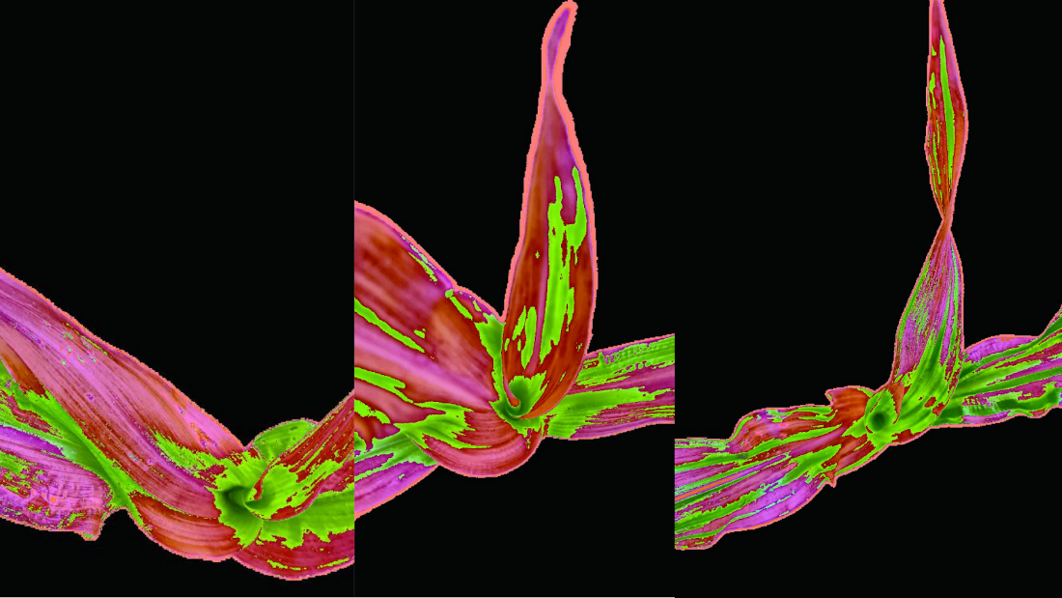
Figure 4.21: Isolation with Red/Green Channel Amplification Image Samples

The filter used in this preprocessing is the enhancement of red and green channels to highlight yellow and reddish discoloration from downy mildew, improving disease detection. This made the yellow parts of the leaves appear red making it more visible for the model to detect downy mildew.
Precision, Recall, and F1-score:
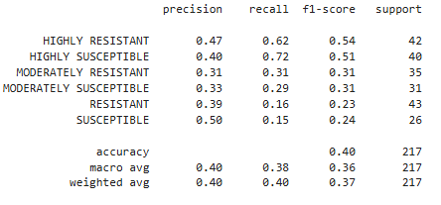
Figure 4.22: Isolation with Red/Green Channel Amplification Image Scores
Confusion Matrix:
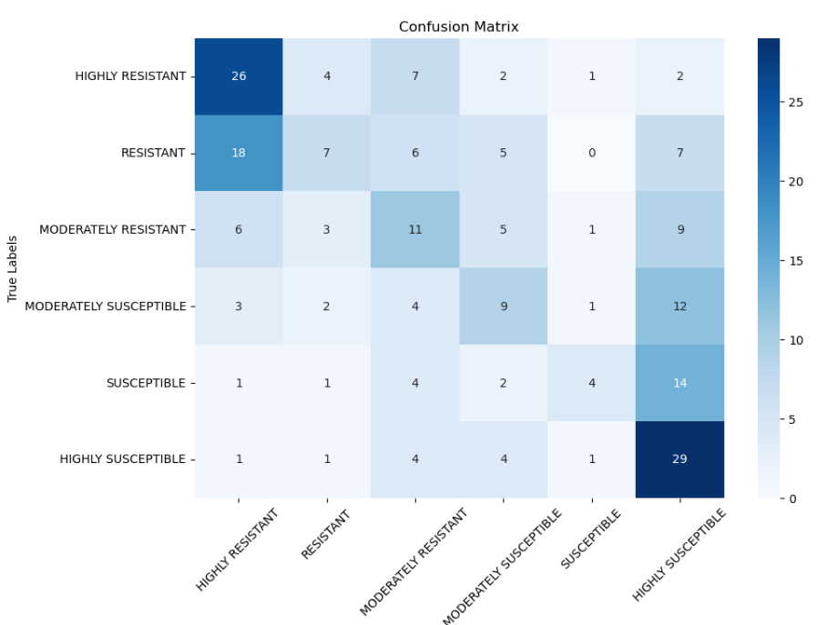
Figure 4.23: Isolation with Red/Green Channel Amplification Image Confusion Matrix

With this filter, the model's performance showed a slight improvement compared to previous results, but still struggled to properly classify the different severities of downy mildew. The highly resistant and highly susceptible class performed the best with an F1-score of 0.54 and 0.51, respectively. Other classes performed better than other preprocessing but still low with an F1-score of 0.31 on both moderately susceptible and moderately resistant. The susceptible and resistant have the lowest score which are 0.24 and 0.23, respectively.
The researchers have observed that even the highly resistant and resistant classes have red shades in them which means that some leaves have yellowing in them. This may mean that during data collection even when an umbrella and black backdrop was used, there were still sun rays that got to the leaves of the corn.
To fine tune the best preprocessing properly, the researchers have picked 3 preprocessing to check which is the best for RGB images. These are the following preprocessing:(1) Isolation, (2) Isolation with Contrast Limited Adaptive Histogram Equalization (CLAHE) using a clip_limit of 1.5, and (3) Isolation with Green and Red Channel Amplification.

Fine Tuning
Isolation Preprocessing for RGB
Precision, Recall, and F1-score:
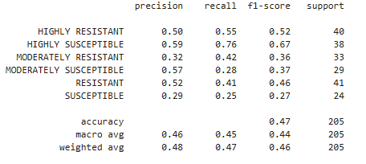
Figure 4.24: Background Isolation with Fine Tuning Scores
Confusion Matrix:
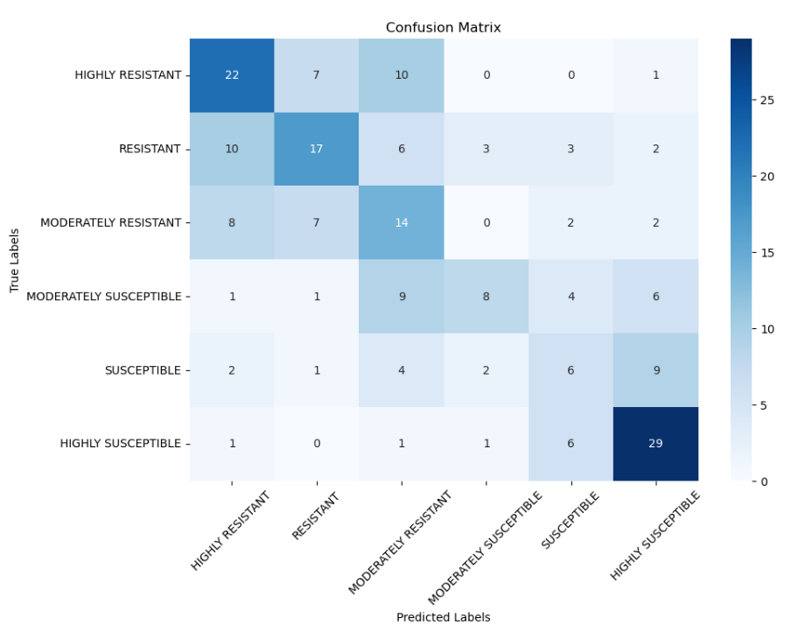
Figure 4.25: Background Isolation with Fine Tuning Confusion Matrix

After fine tuning the model using the isolation preprocessing, the model improved its overall performance from an accuracy of 39% to accuracy of 47%, the macro averaged F1-score rose from 34% to 44%. The highly susceptible showed the greatest improvement, with its F1-score increasing from 0.55 to 0.67. The moderately resistant and resistant also showed improvements, which means that the fine-tuned model was able to learn to extract more relevant patterns from the isolated leaf features. The moderately susceptible class also showed a slight increase from 0.30 to 0.37, and the susceptible class also showed improvement from 0.2 to 0.27. Even though the overall accuracy of the model increased from fine tuning, the model still struggled to properly classify the images.

Isolation + CLAHE Preprocessing for RGB
Precision, Recall, and F1-score:
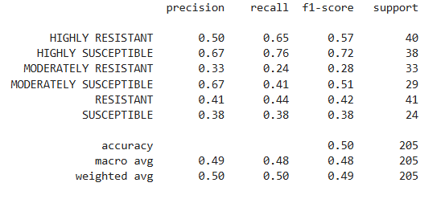
Figure 4.26: Isolation with CLAHE (CL=1.0) with Fine Tuning Scores
Confusion Matrix:
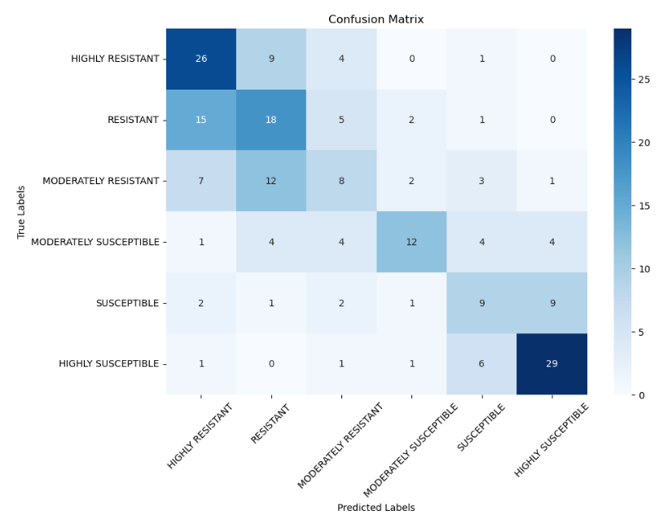
Figure 4.27: Isolation with CLAHE (CL=1.0) with Fine Tuning Confusion Matrix
After fine-tuning the combined preprocessing techniques of isolation and CLAHE with a clip limit of 1, the model showed clear improvements in both accuracy and class balance. The accuracy increased from 39% to 50%, the macro averaged F1-score rose from 36% to 48%. The highly susceptible showed the greatest improvement, with its F1-score increasing from 0.51 to 0.72. The Moderately Susceptible class, which previously had high precision but low recall, improved in balance with a jump in F1-score from 0.30 to 0.51. Resistant and Susceptible also saw moderate gains in F1-scores However, Moderately Resistant remained challenging, showing only a slight increase in F1-score. Even though the overall accuracy of the model increased from fine tuning, the model still struggled to properly classify the images.
Isolation with Green and Red Channel Amplification for RGB
Precision, Recall, and F1-score:
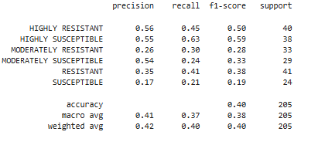
Figure 4.28: Isolation with Red/Green Channel Amplification with Fine Tuning Scores

Confusion Matrix:
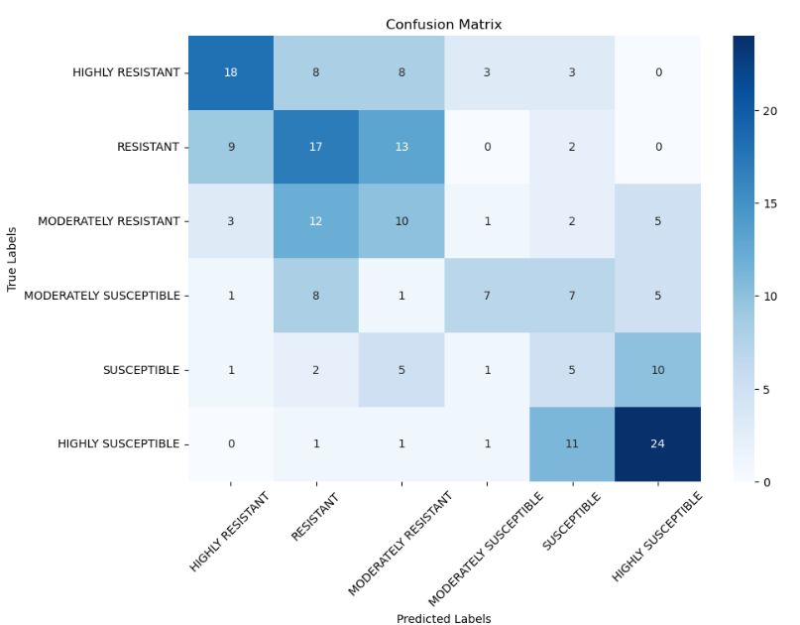
Figure 4.30: Isolation with Red/Green Channel Amplification with Fine Tuning Confusion Matrix

After fine tuning the model using the isolation amplified red and green channels preprocessing, the val accuracy of the model did not improve.
Model | Accuracy | F1 HR | F1 R | F1 MR | F1 MS | F1 S | F1 HS | F1 Macro
Raw | 38% | 57% | 44% | 0% | 12% | 21% | 55% | 31%
Isolated | 47% | 52% | 46% | 36% | 37% | 27% | 67% | 44%
Iso + CLAHE 1.0 | 50% | 57% | 42% | 28% | 51% | 38% | 72% | 48%
Iso + R/G amplification | 40% | 50% | 38% | 28% | 33% | 19% | 59% | 38%
Table 4.3: Comparison of the top 3 preprocessing techniques with Raw.

Moving forward, all RGB model evaluations will use a consistent preprocessing pipeline: leaf isolation followed by CLAHE (Contrast Limited Adaptive Histogram Equalization). This combination has so far produced the highest validation accuracy, suggesting it’s particularly effective at highlighting the features that matter most for classification.

EfficientNetB3 is currently used as the baseline model, as it outperformed other pretrained architectures tested during initial trials. However, to better understand how far this preprocessing approach can take us—and whether model choice or preprocessing has a greater impact—we plan to experiment with additional CNN architectures. This will help clarify which factor plays a more decisive role in classification performance, especially given the specific characteristics of the dataset.
Thermal
Thermal Images taken from UPLB IPB. The severity of downy mildew infection correlates with an increase in temperature, with more severe cases exhibiting higher temperatures.
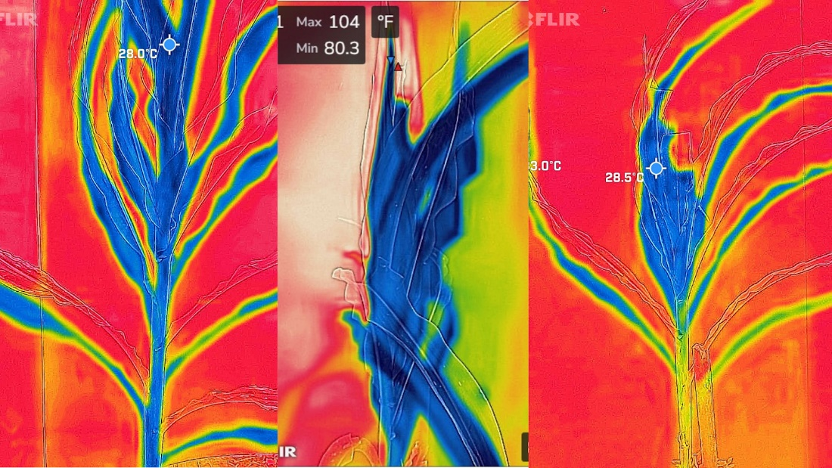
Figure 4.31: Thermal Image Samples
Precision, Recall, and F1-score:
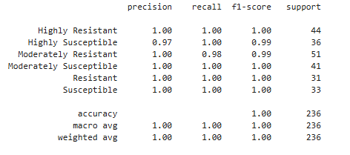
Figure 4.32: Thermal Image Scores
Confusion Matrix:
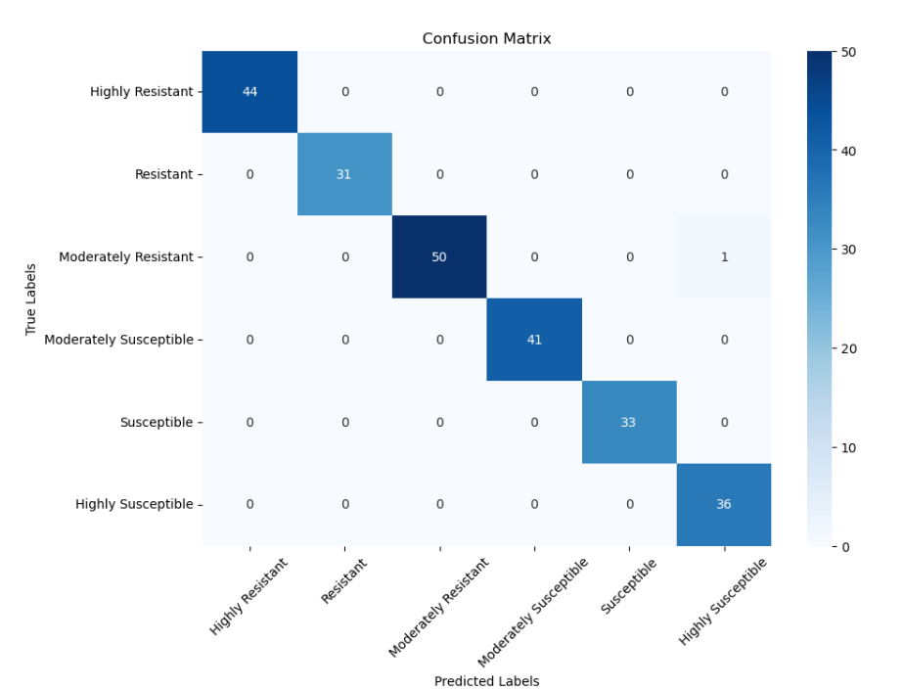
Figure 4.33: Thermal Image Confusion Matrix
The model performed remarkably well on the validation set using thermal images, reaching nearly 100% accuracy across all severity classes. Precision, recall, and F1-scores were also nearly perfect, showing that the model consistently got its predictions right with very few mistakes. The only mistake the model made during validation was a single misclassification in the moderately resistant category. This suggests the model has developed a strong ability to pick up on the subtle thermal differences between classes.

4.2.3 Model Performance Comparison
Thermal Images
Model | Val Accuracy | Val Loss
EfficientNetB3 | 0.995763 | 0.019746
MobileNetV2 | 0.983051 | 0.029744
Table 4.4: Performance Metric Table for Thermal Images with Augmented Dataset
RGB Images
Model | Val Accuracy | Val Loss
EfficientNetB3 | 0.517073 | 1.299749
MobileNetV2 | 0.453659 | 1.497754
Table 4.5: Performance Metric Table for RGB Images with Augmented Dataset

For the thermal images, Table 4.2.3.1 shows the results from training two CNN models—EfficientNetB3 and MobileNetV2—on the augmented dataset. EfficientNetB3 clearly led the pack, hitting a validation accuracy of 99.57% and a test accuracy of 99.33%, along with the lowest validation loss at around 0.0197.This means that the model did not memorize the training data but it actually learned how to generalize, making accurate predictions even on unseen data.
In contrast, the results for the RGB images, shown in Table 4.2.3.2, tell a different story. Using the same training conditions, EfficientNetB3 still outperformed MobileNetV2, but the overall performance was much lower. It achieved a validation accuracy of just 51.7%, with a corresponding validation loss of approximately 1.2997. These results highlight the added difficulty of working with RGB data, where distinguishing features between classes are likely less pronounced or more affected by noise and background variation. So, while it still had the edge, the model clearly struggled more with RGB data—most likely because the features in RGB aren’t as distinct or easy to separate as those in thermal images.

Other models gave decent results, but none came close to what EfficientNetB3 achieved. To keep the comparison simple and to the point, detailed metrics like precision, recall, and F1-score were left out. Sticking to accuracy and loss made it easier to spot the differences in performance without overloading the reader with numbers.

4.3 Analysis of Model Results
THERMAL IMAGES:
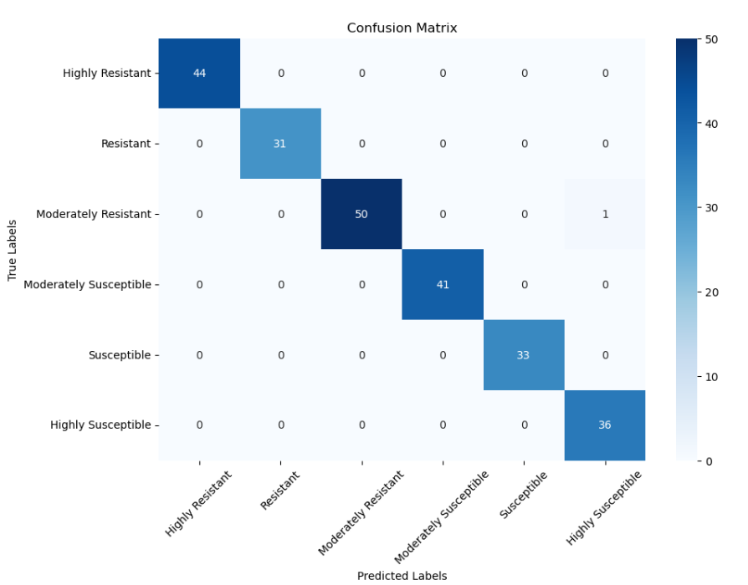
Figure 4.34: Confusion Matrix of EfficientNetB3(Thermal)
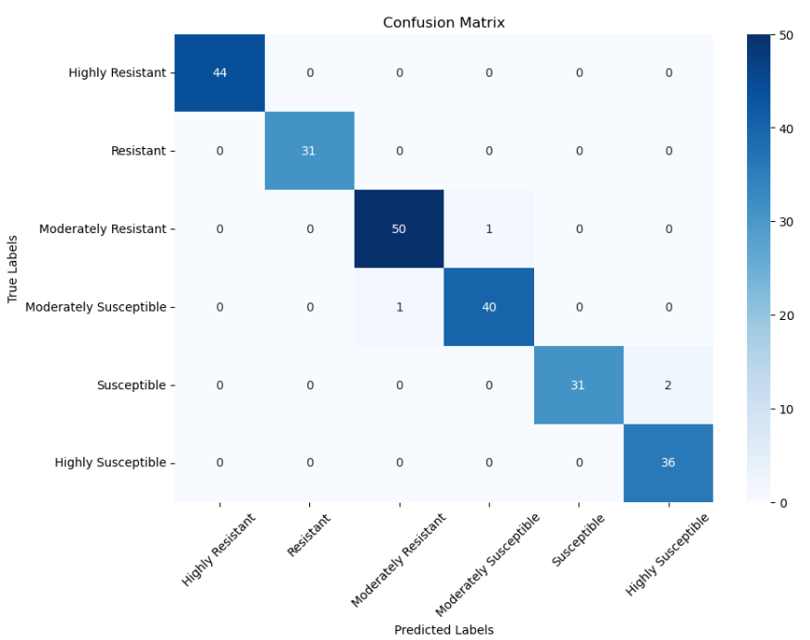
Figure 4.35: Confusion Matrix of MobileNetV2(Thermal)

Comparing the two confusion matrices, while both thermal models were able to correctly and consistently classify all the severity levels, EfficientNet performed slightly better compared to MobileNet. The notable improvements are in the classifications of the Moderately Susceptible class, EfficientNet predicting 41 versus the 40 by MobileNet, as well as in the classifications of the Susceptible class, with EfficientNet predicting 33 and MobileNet predicted 31, while the rest of the classes: Highly resistant, Resistant, Moderately Resistant and Highly Susceptible remained the same. These differences in results, while subtle, show a refinement in the model’s ability to distinguish between the small differences in the Moderate range that were previously misclassified as Highly Susceptible by MobileNet.

RGB IMAGES:
EfficientNetB3
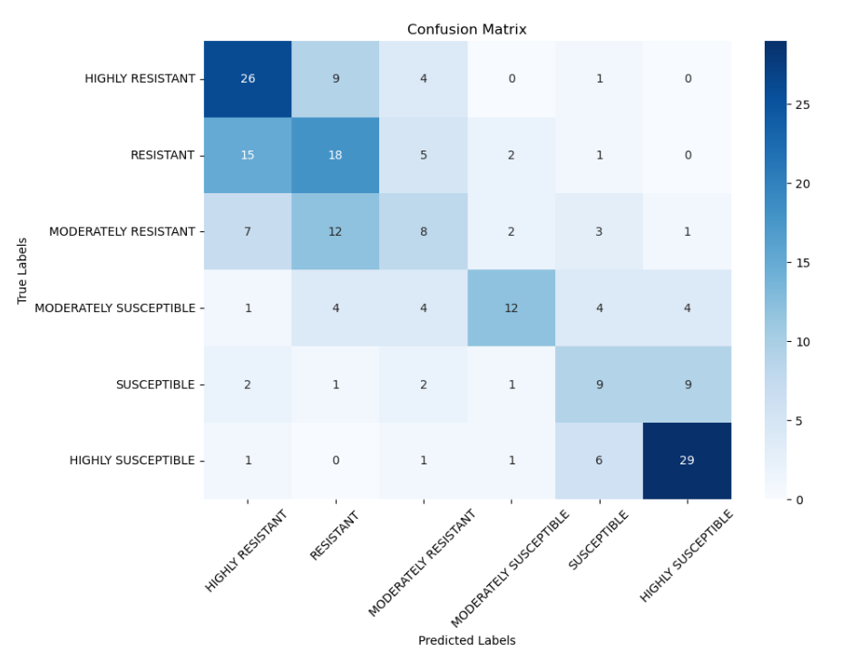
Figure 4.36: Confusion Matrix of EfficientNetB3 (RGB)

MobileNetV2
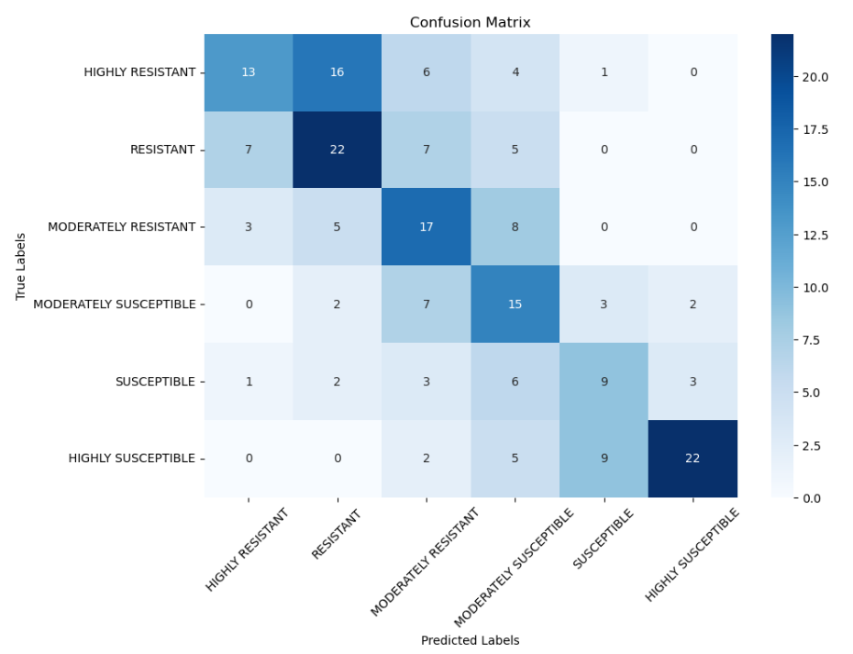
Figure 4.37: Confusion Matrix of MobileNetV2 (RGB)

In the confusion Matrices of the RGB models, while both models are able to classify the severity levels with reasonable accuracy, EfficientNet performed better than MobileNet in several classes: correctly identifying 15 instances compared to 12 in the Moderately Susceptible Class and a significant improvement in the Moderately Resistant class, with EfficientNet identifying 17 compared to the 8 by MobileNet; Additionally, the improvements came with the slightly reduced accuracy of the Highly resistant and Highly susceptible classes but the overall class distribution became more balanced. EfficientNet also achieved a higher validation accuracy than MobileNet, indicating that it has better generalization. These results, which show improvements in performance when classifying the moderate class range indicate that the model is able to identify more subtle changes between similar classes.
The confusion matrix of validation data presented in the figures shows the performance of the CNN architecture models generated by the system. This evaluative tool offers a detailed view of classification accuracy by presenting the number of true positives, true negatives, false positives, and false negatives.

Performance Metrics:
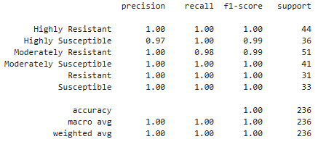
Figure 4.38: System Calculation Performance Metrics for EfficientNetB3(Thermal)

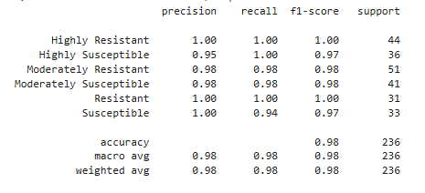
Figure 4.39: System Calculation Performance Metrics for MobileNetV2(Thermal)

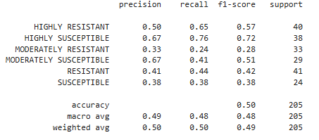
Figure 4.40: System Calculation Performance Metrics for EfficientNetB3(RGB)
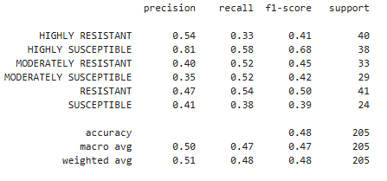
Figure 4.41: System Calculation Performance Metrics for MobileNetV2(RGB)

In evaluating model performance: accuracy, precision, recall, and F1-score were used since they were core classification metrics. Precision, recall, and F1-score in particular, highlighted the specific strengths and weaknesses of each model, allowing for better understanding when comparing how each convolutional neural network architecture performed across the different classes. This is important in multi-class classification where the differences in classes are more nuanced and especially considering that a misclassification in plant disease can cause problems in crop management strategies.

4.4 Comparative Analysis with Existing Approaches

Currently, no known benchmarks exist for RGB-based classification of downy mildew in corn, making direct comparisons difficult. The results of our experiments show that RGB data performed poorly and had limited capability to classify certain classes.
For thermal, however, our model slightly outperformed a similarly trained model, In the study by Barrios et al., their best performing model was also EfficientNet at 98.85% validation accuracy. In this study, the EfficientNet thermal model performed better by achieving 99.57% validation accuracy, indicating marginally better generalizability. These results may show that thermal imagery is more reliable for early detection of downy mildew in corn.

4.5 Challenges and Limitations

4.5.1:Dataset Issues
Starting with the first limitation, the dataset class imbalance posed a significant problem, in which there are classes that are underrepresented in the RGB dataset, particularly the Moderately Susceptible and Moderately Resistant classes. While the human experts are able to distinguish the subtle differences, the images were too similar or identical for the model to find any robust features despite the generally good image quality, which is required for effective model training.
Class weights were applied in an attempt to counteract the imbalance issue, as it helped reduce the bias towards certain classes, however, it could not fully compensate for the lack of diverse data found in the underrepresented classes. Additionally, there were also additional factors that were not in our control such as different lighting conditions and inconsistent leaf orientation, which further affected the RGB model performance.
Attempts to control the lighting were made by using an umbrella during data gathering, however, the leaf images still contained reflections, introducing additional variability for our model to consider, further affecting the RGB model performance. While the leaf orientation was uncontrollable due to the requirement of having the inner leaves be in the data, background noise control was mostly successfully addressed by isolating the corn leaves and removing the background, helping improve the RGB model’s performance by improving input quality and focus on relevant features.

4.5.2: Generalization and Model Performance
The second main limitation was in generalization, with a clear difference in performance between the RGB and thermal models. The thermal model performed well, able to classify all the classes consistently and accurately, it also performed better than similar models trained in a related study. In comparison, the RGB model performed poorly, most likely due to the difference in dataset quality, with the RGB images appearing identical or similar, making it difficult to differentiate between certain classes. For example: Highly Resistant and Resistant, or Moderately Susceptible and Moderately Resistant, both examples have subtle differences that are difficult to discern.
Notably, both RGB and Thermal models showed no significant sign of overfitting or underfitting; Indicating that the pre-processing pipeline, which included normalization, augmentation and other techniques were effective.

4.6 Android Studio for Mobile Application Development

The development of the mobile application was done with Android Studio as the IDE, which has provided all the tools for smooth and efficient application design, testing, and deployment. The application is aimed at the classification of Philippine Downy Mildew in corn and has certain features like image capturing, selection, and analysis that help the user in the identification.

The IDE has built-in capabilities for designing the graphical user interface (GUI), thereby allowing the researchers to design a simple and intuitive application. The application includes buttons that allow the capture and selection of RGB and thermal images, thereby allowing users to upload images easily for identification. Android Studio allows and supports TensorFlow model integration, therefore allowing the researchers to seamlessly integrate the trained models within the application. Such integrations ensure that image classification can be done offline in any location where connectivity is limited or absent. To improve on model accuracy, preprocessing steps such as image resizing and normalization were implemented into the mobile application. The application automatically performs preprocessing on any image uploaded or taken by the users, making sure that the image conforms to the model requirements, which simplifies the classification procedure while ensuring credible classification results.

The debugging tools and emulators within Android Studio were also utilized by the researchers for application testing and refinement. This guarantees that the application is well-executed on mobile devices capable of running the deep learning model. Due to the flexibility of Android Studio, the researchers were able to combine all the system components efficiently, making it possible to deploy the application successfully.
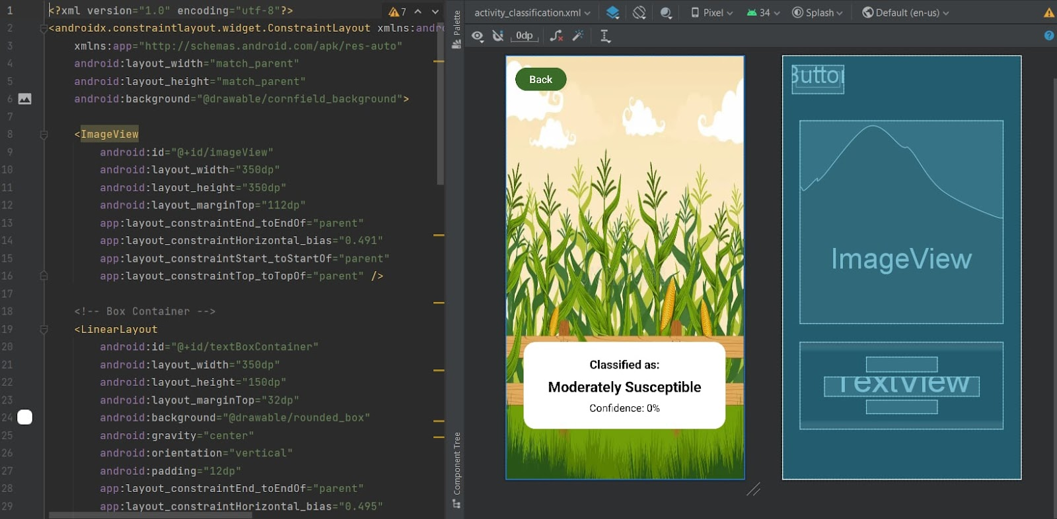
Figure 4.42: Android Studio Application Development

4.6.1 Mobile Application GUI
The graphical user interface (GUI) of the mobile application was initially designed through Canva, where a freely available online background image was utilized. The background image was used across all pages to have a unified and pleasing design. The layout was then applied in Android Studio, making the application intuitive and user-friendly for the users.
The Home Page (Figure 4.43) displays the application's title, "MildewScan," along with five main buttons: "Phone Camera" for capturing images using the device’s camera, "Thermal Gallery" for selecting thermal images, "Browse Gallery" for accessing the full photo library, “Classification” to see information about the classifications used by the model, and "Information" to navigate to the Information Page. After an image is selected, the Classifying Page (Figure 4.44) processes the image uploaded, shows the classification result, and reflects the prediction confidence level.
The Classifications Page (Figure 4.45) shows information about the different classifications for Downy Mildew, alongside the descriptions of each. The Information Page (Figure 4.46) shows information about the application, how to use it, and a brief description of the developers.

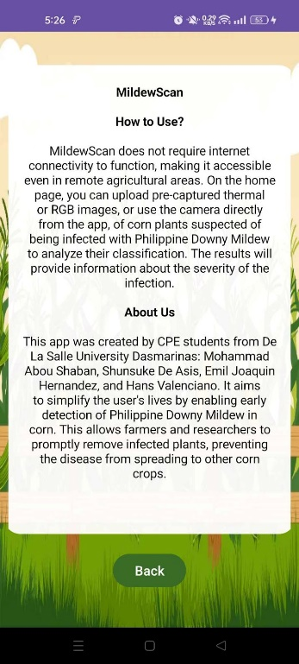
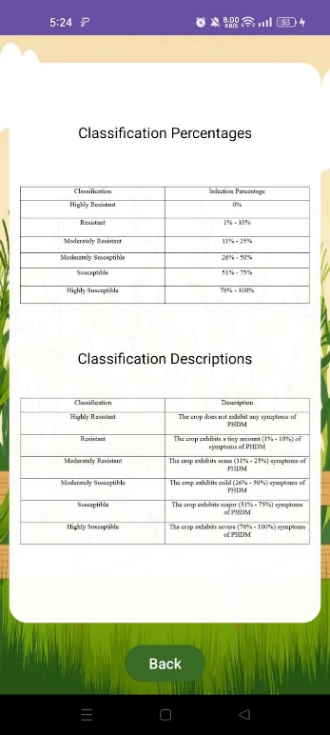
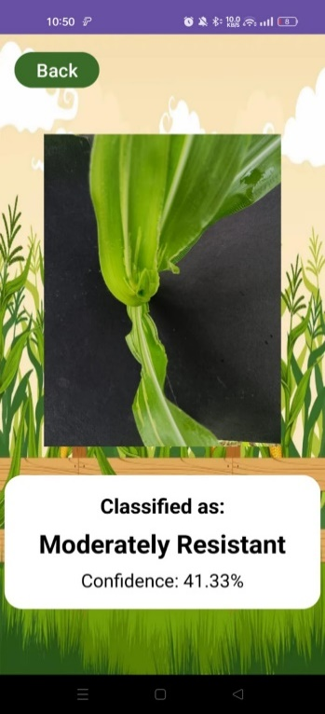
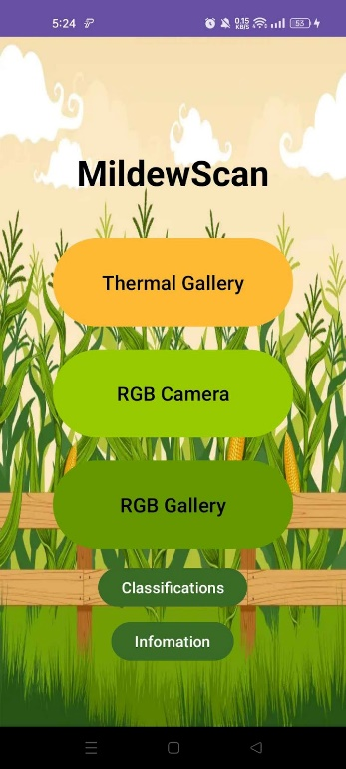
Figure 4.46: Information Page
Figure 4.45: Classification Information Page
Figure 4.44: Classification Page
Figure 4.43: Home Page

4.7 Validation of Findings
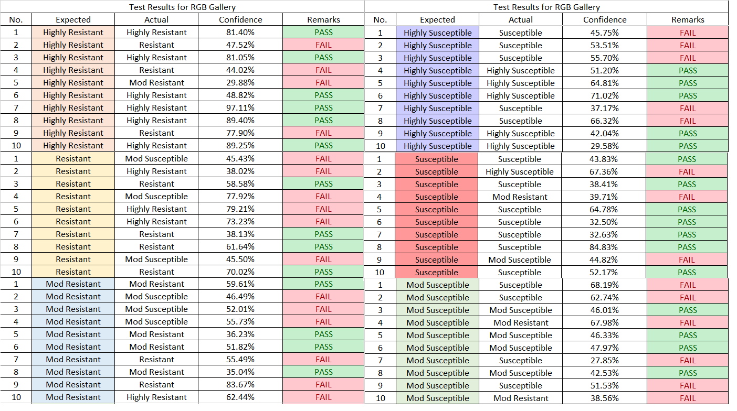
Figure 4.47: EfficientNet RGB Results
For the RGB photos, a total number of 60 trials were carried out, with 10 trials for each classification. Among these, 10 were predicted to be Highly Resistant, 9 were classified as Resistant, 8 as Moderately Resistant, 11 as Moderately Susceptible, 16 as Susceptible, and 6 as Highly Susceptible.
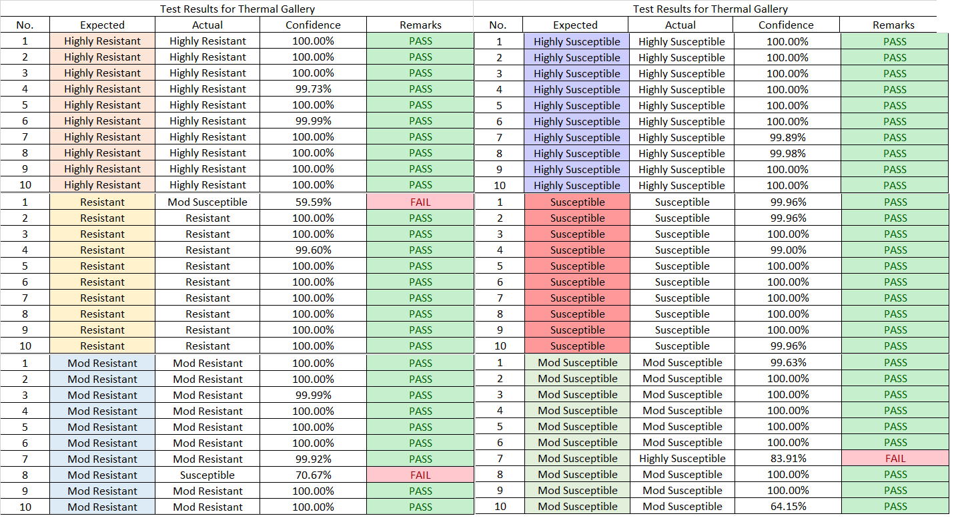
Figure 4.48: EfficientNet Thermal Results

For the Thermal photos, similar trials are conducted, with 10 photos for each class. Among these, 10 were predicted to be Highly Resistant, 9 were classified as Resistant, 9 as Moderately Resistant, 10 as Moderately Susceptible, 11 as Susceptible, and 11 as Highly Susceptible.
Model | Total number of samples | Number of correct predictions | Accuracy
RGB | 20 | 9 | 45%
Thermal | 20 | 16 | 80%
Table 4.6: Field testing results of preprocessed RGB and thermal with rainbow filter

The RGB model shows moderate success at classifying Downy Mildew severity in corn plants, with exact matches between predicted and expected categories in approximately 40% of cases. In instances where the actual classification did not match with the expected classification, the mistakes were limited to adjacent classifications within the range of the six categories. This implies that the model can reasonably differentiate between major changes of the severity of Downy Mildew. The model’s confidence scores vary from about 30% to 95%, with correct predictions typically associated with higher confidence values. In contrast, incorrect predictions were generally made with lower confidence and were usually only one or two categories away from the correct classification. The result implies that even when incorrect, the model produces results relatively close to their targeted classification as opposed to overly high-confidence error classifications.
The Thermal model worked very well, correctly classifying 16 out of 20 trials. Most correct classifications were at high confidence, usually over 90%. This suggests that the model is accurate in its prediction of Downy Mildew using thermal photographs.

The experimental results were evaluated and validated by experts from the University of the Philippines Los Baños, Institute of Plant Breeding as signed below:



4.8 Summary of Findings

When the Philippine Downy Mildew affects a corn plant, it leads to changes in the plant’s internal temperature. These temperature changes can’t be seen just by looking directly at the plant, but they can be detected through infrared or thermal imaging. With the right imaging methods, these differences can be analyzed using machine learning to help spot early signs of infection. Because thermal images reveal even small temperature differences linked to the disease, they’ve proven useful for early detection.
On the other hand, RGB images didn’t do as well when it came to classifying the severity of the disease. The visible signs in RGB photos were often too light or unclear, making it hard to tell the difference between some severity levels. For example, leaves classified as highly resistant and resistant, or moderately resistant and moderately susceptible, can appear almost identical in RGB format. Even with human observation, it is difficult to tell apart certain categories such as susceptible versus highly susceptible because the differences are quite minimal. Although RGB imaging can help flag severely affected plants, it struggles to differentiate between classes that are close in severity.
Thermal imaging, on the other hand, offers clearer distinctions between these closely related categories. Differences such as 25% severity (moderately resistant) versus 26% (moderately susceptible) can be more accurately identified because thermal images reflect internal physiological changes through measurable temperature variations.

In general, the results show that thermal imaging is more effective than regular RGB methods when it comes to detecting and classifying Philippine Downy Mildew in corn. By combining thermal data with machine learning, the system becomes more accurate and can provide faster results, which is especially useful in actual field situations. Turning this system into a mobile app makes it more accessible and convenient for farmers, helping them protect their crops early, minimize losses, and stop the disease from spreading further.

CHAPTER 5

CONCLUSION
This study compares the efficacy of thermal and RGB imaging in identifying Philippine Downy Mildew in corn. The main idea of the conceptual framework is to use a thermal imaging device in addition to a typical mobile phone camera. To divide the severity of a Downy mildew infection into six groups; highly resistant, resistant, moderately resistant, moderately susceptible, susceptible, and highly susceptible. The following conclusions are drawn based on the data and findings presented in Chapter 4:
- A total of 2,208 raw images of corn—1,076 RGB and 1,132 thermal—were gathered from the University of the Philippines Los Baños, Institute of Plant Breeding (UPLB-IPB). Although the goal was to maintain balanced representation across all severity classes, some variation in the number of images per class was unavoidable due to the availability of real-world samples. Despite this, the dataset was sufficient for training two separate convolutional neural network models: one for RGB and one for thermal images. To enhance performance and ensure the models could generalize well, techniques such as batch normalization, dropout, and hyperparameter tuning were used during training.

- Different preprocessing techniques were applied to the RGB images to enhance the visibility of Downy Mildew symptoms, including CLAHE (Contrast Limited Adaptive Histogram Equalization) and manipulation of the RGB channels. The raw, unprocessed images struggled to differentiate between the moderately resistant, moderately susceptible, and susceptible classes. While the combination of isolation and CLAHE preprocessing improved the model’s ability to classify these middle classes more accurately, the overall performance was still not satisfactory.
- There was a clear difference in performance between the preprocessed RGB and thermal models. The thermal model significantly outperformed the RGB model, achieving 99.57% accuracy in validation and 80% in field testing. In comparison, the RGB model's validation accuracy is at 50% and field testing accuracy is at 45%. The thermal model outperformed the RGB model in differentiating severity classifications, as shown by metrics like precision, recall, and F1-score. Without preprocessing, the RGB model struggled with moderately susceptible, moderately resistant and susceptible images, but preprocessing significantly improved its performance.
- Successfully deployed the preprocessed RGB model and the Thermal model using TensorFlow lite into an offline mobile application, making it available to use in the field without any internet access.
Model | Accuracy | F1 HR | F1 R | F1 MR | F1 MS | F1 S | F1 HS | F1 Macro
Raw | 38% | 57% | 44% | 0% | 12% | 21% | 55% | 31%
Isolated | 47% | 52% | 46% | 36% | 37% | 27% | 67% | 44%
Iso + CLAHE 1.0 | 50% | 57% | 42% | 28% | 51% | 38% | 72% | 48%
Iso + R/G amplification | 40% | 50% | 38% | 28% | 33% | 19% | 59% | 38%
Table 5.1: Comparison of the top 3 preprocessing techniques with Raw.

Model | Total number of samples | Number of correct predictions | Accuracy
RGB | 20 | 9 | 45%
Thermal | 20 | 16 | 80%
Table 5.2: Field testing results of preprocessed RGB and thermal with rainbow filter

RECOMMENDATION
This study explored the use of thermal and RGB images with convolutional neural networks (CNNs) for an offline agricultural mobile application. While thermal images demonstrated near-perfect accuracy, RGB images struggled with performance, making them less effective for accurately identifying the severity of Philippine Downy Mildew in corn. Based on these findings, the following suggestions are provided to improve the system and assist future researchers:
To make the system better and help future researchers, these suggestions are given:

- Use Thermal Images instead of RGB images - Future studies are encouraged to focus more on thermal imaging when identifying the severity of Philippine Downy Mildew in corn, as it demonstrated significantly higher accuracy compared to RGB imaging. Researchers should also explore optimizing thermal imaging setups for easier deployment in the field. However, if RGB imaging is still to be utilized, it is important to note that its accuracy remains limited to approximately 50%. To enhance image quality and improve classification results, it is recommended to apply CLAHE (Contrast Limited Adaptive Histogram Equalization) as a preprocessing technique, using a clip limit of 1.0. Among the different preprocessing tested, this configuration yielded the most effective enhancement for RGB data.
- Add Real-Time Detection with Computer Vision – Adding real-time detection can help find parts of the plant that are more likely to be infected, making it easier to check plants quickly while in the field.

- Use RGB Imaging as a Low-Cost Alternative - Although the RGB model only achieved up to 50% accuracy, it may still be used as a reference tool when thermal cameras are unavailable or too expensive for the plant pathology experts. As stated in Chapters 4 and 5, while RGB models perform significantly worse than thermal models, they can offer a basic level of disease identification, especially in more severe cases. Future versions of the system could offer RGB-based classification as an optional fallback for accessibility and affordability.
- It is recommended to replace the use of two illustration boards with a black cone structure, similar to a veterinary recovery cone, for RGB corn image collection. This approach provides a more convenient and consistent setup, reducing background noise while simplifying the process of capturing images.

Bibliography

Biñas Jr, E. E. (2021). The Use of Organic and Inorganic fertilizers and its Effect on the Quality of Corn Products in the Philippines: A Review. Galaxy International Interdisciplinary Research Journal, 9(05), 83-100.

Sukto, S., Lomthaisong, K., Sanitchon, J., Chankaew, S., Falab, S., Lübberstedt, T., ... & Suriharn, K. (2021). Breeding for prolificacy, total carotenoids and resistance to downy mildew in small-ear waxy corn by modified mass selection. Agronomy, 11(9), 1793.

Simon-Ada, E. V. M., Mendoza, J. V. S., Fernandez, E. C. J., Nuñez, J. P. P., Cueva, F. M. D., Manohar, A. N. C., ... & Lantican, D. V. (2024). Resistance Response of Yellow Maize Inbreds and F1 crosses against Philippine Downy Mildew [Peronosclerospora philippinensis (Weston) CG Shaw]. Crop Protection, 106703.

Kundu, N., Rani, G., Dhaka, V. S., Gupta, K., Nayak, S. C., Vocaturo, E., & Zumpano, E. (2022). Disease detection, severity prediction, and crop loss estimation in MaizeCrop using deep learning. Artificial Intelligence in Agriculture, 6, 276–291.

Saleem, M. H., Potgieter, J., & Arif, K. M. (2021b). Automation in agriculture by machine and Deep Learning Techniques: A review of Recent developments. Precision Agriculture, 22(6), 2053–2091.

Barrios, S. Z., Fortaliza, J. J., & Silva, E. (2024). Offline mobile application using infrared thermography and deep learning for detection and severity classification of philippine downy mildew in corn.

Batchuluun, G., Nam, S. H., & Park, K. R. (2022). Deep learning-based plant classification using nonaligned thermal and visible light images. Mathematics, 10(21), 4053.

Omara, J., Talavera, E., Otim, D., Turcza, D., Ofumbi, E., & Owomugisha, G. (2023). A field-based recommender system for crop disease detection using machine learning. Frontiers in Artificial Intelligence, 6, 1010804.

Galeon, D. H., Garcia Jr, P. G., & Palaoag, T. D. (2019). SMS-based ICT tool for knowledge sharing in agriculture. International Journal on Advanced Science, Engineering and Information Technology, 9(1), 342-349.

Hassan, S. M., Jasinski, M., Leonowicz, Z., Jasinska, E., & Maji, A. K. (2021). Plant Disease Identification Using Shallow Convolutional Neural Network. Agronomy, 11(12), 2388. https://doi.org/10.3390/agronomy11122388

Bharman, P., Saad, S. A., Khan, S., Jahan, I., Ray, M., & Biswas, M. (2022). Deep Learning in Agriculture: A Review. *Asian Journal of Research in Computer Science*, 13(2), 28-47. https://doi.org/10.9734/AJRCOS/2022/v13i230311

Vallabhajosyula, S., Sistla, V., & Kolli, V. K. K. (2021). Transfer learning-based deep ensemble neural network for plant leaf disease detection. *Journal of Plant Diseases and Protection*. Advance online publication. https://doi.org/10.1007/s41348-021-00465-8

Francisco, M., Ribeiro, F., Metrôlho, J., & Dionísio, R. (2023). Algorithms and Models for Automatic Detection and Classification of Diseases and Pests in Agricultural Crops: A Systematic Review. *Applied Sciences, 13*(8), 4720. https://doi.org/10.3390/app13084720

Pham, T. N., Tran, L. V., & Dao, S. V. T. (2020). Early Disease Classification of Mango Leaves Using Feed-Forward Neural Network and Hybrid Metaheuristic Feature Selection. IEEE Access, 8, 174975-174985. https://doi.org/10.1109/ACCESS.2020.3031914

Purwanti, E. W., Wahyudi, D., & Hamyana. (2023). Application of Trichoderma sp. and PGPR for preventing downy mildew incidence on sweet corn. Indonesian Journal of Agronomy, 51(1), 101-110.

Salcedo, A.F., Purayannur, S., Standish, J.R., Miles, T., Thiessen, L., & Quesada-Ocampo, L.M. (2021). Fantastic Downy Mildew Pathogens and How to Find Them: Advances in Detection and Diagnostics. *Plants, 10*(3), 435. https://doi.org/10.3390/plants10030435

Khakimov, A., et al. (2022). Traditional and current-prospective methods of agricultural plant diseases detection: A review. *IOP Conference Series: Earth and Environmental Science, 951*, 012002.

Singh, V., Sharma, N., & Singh, S. (2020). A review of imaging techniques for plant disease detection. In Artificial Intelligence in Agriculture (Vol. 4, pp. 229–242). KeAi Communications Co. https://doi.org/10.1016/j.aiia.2020.10.002

Vishnoi, V. K., Kumar, K., & Kumar, B. (2021). Plant disease detection using computational intelligence and image processing. In Journal of Plant Diseases and Protection (Vol. 128, Issue 1, pp. 19–53). Springer Science and Business Media Deutschland GmbH. https://doi.org/10.1007/s41348-020-00368-0

Hashim, I. C., Shariff, A. R. M., Bejo, S. K., Muharam, F. M., Ahmad, K., & Hashim, H. (2020). Application of thermal imaging for plant disease detection. IOP Conference Series: Earth and Environmental Science, 540(1). https://doi.org/10.1088/1755-1315/540/1/012052

Adesokan, M., Alamu, E. O., Otegbayo, B., & Maziya-Dixon, B. (2023). A Review of the Use of Near-Infrared Hyperspectral Imaging (NIR-HSI) Techniques for the Non-Destructive Quality Assessment of Root and Tuber Crops. Applied Sciences, 13(9), 5226. https://doi.org/10.3390/app13095226

Lu, B., Dao, P., Liu, J., He, Y., & Shang, J. (2020). Recent Advances of Hyperspectral Imaging Technology and Applications in Agriculture. Remote Sensing, 12(16), 2659. https://doi.org/10.3390/rs12162659

Anasta, N., Setyawan, F. X. A., & Fitriawan, H. (2021). Disease detection in banana trees using an image processing-based thermal camera. IOP Conference Series: Earth and Environmental Science, 739(1). https://doi.org/10.1088/1755-1315/739/1/012088

Yang, N., Yuan, M., Wang, P., Zhang, R., Sun, J., & Mao, H. (2019). Tea diseases detection based on fast infrared thermal image processing technology. Journal of the Science of Food and Agriculture, 99(7), 3459–3466. https://doi.org/10.1002/jsfa.9564

Sharifani, K., & Amini, M. (2023). Machine Learning and Deep Learning: A Review of Methods and Applications. Social Science Research Network. https://papers.ssrn.com/sol3/papers.cfm?abstract_id=4458723

Mahomodally, A. F. H., Suddul, G., & Armoogum, S. (2023). Machine learning techniques for plant disease detection: an evaluation with a customized dataset. *International Journal of Informatics and Communication Technology (IJ-ICT), 12*(2), 127-139. DOI: 10.11591/ijict.v12i2.pp127-139

Zhou, Z., Majeed, Y., Diverres Naranjo, G., & Gambacorta, E. M. T. (2021). Assessment for crop water stress with infrared thermal imagery in precision agriculture: A review and future prospects for deep learning applications. Computers and Electronics in Agriculture, 182, 106019. https://doi.org/10.1016/j.compag.2021.106019

Messina, G., & Modica, G. (2020). Applications of UAV Thermal Imagery in Precision Agriculture: State of the Art and Future Research Outlook. Remote Sensing, 12(9), 1491. https://doi.org/10.3390/rs12091491

Djaenuddin, N., Syafruddin, S., Patandjengi, B., & Kuswinanti, T. (2020). Short Communication: Potential tests of plant growth bacteria for the control of Peronosclerospora philipinensis in corn. Biodiversitas Journal of Biological Diversity, 21(8). https://doi.org/10.13057/biodiv/d210859

Obaid, K. B., Zeebaree, S., & Ahmed, O. M. (2020). Deep learning models based on image classification: a review. International Journal of Science and Business, 4(11), 75-81.
Rashid, Z., Zaidi, P. H., Vinayan, M. T., Sharma, S. S., & Srirama Setty, T. A. (2012). Downy mildew resistance in maize (Zea mays L.) across Peronosclerospora species in lowland tropical Asia. Crop Protection, 43, 183-191. https://doi.org/10.1016/j.cropro.2012.08.007
Pascual, E. J. A. V., Plaza, J. M. J., Tesorero, J. L. L., & De Goma, J. C. (2019). Disease Detection of Asian Rice (Oryza Sativa) in the Philippines Using Image Processing. Proceedings of the 2nd International Conference on Computing and Big Data - ICCBD 2019. https://doi.org/10.1145/3366650.3366676

John, C., Valdoria., Arlene, R., Caballeo., Brian, Irvin, D., Fernandez., John, Marco, M., Condino. (2019). iDahon: An Android Based Terrestrial Plant Disease Detection Mobile Application Through Digital Image Processing Using Deep Learning Neural Network Algorithm. doi: 10.1109/INCIT.2019.8912053

Appendices

Appendix A
Budget Plan:

ITEM | UNIT COST | QUANTITY | TOTAL COST
HONORIARIA AND PROFESSIONAL FEES
Proposal Defense Thesis Fee | 2,500 | 1 | 2,500
Final Defense Thesis Fee | 3,000 | 1 | 3,000
UPLB Expert Consultation and Assessment | 0 | 10 | 0
EQUIPMENT
Thesis Printing Fee | 2,500 | 1 | 2,500
Thesis Binding Fee | 800 | 1 | 800
SUPPLIES
FLIR One Pro Thermal Camera | 21,000 | 1 | 21,000
½ Illustration Board | 25 | 6 | 150
MISCELLANEOUS
Transportation | 900 | 10 | 9,000
Meals | 750 | 10 | 7,500
Total Cost: 46,450 ;

Appendix B
Source Code

MainActivity.java

package com.example.rgbthermalapp;
import android.Manifest;
import android.content.Intent;
import android.content.pm.PackageManager;
import android.graphics.Bitmap;
import android.net.Uri;
import android.os.Bundle;
import android.provider.MediaStore;
import android.util.Log;
import android.widget.Button;
import androidx.annotation.Nullable;
import androidx.appcompat.app.AppCompatActivity;
import androidx.core.content.ContextCompat;
import com.example.rgbthermalapp.ml.Rgbmodel;
import com.example.rgbthermalapp.ml.Thermalmodel;
import org.opencv.android.OpenCVLoader;
import org.opencv.android.Utils;
import org.opencv.core.CLAHE;
import org.opencv.core.Core;
import org.opencv.core.Mat;
import org.opencv.core.MatOfInt;
import org.opencv.core.Size;
import org.opencv.imgproc.Imgproc;
import org.tensorflow.lite.DataType;
import org.tensorflow.lite.support.tensorbuffer.TensorBuffer;
import java.io.IOException;
import java.nio.ByteBuffer;
import java.nio.ByteOrder;
import java.util.ArrayList;
import java.util.List;
import java.util.Objects;
public class MainActivity extends AppCompatActivity {
Button RGBCam, RGBGal, ThermalGal;
int RGBImageSize = 300, ThermalImageSize = 300;
static {
if (!OpenCVLoader.initDebug()) {
Log.d("OpenCV", "OpenCV not loaded");
} else {
Log.d("OpenCV", "OpenCV loaded successfully");
}
}
@Override
protected void onCreate(Bundle savedInstanceState) {
super.onCreate(savedInstanceState);
setContentView(R.layout.activity_main);
RGBCam = findViewById(R.id.phoneCameraButton);
RGBGal = findViewById(R.id.browseGalleryButton);
ThermalGal = findViewById(R.id.thermalGalleryButton);
RGBCam.setOnClickListener(v -> {
if (ContextCompat.checkSelfPermission(this, Manifest.permission.CAMERA) == PackageManager.PERMISSION_GRANTED) {
Intent camIntent = new Intent(MediaStore.ACTION_IMAGE_CAPTURE);
startActivityForResult(camIntent, 3);
} else {
requestPermissions(new String[]{Manifest.permission.CAMERA}, 100);
}
});
RGBGal.setOnClickListener(v -> {
Intent RGBGalIntent = new Intent(Intent.ACTION_PICK, MediaStore.Images.Media.EXTERNAL_CONTENT_URI);
startActivityForResult(RGBGalIntent, 4);
});
ThermalGal.setOnClickListener(v -> {
Intent ThermalGalIntent = new Intent(Intent.ACTION_PICK, MediaStore.Images.Media.EXTERNAL_CONTENT_URI);
startActivityForResult(ThermalGalIntent, 5);
});
Button classInfoButton = findViewById(R.id.classificationButton);
classInfoButton.setOnClickListener(v -> {
Intent intent = new Intent(MainActivity.this, ClassInfoActivity.class);
startActivity(intent);
});
Button aboutButton = findViewById(R.id.aboutButton);
aboutButton.setOnClickListener(v -> {
Intent intent = new Intent(MainActivity.this, AboutActivity.class);
startActivity(intent);
});
}
@Override
protected void onActivityResult(int requestCode, int resultCode, @Nullable Intent data) {
super.onActivityResult(requestCode, resultCode, data);
if (resultCode == RESULT_OK && data != null) {
Bitmap originalImage;
if (requestCode == 3) {
originalImage = (Bitmap) Objects.requireNonNull(data.getExtras()).get("data");
processImage(originalImage, RGBImageSize, "rgb");
} else if (requestCode == 4 || requestCode == 5) {
Uri dat = data.getData();
try {
originalImage = MediaStore.Images.Media.getBitmap(this.getContentResolver(), dat);
processImage(originalImage, requestCode == 4 ? RGBImageSize : ThermalImageSize, requestCode == 4 ? "rgb" : "thermal");
} catch (IOException e) {
e.printStackTrace();
}
}
}
}
private void processImage(Bitmap originalImage, int size, String type) {
if (originalImage != null) {
Bitmap enhancedImage = applyCLAHE(originalImage);
Bitmap resizedImage = Bitmap.createScaledBitmap(enhancedImage, size, size, false);
try {
if (type.equals("rgb")) {
classifyImage(originalImage, resizedImage, size, Rgbmodel.newInstance(this));
} else {
classifyImage(originalImage, resizedImage, size, Thermalmodel.newInstance(this));
}
} catch (IOException e) {
e.printStackTrace();
}
}
}
private Bitmap applyCLAHE(Bitmap bitmap) {
Mat src = new Mat();
Utils.bitmapToMat(bitmap, src);
Imgproc.cvtColor(src, src, Imgproc.COLOR_RGBA2RGB);
Mat labImage = new Mat();
Imgproc.cvtColor(src, labImage, Imgproc.COLOR_RGB2Lab);
List<Mat> labChannels = new ArrayList<>();
Core.split(labImage, labChannels);
CLAHE clahe = Imgproc.createCLAHE();
clahe.setClipLimit(1.0);
Mat claheResult = new Mat();
clahe.apply(labChannels.get(0), claheResult);
labChannels.set(0, claheResult);
Core.merge(labChannels, labImage);
Mat resultRGB = new Mat();
Imgproc.cvtColor(labImage, resultRGB, Imgproc.COLOR_Lab2RGB);
Bitmap resultBitmap = Bitmap.createBitmap(resultRGB.cols(), resultRGB.rows(), Bitmap.Config.ARGB_8888);
Utils.matToBitmap(resultRGB, resultBitmap);
return resultBitmap;
}
private void classifyImage(Bitmap originalImage, Bitmap processedImage, int size, Object modelInstance) {
TensorBuffer inputBuffer = TensorBuffer.createFixedSize(new int[]{1, size, size, 3}, DataType.FLOAT32);
ByteBuffer byteBuffer = ByteBuffer.allocateDirect(4 * size * size * 3);
byteBuffer.order(ByteOrder.nativeOrder());
int[] intValues = new int[size * size];
processedImage.getPixels(intValues, 0, processedImage.getWidth(), 0, 0, processedImage.getWidth(), processedImage.getHeight());
int pixel = 0;
for (int i = 0; i < size; i++) {
for (int j = 0; j < size; j++) {
int val = intValues[pixel++];
byteBuffer.putFloat((val >> 16) & 0xFF); // R
byteBuffer.putFloat((val >> 8) & 0xFF); // G
byteBuffer.putFloat(val & 0xFF); // B
}
}
inputBuffer.loadBuffer(byteBuffer);
String result;
String confidenceValue;
if (modelInstance instanceof Rgbmodel) {
TensorBuffer outputBuffer = ((Rgbmodel) modelInstance).process(inputBuffer).getOutputFeature0AsTensorBuffer();
float[] confidences = outputBuffer.getFloatArray();
result = getClassLabel(confidences);
confidenceValue = String.format("%.2f", confidences[getMaxIndex(confidences)] * 100) + "%";
((Rgbmodel) modelInstance).close();
} else {
TensorBuffer outputBuffer = ((Thermalmodel) modelInstance).process(inputBuffer).getOutputFeature0AsTensorBuffer();
float[] confidences = outputBuffer.getFloatArray();
result = getClassLabel(confidences);
confidenceValue = String.format("%.2f", confidences[getMaxIndex(confidences)] * 100) + "%";
((Thermalmodel) modelInstance).close();
}
ImageStorage.setImage(originalImage);
Intent intent = new Intent(MainActivity.this, ClassificationActivity.class);
intent.putExtra("result", result);
intent.putExtra("confidence", confidenceValue);
startActivity(intent);
}
private String getClassLabel(float[] confidences) {
String[] labels = {"Highly Resistant", "Highly Susceptible", "Moderately Resistant", "Moderately Susceptible", "Resistant", "Susceptible"};
return labels[getMaxIndex(confidences)];
}
private int getMaxIndex(float[] confidences) {
int maxIndex = 0;
for (int i = 1; i < confidences.length; i++) {
if (confidences[i] > confidences[maxIndex]) {
maxIndex = i;
}
}
return maxIndex;
}
}

activity_main.xml

<?xml version="1.0" encoding="utf-8"?>
<androidx.constraintlayout.widget.ConstraintLayout
xmlns:android="http://schemas.android.com/apk/res/android"
xmlns:app="http://schemas.android.com/apk/res-auto"
xmlns:tools="http://schemas.android.com/tools"
android:layout_width="match_parent"
android:layout_height="match_parent"
android:background="@drawable/cornfield_background"
tools:context=".MainActivity" >
<!-- Title -->
<TextView
android:id="@+id/homePageTitle"
android:layout_width="wrap_content"
android:layout_height="wrap_content"
android:layout_marginTop="116dp"
android:text="MildewScan"
android:textColor="@android:color/black"
android:textSize="32sp"
android:textStyle="bold"
app:layout_constraintEnd_toEndOf="parent"
app:layout_constraintStart_toStartOf="parent"
app:layout_constraintTop_toTopOf="parent" />
<Button
android:id="@+id/thermalGalleryButton"
android:layout_width="250dp"
android:layout_height="100dp"
android:layout_marginTop="40dp"
android:backgroundTint="@android:color/holo_orange_light"
android:text="Thermal Gallery"
android:textSize="18sp"
android:textColor="@android:color/black"
android:drawablePadding="8dp"
android:gravity="center"
android:padding="16dp"
app:layout_constraintTop_toBottomOf="@id/homePageTitle"
app:layout_constraintStart_toStartOf="parent"
app:layout_constraintEnd_toEndOf="parent" />
<Button
android:id="@+id/phoneCameraButton"
android:layout_width="250dp"
android:layout_height="100dp"
android:layout_marginTop="16dp"
android:backgroundTint="@android:color/holo_green_light"
android:text="RGB Camera"
android:textSize="18sp"
android:textColor="@android:color/black"
android:drawablePadding="8dp"
android:gravity="center"
android:padding="16dp"
app:layout_constraintTop_toBottomOf="@id/thermalGalleryButton"
app:layout_constraintStart_toStartOf="parent"
app:layout_constraintEnd_toEndOf="parent" />
<!-- Browse Gallery Button -->
<Button
android:id="@+id/browseGalleryButton"
android:layout_width="250dp"
android:layout_height="100dp"
android:layout_marginTop="16dp"
android:backgroundTint="@android:color/holo_green_dark"
android:text="RGB Gallery"
android:textSize="18sp"
android:textColor="@android:color/black"
android:drawablePadding="8dp"
android:gravity="center"
android:padding="16dp"
app:layout_constraintTop_toBottomOf="@id/phoneCameraButton"
app:layout_constraintStart_toStartOf="parent"
app:layout_constraintEnd_toEndOf="parent" />
<!-- Classification Button -->
<Button
android:id="@+id/classificationButton"
android:layout_width="wrap_content"
android:layout_height="wrap_content"
android:layout_marginTop="12dp"
android:backgroundTint="@color/green"
android:gravity="center"
android:text="Classifications"
android:textColor="@android:color/white"
app:layout_constraintEnd_toEndOf="parent"
app:layout_constraintHorizontal_bias="0.498"
app:layout_constraintStart_toStartOf="parent"
app:layout_constraintTop_toBottomOf="@id/browseGalleryButton" />
<!-- About Button -->
<Button
android:id="@+id/aboutButton"
android:layout_width="wrap_content"
android:layout_height="wrap_content"
android:layout_marginTop="68dp"
android:backgroundTint="@color/green"
android:gravity="center"
android:text="Infomation"
android:textColor="@android:color/white"
app:layout_constraintEnd_toEndOf="parent"
app:layout_constraintHorizontal_bias="0.498"
app:layout_constraintStart_toStartOf="parent"
app:layout_constraintTop_toBottomOf="@id/browseGalleryButton" />
</androidx.constraintlayout.widget.ConstraintLayout>

AboutActivity.java

package com.example.rgbthermalapp;
import android.os.Bundle;
import android.text.SpannableString;
import android.widget.TextView;
import androidx.appcompat.app.AppCompatActivity;

public class AboutActivity extends AppCompatActivity {

@Override
protected void onCreate(Bundle savedInstanceState) {
super.onCreate(savedInstanceState);
setContentView(R.layout.activity_about);

TextView aboutText = findViewById(R.id.aboutTextView);

String aboutContent = "MildewScan\n\n" +
"How to Use?\n\n" +
"MildewScan does not require internet connectivity to function, making it accessible even in remote agricultural areas. On the home page, you can upload pre-captured thermal or RGB images, or use the camera directly from the app, of corn plants suspected of being infected with Philippine Downy Mildew to analyze their classification. The results will provide information about the severity of the infection." +
"\n\nAbout Us\n\n" +
"This app was created by CPE students from De La Salle University Dasmarinas: Mohammad Abou Shaban, Shunsuke De Asis, Emil Joaquin Hernandez, and Hans Valenciano. It aims to simplify the user's lives by enabling early detection of Philippine Downy Mildew in corn. This allows farmers and researchers to promptly remove infected plants, preventing the disease from spreading to other corn crops.";

SpannableString spannableString = new SpannableString(aboutContent);
spannableString.setSpan(new android.text.style.StyleSpan(android.graphics.Typeface.BOLD), 0, 10, 0); // "MildewScan"
spannableString.setSpan(new android.text.style.StyleSpan(android.graphics.Typeface.BOLD), 12, 25, 0); // "How to Use?"
spannableString.setSpan(new android.text.style.StyleSpan(android.graphics.Typeface.BOLD), 434, 444, 0); // "About Us"
aboutText.setText(spannableString);
aboutText.setTextSize(13);
aboutText.setGravity(android.view.Gravity.CENTER_HORIZONTAL);
}
public void onBackButtonClicked(android.view.View view) {
finish();
}
}

activity_about.xml

<LinearLayout xmlns:android="http://schemas.android.com/apk/res/android"
android:layout_width="match_parent"
android:layout_height="match_parent"
android:padding="10dp"
android:orientation="vertical"
android:background="@drawable/cornfield_background"
android:fitsSystemWindows="false"
android:gravity="center_horizontal">
<ScrollView
android:layout_width="351dp"
android:layout_height="565dp"
android:layout_marginTop="30dp"
android:alpha="0.95"
android:background="@drawable/rounded_box"
android:fillViewport="true">
<LinearLayout
android:layout_width="match_parent"
android:layout_height="wrap_content"
android:gravity="center_horizontal"
android:orientation="vertical"
android:padding="12dp">
<TextView
android:id="@+id/aboutTextView"
android:layout_width="match_parent"
android:layout_height="wrap_content"
android:gravity="start"
android:textColor="@android:color/black"
android:textSize="16sp"></TextView>
</LinearLayout>
</ScrollView>
<Button
android:layout_width="wrap_content"
android:layout_height="wrap_content"
android:text="Back"
android:backgroundTint="@color/green"
android:textColor="@color/white"
android:onClick="onBackButtonClicked"
android:layout_marginTop="20dp"/>
</LinearLayout>

ClassificationActivity.java

package com.example.rgbthermalapp;
import androidx.appcompat.app.AppCompatActivity;
import android.graphics.Bitmap;
import android.os.Bundle;
import android.widget.ImageView;
import android.widget.TextView;
public class ClassificationActivity extends AppCompatActivity {
ImageView imageView;
TextView resultTextView, confidenceTextView;
@Override
protected void onCreate(Bundle savedInstanceState) {
super.onCreate(savedInstanceState);
setContentView(R.layout.activity_classification);
imageView = findViewById(R.id.imageView);
resultTextView = findViewById(R.id.result);
confidenceTextView = findViewById(R.id.confidenceTextView);
String result = getIntent().getStringExtra("result");
String confidence = getIntent().getStringExtra("confidence");
Bitmap image = ImageStorage.getImage();
if (image != null) {
imageView.setImageBitmap(image);
}
resultTextView.setText(result);
confidenceTextView.setText("Confidence: " + confidence);
}
public void onBackButtonClicked(android.view.View view) {
finish();
}
}

activity_classification.xml
<?xml version="1.0" encoding="utf-8"?>
<androidx.constraintlayout.widget.ConstraintLayout xmlns:android="http://schemas.android.com/apk/res/android"
xmlns:app="http://schemas.android.com/apk/res-auto"
android:layout_width="match_parent"
android:layout_height="match_parent"
android:background="@drawable/cornfield_background">
<ImageView
android:id="@+id/imageView"
android:layout_width="350dp"
android:layout_height="350dp"
android:layout_marginTop="112dp"
app:layout_constraintEnd_toEndOf="parent"
app:layout_constraintHorizontal_bias="0.491"
app:layout_constraintStart_toStartOf="parent"
app:layout_constraintTop_toTopOf="parent" />
<!-- Box Container -->
<LinearLayout
android:id="@+id/textBoxContainer"
android:layout_width="350dp"
android:layout_height="150dp"
android:layout_marginTop="32dp"
android:background="@drawable/rounded_box"
android:gravity="center"
android:orientation="vertical"
android:padding="12dp"
app:layout_constraintEnd_toEndOf="parent"
app:layout_constraintHorizontal_bias="0.495"
app:layout_constraintStart_toStartOf="parent"
app:layout_constraintTop_toBottomOf="@+id/imageView">
<!-- Classified as Label -->
<TextView
android:id="@+id/classified"
android:layout_width="wrap_content"
android:layout_height="wrap_content"
android:gravity="center"
android:text="Classified as:"
android:textColor="@android:color/black"
android:textSize="20sp"
android:textStyle="bold" />
<!-- Classification Result -->
<TextView
android:id="@+id/result"
android:layout_width="wrap_content"
android:layout_height="wrap_content"
android:layout_marginTop="8dp"
android:gravity="center"
android:text="Moderately Susceptible"
android:textColor="@android:color/black"
android:textSize="25sp"
android:textStyle="bold" />
<!-- Confidence Value -->
<TextView
android:id="@+id/confidenceTextView"
android:layout_width="wrap_content"
android:layout_height="wrap_content"
android:layout_marginTop="8dp"
android:gravity="center"
android:text="Confidence: 0%"
android:textColor="@android:color/black"
android:textSize="18sp" />
</LinearLayout>
<Button
android:id="@+id/backButton"
android:layout_width="wrap_content"
android:layout_height="wrap_content"
android:text="Back"
android:textSize="18sp"
android:layout_marginTop="16dp"
android:layout_marginLeft="16dp"
android:backgroundTint="@color/green"
android:textColor="@color/white"
android:onClick="onBackButtonClicked"
app:layout_constraintTop_toTopOf="parent"
app:layout_constraintStart_toStartOf="parent" />
</androidx.constraintlayout.widget.ConstraintLayout>

ClassInfoActivity.java

package com.example.rgbthermalapp;
import android.os.Bundle;
import androidx.appcompat.app.AppCompatActivity;
public class ClassInfoActivity extends AppCompatActivity {
@Override
protected void onCreate(Bundle savedInstanceState) {
super.onCreate(savedInstanceState);
setContentView(R.layout.activity_class_info); // Link to your XML
}
public void onBackButtonClicked(android.view.View view) {
finish(); // Closes AboutActivity and returns to MainActivity
}
}
activity_class_info.xml
<?xml version="1.0" encoding="utf-8"?>
<LinearLayout xmlns:android="http://schemas.android.com/apk/res/android"
android:layout_width="match_parent"
android:layout_height="match_parent"
android:padding="10dp"
android:orientation="vertical"
android:background="@drawable/cornfield_background"
android:fitsSystemWindows="false"
android:gravity="center">
<!-- White Box Container -->
<LinearLayout
android:id="@+id/classificationContainer"
android:layout_width="match_parent"
android:layout_height="0dp"
android:layout_weight="0.9"
android:layout_marginTop="20dp"
android:layout_marginBottom="10dp"
android:alpha="0.98"
android:background="@drawable/rounded_box"
android:gravity="center"
android:orientation="vertical"
android:padding="12dp">
<!-- First Classification Text -->
<TextView
android:id="@+id/classificationResult1"
android:layout_width="wrap_content"
android:layout_height="wrap_content"
android:layout_marginBottom="12dp"
android:text="Classification Percentages"
android:textColor="@android:color/black"
android:textSize="14sp"
android:gravity="center" />
<!-- First Image -->
<ImageView
android:id="@+id/classificationImage1"
android:layout_width="match_parent"
android:layout_height="200dp"
android:adjustViewBounds="true"
android:contentDescription="Classification Percentages"
android:scaleType="fitCenter"
android:src="@drawable/class_percent"
android:layout_marginBottom="12dp" />
<!-- Second Classification Text -->
<TextView
android:id="@+id/classificationResult2"
android:layout_width="wrap_content"
android:layout_height="wrap_content"
android:layout_marginBottom="12dp"
android:text="Classification Descriptions"
android:textColor="@android:color/black"
android:textSize="14sp"
android:gravity="center" />
<!-- Second Image -->
<ImageView
android:id="@+id/classificationImage2"
android:layout_width="match_parent"
android:layout_height="200dp"
android:adjustViewBounds="true"
android:contentDescription="Classification Descriptions"
android:scaleType="fitCenter"
android:src="@drawable/class_desc" />
</LinearLayout>
<!-- Back Button -->
<Button
android:layout_width="wrap_content"
android:layout_height="wrap_content"
android:text="Back"
android:backgroundTint="@color/green"
android:textColor="@color/white"
android:onClick="onBackButtonClicked"
android:layout_marginTop="10dp" />
</LinearLayout>

ImageStorage.java

package com.example.rgbthermalapp;
import android.graphics.Bitmap;
public class ImageStorage {
private static Bitmap image;
public static void setImage(Bitmap img) {
image = img;
}
public static Bitmap getImage() {
return image;
}
}

