ITF23019: Parallel and Distributed Programming

Report for Lab 3: Executor Framework

Name: Emil Berglund

GitHub: EmilB04

Exercise 1: Run codes in package DemoExRunnable

1.1: Output (2 Screenshots)
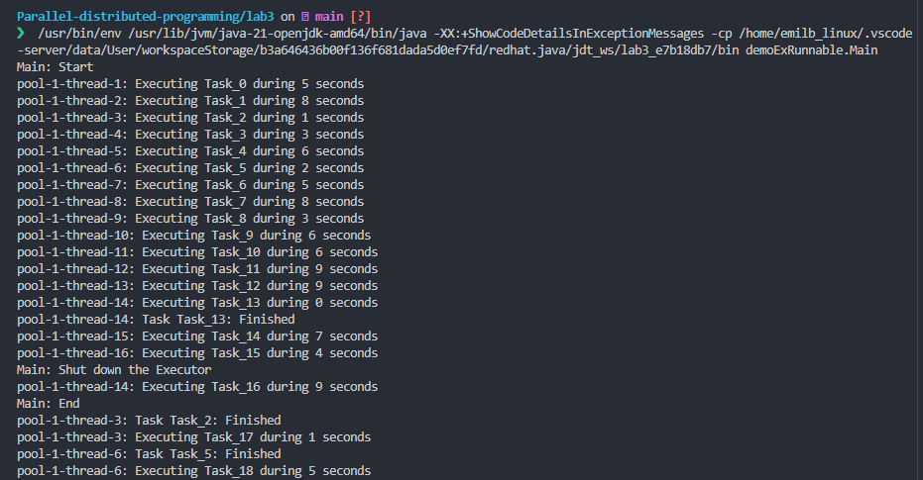
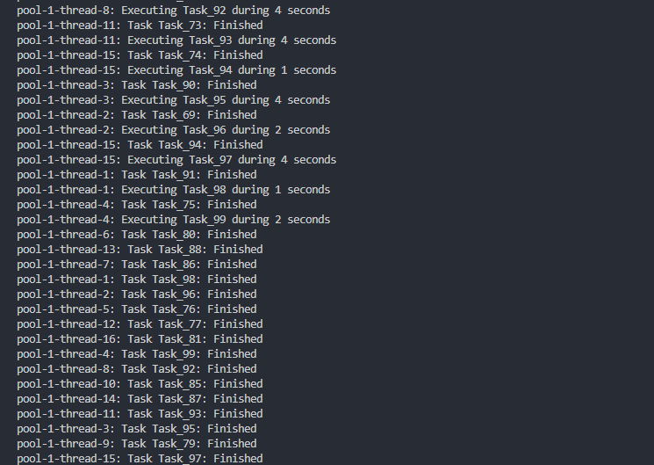

1.2: How different tasks are assigned to different threads
Firstly, The Executor creates a thread pool with 16 threads, which matches the number of available processors.
Secondly, the first 16 tasks are assigned to the 16 available threads in sequential order. When a thread completes its task, it becomes available and picks up the next pending task from the queue.
The tasks are assigned from a work queue in FIFO order, and no thread sits idle when tasks remain in the queue.
Lastly the ThreadPoolExecutor automatically balances the workload. Since task durations are random, threads finish at different times and dynamically pick up new work. This ensures that alle threads stay busy until the queue is empty.

1.3: Why messages are still printed after the main thread ends
The reason why messages are still being printed after the main thread ends is because the program is being shutdown using executor.shutdown() and not executor.shutdownNow().
The current command initiates an orderly shutdown. This means that already submitted tasks continue to execute. New tasks on the other hand are not accepted. In this case it means that all the 100 tasks will be finished, but tasks defined after shutdown will not be executed.
To put another way would be to think of this as a restaurant:
- shutdown() = "Kitchen is closing, but we'll finish all orders already placed"
- Orders already in the queue: Will be made
- New orders after closing: Rejected

Exercise 2: Run code from demoExCallable

2.1: Output (2 Screenshots)
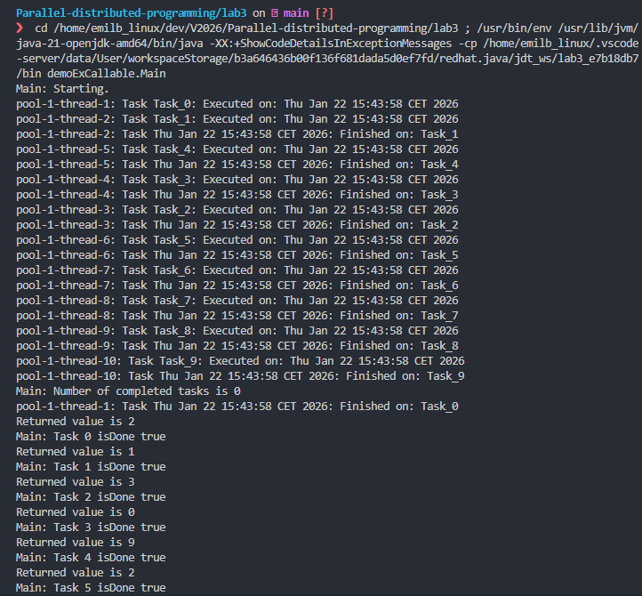
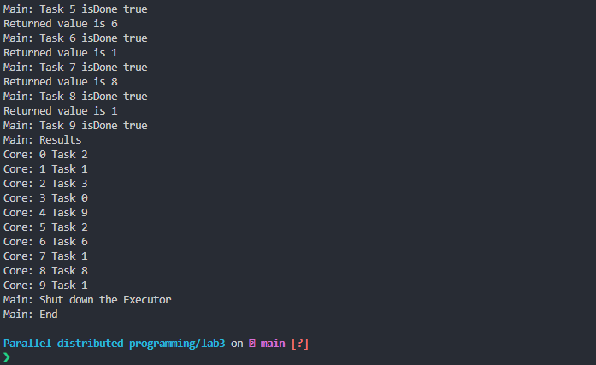

2.2: What happens when calling get() method from a task that is not done
If we call the get() method while a task is not finished, the calling thread will wait until the task is finished. When finished, it will return the computed value (Long in this case) or an exception if it task threw and exception.

Exercise 3: Write multithread program – 100 tasks
Code is under attached files in folder “exercise3”
Below are two screenshots from the output, one from the first 10, and one from the last 10.
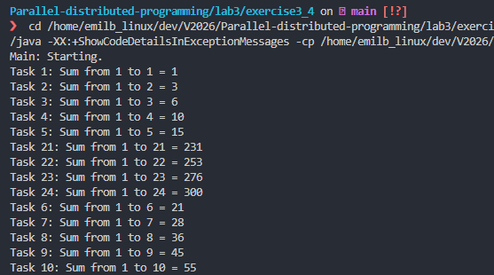
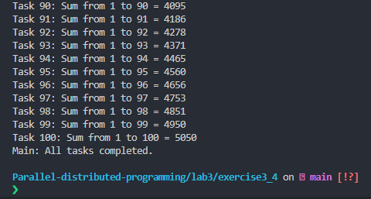

Exercise 4: Parallel program with Speedup

4.1: Complete the implementation of the Main.java
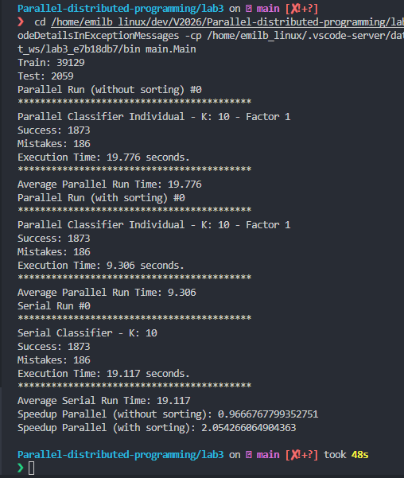

4.2: How Parallel versions are better than serial version:
Parallel versions are better than serial versions mostly because it can divide the work on multiple CPU cores. This allows tasks to run simultaneously instead of one after another. Furthermore, this reduces the total execution time and increases throughput, especially in larger datasets.

4.3: Which parallel version is better and why:
The parallel version with sorting is clearly better. The execution time (9.3 seconds) and speedup (2.05 times) are significantly higher than the “without sorting” version (19.8 seconds, 0.97 times).
Sorting helps the threads process data more efficiently by improving data organization and cache locality, reducing synchronization overhead, and ensuring faster access patterns. The “without sorting” version likely suffers from unbalanced workloads or inefficient memory access, offsetting the benefits of parallelism.

4.4: Changing the size of the dataset
Case | K | RUNS | Parallel (no sort) | Parallel (sort) | Serial | Speedup (no sort) | Speedup (sort)
1 | 10 | 1 | 19.81 s | 12.56 s | 25.23 s | 1.27× | 2.01×
2 | 40 | 2 | 20.29 s | 12.57 s | 22.59 s | 1.11× | 1.80×
3 | 40 | 5 | 19.22 s | 10.12 s | 22.58 s | 1.17× | 2.23×
- Parallel (with sorting) consistently performs better than both the serial version and the unsorted parallel version.
- As K increases (meaning more computation per test sample), both parallel versions slow down, but sorting still gives a higher speedup.
- Increasing RUNS (number of repetitions) gives more stable timing and slightly improves the consistency of the speedup result.

