ITF23019: Parallel and Distributed Programming

Report for Lab 2: Multithreading in Java

Name: Emil Berglund

GitHub: EmilB04

Exercise 1:
- Screenshot of the output from demoThread:
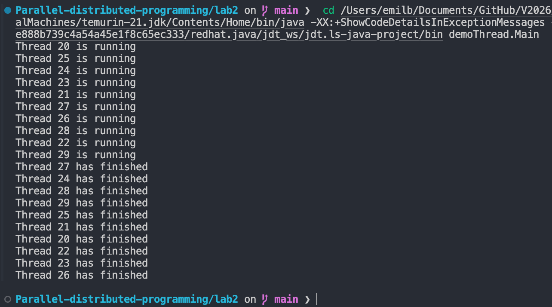
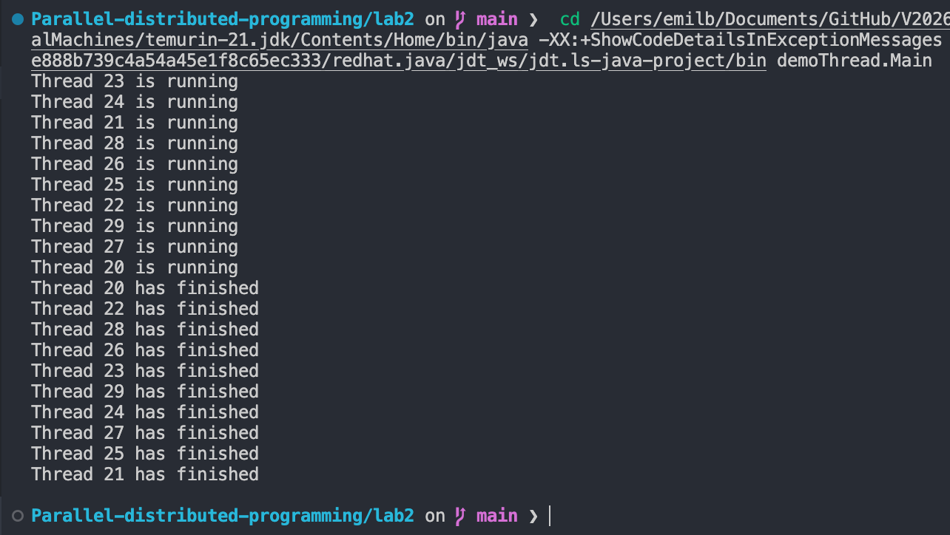
- Explanation of different output, when run several times:
  - When running demoThread, 10 threads get created and because threads run concurrently, their execution order is not guaranteed. The OS scheduler decides when each thread runs, sleeps, and wakes, and that can change every run. After sleeping 500 ms, threads may wake up in any order. Prints from different threads can interleave differently each time. Therefore, the output order varies from run to run.
- Explanation of why threads were not started and finished in the same order:
  - The OS scheduler chooses which thread to run, not the program. Which means starting order doesn’t equal running order. A later-started thread might get CPU time before an earlier one. The 500ms sleep doesn’t guarantee wake-up order. Timers are approximate and wakeups compete for CPU. So, without explicit coordination (e.g., join, locks, barriers), start and finish orders are inherently nondeterministic.
Exercise 2:
- Screenshot of the output from DemoRunnable:
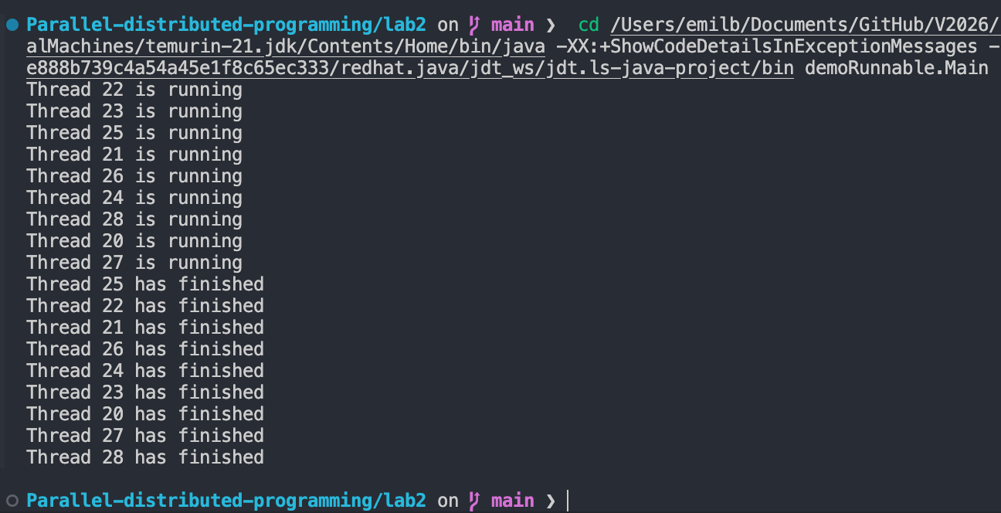
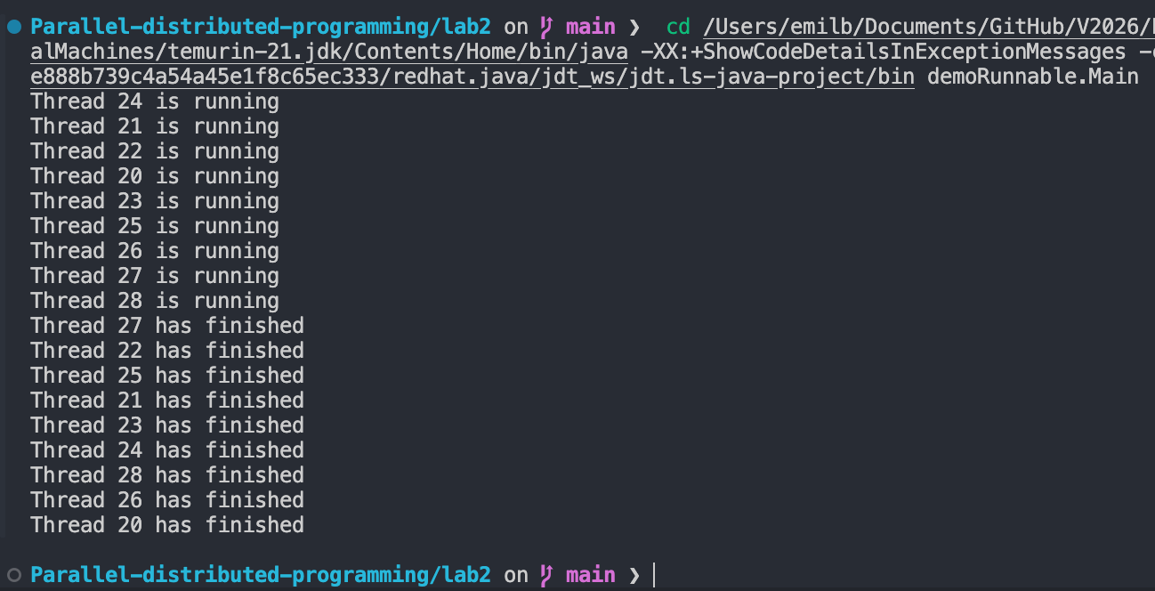
- Explanation of different output, when run several times:
  - The outputs are different each time, mostly due to the same reasons as exercise 1. Threads are scheduled by the OS, so their execution order is not fixed, and can change each run. After each sleep they also wake up in random order and then compete for CPU time.
- Explanation of why threads were not started and finished in the same order:
  - The OS scheduler chooses which thread to run, not the program. Which means starting order doesn’t equal running order. A later-started thread might get CPU time before an earlier one. The 500ms sleep doesn’t guarantee wake-up order. Timers are approximate and wakeups compete for CPU. So, without explicit coordination (e.g., join, locks, barriers), start and finish orders are inherently nondeterministic.
Exercise 3:
- Modify the number of threads created in main from exercise 1 & 2. How are your computer’s resources used when too many threads are created (CPU & RAM)?
Exercise 4:
