Report for Lab 1

Name: Emil Berglund

GitHub: EmilB04

Disclaimer: I did figure 7-9 on my local machine, due to many people being on the hiof server. Thus there is different GUI and file-names
Exercise 1:
Figure 7: Making Cpu0 to run out
Figure 8: Two CPUs are running
Figure 9: Stop running a program with Ctrl- Z.
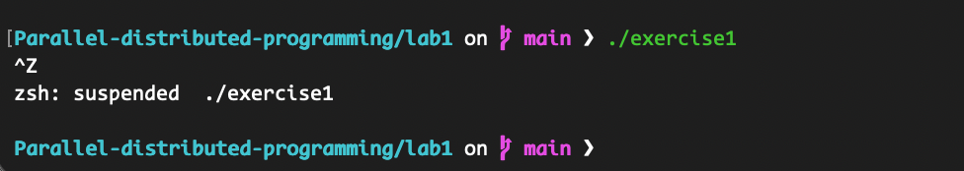
Figure 10: Memory address of the Hello World program
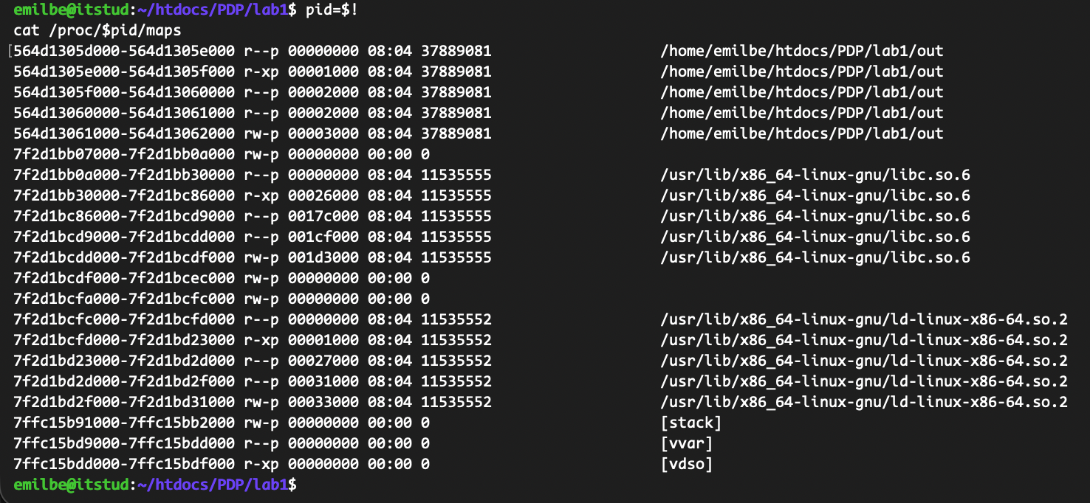
Exercise 2
Figure 15: One possible output of top command.
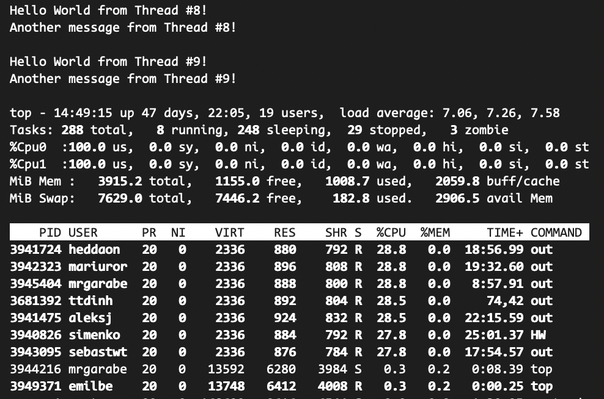
- Due to high load on the server, 2/2 CPUs are running
- Since I only defined 100 threads, I got 100 threads:
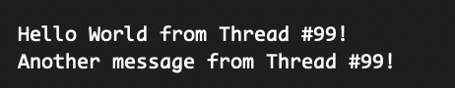

Exercise 3:
Disclaimer. Since it’s relatively long ago since I programmed in C, I got some help from ChatGPT5 with this exercise, mainly the code/syntax, and how to allocate memory.
Screenshot and explanation below.

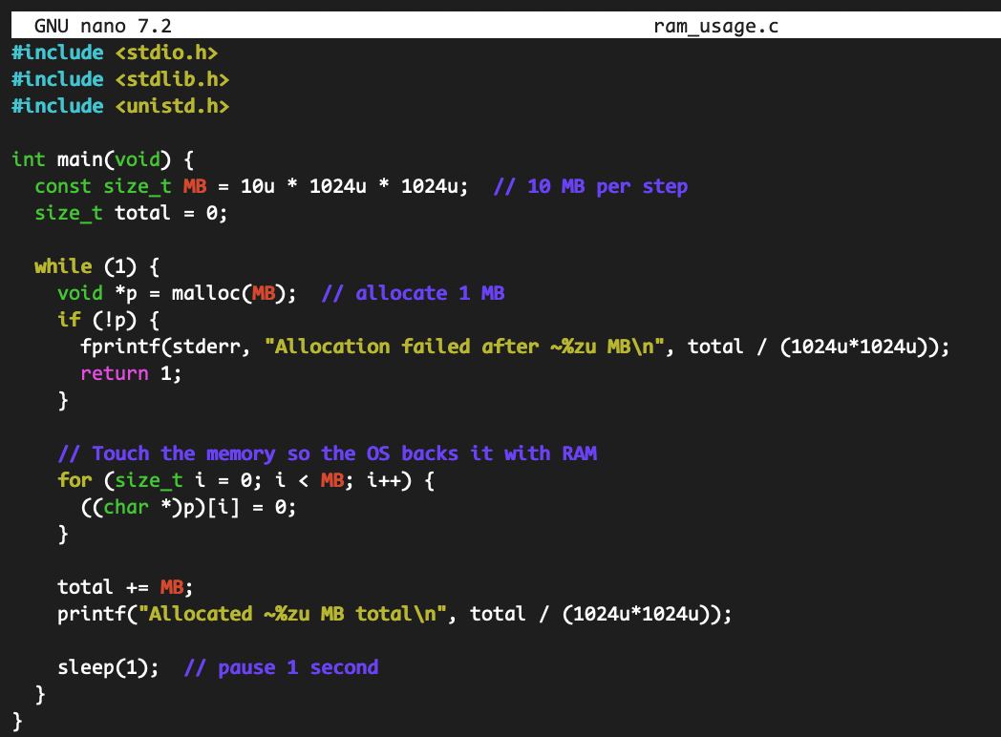
Includes:
- Stdio.h for printing with printf
- Stdlib.h for malloc and size_t
- Unistd.h for sleep
Constants and counters:
- MB is set to 10 x 1024 x 1024 bytes (that’s 10 MB).
- Total keeps track of how many bytes that has allocated so far.
Infinite loop:
- Malloc(MB): Asks the OS for a new 10MB block of memory
  - If malloc returns NULL, there wasn’t enough memory, and the program will show the total amount of memory used and exit
- Touch the memory:
  - The for-loop writes 0 into every byte of the new block
  - This is important because many operating systems don’t give you real RAM until you actually use the memory. Writing to it forces the OS to back those virtual pages with physical memory, so the program’s RAM usage truly increases.
- Update and print:
  - Add 10 MB to total
  - Print the total allocated so far in megabytes
- Sleep(1):
  - Wait for 1 second before the next iteration. This makes the growth gradual and you can easily see the update
No free:
- We never free the blocks on purpose, so the program’s memory usage keeps growing by 10 MB each second until allocation fails or you stop the program (Ctrl-C).

Exercise 4:
Running the code:
- 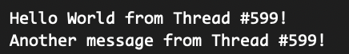
Using top to see which CPU is running the code:
- Since the program is so fast, it is not possible to see which CPU is being used, when running the program. In other words, it does not show up in the overview when writing “top”.
Explaining why Pthread programming is not parallism:
- Pthreads are a tool for concurrency while parallelism is a hardware and runtime property. Threads have no guaranteed parallel execution. If you have only one CPU core, the OS time-slices threads; meaning they run one at a time.
- The code in this exercise demonstrates concurrency (many threads created), but not meaningful parallelism. This is because they mainly print, which is I/O-bound and short lived.

