ITF23019: Parallel and Distributed Programming

Report for Lab 9: Graph Search Algorithms

Name: Emil Berglund

GitHub: EmilB04

Exercise 1:
Subtask 1: Run the program and include screenshot
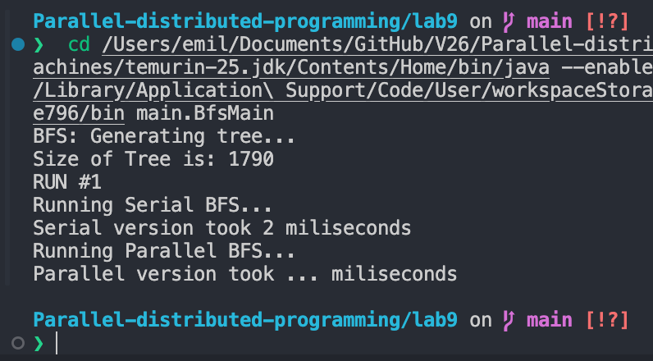
Subtask 2: Implement Parallel BFS
Subtask 3:
Subtask 4:

Exercise 2:

